**PRICE:** $22.98

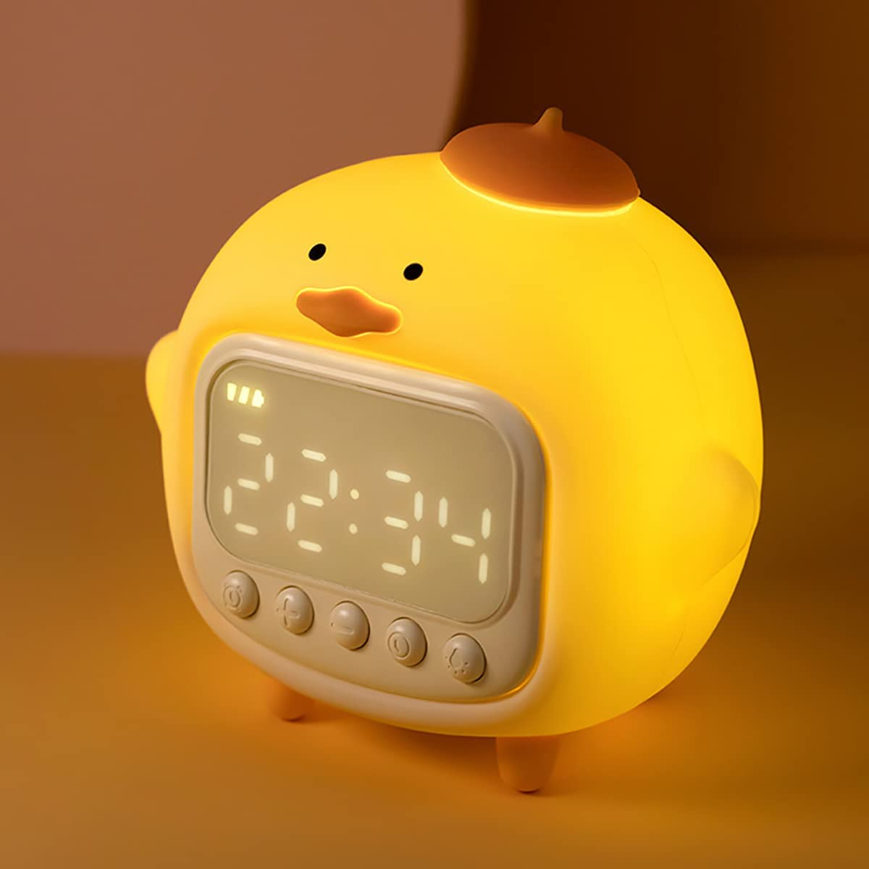

**ID:** CL-05

**Brand:** LEDHOLYT

**Display Type:** Digital

**Style:** Art Deco

**Special Feature:**   
Night Light + Sleep Clock + Wake Up Clock + 5 Kinds of music + Delayed Light Off + Dimming + Volume AdjustmentNight Light + Sleep Clock + Wake Up Clock + 5 Kinds of music + Delayed Light Off + Dimming + Volume Adjustment

**Product Dimensions:** 4.72"W x 5.43"H

* 【Safety Night Light & Kids Wake Up Light】The silicone layer on its surface plays a safe role in protecting your baby, and the soft light and adjustable sound of the duckling alarm clock gives a sense of oppression. Ducky alarm clock is a product designed for all children, including babies.
* 【Clever design, efficient dual-use】Flexible alarm clock design with night light + sleep clock + wake up clock + open alarm clock + 5 kinds of music + delayed light off + dimming + volume adjustment and other functions. Its dimming function can adjust the light brightness and darkness in the night light state, and the delayed light off function can be set to automatically turn off the light after the baby falls asleep. Since it has both night light and alarm clock functions, it can be used as both an alarm clock and a night light.
* 【Soothing Duckling Alarm Clock】This duckling emits a gentle, calming yellow glow while providing alarm clock service for children of all ages.The warm 2700K light drives away the darkness and accompanies children to sleep, allowing parents to get a restful night's sleep. No more struggling with your child's bedtime.
* 【USB Rechargeable & Convenient】1500mAh rechargeable battery, the little duck alarm clock can be recharged by plugging into a micro USB socket, charging time is 2-2.5 hours, it can work for 5 hours when used in night light mode and 100 hours in alarm mode, whether you use it as a night light to carry out or as an alarm clock, it can meet your needs.
* 【A good choice for gifts】The duckling alarm clock can not only be used to decorate the room, but also to develop your child's ability to sleep alone. Duckling alarm clock is made of ABS + HIPS + silicone, not only soft to the touch, but also has a sense of texture. As a birthday gift for children and holiday gifts, it is a good choice.