**PRICE:** $25.80

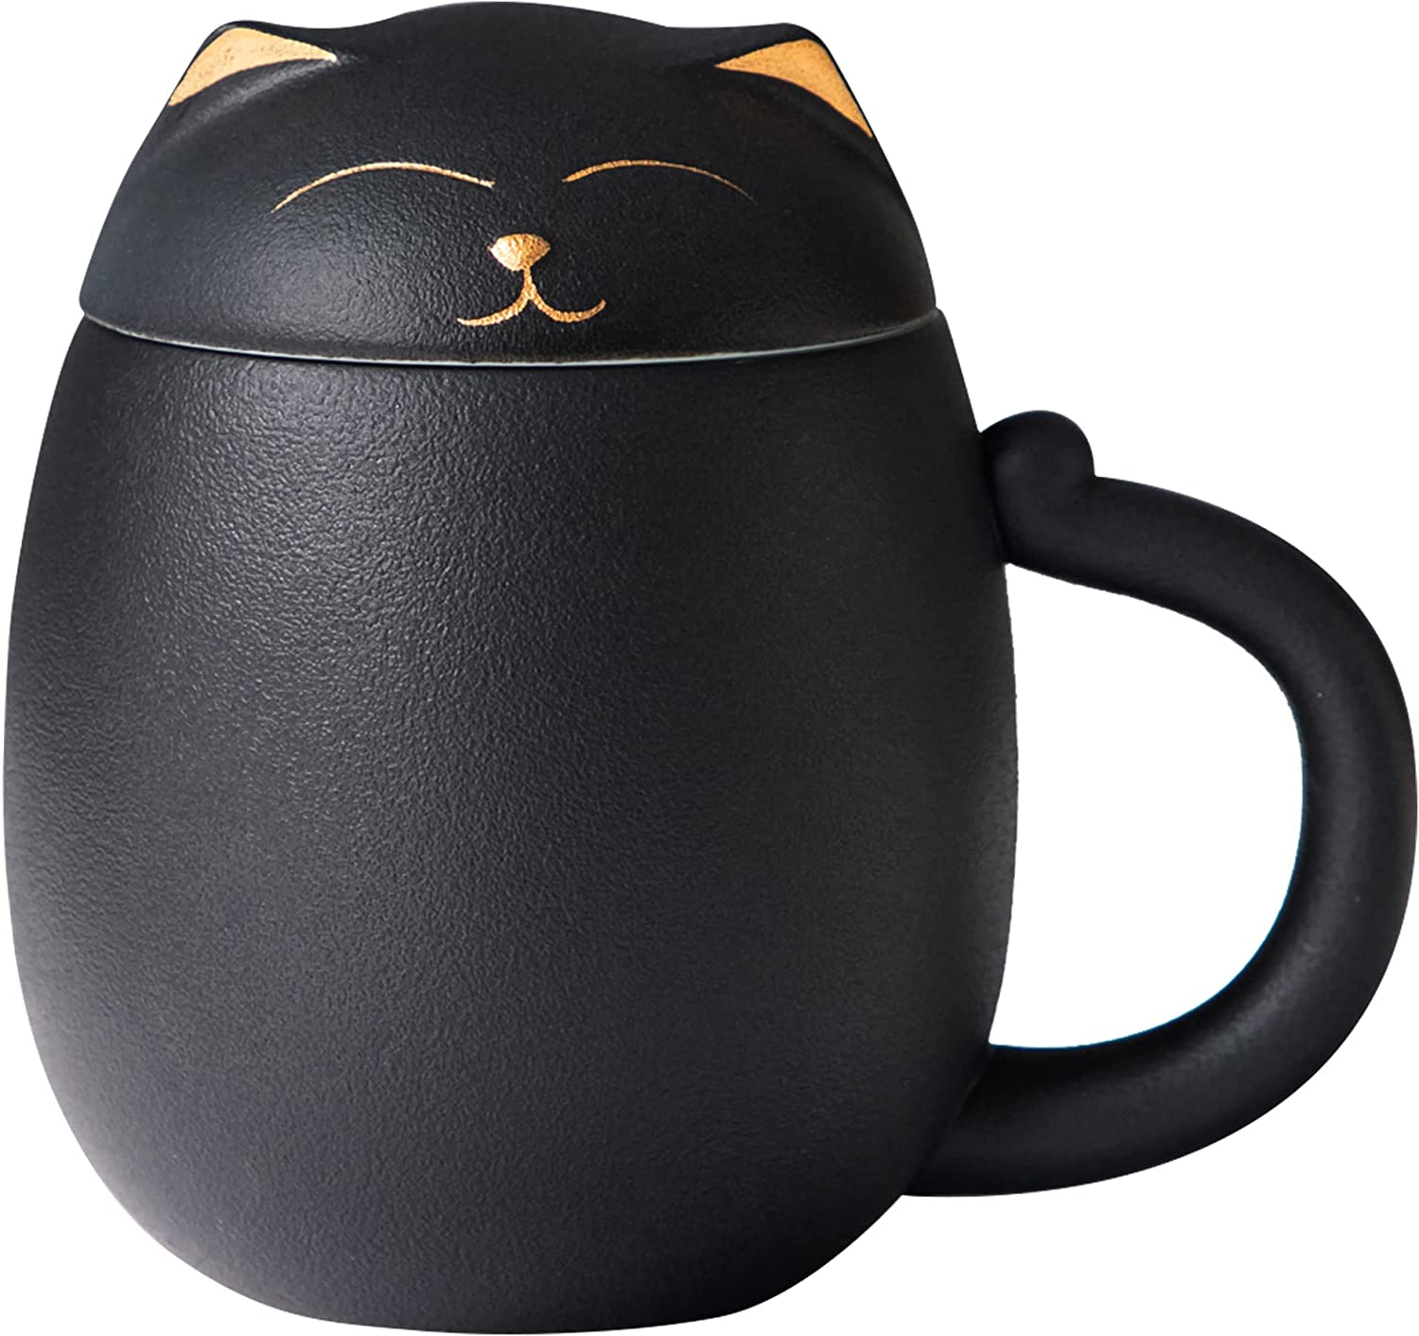

**ID:** MUG-02

**Brand:** HEER

**Color:** Black

**Style:** Modern

**Theme:** Cat,Chinese,Leaf

**Recommended Uses For:** Home

**Material:** Porcelain

**Capacity:** 400 Milliliters

**Item Weight:** 1.2 Pounds

* Traditional Handmade Ceramics: Selected porcelain clay, made by fine traditional Chinese handicraft, fired at 1300°C high temperature. The glaze is free of lead and cadmium, safe and healthy to drink, and very easy to clean.
* Cute Cat: The cute cat shape and the handle is the tail of a cat, which means it is scald-proof and smooth to hold. The lid is designed to keep your tea hot while steeping and can be used as a tray for the infuser to catch drips.
* Separate Strainer: A ceramic strainer is hidden inside the tea cup, with a stainless steel carrying handle that won't burn your hands. The ceramic strainer is better at retaining the original flavor of the tea.
* Multi-purpose: 13.5oz（400ml）large capacity, not only can be used to make loose tea, blooming tea and flower tea, the cup can also be used for coffee, milk and water, simple filtration teacups great for family daily, suitable for office and home.
* Gift with Heart: This is a tea accessories for tea lovers, you can present this gift to cat lovers such as friends, family or colleagues on occasions such as birthdays, anniversaries, Valentine's Day, Christmas and housewarming.