**PRICE:** $26.99

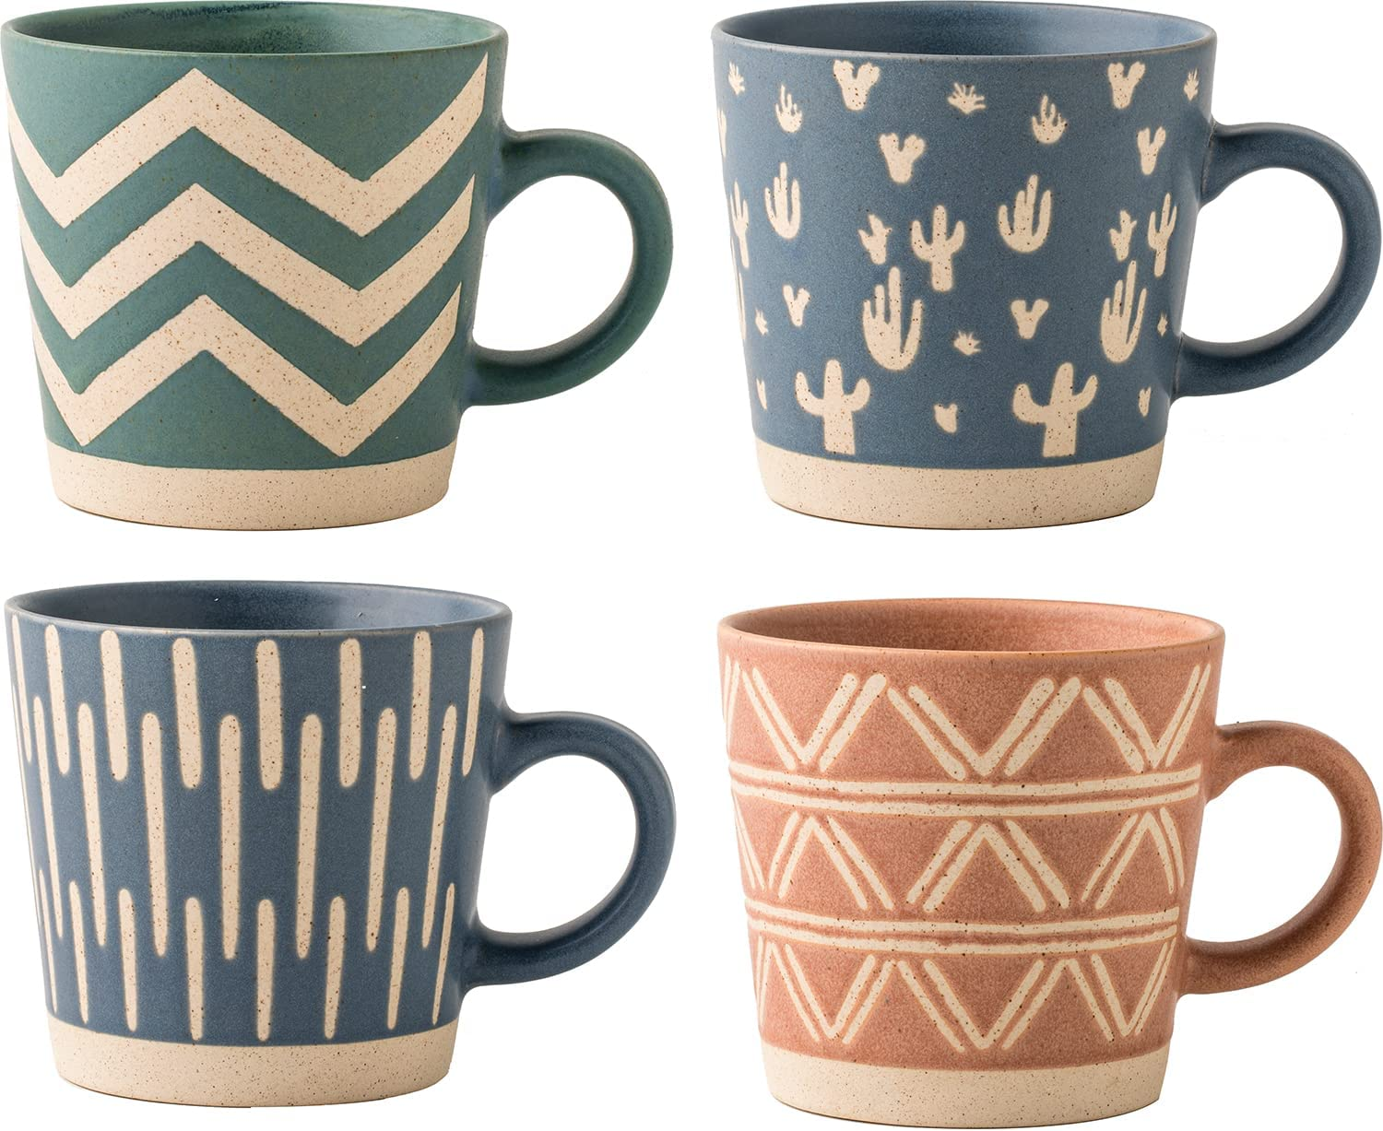

**ID:** MUG-08

**Brand:** Buren Ceramics

**Color:** Teal, Blue, Pink, sky

**Special Feature:** Microwave Safe

**Style: Modern**

**Theme:** Modern

**Material:** Ceramic

**Capacity:** 12 Fluid Ounces

**Item Weight:** 1 Pounds

* BRIGHTEN YOUR DAY WITH OUR COFFEE MUGS: Start your day feeling vibrant with our artistic multicolor coffee mug set that will brighten your mood. The bold and cheerful design adds elegance and uniqueness to your kitchen and will be your great companion as you begin the day with a cup of coffee, tea, and any beverage. You can use these sets as your espresso cup, tea mug, latte cup, and other drinks you want to pair with our cup.
* FUNCTIONAL SETS THAT SUIT YOUR NEEDS: This Buren Ceramic set includes 4 mugs with an beautiful abstract design. Not only will you drink your coffee for the sunrise, but you have all the day to sip and smile, knowing you have all you need on your tabletop. Each mug has its own unique design with its own personality.
* A FULL PACKAGE OF FOUR: Our 4 Mugs is the perfect addition for your kitchen and includes a complete package of four sets of mugs. The box used is thoughtfully packaged and protected with styrofoam to ensure it's delivered to you safely. Our microwave-safe mugs are stylish and sturdy.
* A SET FOR EVERYONE: Do you still have no idea what to give to your family, officemates, and friends? This set of mugs feels like a hug when they begin their day and work with their hot beverage. Imagine them drinking their tea throughout the day while remembering you. What a personal touch! Our giftable coffee set is a special present to collectors, relatives, workmates, and friends—It has a pretty box that goes well with what's inside.
* A DETAIL-ORIENTED BRAND: Our coffee kitchen cups are not just used at home but also used by various people in places like offices and events for different occasions. With attention to detail, from designing to packaging, our products are manufactured using a lead-free and cadmium-free process to ensure that you are safe while you cheerfully drink.