**PRICE:** $21.99

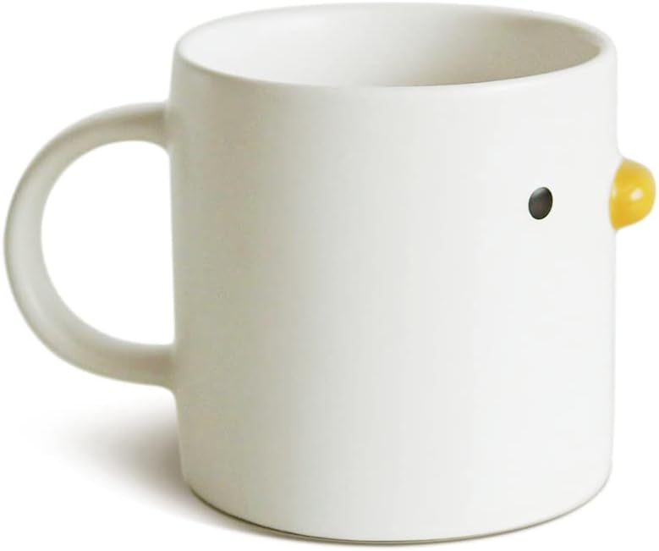

**ID:** MUG-06

**Brand:** PURROOM

**Color:** White

**Style:** Coffee Mug

**Capacity:** 400 Milliliters

**Theme:** Valentine's Day / Birthday / Family / Friend

* Interesting styling】 Hand-glazed yellow chick mouth cup. Looks like a simple mug. Creative, cute design stimulates your imagination and inspires you to start the day well. Have your coffee or your favorite beverage.
* Use in multiple scenarios】 The cute chick mug is suitable for home, office and party to create atmosphere every time. Make your friend or college burst out laughing. Release the pressure and feel more relaxed.
* Perfect gift】 This ceramic mug is perfect for all drinks, coffee, tea, milk. Great gift for family, friend, teacher for Christmas, New Years, Festival or Birthday. It will be an unforgettable gift.
* High quality ceramic】 With a comfortable grip, easy to clean. Hand wash recommended, matte and delicate, corrosion-resistant and worry-free for healthy use. Thick high-end ceramic materials can be heated in a microwave oven.
* The same creative design】 The creative chicken-shaped coffee mug made from Best China Porcelain, many more mugs, bowls and pet's toys in the same design can be found in our Amazon shop.
* Products are hand-glazed and each product is carefully inspected before leaving the factory. If a customer encounters issues such as unacceptable minor defects or uneven glaze color, submit an exchange directly to Amazon.