**PRICE:** $27.99

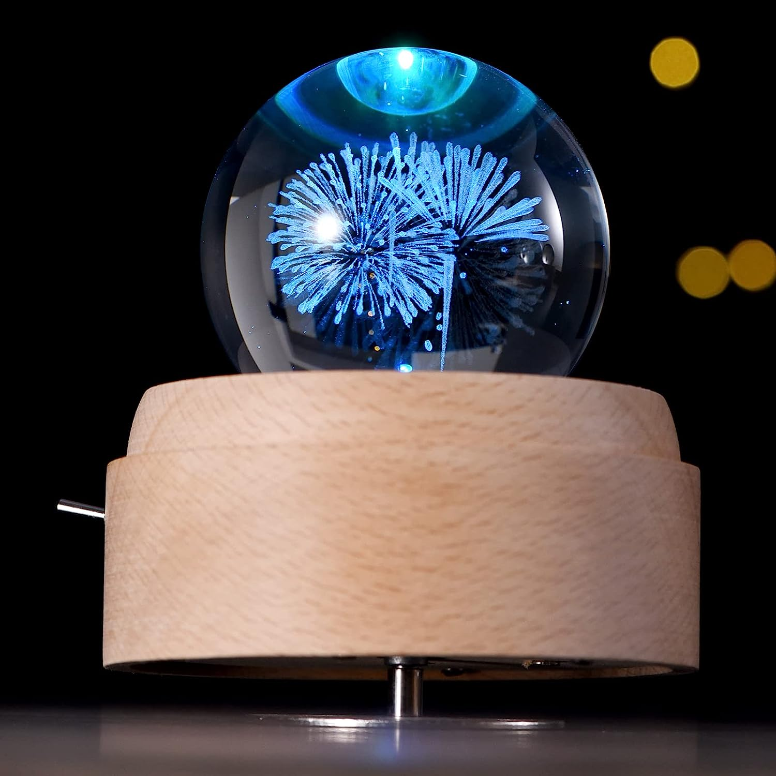

**ID:** SN-06

**Color**:  Brilliant Fireworks

**SIZE:** SIZE M

**CATOGERY:** Snow ball decor

**BRAND: Cường House**

* PREMIUM MATERIAL: The base of the music box is made of natural beech wood, the wood is dense and has an elegant texture. Warm color, no paint, natural and healthy, long service life. The music box uses a high-quality movement, and the music quality is excellent. Turn the clockwork at the bottom of the base, and the music of Canon will play.
* Spinning: This 3D crystal ball music box is very romantic and suitable for kids and adults. A crystal ball with a wooden base spins while music is playing. The wonderful songs in the box will make you happy.
* FUNCTIONALITY: This 3D crystal ball music box is perfect for kids and adults. There are LED lights on the base, which are very bright. The product is rechargeable via USB and can be used as a bed light or flashlight.
* Decoration: Crystal ball diameter: 7cm, exquisite 3D carving process. The fantastic crystal ball and solid wood base are the perfect combination. Not only can be used as a music box, but also as a decoration. Luxury desktop decoration for office, home, KTV, cafe, hotel.
* Best Gift: Birthday, Party, Valentine's Day, Christmas, Graduation, Mother's Day or as a bridesmaid gift, bridesmaid gift, mother of the bride gift, girlfriend gift or thank you gift.