**PRICE:** $14.99

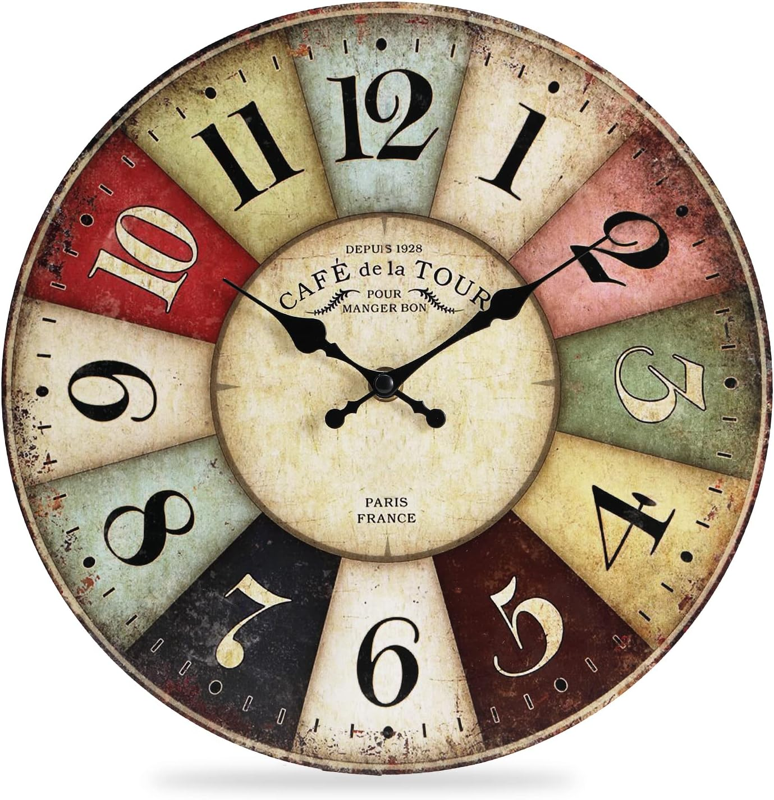

**ID:** CL-03

**Brand:** Generic

**Color:** Vintage Brown

**Display Type:** Analog

**Style:** Vintage

**Special Feature:** Silent Clock

**Product Dimensions:** 12"W x 12"H

**Power Source:** Battery Powered

**Age Range:** Adult

**Shape**: Round

**Material:** Wood

* 【Easy to Read Wall Clocks】- Each number area of the clock designed with differernt colors, 12 inches diameter wooden colorful dial, black and white large Arabic numerals and hands, no frame no shiny glass cover, without any light reflection, it's also easy to read for any others who have poor sight even from a distance or side.
* 【Large Silent Non-Ticking Wall Clock】- High quality silent sweep movement keeps accurate time and absolutely silent environment in day and night.Battery operated takes 1 "AA" Carbon Zinc battery.The sturdy nail hook design on the back provides extremely easy installation.
* 【Decorative Vintage Wall Clock for Gift】- The colorful clock decorates the dining room, living room, classroom, cabinet, office,library or any wall of any color, hanging on the wall or on the table are both beautiful,stylish and retro.A perfect choice for christmas gift, Father's day, Thanksgiving Day, Halloween, birthday presents, holiday gifts etc.
* 【Wooden Round Wall Clocks】- Made of quality MDF, no harm and Eco-friendly Material, this clock can be used in all room of your home included baby room. Dimensions -12 inch x 12 inch x 0.98 inch.
* 【Service Guarantees】- 1 year quality warranty and 90 days policy of a full refund or replacement.If you have any questions about our product,please feel free to contact us,we will give you a satisfed solution within 24 hours.