**PRICE:** $11.98

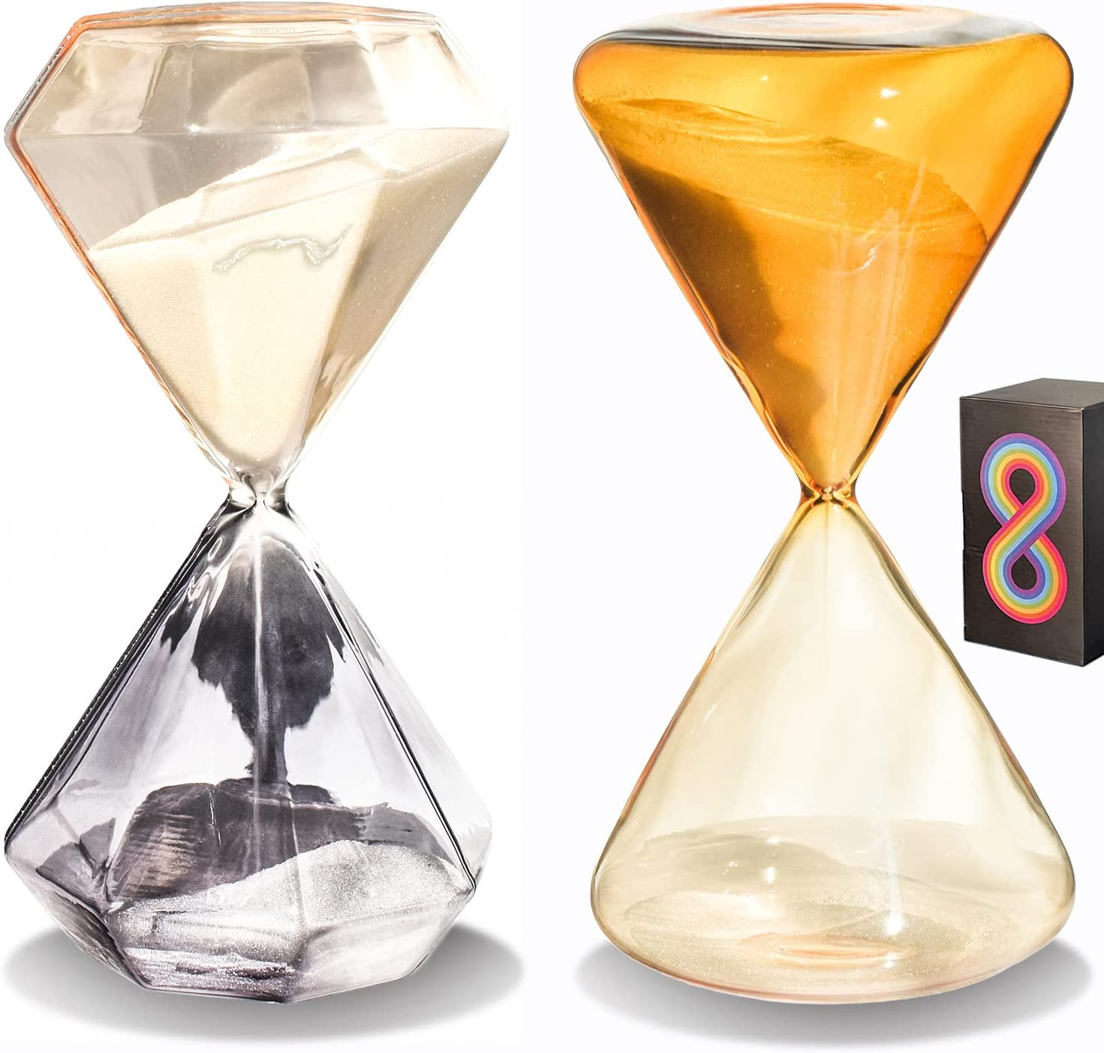

**ID:** CL-06

**Color:** Set of 2

**Brand:** SEMEDOYO

**Material:** Glass

**Product Dimensions:** 3.38"D x 3.38"W x 6.39"H

**Number of settings: 2**

* Colorful Hourglass for Your Colorful Life. Beautiful Designed Gift Box Package for a Gift or Collection.
* Hourglass Set of 2. Height: 6.39 inches. Width: 3.38 inches. 15 minutes triangle shape hourglass with orange and champagne color glass and 30 minutes diamond cut shape hourglass with champagne and grey color glass. The handcrafted hourglass sand timer set is made of environmental glass with an artistic design by japanese designer Hitomi K. The design inspiration comes from the graceful sunset at Mount Fuji in autumn.
* HOUR GLASSES WITH SAND 30 MINUTES.The hourglass timer set can be a nice plasma hourglass decor,hour sand glass and wall timer.The sand timer pack with sand clock 15 minutes and half hr timer are great decor. You can use the decorative sand clock decor as a biloba hourglass desk decor,hourglass game timer,yoga timer hour glass unity and meditation 2 pack timer without sound.The mini timer can also be assembled as table centerpiece with cute timer.You can add some seasonal decor around the sand watch for desk and it'll be a desktop timer decoration as a study decor.The hour glasses decorative with 30 min hourglass and 15 minutes hourglass can also be used as yoga glasses and sand for office.
* DECORATIVE SAND TIMER 30 MINUTES. ELEGANT DECORATIVE HOURGLASS SAND TIMERS. Hour glasses with sand 15 minutes and 30 minutes sand timer art are wonderful time management tool as minute watch and sand ceremony hourglass handpro. By a slightly glance of the large hourglass tea timer you would see time go through the symmetrical hour glass timer. The Hourglass sand timers can meet the requirement of buying a hoirglass timer or decorative yoga decor sand timmer for timer meditation. The hourglass 15 minutes is also a nice and helpful sand timer for cooking clock timer. The 15 min sands clock can also be used as reaper hourglass, hourglass teal sand, hourglass pearl and jumbo time timer.
* LAGRE HOURGLASS SAND TIMER.UNIQUE DESIGNED DRIP HOURGLASS.These beautiful timers clock will help you work more efficiently and initiate an immersed atmosphere to feel the sence of time.They can improve your life quality by focusing on time.The 15 minute timer sand can meet various uses,you can use it as sand office decor,time glass,large hour glasses with sand and 15 minute timeglass.You can use the timeless design sand glass timer 15 minutes at parties as minute game timer and office decor yoga in your company as a large sand timer for office sand watch for desk.Home desk timer as gifts for women,gift for christmas decorations,thanksgiving decoration,gift for baby shower and birthday party.
* DECORATIVE SAND CLOCK 15 MINUTES. This hourglass timer 15 min can be used as game timer sand for play time, yoga classroom timer, unique cooking timer and meditation timer clock for table decorations. The 15 minute hourglass is also a good choice of yoga watch, Study, hourglass wedding sand ceremony and Exercise or Games as centerpiece decorations for dining room. The sand watch can help you to 100% focus on your mind and body. This hour sand glass and hour glass set has 2 sand timmers could also be a table decorations for livingroom. We have a 15 min decor timer and a big timer sand watch 30 minutes to meet your varied needs and different color for your various and stylish home decorations.
* MULTIFUNCTIONAL HOURGLASS ORNAMENT. The 15 minute sand clock could be a reminder for play time management hourglass.This 15 minute hourglass is a useful sand timer decor for your meditation.The big hourglass that made of sand and glass is a quality product to be used as a decortive sand timer or desktop timer for home study decor.This sand timer hour glass is a appropriate study timer clock,the timer with sand can also be a bookshelf decor as a beautiful time sand glass to decorate your Space for learning.This 15 minute hourglass timer can be used as exercise timer and play work timer.The decorative timer is a great yoga glass as well as bookshelf decorative objects and unique kitchen timer.