**PRICE:** $59.99

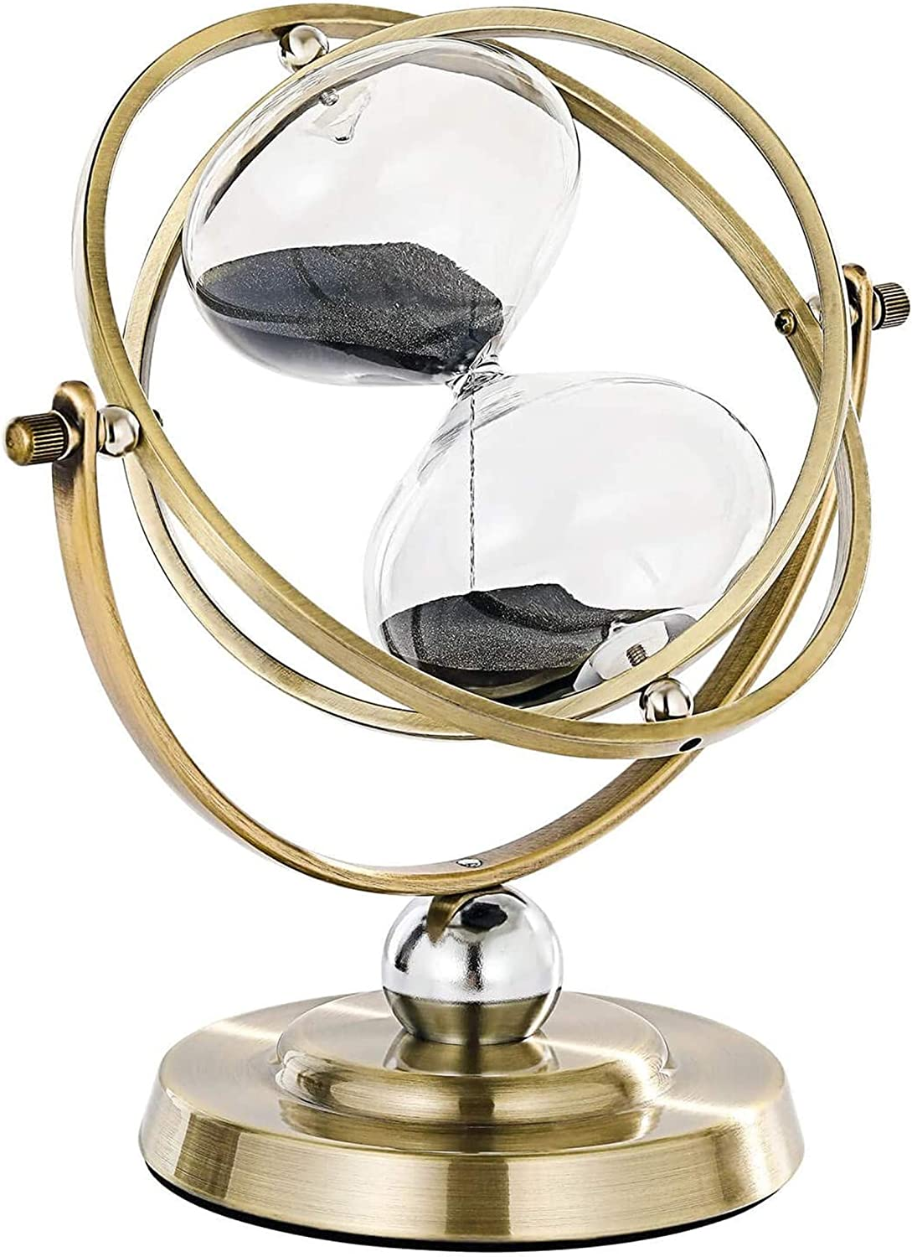

**ID:** CL-04

**Color:** 720° Rotating, Black Sand

**Brand:** SuLiao

**Material:** Metal

**Product Dimensions:** 9"D x 9"W x 10"H

**Number of settings:** 2

* Rotating Hourglass: You can easily 360° adjust the angle as you like to relax your mood and relieve work pressure. By flipping the hourglass, you will get 60 minutes of uninterrupted workflow that stay focused and productive for longer.
* Europe Style Hourglass: The 60 minutes sand timer has elegant metal bases, matched with the stylish bronzed process, the texture is beautiful and classic. The 60 min hourglass will give your office, desk, home such a classy touch and self-confident
* Precise Time: The metal hourglass is engineered in the USA to the highest quality ±3 minute industry standard. The vintage 60 minute sand timer can help you to follow up on the work easily, and to prevent the fatigue caused by overtime working.
* Beautiful Decor & Cool Gifts: The hourglass timer outlook is designed as the classic American style. The sand timer is perfect for office, study rooms decor, and meaning gifts for your family, friends. And it's bound to amaze and impress your guests.
* DOUBLE PACKAGED: Arrives carefully packaged to ensure you receive it in perfect condition.Guarantee: We will supply friendly after-sale service, free replacement if any shipping broken.100% customer satisfaction and quality guarantee.