**PRICE:** $25.99

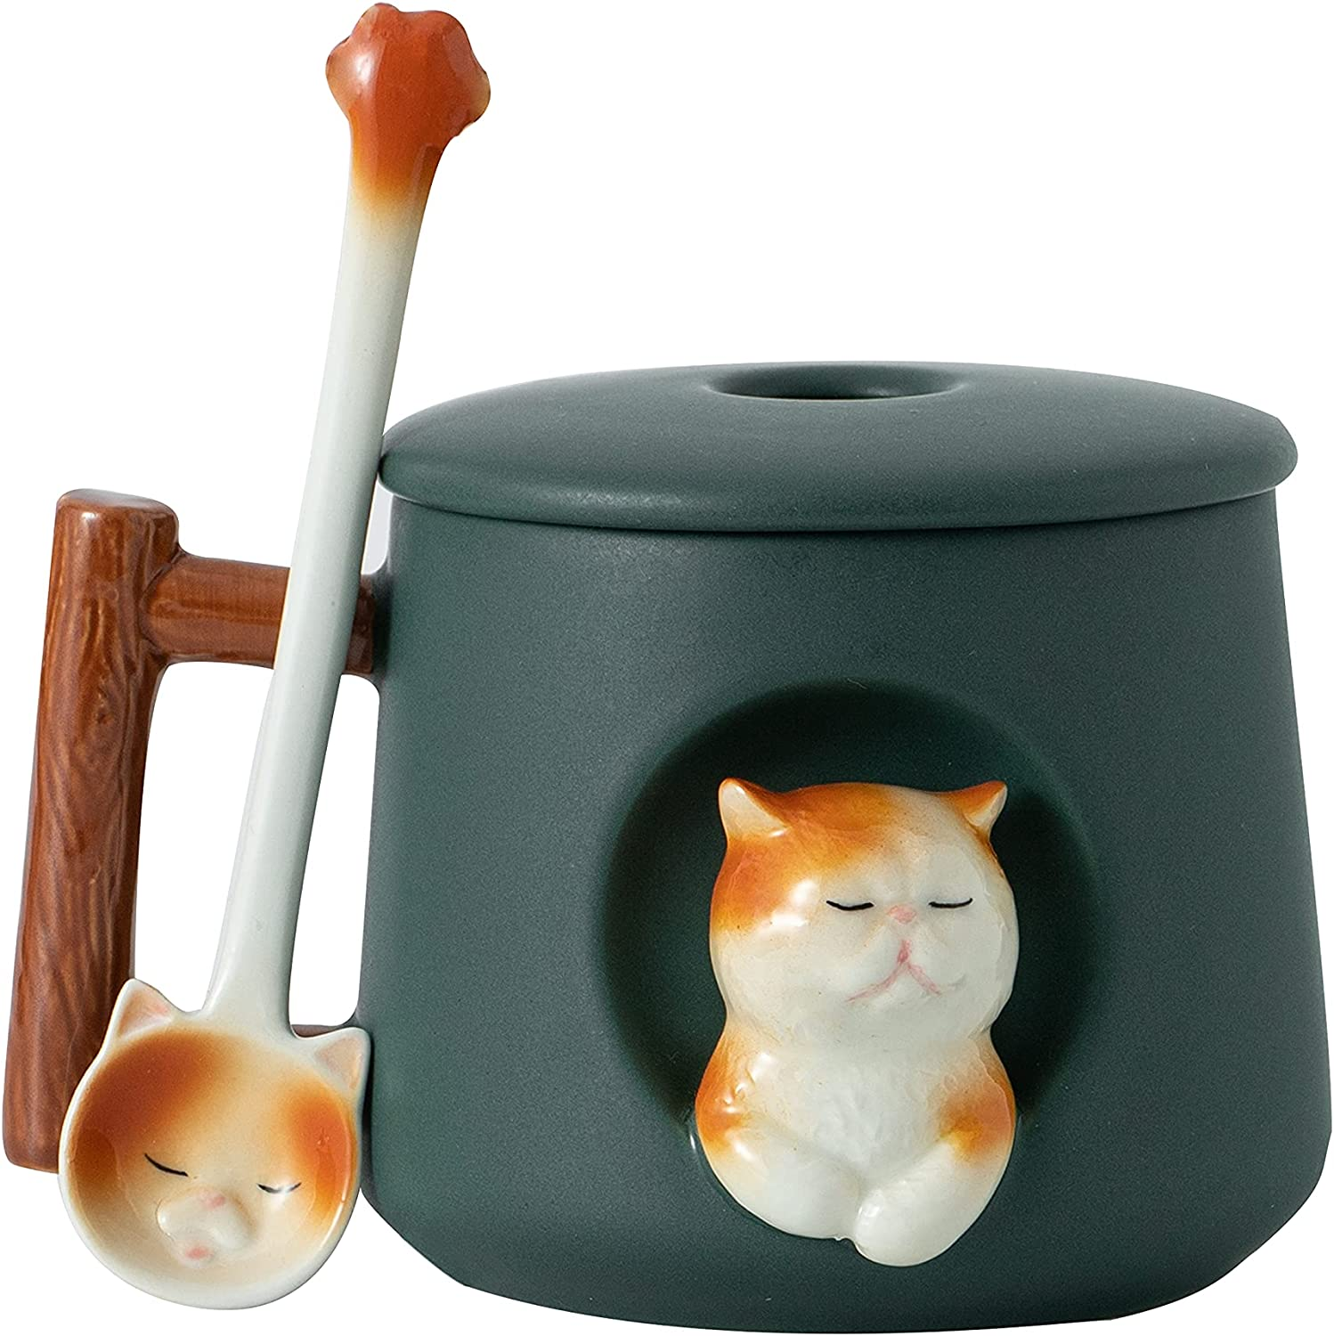

**ID: MUG-01**

**COLOR:** Green

**Material:** Ceramic

**Capacity:** 14 Pounds

**Brand:** DIHOclub

**Special Feature:** Microwave_safe, leak_proof, Microwave Safe

**Style:** Novelty,cute

**Theme:** Animals

* Adorable 3D Design: This mug features a cute Persian cat peeking out the side and smiling at you. It's hand-painted and highly recommended by our customers.
* Versatile Use: Enjoy your favorite hot or cold drinks with this eye-catching mug at home or in the office. It's perfect for coffee, tea, milk, water, beer, juice, cola, and more.
* Perfect Size: Measuring 5.2 x 3.66 x 3.74 inches, this mug is the perfect size for your daily dose of caffeine. It's matte glazed with a wood texture handle, giving it a natural feel. Plus, it comes with a cute ceramic claw spoon and a lid.
* Safe and Healthy: Made of high-temperature ceramic, this mug is safe for use in the microwave and dishwasher. It's also lead-free and healthy for you.
* Ideal Gift: This unique and cute animal cup is the perfect gift for animal lovers, as well as your loved ones, family, kids, friends, and colleagues. It's suitable for occasions like birthdays, anniversaries, Christmas, Valentine's Day, and more. No one can resist such a cute gift.