**PRICE:** $9.99

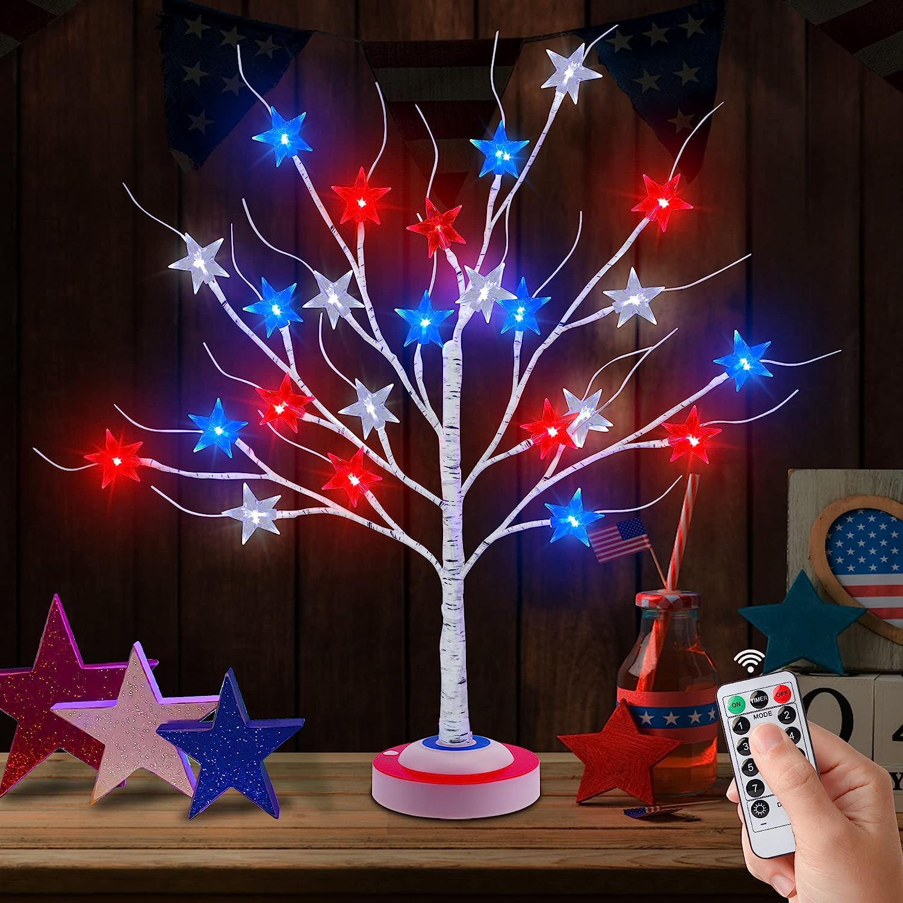

**ID:** MUG-03

**Color:** 1Pack

**Brand:** DONSAJI

**Theme:** Christmas

**Item Dimensions:** 4.73 x 4.73 x 25 inches

**Light Color:** Red

* Red White and Blue Decorations: We specifically designed this patriotic tree light with red white blue base for 4th of July Independence Day, and matched with 3D shaped star lights, strong patriotic elements will creat an exciting atmosphere for your 4th of July
* Timer/Remote/8 Modes: This lighted tree is rich in functions: timer, remote control, 8 lighting modes, 11 brightness levels, you can choose favorite mode through the remote control or buttons on the base, which are not available in other ordinary tree lights
* 2 Power Supply Modes: This artificial tree light has 2 power supply modes: one powered by USB, the other powered by 3 AA batteries (batteries not included), different power supply modes offer you more choice and convenience
* Adjustable Branches: This 4th of July tree is made of premium materials, 25 inch in height, tree branch is flexible and adjustable, you can move the wire branches to reshape as you want, can also hang some small ornaments to decorate the tree lights
* Widely used: This tabletop lighted birch tree is ideal for 4th of July, American Flag Day, Independence Day, Memorial Day. It can be placed anywhere you want to decorate, such as tables and fireplaces, making your home and party more attractive and festive