**PRICE:** $15.99

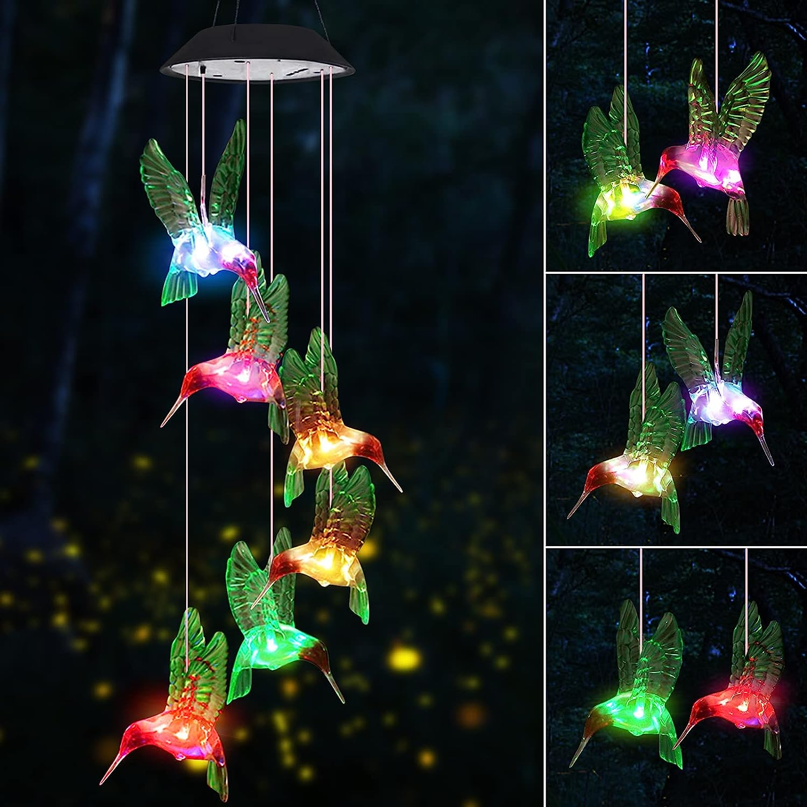

**ID:** MUG-04

**Brand:** WeeksEight

**Color:** Blue

**Material:** Acrylonitrile Butadiene Styrene (ABS)

**Style:** Modern

**Special Feature:** Light Weight

* COLORFUL MAGICAL WIND CHIMES: These are interesting and magical wind chimes that keep you in a good mood. At night, they will shine in wonderful colors, red yellow blue green purple and orange. They will Changing various kinds of brilliant colors to light up your heart, making you and family happy. You'll love them. (GIFTS FOR MOM, MOM GIFTS, BIRTHDAY GIFTS FOR MOM, GRANDMA GIFTS, GARDEN GIFTS FOR MOM)
* SOLAR POWER WIND CHIME: When you receive a gift, first turn on the solar charging switch. In sunny days, they will charge themselves and glow at night. Just hang the solar wind chimes in your fence, courtyard, window, door and front porch. On a quiet night, the lovely wind chimes will make you feel at ease and make your yard beautiful and colorful.
* WIND CHIMES UNIQUE OUTDOOR CLEARANCE: Unique rain-proof and moisture-proof design. What’s more, they will not get deformed, light weight, easy to hang. They can be placed both indoors and outdoors, which are ideal gifts for decorating yard garden patio backyard, front porch and bedroom, making your life interesting. A variety of styles are available for you to choose from: Solar hummingbird wind chime, Butterfly Wind Chime, Crystal Ball Wind Chime, Stars Wind Chime.
* TOP GIFTS OR MEMORIAL WIND CHIMES: The interesting wind chimes light decoration is not only the best gift for girlfriend, wife's wedding anniversary, child's birthday, mother's birthday, or Mother's Day, Father's Day, Christmas Thanksgiving Day, Best gifts for elderly mom, But also the high-quality interesting led wind chimes gardening/home gift for anniversaries.
* WOMEN GIFT IDEAS WIND CHIMES: Christmas gift, Thanksgiving gift , Mothers day gifts, gifts for grandma, gifts for sister, mother in law gift, gift for daughters, valentines day gifts, gifts for sister, best friend gift, mothers day gifts for wife.