**PRICE**: $ 22.99

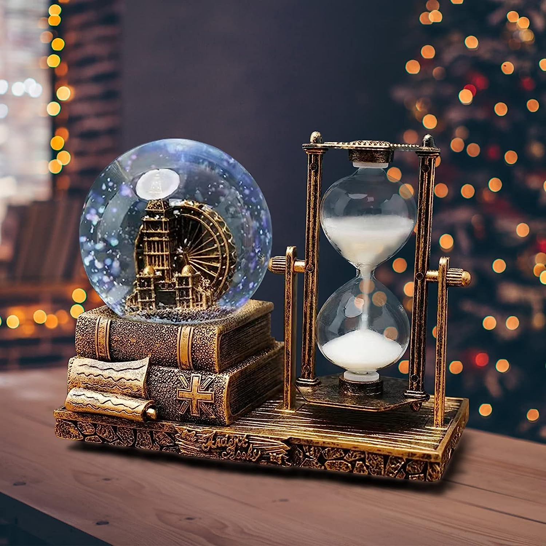

**ID:** SN-02

**Brand**: HUIHUATUOWEILSQ

**Material:** Resin, Glass

**Color:** brass Ferris Wheel

**Item Dimensions:** 8 x 7 x 4.5 inches

**Style:**   
Table decorations for living room

* 【High Quality】snow globes We use resin and lead-free high transparency glass, sand timer We use carefully selected sand, durable and environmentally friendly materials to add protection to your decoration。
* 【Unique Design】snow globe kit is a combination of the Eiffel Tower decoration and sand timer combined with, hourglass timer is freely reversible and measures 8 x 7 x 4.5 inches, the perfect size for the perfect addition to any space.
* 【LED music and light with】 The mini snow globe base is equipped with a power switch, when the power is activated the music and lights turn on randomly, when gently shaken the light function adds a magical touch to this musical snow globe, creating a dreamy ambience to relax and create a cosy environment，（The LED flashing light in the dark will be better）
* 【paris decor】 This vintage paris themed bedroom decor is perfect for the living room, bedroom, dressing table, desk, windowsill or next to the computer to relieve stress, soothe the mood and relax the eyes.
* 【Unique Gift】If you are worried about what to give as a gift, you can choose this unique crystal ball hourglass decoration, which is especially suitable for office workers, students and people who work long hours at the computer. A perfect gift for holidays, birthdays, celebrations and families. We supply (batteries)