**Price:** $27.99

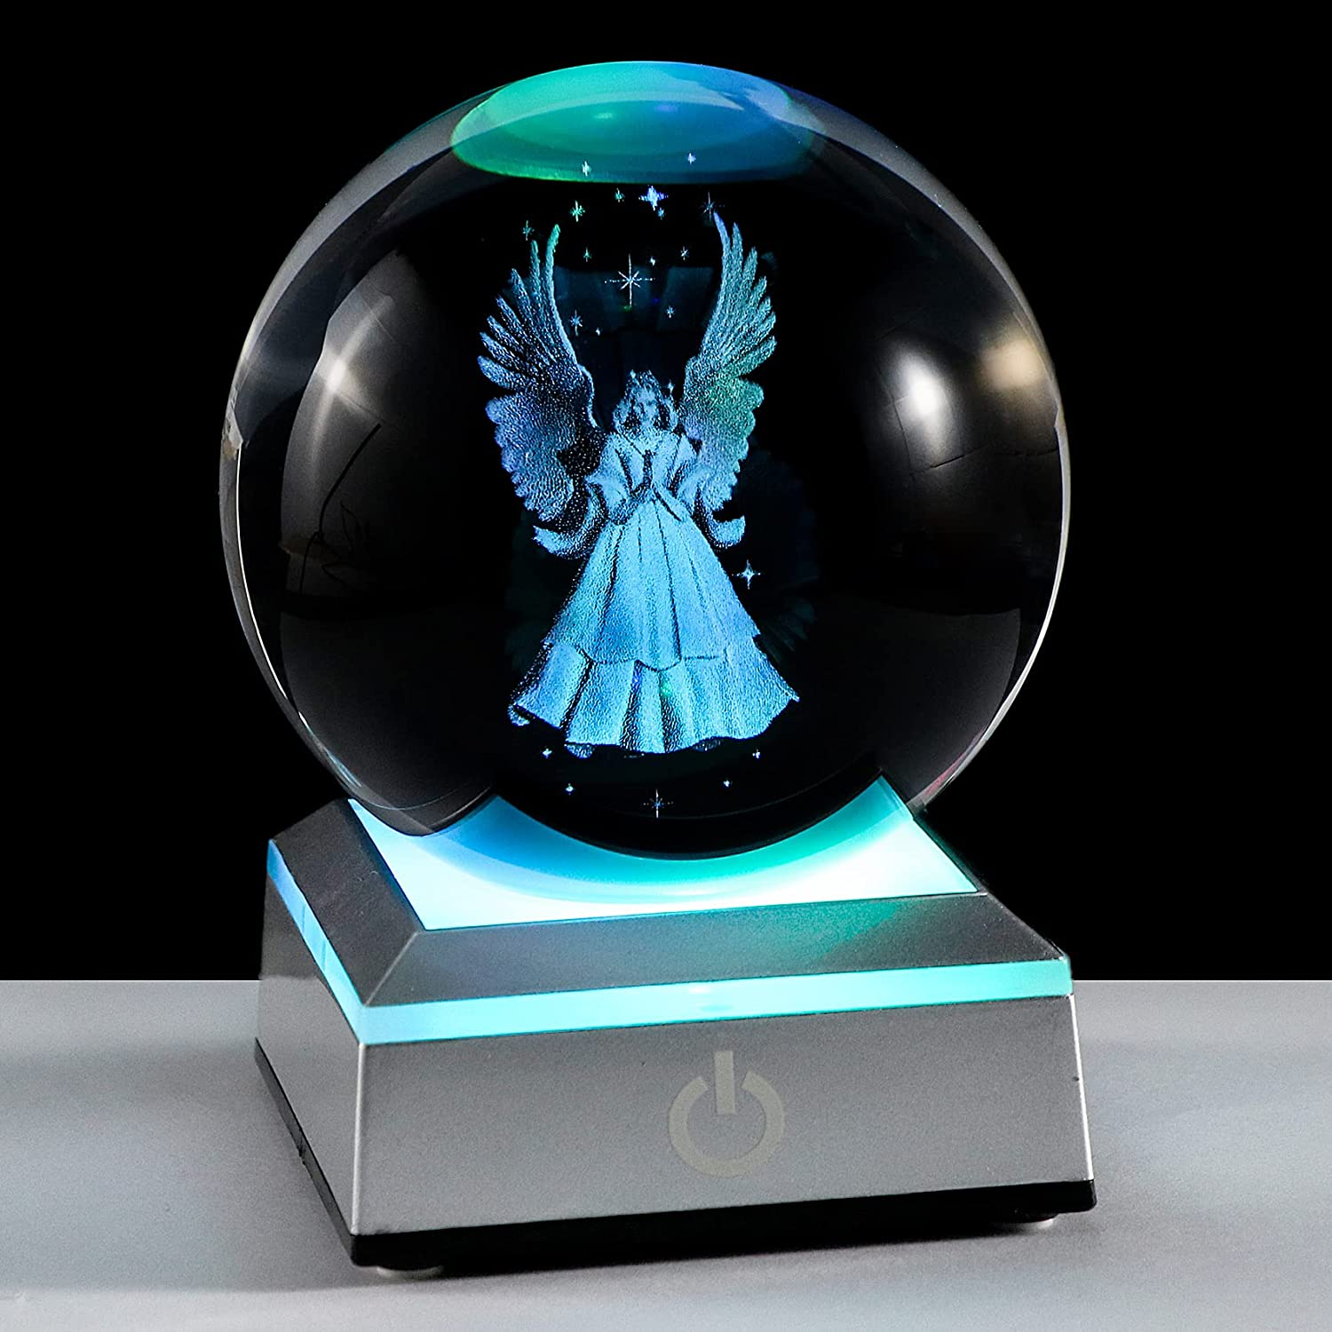

**ID:** SN-01

**Theme**: Silver

**CATOGERY:**  Snow ball decor

**SIZE:** Size M

**Brand**: Ornalrist

**Color**: Angel

**Material:** Glass

**Occasion:** Christmas, Wedding, Father S Day, Mother S Day, Birthday

* HIGH QUALITY K9 CRYSTAL & 3D LASER ENGRAVING: Made of HIGH-QUALITY K9 Crystal. This lifelike angel image is etched by Advanced 3D Laser Engraving Technology. It is Optically Clear, Which makes it perfect for Showcasing 3D Engraved Images. It is highly durable, and even after a lifetime of use, k9 crystals never lose their original shine. Each ball is equipped with a silver LED light base
* MEMORIAL ANGEL GIFTS - Angel figurine means love, happinesse, and peace, our angel gift can be a warm gift for your family, especially for your mum, nanny, wife and your closed friends. It can be a wonderful present for kids, friends or teacher. Or as a Christmas gift, birthday gift,memorial gifts, sympathy gifts, Father's day Gifts, Mother's day Gifts, wedding gifts to your mum, dad, family and so on
* BEAUTIFUL DECORATIVE ORNAMENTS - Each k9 crystal ball is clear, it is equipped with a sliver LED stand which is with colorful light, you can freely put them on your bedside table, desk, bookshelf, coffee table in the living room, etc., as a perfect decoration. When you open the stand's light, the angel becomes more clear, changing and colorful light makes patterns more beautiful. It can be used as nightlight
* COLORFUL LIGHT BASE - The light of the LED base can change color automatically or fixed color, and it will make all patterns become much clearer, especially in a dark environment, even you can use it as a night light. The light base has two models of power supply, one is using 3 AAA 1.5V batteries, another one is using the charging cable (the package doesn't include battery and plug), you can use the cable to connect the computer, car or portable charger
* Service Guarantee - Each ball is selected by workers carefully. Every ball is packed in a beautiful gift box, there is a wipe and greeting card in the gift box, ready to be a gift to someone you love. Please contact us by email freely at any time if you have any questions, we will solve it for you and make you satisfied 100%