**PRICE**: $11.99

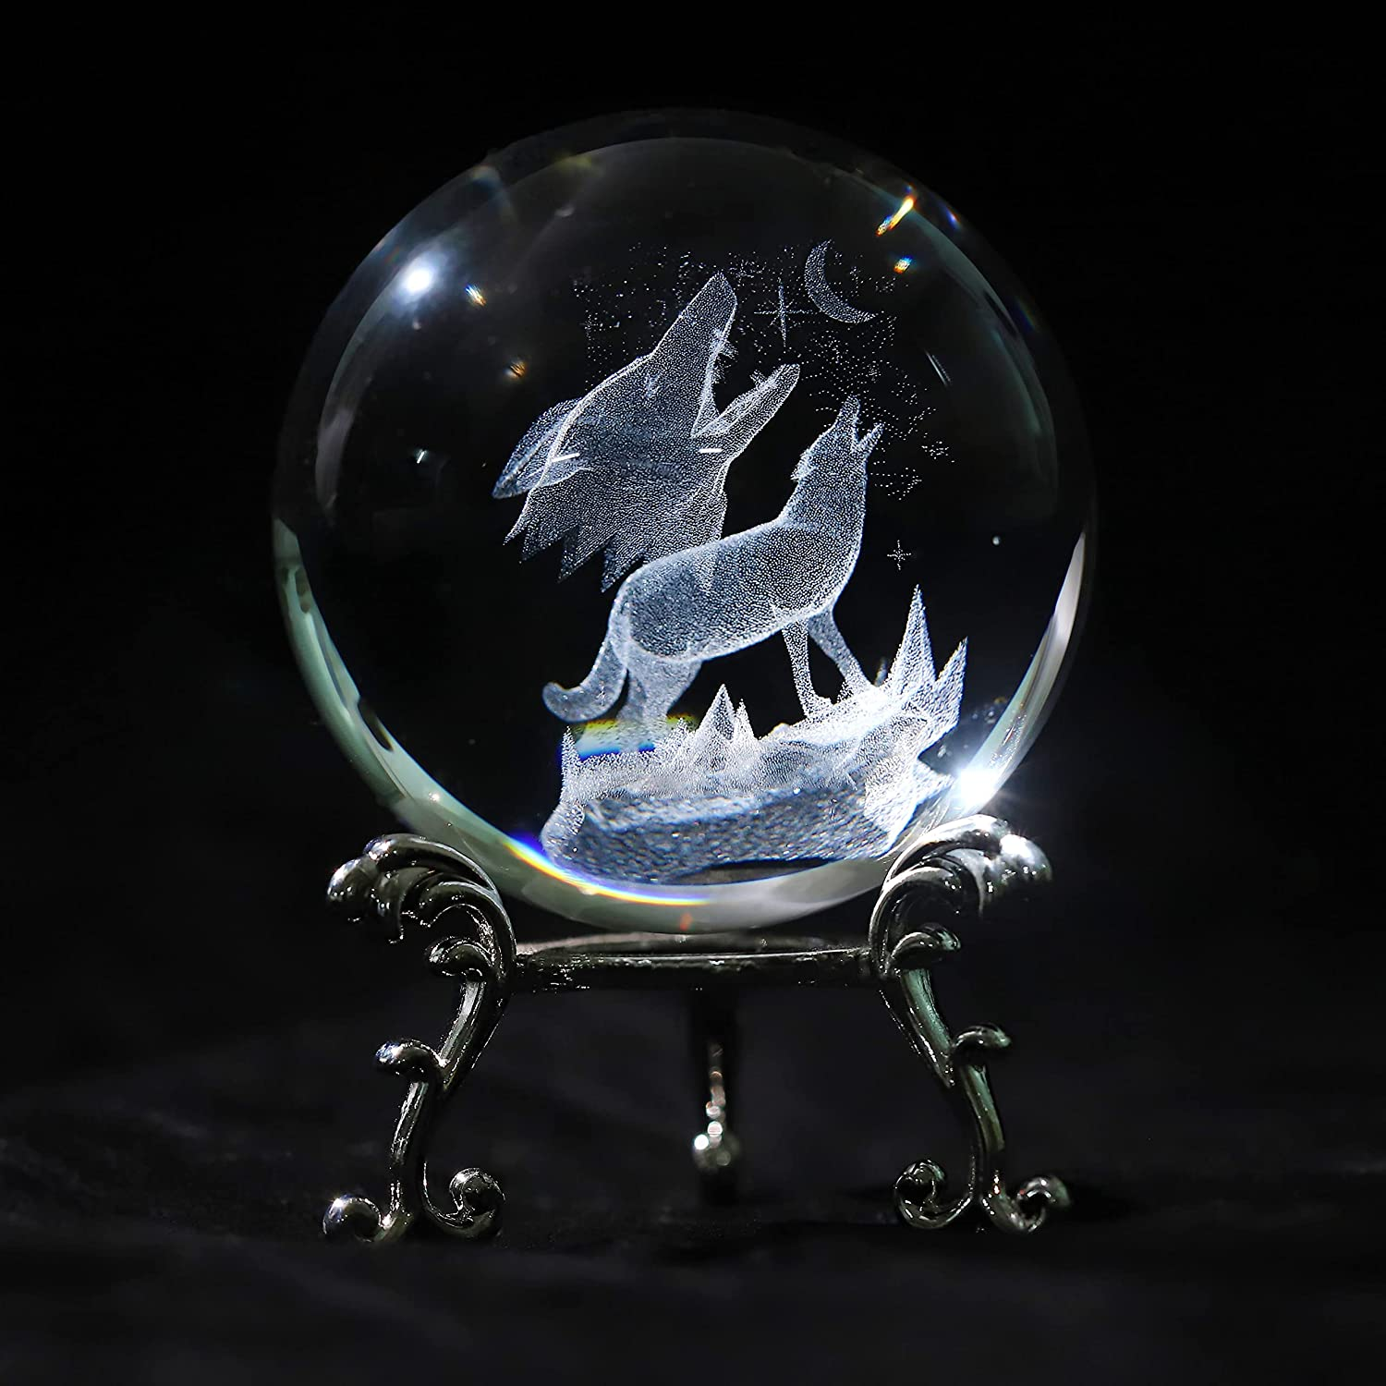

**ID:** SN-09

**Color:** Wolf

**Brand:** Vskikris

**Material:** Glass

**Mounting** **Type**: Tabletop

**Seasons:** All Seasons

* Material: 3d Laser crystal ball is made of k9 crystal glass,by using 3d laser engraving technology.
* our crystal ball will be fully inspected before shipment, ensuring that the ball in the hands of every consumer is not flawed
* Diameter: 60mm(2.36in) 3D crystal ball.3D etching art on the inside of this crystal ball.The internal image of crystal ball is 3D laser engraving technology
* Decoration: This 3D crystal ball paperweight is Good for Your Bedroom, Sitting Room, Hotel, Disco, Bar, Study and Office.
* Exquisite Gift for Friend, Astronomy Lover, Physics Teachers, Boyfriend, Classmate of Birthday Holiday Christmas Day New Year