**PRICE:** $41.99

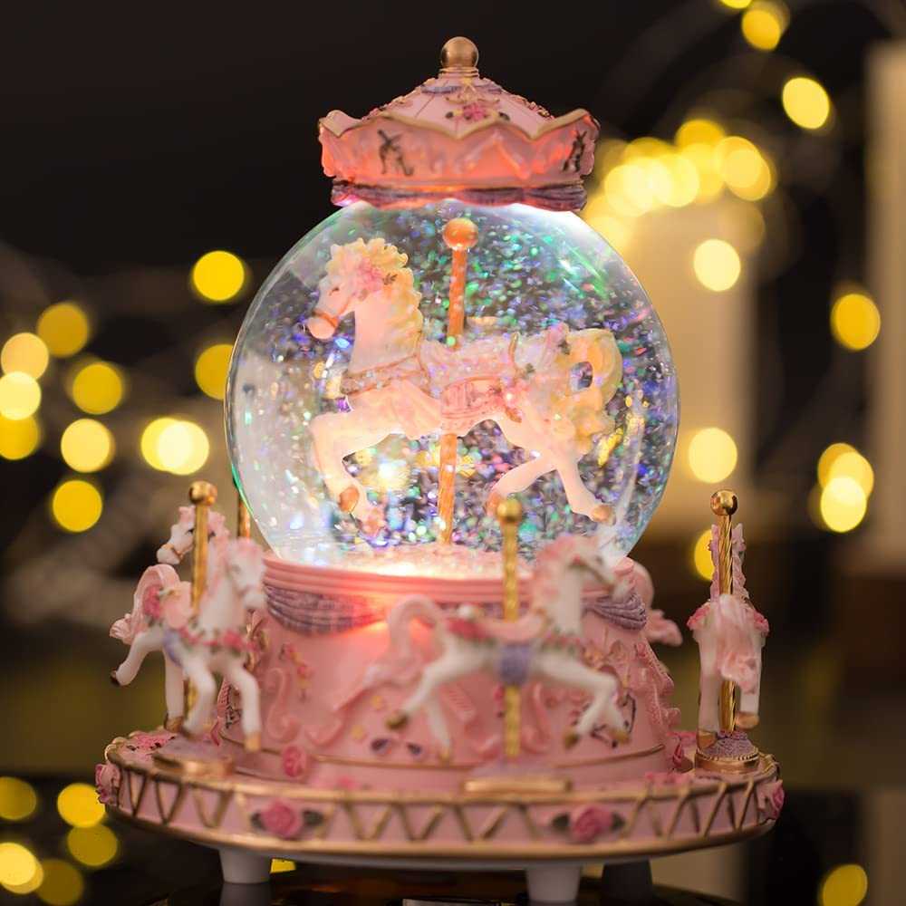

**ID:** SN-07

**Brand:** LOVE FOR YOU

**Material**: Metal

**Color:** You Are My Sunshine

**Item Dimensions:** 5.9 x 5.9 x 7.1 inches

**Style:** Classic

* Gift: If you are still worried about what gift to give to your beloved Sweetheart Baby, please don't hesitate to give this music box to her. It will become a precious souvenir for many years to come. This music box is perfect as a gift, with such great music and great shape, whether it's Christmas, birthday or other holidays.
* Gift packaging: each product is wrapped in manual gift paper and tied with a cute bow to make the gift more ceremonial ❤️ If you like it, don't hesitate! Join the shopping cart now!
* High-quality hand-painted: The creative music box is made of high-quality resin, durable, and can accompany you for a longer time. Color hand-painted, each stroke is hand-painted by the artist, with exquisite carvings and more refined details.
* Colorful Changing LED Light: Turn on the switch, the light is a slow, gradual bright light, and the warm gradual light can always create a friendly, romantic, and dreamy atmosphere.♫ Mechanical music box with a beautiful design, No battery required. Once gently rotated the clockwork to the right and then released, the music will be playing. Very easy to use; a perfect decoration in your room or living room.
* Size:5.9×5.9×7 in/15×15×18 cm. ♫ Melody: Precision 18-note musical movements, the sound is clear and pleasant. The music playback is smooth and coherent, and the classic "You Are My Sunshine" plays for about 1 minute. This is a traditional song circulating for more than 80 years, and its story is spread all over the world. Twist the clockwork to enjoy this classical music. Its sound makes you feel like you are in spring.