**PRICE:** $11.39

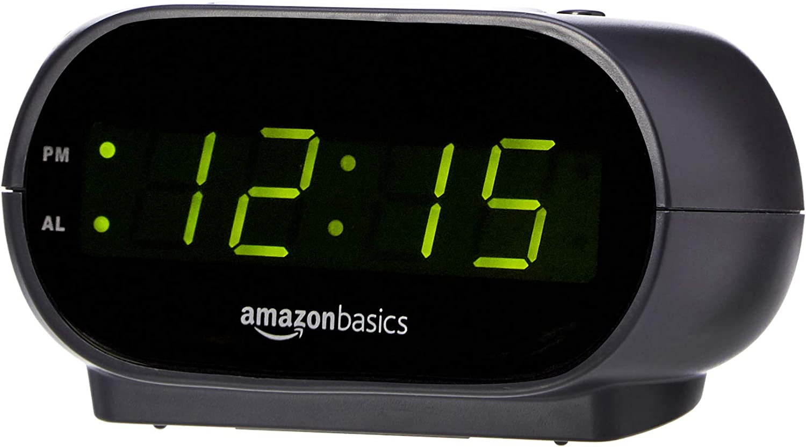

**ID:** CL-01

**Style**: Alarm Clock

**Brand:** Amazon Basics

**Color:** Black

**Product Dimensions:** 4.5"L x 3.5"W x 2.4"H

**Power Source:** Corded Electric

**Included Components:** Owner's Manual

**Item Weight:** 185.9 Grams

**Hardware Interface:** Unknown

**Display Type:** Digital

* Digital alarm clock with a 0.7-inch green LED display for easily checking the time at a glance
* Built-in nightlight gently illuminates a dark room
* Repeating snooze function makes it possible to sleep a little longer
* AC powered with integrated power supply. Batteries may be used as a backup power source to ensure time and alarms are retained in memory for 8 hours (refer to User Manual for details)
* Measures 4.5 x 3.5 x 2.4 inches (LxWxH); weighs 0.4 pounds (6.6 oz) Note: Batteries are not included