**PRICE:** $28.99

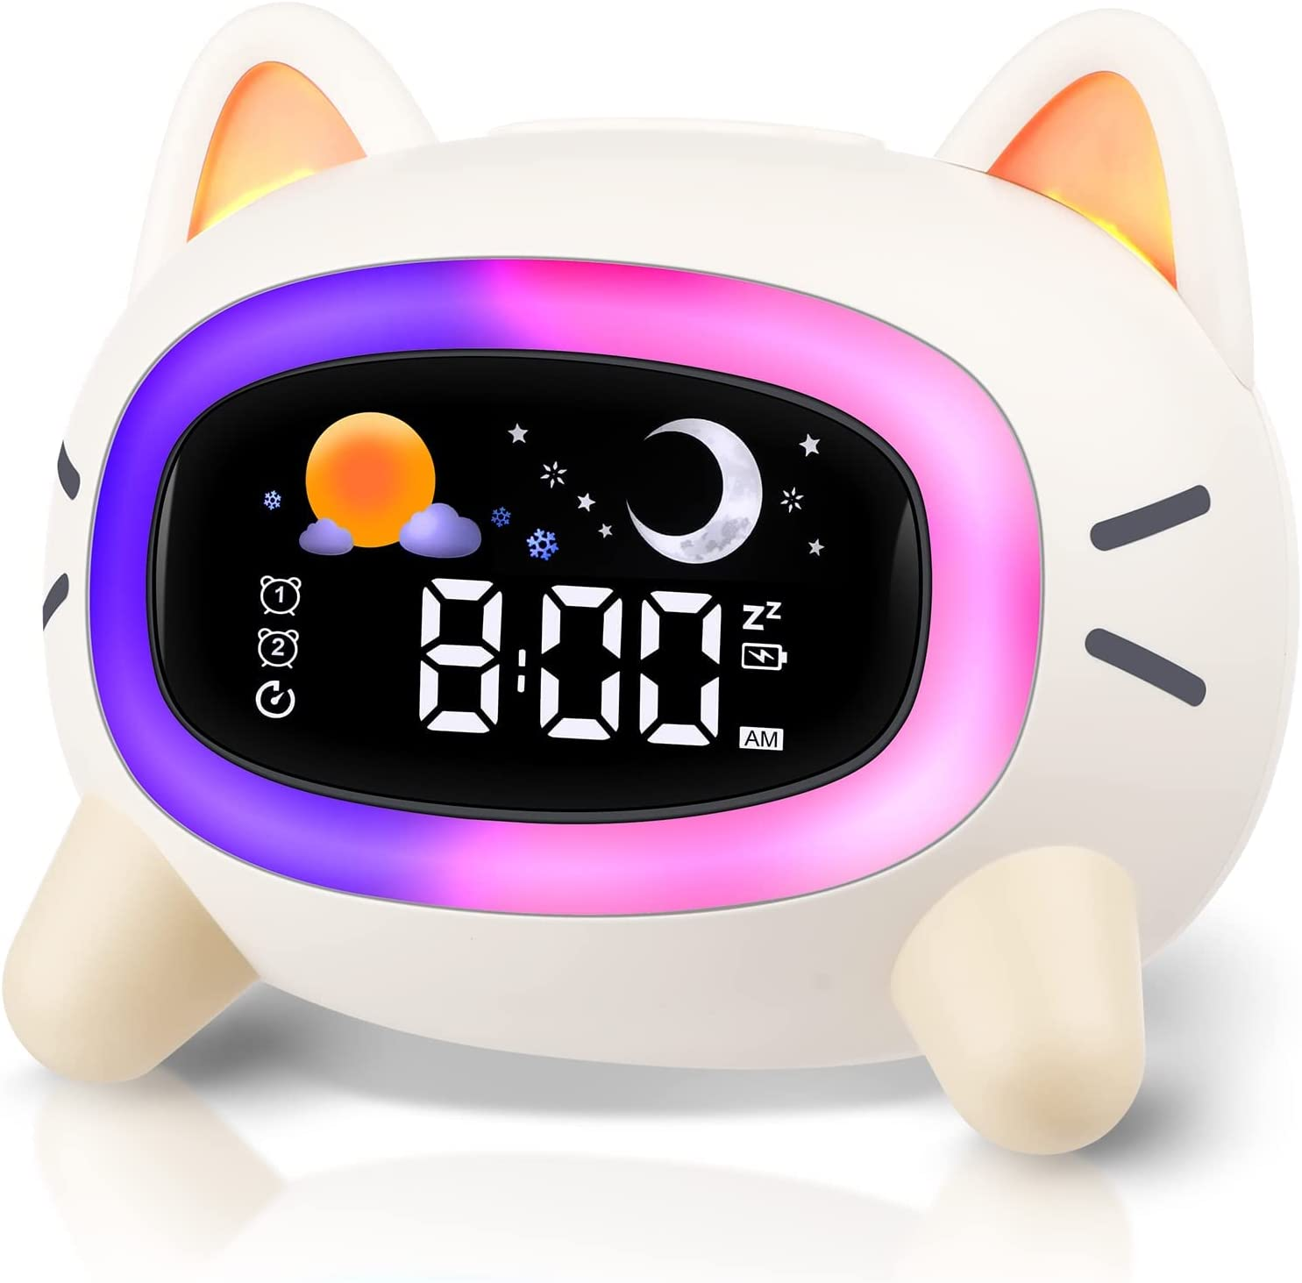

**ID:** CL-10

**Brand:** ANALOI

**Color:** Cat Alarm Clock

**Display Type:** Digital

**Style:** Cat Alarm Clock

**Special Feature:** Timer, Alarm, Double Bell, Noise Machine, Mood Light

**Product Dimensions:** 4.72"W x 4.92"H

**Power Source:** Battery Powered

**Shape:** Cat

* [ESTABLISH A REGULAR ROUTINE]This kids alarm clock helps kids develop a regular routine by indicating when it's time to wake up or go to bed. It uses a green light and flashing sun icon to indicate wake-up time, and a blue light with a flashing moon icon to signal bedtime.
* [ACCOMPANY KIDS TO SLEEP]With 7 soothing sounds and 5 lighting modes, this sleep sound machine creates a soothing sleep environment for kids. The combination of gentle sound and calming light helps alleviate loneliness and promotes better sleep when kids are alone.
* [NO MORE WORRIES ABOUT OVERSLEEPING]This alarm clock for bedrooms features 2 alarm settings, allowing you to set alarms for weekdays or every day. With the snooze mode, this ok to wake clock sounds again after 9 minutes, giving kids the opportunity to snooze up to 3 times.
* [PORTABLE ALARM CLOCK]This digital wake up alarm is small and lightweight, making it easy to carry. With a build-in 1800 mAh battery, this sleep training clock for kids can last up to 60 hours on a full charge, ensuring portability and convenience.
* [SAFE AND LOVELY DESIGN]Designed in an adorable cat shape, this rechargeable bedside lamp is appealing to children and makes for an ideal gift. Made from safe ABS and silicone materials, you can confidently place this night light by your children's bedside.