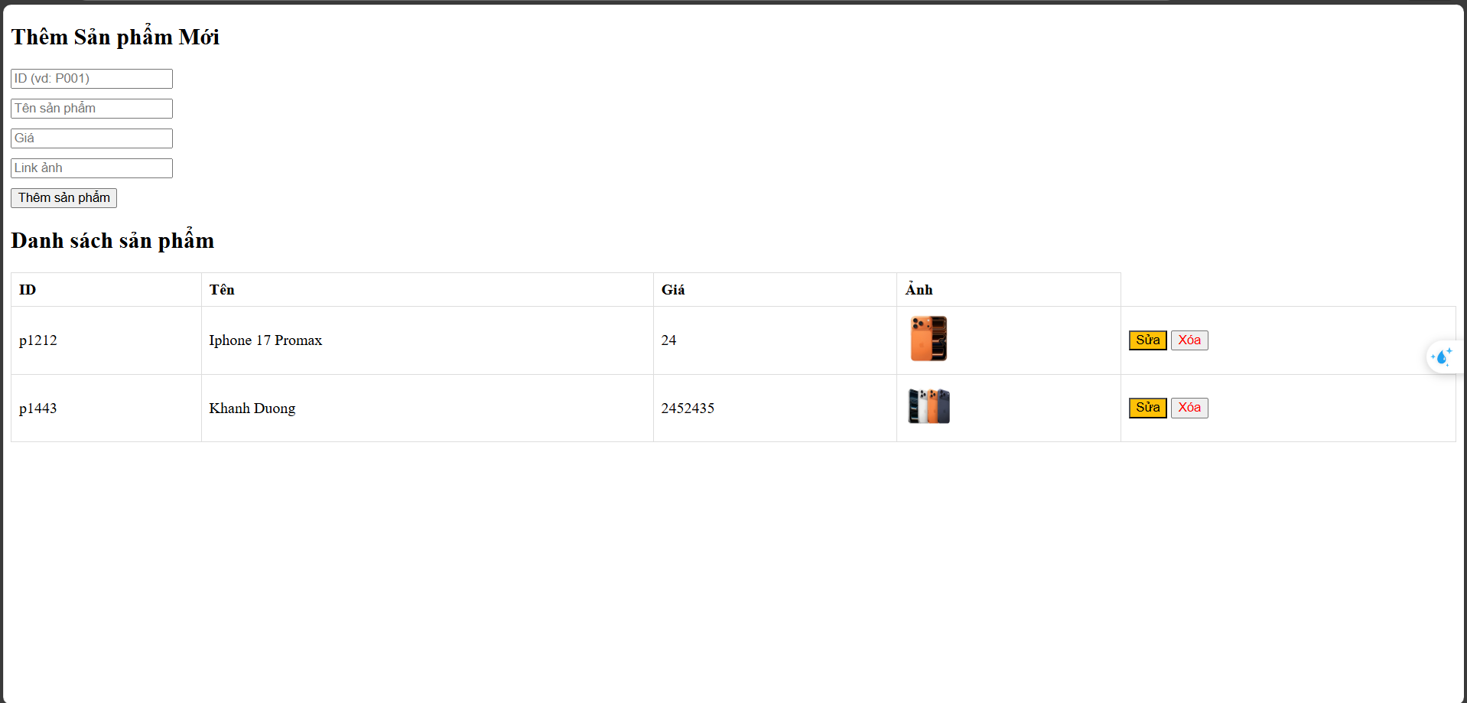

Link github: https://github.com/PhamHinh2004/CongNghMoi

