Phạm Hoài Vy Giang

MSSV: 2451050007

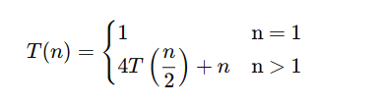

T(n) =4T(n/2) +n

⬄ 4[4T(n/4) + n/2] +n =16T(n/4) + 2n +n =16T(n/4) +3n= $4^{2}$ T(n/2^2)+3n

⬄16[4T(n/8) + n/4] + 3n= 64T(n/8) +4n+3n=64T(n/8)+7n= $4^{3}$ T(n/2^3)+7n

⬄64[4T(n/16)+n/8] +7n= 256T(n/16) +8n +7n=256T(n/16)+15n= $4^{4}$ T(n/2^4)+15n

……………

⬄ T(n)= $4^{k}$ T(n/ $2^{k}$) +($2^{k}$-1)n

Chương trình dừng lại khi : n/ $2^{k}$ =1 => n= $2^{k}$ =>k=

⬄ T(1) + ($2^{log_{2}n}$-1)n

T(n) = $4^{log_{2}n}$ T(1) + ($2^{log_{2}n}$-1)n= $2^{2 log_{2}n}$ T(1)+ ($2^{ log_{2}n}$-1)n

= $n^{2}$ T(1)+n(n−1) $≈$ O($n^{2}$)