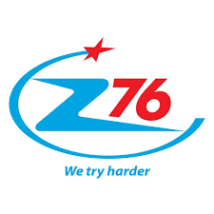 | 76 ONE MEMBER LIMITED LIABILITY COMPANY  Address: Kiêu Ky - Gia Lam - Ha Noi.  Tel: (+84)24 38276386 - (+84)24 36770035  Fax: (+84)24 38276406  E-mail: info@z76.vn

QUOTATION
NO.300420/76-DKI

Hanoi, April 30, 2020
TO: DKI Research
Dear Sirs/Madam,
We are pleased to send you our quotation for Face shield nationa defense from Z76 as follows:
No | Description | Quantities  (pcs) | Unit Price  (CAD/pcs) | Referenced Photos
1 | Face shield national defense P.FS.05  + Specification: as per Referenced Photos  + Packing:  -30 pcs/PE  - 10PE/carton/17kg  = 300pcs/carton  -carton size:560x790x270mm | 1,000,000 |  | 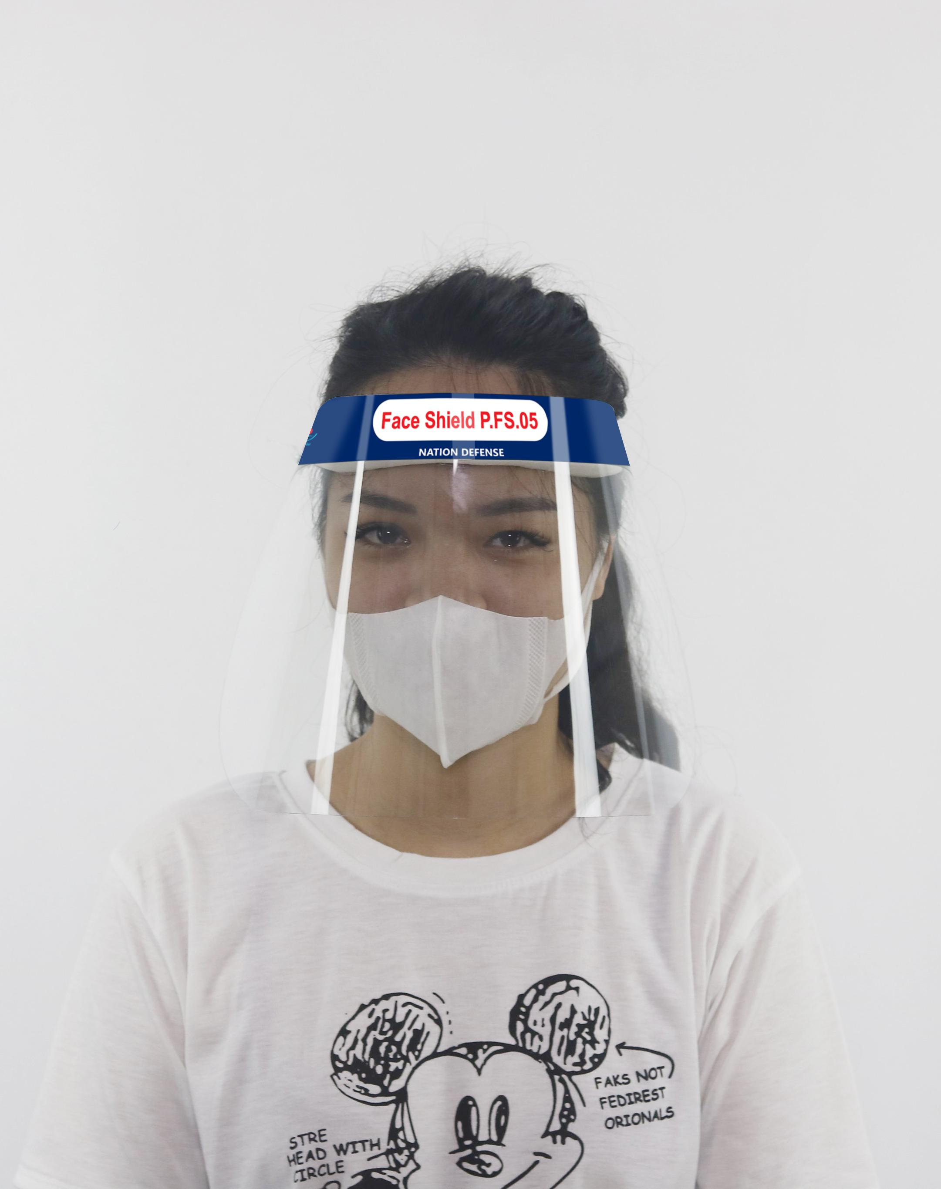  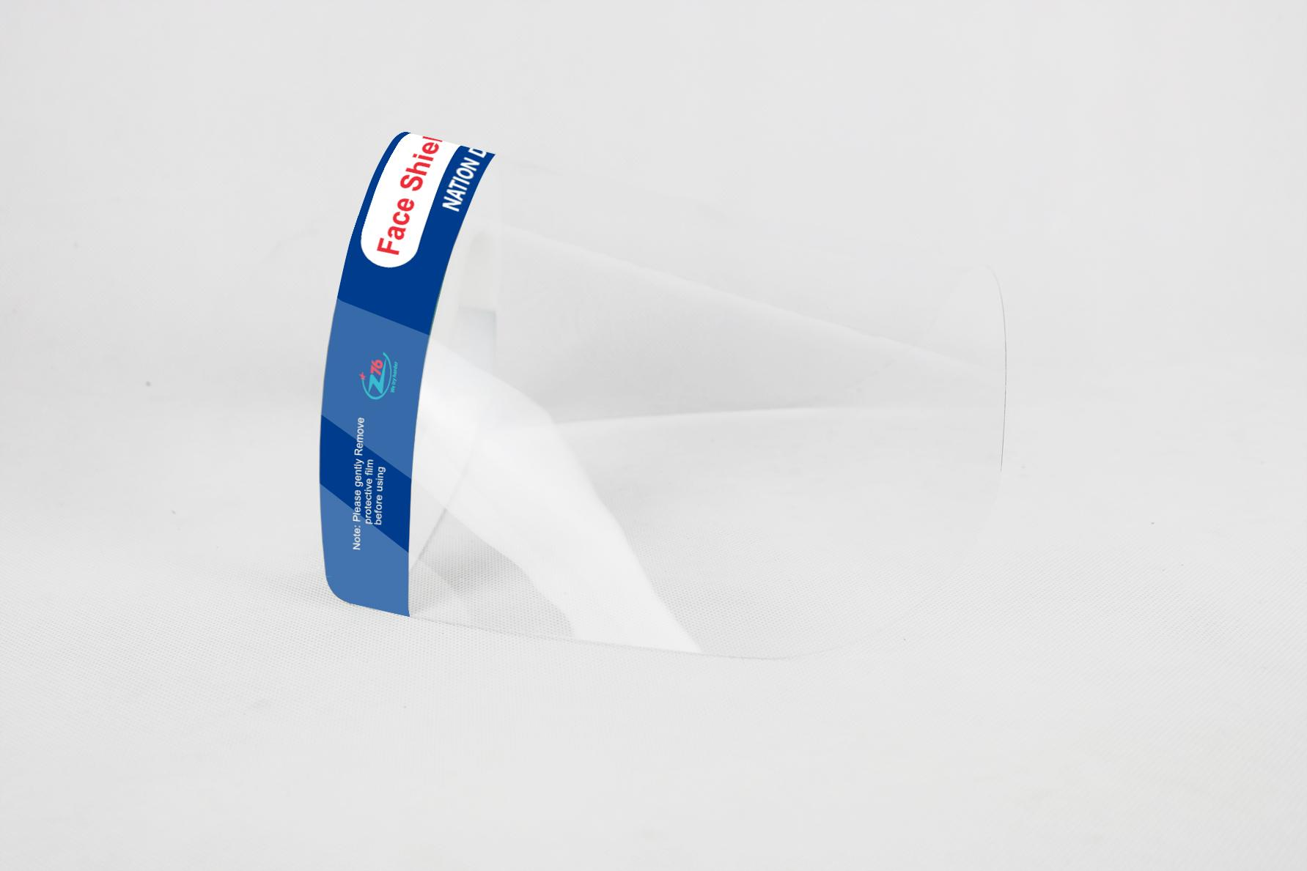  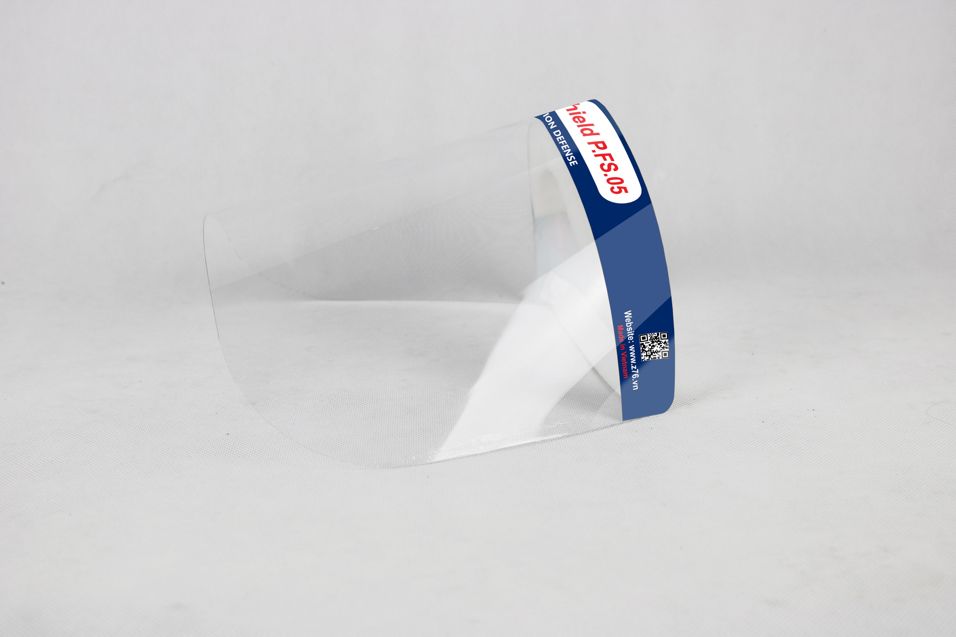  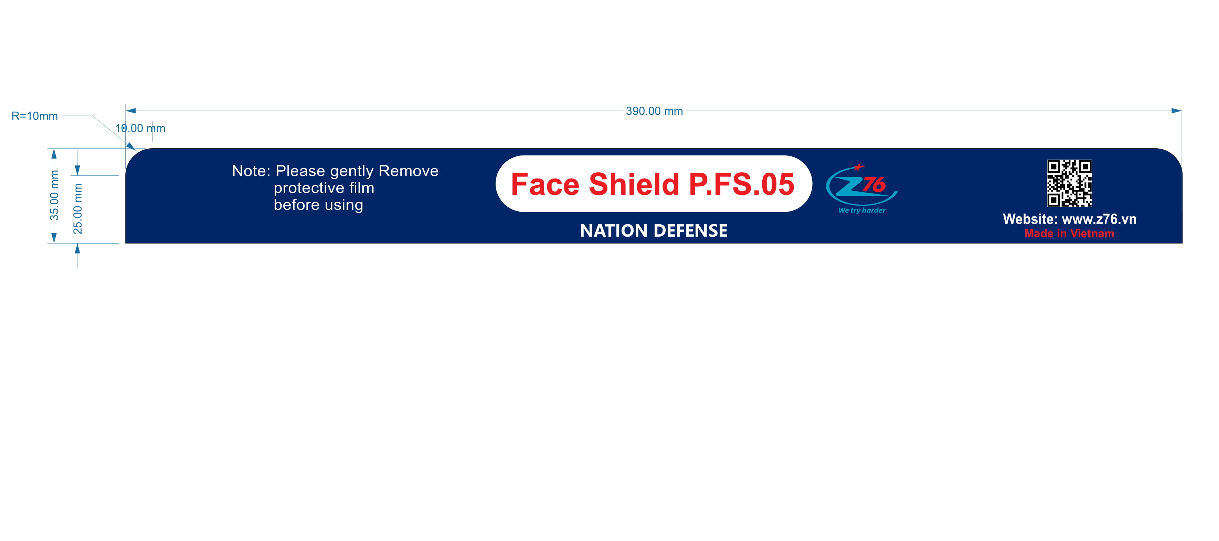  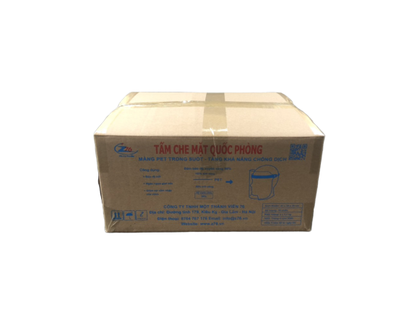  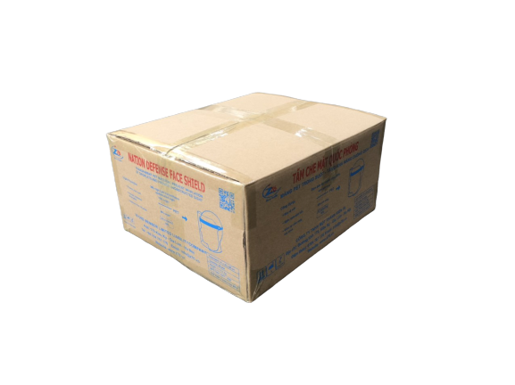
  CIF Winnipeg Airport, Manitoba, Canada
  1.67CAD/pcs
  FCA Z76-Kieu Ky-Gia Lam- Ha Noi
  1.17CAD/pcs

* Quoted price is for MOQ of 1,000,000 pcs
* Color box is subject to change to comply with Vietnam government export regulation.
* Payment: 30% deposit of total contract amount in advance by T/T, balance 70% by LC for each shipment.
* Delivery: - 1st lot: 300,000pcs after 07 working days from the date of deposit
- 2st lot: 700,000pcs after 07 working days from the first delivery date
Notice: the time is considered as the delivery lead time, is the time z76 hands over the goods to the forwarder ( not including the delivering time from z76 to Canada).
* Validity of quotation: 45 days from the issuing date or when new quotation issued.
We hope that our quotation will meet your requirement.
With Best Regards,
76 ONE MEMBER LIMITED LIABILITY COMPANY

