|  |  |  |
| --- | --- | --- |
| **LAB221 Assignment** | **Type:** | **Long Assignment** |
| **Code:** | **J2.L.P0007** |
| **LOC:** | **300** |
| **Slot(s):** | **10** |

**Title: Text Chat System (TCS)**

**Background**

Online chat may refer to any kind of communication over the Internet that offers a real-time transmission of text messages from sender to receiver. Chat messages are generally short in order to enable other participants to respond quickly. Thereby, a feeling similar to a spoken conversation is created, which distinguishes chatting from other text-based online communication forms such as Internet forums and email. Online chat may address point-to-point communications as well as multicast communications from one sender to many receivers.

**Program Specifications**

There are two programs in the TCS. The first program is TCS server, it authenticates the users, update the list of online users to all the currently online, create a connection between sender and receiver, store the offline messages. To reduce the server system resources, the chat server should be a text based UI. The second one is the TCS client; it provides login, view list users, and send message to a selected user.

**Features:**

* ***Register***
* ***Login***
* ***List of users***
* ***Chat online***
* ***Chat offline***

***Expectation of User interface:***

Register GUI:

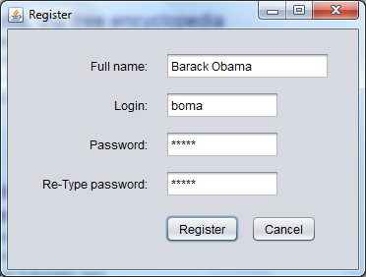

Login GUI:

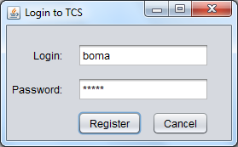

List of users:

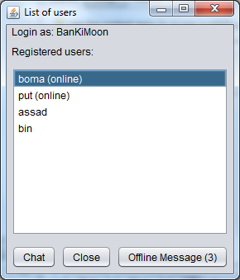

Offline Message (3): User has 03 offline messages.

Chatting window:

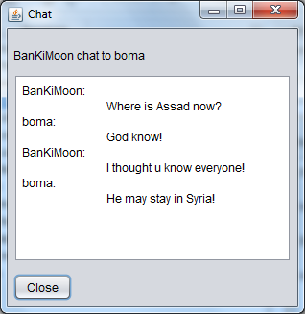

Offline Message:

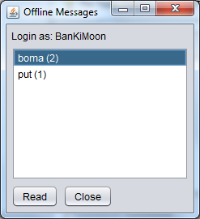

**Guidelines**

-Socket, ServerSocket, JList, JTextArea.

-Uses files to store the user accounts, offline messages.