The John D. O’Bryant School of
Mathematics and Science

{{CERTIFICATE}}
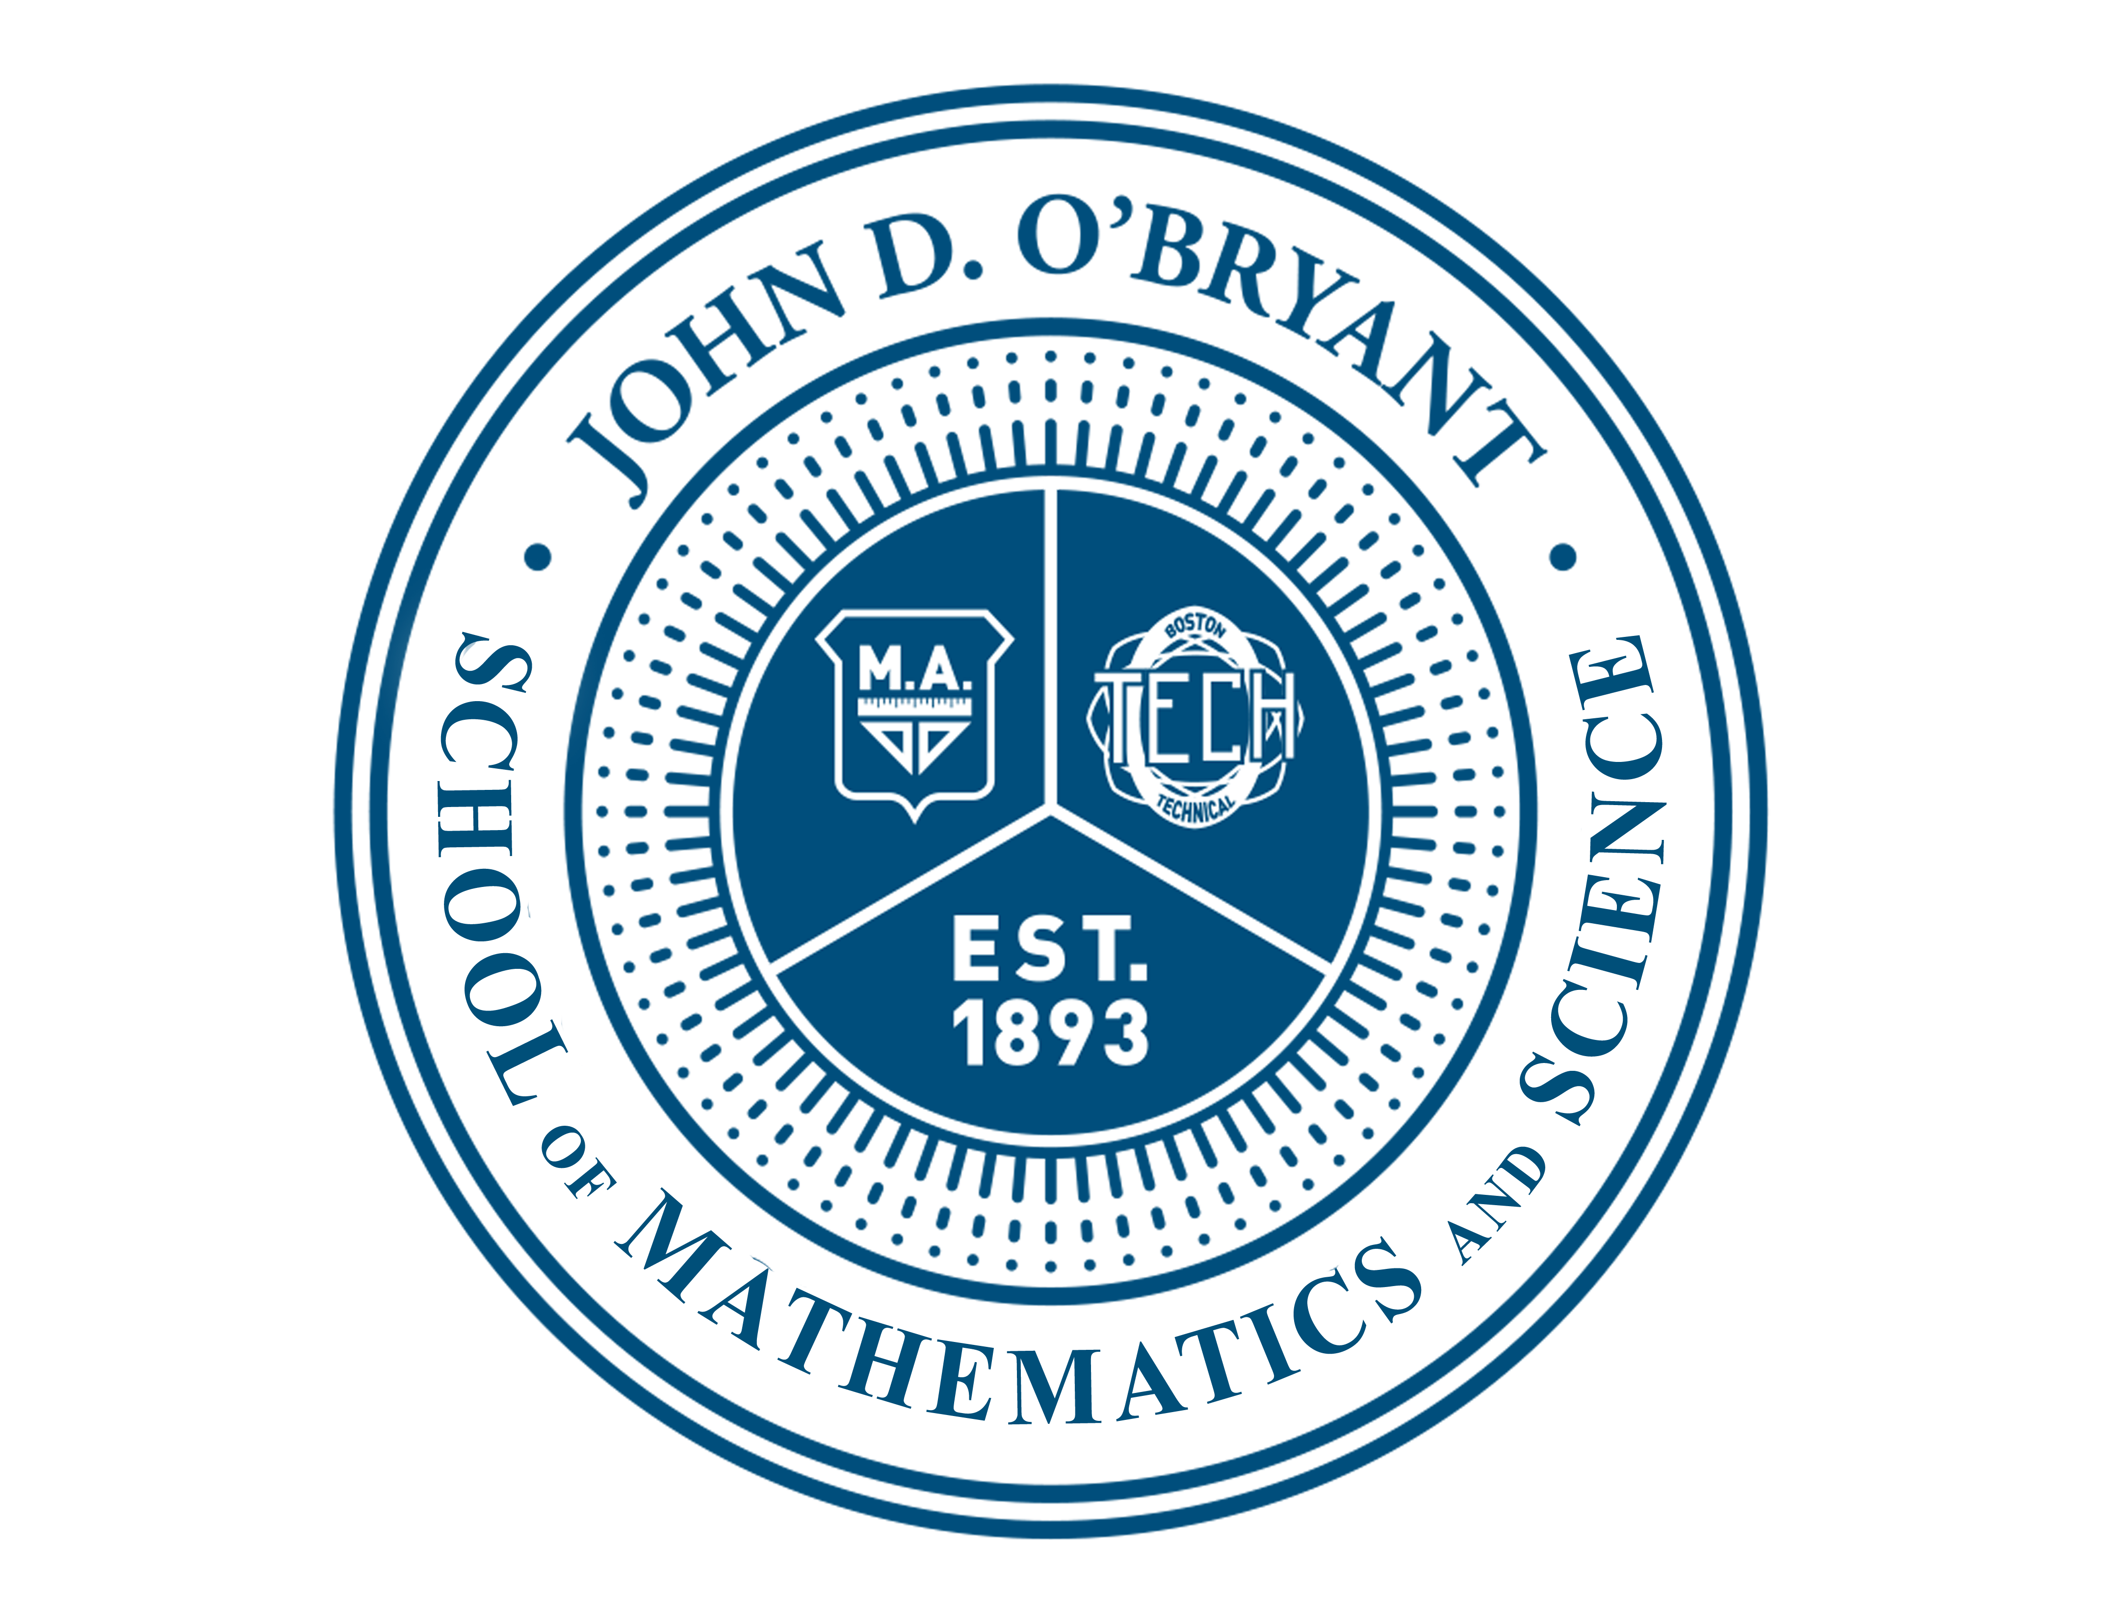
{{FULLNAME}}
In recognition of exceptional scholastic achievement during the {{TERMNO}}^{{{SUFFIX}}} marking term
of the {{SCHOOLYEAR}} school year.

{{MONTH}}, {{YEAR}} Congratulations! Ms. Patreka Wood Head of School
O’Bryant PRIDE

Perseverance Respect Integrity Discipline Excellence

