The John D. O’Bryant School of
Mathematics and Science

Honor Roll
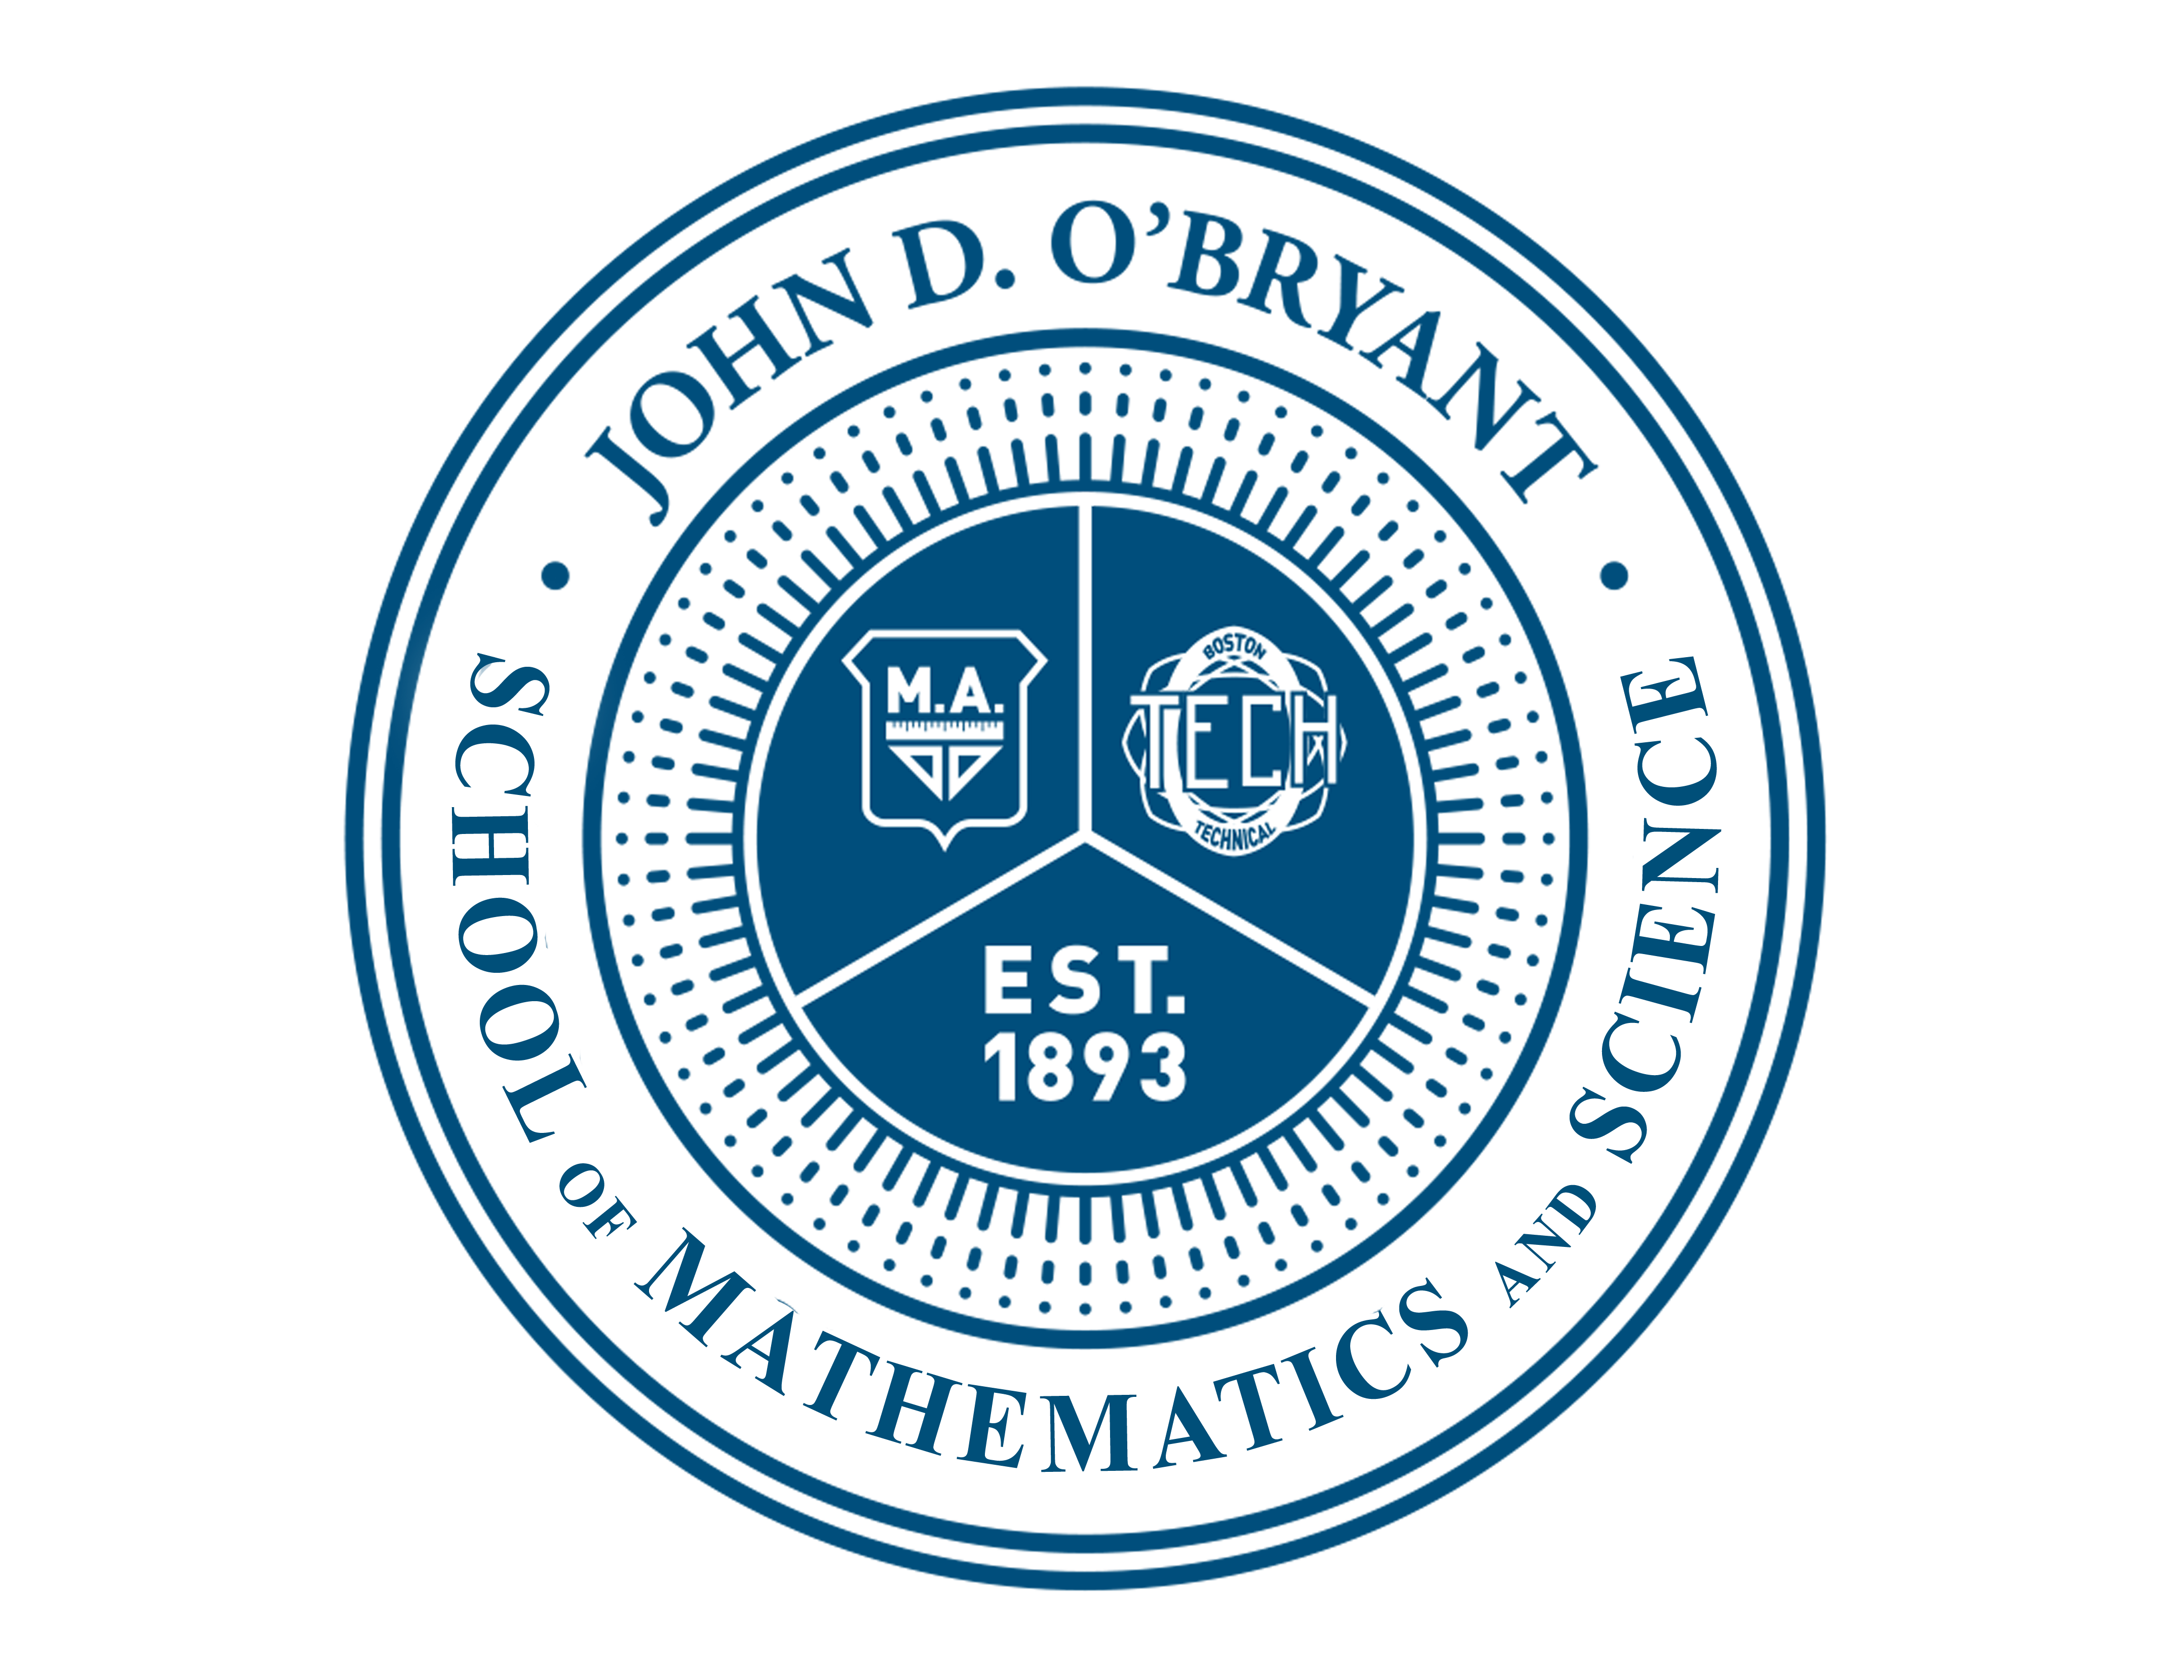
{{FIRSTNAME LASTNAME}}
In recognition of exceptional scholastic achievement during the 1st marking term
of the 2023-2024 school year.

{{MONTH}}, {{YEAR}} Congratulations! Ms. Patreka Wood Head of School
O’Bryant PRIDE

Perseverance Respect Integrity Discipline Excellence

