MagB_inv: A high performance Matlab program for estimating the magnetic basement relief by inverting magnetic anomalies
Luan Thanh Pham^{a,*}, Erdinc Oksum^{b}, David Gómez-Ortiz^{c}, Thanh Duc Doª
a VNU University of Science, Faculty of Physics, 334 Nguyen Trai, Thanh Xuan, Hanoi, Vietnam
b Süleyman Demirel University, Engineering Faculty, Department of Geophyisical Engineering, 32260 Isparta, Turkey
c ESCET, Universidad Rey Juan Carlos, Móstoles, Madrid, Spain
USER GUIDE
Description
MagB_inv uses an iterative procedure based on Parker (1972) Fourier domain forward expression of magnetic anomalies to determine the depth to the basement from gridded magnetic anomalies. The code is designed in Matlab environment (version R2013b) with an easy-to-use graphical interface (GUI) allowing the user an interactive control on managing the iterative procedure for a complete interpretation and illustrating the results data in interest without requiring any coding knowledge. The GUI also provides additional options for the visualization of the output data either in 2D maps and cross-sectional view. Outputs can be exported either numeric data or as images.
- Parker, R.L., 1972. The rapid calculation of potential anomalies. Geophys. J. Roy. Astron. Soc. 31, 447–455.

Run the Code: Locate the program code to the working space of matlab or vica versa the working space of matlab to the source directory of the code and thereafter type the name of the code to the command window of matlab.
By running of the MagB_inv program a simple graphical interface pops up covering the half of the screen to the left. The configuration of the main GUI window is illustrated in Fig. 1. Here the upper part of the window allows the user to track the statistical information of loaded data. Below this, it includes the main control panel which enables the settings for the initial parameters, the criterion for the termination of the iterative procedure and the settings for interactive filtering of the data (Fig. 1). The remaining part of the window is the display area for the input map.
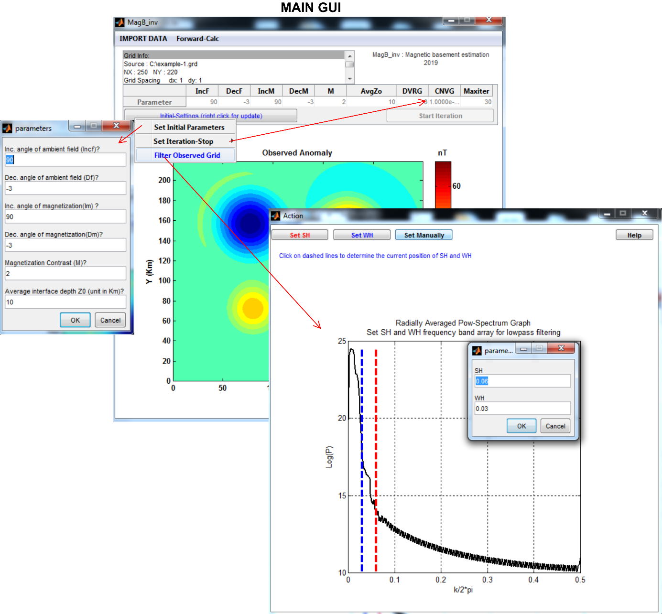
Figure 1. Screenshot from MagB_inv main GUI after a successful data loading and performing the settings prior the start of the iteration procedure.
Required data and formats
Loading the magnetic data set is provided by the interactive “Import Data” menu located at the top left of the window which allows the user loading either a grid file or an equal spaced xyz column wise data where as both are compatible with Golden Software Surfer formats (*.grd [Surfer 7 Binary grid / Surfer 6 text grid], *.dat [Surfer dat files]) (Fig. 2).
Figure 2. Supported formats for the gridded input magnetic data by MagB_inv.
The algorithm approves square as well as rectangular input grids. However, the grid interval is also required to be equal to the east and north directions. Otherwise a warning box occurs in the case of incompatibility. The code stores the input data, the grid information and the settings of initial parameters to a temporary *.mat file and retrieves them at every start of an iterative process.
Inversion procedure and storing the outputs
After successful data loading, information about the active input grid is listed in the uppermost grid info box and a map view of the input is displayed. Then the required input parameters related to the ambient field, magnetization and the average depth of magnetic interface need to be entered in their related edit boxes which appears by the drop menu item of the “Initial-Settings” button (Fig 3). The units of the magnetic anomalies are nT, magnetization vector directions in degree, magnetization contrast in A/m and distances are in km. The behavior of the termination of the iteration procedure can also be controlled and set by the settings menu item which the divergence-mode (default) or the convergence-mode can be activated. The iterative procedure in the divergence-mode terminates when the root mean square error (RMS) between the two estimated data sets from successive steps of the iteration has increased relative to the previous step whereas in the convergence-mode the iteration stops when the RMS is below a predefined threshold value. In all cases, however, the iterative procedure stops when the user-defined maximum number of iterations has been accomplished.
Desription of abbreviations in the control panel are as below:
IncF/IncM: inclination angle of ambient field and magnetiation, respectively.
DecF/DecM: declination angle of ambient field and magnetiation, respectively.
Z0: average depth of the interface.
DVRG / CNVG: divergence mode, convergence mode respectively. If DVRG is activated then it takes the value 1, otherwise it takes the value zero and the CNVG takes the treshold value set by the user.
Maxiter: The maximum number of iteration in the case of none of the stopping criteria has been accomplished.

Figure 3. Input parameters related to the ambient field, magnetization and the average depth of magnetic interface and settings of behaviour of the termination of the iterative procedure.
The “Filter Observed Grid” drop menu item under the Initial-Settings pops up a temporary second window to the right of the main window which enables the user configuring the roll-off frequencies SH and WH of the high-cut filter interactively by mouse clicks on the radially averaged power spectrum plot for their positions or also by option as manually entering (Fig.4). Once the filter parameters are defined, “Start Iteration” button enables from “off” to “on” state and the iterative procedure can be started.
Figure 4. Setting the roll-off frequency parameters of the high-cut filter.

After confirming the inputs, the algorithm is iteratively continued until the behavior of the termination is realized. Finally, the code appends the “inverted basement depth and the magnetic response due to this depth model, the difference between the observed and calculated magnetic anomalies and the RMS errors after each iteration to the temporary *.mat file created in relation with the observed input grid”. Eventually, the code pops up a new control window next to the main GUI that allows the user to visualize any of the output maps/graphics which can be preferred interactively with simple mouse controls (Fig. 5). By preference, the results at any section of the maps can also be illustrated together with their profile views (Fig. 6). Color adjustment on maps or a 3D view are additional tools provided by this control window.

Figure 5. The output GUI window after the iterative process. Selection of output maps/graphics is enabled by a popup window activated by mouse clicks on screen.

Figure 6. Cross-section view style from user defined profile position enabled by “Cross-Section” menu button.
All of the output data can be exported by a user defined name either to a *.mat file comprising the complete inputs/outputs or to separated files of *.grd format for the maps and *.dat format for the RMS vector and for any extracted profile data (Fig. 7). Exported *.mat files from MGB_inv code can be reloaded by the “Import Data” menu at the main Gui of the program. Thus, saving by this format has the advantage to re-view all the inputs, settings and the interpretation results at any time. Additionally, all the input/output maps and graphics illustrated at the GUI windows of the code can be exported as portable network graphic (*.png) images of 500 dpi in resolution.
Figure 7. Export menu items at the output GUI window.

Description for variables in a *.mat file exported from MagB_inv code: Data and their variables in Matlab can be retrieved into the storage simply by writing “load(‘filename*.mat’)” to the command window or to a script in Matlab. Variables from an MagB_inv *.mat file storage are as follows;
T: matrix of input magnetic anomaly grid,
nx, ny: number of columns and rows of the input grid, respectively.
dx, dy: grid spacing distance in x and y direction.
xmin, xmax, ymin, ymax: map limits in x and y direction.
x, y : mesh of of grid node coordinates in x and y direction.
SH, WH: roll-off frequencies used for high-cut filter during the iterative process.
p: radially averaged power spectrum data.
px: frequency axis.
Zcalc, Tcalc, Tdiff: calculated basement grid, calculated magnetic response grid and the difference between the input and output magnetic anomalies, respectively.
rmstor: rms values stored during the iterative process.
filnam: source file name of the input data grid.
setto: vector containing the settings of ambient field and magnetization, the behavior of the iteration stopping and the maximum iteration number in order of
IncF | DecF | IncM | DecM | M | Z0 | DVRG | CNVG | Maxiter

Note: an exported *.mat files from MGB_inv code can be reloaded by the “Import Data” menu at the main Gui of the program to review any previous interpretation.
Additional function for forward modelling
Besides the inversion scheme, the code also includes an in-built GUI window for performing forward calculation to obtain magnetic model anomalies from an input of depth grid. The related GUI window for such a process can be activated by the button press on “Forward-Calc” menu item located at the uppermost of the main GUI (Fig. 8)
Figure 8. Steps for forward calculation to obtain magnetic model anomalies from an input of depth grid.

