

I. SALES PORTAL OVERVIEW & SYSTEM SCOPE

1.1 Context & Objectives
The iHeal E-Commerce System is a wellness platform developed on WordPress, specializing in premium dietary supplements inspired by Medical Medium teachings. To reduce dependency on third-party marketplaces (Shopee, Facebook) and overcome fragmented multi-channel operations, iHeal established an independent digital commerce platform. Within this architecture, the Sales Portal serves as an internal operational workspace tailored for sales representatives to monitor performance metrics, fulfill orders, process post-purchase refund requests, and support customers directly.

1.2 System Scope & Boundaries
To enforce Role-Based Access Control (RBAC) and data integrity, the functional boundary of the Sales Portal is defined as follows:
- In-Scope (Operational Capabilities):
  - Role-based Sales authentication and session management.
  - Performance dashboard tracking core sales KPIs, revenue trends, and order status distributions.
  - Read-only catalog browsing for products, custom bundles (Mix & Save), and active promotional vouchers.
  - Order fulfillment management, status updates, and internal note tracking.
  - Post-purchase return, exchange, and refund request processing.
  - Customer directory lookups and order history inspection.
  - Transaction auditing and report data exporting (XLSX, CSV).
  - Real-time customer chat, health protocol journey tracking, notification feed, and EN/VI interface switching.
- Out-of-Scope (Restricted Access):
  - Product creation, pricing modifications, and catalog/inventory master configurations (managed exclusively by Brand Operators).
  - Financial payment gateway credentials setup, automated marketing campaign triggers, and system permission management.
  - Real-time inventory synchronization with external marketplaces (Shopee/Facebook).
  - Core WordPress hosting, server security, and infrastructure administration.

1.3 Technical Environment
- Platform: WordPress 6.9.4 with WooCommerce 10.7.0 (HPOS enabled)
- Theme & UI: Custom ihear_sales_module (HTML5, CSS3, JavaScript, jQuery 3.7.1)
- Database: MySQL (shared schema across subdomains)
- Hosting & Security: Hostinger Shared Hosting, Cloudflare SSL/TLS, HTTPS enforced

II. FUNCTIONAL REQUIREMENTS & UI
Figma Design & Prototype Link: https://www.figma.com/design/qSLfmgE1ncx1NiXbs8BxWa/Sales-portal?node-id=0-1&t=nZMEdQWA5Mzheqx8-1

1. Authentication & Authorization
FR-ID | Description (Functional Requirement) | Priority
FR-S-001 | The system shall provide a dedicated Sales login page at /sales/login/ accepting WordPress username (or email) and password. Successful login starts a persistent session valid for 30 days unless the rep logs out. | Must
FR-S-002 | The system shall accept the optional redirect to query parameter on the login URL and, after successful authentication, redirect the rep to that URL when it points to the same host. Otherwise the rep is sent to the sales dashboard /sales/. | Must
FR-S-003 | The system shall protect every sales page with an authentication guard. Unauthenticated requests are redirected to the sales login page; the originally requested URL is preserved in redirect to so the rep returns to it after logging in. | Must
FR-S-004 | The system shall display the sales rep’s display name, role label (“Sales”), and avatar in the top-right user widget on every page. | Must
FR-S-005 | The system shall allow a signed-in sales rep to log out from the avatar dropdown. The session cookie is invalidated and the rep is redirected to the sales login page. | Must
FR-S-006 | The system shall verify on every page that the signed-in user. Users without this marker (e.g. customers logging in by mistake) shall be signed out and redirected to the login page. | Should



2. Dashboard & Performance Overview
FR-ID | Description (Functional Requirement) | Priority
FR-S-007 | The system shall display a Sales Dashboard at /sales/ showing three KPI cards: Total Order, Total Sales, and Total Profit, all aggregated for the current calendar month and compared with the previous month. | Must
FR-S-008 | The system shall compute KPIs using the WooCommerce HPOS API restricted to orders in status completed, processing, or on-hold. | Must
FR-S-009 | The system shall display a 6-month revenue-trend line chart on the dashboard. Each bucket aggregates for orders created in that month. | Must
FR-S-010 | The system shall display an Order Status doughnut chart with four segments (Completed, Shipped, Processing, Cancelled) and a percentage legend, mapping all underlying WC statuses into the four buckets. | Must
FR-S-011 | The system shall display a Top Selling Products list (3 items) ranked by total units sold. Each row shows product image (4-tier fallback), name, “X sold” descriptor, and unit price. | Must
FR-S-012 | The system shall display a Recent Orders table on the dashboard listing the 5 most recent orders with: order ID, customer ID, date, items count, total, and status badge. | Should
FR-S-013 | The system shall display the personalized greeting “Hello {first name}!” together with a date-aware “Good Morning / Afternoon / Evening” headline at the top of the dashboard. | Should

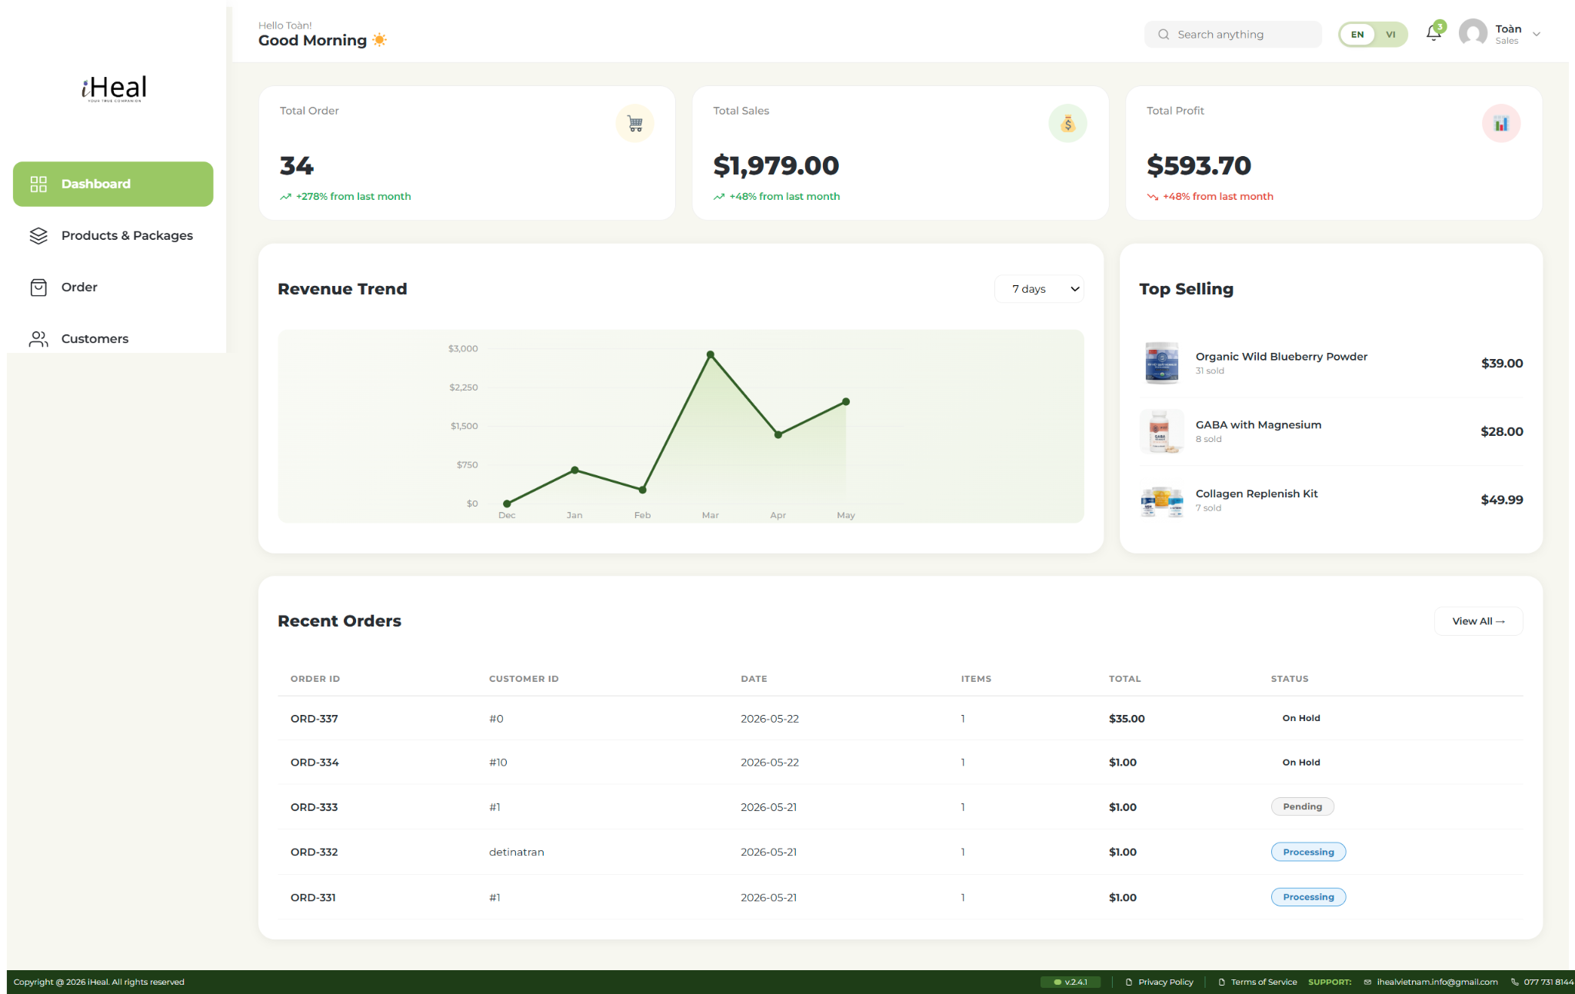 | 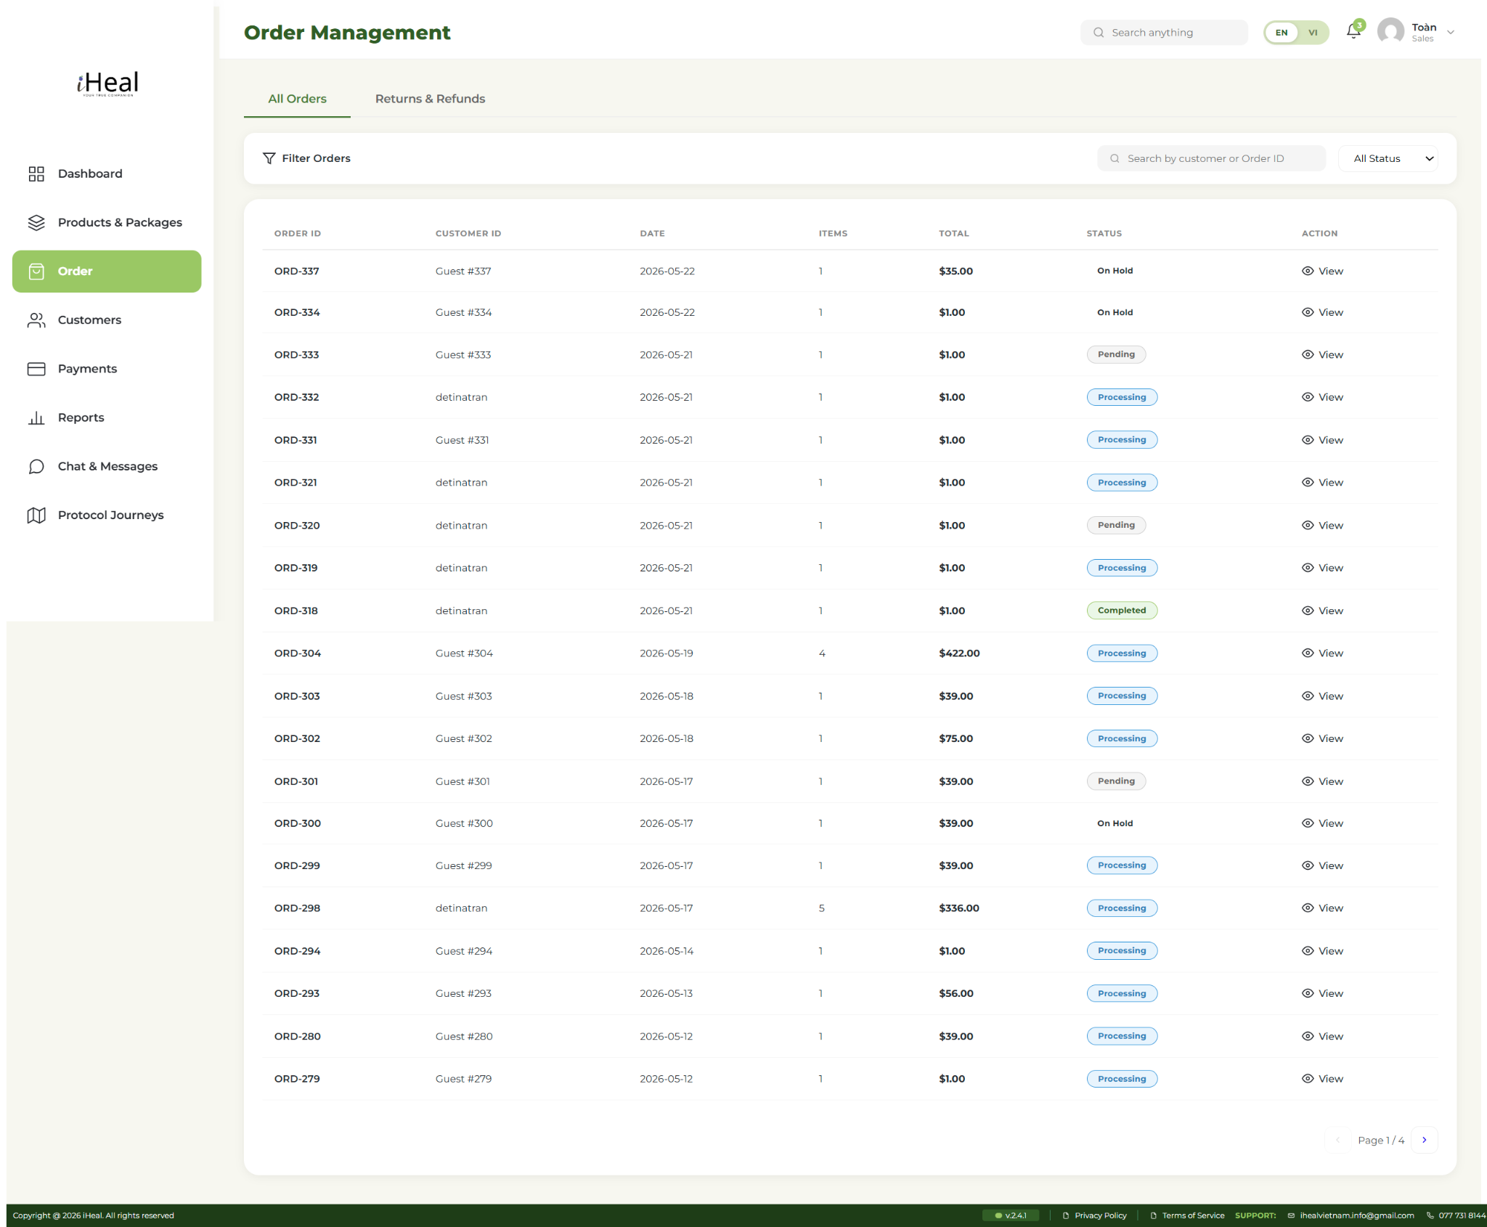

3. Products & Packages
FR-ID | Description (Functional Requirement) | Priority
FR-S-014 | The system shall display a Products & Packages page at /sales/products/ with three tabs Product List, Bundle List, Promotion letting the rep browse the full catalog. | Must
FR-S-015 | The Product List tab shall show every WooCommerce product with image, name, SKU/product ID, category, price, stock, and active status. | Must
FR-S-016 | The Bundle List tab shall show every Mix & Save bundle and Gift Set defined by the operator, including bundle name, included products, discounted price, and active status. | Should
FR-S-017 | The Promotion tab shall show every currently-active voucher with code, type (percent / fixed / free-shipping), value, validity period, and remaining usage. | Should
FR-S-018 | The system shall allow the rep to open a product detail view containing description, health benefits, images, current stock, average rating, and recent sales velocity. Editing the product is not permitted in this role. | Should
FR-S-019 | The system shall allow the rep to search and filter the product list by name, category, stock status, or price range. | Should

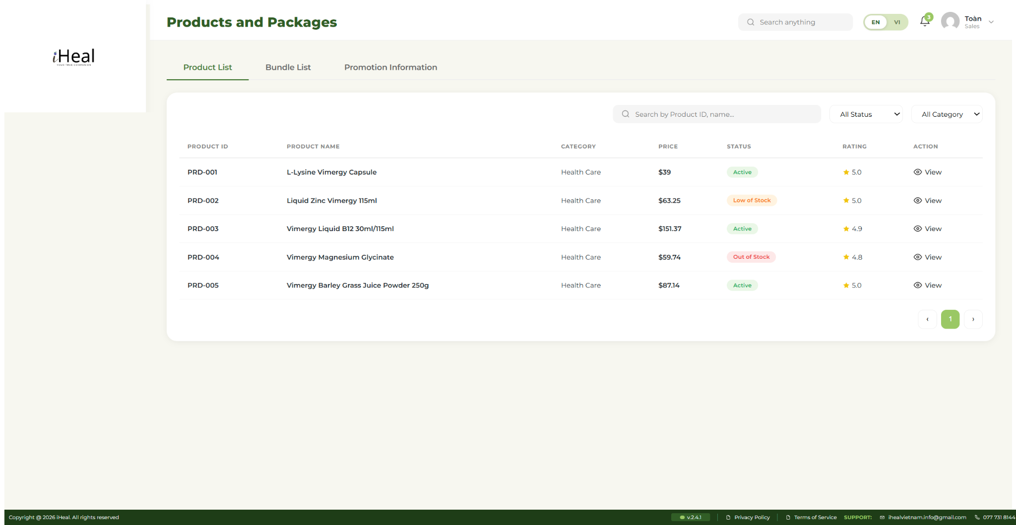 | 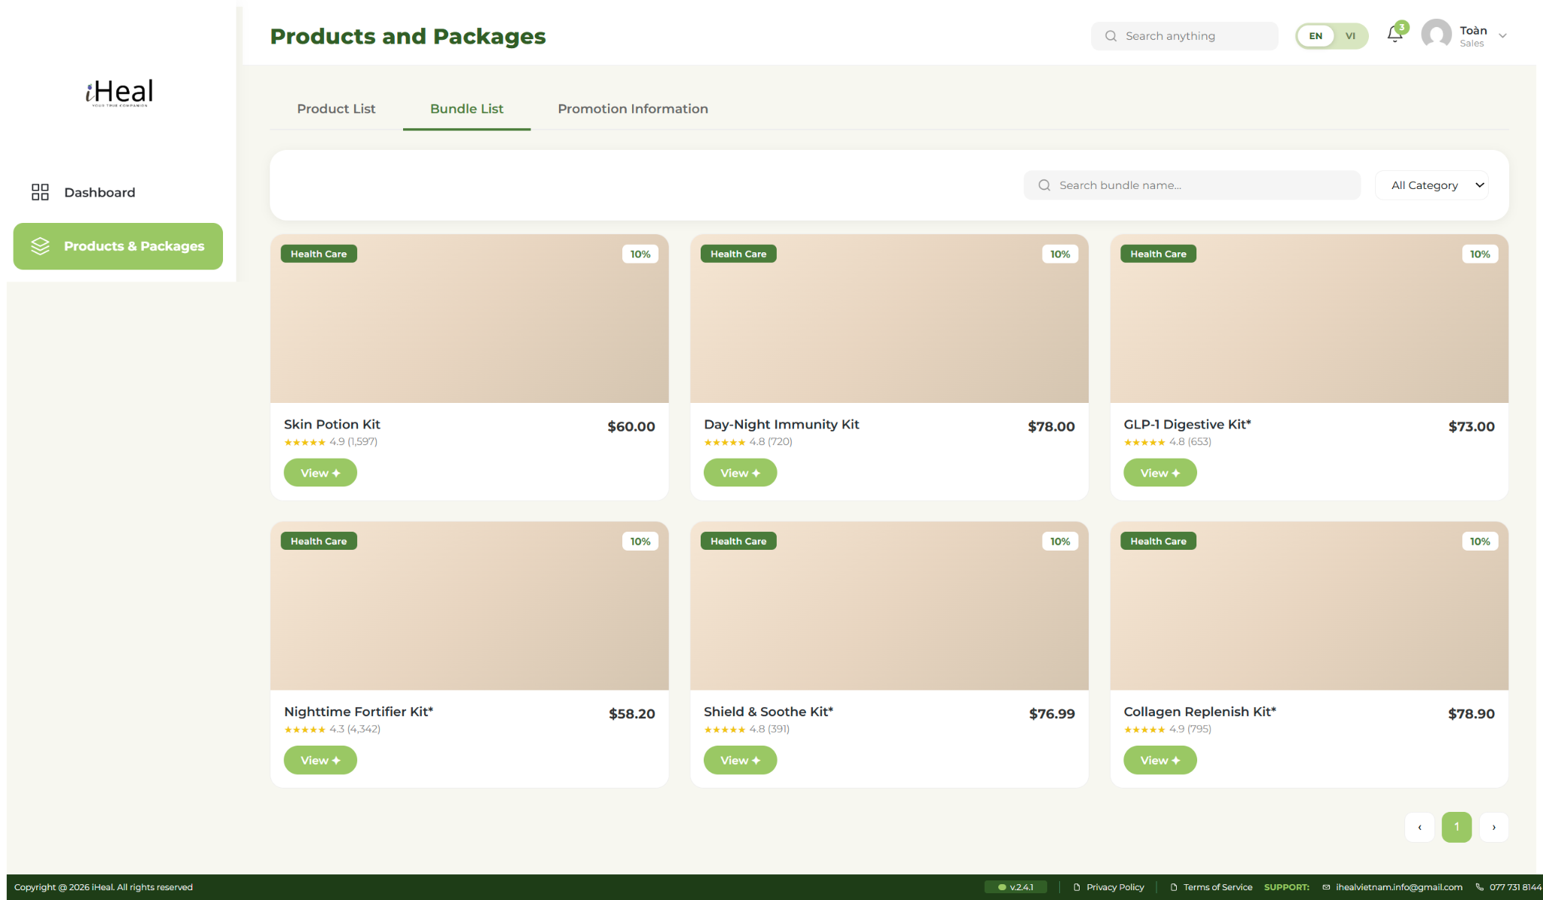
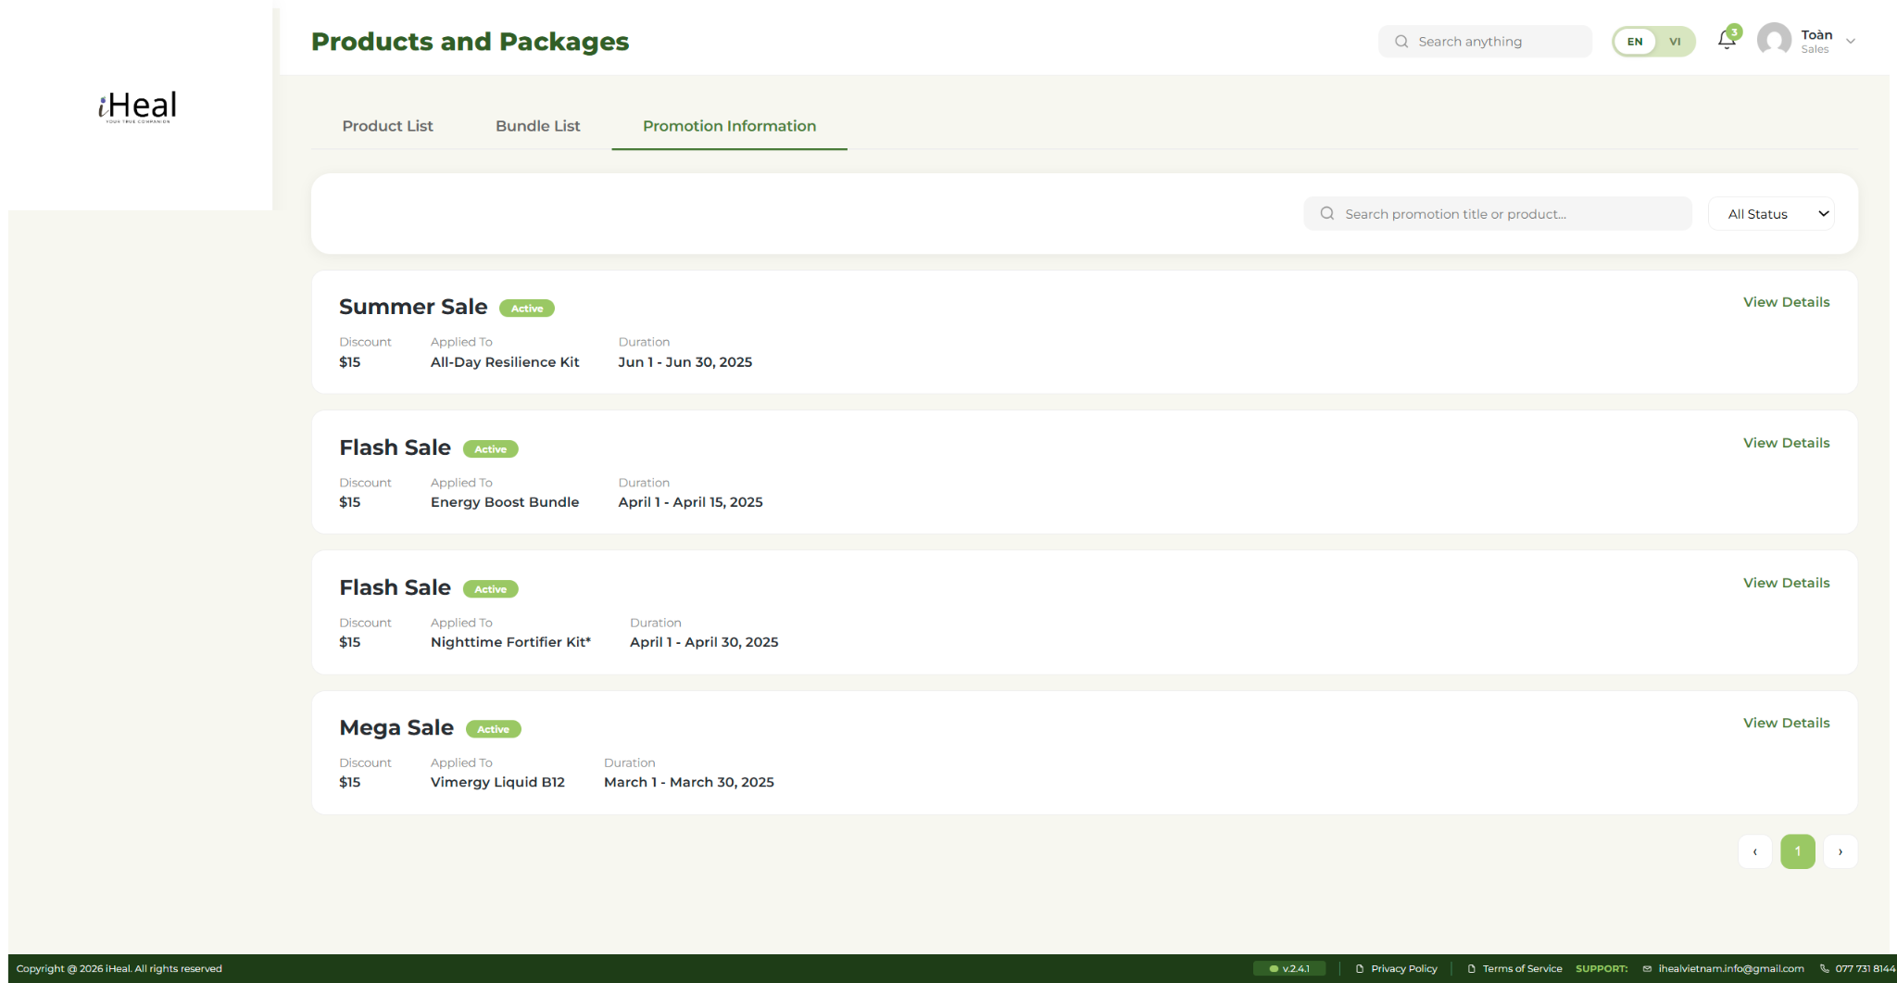

4. Order Management
FR-ID | Description (Functional Requirement) | Priority
FR-S-020 | The system shall display a Sales Order Management page at /sales/order/ with three tabs: All Orders, Order Details, Refunds & Cancellations. | Must
FR-S-021 | The system shall allow the rep to filter orders by status (All / Pending / Processing / Shipping / Completed / Cancelled / Refunded), date range, and to search by order ID or customer name. | Must
FR-S-022 | The system shall allow the rep to open the detailed view of any order, showing line items (with thumbnails via 4-tier fallback), billing/shipping addresses, payment method, transaction ID, and full status history. | Must
FR-S-023 | The system shall allow the rep to update an order’s status (e.g. mark as Shipped or Delivered) and to add an internal note. | Should
FR-S-024 | The system shall surface a sub-tab “Refunds & Cancellations” listing orders that have a pending or processed refund request, with quick links to the corresponding return-request record. | Should

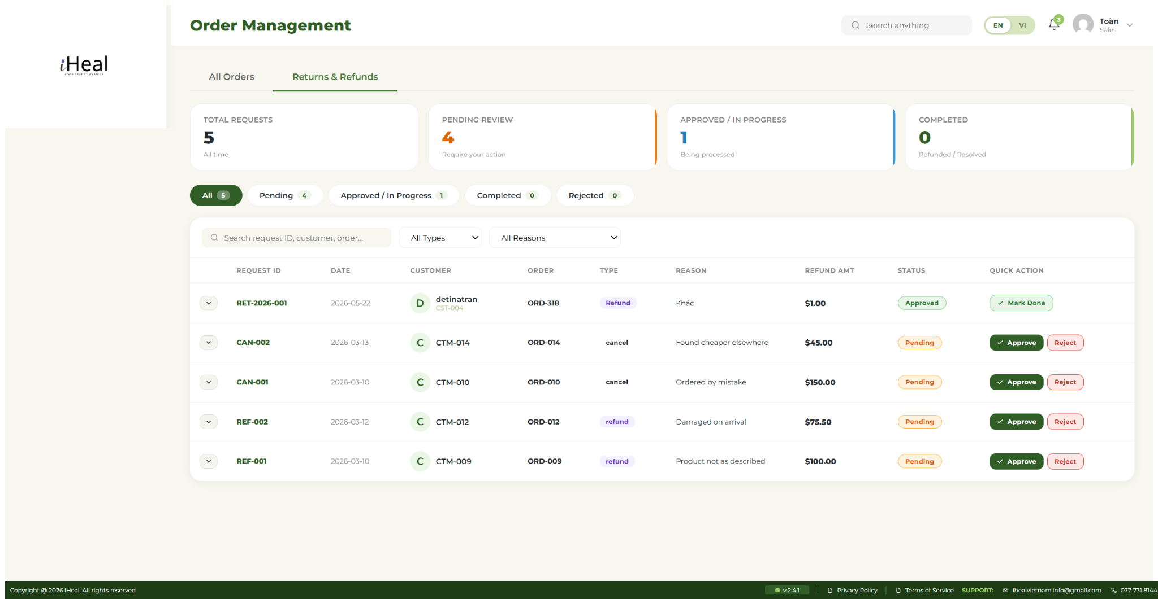

5. Returns & Refunds
FR-ID | Description (Functional Requirement) | Priority
FR-S-051 | The system shall display a Returns & Refunds page at /sales/returns/ listing every refund/return/exchange request submitted by customers, sorted with most recent first. Columns: Request ID, date, customer, order, type (Refund / Exchange / Return), reason, refund amount, status. | Must
FR-S-052 | The system shall allow the rep to filter the request list by type, status (Pending / Reviewing / Approved / Rejected / Processed), and date range. | Must
FR-S-053 | The system shall allow the rep to open a request detail view containing: customer info, original order summary, requested type, reason (from the predefined list of 7), customer description, and timeline of status changes. | Must
FR-S-054 | The system shall allow the rep to change the status of a request (Approve / Reject / Mark as Processed) and to add a public note that the customer will see in their My Refunds tab. | Should
FR-S-055 | The system shall enforce that only one non-terminal request can exist per order at any time. Duplicate submissions are auto-rejected by the customer side; this page surfaces the existing request when the rep attempts a manual creation. | Should
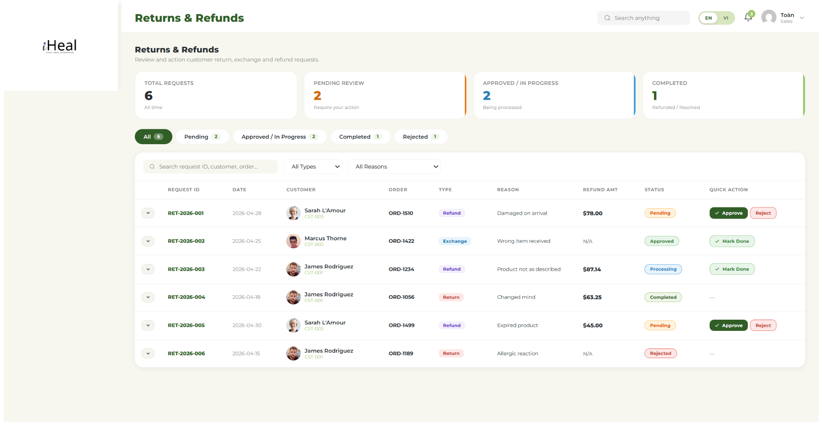

6. Customer Management
FR-ID | Description (Functional Requirement) | Priority
FR-S-025 | The system shall display a Customers Profile page at /sales/customers/ listing every user with role customer, sorted by registration date descending. | Must
FR-S-026 | The system shall show, for each customer row in the side list: avatar (Gravatar by default), display name, and customer ID. | Must
FR-S-027 | The system shall display, when a customer is selected, a detail panel including: avatar, status pill, email, phone address , age group, overall status and loyalty points. | Must
FR-S-028 | The system shall display an Order History table for the selected customer. Columns: order ID, date, items count, total, status, and an action icon for opening the order. Empty state is rendered when the customer has no orders. | Must
FR-S-029 | The system shall allow the rep to filter the order history by status using a dropdown above the table. | Should
FR-S-030 | The system shall allow the rep to search the customer list by ID or name. The query updates the side list without leaving the page. | Should

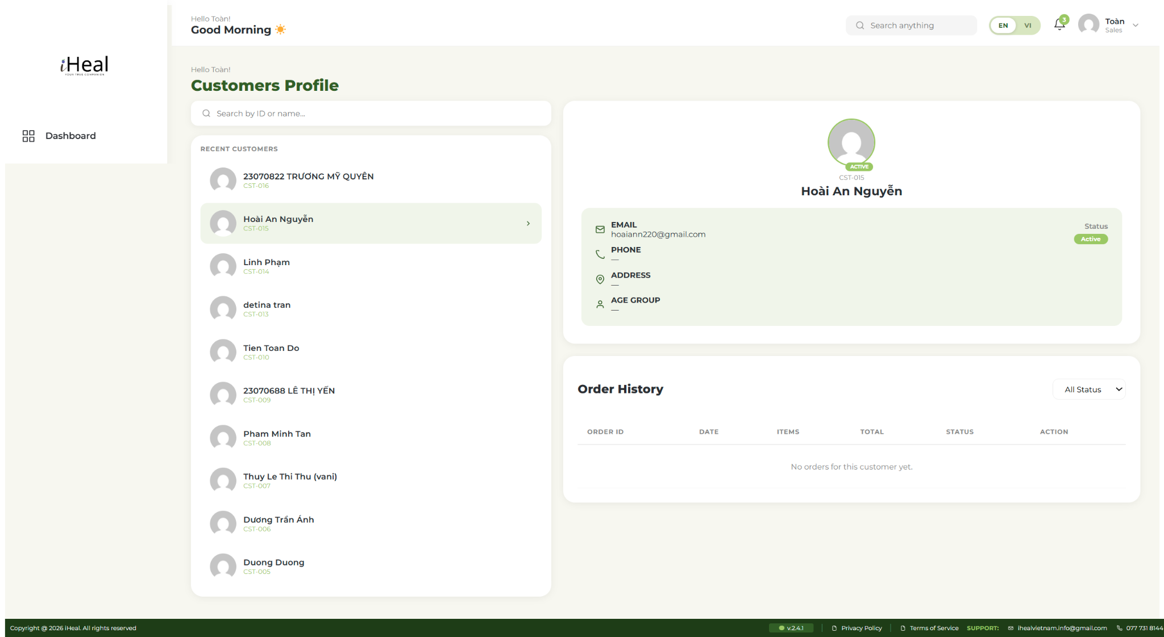

7. Payments
FR-ID | Description (Functional Requirement) | Priority
FR-S-031 | The system shall display a Sales Payments page at /sales/payment/ listing recent transactions. Each row maps to one order with payment ID, customer ID, order ID, status, date, and amount. | Must
FR-S-032 | The system shall allow the rep to filter the payment list by status (Paid / Pending / Fail / Refunded) and to search by customer or order ID. | Must
FR-S-033 | The system shall allow the rep to open a payment detail panel showing customer information (ID, email, phone), order information (ID, date), and payment details (method, transaction ID, amount). | Must
FR-S-034 | The system shall display an empty state (“No payment to display yet.”) when the underlying orders table is empty. | Should
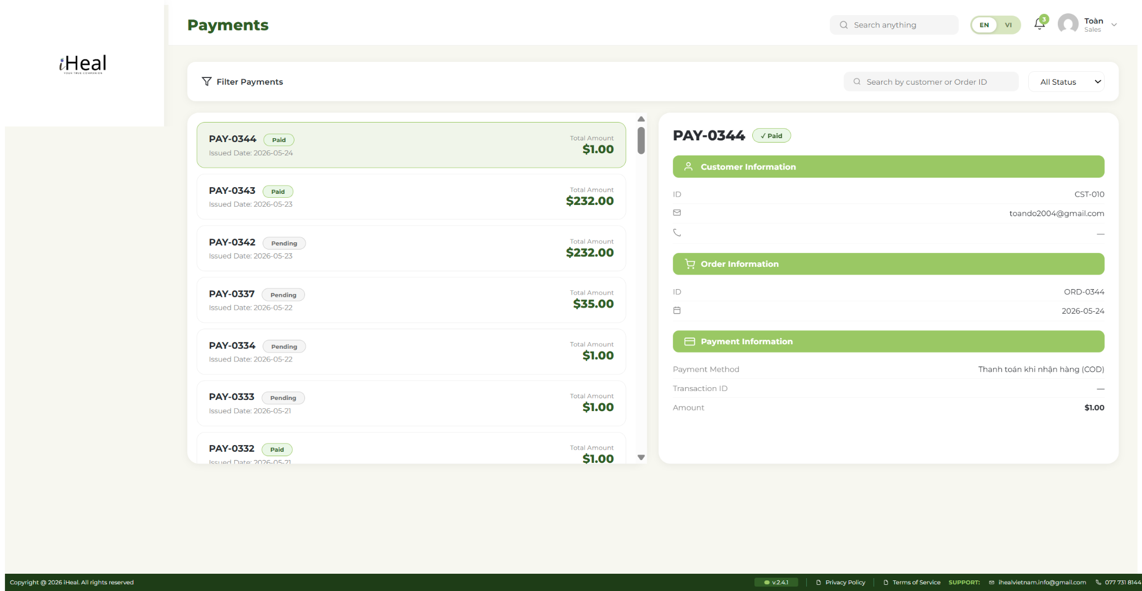

8. Reports & Export
FR-ID | Description (Functional Requirement) | Priority
FR-S-035 | The system shall display a Sales Report page at /sales/report/ with a selectable date range (Last 7 / 30 / 90 days, This Year, Custom). The selected range updates every chart on the page. | Should
FR-S-036 | The system shall display, within the selected range, a Profit Trend line chart and an Order Status doughnut chart. | Should
FR-S-037 | The system shall display a Top Revenue Products table listing the highest-grossing products in the selected range with units sold, gross revenue, and percentage of total. | Should
FR-S-038 | The system shall display a Customer Age Group bar chart visualising distribution of orders across customer age buckets. | Could
FR-S-039 | The system shall allow the rep to export the active report as XLSX or CSV. The export contains the data tables and KPIs for the chosen date range. | Could

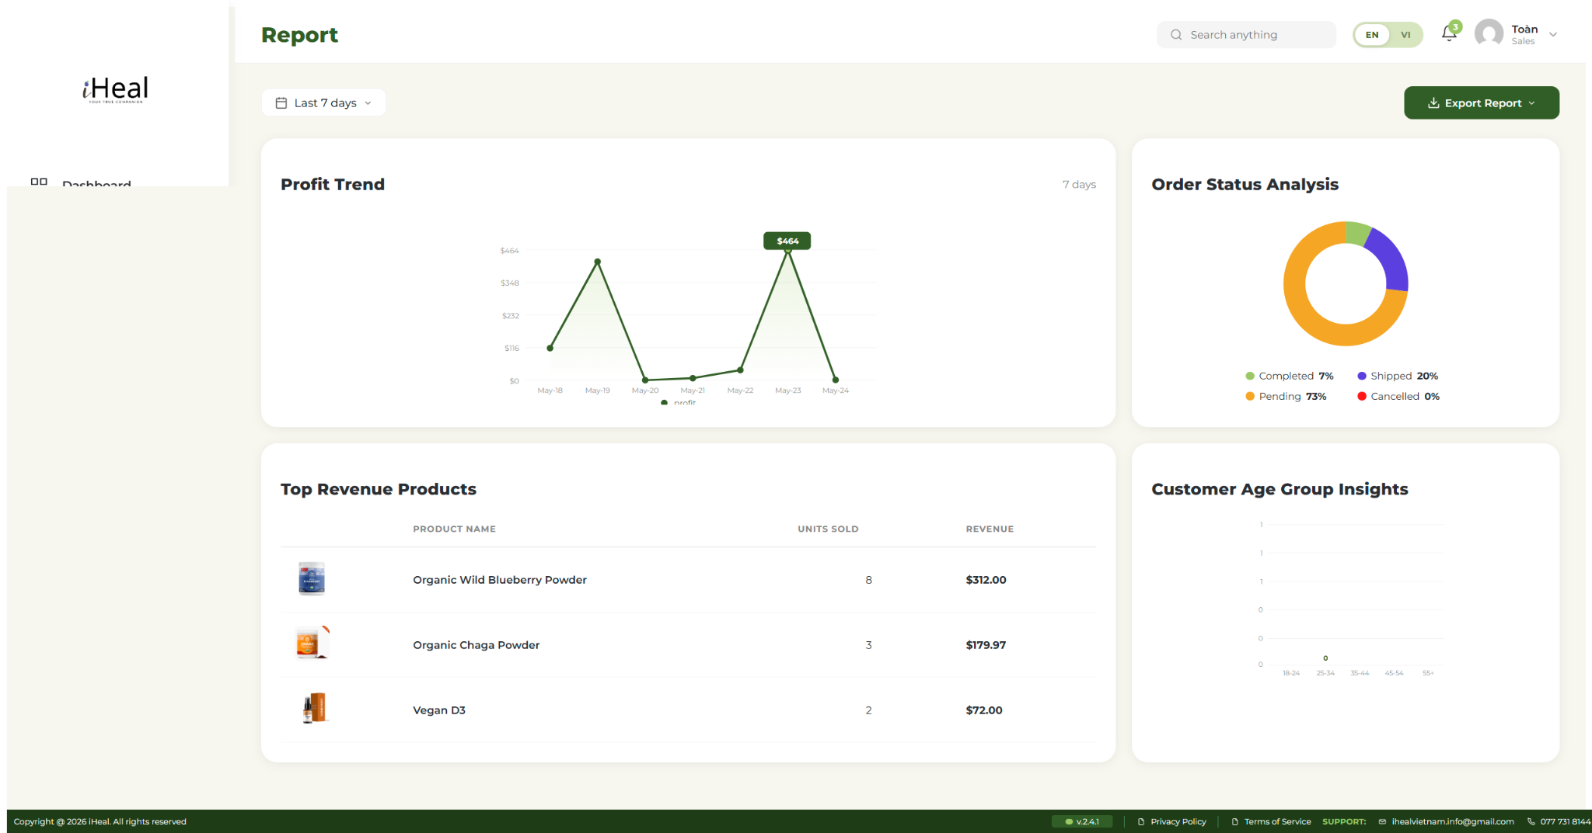 | 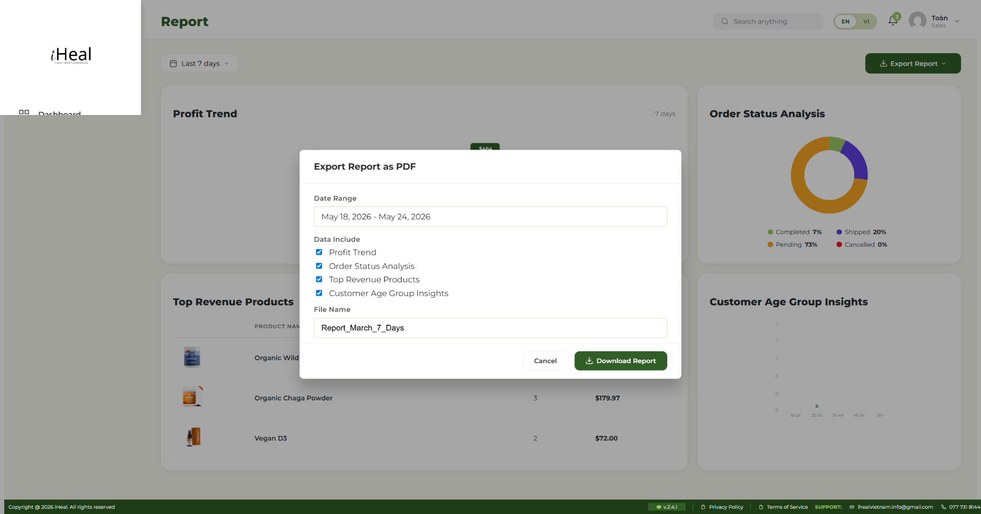
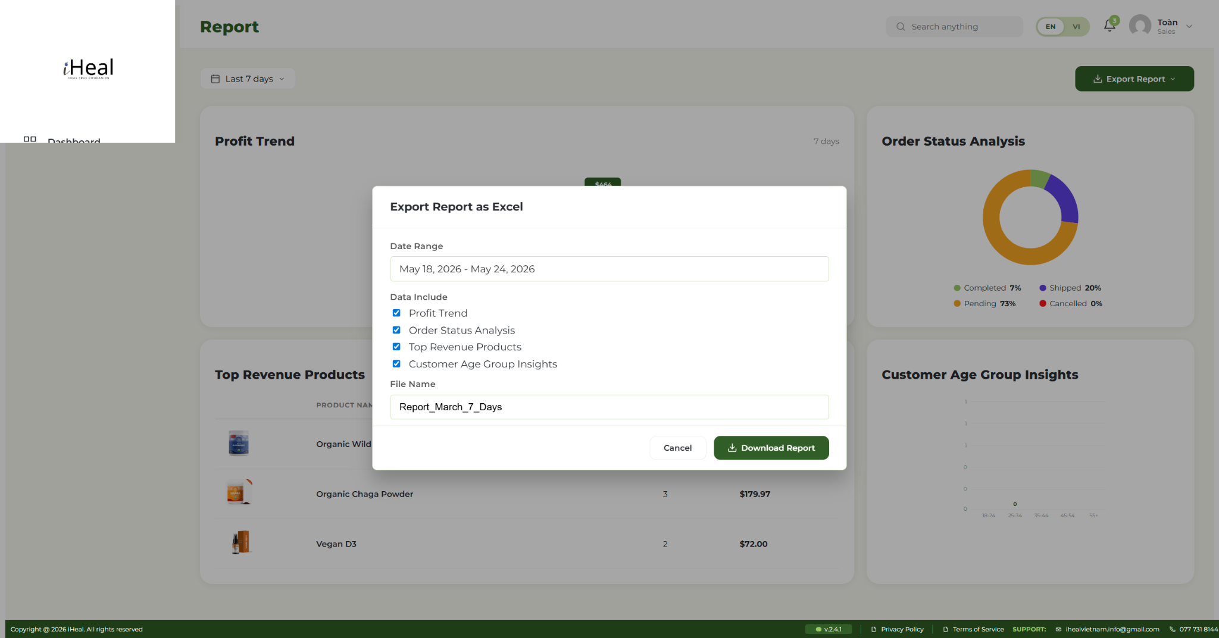 | 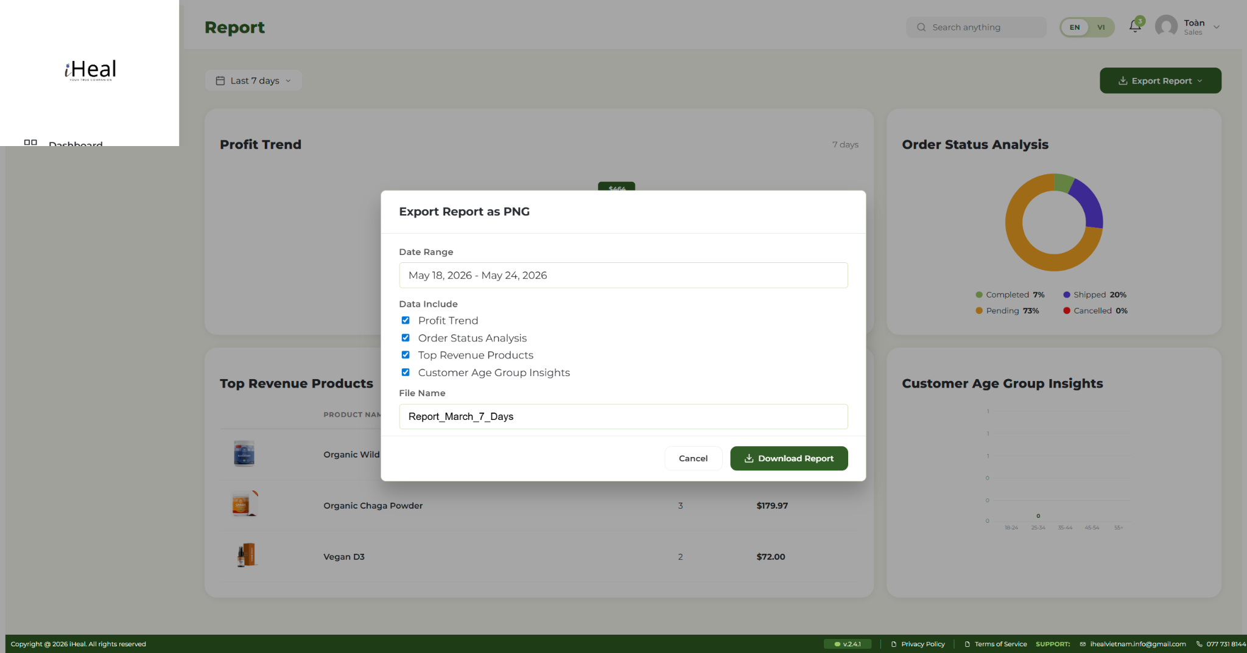

9. Chat & Messages
FR-ID | Description (Functional Requirement) | Priority
FR-S-040 | The system shall display a Chat & Messages page at /sales/chat/ with a conversation list on the left and the active thread on the right. Each conversation shows participant name, tag (Customer / Sales / Operator), last-message preview, and timestamp. | Must
FR-S-041 | The system shall allow the rep to send a text message in any open conversation. Messages are appended via the shared chat helper and immediately visible to the other participant on their side. | Must
FR-S-042 | The system shall allow the rep to start a new conversation from a contact modal listing every operator, every other sales rep, and every customer (live from wp_users). Each contact card shows ID, display name, and role tag. Selecting a contact opens a deterministic thread ID so repeat clicks do not create duplicates. | Should
FR-S-043 | The system shall allow the rep to attach an image (JPG, PNG, GIF, WebP, max 5 MB) to a chat message. The file is uploaded via wp_handle_upload; the URL is stored as part of the message and rendered inline. | Should
FR-S-044 | The system shall allow the rep to delete a conversation after confirmation. Deletion removes the thread from the shared store and is visible immediately to the other participant. | Could
FR-S-045 | The system shall filter the conversation list by tag (All / Customer / Sales / Operator) and search by participant name. | Should
FR-S-046 | The system shall display an unread-message badge on the chat icon in the header, with the unread count for the current rep. | Should
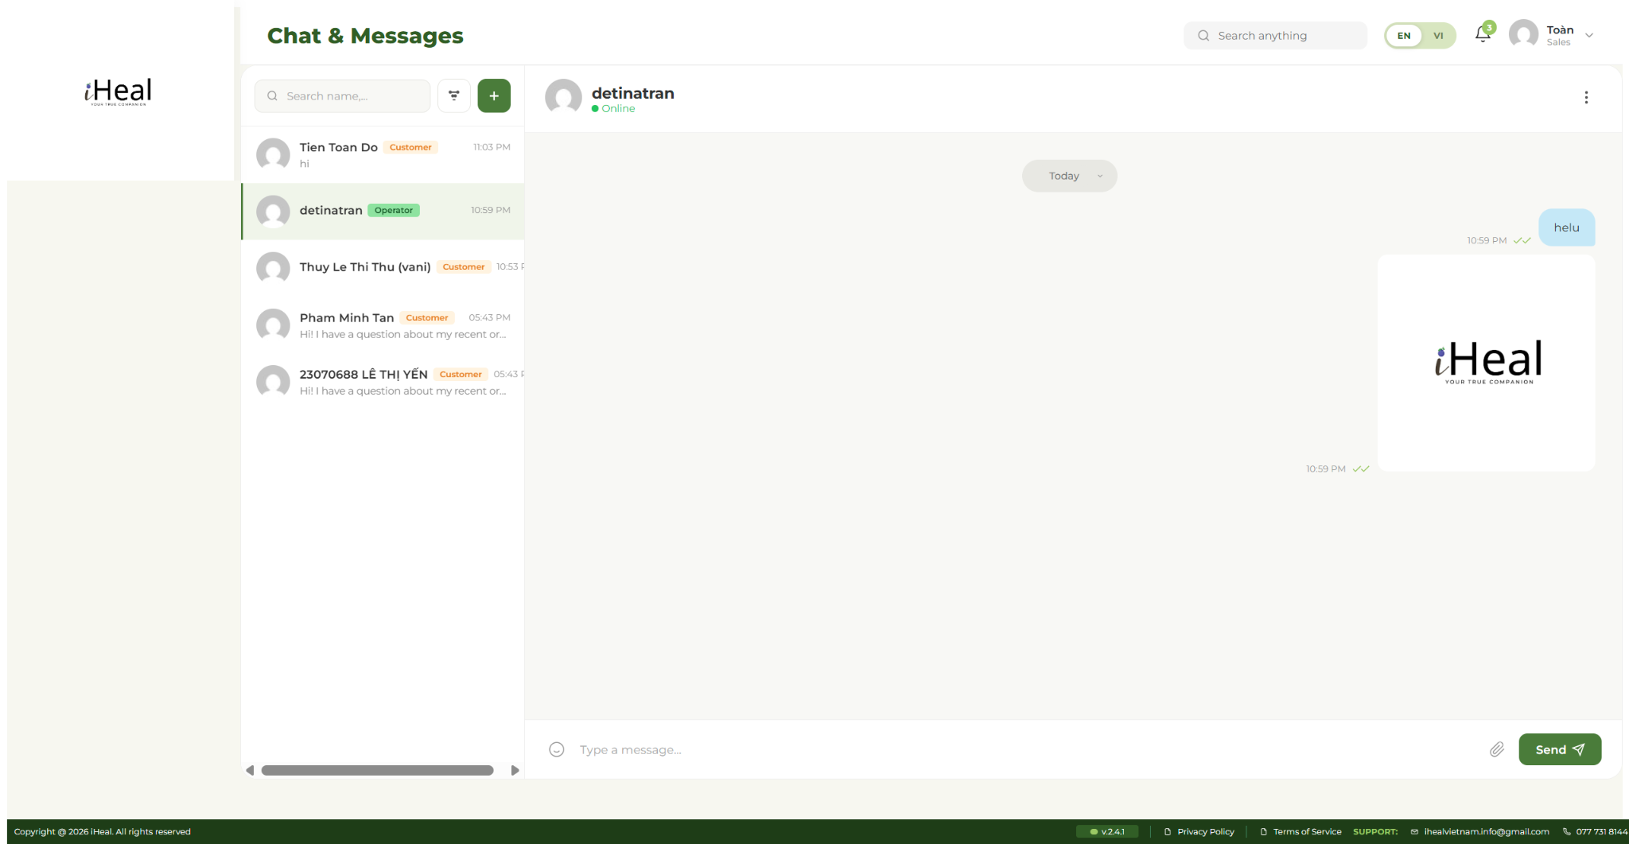

10. Protocol Journey Builder
FR-ID | Description (Functional Requirement) | Priority
FR-S-047 | The system shall display a Protocol Journey Builder page at /sales/protocols/ for the rep to assign, monitor and manage 30-, 60-, and 90-day health journeys for assigned customers. | Could
FR-S-048 | The system shall allow the rep to select a target customer and build a step-by-step protocol consisting of recommended products, daily tasks (e.g. “drink celery juice”), and milestones at the 25 / 50 / 75 / 100 % progress marks. | Could
FR-S-049 | The system shall display, for any assigned protocol, current completion percentage and the list of completed/pending steps as reported by the customer’s My-Journey check-ins. | Could
FR-S-050 | The system shall allow the rep to edit an existing protocol (add/remove steps, change recommended products) or end a protocol early. The customer is notified of any change. | Could

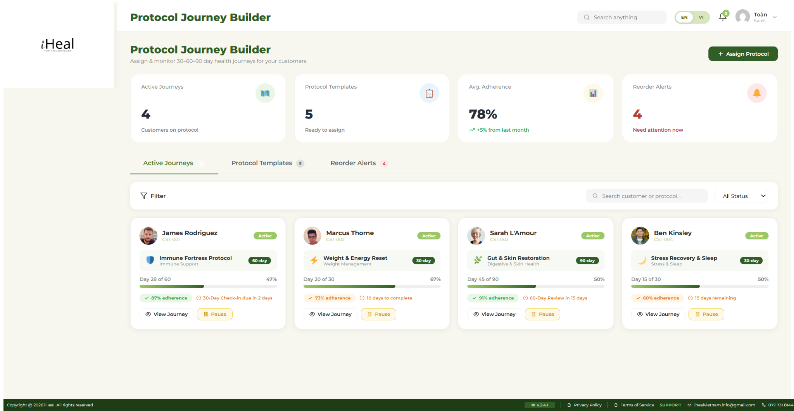 | 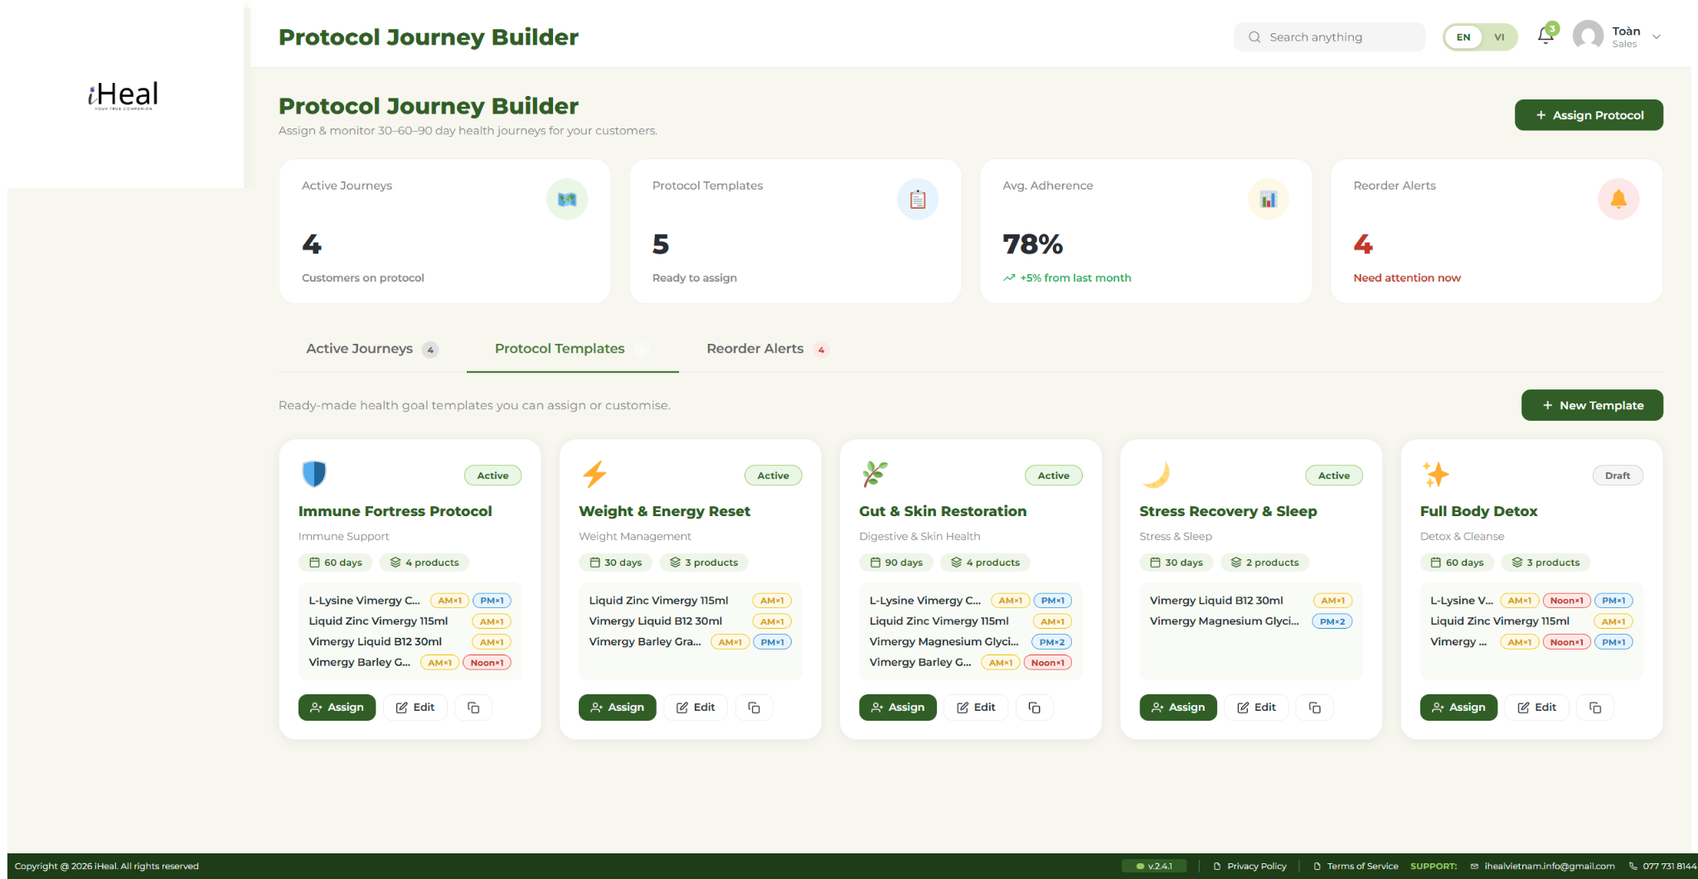
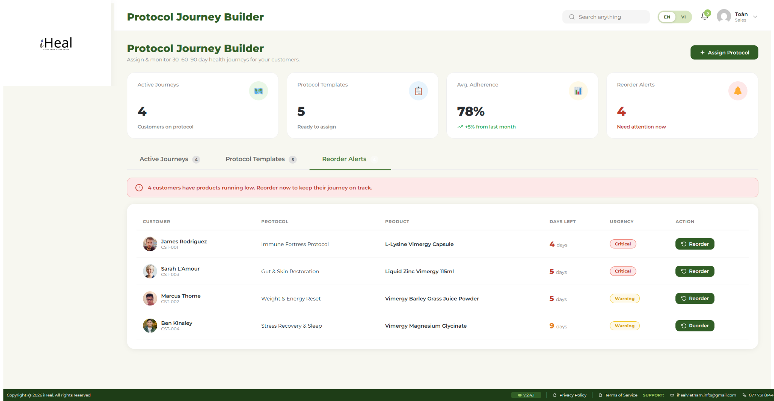

11. Notifications
FR-ID | Description (Functional Requirement) | Priority
FR-S-056 | The system shall display a Sales Notifications page at /sales/notifications/ listing notifications addressed to the rep, sorted with most recent first. | Must
FR-S-057 | The system shall allow the rep to mark a notification as read by clicking it. The bell icon in the header shows an unread badge, updated in real time. | Should
FR-S-058 | The system shall allow the rep to filter notifications by tab (All / Orders / Refunds / Messages / System). The active tab is preserved across page reloads. | Could
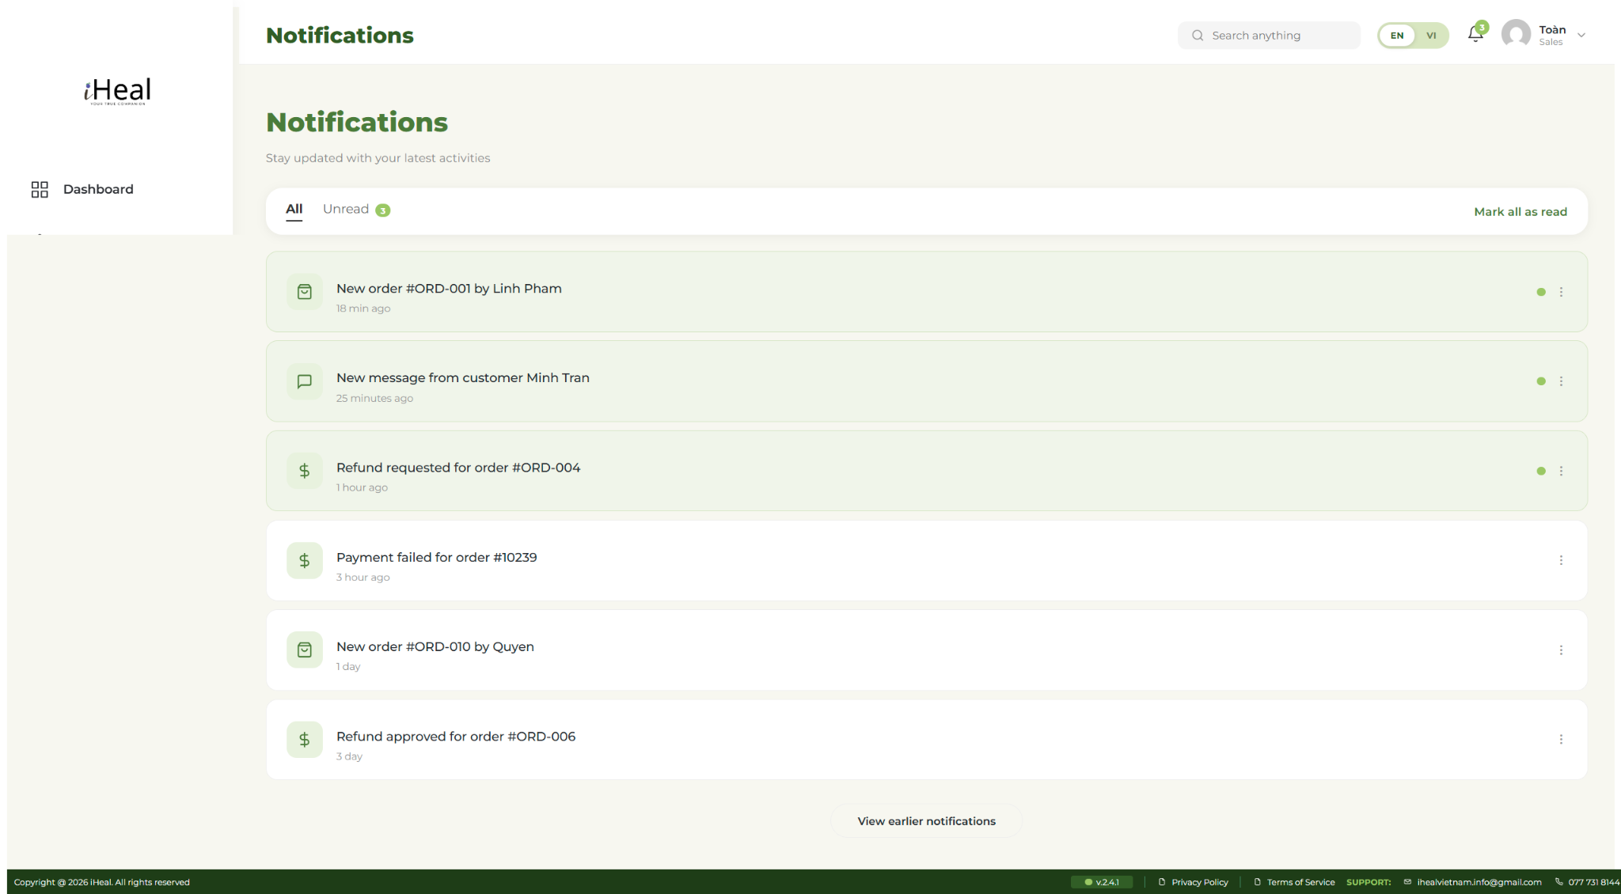

12. Account Settings
FR-ID | Description (Functional Requirement) | Priority
FR-S-059 | The system shall display a Sales Account Settings page at /sales/account-settings/ showing the rep’s profile and account info. Data is sourced live from wp_users and usermeta. | Must
FR-S-060 | The system shall allow the rep to edit their full name, email, phone, and birthdate via the profile form. | Must
FR-S-061 | The system shall validate the submitted email and refuse the save if the new email is empty or already used by another user. Errors are displayed inline above the form. | Must
FR-S-062 | The system shall provide a “Change Password” page (?change-password) requiring the current password and a new password (minimum 8 characters, mixing letters and digits). On success all other sessions for the account are revoked. | Must
FR-S-063 | The system shall display the rep’s avatar (Gravatar by numeric user ID) and a “Join at {YYYY-MM-DD}”. | Should
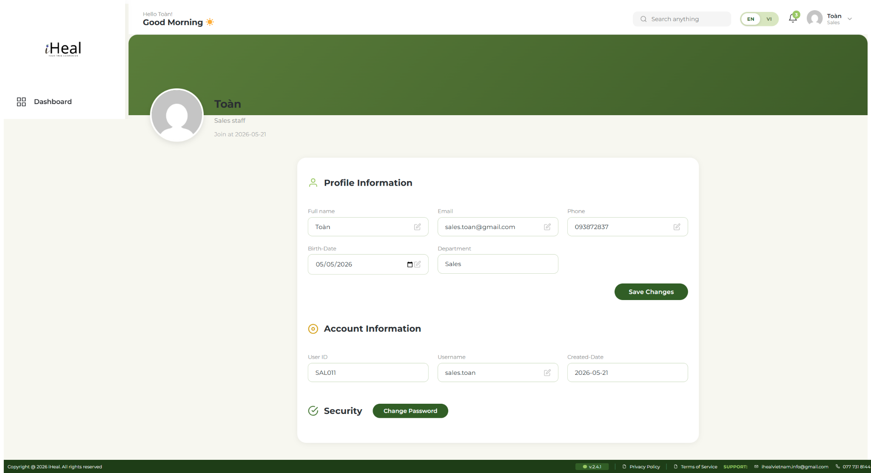

13. Navigation & Internationalization
FR-ID | Description (Functional Requirement) | Priority
FR-S-064 | The system shall provide a persistent left sidebar on every sales page listing the 8 destinations: Dashboard, Products & Packages, Order, Customers, Payments, Reports, Chat & Messages, Protocol Journeys. The current page is highlighted with the brand-primary color. | Must
FR-S-065 | The system shall provide a persistent top header on every sales page with: greeting + page title, search box, EN/VI language switch, notifications bell with unread count, and avatar dropdown (Account Settings / Log out). | Must
FR-S-066 | The system shall allow the rep to switch the interface between Vietnamese and English via an EN/VI pill in the header. Every translatable string carries a data-vi attribute consumed by the shared lang-switch script. The preference is persisted in localStorage and applied without page reload. | Must
FR-S-067 | The system shall translate status labels (Paid →, Pending →, Refunded →, Failed) consistently across every table and badge using the shared in sales-lang-switch.js. | Should
FR-S-068 | The system shall include a fixed footer at the bottom of every page with version pill, Privacy Policy, Terms of Service, support email, and support phone matching the customer/operator footer design. | Should
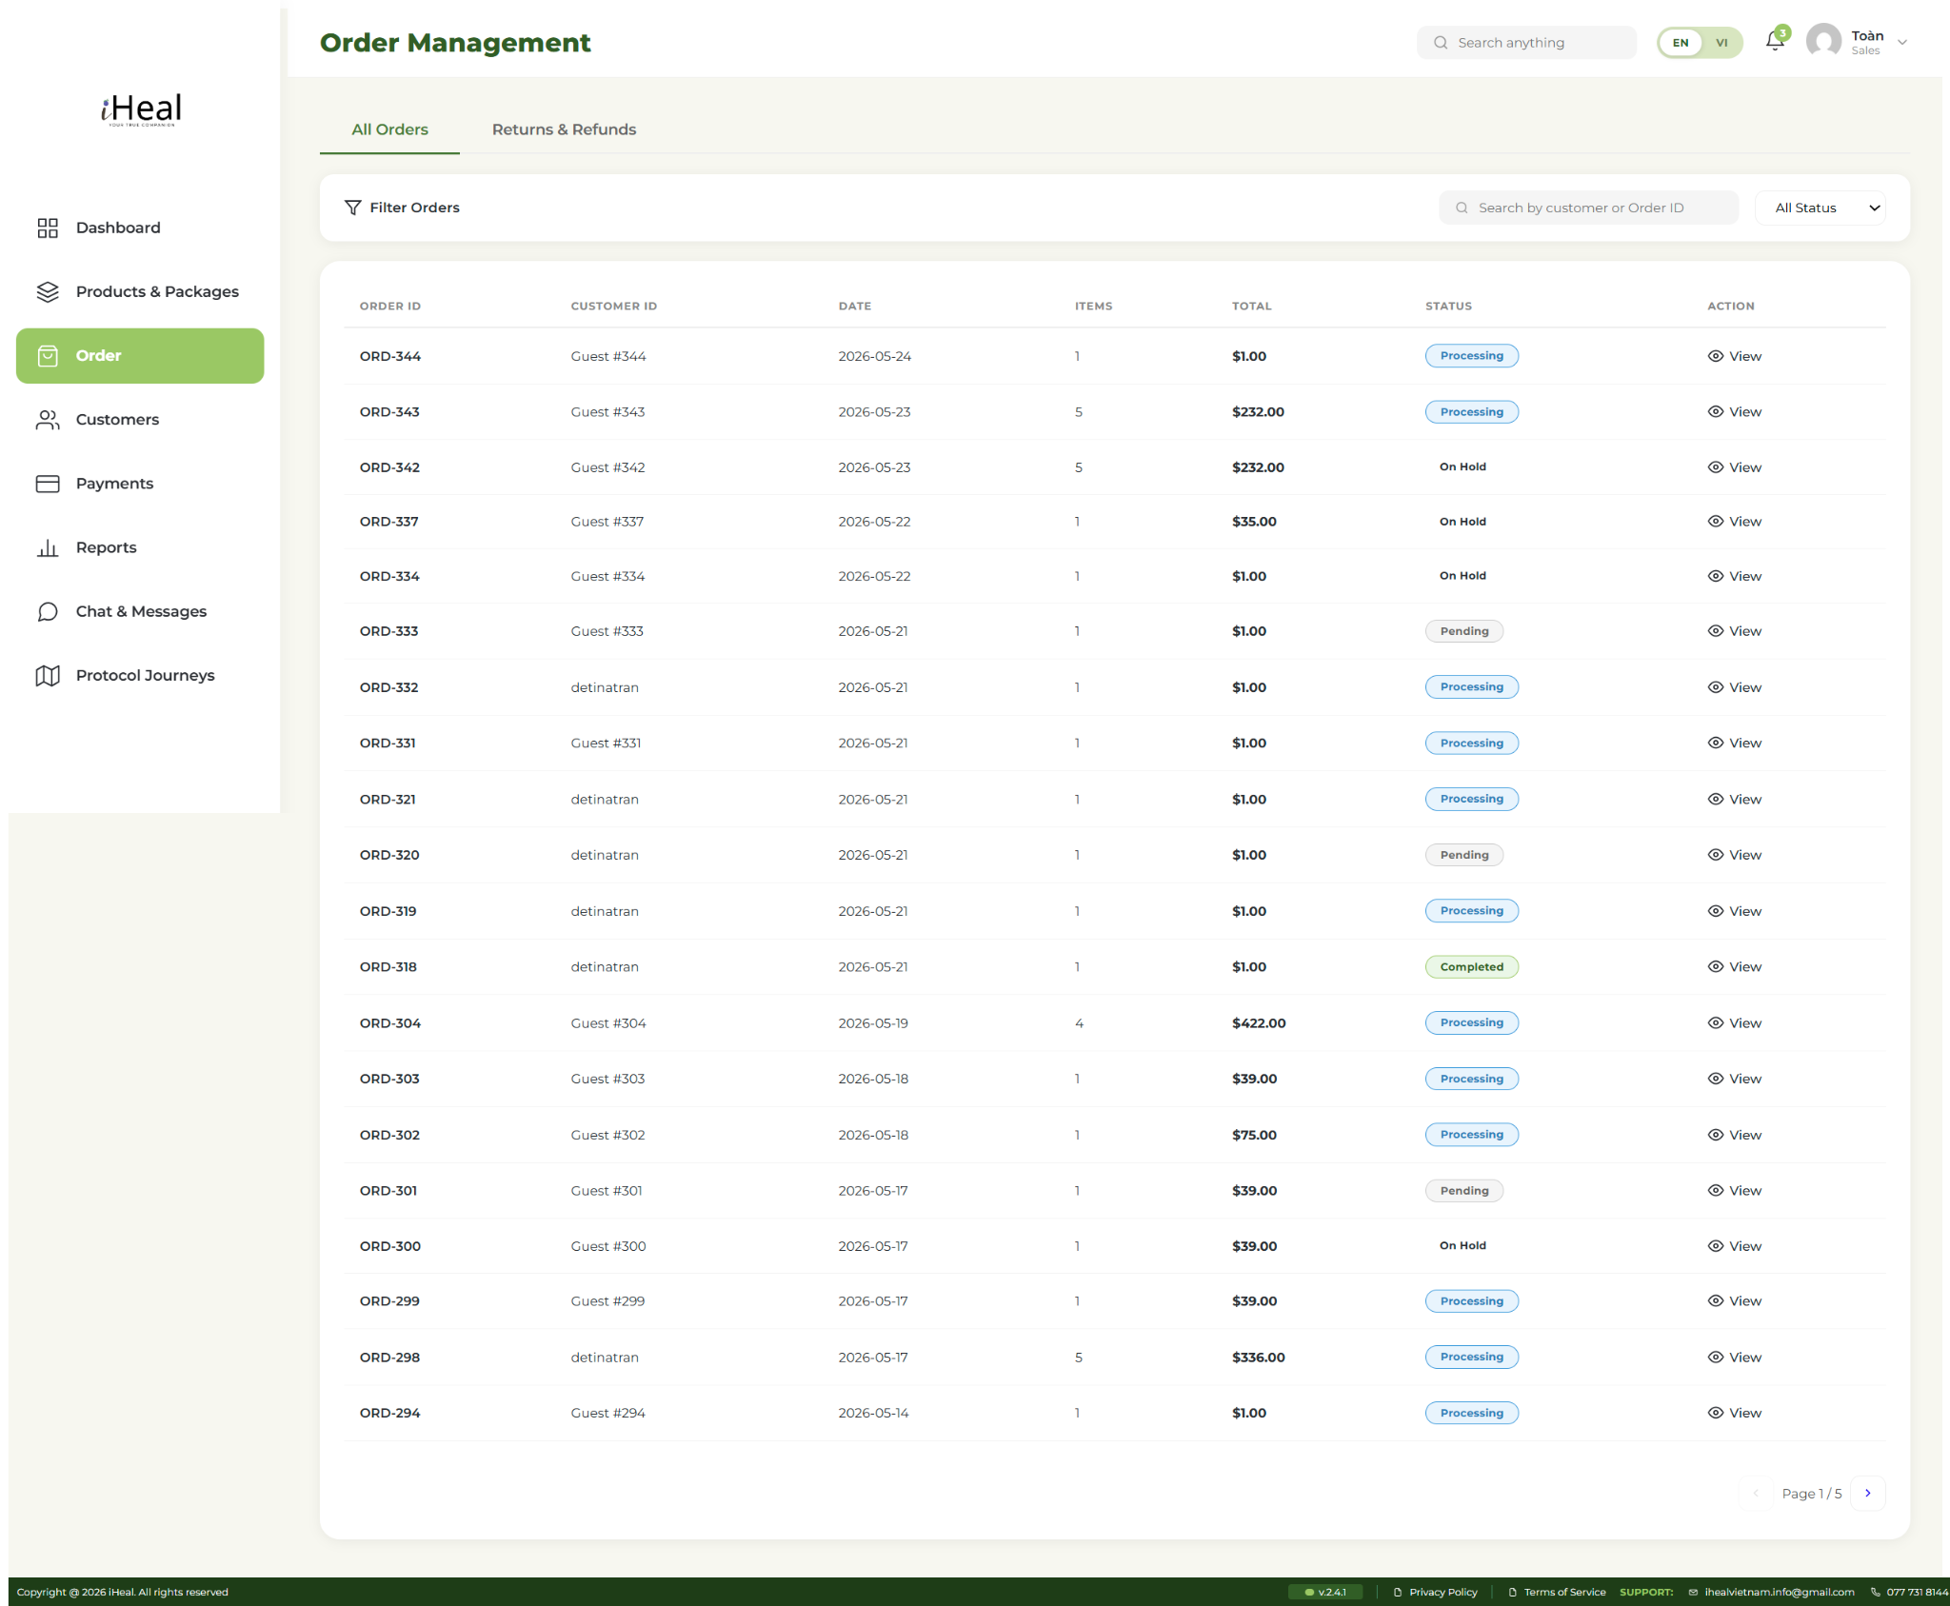

III. USE CASE DIAGRAM
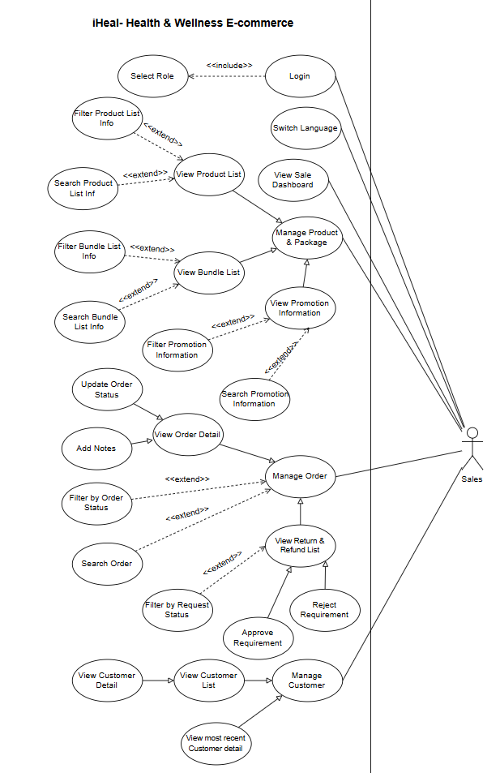 | 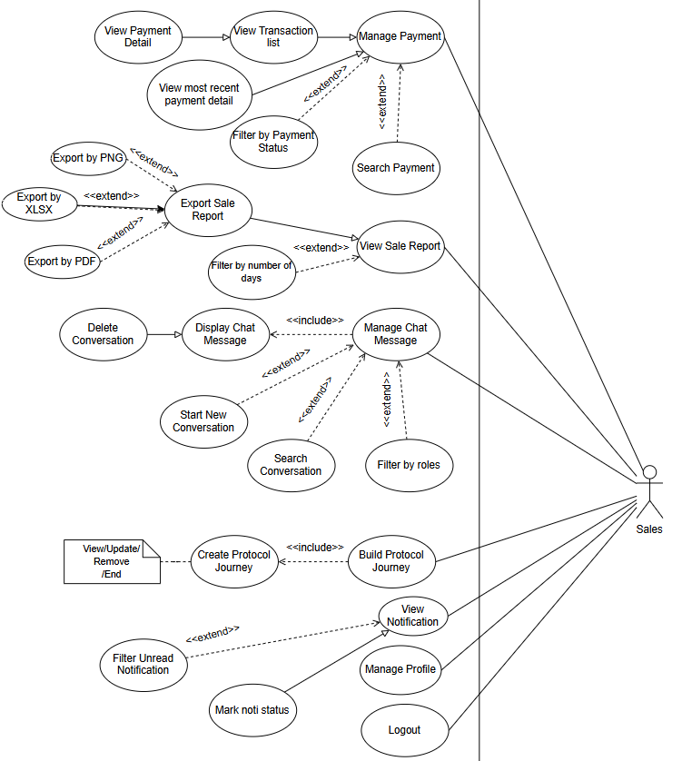
Use case of sales roles - Table lists
No | Code | Name | Brief Description
1 | SA-001 | Login | Sales staff logs in using email/username and password. The system routes credentials based on role selection.
2 | SA-002 | Logout | Sales staff ends session via avatar dropdown; cookie invalidated, redirect to login
3 | SA-003 | Switch Language | Sales staff switches interface between Vietnamese and English via EN/VI pill; preference saved
4 | SA-004 | View Dashboard | Sales staff views dashboard with KPIs, revenue trend chart, order status chart, top products, and recent orders. Time-period selector applies across widgets.
5 | SA-005 | Manage Product & Package | Sales staff views product list, bundle list, and promotions; searches, filters, and views details. No editing rights.
6 | SA-006 | Manage Order | Sales staff views order list, searches, filters, views details, updates status, and adds internal notes.
7 | SA-007 | Manage Customer | Sales staff views customer list, searches by name/ID, views profile details and order history.
8 | SA-008 | Manage Payment | Sales staff views transaction list, filters by status, searches, and views payment details.
9 | SA-009 | View Report | Sales staff views sales report with date range filter, charts, and exports to PNG, XLSX, or PDF format.
10 | SA-010 | Manage Chat Message | Sales staff sends/receives messages and images, starts new conversations, deletes chats, and sees unread badges.
11 | SA-011 | Build Protocol Journey | Sales staff assigns and manages 30/60/90-day health journeys with steps, tasks, milestones, and progress tracking.
12 | SA-012 | View Notification | Sales staff views notifications, marks as read, filters by type, and sees unread count on bell icon.

