I. SYSTEM TEST PLAN

1.1 Test Objectives
Verify that the Sales Portal works correctly according to the functional specifications, meeting strict standards for Role-Based Access Control (RBAC), transaction and financial data integrity, and a stable workflow for sales staff before system delivery.

1.2 Testing Scope

1.2.1 In-Scope (Manual Functional Testing)
Using a risk-based testing strategy, testing focuses on Manual Functional Testing across three core modules:
Module 1: Authentication & Role-Based Access Control (RBAC):
  - Test login functionality with valid data (Positive) and invalid data, empty fields, or locked accounts (Negative).
  - Test the 30-day session persistence feature (Keep me logged in) and the post-login redirect parameter (redirect_to).
  - Test internal page protection (Authentication Guard) and role verification (role_label = Sale) across all internal URLs.
Module 2: Order Management & Returns/Refunds Processing:
  - Test searching, pagination, and multi-condition filtering on the orders list (by status, date range, order ID, or customer name).
  - Test updating order statuses (Shipped, Completed) and logging internal notes.
  - Test the return and refund review workflow: approving requests (Approve), rejecting requests (Reject), and verifying the business rule that allows only one active return request per order.
Module 3: Dashboard KPIs & Analytics:
  - Test data calculations for the three KPI summary cards (Total Orders, Total Sales, Total Profit based on 30% margin for completed, processing, and on-hold orders).
  - Test chart data updates on the Revenue Trend line chart when switching between time filters (7 days, 30 days, 90 days) to prevent frozen chart issues (Bug CP1G-72).
  - Test the exclusion logic that removes items containing the keyword "test" from the Top Selling Products list.

1.2.2 Out-of-Scope
- UI & Visual Testing: No pixel-level layout checks, margin/padding verification, exact hex color validation, or responsive screen resizing tests.
- Standalone API Testing: No automated API testing using Postman or direct requests to REST API/AJAX endpoints (all tests are executed via web user actions in the browser).
- Direct Database Testing: No manual SQL queries executed directly inside MySQL (data is verified through the web UI output).
- Non-Functional Testing: No load or performance testing (JMeter) and no penetration security testing.
- Other Subsystems & Live Integrations: No testing of the Customer Portal, Brand Operator admin settings, real bank/gateway fund transfers, or inventory syncing with third-party marketplaces (Shopee/Facebook).

1.3 Test Environment
- Target Web URL: [https://sales.ihealwehear.site](https://sales.ihealwehear.site)
- Underlying Platform: WordPress 6.9.4 with WooCommerce 10.7.0 (HPOS API) running on MySQL database.
- Execution Browser: Google Chrome Desktop (latest stable version).
- Test Accounts:
  - Valid Sales Account: sales.toan
  - Permission Control Accounts: Regular Customer account (detinatran@gmail.com) and Brand Operator admin account (toando63)

1.4 Test Methods & Design Techniques
All tests follow the Black-box Functional Testing approach, using standard test design techniques:
- Equivalence Partitioning (EP): Dividing input data into valid sets (Positive Test Cases) and invalid sets (Negative Test Cases) for login forms, search inputs, and refund reason dropdowns.
- Boundary Value Analysis (BVA): Testing boundary limits for password length (minimum 8 characters), input text limits, and date filter ranges.
- State Transition Testing: Verifying valid and invalid status transitions across the Order lifecycle (Processing → Shipped → Completed) and Return requests (Pending → Approved / Rejected).

1.5 Test Suspension & Exit Criteria

1.5.1 Entry Criteria
- The Sales Portal environment is stable on the server, with initial sample data loaded (products, orders, customer accounts).
- The functional specification document (iHeal_SalesPortal_Functional_Specification.docx) and corresponding UI screens are approved as the baseline for expected results.

1.5.2 Suspension & Resumption Criteria
- Suspension: Testing is paused if a Blocker defect occurs in the login flow preventing system access, or if the database loses connection.
- Resumption: Testing resumes once the blocker is resolved and successfully deployed to the test environment.

1.5.3 Exit Criteria
- 100% of planned test cases for the three core modules are executed.
- 0 open defects at Blocker or Critical severity levels.
- Minimum Pass rate of 95% across all executed test cases.
- All identified functional defects are logged in detail on Jira Project CP1G (including Summary, Steps to Reproduce, Actual Result, Expected Result, and screenshot evidence).

II. TEST EXECUTION & RESULTS

2.1 Test Execution Summary
Functional testing was thoroughly conducted across the three designated modules of the Sales Portal on the iHeal platform. All 52 designed test cases were executed, re-tested following defect remediation, and attained an absolute 100% final pass rate:

Testing Module | Total TCs | Passed | Failed | Blocked | Final Pass Rate (%)
Module 1: Authentication & Role-Based Access Control (RBAC) | 12 | 12 | 0 | 0 | 100%
Module 2: Order Management & Returns/Refunds Processing | 23 | 23 | 0 | 0 | 100%
Module 3: Dashboard KPIs & Analytics | 17 | 17 | 0 | 0 | 100%
Total | 52 | 52 | 0 | 0 | 100%

2.2 Execution Metrics
- Total Executed Test Cases: 52 / 52 (Execution Rate: 100%)
- Final Pass Rate: 100% (52 / 52 Passed after re-testing)
- Open / Blocked Rate: 0%

III. DEFECT MANAGEMENT & TRACKING

3.1 Defect Tracking via Jira
All defects identified during the test execution cycles were systematically logged, tracked, and monitored in Jira under project CP1G (Capstone Project 1 – Group 1).
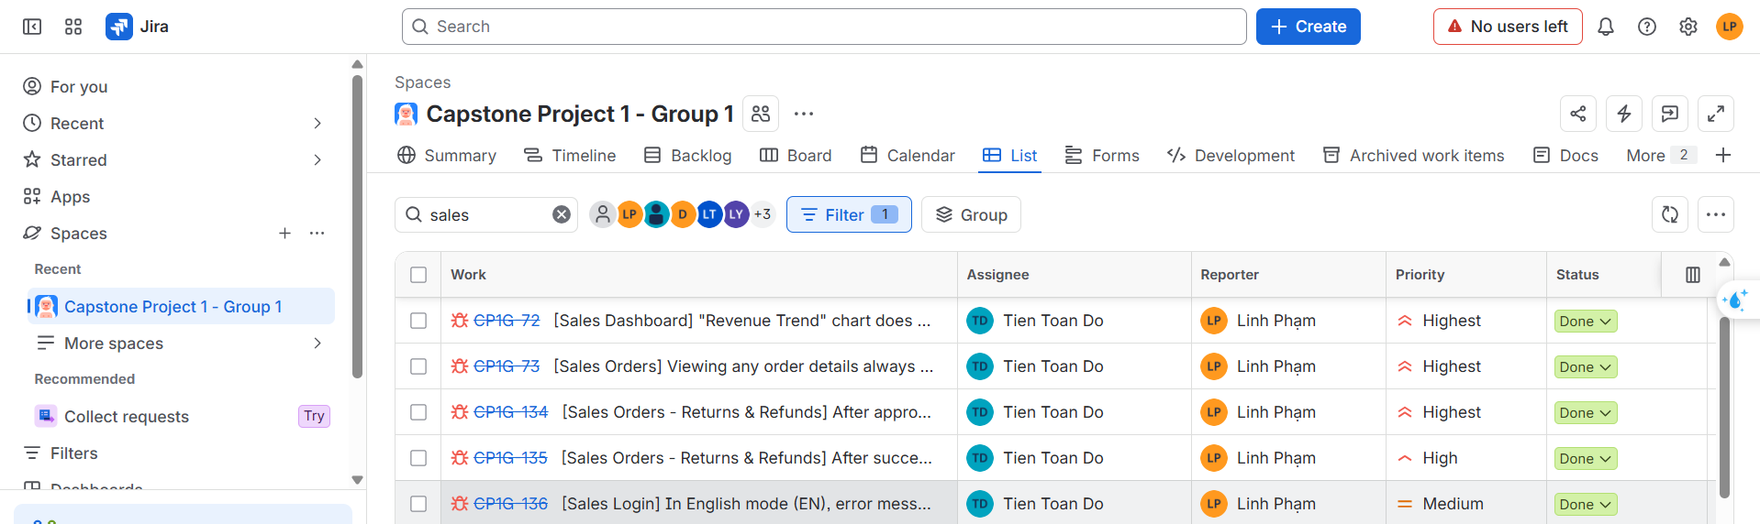

3.2 Defect Resolution Summary
- Total Defects Logged: 7
- Total Defects Resolved & Closed: 7 (100% Resolution Rate)
- Total Open / Unresolved Defects: 0 (Zero Open Defects)

IV. CONCLUSION & SIGN-OFF
Exit Criteria Evaluation:
  - Test Case Execution: 100% completed (52 / 52 test cases).
  - Defect Resolution: 100% of recorded bugs (7/7 defects) were resolved, re-tested, and closed.
  - Remaining Defects: 0 Critical, 0 Major, and 0 Minor open defects in the backlog.
  - Overall Pass Rate: 100% achieved, fully meeting the project's quality exit criteria.
Final Sign-off Recommendation: The verified features within the Sales Portal demonstrate solid functional stability, operate strictly in compliance with system specifications, and are Ready for Acceptance Sign-off and Release.

