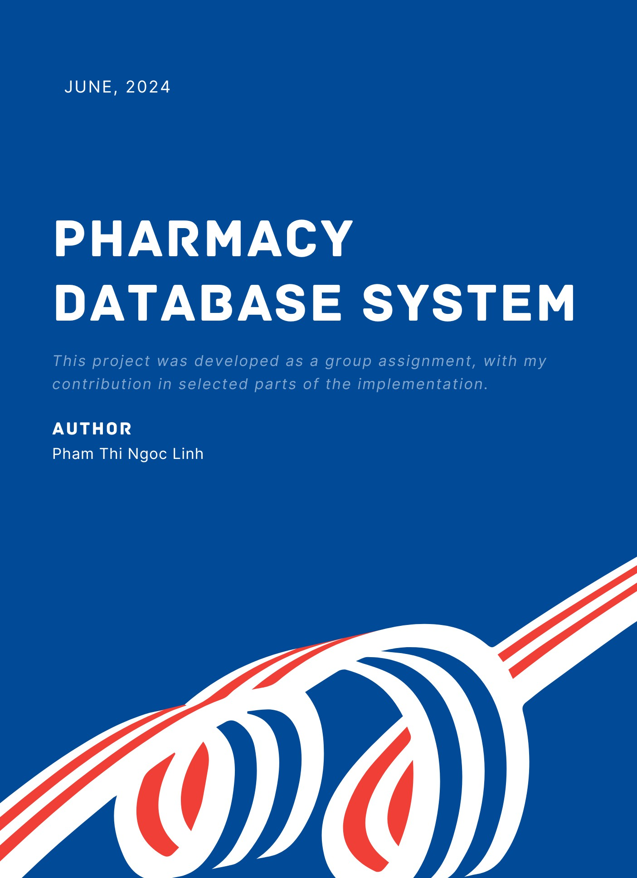

1. BUSINESS PROBLEM & SYSTEM OBJECTIVES
365 Pharmacy operates in the wholesale and retail of pharmaceuticals, functional foods, and medical equipment. Its operations involve three main business challenges:
- Inventory Control & Safety Buffers: Medicines require accurate tracking of batches and stock quantities. The system must provide real-time stock information so that sales staff can check product availability before confirming prescriptions and avoid backorders.
- Transactional Integrity: Each customer purchase may include multiple prescription medicines and must be processed by an authorized pharmacist. The database must maintain accurate relationships between orders, pharmacists, order items, and electronic sales invoices in accordance with regulatory requirements, including Decree No. 123/2020/ND-CP.
- Data Lifecycle & Storage Optimization: The pharmacy processes a large number of retail transactions daily, causing the volume of financial invoice data to increase over time. This can increase database size and reduce indexing performance. Therefore, the system should automatically archive or remove invoices older than two years while preserving the necessary information for audit purposes.

2. DATABASE ARCHITECTURE & MODELING

2.1 Entity-Relationship Modeling (ERD)
I contributed to the development and refinement of the conceptual Entity-Relationship Diagram (Figure 1). The diagram identifies seven essential operational entities and their relationships:
- Customer: Represents customers who purchase products and stores their contact and basic personal information.
- Pharmacist: Represents pharmacy staff and stores their professional license numbers and qualifications.
- Supplier: Represents pharmaceutical suppliers and stores information about their certifications and quality standards, such as GMP, FDA, and ISO.
- Drug: Represents pharmaceutical products and stores information such as price, unit, batch number, current stock quantity, and expiration date.
- Order & OrderDrug (Junction Table): The OrderDrug table resolves the many-to-many relationship between Order and Drug. It records the quantity and selling price of each drug included in an order.
- Invoice: Represents electronic invoices related to customer orders. It stores information such as payment method (Cash, Bank Transfer, and Credit Card) and invoice timestamps.
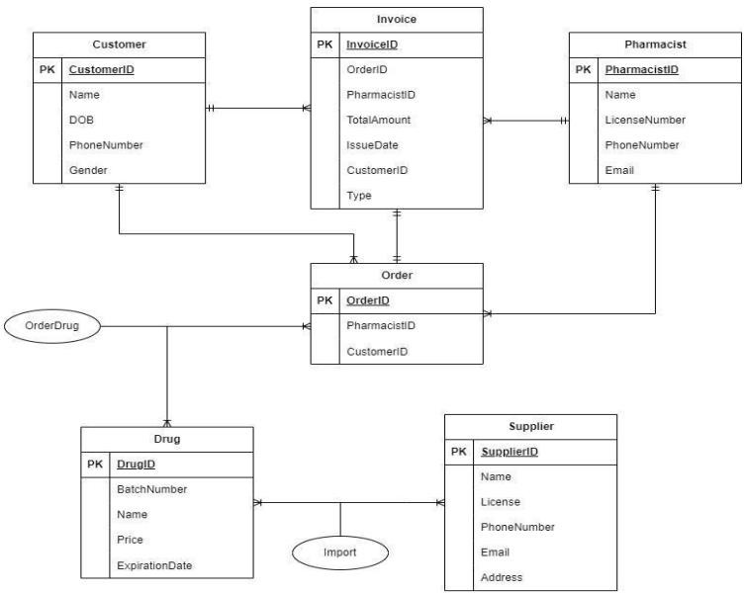
- Import: Represents drug procurement records and links suppliers with incoming drug batches for stock replenishment.

2.2 Relational Schema & Normalization
Based on the conceptual ERD, we developed the relational schema and normalized it to the Third Normal Form (3NF). This process helps reduce data redundancy and prevent insertion, update, and deletion anomalies.
- Customer (CustomerID [PK], Name, PhoneNumber, Gender)
- Pharmacist (PharmacistID [PK], Name, LicenseNumber, PhoneNumber, Email)
- Supplier (SupplierID [PK], Name, License, PhoneNumber, Email, Address)
- Drug (DrugID [PK], BatchNumber, Name, Price, StockQuantity, Unit, ExpirationDate)
- Order (OrderID [PK], PharmacistID [FK], CustomerID [FK])
- OrderDrug (OrderID [PK, FK], DrugID [PK, FK], OrderedQuantity, Price)
- Invoice (InvoiceID [PK], OrderID [FK], PharmacistID [FK], CustomerID [FK], TotalAmount, IssueDate, Type)
- Import (ImportID [PK], SupplierID [FK], DrugID [FK], ImportQuantity, ImportPrice, ImportDate)
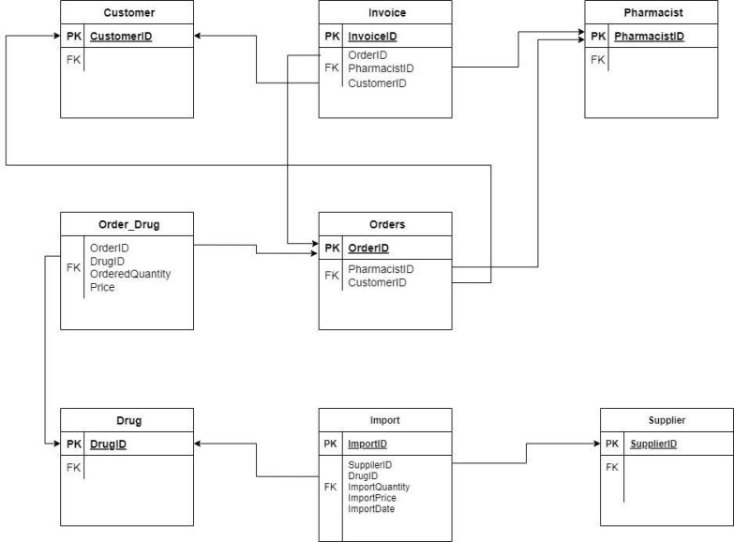

3. ADVANCED SQL IMPLEMENTATION & BUSINESS SOLUTIONS
My primary individual responsibility involved analyzing and solving specific operational scenarios using T-SQL queries. The detailed implementations are presented below:

3.1 Scenario 1: Automated Data Lifecycle Management — Purging Obsolete Invoices
In compliance with audit and operational policies, transactional invoices that are more than 2 years old must be purged to conserve storage space and maintain query execution speed on transaction tables.
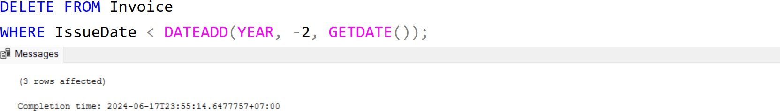
Purpose:
    - Helps maintain database performance by reducing unnecessary data
    - Ensures the system only stores relevant and recent transaction records.

3.2 Scenario 2: Point-of-Sale Stock Availability Verification
Before confirming customer orders, pharmacists must verify whether requested medicines have adequate stock. To avoid stockouts for emergency orders, the system requires a safety buffer threshold of at least 3 units to classify a drug as "Available".
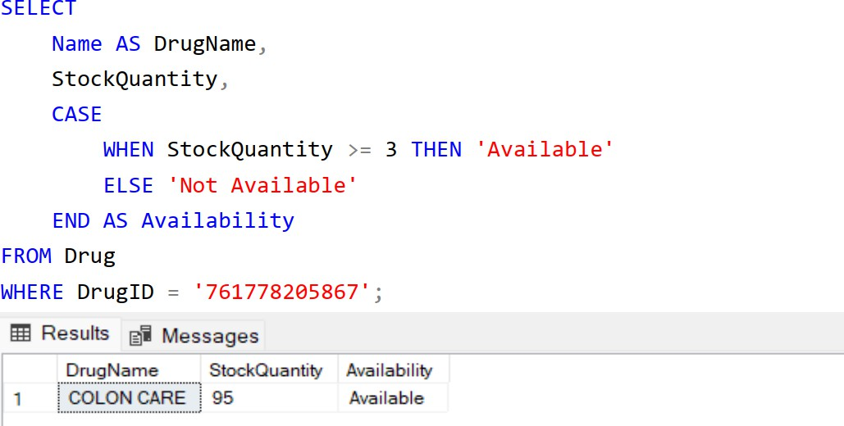
Purpose:
    - Supports order processing by verifying stock availability before confirming a purchase
    - Helps prevent situations where orders are placed for out-of-stock products

3.3 Scenario 3: Controlled Drug Insertion with Defensive Duplicate Checking
When cataloging new pharmaceutical arrivals, pharmacists must be prevented from creating duplicate entries for already existing items (avoiding primary key collision errors and duplicate catalog listings).
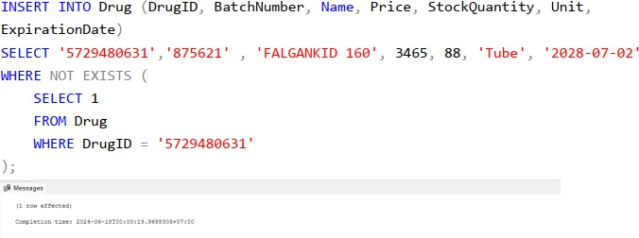
Purpose:
    - Prevents duplicate records in the system
    - Ensures data integrity during the insertion process

4. CONCLUSION
The implementation of the 365 Pharmacy database demonstrated how relational database concepts can be applied to support pharmacy operations and improve data management. The main learning outcomes are as follows:
- Data Modeling: Transformed pharmacy business requirements into a structured 3NF relational schema and designed junction tables such as OrderDrug and Import to represent relationships between entities.
- Data Integrity: Applied primary keys, composite keys, and foreign keys to maintain data accuracy and consistency across related tables and sales transactions.
- SQL Problem-Solving: Developed SQL queries using date functions such as DATEADD and GETDATE, conditional logic with CASE, and subqueries with NOT EXISTS to address practical business requirements.
- Practical Experience: This project provided hands-on experience in database design, SQL development, and data management, providing a useful foundation for further work in data analysis and software testing.

