Setup Qt Creator for Raspberry Pi cross compilation – [Co]
If you do not have installed Qt Creator, follow the instructions in the Qt download page to download and install it. Then, follow these instructions to configure cross-compilation support.
First, open Qt Creator, go to the Tools -> Options menu, select the Devices section and Devices tab. Add a new Generic Linux Device.
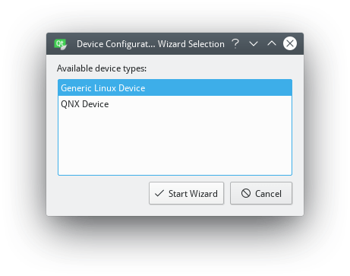
Set a name for the configuration (Raspberry Pi), the network name or IP, the username (pi) and password (by default raspberry).
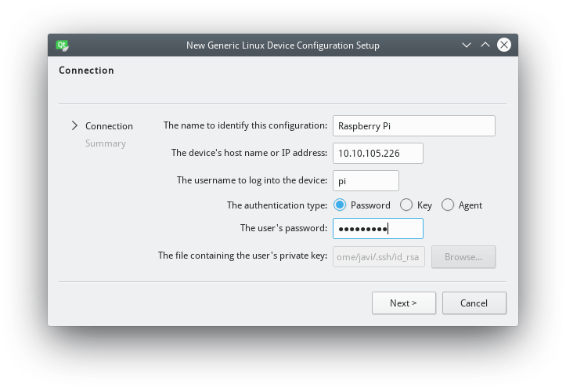
Before you finish the wizard, the connection to your Raspberry Pi will be verified and you will have then a new device configured in Qt Creator.
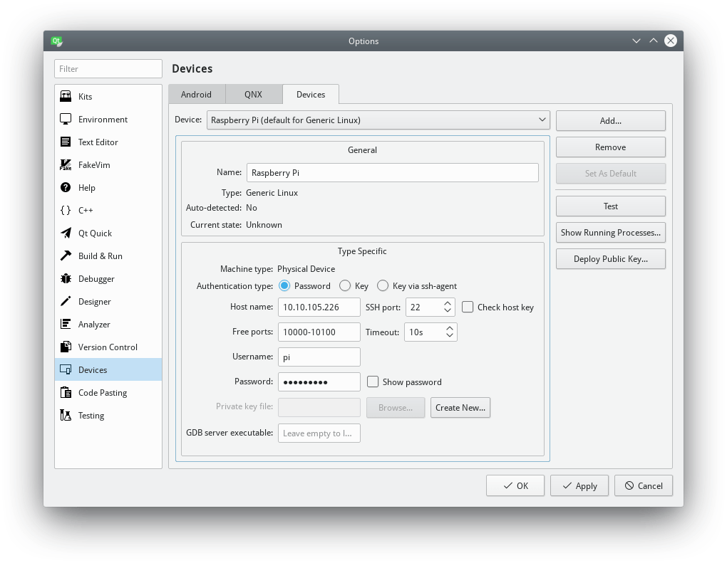
Next, go to the Kits section and Compilers tab, Add GCC C and C++ cross compilers for Raspberry Pi.
The path for the GCC C Raspberry Pi compiler is ~/raspi/tools/arm-bcm2708/gcc-linaro-arm-linux-gnueabihf-raspbian-x64/arm-linux-gnueabihf/bin/gcc.
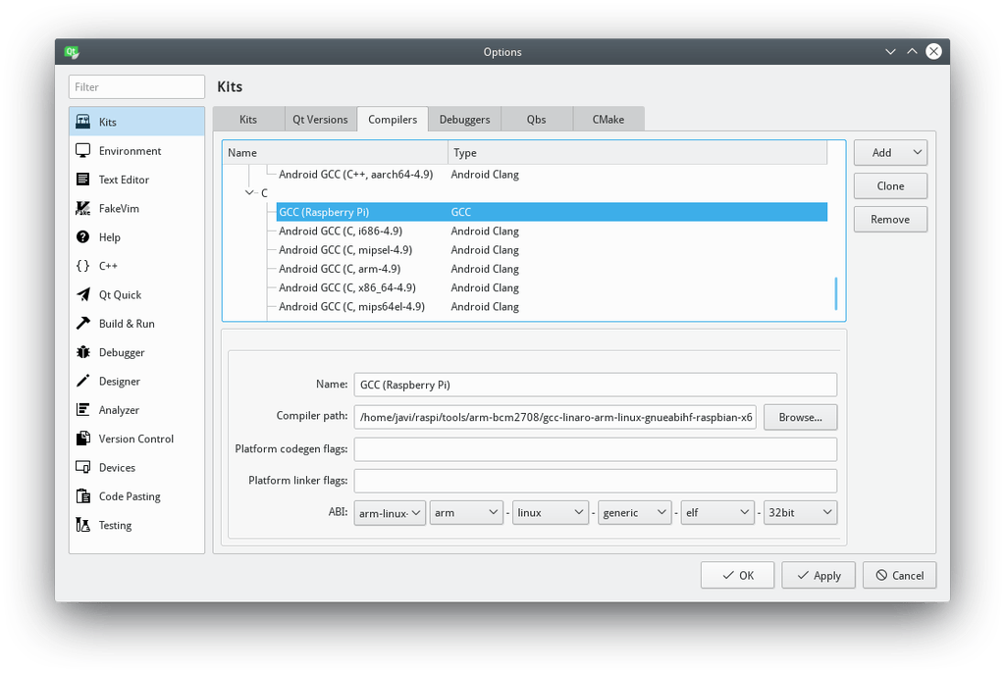
The path for the GCC C++ Raspberry Pi compiler is the same as for the GCC C compiler.
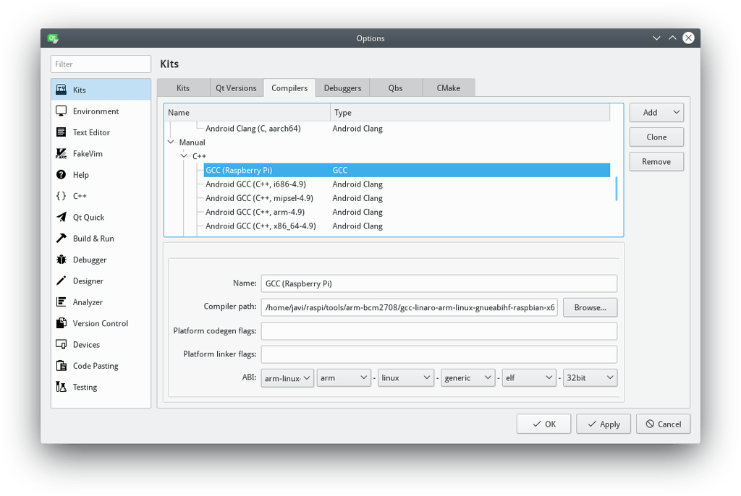
Next, go to the Debuggers tab, and Add a debugger, set its path to ~/raspi/tools/arm-bcm2708/arm-rpi-4.9.3-linux-gnueabihf/bin/arm-linux-gnueabihf-gdb.
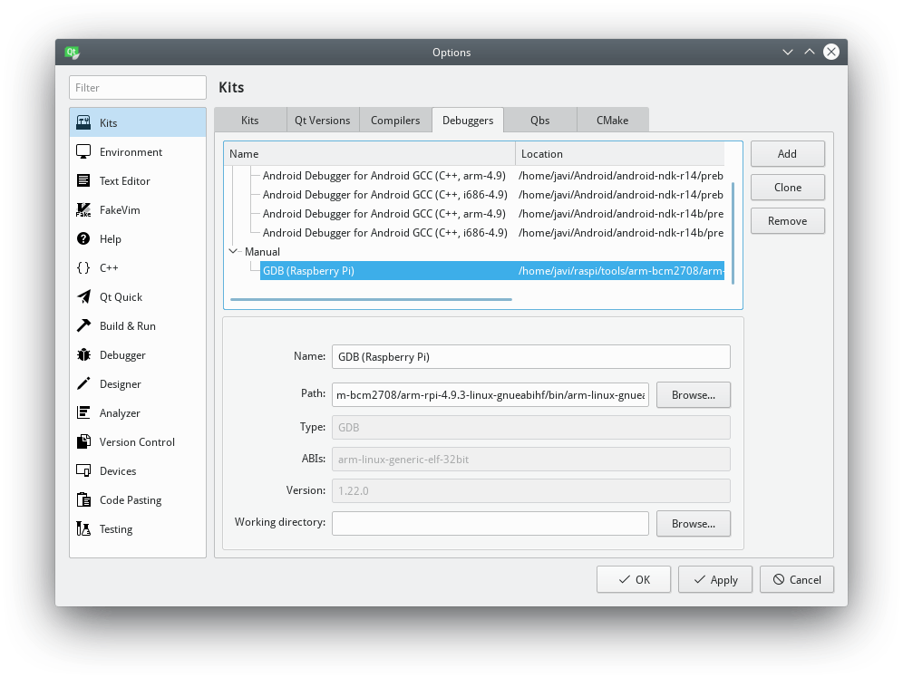
Go to the Qt Versions tab and Add a new version: Qt 5.12 (Raspberry Pi), set the qmake path to ~/raspi/qt5/bin/qmake.
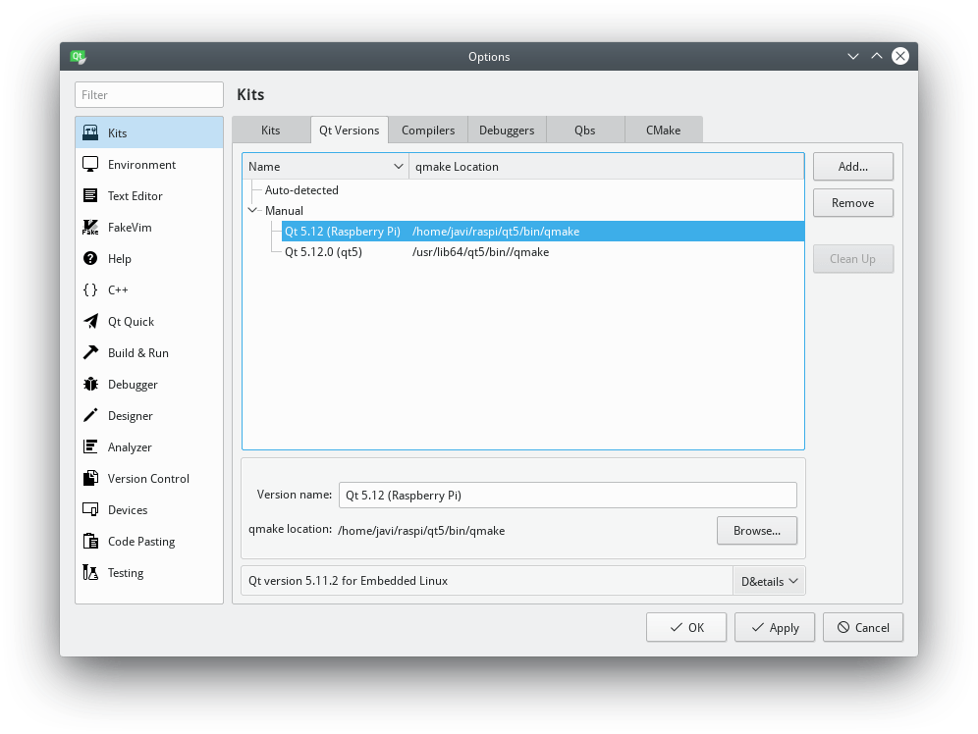
Finally, go to the Kits tab, Add a new kit, set the name and icon you prefer, and pay attention to the following configuration:
- Device type: Generic Linux Device
- Device: Raspberry Pi (defaut for Generic Linux)
- Sysroot: ~/raspi/sysroot
- Compiler C: GCC (Raspberry Pi)
- Compiler C++: GCC (Raspberry Pi)
- Debugger: GDB (Raspberry Pi)
- Qt version: Qt 5.12 (Raspberry Pi)
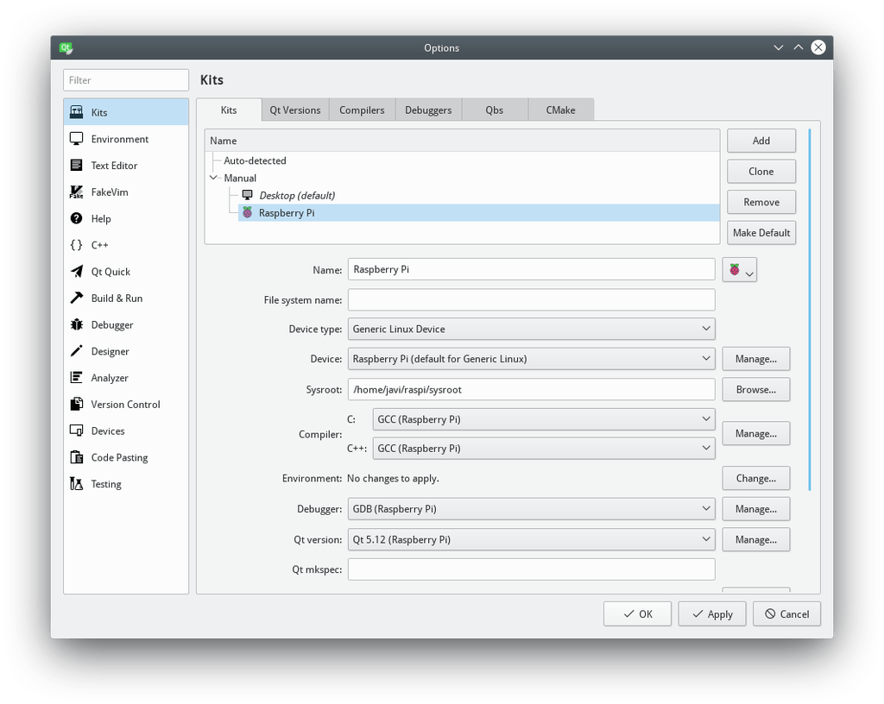
All the configuration is already done. You can test your configuration by creating anew project and selecting the previously defined kit configuration: Raspberry Pi.
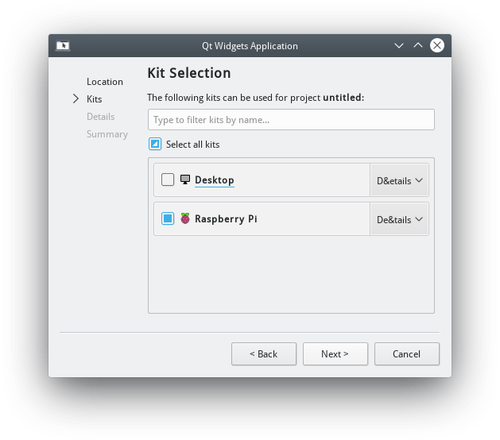
Congratulations! You can now design, build and deploy your Qt Raspberry Pi apps in you computer and, execute and debug them directly in your Raspberry Pi.
