NHÓM 1

* Phạm Nguyễn Cao Triều MSSV: 22207123
* Trương Quang Hưng MSSV: 22207113
* Nguyễn Anh Thiện MSSV: 22207121
* Huỳnh Phạm Minh Tú MSSV: 22207094

Example: A given message M = [1,2,3,4,5,6,7,8,9,10,11] is to be encoded by using ***a polynomial vector*** with roots is X4 + X + 1; (15,11) and GF(16). Find the codeword of Reed Solomon encoder?

**Solution**

Có: GF(16) = 24 (4 bits) và X4 + X + 1= 0 => X4  = X + 1

|  |  |  |  |
| --- | --- | --- | --- |
|  | Polynomial | Binary | Decimal |
| 0 | 0 | 0 0 0 0 | 0 |
|  | 1 | 0 0 0 1 | 1 |
|  | X | 0 0 1 0 | 2 |
|  | X2 | 0 1 0 0 | 4 |
|  | X3 | 1 0 0 0 | 8 |
|  | X4 = X + 1 = 1 + | 0 0 1 1 | 3 |
|  | X5 = X4.X = X2 + X = + | 0 1 1 0 | 6 |
|  | X6 = X5.X = X3 + X2 = + | 1 1 0 0 | 12 |
|  | X7 = X4.X3 = (X + 1). X3 = X4 + X3 = X3 + X + 1 = + + 1 | 1 0 1 1 | 11 |
|  | X8 = X7.X = (X3 + X + 1 ).X = X4 + X2 +X = X + 1+ X2 +X = 1+ X2 = + 1 | 0 1 0 1 | 5 |
|  | X9 = X8.X = (1+ X2).X = X3 + X = + | 1 0 1 0 | 10 |
|  | X10 = X9.X = (X3 + X).X = X4 + X2 = X + 1+ X2 = + +1 | 0 1 1 1 | 7 |
|  | X11 = X10.X = (X + 1+ X2).X = X3 + X2 + X = + + | 1 1 1 0 | 14 |
|  | X12 = X11.X = (X3 + X2 + X).X = X4 + X3 + X2  = X + 1+ X3 + X2 = + + + 1 | 1 1 1 1 | 15 |
|  | X13 = X12.X = (X + 1+ X3 + X2).X = X4 + X3 + X2 + X = X3 + X2 + 1 = + + 1 | 1 1 0 1 | 13 |
|  | X14 = X13.X = (X3 + X2 + 1).X = X4 + X3 + X = X3 + 1 = + 1 | 1 0 0 1 | 9 |

* g(X) = (X + )(X + )… (X + )

= (X + )(X + ) (X + )(X + ) = (X +1)(X +2) (X +4)(X +8)

= X4 + 15X3 + 3X2 + X + 12

(15,11) => n = 15, k = 11, 2t = n-k = 4 => X2t = X4

* M(X) = 1X10 + 2X9 + 3X8 + 4X7 + 5X6 + 6X5 + 7X4 + 8X3 + 9X2 + 10X1 + 11X0
* X2tm(X) = 1X14 + 2X13 + 3X12 + 4X11 + 5X10 + 6X9 + 7X8 + 8X7 + 9X6 + 10X5 + 11X4

**b(X) = X2tm(X) mod g(X)**

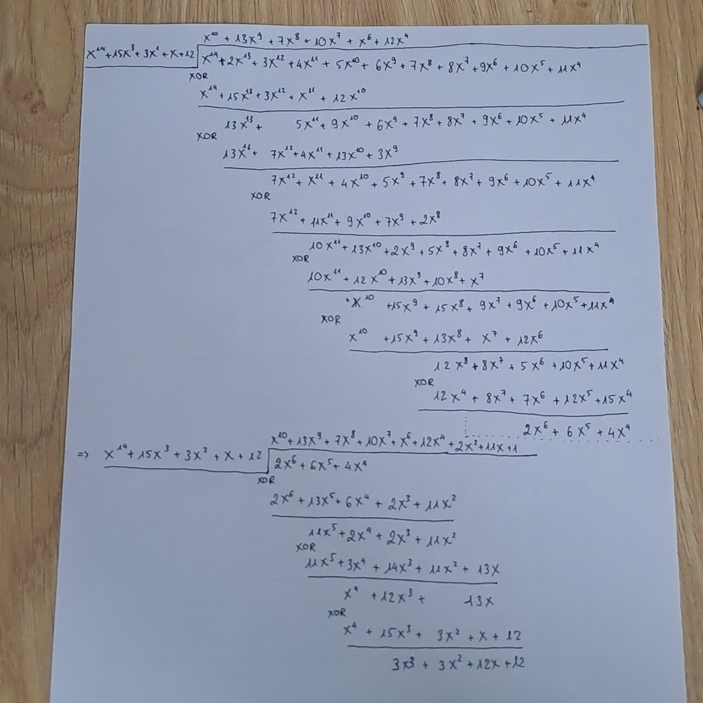

* **U(X) = b(X) + Xn-km(X)**

= X14 + 2 X13 + 3X12 + 4 X11 + 5 X10 + 6 X9 + 7 X8 + 8 X7 + 9 X6 + 10 X5 + 11 X4 + 3 X3 + 3 X2 + 12 X + 12