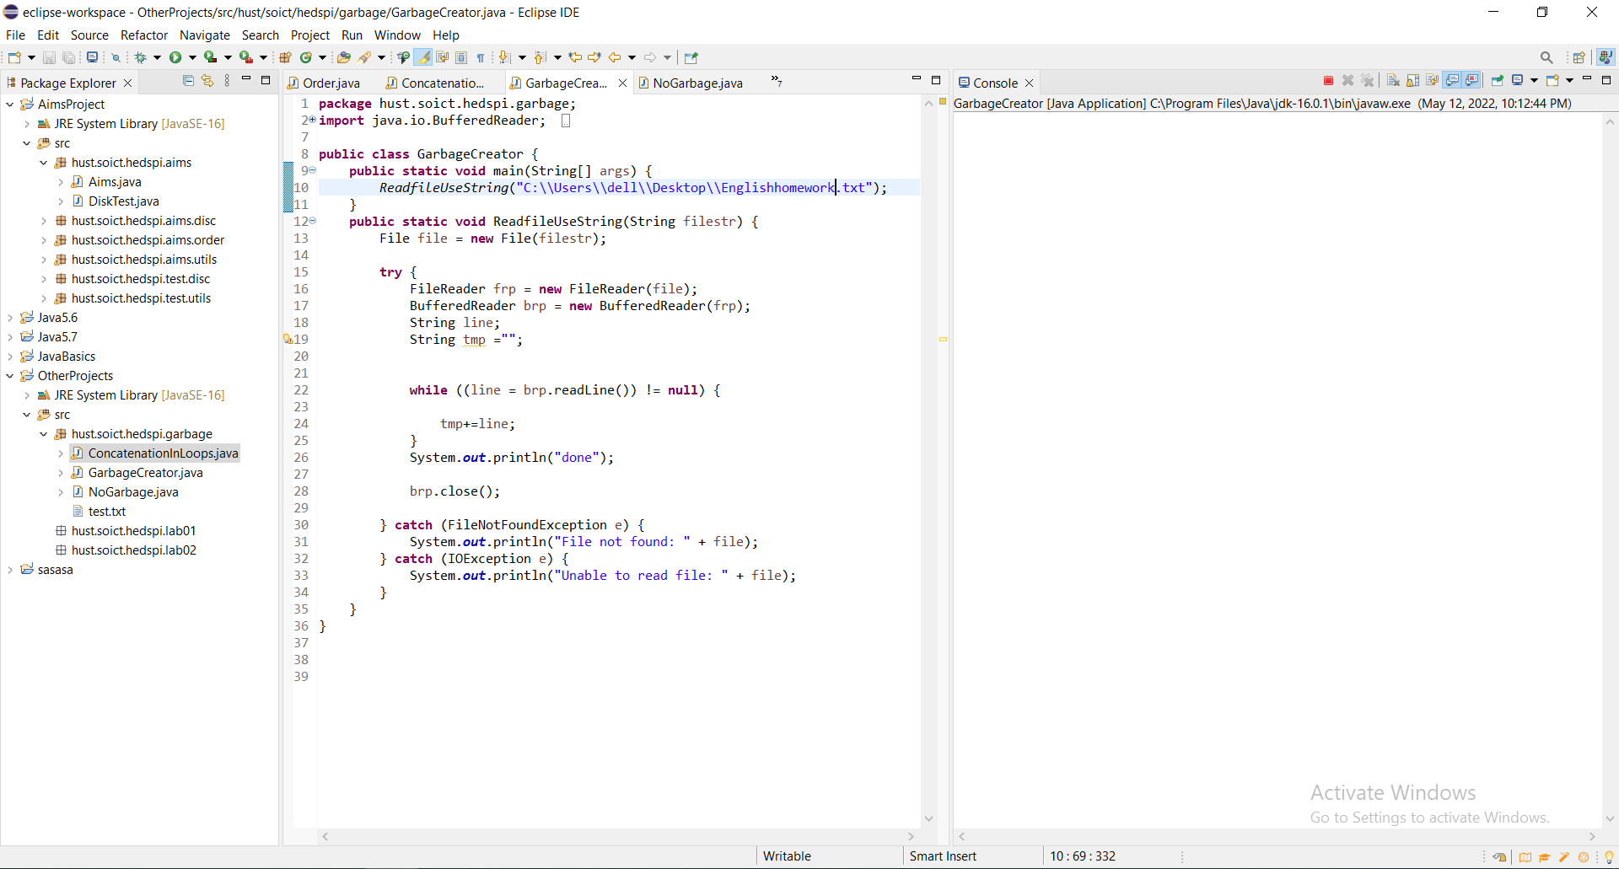

- When I Read a text/binary file to a **String** without using **StringBuffer** to concatenate String (only use **+** operator) ,the program can’t work or work very slow when I choose a very long file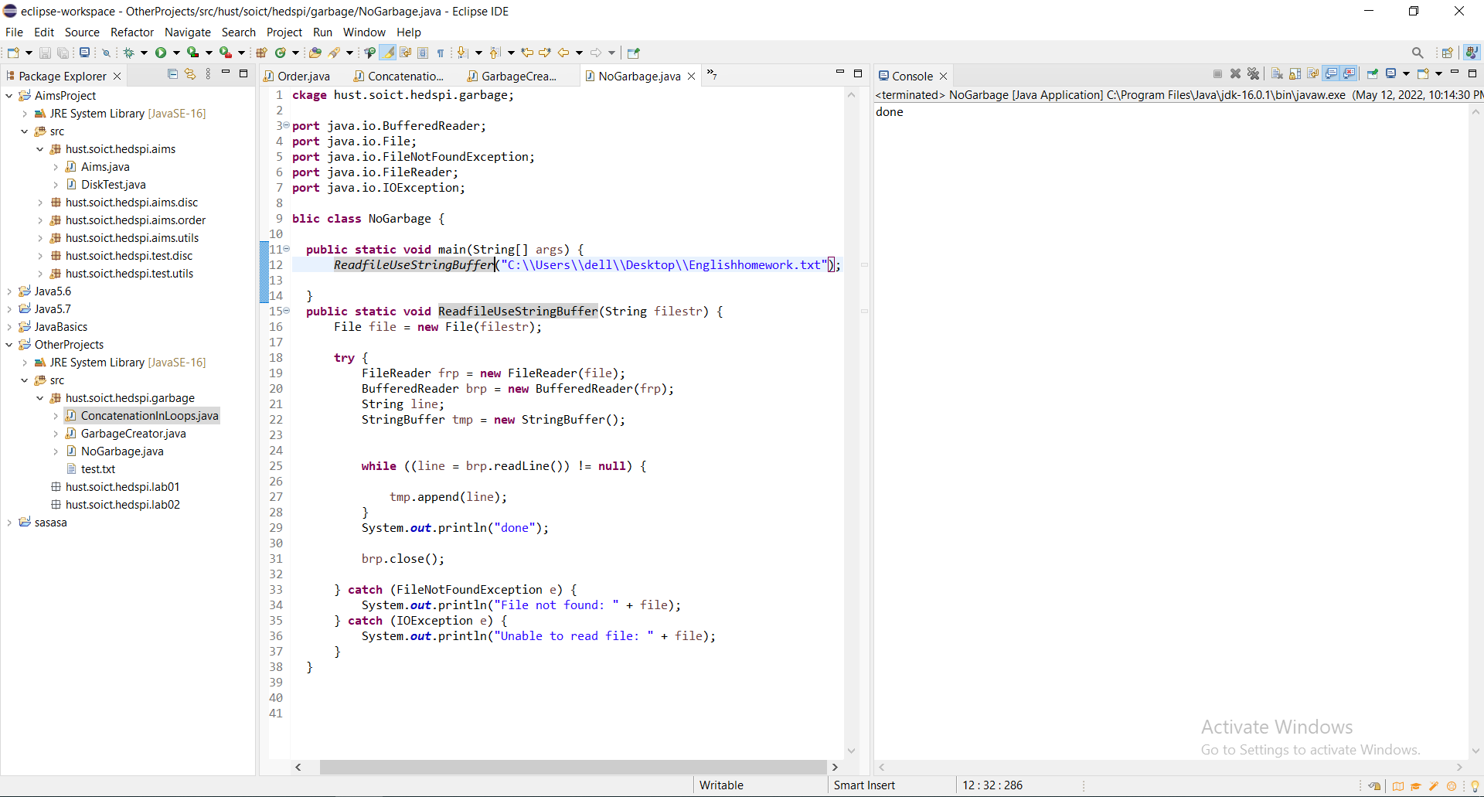

When I use Stringbuffer it’s work very fast.