Test RE  
FALL 2021  
Subject: WED201c  
Duration: 120 minutes

**Objectives:**

1. Create a style sheet file and link it to the html file.
2. Create a javascript file and link it to the html file.

**Background:**

In this practice exam, you are given a folder “**Resource**”. You are going to use page “index.html” to finish the exam.

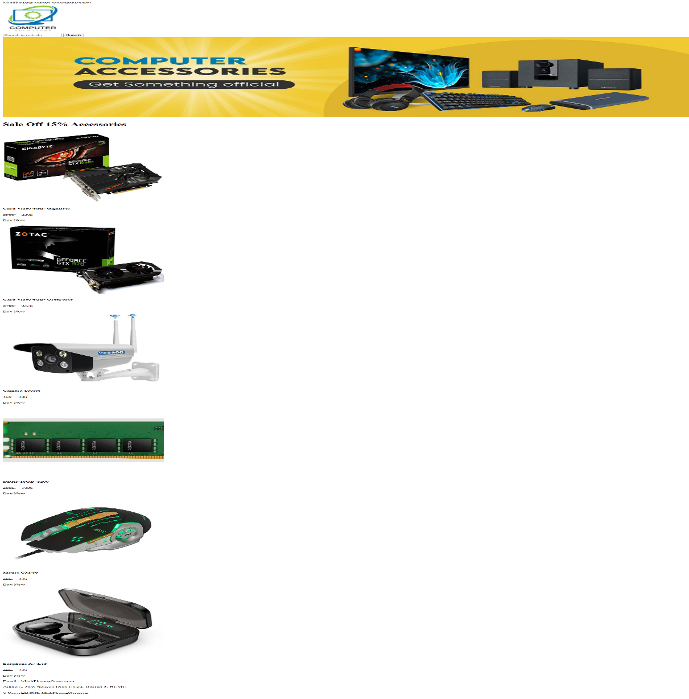**Before styling index.html page**

**After styling index.html page**



**Required:**

1. Create a file called styleindex.css to format the index.html page and save it to the **Resource folder**.
2. Create a file called “mycode.js” and save it to the **Resource folder**.

**Evaluation**

**A. HTML [3 marks]**

* Embed the styleindex.css file in the head tag of the index.html page [0.5 points].
* Embed the mycode.js file at the end body tag of the index.html page [0.5 points].
* Create appropriate classes for div tags [1 points].
* Use ul and li tags to create a vertical menu as shown above [ 1 points].

**B. CSS [ 6 marks]**

* Use margin and padding to create the right spacing for the contents [2 points].
* Use color and background to format for the contents [1 points].
* Use width, height to format images as shown above [1 points].
* Use border-radius to corner for div tags [ 1 points].
* Use box-shadow to shade the contents [1 points].

1. **Javascript [1 marks]**

* Create a function with name CustomerInfo to process customer purchase information [ 1 points].
* 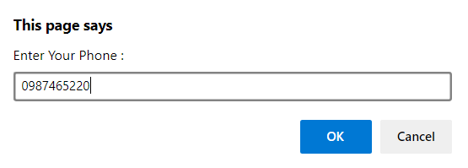When the user clicks on the button, the following dialog box will be displayed:

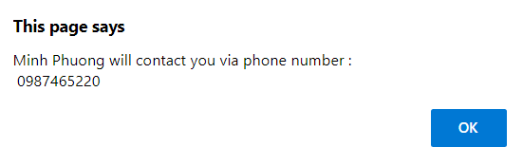

**The end**