**Chapter 9: Test of hypotheses for a single sample**

1. **Concept of Hypothesis Testing**

A hypothesis is a claim (assertion) about a population parameter.

: Null Hypothesis and : Alternative Hypothesis

One very important guideline is that **no information from the sample** is **used in the hypothesis’s statements**.

The null hypothesis always contains equality (=, ≤, or ≥).

If H1 contains a “ ≠ ” symbol, the hypothesis test is two-tailed. If H1 contains a “>” symbol, the hypothesis test is right-tailed, and if H1 contains a “<” symbol, the hypothesis test is left-tailed. (Note: Some authors use only the equal symbol in the null hypothesis statement.)

A procedure leading to a decision about a particular hypothesis is called a **test of a hypothesis.**

E.g.

1. **Test of hypotheses on population mean**
2. **If is known 🡪 Z test of hypothesis for the mean**

**1st way: Tradition method**

| **Step** |  | **Two-tailed Test** | **Right-tailed Test** | **Left-tailed Test** |
| --- | --- | --- | --- | --- |
| **1** | **Formulate the two hypotheses** |  |  |  |
| **2** | **Identify**  **critical values** |  | | |
| **3** | **Compute**  **test statistic** |  |  |  |
| **4** | **Decision** | If the test statistic is in critical region → Reject  If the test statistic is in acceptance region → Fail To Reject | | |

1. **If is unknown 🡪 t test of hypothesis for the mean**

**1st way: Tradition method**

| **Step** |  | **Two-tailed Test** | **Right-tailed Test** | **Left-tailed Test** |
| --- | --- | --- | --- | --- |
| **1** | **Formulate the two hypotheses** |  |  |  |
| **2** | **Compute**  **test statistic** |  | | |
| **3** | **Identify**  **critical values** |  |  |  |
| **4** | **Decision** | If the test statistic is in critical region   * Reject ~ Fail To Reject   If the test statistic is in acceptance region   * Fail To Reject ~ Reject | If the test statistic is in critical region   * Reject ~ Fail To Reject   If the test statistic is in acceptance region   * Fail To Reject ~ Reject | If the test statistic is in critical region   * Reject ~ Fail To Reject   If the test statistic is in acceptance region   * Fail To Reject ~ Reject |

**Step 1: Formulate two hypotheses. (State the null and alternative hypotheses for the appropriate hypothesis test.)**

**Step 2: Compute test statistic**

**Step 3: Identify the critical value (State the correct decision rule for the test of hypothesis in terms of a z- or t-test statistic and appropriate rejection region at the indicated significance level.)**

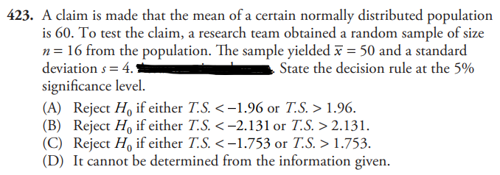

1. **Test of hypotheses on population proportion 🡪 Z test of hypothesis for the proportion**

**1st way: Tradition method**

| **Step** |  | **Two-tailed Test** | **Right-tailed Test** | **Left-tailed Test** |
| --- | --- | --- | --- | --- |
| **1** | **Formulate**  **two hypotheses** |  |  |  |
| **2** | **Compute**  **test statistic** |  | | |
| **3** | **Identify**  **critical values** |  |  |  |
| **4** | **Decision** | If the test statistic z0 is in critical region   * Reject ~ Fail to Reject   If the test statistic z0 is in acceptance region   * Fail To Reject ~ Reject | If the test statistic z0 is in critical region   * Reject ~ Fail to Reject   If the test statistic z0 is in acceptance region   * Fail To Reject ~ Reject | If the test statistic z0 is in critical region   * Reject ~ Fail to Reject   If the test statistic z0 is in acceptance region   * Fail To Reject ~ Reject |

**Step 1: Formulate two hypotheses. (State the null and alternative hypotheses for the appropriate hypothesis test.)**

**Step 2: Compute test statistic**

**Step 3: Identify the critical value (State the correct decision rule for the test of hypothesis in terms of a z- or t-test statistic and appropriate rejection region at the indicated significance level.)**

1. **Identify type of errors in testing hypothesis**

**Type I Error: Reject when is true.**

**Type II Error: Fail to Reject when is false.**

