 

Q1:

Software Requirements Specification

for

Pet Medical Appointment System

Version 1.0 approved

Prepared by

Nguyễn Quang Minh, HE176167

FPT University Campus Ha Noi

Tuesday, March – 26 - 2024

Q2:

Q3:

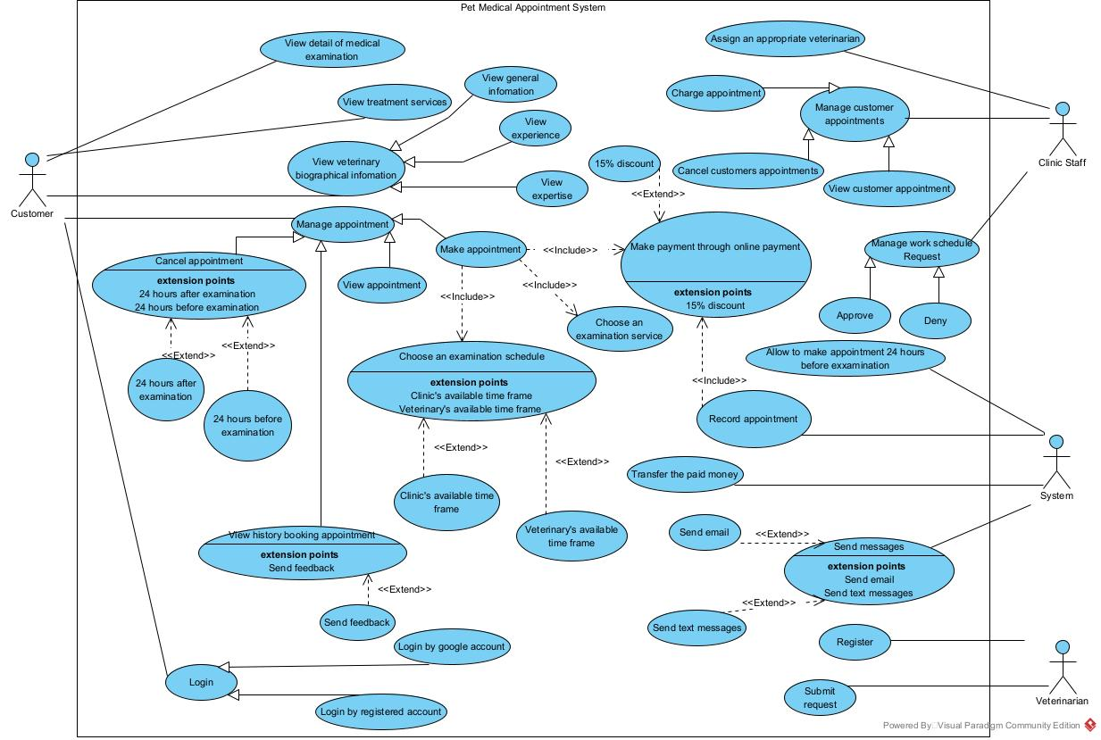

|  |  |  |
| --- | --- | --- |
| **#** | **Actor** | **Description** |
| 01 | Customer | People who want to examine their pets. |
| 02 | Clinic Staff | Manage customer appointment and veterinarian. |
| 03 | System | Control and manage. |

|  |  |  |  |
| --- | --- | --- | --- |
| **#** | **Use Case** | **Actors** | **Description** |
| UC-01 | Send feedback | Customer | Customer can send feedback after use the specific service. |
| UC-02 | Transfer the paid money | System | In case customer cancels the appointment 24 hours before the time of examination, the system will transfer the paid money back to the customer. |
| UC-03 | View customer appointment | Clinic Staff | Clinic Staff can view customer appointments. |

Q4:

|  |  |  |
| --- | --- | --- |
| ID | Rule Definition | Use cases |
| BR-01 | Feed back must be unique in a same appointment. | UC-01 |
| BR-02 | Customer must connect bank account to the system. | UC-02 |
| BR-03 | Feed back must be send after make appointment. | UC-01 |
| BR-04 | Feed back must use valid words. | UC-02 |
| BR-05 | Feed back not exceed 150 words. | UC-02 |

**Q5:**

A, Pet Medical Appointment System can accepts 1500 users at a same time so that when they make appointment, everyone can view their payment information as soon as possible.

When testing:  
- If 1501 customer access at the same time, test whether the server will still live or not.

B, Pet Medical Appointment System using hard security such as HTTPs (HTTP Sucure) to prevent other transport to steal information from client to server and back.

When testing:

- A transport try to modify request ,then it will be rejected by server.