**NHÓM 7** -Thành viên nhóm:

+ Phạm Văn Đồng (*Nhóm trưởng*)

+ Lê Huy Hoàng.

+ Phạm Tấn Quốc.

+ Lê Viết Kha.

+ Đào Ngọc Hiếu.

Tên dự án:

**E-COMMERCE WEBSITE FOR ONLINE SALES**

**Target:**

- Build an e-commerce website to sell the company's products/services online.

- Increase sales and expand markets.

- Provide a convenient and safe online shopping experience for customers.

**Scope:**

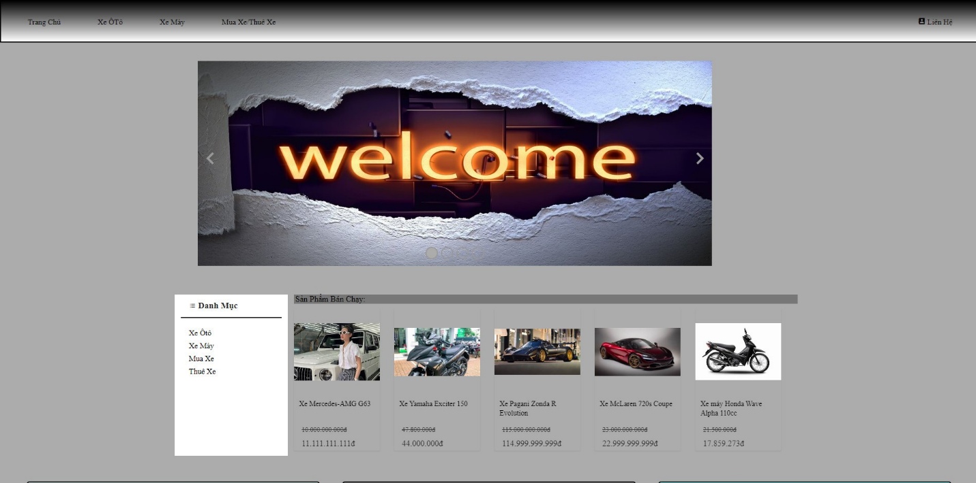- Design a friendly, easy-to-use website interface

- Building basic functions of e-commerce website:

- Home page

- Product catalog

- Product details

- Shopping cart

- Payment

**Functional Requirements**

**Home page**

*  Display featured products and new products.
* Display main product categories.

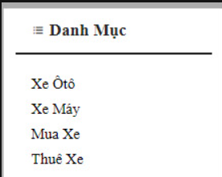

**Product catalog**

* Display list of products by category. 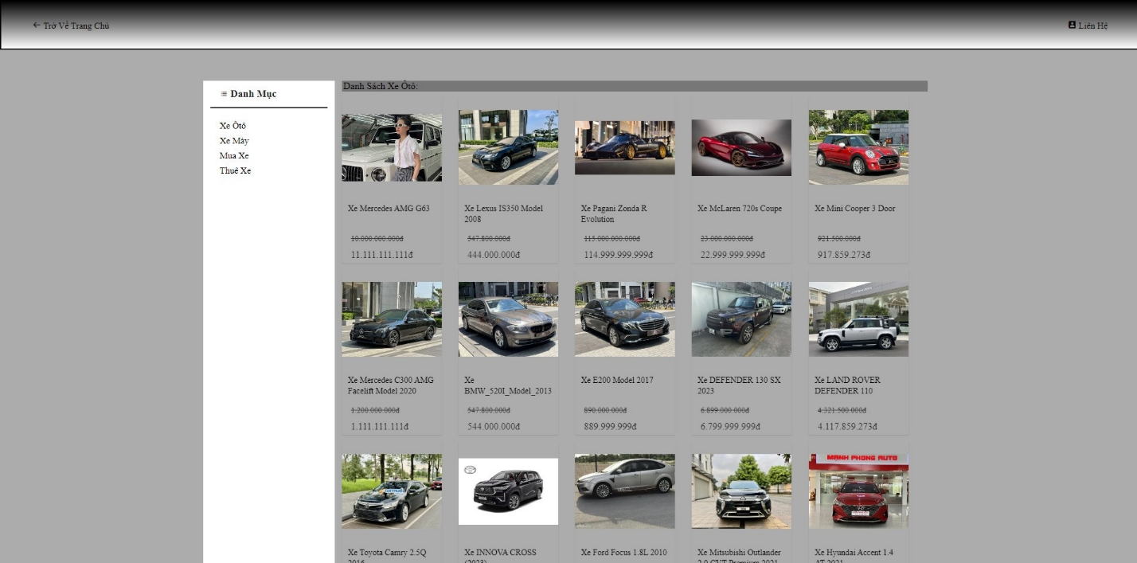
* 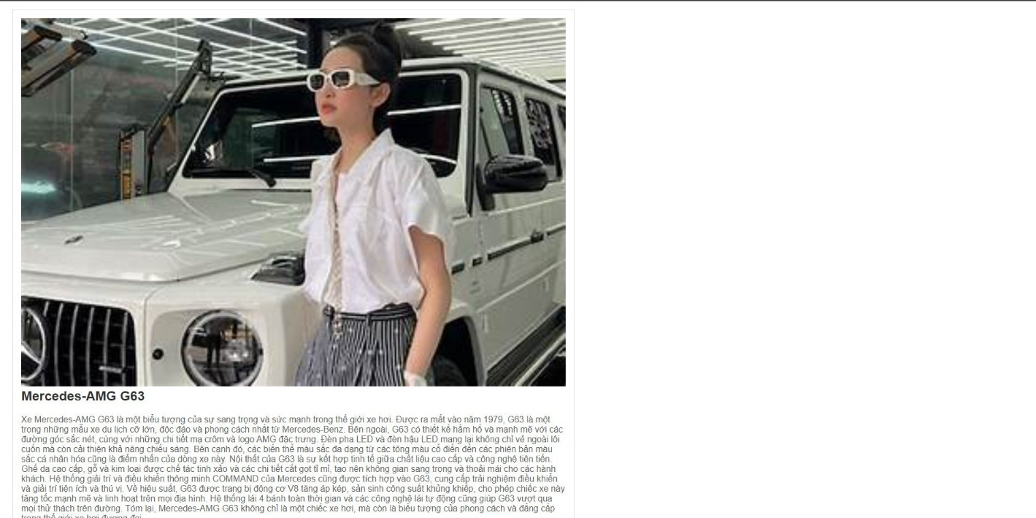 Display product photo, name, price, short description.

**Product details**

* Display photo, name, price, detailed description of the product.
* Add products to the product ordering section.

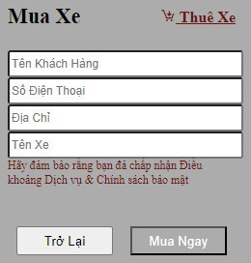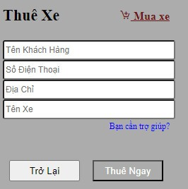

**Ordered**

* Displays the list of products in the order.
* Deposit order money.
* Switch to payment page.

**Payment:**

* When the order is successful.
* Staff calls to confirm the order.
* Send transfer information.
* Start delivery to the customer**.**

**Non-functional Requirements**

* User-friendly interface: Use white, black, and gray as the main colors, adhering to a classic style.
* Fast page loading speed.
* Customer and transaction information security.
* Ease of maintenance and upgrade.

**Technology Used**

* Programming languages: HTML - CSS, JavaScript.

**Implementation Plan**

* Requirement analysis and system design.
* Build the website interface.
* Build basic functions.
* Integrate online payment gateway.
* Build content and product management system.
* Optimize the website for search engines (SEO).
* Testing and debugging.
* Deploy the website to the live environment.
* Maintain and upgrade the website.

**Here are the details on the factors you mentioned:**

**Objectives**

**1. Build an e-commerce website to sell the company's products/services online:**

- Create a platform that helps the company reach and serve online customers more easily and effectively.

**2. Increase sales and expand markets:**

- Use the website as the main sales channel, attract more customers, increase revenue, and expand the market.

**3. Provide a convenient and safe online shopping experience for customers:**

- Ensure that customers can shop easily and feel secure when conducting online transactions.

**Scope**

**1. Design a friendly, easy-to-use website interface:**

- The interface must be user-friendly, easy to navigate, and suitable for all customer demographics.

**2. Build basic functions of an e-commerce website:**

- Home page: Display featured products, new products, and main product categories.

- Product catalog: Display a list of products by category with photos, names, prices, and short descriptions.

- Product details: Display detailed product information, including photos, names, prices, detailed descriptions, and the ability to add products to the cart.

- Shopping cart: Display the list of products added to the cart, allow for order deposits, and proceed to the payment page.

- Payment: Process payments when an order is successfully placed, including phone confirmation, sending transfer information, and initiating delivery.

**Functional Requirements**

**1. Home page:**

- Display featured products and new products: Attract customers' attention immediately upon visiting the site.

- Display main product categories: Help customers easily find the types of products they are interested in.

**2. Product catalog:**

- Display a list of products by category: Provide quick information about products in each category.

- Display product photos, names, prices, and short descriptions: Give customers an overview of the products.

**3. Product details:**

- Display product photos, names, prices, and detailed descriptions: Provide enough information for customers to make a purchasing decision.

- Add products to the ordering section: Provide convenience for customers who want to purchase products.

**4. Ordering:**

- Display the list of products in the order: Help customers review the products they have chosen.

- Deposit order money: Allow customers to make a deposit to secure their order.

- Switch to the payment page: Continue the purchasing process.

**5. Payment:**

- When the order is successful: Confirm the successful order with the customer.

- Staff calls to confirm the order: Verify the order by phone to ensure accuracy.

- Send transfer information: Provide information for the customer to make the payment transfer.

- Start delivery to the customer: Begin the shipping process after payment confirmation.

**Non-functional Requirements**

**1. User-friendly interface:**

- Use white, black, and gray as the main colors, adhering to a classic style.

**2. Fast page loading speed:**

- Optimize the code and resources to ensure fast loading times, improving user experience.

**3. Customer and transaction information security:**

- Implement security measures to protect customer data and online transactions.

**4. Ease of maintenance and upgrade:**

- Design the system to be easy to maintain and upgrade when necessary.

**Technology Used**

**1. Programming languages: HTML, CSS, JavaScript**

- HTML and CSS to build the structure and design of the user interface.

- JavaScript to develop interactive functions on the website.

**Implementation Plan**

**1. Requirement analysis and system design:**

- Gather requirements from the client, analyze, and create a detailed design plan.

**2. Build the website interface:**

- Design the user interface according to the chosen classic style.

**3. Build basic functions:**

- Develop basic website functions such as the home page, product catalog, product details, shopping cart, and payment.

**4. Integrate online payment gateway:**

- Connect the website with online payment gateways to support the payment process.

**5. Build content and product management system:**

- Develop a system that allows administrators to easily manage the website's content and products.

**6. Optimize the website for search engines (SEO):**

- Implement SEO techniques to enhance the website's visibility on search engines.

**7. Testing and debugging:**

- Perform comprehensive testing to ensure all functions work correctly and reliably.

**8. Deploy the website to the live environment:**

- Launch the website in the live environment and start operations.

**9. Maintain and upgrade the website:**

- Regularly maintain and update the system to ensure the website runs smoothly and meets changing needs.

**Project Conclusion**

Building an e-commerce website is a challenging but promising project. By applying modern technologies and adhering to functional and non-functional requirements, we can successfully create an e-commerce website that benefits both the company and its customers.