**Handling requirements**

|  |  |
| --- | --- |
| Who will use this ticket system? | - Customer  - Ticket vendor machine |
| What systems does the ticketing system interact with? | - Affiliate Bank |
| What functions do customers use in the system? | - Choose payment  - Choose destination  - Enter credit card  - Scan QR code |
| What function does the ticket vending machine perform in the system? | - Show potential destinations  - Payment verification  - Issue the ticket  - Account fee  - Payment validation error |
| What function does the linked bank perform in the system? | - Support scanning QR code |

|  |  |
| --- | --- |
| Functional requirements | - Input data of potential locations that guests can choose from the menu into the system  - Improved location list menu  - Manage the number of tickets  - Search for places  - Show estimated time to go to places  - Book tickets  - Calculation invoices  - Report on ticket sales  - Scoring customer satisfaction |
| Non-functional requirements | |  |  | | --- | --- | | - Response time | + Time for the system to respond to user information is 3 seconds  + Time to display the menu after the customer chooses the payment method is 3 seconds  + Time to confirm destination again is 2 seconds  + Payment verification time is 5 seconds  + Time to charge and issue invoices is 3 seconds | | - Reliability | + The system always works according to the time frame of the train station, bus station, …  + All transactions are done successfully  + Stable system, limited data loss error  + When the system crashes, the maximum time to recover is 2 hours  + Time to restart ticket machines is 5 minutes | | - Wattage | + Each person can only book a maximum of 3 tickets on one machine  + Transactions are made up to one minute | | - Possibility | + Simple interface, easy to use  + Languages ​​Vietnamese and English | | - Safety information | + Ensure customer security  + Ensure customer payment account information | | - Maintainability | + Ensure data storage and transfer when there is a problem  + Easy installation system, does not take much time, up to 2 days | |
| Domain requirement | - Ticket machines comply with IEC 60335-2-75 for automatic systems |

* Use case diagram:

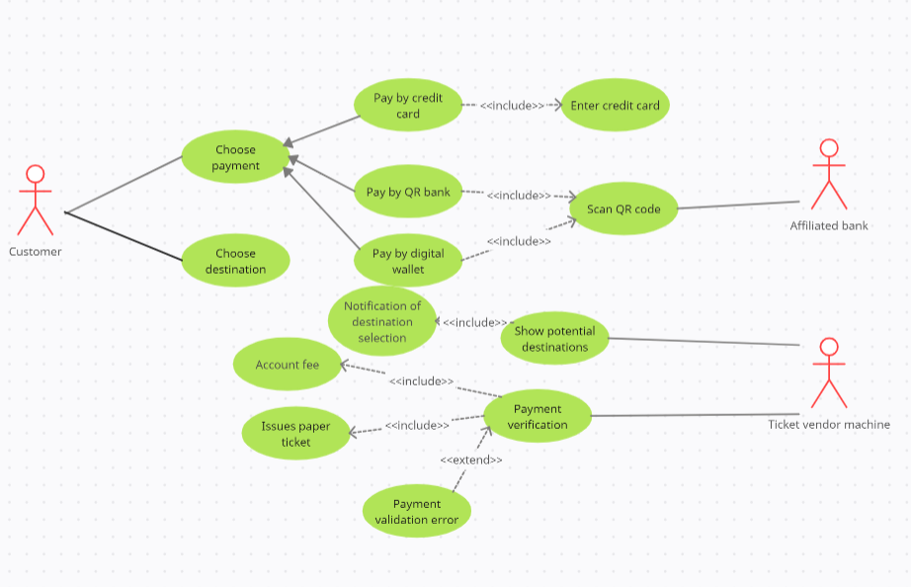

* Use case description:

|  |  |
| --- | --- |
| Choose payment | Customer choose the type of payment |
| Pay by credit card | Customer use credit card to pay |
| Pay by QR bank | Customer use linked bank account to pay |
| Pay by digital wellet | Customer use digital wellet to pay |
| Enter credit card | Customer enters valid credit card to pay |
| Scan QR code | Customer scan QR code to pay |
| Choose destination | Customer selects the destination they want to go |
| Show potential destinations | Ticket vendor machine displays a list of destinations customer can to go |
| Notification of destination selection | Ticket vendor machine inform customer to select destination |
| Payment verification | Ticket vendor machine verify the customer’s payment |
| Account free | Ticket vendor machine charge money into customer’s account |
| Issues paper ticket | Issues paper ticket |
| Payment validation error | Ticket vendor machine verify payment failed (invalid credit card, insufficient account balance, …) |

* Activity diagram: the process of passenger’s buying a ticket form ticket vendor machine

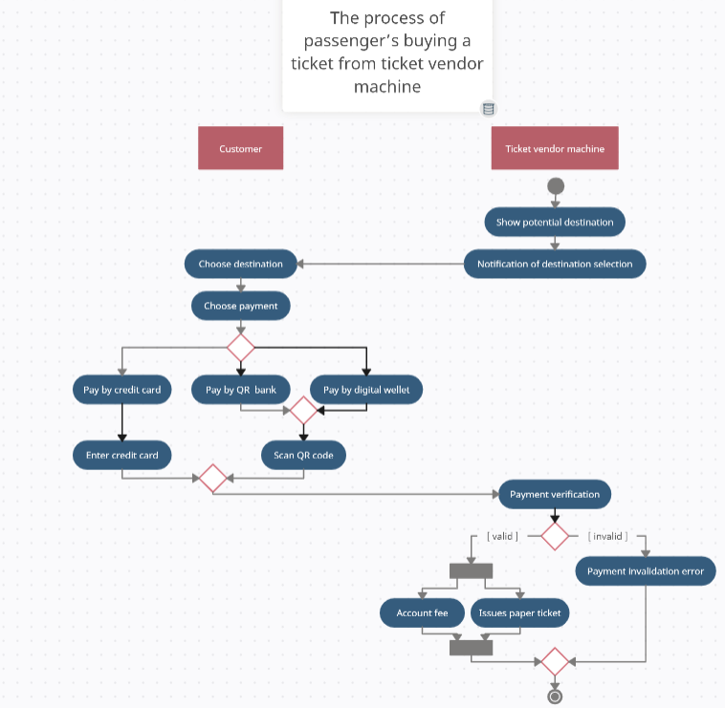

* Activity diagram: communication among systems

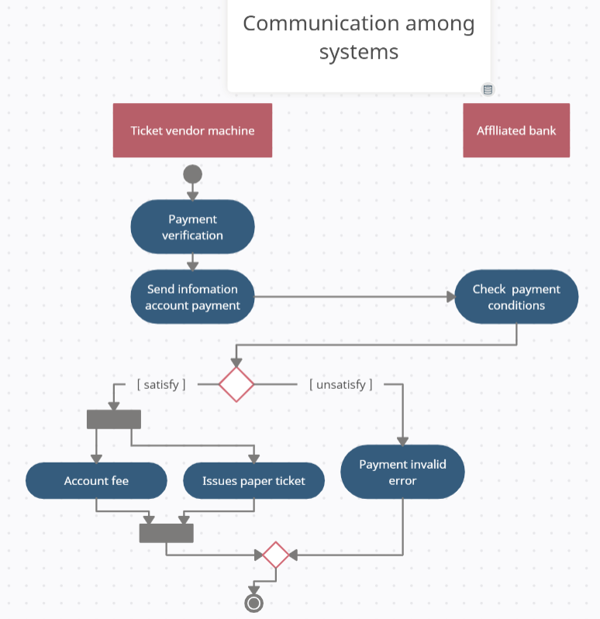

* Sequence diagram: passengers use digital wellet to pay

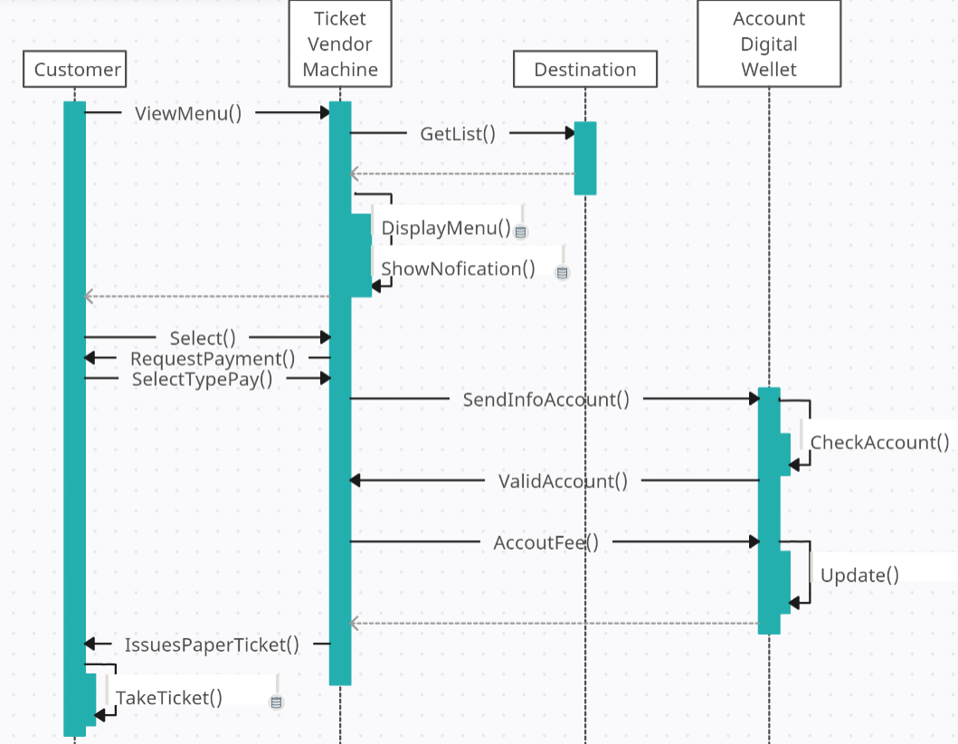

* Class diagram:

