**I will demo the case where passengers use digital wellet to book 2 tickets to Nha Trang**

* First, the tickets machine displays the original interface.

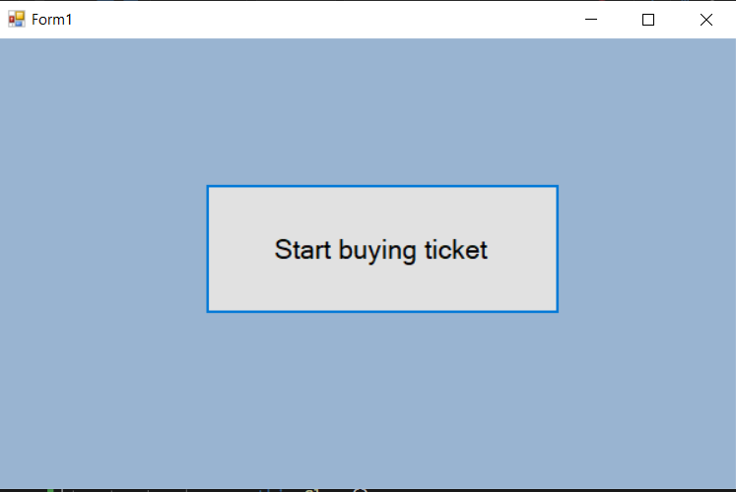

* Passenger press the button to start buying ticket, a main screen will open, it contains list destinations in Database.

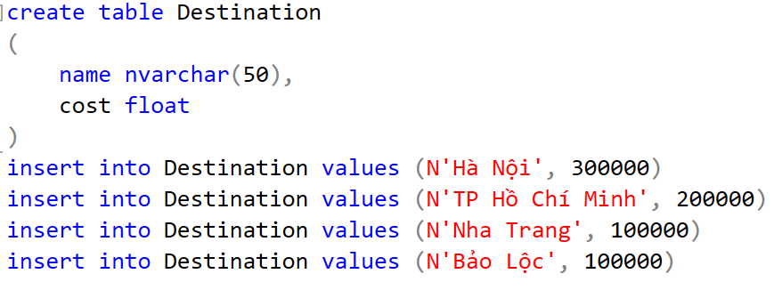

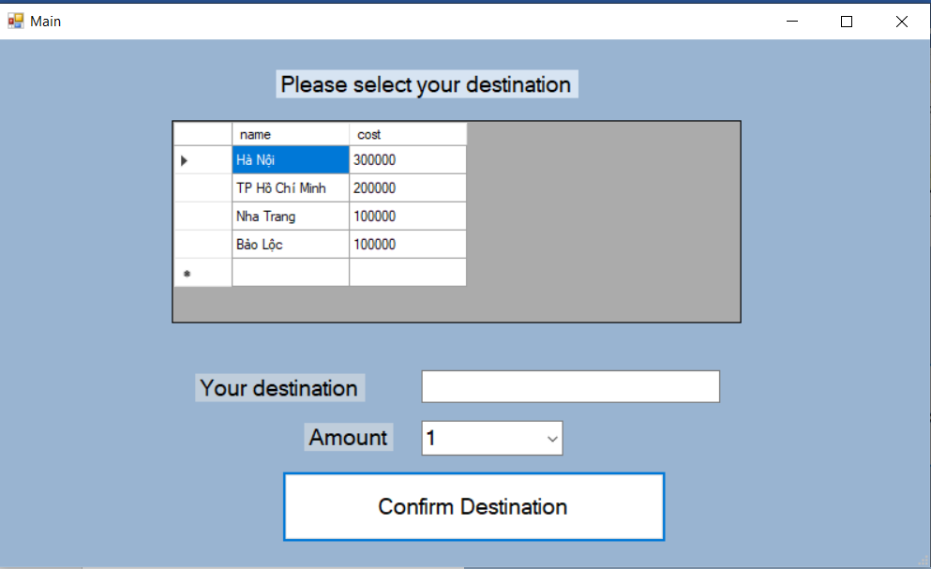

* Passenger choose Nha Trang destination line.
* “Nha Trang” will be displayed in “Your destination”, passenger choose the number of tickets is 2, then they press the button to confirm.

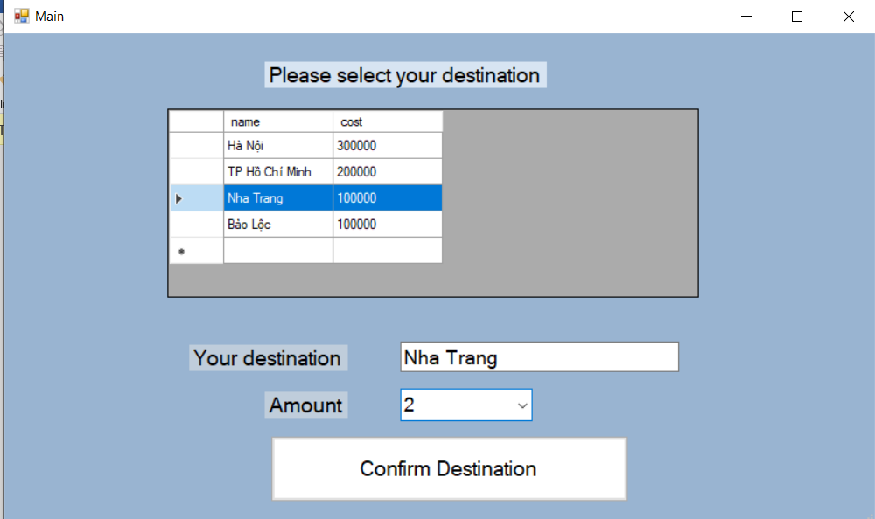

* The confirmation dialog pops up, passenger choose “Yes” to countine.

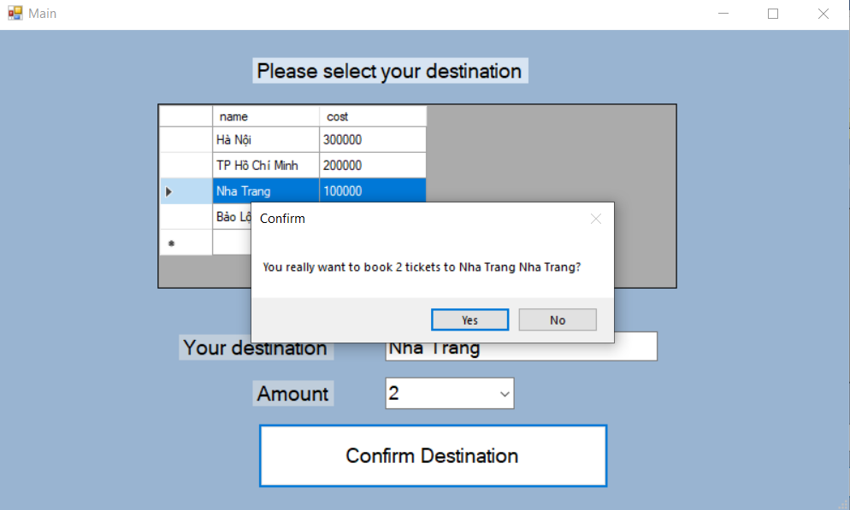

* The payment method selection screen appears.

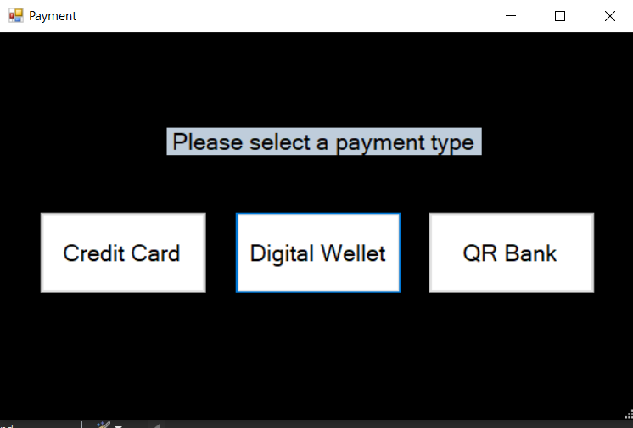

* Passenger choose to pay by digital wellet.

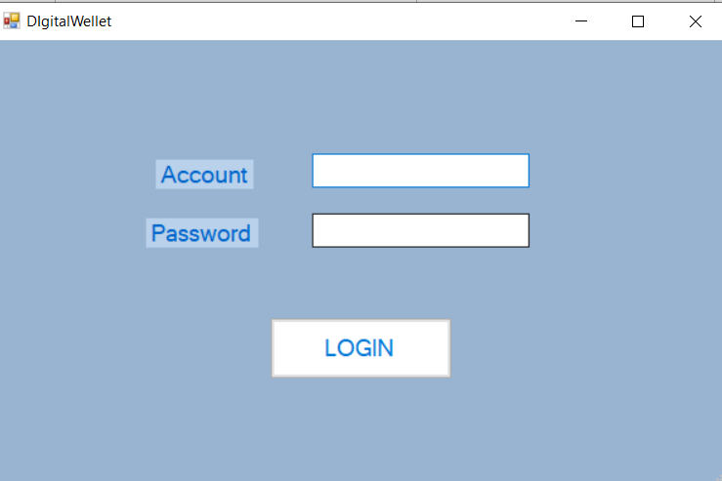

* In Database, an account list has been created before.

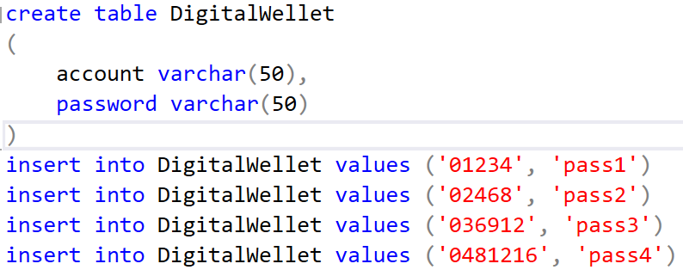

* If passenger enter the wrong account, the message “account does not exist” will appears aften they press “LOGIN”.

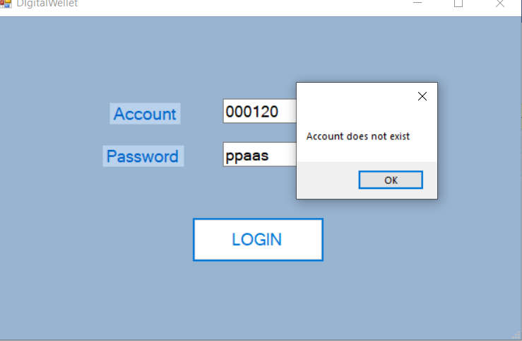

* When they enter a valid account, the ticket machine will show the end screen. (“account: 01234” and “password: pass1” is a valid account)



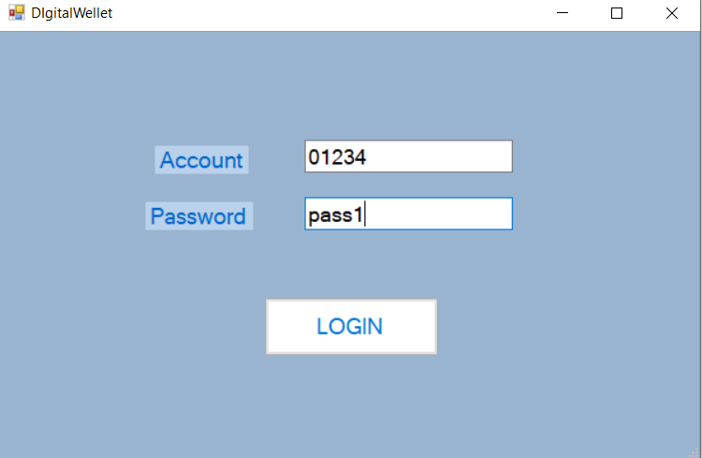

* The end screen appears with the notes.

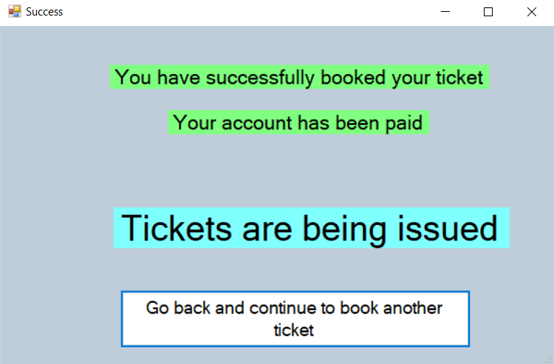

* Customer’s account has been paid and the machine is issuing tickets.
* Pasenger can click the button below to book another ticket.