VIETNAM NATIONAL UNIVERSITY HCMC

UNIVERSITY OF INFORMATION TECHNOLOGY



Subject: Modern Internet Of Things Technology

Topic: Gas Leak Alert through

Smart Phone

Lecturer: LE TRUNG QUAN

Lecturer: NGUYEN VAN BAO

Members:

* Đậu Đình Quang Anh - 20521059
* Phạm Thuỳ Dung- 20521214

Table Of Contents

1. Introduction 2

2. Structure 3

2.1 Components 3

2.1.1 Wifi – Kit module ESP8266 3

2.1.2 Led 4

2.1.3 Push Button 4

2.1.4 Buzzer 3V 5

2.1.5 Servo SG90 6

2.1.6 MQ-2 6

2.1.7 Relay Module 7

2.1.8 Fan 8

2.1.9 Battery 12V (Lion Rechargeable) 8

2.1.10 Jumper wires 9

2.2 Hardware Connection Diagram 9

2.3 Implementation Diagram 10

2.4 Blynk Dashboard 11

2.5 Real-Life Image 11

3. Demo 12

4. Conclusion 12

# Introduction

Gas leaks pose a serious threat to both people and property, with the potential to cause extensive damage and even fatalities. These leaks can lead to catastrophic outcomes such as fires, explosions, and health hazards due to exposure to toxic gases. Addressing this problem requires the implementation of effective detection and alert systems that can mitigate risks and enhance safety measures.

The Gas Leak Alert System, equipped with features like automatic door opening and fan activation, emerges as a crucial solution in combating the dangers associated with gas leaks. By swiftly detecting the presence of gas leaks in various environments, this system plays a pivotal role in averting potential disasters. Moreover, its integrated functionalities, such as automatic door opening to facilitate ventilation and fan activation to disperse hazardous gases, further enhance its effectiveness in safeguarding lives and property.

In this report, we delve into the structure, components, and operational mechanisms of the Gas Leak Alert System, shedding light on how it addresses the pressing issue of gas leaks while offering enhanced safety measures through innovative features like automatic door opening and fan activation.

# Structure

## Components

### Wifi – Kit module ESP8266

The ESP8266 module integrates microcontroller unit (MCU) along with Wifi chip, therefore, it allows to connect to Wifi networks and communicate with other devices over the internet

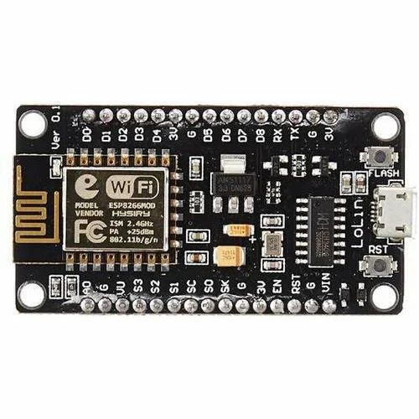

**Purpose**: It is the brain of the system to help connect to Wifi networks and communicate with buzzer, fan, and door…

### Led

A light emitting diode (LED) is semiconductor device that emits light when an electric current passes through it.



**Purpose**: it presents the system is in situation of working or not, so, when it lights, it means the system is working and allows the individual to know about it easier.

### Push Button

A Push Button is a simple mechanical switch that momentarily closes an electrical circuit when pressed.

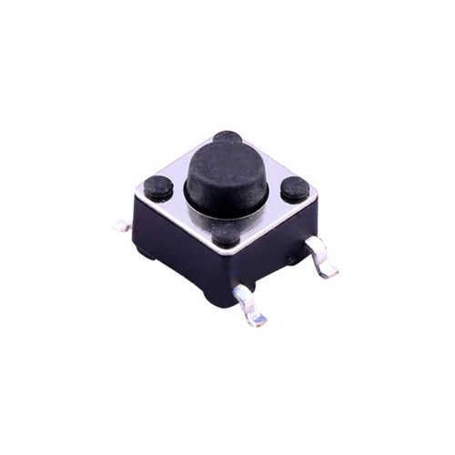

**Purpose**: it uses to open or close the system and the door.

### Buzzer 3V

A buzzer is an electronic device that produce sound, typically in the form of a countinuous or intermittent tone, when an electronic current passes through it



**Purpose**: It uses to produce the sound when detecting the gas exceeds the limit permission.

### Servo SG90

A SG90 is a lightweight and affordable servo motor with relatively low torque and speed, making it suitable for applications such as remote door, windows, car,…



**Purpose**: It uses to control the door

### MQ-2

The MQ-2 sensor is a type of gas sensor widely used for detecting various gases such as methane, propane, butane, alcohol, smoke, and other combustible gases.



Purpose: It uses to detect the gas from lighter

### Relay Module

A relay module is an electronic device that consists of one or more relays, along with associated circuitry, packaged together in a convenient form factor for easy integration into electronic circuits and systems.

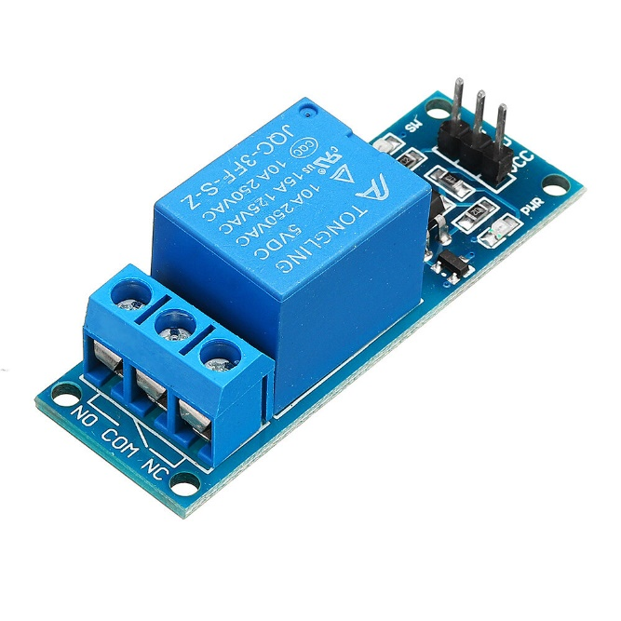

Purpose: It uses to control the flow of electricity in circuits by opening or closing electrical contact in response to Fan.

### Fan

A fan is a mechanical device that creates airflow by rotating blades or vanes to circulate air.



**Purpose**: It uses to vent the gas to outdoor of the home.

### Battery 12V (Lion Rechargeable)

A lithium-ion (Li-ion) rechargeable battery is a type of rechargeable battery commonly used in portable electronic devices such as smartphones, laptops, tablets, cameras, and electric vehicles.



**Purpose**: It uses to supply the power to the Fan

### Jumper wires

A jumper wire is a short, thin wire used to connect two points in an electronic circuit.



Purpose: It uses to create connections between components on circuit board.

## Hardware Connection Diagram

Here is Circuit Diagram with connection of all components

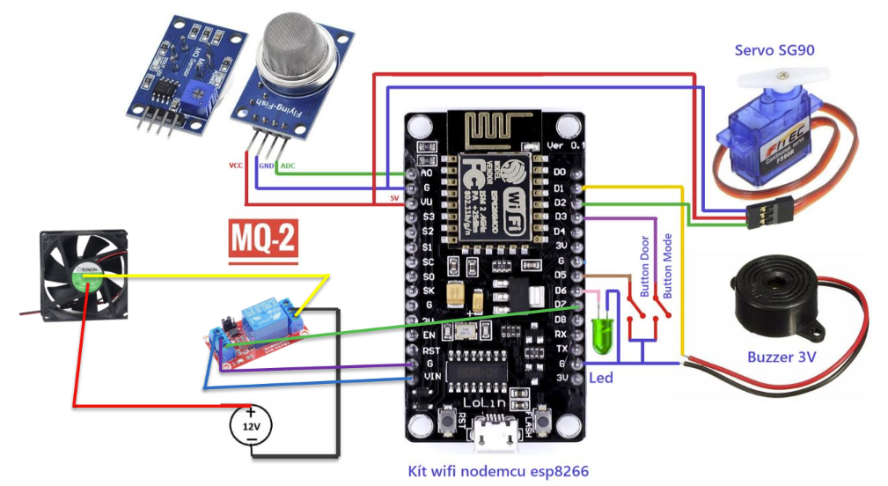

## Implementation Diagram

Below diagram shows the implementation of Gas leak alert system:

Firstly, we push the button mode to make the system working. Using Gas from Lighter in front of MQ2, in this time, MQ2 will detect the gas. Based on the setup limit gas detection created before, when the gas is beyond the limitations of permission, it will activate the system like opening the door, making buzzer, and activating the fan. When the measurement of the gas leak reduces to zero, the system will finish. Then, the air will be fresh and prevent from damage of toxic gas. After that, we can close the door manually.

## Blynk Dashboard

Here is about the User Interface. It includes: Blynk Web, Blynk Mobile App, and notifications of the message via email.

## Real-Life Image

Here is about the simulation of Gas leak Alert:

# Demo

Following this link: <https://drive.google.com/file/d/1KK2k1lZCoT0w6VYXgOOAacG8_ei-7-Kz/view?usp=sharing>

# Conclusion

In conclusion, the integration of a gas leak alert system with smartphone notifications, automatic door opening, and fan activation significantly enhances safety measures by offering a swift and comprehensive response to gas leaks. By combining proactive detection with automated responses and instant alerts, the system mitigates risks and safeguards lives and property effectively.