Pham Thuy Dung – 20521214

Ex00:

Here is result:

Ex01:

Here is result:

Ex02:

Here is result:

Ex03:

Here is result:

Ex04:

Here is result:

Ex1.1

Here is result

Ex11:

Here is result

Ex12:

Here is result

Ex13

Here is result:

Ex21

Here is result

Ex22:

Here is result:

Ex23:

Here is result

Ex3:

Here is result

Ex41

Here is result

Ex42:

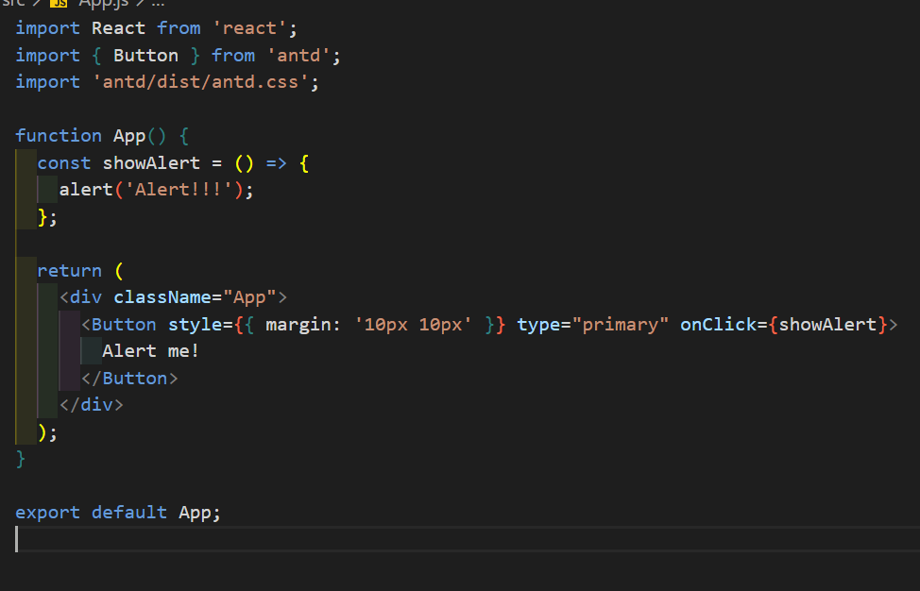

Here is output:

Ex43:

Here is result:

Ex46:

Here is result:

Ex47:

Here is result:

Homework:

Homework1:

Here is output:

Homework 2:

Here is output:

