DBI ASSIGMENT

Nhà Sách Trực Tuyến VinaBook

(http://www.vinabook.com/)

SE1722 – Group 1

Thành Viên

Thành viên:

* Nguyễn Minh Duy
* Phạm Tuấn Dương
* Vũ Hoàng Long
* Hoàng Phan Quốc Đạt

1. **User Requirement**

The selling website of Electronic Bookstore (Vinabook) includes 2 main users:

Users, Staff in which the access rights of the above 3 objects are as follows:

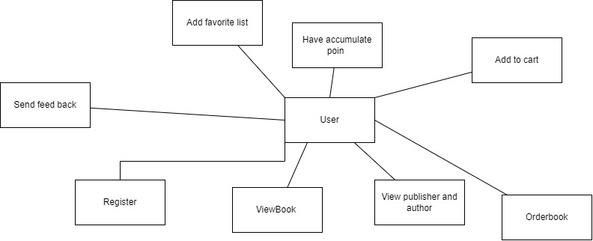

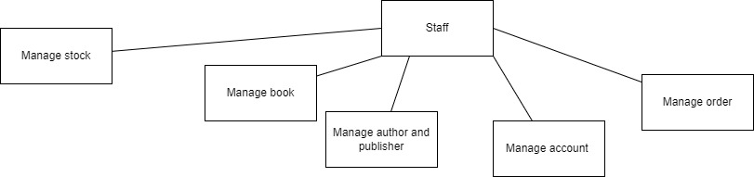

Users:

* Regiser:

+UserID cant not be duplicate

+Password need to be check for security

+ Name

+ phone number

+ email

* View book

+ Watch the all propery of book such as

* View publisher and author:

+ User can view publiser and author with all information name

+ User can also view all book of publiser and author

* Order book:

+ Make an order with many book

+ User need to fill the detail order: Name, Address of recevier

+Order will contain the information Name, Address of recevier , estimated shipdate and have date of

* Send feedback:

+User can send feedback for each book, each feedback will have votestar which in range between 1 to 5 star

+Feedback also have title and description (the comment) of user for the book

* Add to favorite list:

+User can have a list containing the favorite book of them which user can store for after and easily watch it later

* Have accumulate point:

+When ever the user purschase , use can get bonus point which can be use later to have discount

* Add to cart

+ Add items to cart and view

Staff:

-Can mange the book:

+Add the new book with all property

+ view all property and all the vote of book which the user can’t view all vote of book

* Can mange the publisher and the author:

+Can edit and add the information of publisher and author

+Publisher and author both have attributes: Name and description

* Can mange account of user

+ can help user change account password

* Can manage order

+View all order detail

The website Vinabooks sells Books. All items are displayed with the following information:

* Product Name
* Authors
* Publishers
* Publisher Company
* Origional cost
* Effective sale (after discount)
* Status (in stock, out of stock, out of business)
* Quality
* Introduction Books
* Detail Introduction

+ License

+ Language

+ Size

+ Number of Pages

+ Publisher

+ Publishing Company

+ Product Code

+ Mass

+ Format

+ Release Date

* Evaluate (Vote stars 1- 5) & Comment from Users

The products are divided into different product categories, each of which has its own specifications:

1. Economic book

* Subcategories:

+ Foreign trade

+ Human Resources & Employment

+ Characters & Business Lessons

+ Analysis & Economic Environment

+ Administration - Leadership

+ Finance - Currency

+ Finance - Accounting

+ Law documents

+ Investing in securities

+ Start-up / Work skills

* Authors
* Publishing Company

1. Book of domestic literature

+ Romantic

+ History

+ Detective

+Fiction

+Children

+ Poetry

* Authors
* Publishing Company

1. Foreign Language Books

+Fairy Tales & Myths

+Literary Criticism

+Reporting

+Chronicle

+Books About Literary Characters

+Poem

+Children

* Authors
* Publishing Company

1. Blockchain Book

+ Newly Released Blockchain Book

1. Books of Foreign Literature

+ Fairytales & Myths

+ Literary Criticism

+ Reportage, reportage

+ Books about literary characters

+ Poem

+ Novel

+ Comic swordplay

+ History Story

+ Short story

+ Children's Stories

+ Detective Stories, Cases

+ Horror Fiction

+ The language novels

+ Passion novels Enjoy Book – Life

* Authors
* Publishing Company

1. Enjoy Book – Life

+Beauty Secrets

+Happiness Family

+Housewife

+MaintainingChildren

+CookingBooks

+Plants

+Aquariums

+Domestic Pets

+Adolescent Handbooks

+Sex Education

+Physiology

* Authors
* Publishing Company

1. Children's books

+ Science

+ Social

+ Comic

+ Art, Music

* Authors
* Publishing Company

1. Self Development Book

+Scienctist

+Philosophers

+Politicians

* Authors
* Publishing Company

1. Informatics - Foreign Language Books

+English

+Chinese

+Dictionaries

+Special Dictionaries

+Databases

+Operating Systems

+Internet & Networking

+Programming & Application Software

+Web

+ProgrammingBasic

+Informatics Office

+Informatics Graphics

* Authors
* Publishing Company

1. Specialized book

+Music

+Politics,

+Philosophy Travel

+Basic Sciences

+Technology

+Social Sciences

+History

+Geography,

+Architecture

+Forestry

+Law

+Religion

+Sports

+Culture

+Arts

+Medicine

+Journalism

* Authors
* Publishing Company

1. Textbook

+References book

+University book

+ High school book

+Middle school

+Primảy school

* Authors
* Publishing Company

1. Magazine – Stationery

+Note book

+Calender

+Colored pen

* Authors
* Publishing Company

1. **ER Diagram**

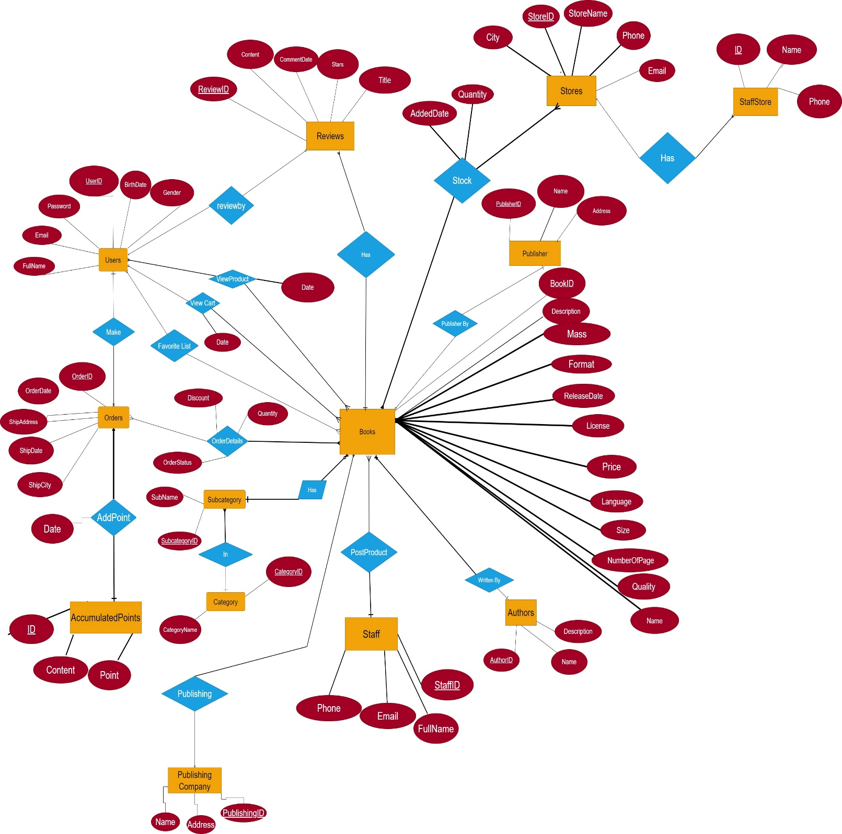

1. **Database Scheme**

1.       Table User

|  |  |  |
| --- | --- | --- |
| Column Name | Data Type | Key/Index/Constraint |
| UserID | nvarchar(50) | NOT NULL Primary key |
| UserName | nvarchar(50) | NOT NULL |
| Email | nvarchar(50) | NOT NULL |
| [Password] | nvarchar(100) | NOT NULL |
| Phone | nvarchar(10) | NULL |
| Gender | varchar(5) | NOT NULL |
| BirthDate | date |  |

2.   Publishers

|  |  |  |
| --- | --- | --- |
| Column Name | Data Type | Key/Index/Constraint |
| PublisherID | int | NOT NULL primary key |
| PublisherName | nvarchar(100) | NOT NULL |
| [address] | nvarchar(200) |  |

3.   Authors

|  |  |  |
| --- | --- | --- |
| Column Name | Data Type | Key/Index/Constraint |
| AuthorID | int | NOT NULL primary key |
| [Name] | nvarchar(50) | NOT NULL |
| [Description] | nvarchar(4000) | NOT NULL |
| BirthDate | date |  |

4.   Category

|  |  |  |
| --- | --- | --- |
| Column Name | Data Type | Key/Index/Constraint |
| CategoryID | int Identity | NOT NULL primary key |
| CategoryName | nvarchar(100) | NOT NULL |

5.   SubCategory

|  |  |  |
| --- | --- | --- |
| Column Name | Data Type | Key/Index/Constraint |
| SubcategoryID | int Identity | NOT NULL primary key |
| SubCategoryName | nvarchar(100) | NOT NULL |
| CategoryID | int | NOT NULL  references Category(CategoryID) |

6.   Orders

|  |  |  |
| --- | --- | --- |
| Column Name | Data Type | Key/Index/Constraint |
| OrderID | int | NOT NULL primary key |
| OrderDate | date | NOT NULL |
| OrderStatus | nvarchar(200) | NOT NULL |
| ShipAddress | nvarchar(200) | NOT NULL |
| ShipCity | nvarchar(50) | NOT NULL |
| UserID | nvarchar(50) | NOT NULL  References Users(UserID) |

7.   Books

|  |  |  |  |
| --- | --- | --- | --- |
| Column Name | Data Type | Key/Index/Constraint | Check |
| BookID | int | NOT NULL primary key |  |
| [Name] | nvarchar(100) | NOT NULL |  |
| Price | int | NOT NULL | >= 0 |
| Stock | int | NOT NULL | >= 0 |
| SubcategoryID | int | NOT NULL  references SubCategory(SubCategoryID) |  |
| PublisherID | int | NOT NULL  references Publishers(PublisherID) |  |
| AuthorID | int | NOT NULL References Authors(AuthorID) |  |

8.   OrderDetail

|  |  |  |  |  |
| --- | --- | --- | --- | --- |
| Column Name | Data Type | Key/Index/Constraint | Check | Default |
| BookID | int | NOT NULL References Books( BookID ) |  |  |
| OrderID | int | NOT NULL References  Orders(OrderID) |  |  |
| Quantity | int | NOT NULL | > 0 | 1 |
| Discount | int | NOT NULL | <= 1 | 0 |

10. Table Comment

|  |  |  |
| --- | --- | --- |
| Column Name | Data Type | Key/Index/Constraint |
| CommentID | int | Identity Primary Key |
| Content | nvarchar(50) |  |
| UserID | nvarchar(50) | NOT NULL  References Users(UserID) |
| BookID | int | NOT NULL References Books( BookID ) |
| Title | Nvarchar(100) |  |

11. Table Staffs

|  |  |  |
| --- | --- | --- |
| Column Name | Data Type | Key/Index/Constraint |
| StaffID | int | Identity Primary Key |
| FullName | nvarchar(50) | NOT NULL |
| Email | nvarchar(50) | NOT NULL |
| Phone | nvarchar (10 | NOT NULL |

12.[Favorites list]

|  |  |  |
| --- | --- | --- |
| Column Name | Data Type | Key/Index/Constraint |
| BookID | int | NOT NULL   References Books( BookID ) |
| UserID | nvarchar(50) | NOT NULL  References Users(UserID) |

13. Post By

|  |  |  |
| --- | --- | --- |
| Column Name | Data Type | Key/Index/Constraint |
| StaffID | int | NOT NULL   References Staff( StaffID ) |
| AuthorID | int | NOT NULL  References Authors(AuthorID) |

14. Written By

|  |  |  |
| --- | --- | --- |
| Column Name | Data Type | Key/Index/Constraint |
| BookID | int | NOT NULL   References Books( BookID ) |
| AuthorID | int | NOT NULL  References Authors(AuthorID) |

15 View Cart

|  |  |  |
| --- | --- | --- |
| Column Name | Data Type | Key/Index/Constraint |
| Date | Date | NOT NULL |
| UserID | nvarchar(50) | NOT NULL  References Users(UserID) |
| BookID | int | NOT NULL  references Books(BookID) |
|  |  | PrimaryKey(UserID,BookID) |

16. View Product

|  |  |  |
| --- | --- | --- |
| Column Name | Data Type | Key/Index/Constraint |
| Date | Date | NOT NULL |
| UserID | nvarchar(50) | NOT NULL  References Users(UserID) |
| BookID | int | NOT NULL  references Books(BookID) |
|  |  | PrimaryKey(UserID,BookID) |

17. AccumulatedPoints

|  |  |  |
| --- | --- | --- |
| Column Name | Data Type | Key/Index/Constraint |
| ID | int Identity | NOT NULL primary key |
| Content | nvarchar(100) | NOT NULL |
| Point | int | Check(Point < 1000) |

18 AddPoint

|  |  |  |
| --- | --- | --- |
| Column Name | Data Type | Key/Index/Constraint |
| ID | int | NOT NULL References AccumalatedPoints(ID) |
| Date | date | NOT NULL |
| OrderID | int | NOT NULL References Orders(OrderID) |

19 PublishingCompany

|  |  |  |
| --- | --- | --- |
| Column Name | Data Type | Key/Index/Constraint |
| PublishingID | int | NOT NULL Primary key |
| Address | Nvarchar(50) | NOT NULL |
| Name | Nvarchar | NOT NULL |

20 PublishingBy

|  |  |  |
| --- | --- | --- |
| Column Name | Data Type | Key/Index/Constraint |
| PublishingID | int | NOT NULL   References Publishing( PublishingID ) |
| CategoryID | int | NOT NULL  References Category(CategoryID) |

21 CategoryWriteBy

|  |  |  |
| --- | --- | --- |
| Column Name | Data Type | Key/Index/Constraint |
| CategoryID | int | NOT NULL   References Category( CategoryID ) |
| AuthorID | int | NOT NULL  References Authors(AuthorID) |

CREATE TABLE Users

(

UserID nvarchar(50) NOT NULL Primary key,

UserName nvarchar(50) Not null,

Email nvarchar(50) Not null unique,

[Password] nvarchar(100) NOT NULL,

BirthDate date,

Phone nvarchar(10),

Gender varchar(5) NOT NULL

)

CREATE TABLE Publishers(

PublisherID int NOT NULL primary key,

PublisherName nvarchar(100) NOT NULL,

[Address] nvarchar(200)

)

Create table Staff

(

StaffID int Primary key,

FullName nvarchar(100),

Email nvarchar(255),

Phone varchar(10),

Check (len(Phone) = 10)

)

CREATE TABLE Authors(

AuthorID int NOT NULL primary key,

[Name] nvarchar(50) NOT NULL,

[Description] nvarchar(4000) NOT NULL,

BirthDate date,

)

CREATE TABLE Category(

CategoryID int Identity NOT NULL primary key,

CategoryName nvarchar(100) NOT NULL

)

CREATE TABLE SubCategory (

SubcategoryID int Identity NOT NULL primary key,

SubCategoryName nvarchar(100) NOT NULL,

CategoryID int NOT NULL references Category(CategoryID)

)

CREATE TABLE Orders(

OrderID int Identity NOT NULL primary key ,

OrderDate date NOT NULL,

ShipDate date NOT NULL,

OrderStatus nvarchar(200) NOT NULL,

ShipAddress nvarchar(200) NOT NULL,

ShipCity nvarchar(50) NOT NULL,

UserID nvarchar(50) NOT NULL References Users(UserID)

)

Create table Stores

(

StoreID int Primary key,

StoreName nvarchar(100),

Phone varchar(10),

Email varchar(255),

City nvarchar(20)

)

CREATE TABLE Books (

BookID int NOT NULL primary key,

[Name] nvarchar(100) NOT NULL,

Price float NOT NULL,

Stock int NOT NULL,

SubcategoryID int NOT NULL references SubCategory(SubCategoryID),

PublisherID int NOT NULL references Publishers(PublisherID),

AuthorID int NOT NULL References Authors(AuthorID),

[Description] nvarchar(4000) not null,

Mass float not null,

[Format] nvarchar(100) not null,

[ReleaseDate] date not null,

License nvarchar(100) not null,

[Language] nvarchar(50),

Size float not null,

NumberOfPages int not null,

Quanlity varchar(5),

StaffID int not null references Staff(StaffID),

check (Stock >= 0),

check(Price >= 0)

)

Create table Stock

(

AddedDate date not null,

Quantity int not null,

BookID int not null references Books(BookID),

StoreID int not null references Stores(StoreID)

)

Create table PublishingCompany

(

PublishingID int Primary key,

[Address] nvarchar(100),

[Name] nvarchar(100),

)

Create table Publishing

(

PublishingID int not null references PublishingCompany(PublishingID),

BookID int not null references Books(BookID)

)

CREATE TABLE OrderDetail

(

BookID int NOT NULL References Books( BookID ) ,

OrderID int NOT NULL References Orders(OrderID),

Quantity int NOT NULL default 1,

Discount int NOT NULL default 0,

check(Quantity > 0),

check(Discount >= 0 AND Discount <= 1),

primary key(BookID,OrderID)

)

Create TABLE Reviews

(

ReviewID int identity PRIMARY KEY,

UserID nvarchar(50) NOT NULL References Users(UserID),

Content nvarchar(4000) not null,

CommentDate date not null,

Stars int not null,

Title nvarchar(100),

BookID int not null references Books(BookID)

)

Create table viewCart

(

[Date] date not null,

UserID nvarchar(50) NOT NULL References Users(UserID),

BookID int not null references Books(BookID)

)

Create table ViewProduct

(

[Date] date not null,

UserID nvarchar(50) NOT NULL References Users(UserID),

BookID int not null references Books(BookID)

)

Create table AccumulatedPoints

(

ID int identity Primary key,

Content nvarchar(255) not null,

Point int not null

)

Create table AddPoint

(

[Date] date,

OrderID int References Orders(OrderID),

ID int References AccumulatedPoints(ID)

)

CREATE TABLE [Favorites list]

(

BookID int NOT NULL References Books( BookID ) ,

UserID nvarchar(50) NOT NULL References Users(UserID)

)