EASTERN INTERNATIONAL UNIVERSITY
SCHOOL OF COMPUTING AND INFORMATION TECHNOLOGY
DEPARTMENT OF SOFTWARE ENGINEERING



PROJECT 2 REPORT

3BRO – Online Shopping Management System

Students
Nguyễn Hoàng Hảo – 2231200040
Phạm Văn Huy – 2231200034
Nguyễn Nhật Tân – 2131200052

Supervisor
Nguyễn Xuân Cường

Ho Chi Minh, March, 2026

ABSTRACT

In today’s digital age, online shopping has become an essential part of modern life as people increasingly seek convenience, speed, and flexibility. The fast-paced lifestyle often leaves individuals with limited time to visit physical stores, making e-commerce platforms a practical solution for purchasing everyday products. However, many users still struggle with inefficient shopping experiences, unclear product information, and complicated checkout processes.

To address these challenges, this e-commerce website was created with the goal of providing a simple, seamless, and user-friendly online shopping experience. The platform allows customers to browse products easily, compare prices, read detailed descriptions, and make secure purchases from the comfort of their homes. With features such as smart product searching, category filtering, order tracking, and personalized recommendations, the website ensures that users can shop quickly and effectively.

In addition, the system offers an intuitive admin dashboard that helps store owners manage products, monitor orders, update inventory, and analyze sales performance with ease. This creates a smooth connection between buyers and sellers, improving both customer satisfaction and business efficiency.

By combining convenience, transparency, and modern technology, this e-commerce website aims to enhance the way people shop online and bring a more enjoyable, efficient, and reliable digital shopping experience to everyday life.

ACKNOWLEDGES

We would like to sincerely thank our supervisor, Lecturer Nguyen Xuan Cuong, for always supporting and guiding us throughout this project. His friendly attitude, clear explanations, and constant encouragement made the entire process much easier and more enjoyable for us.
Whenever we faced difficulties or got stuck, he was always willing to help, give advice, and motivate us to keep moving forward. His patience and dedication not only helped us complete this project successfully but also taught us valuable lessons that we will carry with us in the future.
We are truly grateful for his time, support, and kindness. This project would not have been the same without him.

TABLE OF CONTENT
ABSTRACT i
ACKNOWLEDMENTS ii
TABLE OF CONTENT iii
LIST OF FIGURES v
Chapter 1: Introduction 1
1.1 Motivation 1
1.2 Objective 1
1.3 Project Overview 1
Chapter 2: System Design 3
2.1 System Workflow 3
2.1.1 General use case diagram 3
2.1.2 Detail use case diagram 5
2.1.3 Active Diagram 19
2.2 Database 8
2.2.1 User Table 8
2.2.2 User Role Table 8
2.2.3 Role Table 8
2.2.4 Activation Code Table 8
2.2.5 Product Table 8
2.2.6 Category Table 8
2.2.7 Cart Table 8
2.2.8 Cart Item Table 8
2.2.9 Order Table 8
2.2.10 Order Detail Table 8
2.2.11 Discount Table 87
2.2.12 Order Discount Table 87
2.2.13 Payment Table 87
2.2.14 Shipment Table 87
2.2.15 Review Table 87
2.2.16 Deleted User 87
2.2.17 Deleted Order 88
2.2.18 Deleted Order Detail 88
2.2.19 Deleted Product 88
2.2.20 Database Diagram 89
Chapter 3: Application Function 90
3.1.1 Login Screen 90
3.1.2 Sign up Screen 91
3.1.3 Home Screen 91
3.1.4 Profile Screen 93
3.1.5 Product Screen 94
3.1.6 View Detail Product Screen 95
3.1.7 View Cart Screen 9
3.1.8 Payment Screen 97
3.1.9 View Order Screen 98
3.1.10 Contact Screen 99
3.1.11 Dashboard Screen 100
3.1.12 Add Product Screen 101
3.1.13 View Product Information in Admin Screen 102
3.1.14 View Orders in Admin Screen 103
3.1.15 View Users in Admin Screen 104
3.1.16 View Feedback in Admin Screen 105
3.1.17 View All Shipment in Admin Screen 106
3.1.18 Profile Setting Admin Screen 107
3.1.19 Support Management in Admin Screen: 108
3.1.20 Discount in Admin Screen 109
3.1.21 Notification Setting Admin Screen 110
Chapter 4: Related Work 111
4.1 Settings 111
4.2 Feature Comparison 111
4.3 3BRO’s Competitive Advantages 111
Chapter 5: Conclusion & Future Works 112
5.1 Conclusion 112
5.2 Future Works 112
References 113

LIST OF FIGURES
Figure 1: General Use Case 3
Figure 2: Detailed Use Case Diagram – Manage Account 5
Figure 3: Detailed Use Case Diagram – Manage Products 8
Figure 4: Detailed Use Case Diagram – Search & Discovery products 10
Figure 5: Detailed Use Case Diagram – Manage Cart 1
Figure 6: Detailed Use Case Diagram – Pay for products 12
Figure 7: Detailed Use Case Diagram - Track the Order 15
Figure 8: Detailed Use Case Diagram – Report 17
Figure 9: Create User Account Status 19
Figure 10: Login 21
Figure 11: Logout User 23
Figure 12: Update Password 25
Figure 13: Forget Password 27
Figure 14: View User Profile 30
Figure 15: Add User Account 32
Figure 16: Update User Account 34
Figure 17: Delete User Account 36
Figure 18: Lock User Account 38
Figure 19: Add Product Information 40
Figure 20: Update Product Information 42
Figure 21: Delete Product Information 44
Figure 22: Add Discount For Product 45
Figure 23: Search Product 48
Figure 24: Add Product In Cart 50
Figure 25: View Cart 53
Figure 26: Delete Product In Cart 56
Figure 27: Update Product In Cart 58
Figure 28: View & Confirm Payment 61
Figure 29: Choose Payment Method 64
Figure 30: Confirm Invoice Cancellation 67
Figure 31: Refund Payment 70
Figure 32: View Status Invoice 72
Figure 33: View History of Transaction 74
Figure 34: View Order List 76
Figure 35: Review and approves customer orders 78
Figure 36: Cancel Order 80
Figure 37: Report 83
Figure 38: Login Screen 90
Figure 39: Sign up Screen 91
Figure 40: Home Screen 91
Figure 41: Profile Screen 93
Figure 42: Product Screen 94
Figure 43: View Detail Product Screen 95
Figure 44: View Cart Screen 96
Figure 45: Payment Screen 97
Figure 46: View Order Screen 98
Figure 47: Contact Screen 99
Figure 48: Dashboard 100
Figure 49: Add Product Screen 101
Figure 50: View Product Information in Admin Screen 102
Figure 51: View Order in Admin Screen 103
Figure 52: View Users in Admin Screen 104
Figure 53: View Feedback in Admin Screen 105
Figure 54: View All Shipment in Admin Screen 106
Figure 55: Profile Setting Admin Screen 107
Figure 56: Support Management in Admin Screen 108
Figure 57: Discount in Admin Screen 109
Figure 58: Notification Setting Admin Screen 110

Chapter 1: Introduction
  - Motivation
In many small and medium-sized shops, the process of selling products is still done manually or through social media messages. This often leads to issues such as slow responses, missing orders, incorrect product information, or difficulty tracking inventory. Customers may also experience delays when trying to confirm their orders or check the availability of items.
We wanted to create a simple online shopping system that helps solve these problems. Our idea is to make it easier for both customers and store owners to manage products, view orders, and complete purchases without dealing with the limitations and mistakes that often happen when using manual methods.
  - Objective
The goal of this project is to develop a user-friendly e-commerce website with the following main objectives:
- Allow customers to browse products, view details, and make purchases online.
- Provide store owners with an efficient way to manage products, orders, and customer information in one place.
- Reduce common problems like missing orders, incorrect product data, or delayed communication with customers.
- Save time for both buyers and sellers by automating the shopping and order management process.
  - Project Overview
This project focuses on building a simple e-commerce website that helps manage product listings, customer orders, and inventory in a more organized way. The main purpose is to make online shopping easier, faster, and more reliable for both customers and store owners.
With this system, customers can browse available products, add items to their cart, and complete purchases without needing to message or call the shop. At the same time, store owners can clearly view all orders, track inventory, update product information, and manage customer records in one central platform.
The website is designed mainly for small and medium-sized businesses that do not have an advanced online selling system. It provides them with an easy and effective tool to organize sales, avoid common errors, and improve the overall shopping experience for their customers.

Chapter 2: System Design

- System Workflow
- General use case diagram

Figure 1: General Use Case
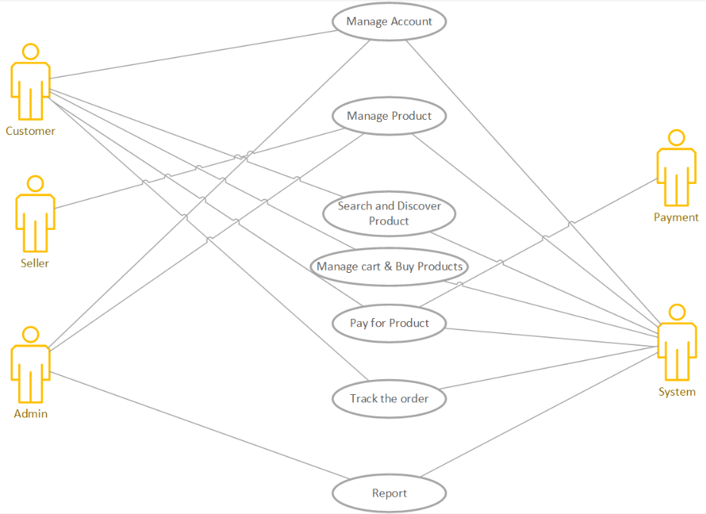

- Customer: The main actor who uses your application for searching and purchasing products for their daily needs.
- Login, register the account
- Search the key word to find the products
- Add products to your cart to save them or you can pay directly.
- Track the shipping route of order

- Admin: The administrator responsible for maintaining and monitoring the system.
- Remove, update, add, clock the account of customer in the database
- Remove, add and update the information about the product. Manage product quantity in stock.
- Collect customer reviews.
- Manage all sales data including revenue, profit, number of products sold or returned.

- Seller:
- Can do some admin functions including adding, deleting and editing products.
- View customer payment, review.

- System: Core components of the application that interact with other actors.
- Manage all store functions, ensure that functions operate properly in accordance with consumer needs.
- Provide interfaces for User and Admin.
- Executes logic functions (e.g., total price, filter products, etc.)

- Payment Method: Service that serves customers to pay for their products (credit card, e-wallet, cash, etc.)

- Detail use case diagram

Figure 2: Detailed Use Case Diagram – Manage Account
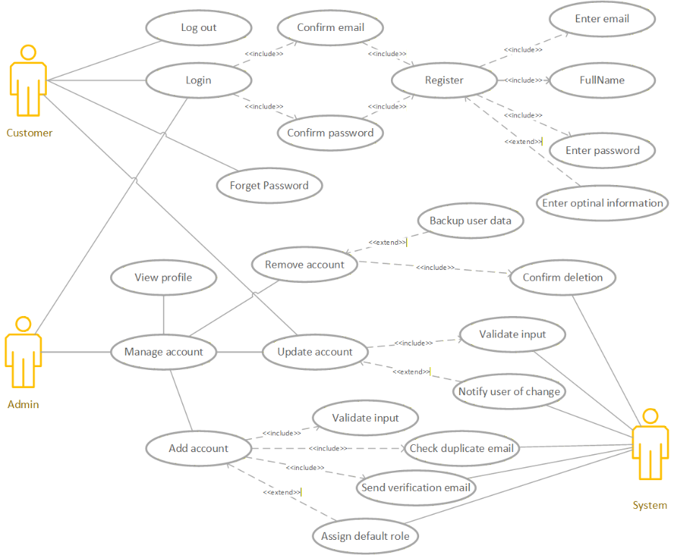
- Customer
- Register:
- Enter email, Enter password, Full Name: input basic information.
- Enter optional information: input optional data (phone number, address, etc.).
- Confirm email (including): the system sends a verification email.

- Result: a new account is created after successful verification.
- Login:
- Confirm password: the system validates the password.
- Confirm email: if not yet verified, the system requires confirmation.
- Result: users can access the system if credentials are valid.
- Log out:
- Customers can log out the account, but the information still be stored on the server.
- Forget password:
- Customers use forget password function to update the new password when customers
- Manage account:
- Allow the customer to update their own account.

- Admin
- The admin is responsible for managing user accounts — adding, updating, and removing users in the system.

- Add account:
- Includes:
- Validate input: check data validity.
- Check duplicate email: ensure the email is unique.
- Send verification email: send verification to new users.
- Extends:
- Assign default role → assign a default user role (e.g., Customer, Seller).
- Update account:
- Includes:
- Validate input: check the updated data.
- Extends:
- Notify user of change: send a notification to the user after the change.

- Remove account:
- Includes:
- Confirm deletion: ask for confirmation before deletion.
- Backup user data: back up data before removing the account.
- Extends:
- Notify user of change: inform the user that their account was removed.

- View customer profile:
- Admin can view all of list customer profiles.
- Manage account:
- A main use case that includes Add, Update, and Remove account actions.

- System
- The System acts as an internal automated actor that performs validation, verification, and notification tasks.
  - Validate input: check data format, email structure, password length, etc.
  - Check duplicate email: ensure no existing user has the same email.
  - Send verification email: send a confirmation email to users.
  - Assign default role: automatically assign a default role upon account creation.
  - Notify user of change: notify users when their account information is modified or deleted.
  - Backup user data: back up user information before deletion.

Figure 3: Detailed Use Case Diagram – Manage Products
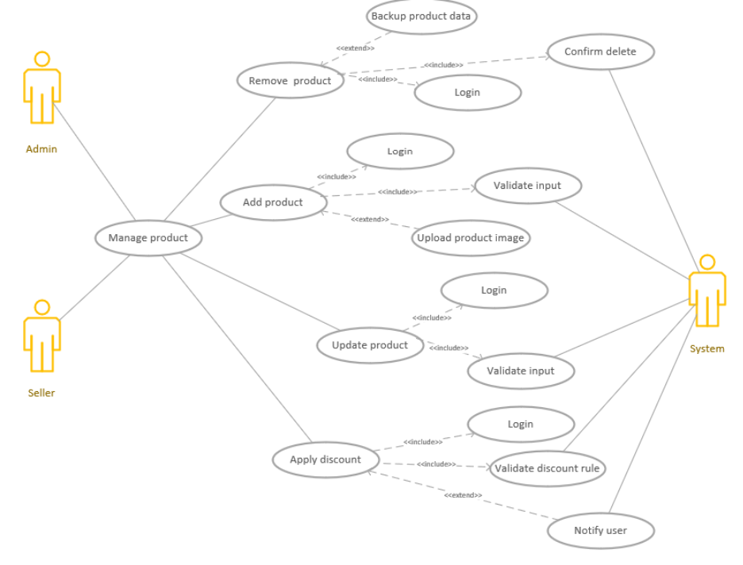
- Admin
- The Admin is responsible for managing all products in the system.
- Add product
- Includes:
- Login: ensure the admin is authenticated.
- Validate input : check that entered data is valid (price, name, image, etc.).
- Upload product image : upload the product image to the system.
- Extends:
- Notify user : notify sellers or other administrators that a new product has been added.
- Update product
- Includes:
- Login
- Validate input
- Extends:
- Notify user: inform sellers or other admins that the product information has been updated.
- Remove product
- Includes:
- Login
- Confirm delete: confirm before deleting the product.
- Backup product data: save a backup of product data before deletion.
- Extends:
- Notify user: send a notification that the product has been deleted.
- Apply discount
- Includes:
- Login
- Validate input
- Validate discount rule: check discount conditions (max %, validity period, etc.).
- Extends:
- Notify user: inform customers or sellers about the new discount program.

- Seller
- The Seller is the product owner and has permission to add, update, or apply discounts to their own products.
- Can perform similar actions as the admin, but only within their own products.
Includes:
- Add product, Update product, Apply discount.
- Does not have permission to remove products belonging to others unless granted.

- System
- The System is a secondary actor — it automatically handles technical or background operations.
- Functions performed by the System:
- Validate input: check the correctness of entered data (e.g., non-negative price).
- Upload product image: handle image uploads to the server.
- Validate discount rule: ensure discount conditions are valid.
- Confirm delete display a confirmation dialog before deletion.
- Backup product data: save a copy of product data before deleting it.
- Notify user: send notifications via email, popup, or dashboard alerts.

Figure 4: Detailed Use Case Diagram – Search & Discovery products

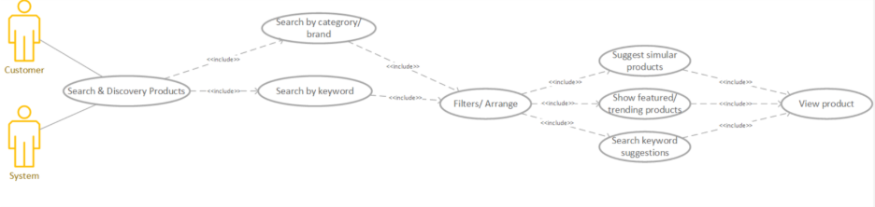

- User (Customer)
- Actor: User
- Description: This use case describes the general functionality that allows the user to search, browse, and discover products in the online shopping system. The user can search by keyword or by category/brand, apply filters or sorting options (price, address, trending, ...), and view featured or trending items. The system may also suggest related or similar products and provide keyword recommendations to enhance the search experience.
- Flow:
- The user opens the search interface.
- Search by category/brand & by keyword: The user enters a keyword or selects a category/brand.
- Filter/Arrange: The user can apply filters (price, rating, availability, etc.) or sort the results.
- View product: The user can click on any product to view more details.
- Customers will see more details of the products: view rating, comments, price, images, recommended products, shop, or mark to liked, ...

- System
- Search by category/brand & by keyword: Process data and search for information.
- Handle all search filters entered by customers.
- Ensure stock availability and return matching products.
- Filter/ Arrange
- System handles results with filtering and sorting options (e.g., by price, popularity, rating).
- System gets appropriate products from database and returns to user.

Figure 5: Detailed Use Case Diagram – Manage Cart
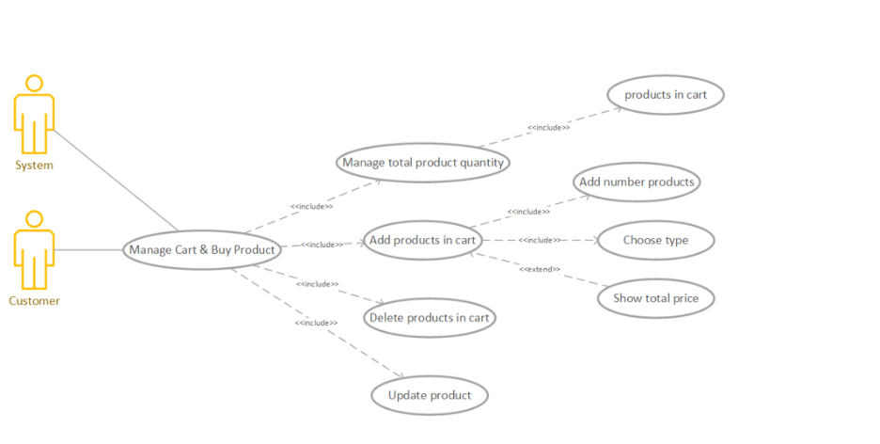
- User, System
- Actor: User, System.
- Description: This use case describes the process in which a customer interacts with the system to manage their shopping cart and view products before proceeding to purchase. It includes adding, removing, and managing product quantities in the cart, as well as viewing product details and cart summary.
- Flow:
- The customer browses the product list or searches for a product.
- The customer selects a product and views detailed information.
- The customer chooses the desired quantity and clicks “Add to Cart.”
- The system checks stock availability and adds the selected product to the cart.
- The system will update information for customer number of products, number of items.
- The system automatically recalculates the total cart value after each modification.
- The system confirms all updates and displays the latest cart summary.
- The customer can view their cart at any time to:
- See all the added items.
- Update the quantity of each product.
- Remove unwanted items.

Figure 6: Detailed Use Case Diagram – Pay for products

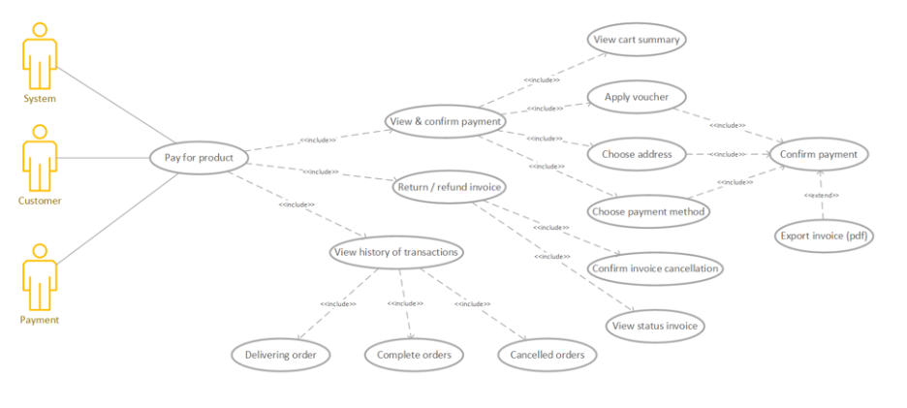
- Customer
- Actor: Customer
- Description: The customer performs the process of paying for products added to the shopping cart. The system displays order details, allows the customer to apply vouchers, select an address and payment method, and confirm the payment.
- Flow:
- The customer selects products and adds them to the cart.
- The customer clicks the “Purchase” option in the cart.
- View summary: Customer to view a summary of the products added to their cart before proceeding to checkout
- Customers will select a voucher to discount, choose address to receive order, and choose how to pay (credit card, bank transfer, e-wallet, cash on delivery, etc.). Then, customer will pay for orders.
- After paying for orders, customer can export invoices.
- Customers click the “Return goods” to cancel order
- Customers need to give reason to confirm cancel order.
- Customer can view status of the order.
- View history of transactions: Customer can view order transactions.
- Delivering order: keep track of ordering on way.
- Complete orders: orders that deliver to customer completely.
- Cancelled order: orders that customers cancelled.
System
- View & Confirm payment:
- Receive payment request from customer.
- Validate and record successful payment in database.
- Communicate with external payment services for transaction processing.
- Return and refund invoice:
- Send notification for user to cancel order.
- Send notifications or confirmations about payment status.
Payment:
- The external payment service handles transaction processing
- Connect to the system when a payment method is selected.
- Send message “Success” or “Failed” to system.

Figure 7: Detailed Use Case Diagram - Track the Order

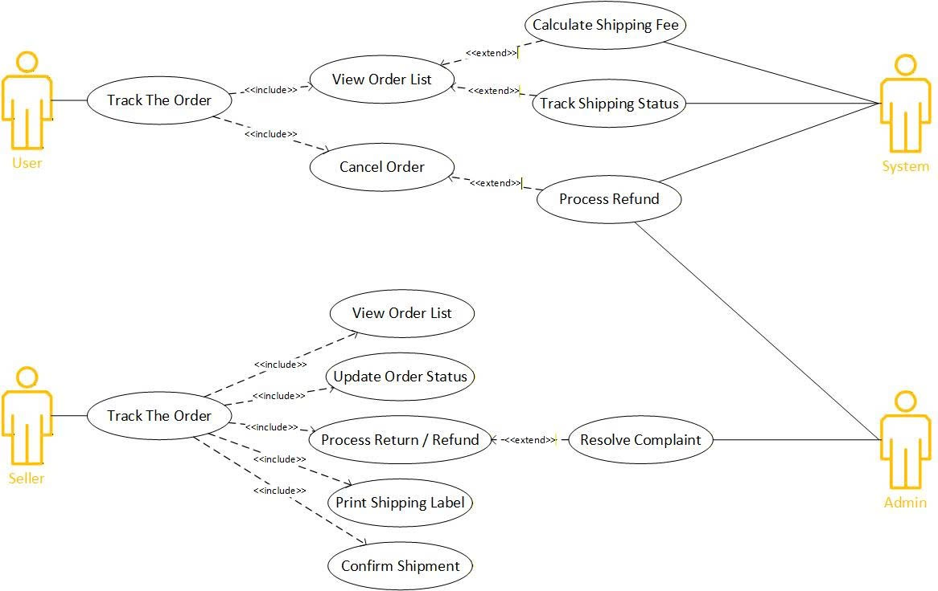

- Customer
- Represents the customer who uses the e-commerce platform to make purchases.
- Responsible for placing orders, checking order details, canceling orders, and tracking the delivery process.

- View Order List: View all orders that have been placed in detail.
- Cancel Order: Cancel an order before it is processed or shipped.
- (Supported by System):
- Calculating Shipping Fee: The system automatically calculates delivery fees.
- Track Shipping Status: The system synchronizes delivery updates from shipping partners.
- Process Refund: The system handles refunds for canceled or failed orders.
- Shop Owner
- Represents the merchant who manages all customer orders for their store.
- Responsible for updating order statuses, processing returns/refunds and managing shipments.

- View Order List: View all orders placed by customers in the seller’s shop.
- Update Order Status: Update the order progress (pending, shipping, delivered, completed).
- Process Return / Refund: Handle return or refund requests initiated by customers.
- Print Shipping Label: Print shipping labels before dispatching the package.
- Confirm Shipment: Confirm that the package has been handed over to the delivery service.
- (Supported by Admin):
- Resolve Complaint: The admin intervenes in dispute resolution between customer and seller.

- Admin (System Administrator)
Oversee the entire order management process across the platform. Handles disputes, refunds approvals, and ensures policy compliance.
- Resolve Complaint: Manage complaints and conflicts between customers and sellers.
- Process Return / Refund: Supervise refund and return processes initiated by sellers or customers.
- System (Automated Processes)
Performs background operations automatically to support the order workflow. Integrates with payment gateways and shipping service APIs.
- Calculate Shipping Fee: Automatically calculates delivery fees based on distance and product weight.
- Track Shipping Status: Syncs delivery updates from logistics providers (GHN, GHTK, J&T, etc.).
- Process Refund: Automatically refund payments for canceled or failed orders.

Figure 8: Detailed Use Case Diagram – Report

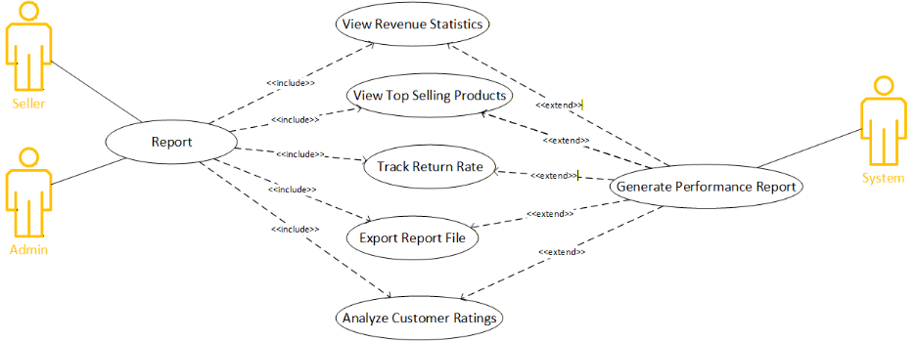

- Seller
- The Seller can view and analyze business performance data, can track revenue, returns, and customer ratings, generate reports and export them for review or record keeping.
- View Revenue Statistics: Show sales, revenue, and profit trends by period.
- View Top Selling Products: Show list of best-selling products by quantity or revenue.
- Track Return Rate: Monitor product return and refund percentages.
- Export Report File: Export report data to PDF, Excel.
- Analyze Customer Ratings: Analyze customer reviews and satisfaction scores.

- Admin
- The Admin oversees system-wide business analytics, they can access reports of all sellers and verify accuracy, admins handle overall performance evaluations and rankings.
- View Revenue Statistics: Show sales, revenue, and profit trends by period.
- View Top Selling Products: Show list of best-selling products by quantity or revenue.
- Track Return Rate: Monitor product return and refund percentages.
- Export Report File: Export report data to PDF, Excel.
- Analyze Customer Ratings: Analyze customer reviews and satisfaction scores.

- System
- The System automatically generates and updates reports, calculates shop rankings and profit summaries, ensures data synchronization between transactions and analytics.
- Generate Performance Report: Combine multiple analytics into a comprehensive performance report.

- Active Diagram
Register User Account

Figure 9: Create User Account Status

- User
- Start: Begin the registration process.
- Request register: Initiate a registration request.
- Enter information: Fill in personal details (e.g., name, email, password).
- Request and receive code again: Request to resend activation code if needed.
- Enter the active code: Input the activation code received via email.
- Display the failed information: Show an error message if the code is invalid.
- Display successful information and move to login UI: show a success message and redirect to the login interface.
- End: Complete the registration process.
- System
- Checking user information is valid or not (duplicate email).
- Create active code and send to email: Generate an activation code and send it to the user's email.
- Get active code and query in database: Receive the activation code from the user and check it in the database.
- Decision point: Verify whether the activation code exists in the database.
- Database:
- Save user information in database: Store the user's registration details.
- Save active code in database: Save the generated activation code.
- Process Flow Summary
- The user requests to register and enter their information.
- If valid information → generates an activation code and sends it via email.
- If invalid information → display invalid information and user enter information again.
- The database stores both the user information and the activation code.
- The user inputs the activation code.
- The system checks the code in the database.
- If valid → display success and redirect to login.
- If invalid → display error message.

Figure 10: Login
- User
- Start: Begin the login process.
- Request login: Initiate a login request.
- Enter login information: Input credentials (e.g., username and password).
- Display the failed information: Show an error message if login fails.
- Display successful information: Show a success message if login is successful.
- End: Complete the login process.
- System
- Checking user information is valid or not (duplicate email...).
- Get information and queries in database: Receive login credentials and check them against the database.
- Decision point: Verify whether the user information exists in the database.
- Database
- Browse the list of users: Search through stored user data to validate credentials.
- Process Flow Summary
- The user requests to log in and enter their username and password.
- If valid information → receives the information and queries the database.
- If invalid information → display invalid information and user enter information again.
- The database searches for matching user data.
- If the credentials are valid → display success message.
- If invalid → display error message.

Figure 11: Logout User
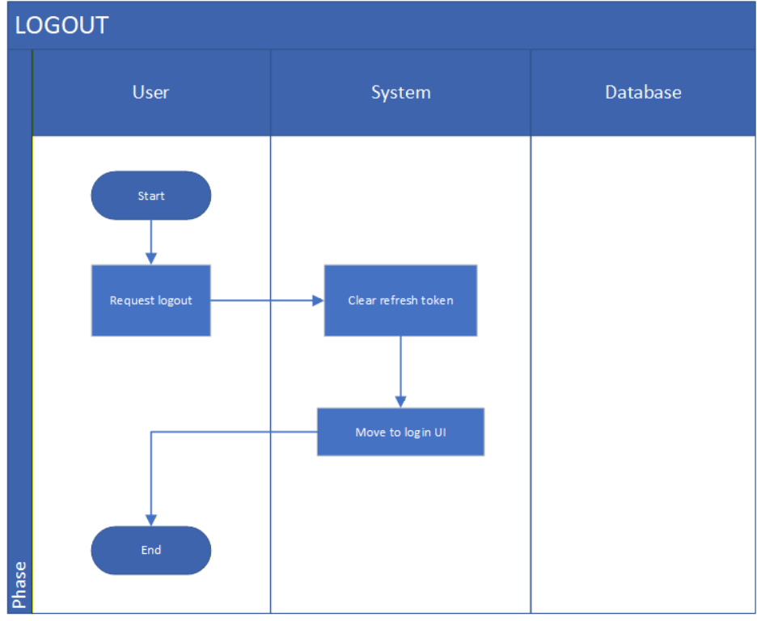

- User
- Start: Begin the logout process
- Request logout: Initiate a logout request.
- End: Complete the logout process.
- System
- Clear user information: Remove refresh token.
- Move to login UI: Redirect the user to the login interface.
- Database
- No actions are performed in the database during the logout process.
- Process Flow Summary
- The user requests to log out.
- The system clears the user's session or login data.
- The system redirects the user to the login screen.
- The process ends

Figure 12: Update Password
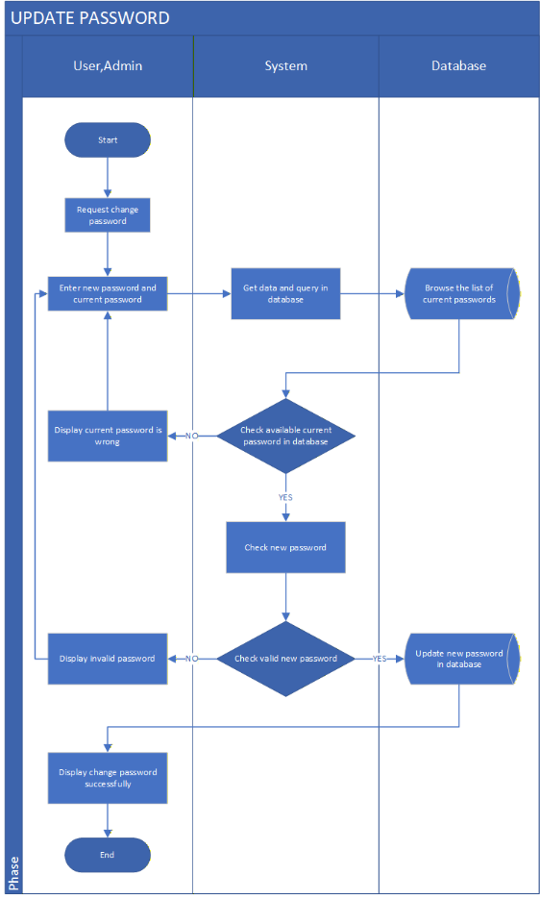

- User/Admin
- Start: Begin the password update process.
- Request change password: Initiate a password change request.
- Enter new password and current password: Input both the current and new password.
- Display invalid password: Show an error message if the current password is incorrect.
- End: Complete the process.
- System
- Get data and query in database: Retrieve the entered data and check it against the database.
- If the current password is valid: Decision point to verify the current password.
- Check new password: Validate the new password format or rules.
- If a new password is valid: Decision point to confirm the new password meets requirements.
- Database
- Browse the list of current passwords: Search for the current password in the database.
- Update new password in database: Save the new password if it passes validation.
- Process Flow Summary
- User/Admin requests to change passwords and enter both current and new passwords.
- System checks the current password against the database.
- If the current password is incorrect → display error message.
- If correct → system validates the new password.
- If valid → update password in the database and display success message.

Figure 13: Forget Password
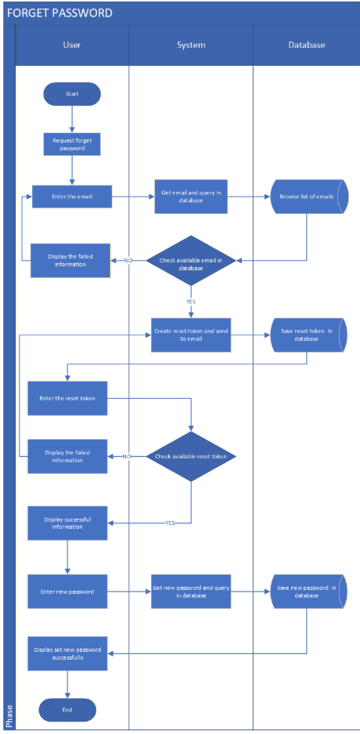
- User
- Start: Begin the password recovery process.
- Request to forget password: Initiate a password reset request.
- Enter the email: Input the registered email address.
- Display the failed information: Show an error message if the email is not found.
- Enter the reset token: Input the reset token received via email.
- Display the failed information: Show an error message if the token is invalid.
- Display successful information: Show a success message if the token is valid.
- Enter new password: Input a new password.
- Display password reset successfully: Confirm that the password has been reset.
- End: Complete the process.
- System
- Get email and query in database: Receive the email and check it against the database.
- If email is available in database: Decision point to verify email existence.
- Create reset token and send to email: Generate a reset token and send it to the user.
- Get a reset token and query in the database: Receive the token and check it against the database.
- If a reset token is available in database: Decision point to verify token validity.
- Get new password and save in database: Receive the new password and update it in the database.
- Database
- Browse a list of emails: Search for the email in the database.
- Save reset token in database: Store the generated reset token.
- Save new password in database: Update the user's password.
- Process Flow Summary
- User requests password reset and enters their email.
- System checks email in the database.
- If valid, the system generates a reset token and sends it via email.
- User enters the token.
- System verifies the token.
- If valid, the user enters a new password.
- System saves the new password and confirms success.

Figure 14: View User Profile
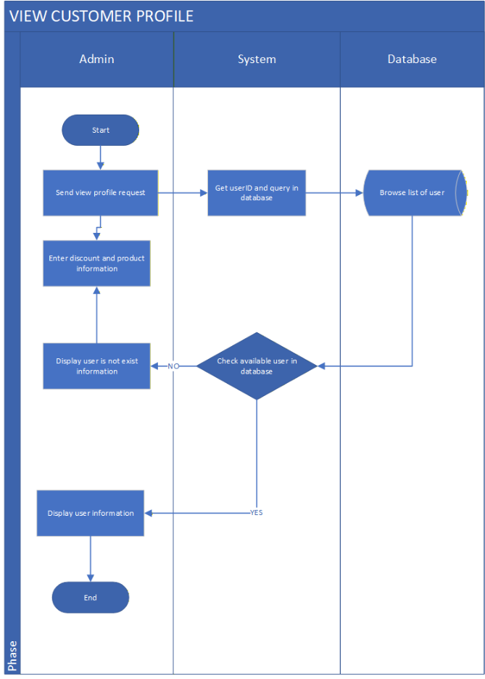
- Admin
• Start: Begin the process of viewing a customer profile.
• Send view profile request: Admin initiates a request to view a customer's profile.
• Enter discount and product information: Admin may input discount or product information (only when the user exists).
• Display user does not exist information: Show an error message if the user ID does not exist.
• Display user information: Show the customer’s profile details if the user exists.
• End: Complete the process.
- System
• Get user ID and query in database: Receive the user ID and query the database.
• If user is available in database: Decision point to verify existence.
• Display user does not exist information: Return error if user does not exist.
• Send customer information to Admin: Provide profile data if the user exists.
- Database
• Browse list of users: Search the user table for matching user ID.
- Process Flow Summary
1. Admin sends a request to view a customer profile.
2. System receives the user ID and queries the database.
3. Database checks for the user.
4. If user does not exist → system sends an error → admin sees “User does not exist”.
5. If user exists → system returns user info → admin views profile.
6. Admin may enter discount or product information.
7. Process ends.

Figure 15: Add User Account
- Admin
- Start: Begin the process of adding a user.
- Request to add user: Initiate a request to create a new user account.
- Enter user information: Input the user's details (e.g., name, email, role).
- Display user exists information: Show a message if the user already exists.
- Display successful information: Show a confirmation message if the user is added successfully.
- End: Complete the process.
- System
- Get data and query in database: Receive the user information and check it against the database.
- Decision point – If user is available in database:
- YES → Notify that the user already exists.
- NO → Proceed to save the new user information.
- Database
- Browse the list of users: Search for existing users in the database.
- Save user information in database: Store the new user's data.
- Process Flow Summary
- Admin initiates the process and enters user details.
- System checks if the user already exists in the database.
- If the user exists → display a message indicating duplication.
- If not → save the new user and confirm success.

Figure 16: Update User Account
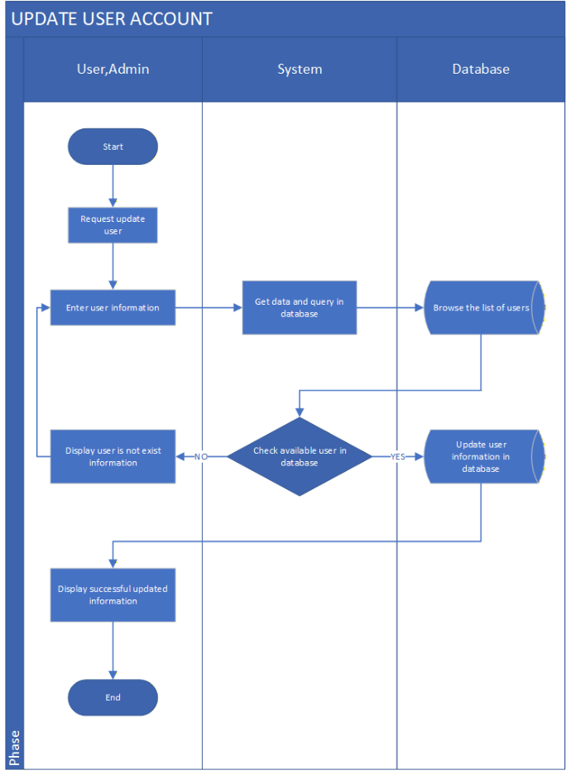
- User/Admin
- Start: Begin the update process.
- Request update user: Initiate a request to update user information.
- Enter user information: Input the updated user details.
- Display user does not exist information: Show an error message if the user is not found.
- Display successful updated information: Show a confirmation message if the update is successful.
- End: Complete the process.
- System
- Get data and query in database: Receive the input and check it against the database.
- Decision point – If user is available in database:
- NO → Notify that the user does not exist.
- YES → Proceed updates the user information.
- Database
- Browse the list of users: Search for the user in the database.
- Update user information in database: Save the updated user details.
- Process Flow Summary
- Admin requests to update a user and enters the new information.
- System checks if the user exists in the database.
- If not found → display error message.
- If found → update the user information and confirm success.

Figure 17: Delete User Account
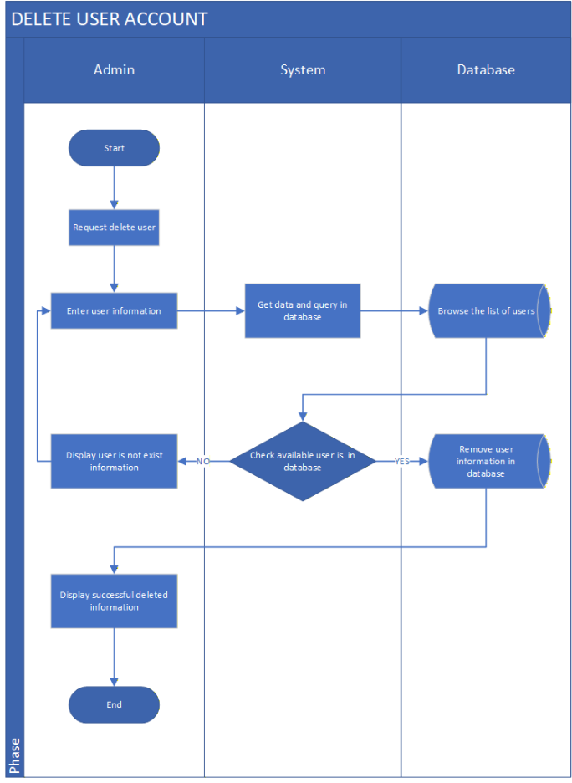

- Admin
- Start: Begin the deletion process.
- Request delete user: Initiate a request to remove a user account.
- Display user does not exist information: Show an error message if the user is not found.
- Display successfully deleted information: Show a confirmation message if the deletion is successful.
- End: Complete the process.
- System
- Get data and query in database: Receive the request and check the user data in the database.
- Decision point – If user is available in database:
- NO → Notify that the user does not exist.
- YES → Proceed to delete the user.
- Database
- Browse the list of users: Search for the user in the database.
- Remove user information in database: Delete the user’s data.
- Process Flow Summary
- Admin requests to delete a user.
- System checks if the user exists in the database.
- If not found → display error message.
- If found → delete the user and confirm success.

Figure 18: Lock User Account
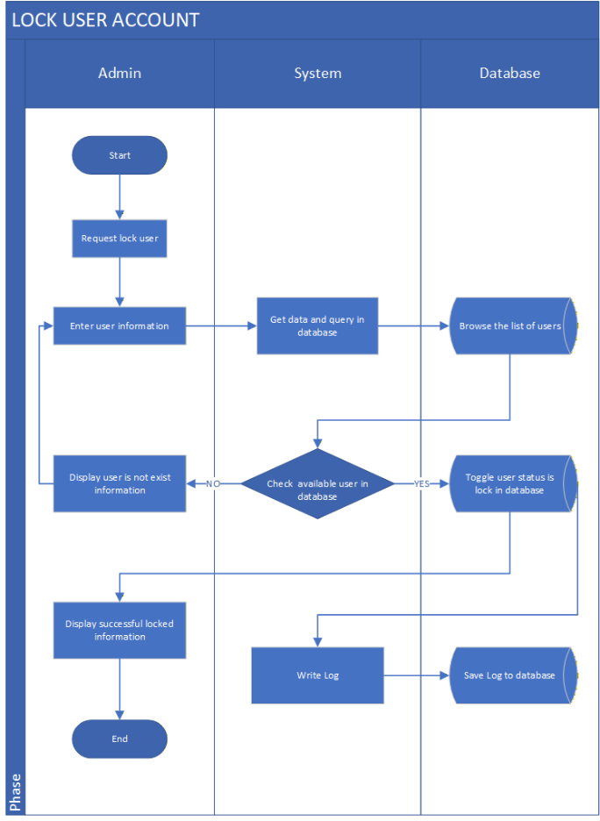
- Admin
- Start: Begin the account locking process.
- Request lock user: Initiate a request to lock a user account.
- Enter user information: Input the user’s details.
- Display user does not exist information: Show an error message if the user is not found.
- Display successfully locked information: Show a confirmation message if the account is successfully locked.
- End: Complete the process.
- System
- Get data and query in database: Receive the user information and check it against the database.
- Decision point – If user is available in database:
- NO → Notify that the user does not exist.
- YES → Proceed to lock the account and write a log entry.
- Database
- Browse the list of users: Search for the user in the database.
- Toggle user status is lock in database: Change the user’s status to “locked.”
- Save Log to database: Record the action in the system log.
- Process Flow Summary
- Admin requests to lock a user and enters the user’s information.
- System checks if the user exists in the database.
- If not found → display error message.
- If found → lock the account, save the log, and confirm success.

Figure 19: Add Product Information
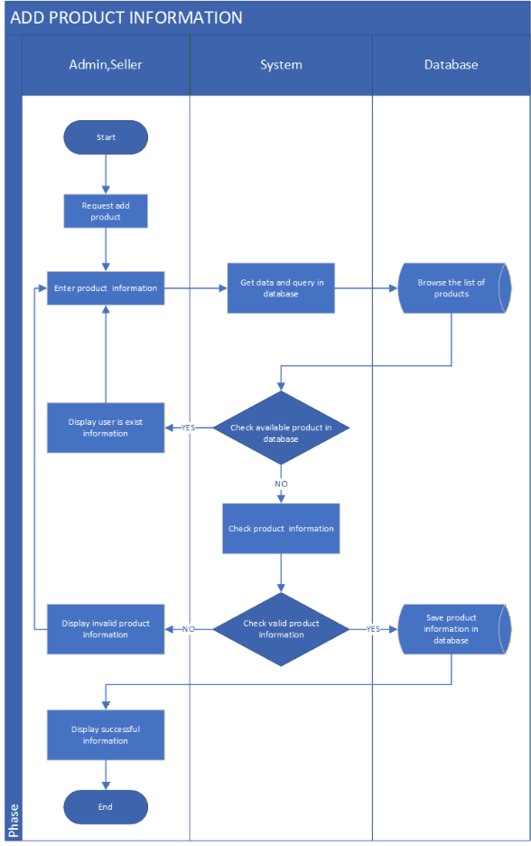
- Admin/Seller
- Start: Begin the process of adding a product.
- Request add product: Initiate a request to add product information.
- Enter product information: Input product details (e.g., name, category, price).
- Display user exists information: Confirm that the user is recognized by the system.
- Display invalid product information: Show an error message if the product data is incorrect.
- Display successful information: Show a confirmation message if the product is added successfully.
- End: Complete the process.
- System
- Get data and query in database: Receive the product data and check it against the database.
- Decision point – If product is available in database:
- YES → Notify that the product already exists.
- NO → Proceed validating the product information.
- Check product information: Verify the accuracy and completeness of the product data.
- Decision point – If product information is valid:
- YES → Save the product.
- NO → Notify invalid data.
- Database
- Browse the list of products: Search for existing products.
- Save product information in the database: Store the new product details.
- Process Flow Summary
- Admin or seller requests to add a product and enter its information.
- System checks if the product already exists.
- If it does → display duplication message.
- If not → validate the product data.
- If valid → save to database and confirm success.
- If invalid → display error message.

Figure 20: Update Product Information
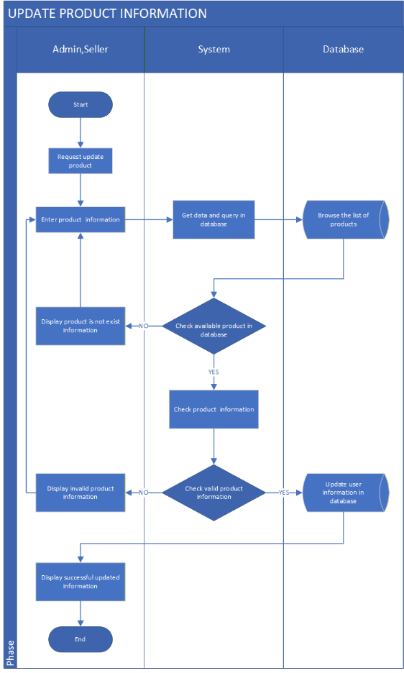
- Admin/Seller
- Start: Begin the product update process.
- Request to update product: Initiate a request to modify product information.
- Enter product information: Input updated product details.
- Display product does not exist information: Show an error message if the product is not found.
- Display invalid product information: Show an error message if the updated data is incorrect.
- Display successful updated information: Show a confirmation message if the update is successful.
- End: Complete the process.
- System
- Get data and query in database: Receive the product data and check it against the database.
- Decision point – If product is available in database:
- NO → Notify that the product does not exist.
- YES → Proceed to validate the updated information.
- Check product information: Verify the accuracy and completeness of the updated product data.
- Decision point – If product information is valid:
- NO → Notify of invalid data.
- YES → Proceed to update the product.
- Database
- Browse the list of products: Search for the product in the database.
- Update user information in database: Save the updated product details.
- Process Flow Summary
- Admin or seller requests to update a product and enter new information.
- System checks if the product exists in the database.
- If not found → display error message.
- If found → validate the updated data.
- If valid → update the product and confirm success.
- If invalid → display error message.

Figure 21: Delete Product Information
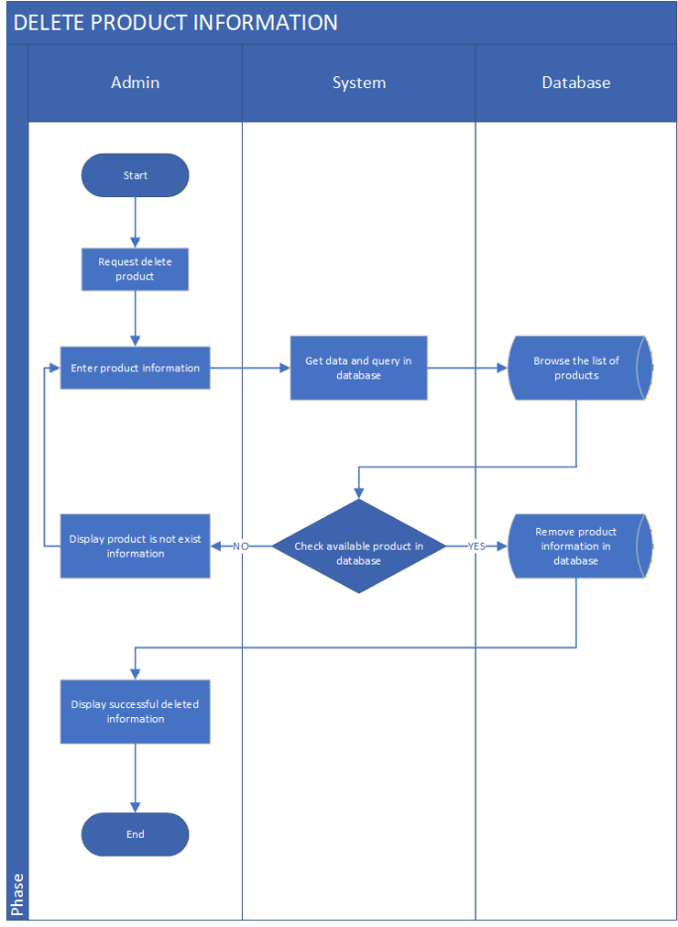

- Admin
- Start: Begin the product deletion process.
- Request to delete product: Initiate a request to remove a product.
- Display product does not exist information: Show an error message if the product is not found.
- Display successful deleted information: Show a confirmation message if the product is successfully deleted.
- End: Complete the process.
- System
- Get data and query in database: Receive the product data and check it against the database.
- Decision point – If product is available in database:
- NO → Notify that the product does not exist.
- YES → Proceed to delete the product.
- Database
- Browse the list of products: Search for the product in the database.
- Remove product information in database: Delete the product data.
- Process Flow Summary
- Admin requests to delete a product.
- System checks if the product exists in the database.
- If not found → display error message.
- If found → remove the product and confirm success.

Figure 22: Add Discount For Product

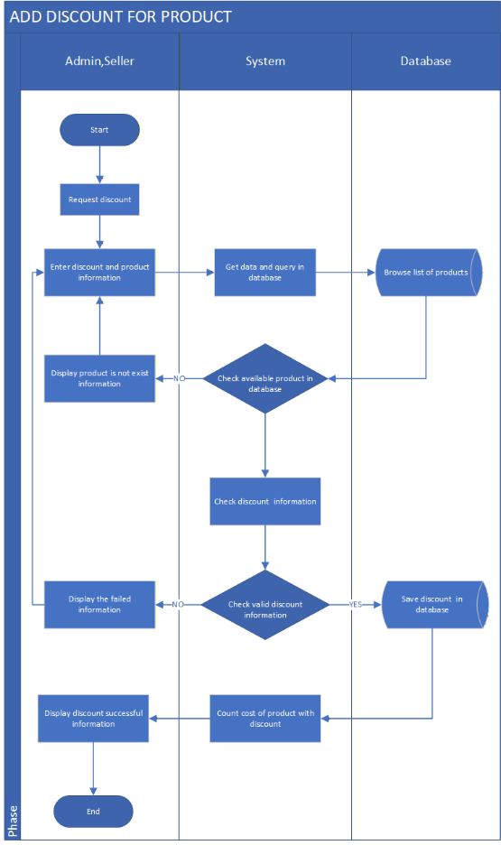
- Admin/Seller
- Start: Begin the discount process.
- Request discount: Initiate a request to apply a discount to a product.
- Enter discount and product information: Input product details and discount values.
- Display product is not exist information: Show an error message if the product is not found.
- Display the failed information: Show a general failure message if the process cannot proceed.
- Display discount successful information: Confirm that the discount was applied successfully.
- Display discount unsuccessful information: Show an error message if the discount data is invalid.
- End: Complete the process.
- System
- Get data and query in database: Receive the input and check it against the database.
- Decision point – If product is available in database:
No → Notify that the product does not exist.
Yes → Proceed validating the discount information.
- Check discount information: Verify the accuracy and validity of the discount data.
- Decision point – If discount information is valid:
- No → Notify that the discount is invalid.
- Yes → Proceed to save the discount.
- Database
- Browse list of products: Search for the product in the database.
- Save discount in database: Store the discount details for the product.
- Process Flow Summary
- Admin or seller requests to apply for a discount and enters product and discount details.
- System checks if the product exists in the database.
- If not found → display error message and end process.
- If found → validate the discount information.
- If valid → save the discount and confirm success.
- If invalid → display error message and end process.

Figure 23: Search Product
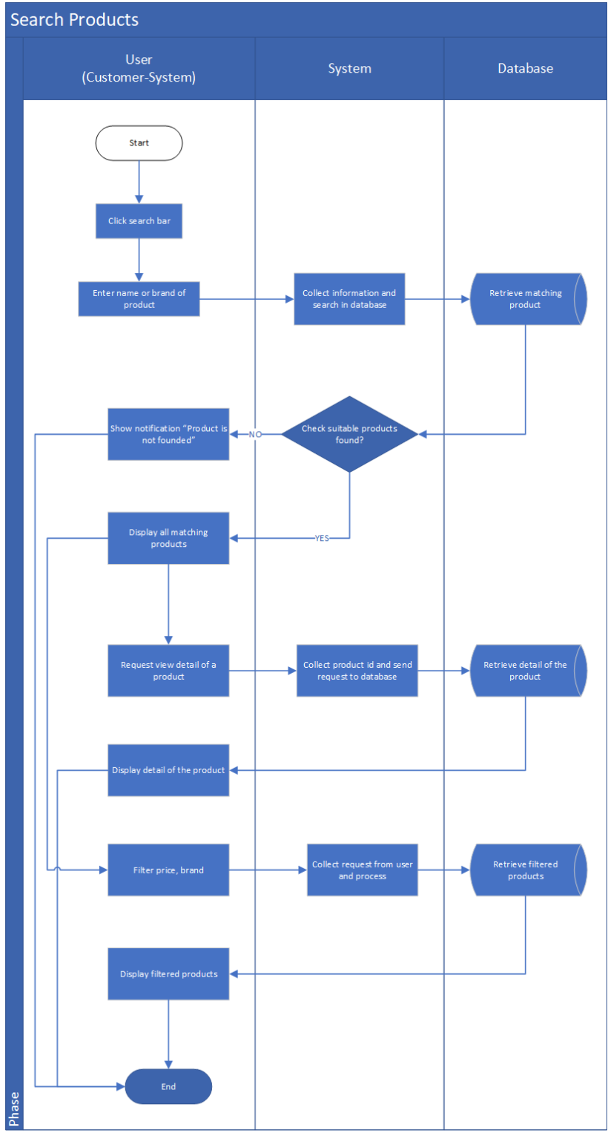
- User
- Start: The user begins the process by clicking on the search bar.
- Enter name or brand of product: The user types a product name or brand to search for.
- Show notification “Product is not found”: Displayed when the system receives information from the database that no suitable products were found.
- Displaying all matching products: Shown when the system receives products that match the user’s search criteria.
- Request view details of the product: The user selects a specific product to see its details.
- Collect product ID and send request to database: The system collects the selected product’s ID and sends a request to the database.
- Database: Retrieve details of the product: The database retrieves detailed information about that product.
- Display details of the product: The system shows detailed product information (description, price, images, etc.) to the user.
- Filter price, brand: The user can apply filters (for example, price range or brand).
- Display filtered products: The system displays the filtered results to the user.
- System
- Collect information and search in database: The system takes the input from the user and prepares a search query.
- Check suitable products found: The system checks whether any matching products were found.
- If NO: The system notifies the user that no product was found.
- If YES: The system proceeds to display the matching products.
- Collect product ID and send request to database: The system collects the selected product’s ID from the user and sends a request to the database.
- Collect request from user and process: The system receives the filter request (such as price or brand) and processes it.
- Database
- Retrieve matching product: The database searches for all products that match the entered keyword or brand name.
- Retrieve detail of the product: The database retrieves detailed information about the selected product.
- Retrieve filtered products: The database returns the filtered product list based on the user’s criteria.
- Process Flow Summary
- The user clicks on the search bar in the application.
- The user enters a product name or brand they want to find.
- The system collects the entered keyword and sends a search request to the database.
- The database looks for matching products that correspond to the user’s keyword.
- The database returns the search results to the system.
- The system checks whether any suitable products were found.
- If no products are found:
→ The system shows a message: “Product is not found.”
→ The flow ends.
- If products are found:
→ The system continues to display them.
- The system displays a list of all matching products to the user.
- The user selects a specific product to view details.
- The system collects the product ID of the selected item and sends a request to the database.
- The database retrieves the product details (e.g., name, price, description, images).
- The system displays the product detail page to the user.
- The user applies filters such as price range or brand.
- The system processes the filter request and sends it to the database.
- The database retrieves the filtered products.
- The system displays the filtered list of products to the user.
- After viewing or filtering, the user may end the search session.
- The flow ends.

Figure 24: Add Product In Cart

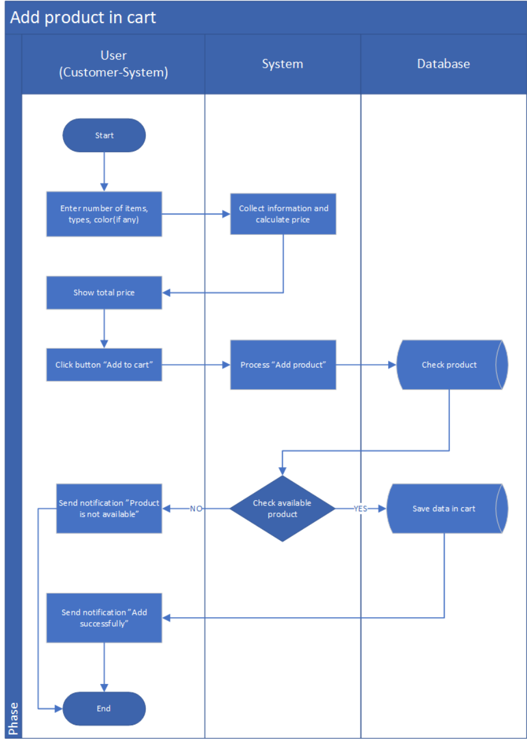

- User
- Start: The user begins the process by entering product details such as quantity, type, and color (if applicable).
- Enter number of items, types, color (if any): The user provides product specifications before adding to cart.
- Show total price: The system displays the total price based on the selected quantity and product details.
- Click button “Add to cart”: The user clicks the “Add to cart” button to confirm adding the selected product.
- Send notification “Product is not available”: Displayed when the product is unavailable or out of stock.
- Send notification “Add successfully”: Displayed when the product has been successfully added to the cart.
- System
- Collect information and calculate price: The system gathers the user’s input (quantity, type, color) and calculates the total price.
- Process “Add product”: The system processes the user’s request to add the selected product to the cart.
- Check available product: The system checks whether the requested product is available in stock.
- If NO: Sends notification “Product is not available.”
- If YES: Proceeds to save data in the cart and confirms success.
- Database
- Check product: The database verifies whether the selected product exists and if sufficient stock is available.
- Save data in cart: The database stores the product information (ID, quantity, color, etc.) in the user’s shopping cart.
- Process Flow Summary
- The user enters the number of items, type, and color (if any).
- The system collects the provided information and calculates the total price.
- The system displays the total price to the user.
- The user clicks the “Add to cart” button.
- The system processes the “Add product” request.
- The system checks product availability by querying the database.
- The database verifies the product details and stock quantity.
- The system checks whether the product is available:
- If NO:
→ The system sends a notification: “Product is not available.”
→ The flow ends.
- If YES:
→ The database saves the product data in the cart.
- The system sends a notification: “Add successfully.”
- The flow ends.

Figure 25: View Cart

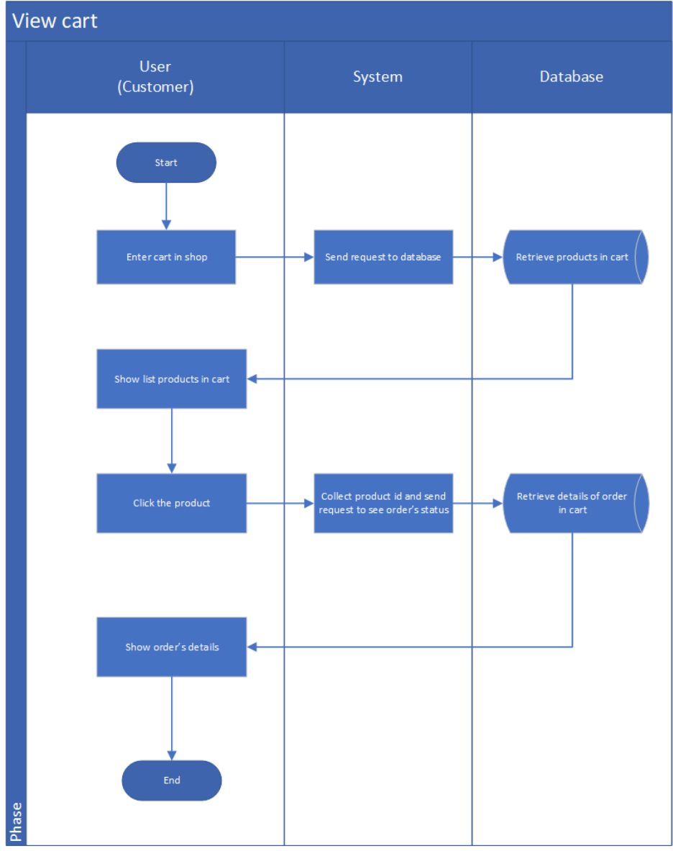

- User
- Start: The user begins the process by opening the cart section in the online shop.
- Enter cart in shop: The user accesses the shopping cart to review items.
- Show list products in cart: The system displays a list of all products currently stored in the user’s cart.
- Click the product: The user clicks on a specific product in the cart to view its order status or details.
- Show order’s details: The system shows detailed information about the selected product (quantity, price, color, order status, etc.).
- System
- Send request to database: The system sends a request to the database to retrieve the list of products currently in the user’s cart.
- Collect product ID and send request to see order’s status: When the user selects a product, the system collects its ID and sends a request to the database to fetch detailed information.
- Database
- Retrieve products in cart: The database retrieves all products that are currently saved in the user’s shopping cart.
- Retrieve details of order in cart: The database retrieves full details of the selected product or order in the cart (price, quantity, status, etc.).
- Process Flow Summary
- The user enters the cart section in the shop.
- The system sends a request to the database to retrieve the user’s cart information.
- The database retrieves all products currently in the cart.
- The system displays the list of products in the cart to the user.
- The user clicks on a specific product to view details.
- The system collects the selected product’s ID and sends a request to the database.
- The database retrieves the details of that product or order in the cart.
- The system displays the product or order details to the user.
- The flow ends.

Figure 26: Delete Product In Cart

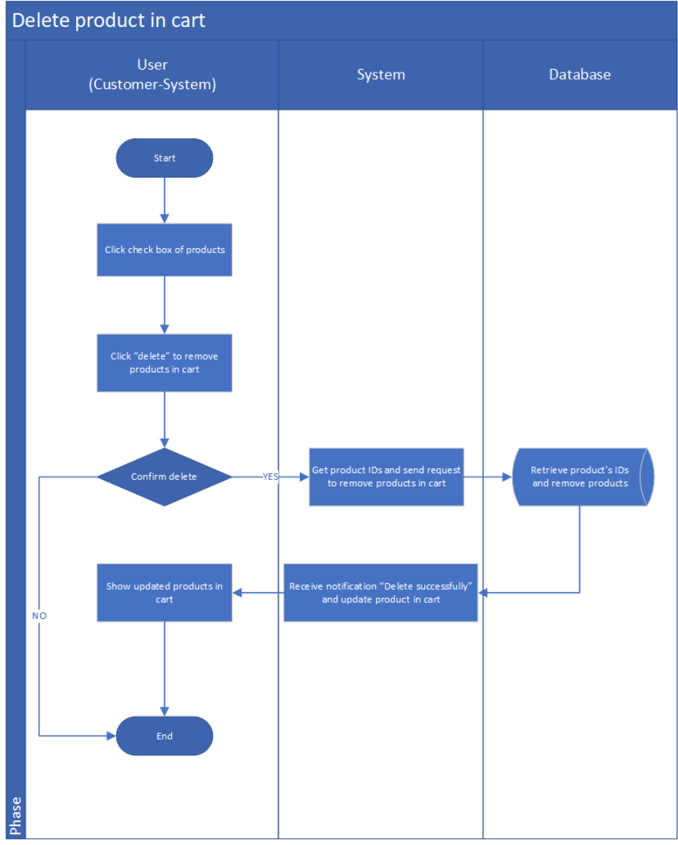

- User (Customer)
- Start: The process begins when the user wants to remove one or more products from their shopping cart.
- Click checkbox of products: The user selects the product(s) they want to delete from the cart by checking the corresponding boxes.
- Click “Delete” to remove products in cart: The user clicks the Delete button to initiate the removal process.
- Confirm delete:
- If No, the system cancels the deletion and returns to show the current list of products in the cart.
- If Yes, the deletion continues.
- Show updated products in cart: The system displays the updated cart after the selected products have been deleted.
- End: The process ends.
- System
- Get product IDs and send request to remove products in cart: The system collects the IDs of the selected products and sends a request to the database to delete them.
- Receive notification “Delete successfully” and update product in cart: After receiving confirmation from the database, the system updates the cart and notifies the user that the deletion was successful.
- Database
- Retrieve product’s IDs and remove products: The database receives the deletion request, identifies the selected products using their IDs, and removes them from the cart records.
- Process Flow Summary
- The user checks the boxes of the products they want to delete.
- The user clicks Delete.
- The system asks the user to confirm deletion.
- If the user cancels (No), the system shows the same cart.
- If the user confirms (Yes):
- The system retrieves the selected product IDs.
- The system sends a request to the database to remove the products.
- The database deletes the products from the cart.
- The system receives confirmation and updates the cart view.
- The updated cart is shown to the user.
- The process ends.

Figure 27: Update Product In Cart

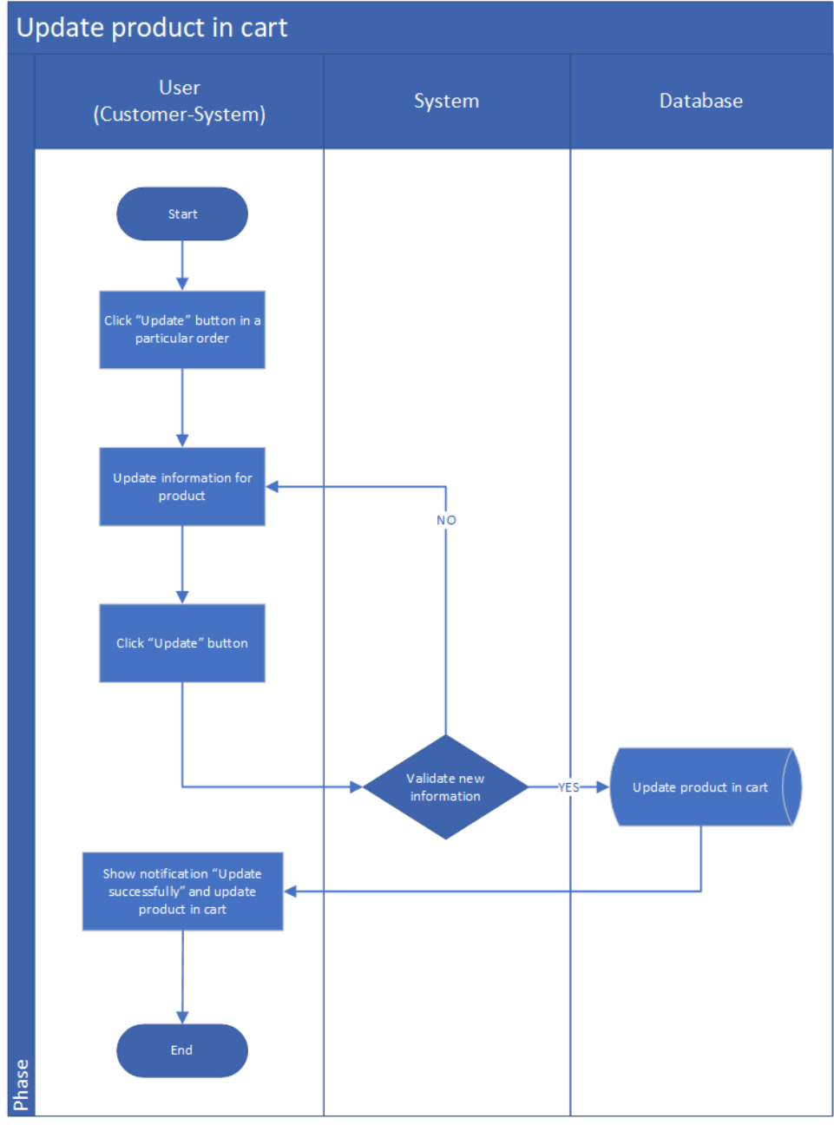

- User (Customer)
- Start: The process begins when the user wants to modify product information in their cart (e.g., quantity, size, color).
- Click “Update” button in a particular order: The user selects the product they wish to update and clicks the Update button.
- Update information for product: The user edits the desired information for the product in the cart.
- Click “Update” button: The user confirms the change by clicking Update again.
- Show notification “Update successfully” and update product in cart: After the update is validated and completed, the system notifies the user and shows the updated cart.
- End: The process ends.
- System
- Validate new information.
- If No, the system rejects the update and prompts the user to correct invalid information.
- If Yes, the system proceeds to update the cart.
- Send request to database to update product in cart: Once validated, the system sends the updated information to the database.
- Receive confirmation and notify user: The system receives confirmation from the database and displays a success message.
- Database
- Update product in cart: The database updates the record of the selected product with new information (e.g., new quantity or attributes).
- Process Flow Summary
- The user clicks the Update button for a specific product in their cart.
- The user modifies the product details.
- The user clicks Update to confirm changes.
- The system validates the new information.
- If invalid, the system notifies the user to correct it.
- If valid, the system updates the database.
- The database updates the product information in the cart.
- The system receives confirmation and displays a success message.
- The updated product is shown in the cart.
- The process ends.

Figure 28: View & Confirm Payment

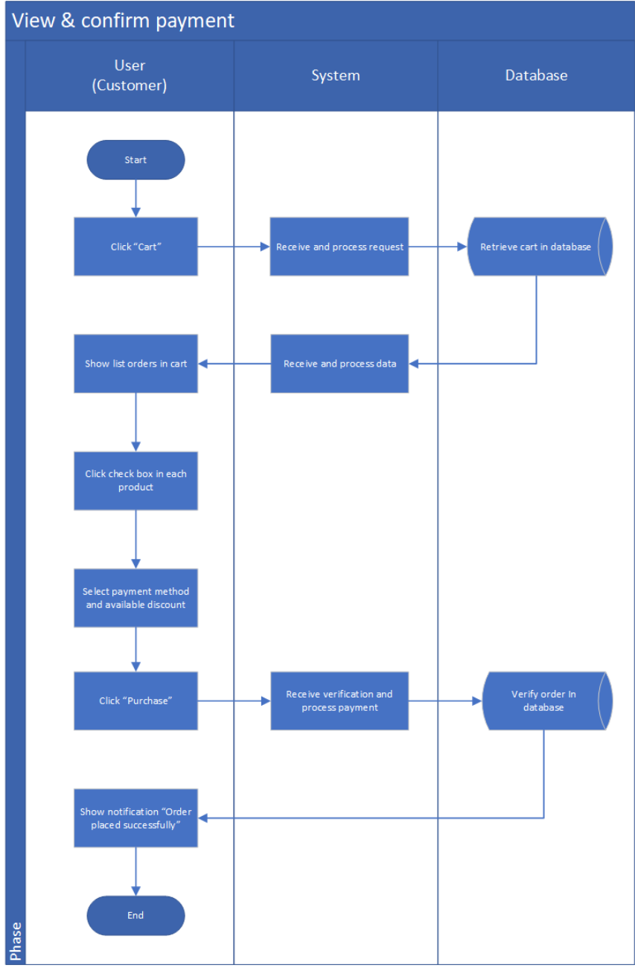
- User (Customer)
- Start: The process begins when the user wants to review their cart and confirm payment.
- Click “Cart”: The user accesses their shopping cart to review the items before checkout.
- Show list orders in cart: The system displays all the items currently in the user’s cart.
- Click check box in each product: The user selects the specific items they want to purchase.
- Select payment method and available discount: The user chooses their preferred payment method (e.g., credit card, PayPal) and applies any available discounts or coupons.
- Click “Purchase”: The user confirms their order and initiates the payment process.
- Show notification “Order placed successfully”: After payment verification, the user receives confirmation that the order has been placed successfully.
- End: The process ends.
- System
- Receive and process request: The system receives the user’s request to open the cart and prepares to display cart contents.
- Receive and process data: The system gathers product data and sends a request to the database.
- Receive verification and process payment: After the user confirms the order, the system verifies the payment details and processes the transaction.
- Notify user of success: Once the payment is confirmed, the system sends a success message to the user.
- Database
- Retrieve cart in database: The database retrieves the user’s cart items and their associated details.
- Verify order in database: The database validates the selected items, confirms availability, and finalizes the order record once payment is processed.
- Process Flow Summary
- The user clicks the Cart button to review their items.
- The system receives the request and retrieves cart details from the database.
- The system displays the list of products in the cart.
- The user selects items to purchase.
- The user chooses a payment method and applies available discounts.
- The user clicks Purchase to confirm.
- The system verifies payment and sends a confirmation request to the database.
- The database validates and confirms the order.
- The system notifies the user that the order was placed successfully.
- The process ends.

Figure 29: Choose Payment Method

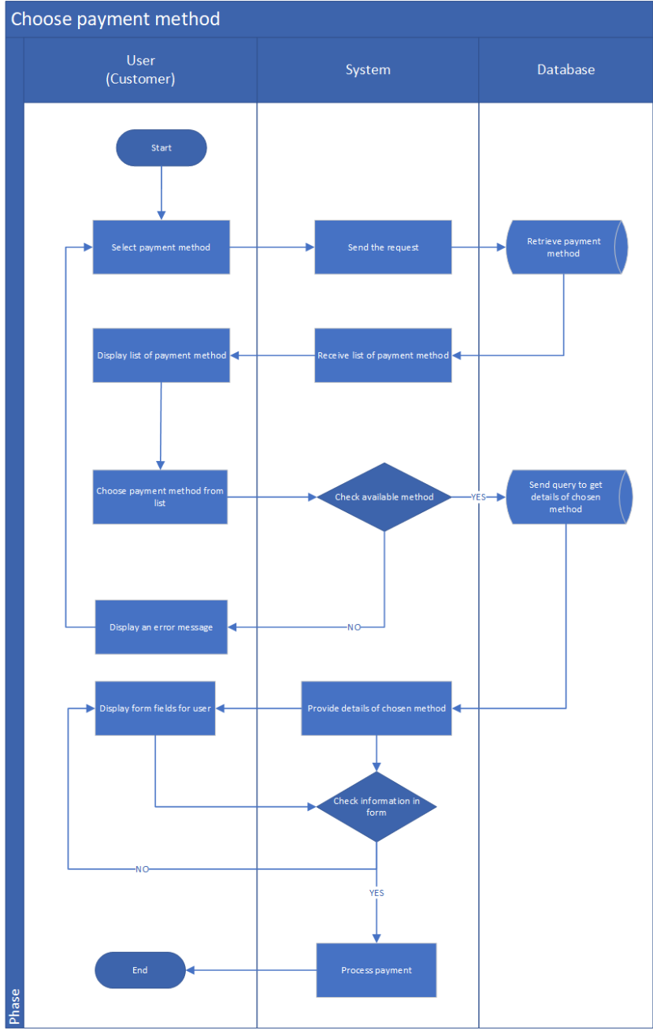
- User (Customer)
- Start: The process begins when the user proceeds to choose a payment method.
- Select payment method: The user clicks on the option to choose a payment method for their purchase.
- Display list of payment methods: The system shows the available payment methods for the user to select.
- Choose payment method from list: The user selects one of the available payment methods.
- Display an error message: If the chosen method is unavailable, the system displays an error message and the process ends.
- Display form fields for user: If the payment method is available, the system displays necessary input fields for payment information (e.g., card number, bank details).
- End: The process ends if the user does not complete the form or if information validation fails.
- System
- Send the request: When the user opens the payment selection, the system sends a request to the database to retrieve available payment methods.
- Receive list of payment methods: The system receives the list from the database and displays them to the user.
- Check available method: When the user selects one, the system checks whether the chosen method is active and usable.
- Provide details of chosen method: If available, the system provides the necessary form and payment details.
- Check information in form: The system validates the payment information entered by the user.
- Process payment: If the information is correct, the system initiates the payment process.
- Database
- Retrieve payment methods: The database provides the system with the list of all available payment methods.
- Send query to get details of chosen method: Once a method is selected, the system queries the database to retrieve additional details (e.g., API endpoint, payment configuration, or account info).
- Process Flow Summary
- The user chooses to select a payment method.
- The system requests available payment options from the database.
- The database retrieves and sends the list of payment methods.
- The system displays the available methods to the user.
- The user selects one method.
- The system checks the availability of the chosen method:
- If not available, an error message is displayed.
- If available, the system retrieves payment details from the database.
- The system displays a payment form for the user to fill in.
- The user enters information; the system validates the input.
- If validation passes, the system processes the payment.
- The process ends.

Figure 30: Confirm Invoice Cancellation

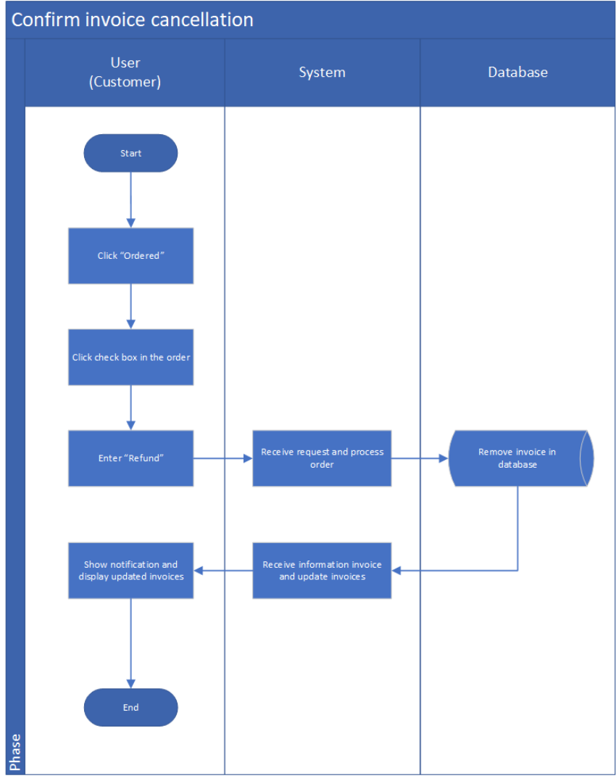
- User (Customer)
- Start: The process begins when the user wants to cancel a previously created invoice.
- Click “Ordered”: The user navigates to the order list by clicking the “Ordered” button.
- Select invoice: The user checks the box next to the invoice they wish to cancel.
- Enter “Refund”: The user confirms the cancellation by selecting the “Refund” option.
- Show notification and updated list: The system displays a notification confirming successful cancellation and shows the updated list of invoices.
- End: The process ends after the invoice status is updated and shown to the user.
- System
- Receive request and process order: When the user confirms the refund, the system receives the cancellation request.
- Send delete request to database: The system sends a request to the database to remove the corresponding invoice.
- Receive confirmation from database: The system receives confirmation that the invoice has been successfully removed.
- Update invoice list: The system updates the invoice list and prepares it to be shown to the user.
- Display updated information: The system displays the updated invoices and shows a notification to the user.
- Database
- Remove invoice in database: Upon receiving the request from the system, the database deletes the corresponding invoice record.
- Return confirmation: The database sends a confirmation response back to the system indicating successful removal of the invoice.
- Flow Summary
- The user navigates to the order list by clicking “Ordered.”
- The user selects the invoice to cancel by checking the box.
- The user confirms cancellation by selecting “Refund.”
- The system receives the request and processes the cancellation.
- The database removes the invoice record.
- The system updates and displays the revised list of invoices.
- The user sees a success notification confirming the cancellation.
- The process ends.

Figure 31: Refund Payment
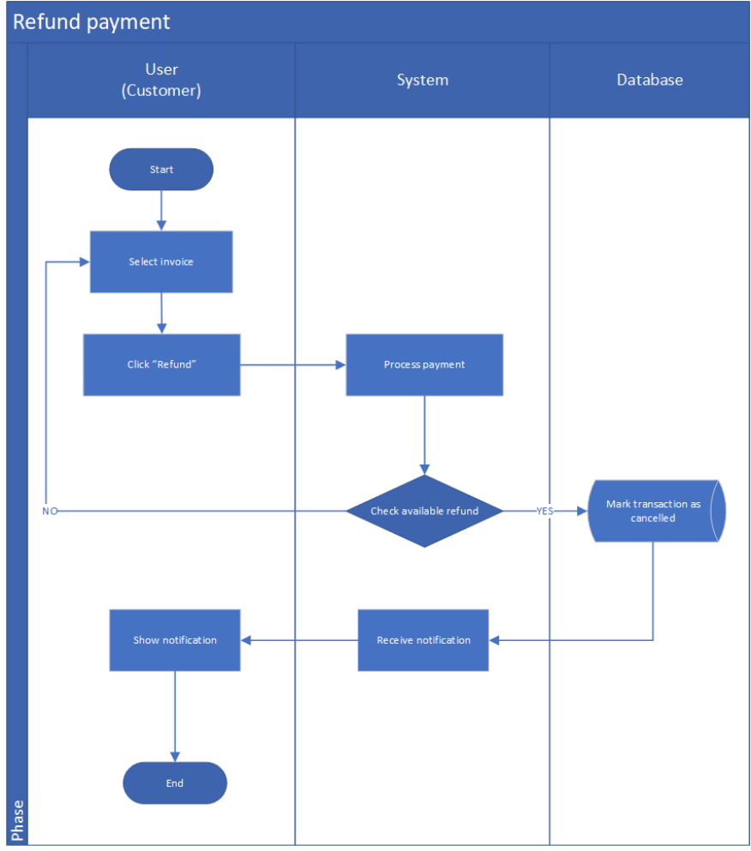

- User (Customer)
- Start: The process begins when the customer decides to request a refund for a completed payment.
- Select invoice: The user selects the specific invoice that they wish to refund.
- Click “Refund”: The user initiates the refund process by clicking the “Refund” button.
- Show notification: Once the system processes the refund and returns confirmation, the user is notified of the refund status (e.g., successful or unavailable).
- End: The process ends after the user views the notification.
- System
- Process payment: When the user clicks “Refund,” the system processes the refund request and prepares to validate whether the payment can be refunded.
- Check available refund: The system verifies if the selected payment transaction is eligible for a refund (for example, ensuring the transaction hasn’t already been refunded or is still within the refundable period).
- If unavailable: The system sends a message that a refund cannot be processed, and the process ends.
- If available: The system proceeds to mark the transaction as cancelled in the database.
- Receive notification: Once the database confirms the update, the system retrieves the result and sends a refund confirmation or failure notice to the user interface.
- Database
- Mark transaction as cancelled: The database updates the status of the corresponding transaction to “Cancelled” or “Refunded,” recording all relevant refund details (e.g., refund date, reason, refund ID).
- Process Flow Summary
- The user selects the invoice for which they want a refund.
- The user clicks “Refund.”
- The system receives the refund request and begins processing it.
- The system checks if the payment is eligible for refund.
- If not available, the system notifies the user that the refund cannot be processed.
- If available, the system updates the database to mark the transaction as refunded.
- The database confirms the update.
- The system receives confirmation and displays a refund notification to the user.
- The user views the notification, and the process ends.

Figure 32: View Status Invoice
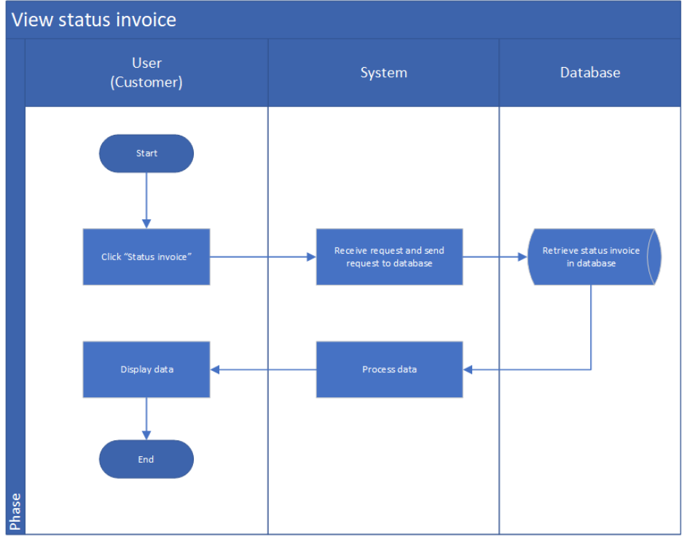

- User (Customer)
- Start: The process begins when the customer wants to check the current status of an invoice.
- Click “Status Invoice”: The user initiates the process by selecting the option to view the status of an invoice.
- Display data: After the system retrieves and processes the information, the invoice status details are displayed to the user.
- End: The process ends when the user finishes viewing the invoice information.
- System
- Receive request: When the user clicks “Status Invoice,” the system receives the request to view invoice details.
- Send request to database: The system sends a query to the database to retrieve the corresponding invoice status information.
- Process data: Once the data is received from the database, the system processes and formats it for display (e.g., invoice number, date, status, total amount).
- Send data to user interface: The system sends the processed data back to the user interface for presentation.
- Database
- Retrieve status invoice: The database searches for the invoice record based on the user’s request and retrieves relevant data (e.g., invoice ID, creation date, total amount, current status).
- Return data: The database sends the retrieved invoice details to the system for further processing.
- Process Flow Summary
- The user decides to check the status of an invoice.
- The user clicks “Status Invoice.”
- The system receives the request and sends a query to the database.
- The database retrieves the invoice status information.
- The database returns the data to the system.
- The system processes and formats the retrieved information.
- The system displays the invoice details and status to the user.
- The user views the information, and the process ends.

Figure 33: View History of Transaction
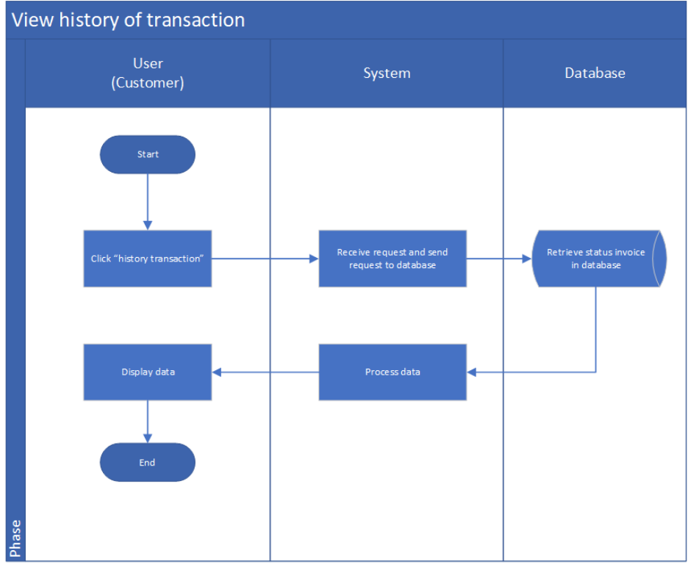

- User (Customer)
- Start: The process begins when the customer wants to view the history of their past transactions.
- Click “History Transaction”: The user selects the “History Transaction” option to see previous payment or order records.
- Display data: Once the system retrieves and processes the data, the list of transaction histories (including transaction IDs, dates, amounts, and statuses) is displayed to the user.
- End: The process ends when the user finishes viewing the transaction history.
- System
- Receive request: The system receives the user’s request to view their transaction history.
- Send request to database: The system sends a query to the database to fetch all transactions associated with the current user.
- Process data: After receiving the data from the database, the system formats and prepares it for presentation (e.g., sorting by date or filtering by transaction type).
- Send data to user interface: The system sends the processed transaction data to the user interface for display.
- Database
- Retrieve transaction history: The database retrieves all records of transactions linked to the customer account, including details like transaction date, total amount, payment status, and invoice ID.
- Return data: The database sends the retrieved information back to the system for further processing.
- Process Flow Summary
- The user decides to view their transaction history.
- The user clicks “History Transaction.”
- The system receives the request and sends it to the database.
- The database retrieves all related transaction records.
- The database returns the data to the system.
- The system processes and formats the information.
- The system displays the list of transactions to the user.
- The user views the information, and the process ends.

Figure 34: View Order List
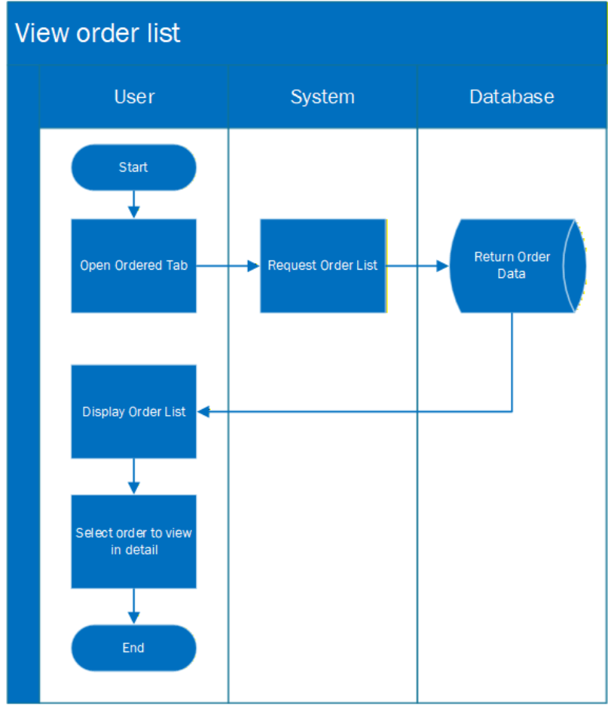

- User (Customer):
- Start: Begin the process of viewing order history.
- Open Ordered Tab: The user navigates to the “Orders” section in the system UI.
- Display Order List: User views the list of previously created orders.
- Select order to view in detail: User chooses a specific order for further inspection (leading to view detail activity).
- End: The order viewing process is complete.

- System:
- Request Order List: The system receives the request from the user and queries the database for the user's order history.
- Database:
- Return Order Data: The database retrieves all order records belonging to the user and sends them back to the system.
- Flow Summary:
- User starts the process to view order list.
- User opens the “Orders” tab.
- System requests order list data from the database.
- Database fetches and returns order records.
- System displays the order list to the user.
- User selects an order to view detailed information.
- Process ends.

Figure 35: Review and approves customer orders
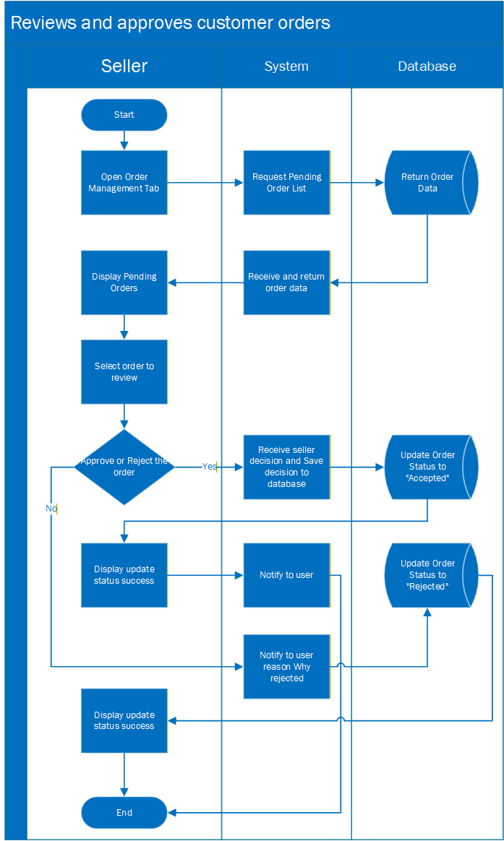

- Seller:
- Start: Seller begins the order management process.
- Open Order Management Tab: Seller navigates to the order management dashboard.
- Display Pending Orders: Seller sees list of orders that require action (pending review).
- Select order to review: Seller chooses an order to inspect details.
- Approve or Reject the order: Seller either approves (order moves to processing) or rejects (notify customer).
- If Reject — Enter rejection reason: When rejecting, seller types a short reason/ message explaining why.
- Display update status success: Seller receives visual confirmation that the order status update has been processed.
- End: Seller completes the review session.
- System:
- Request Pending Order List: Upon seller opening the tab, the system queries the database for orders with status = pending.
- Receive and return order data: The system obtains the records from the database and prepares them for display.
- Receive seller decision (approve/reject) and Save decision to database: Capture the seller’s action and any rejection reason provided. Issue update request to set order status to Accepted or Rejected and include rejection reason if any.
- Notify the user: Send a notification to the customer: if accepted → confirmation; if rejected → notification that includes the seller’s reason.
- Database:
- Return order data: Respond to the system’s query with the list of pending orders and their stored details.
- Update order status to “Accepted” (when approved): Persist the new state.
- Update order status to “Rejected” and store reason (when rejected): Persist the rejection status and save the seller’s rejection message for audit and notification.
- Process Flow summary:
- Seller opens Order Management then System requests pending orders from Database.
- Database returns pending order data → System displays the pending orders to Seller.
- Seller selects an order and decides: Approve or Reject.
- Approve path:
- System saves status = Accepted to Database.
- Database acknowledges.
- System notifies the customer of acceptance.
- System shows success confirmation to Seller → end.
- Reject path:
- Seller enters a rejection reason.
- System saves status = Rejected and the reason to Database.
- Database acknowledges.
- System notifies the customer with the rejection reason.
- System shows success confirmation to Seller → end.

Figure 36: Cancel Order

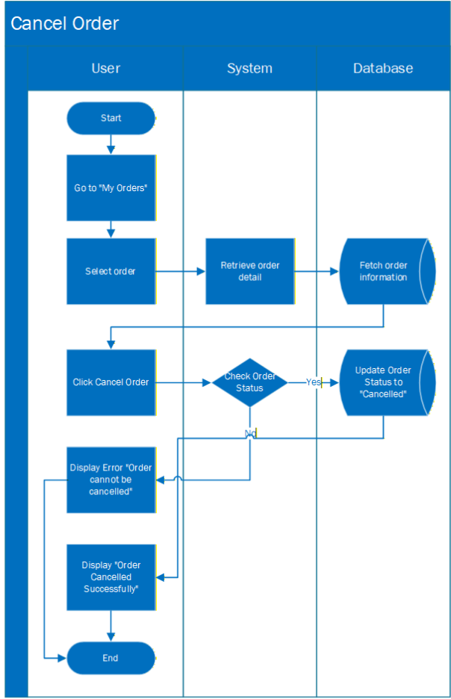

- User (Customer):
- Start: Begin the order cancellation process.
- Go to "My Orders": The user navigates to the “My Orders” section to view their order list.
- Select order: The user selects the order they want to cancel.
- Click Cancel Order: The user initiates the cancellation request.
- Display Error "Order cannot be cancelled": If the order is not eligible for cancellation (e.g., already shipped), an error message is shown.
- Display "Order Cancelled Successfully": If the cancellation is valid, the user sees a success message.
- End: The cancellation process ends.
- System:
- Retrieve order detail: The system receives the order selection and retrieves its details from the database.
- Check Order Status: The system verifies whether the order is eligible for cancellation (e.g., processing vs shipped).
- Database:
- Fetch order information: The database returns the selected order’s information to the system for status checking.
- Update Order Status to “Cancelled”: If allowed, the database updates the order status to "Cancelled".
- Process flow summary
- User opens “My Orders”.
- User selects an order and clicks “Cancel Order”.
- System retrieves order details from the database.
- System checks if the order status is eligible for cancellation.
- If not eligible → System displays error message to user.
- If eligible → System updates order status to “Cancelled” in the database.
- System displays a success message to the user.
- Process ends.

Figure 37: Report
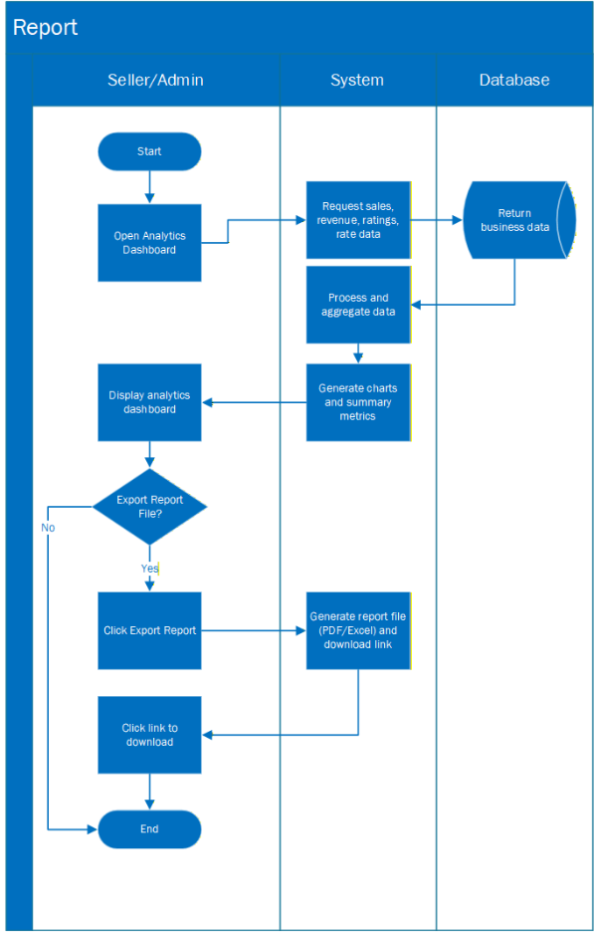

- Seller/Admin:
- Start: initiates the reporting functionality to review system analytics.
- Open the Analytics Dashboard: accesses the analytics dashboard in the system to begin reviewing business performance.
- View analytics charts and statistics (sales, revenue, ratings, return rate, etc.): The dashboard displays key business metrics including revenue trends, top-selling products, customer ratings, and return rate for review.
- Decide whether to export the report file: evaluate if the displayed analytics need to be exported for documentation or further analysis.
- If exporting → click "Export Report": If export is required, the Seller/Admin selects the export option to generate a downloadable report file.
- If no exporting: The reporting session is completed.
- Click download link: The system provides a download link and the Seller/Admin clicks to download the generated PDF or Excel report.
- End the process: The reporting session is completed.
- System:
- Receive dashboard access request: The system receives a request from the Seller/Admin to access the analytics dashboard and begin loading performance data.
- Request sales, revenue, rating, and return data from the database: The system sends a query to the database to retrieve required business information including sales figures, revenue records, customer ratings, and return statistics.
- Process and aggregate business data: The system processes the collected data, performs calculations, aggregates results, and prepares structured analytics.
- Generate analytics charts and summary metrics: The system converts the processed data into charts, graphs, and summary metrics for visual presentation on the dashboard.
- Generate PDF/Excel file and provide download link: If the user requests exporting the report, the system generates the selected file format (PDF/Excel), stores it temporarily, and provides a secure download link to the user.
- Database:
- Retrieve business data (sales, returns, ratings, revenue): The database searches and retrieves all relevant business records including sales transactions, return logs, customer rating data, and revenue history.
- Return data to the system for analysis: The database sends the requested business data back to the system for processing, aggregation, and visualization.
- Process Flow Summary:
- Seller/Admin opens the analytics dashboard.
- System sends a request to the database for business data.
- Database returns sales, revenue, ratings, and return rate information.
- System processes and aggregates the data, then displays charts and analytics.
- Seller/Admin views the dashboard.
- Seller/Admin chooses whether to export the report.
- If export is selected, the system generates a PDF/Excel report and provides a download link.
- Seller/Admin downloads the report file.
- Process ends.

- Database

User Table
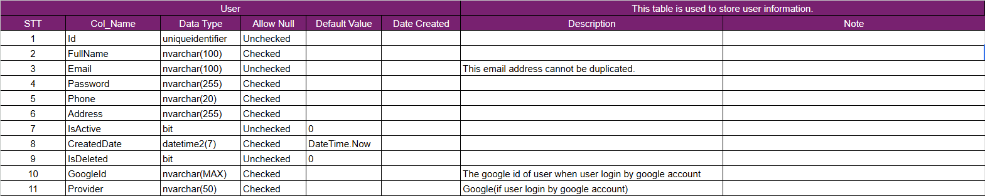

User Role Table

Role Table

Activation Code Table
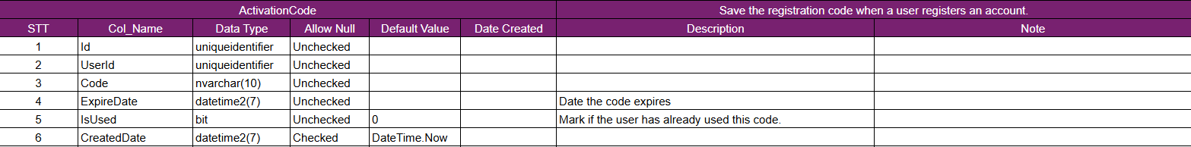

Product Table
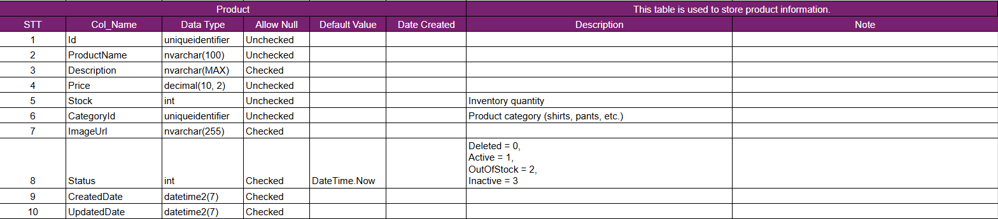

Category Table
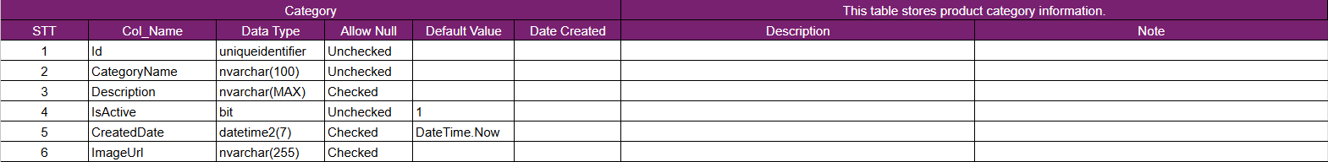

Cart Table

Cart Item Table
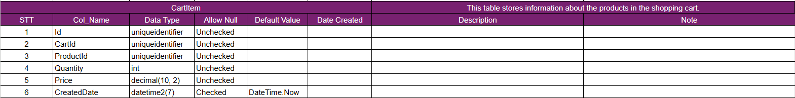

Order Table
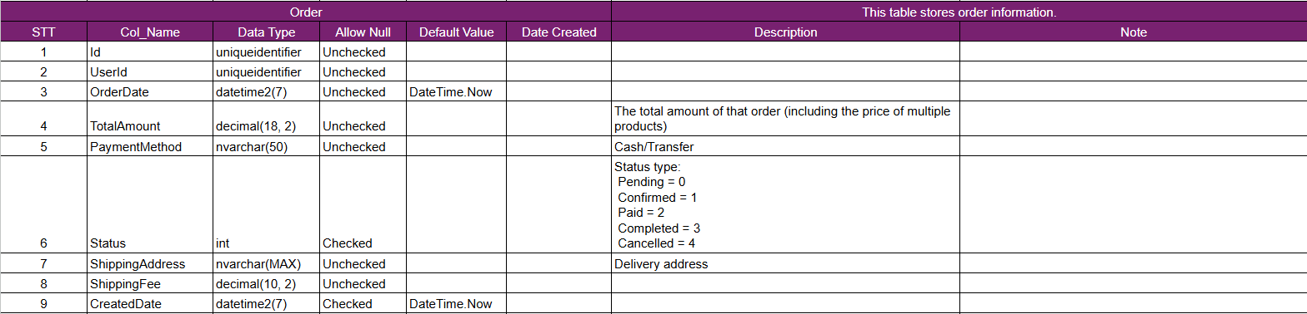

Order Detail Table
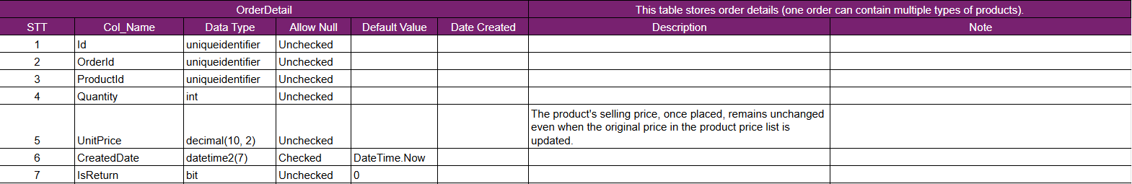

Discount Table
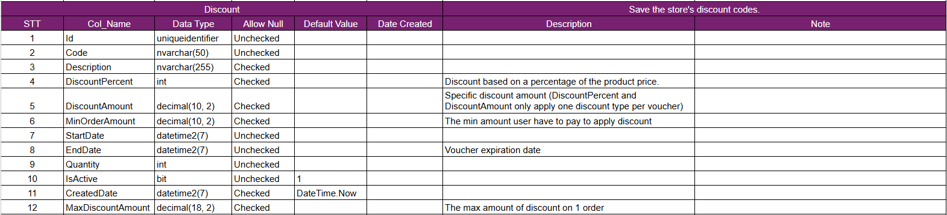

Order Discount Table
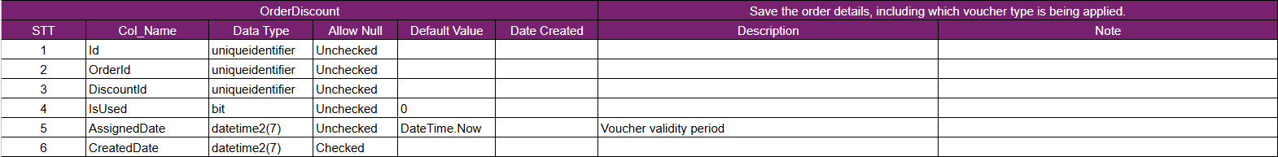

Payment Table
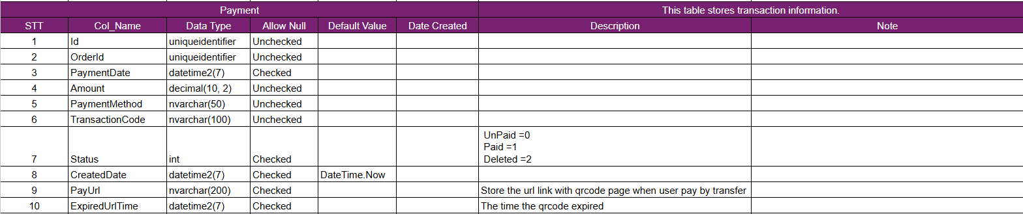

Shipment Table
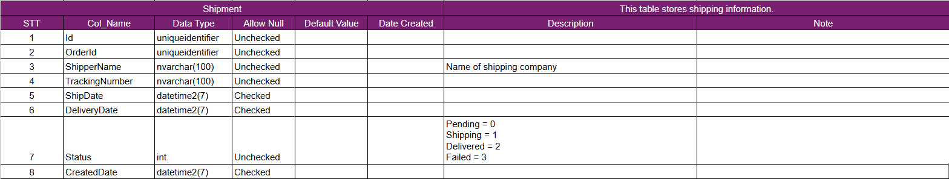

Review Table
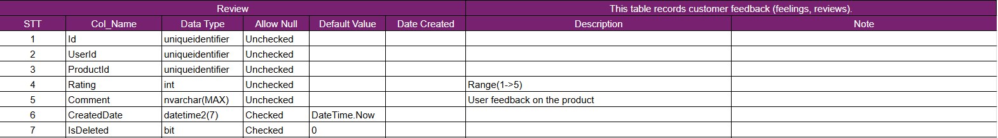

Deleted User
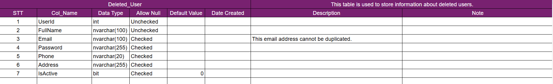

Deleted Order
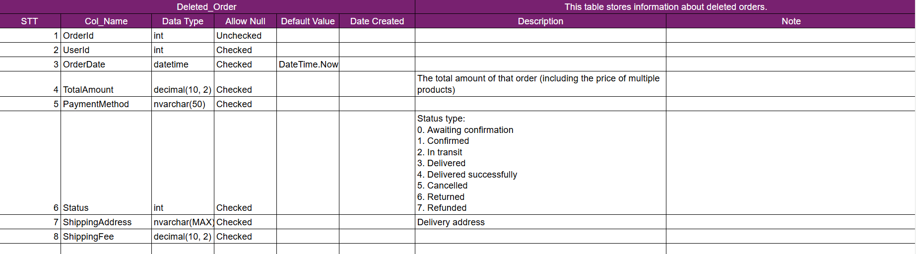

Deleted Order Detail
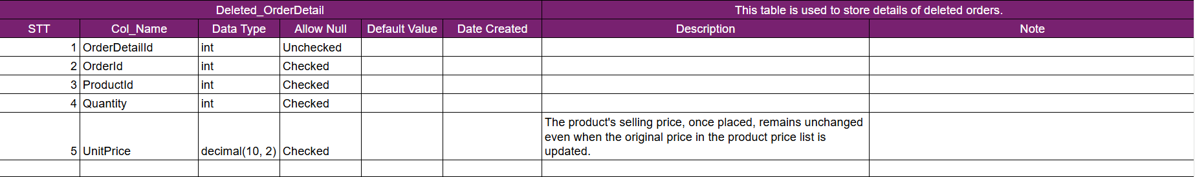

Deleted Product
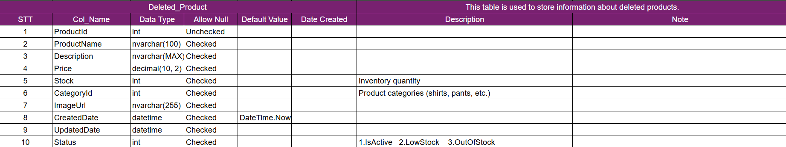
- Activation Code
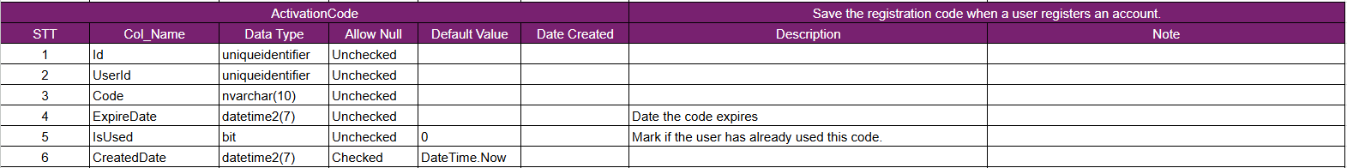

Refresh Token
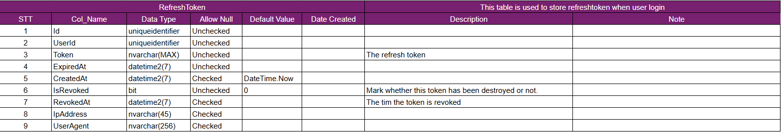

Refund
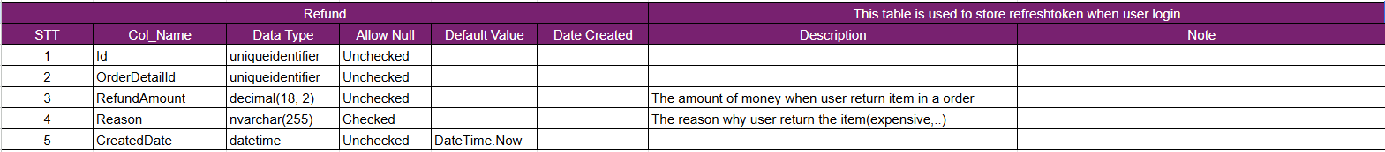

Support
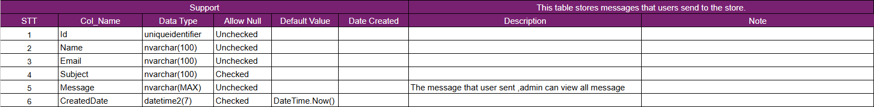

User Location
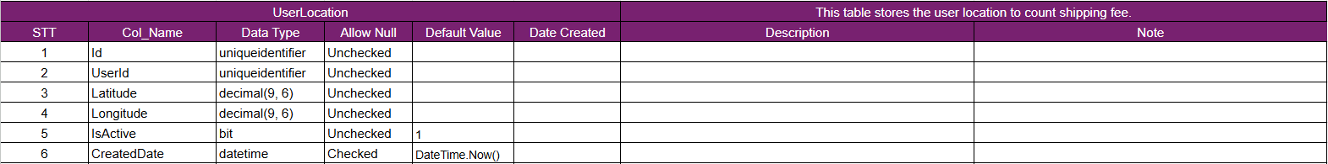

Product Image

Database Diagram

Chapter 3: Application Function
- Login Sign-Up and forgot password Screens
- Login Screen

Figure 38: Login Screen
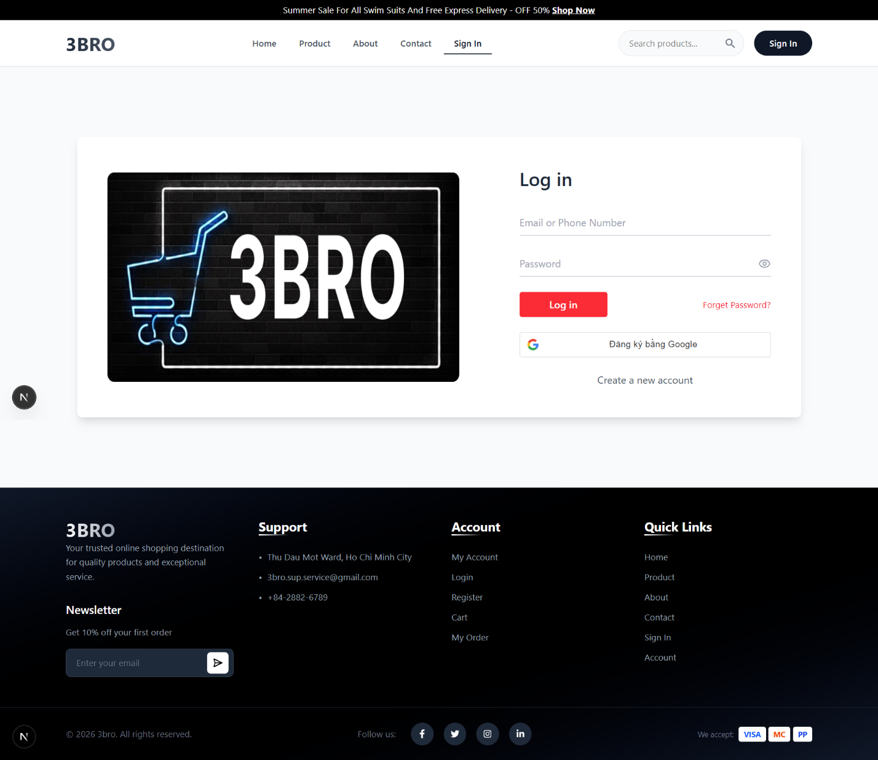

- Sign up Screen

Figure 39: Sign up Screen
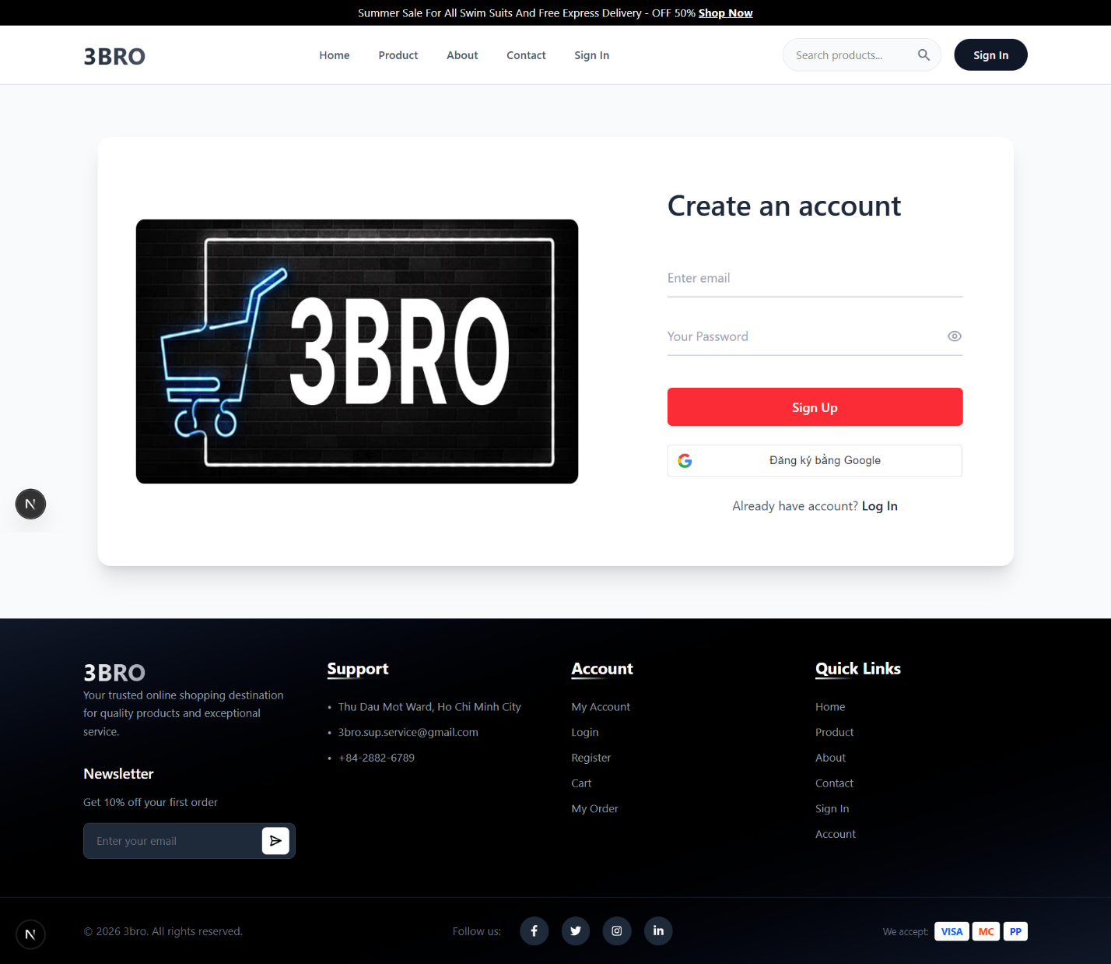

- Home Screen

Figure 40: Home Screen
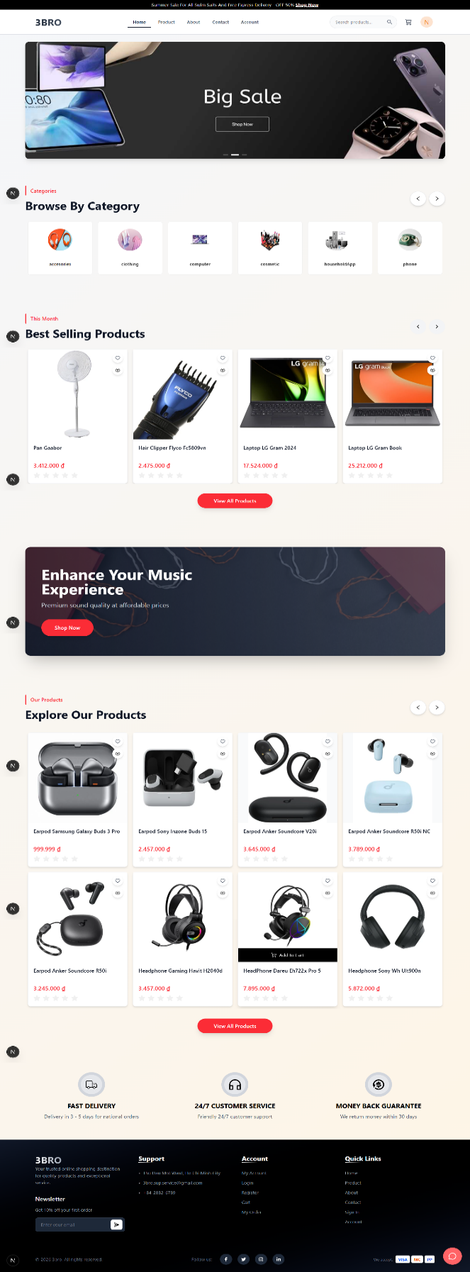
- Profile Screen

Figure 41: Profile Screen
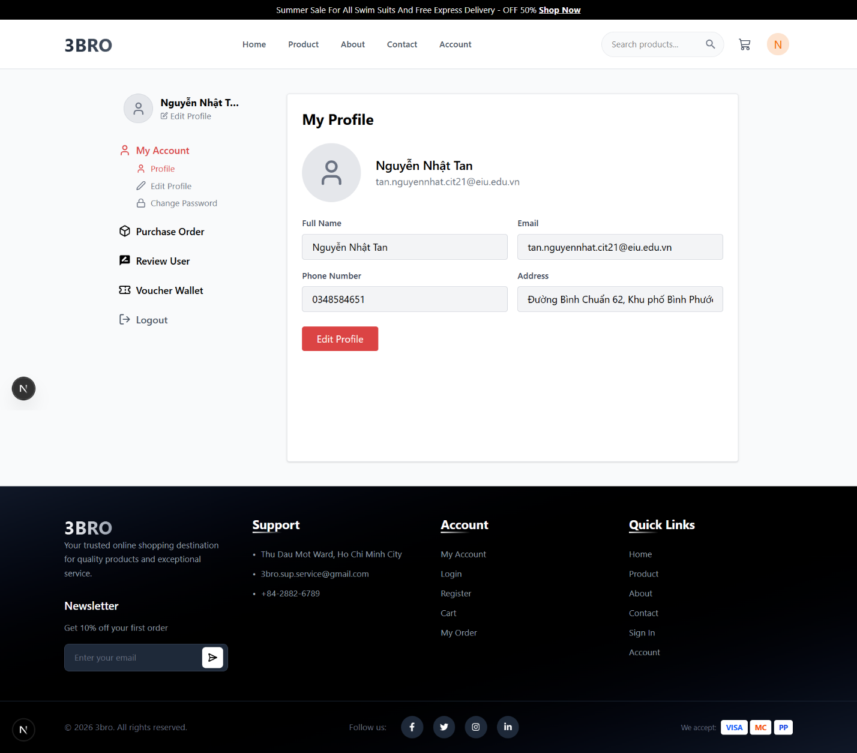

Product Screen

Figure 42: Product Screen
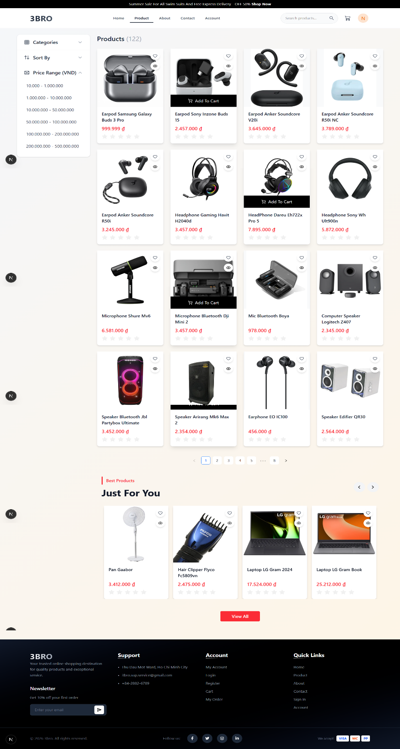
- View Detail Product Screen

Figure 43: View Detail Product Screen
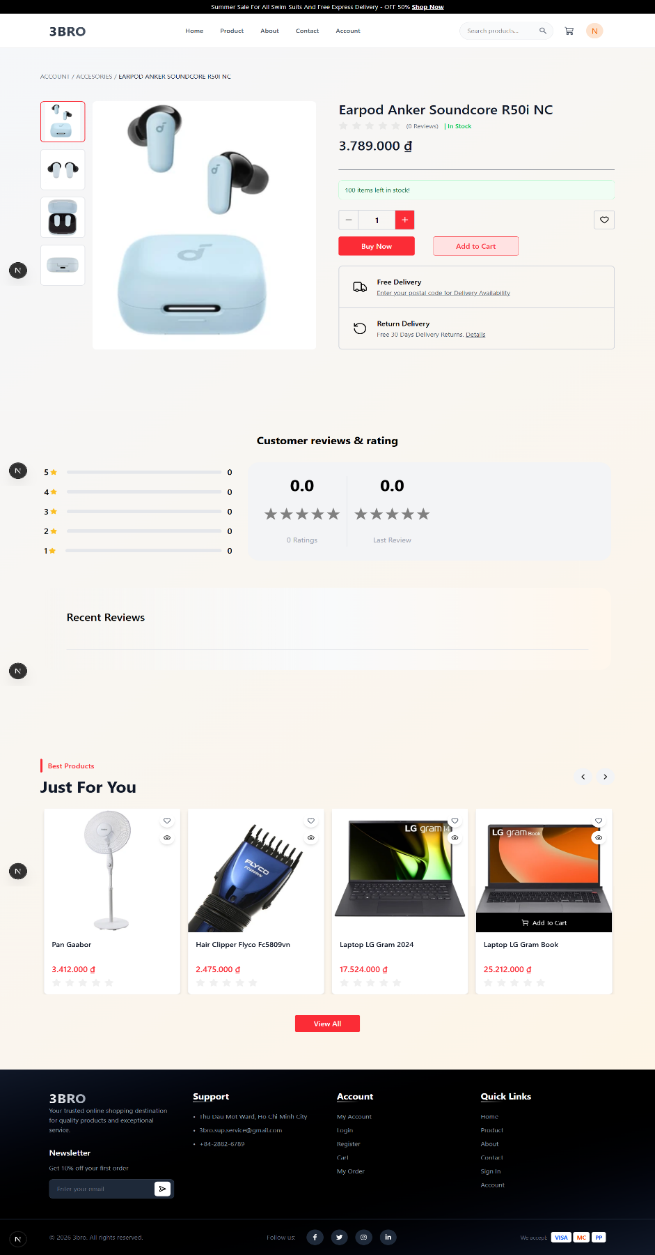

View Cart Screen

Figure 44: View Cart Screen
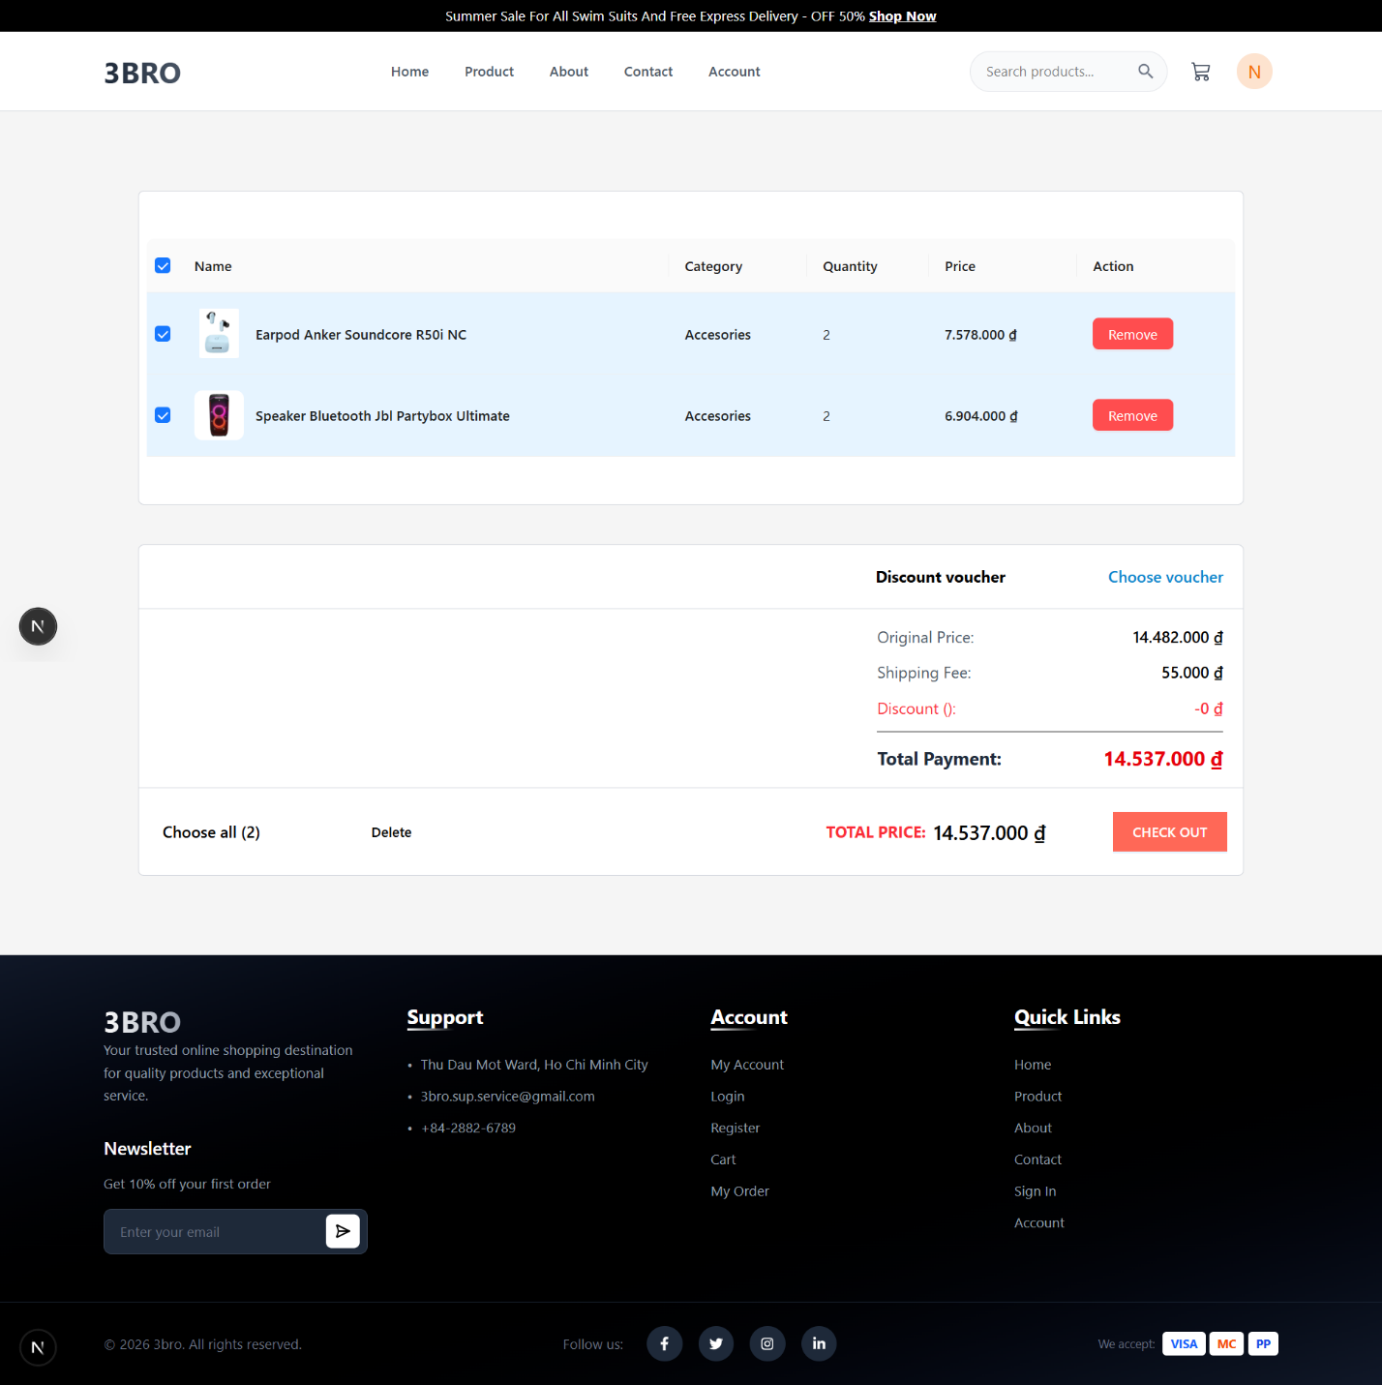

- Payment Screen

Figure 45: Payment Screen
When you click buy in cart UI or buy now, it will move to payment UI.
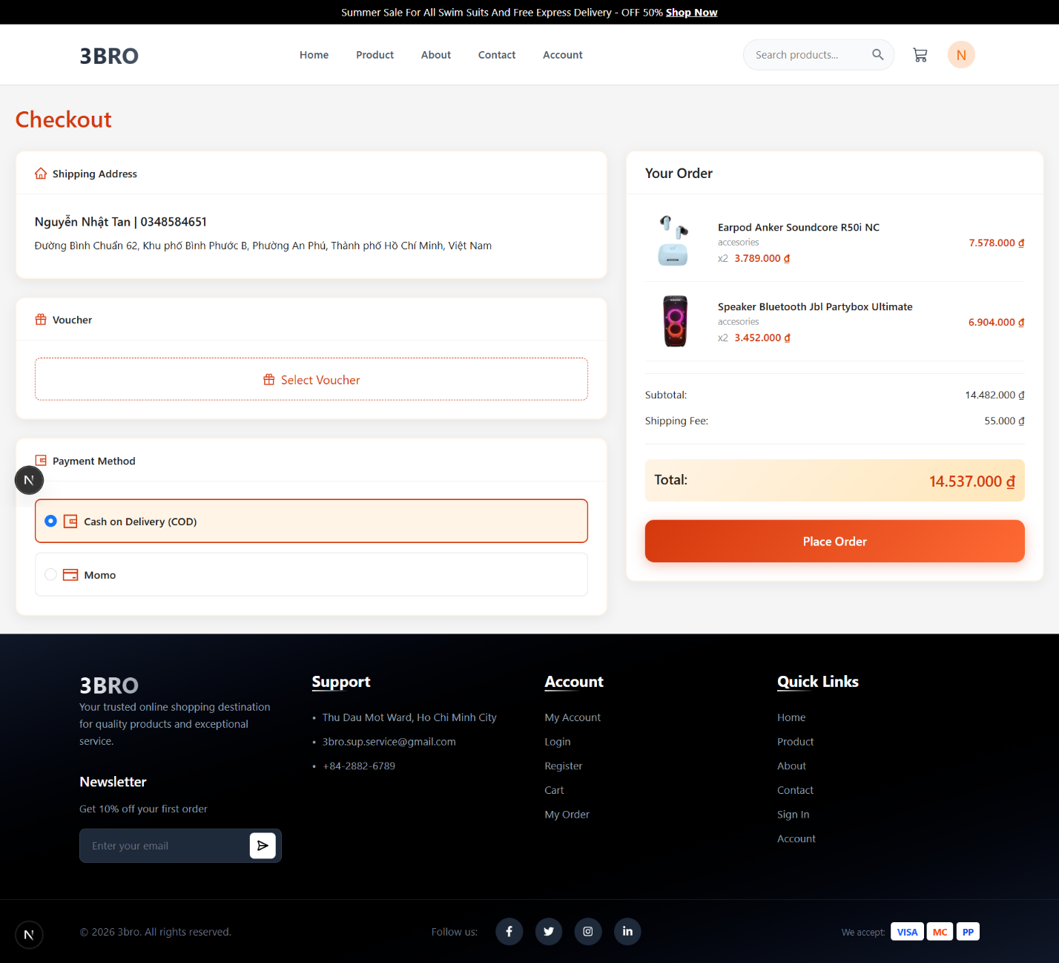
- View Order Screen

Figure 46: View Order Screen
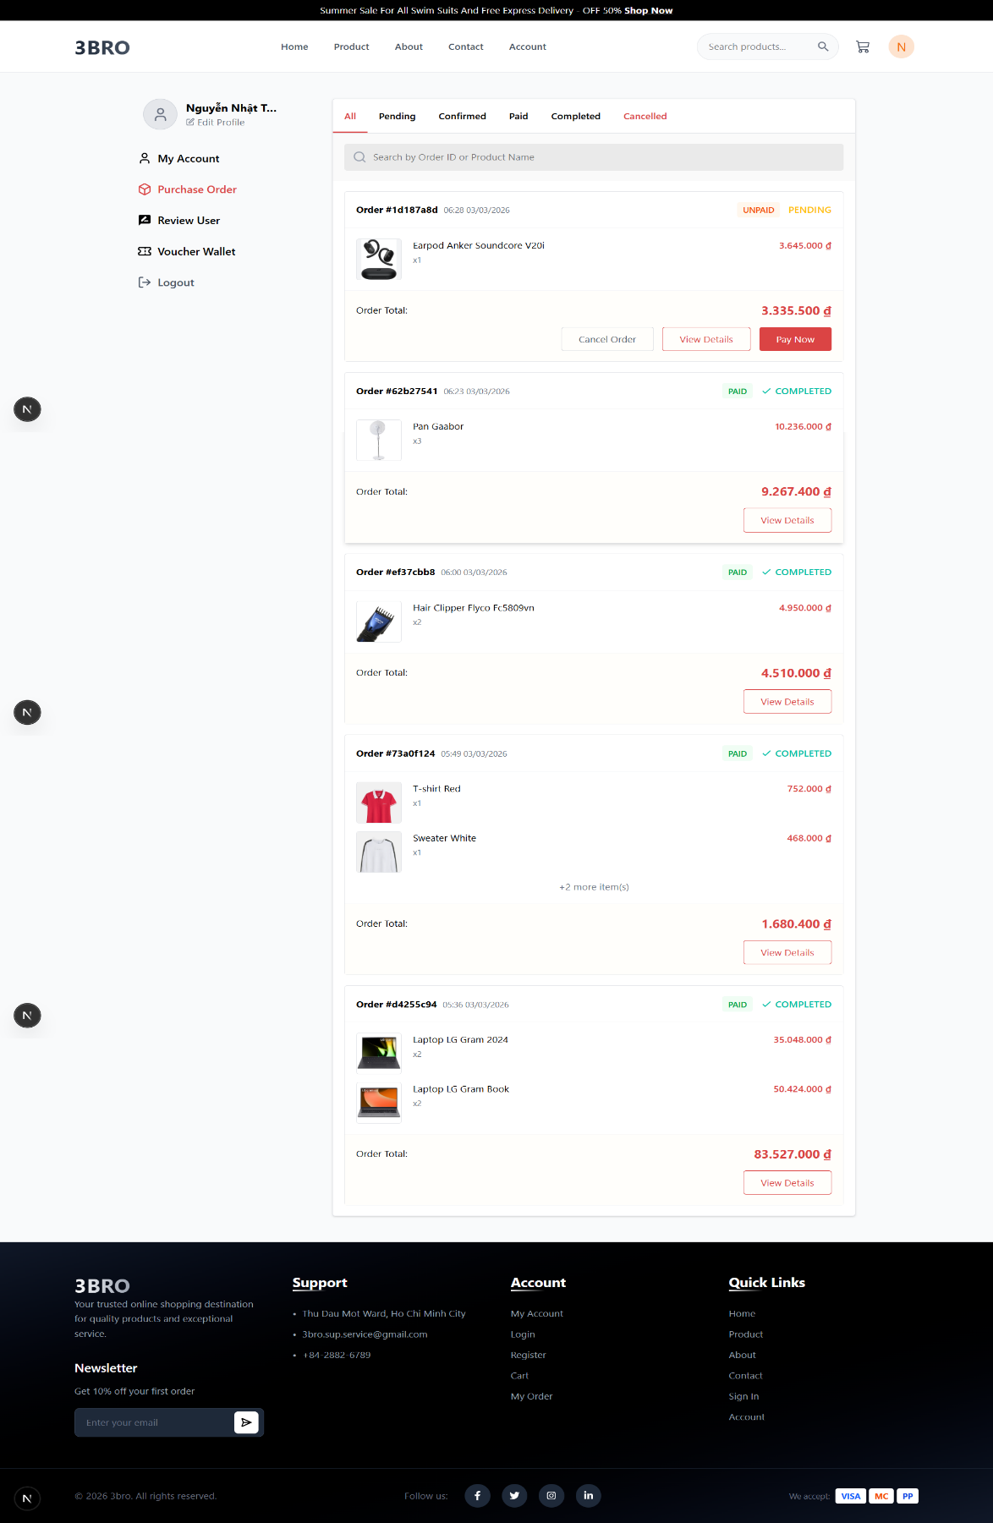
- Contact Screen

Figure 47: Contact Screen
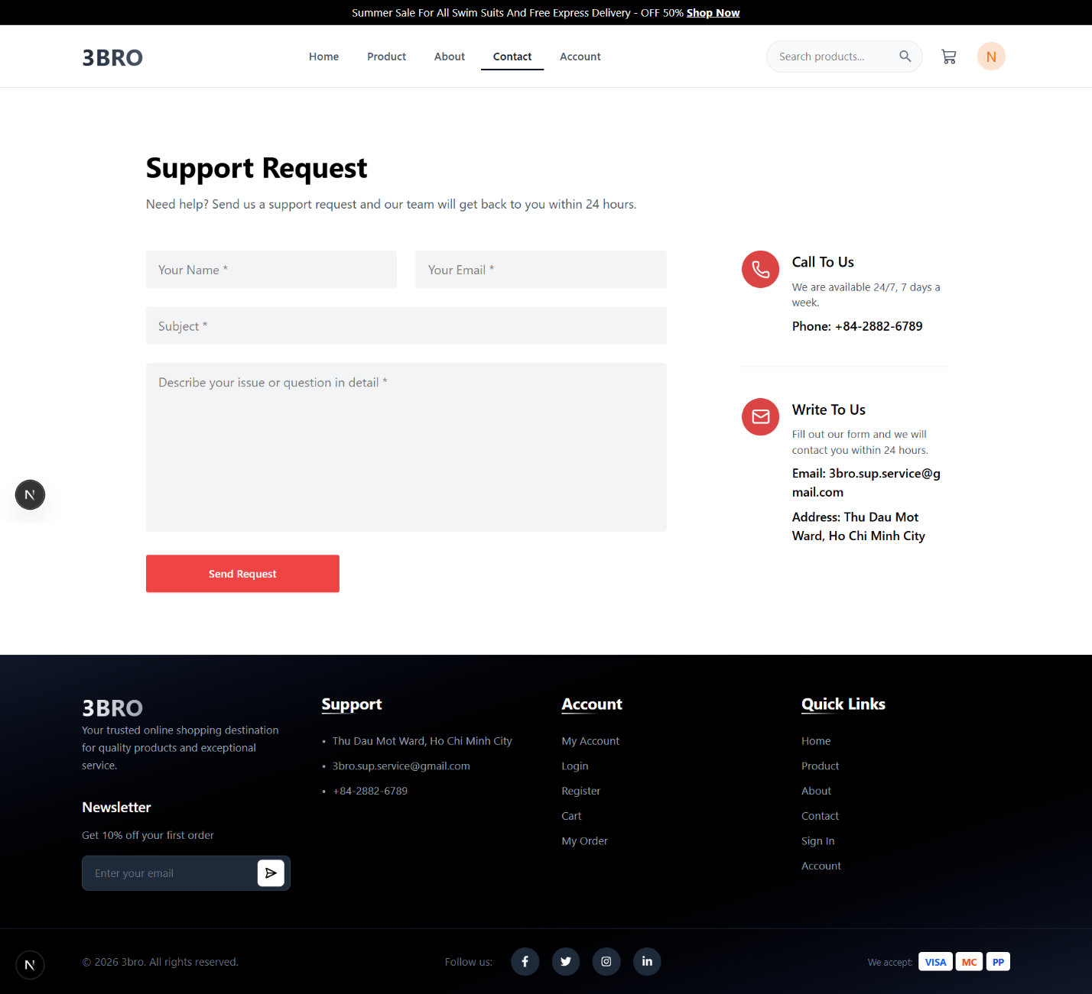

- Dashboard Screen

Figure 48: Dashboard
Only accept admin enter to this UI to see statistics.
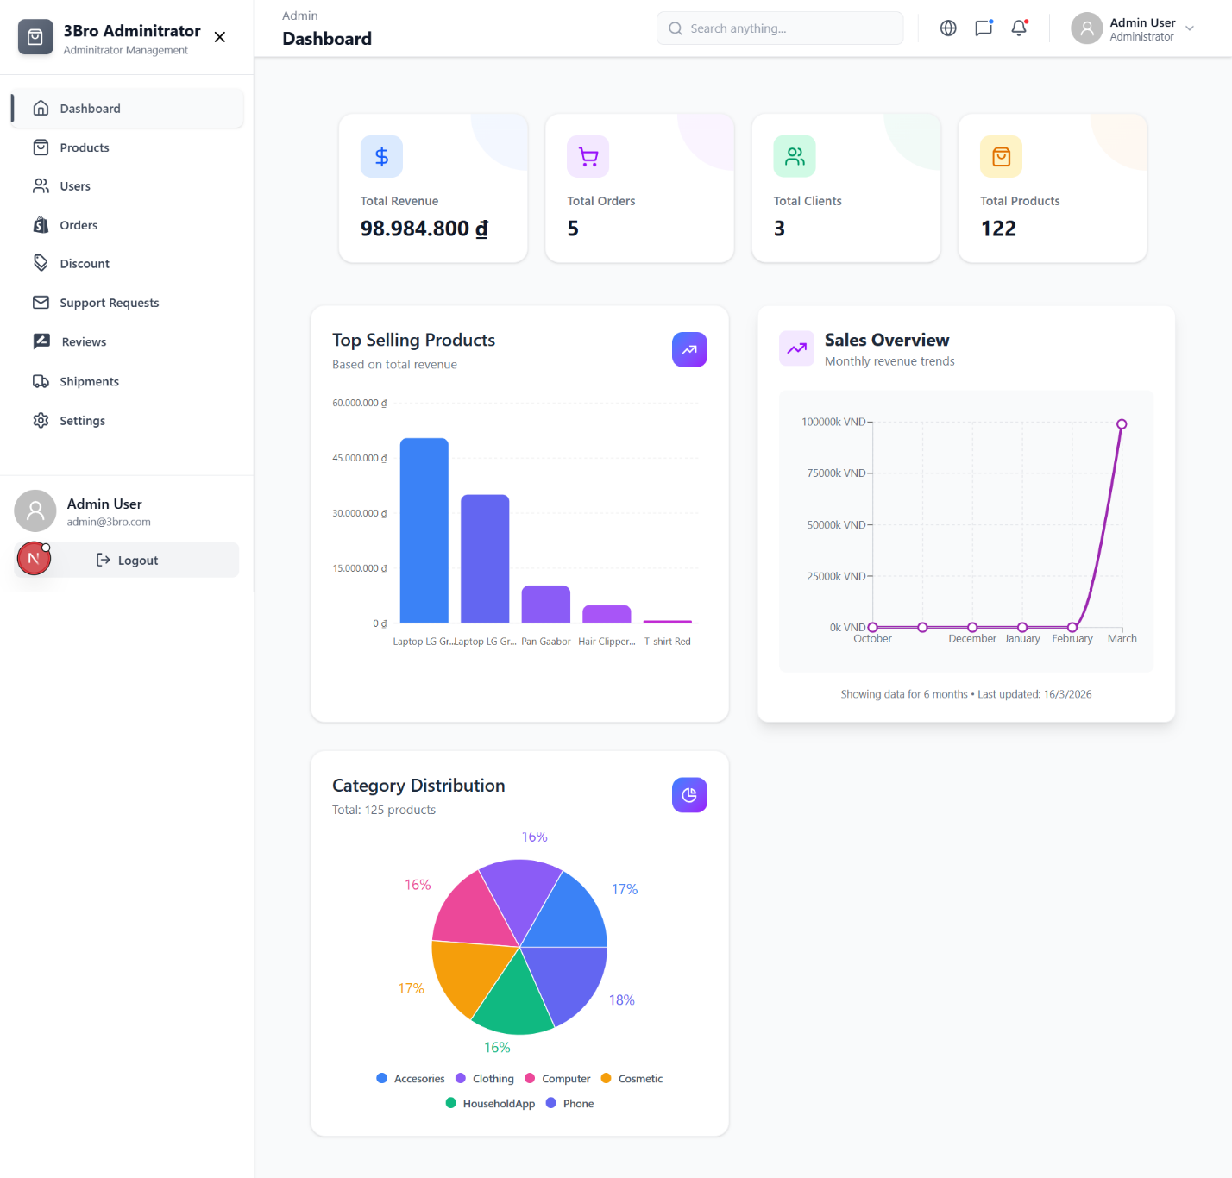

- Add Product Screen

Figure 49: Add Product Screen
The additional function for dashboard.
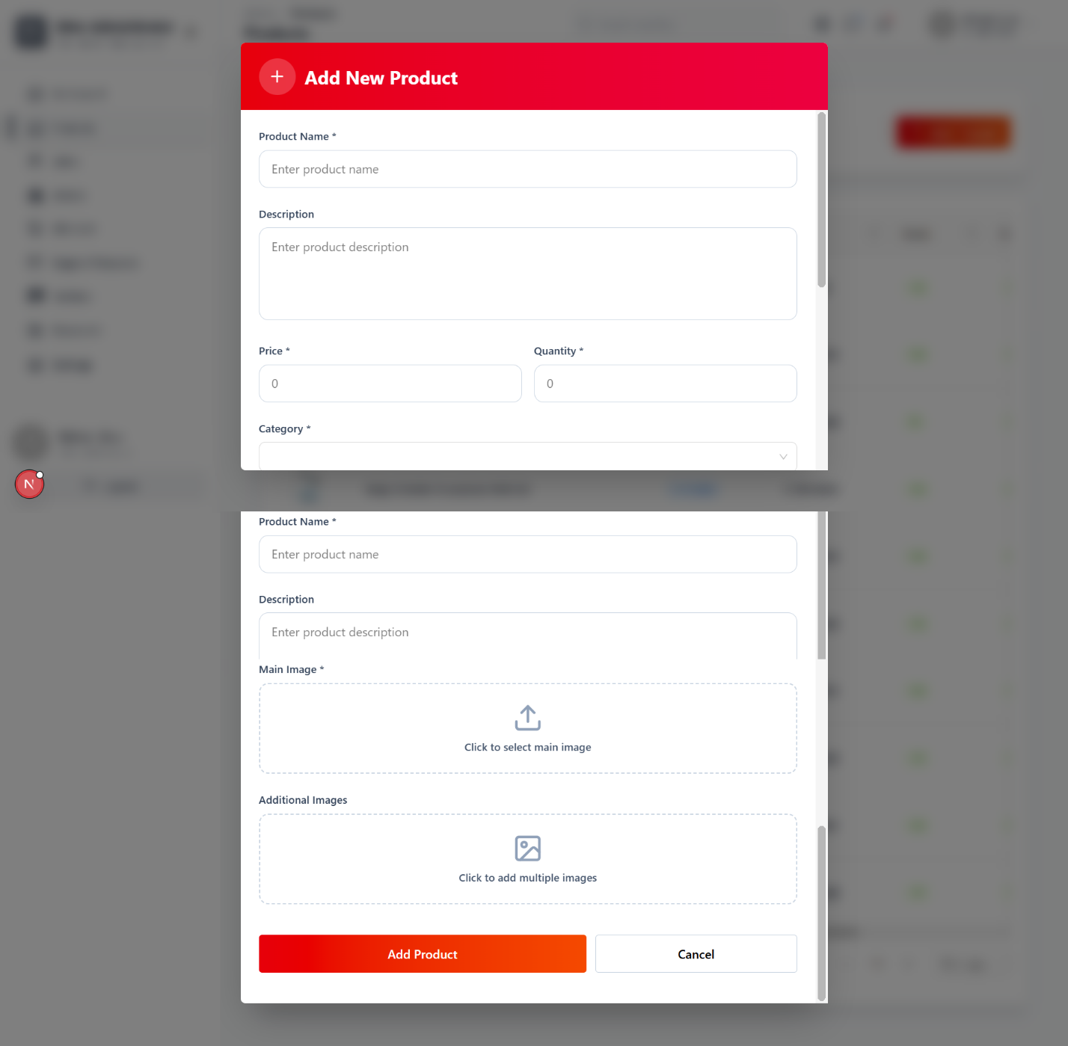

- View Product Information in Admin Screen

Figure 50: View Product Information in Admin Screen
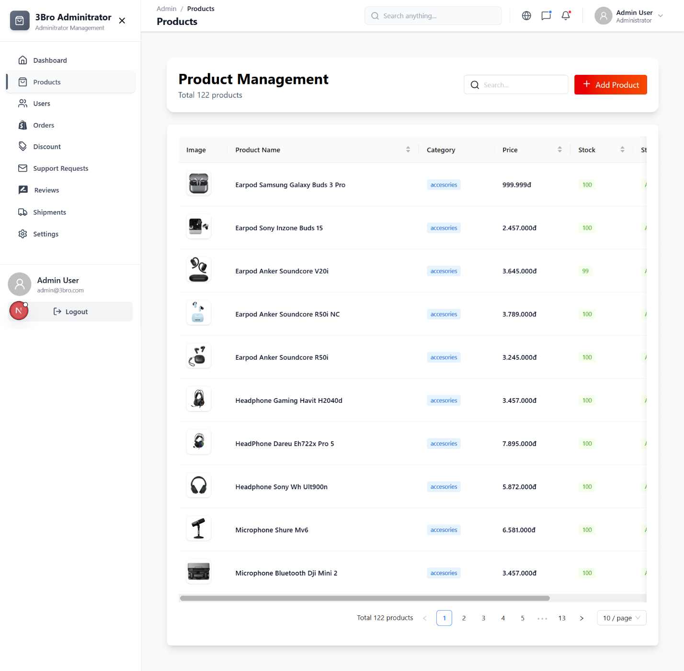
- View Orders in Admin Screen

Figure 51: View Order in Admin Screen
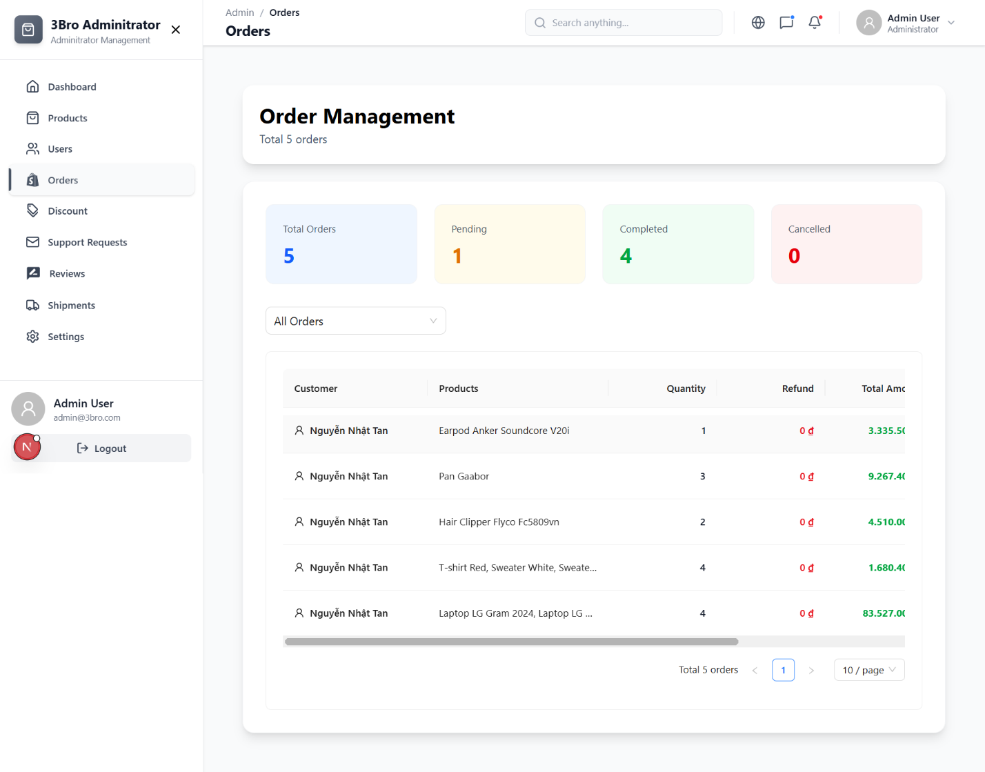
- View Users in Admin Screen

Figure 52: View Users in Admin Screen
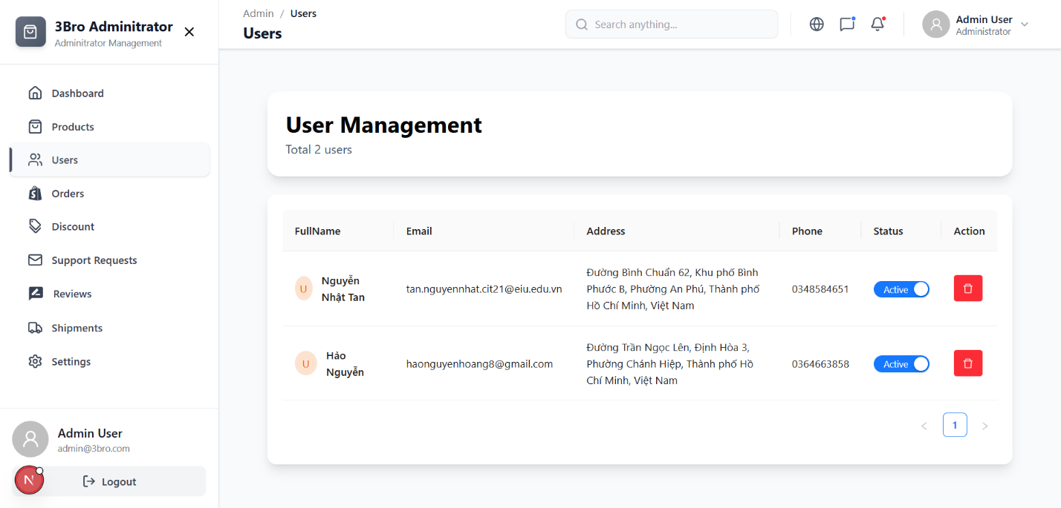

- View Feedback in Admin Screen

Figure 53: View Feedback in Admin Screen
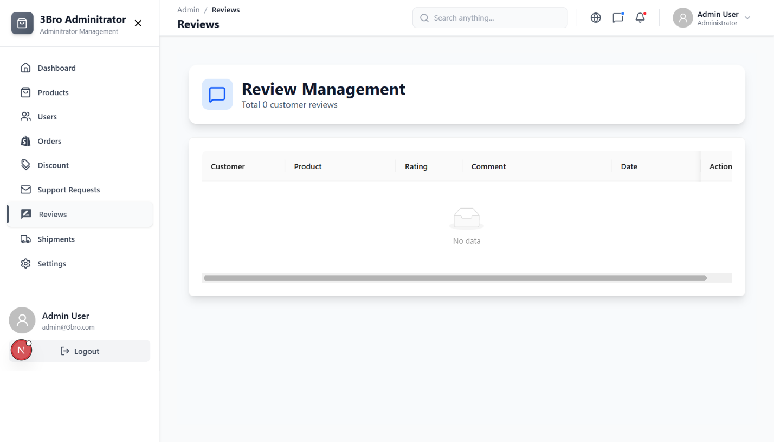
- View All Shipment in Admin Screen

Figure 54: View All Shipment in Admin Screen
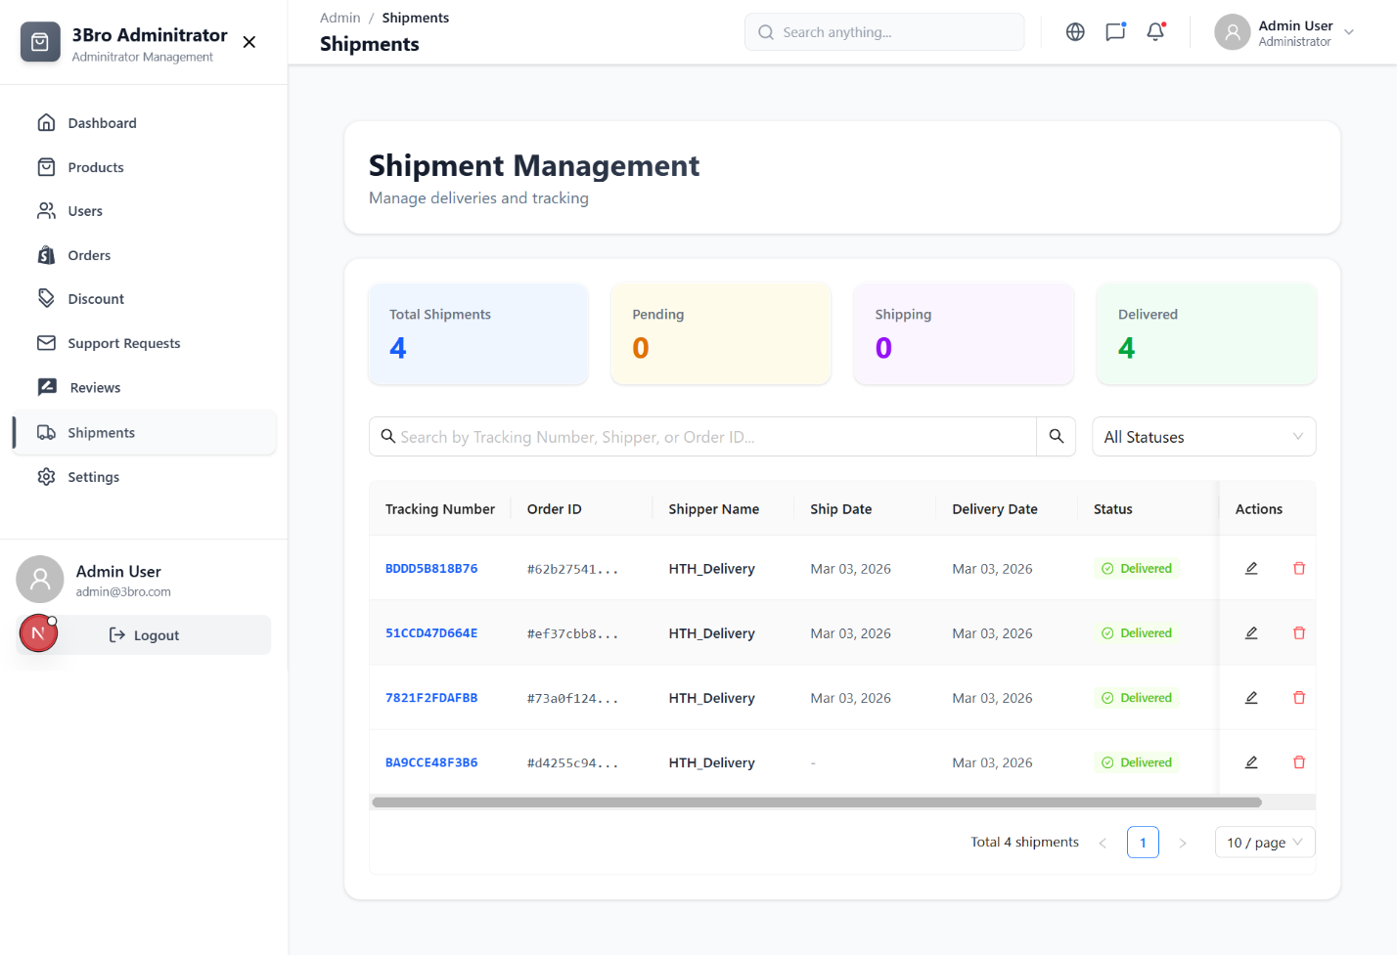
- Profile Setting Admin Screen

Figure 55: Profile Setting Admin Screen
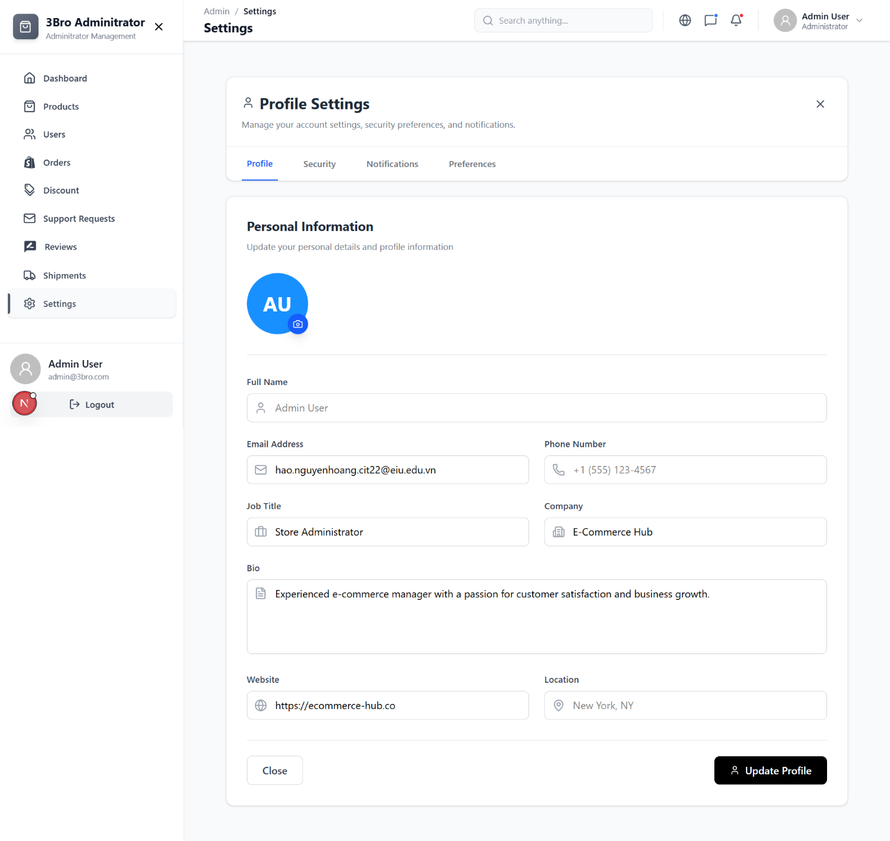
- Support Management in Admin Screen:

Figure 56: Support Management in Admin Screen
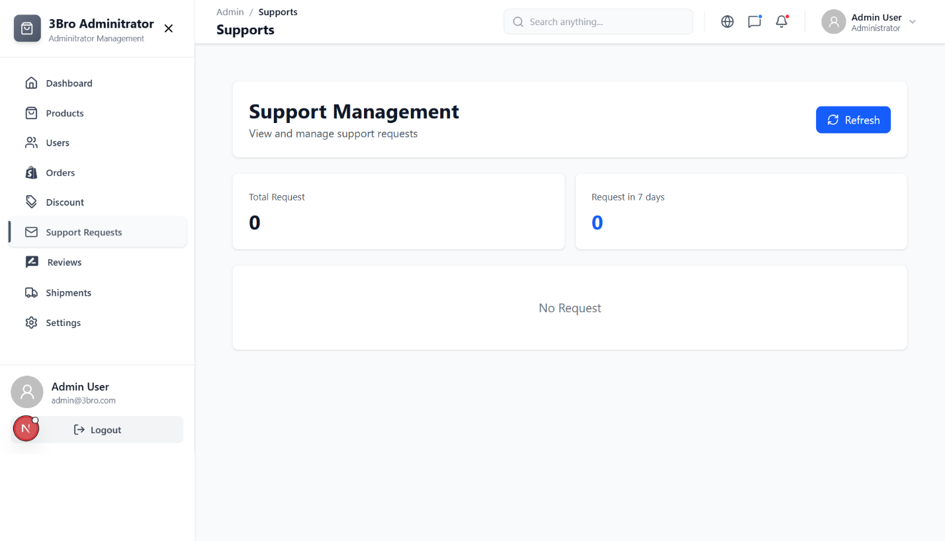
- Discount in Admin Screen

Figure 57: Discount in Admin Screen
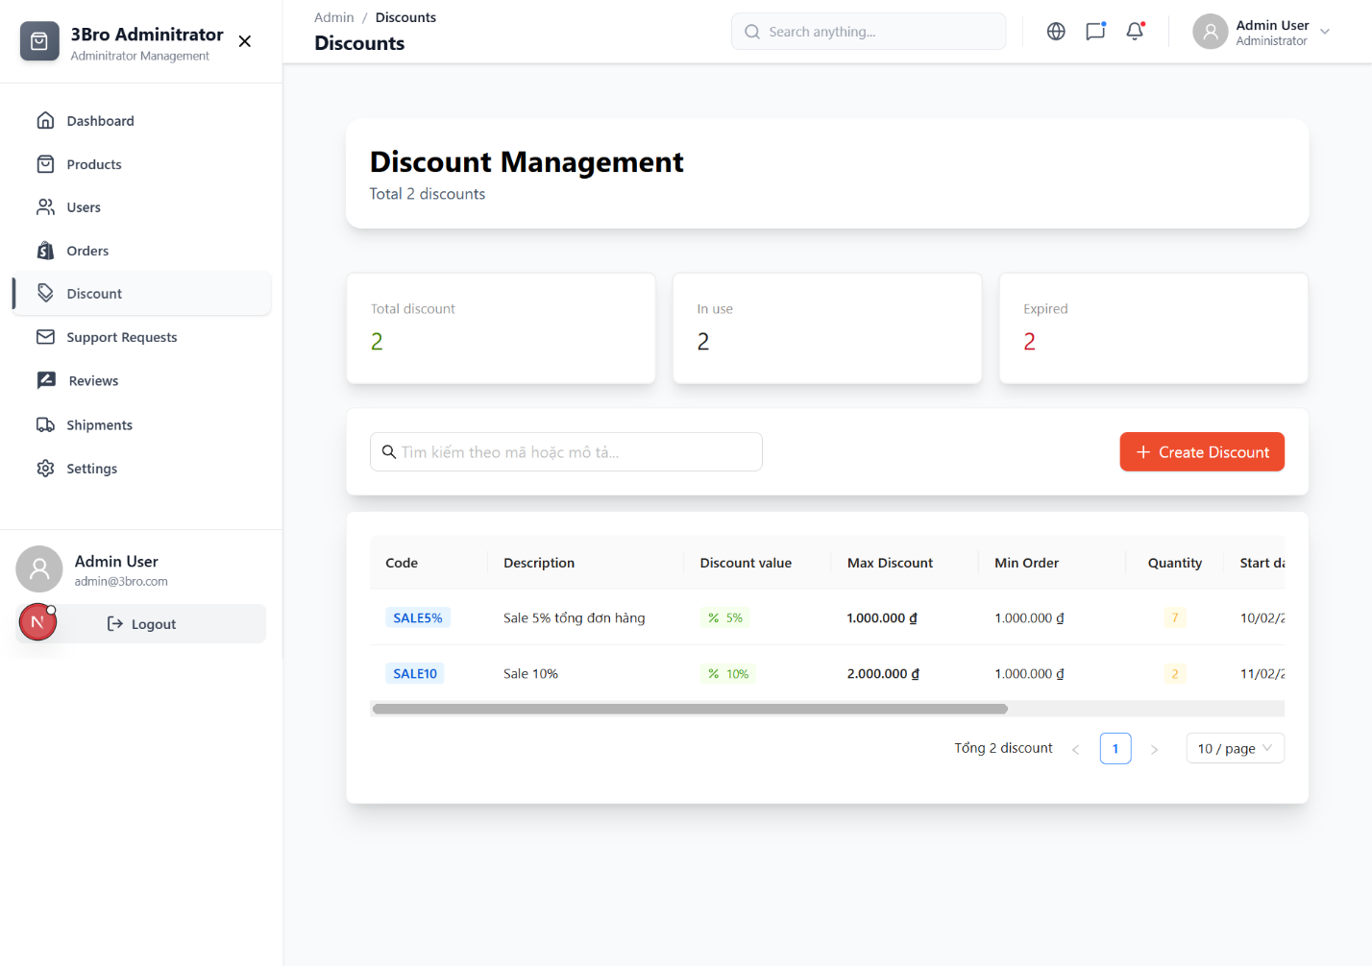
- Notification Setting Admin Screen

Figure 58: Notification Setting Admin Screen
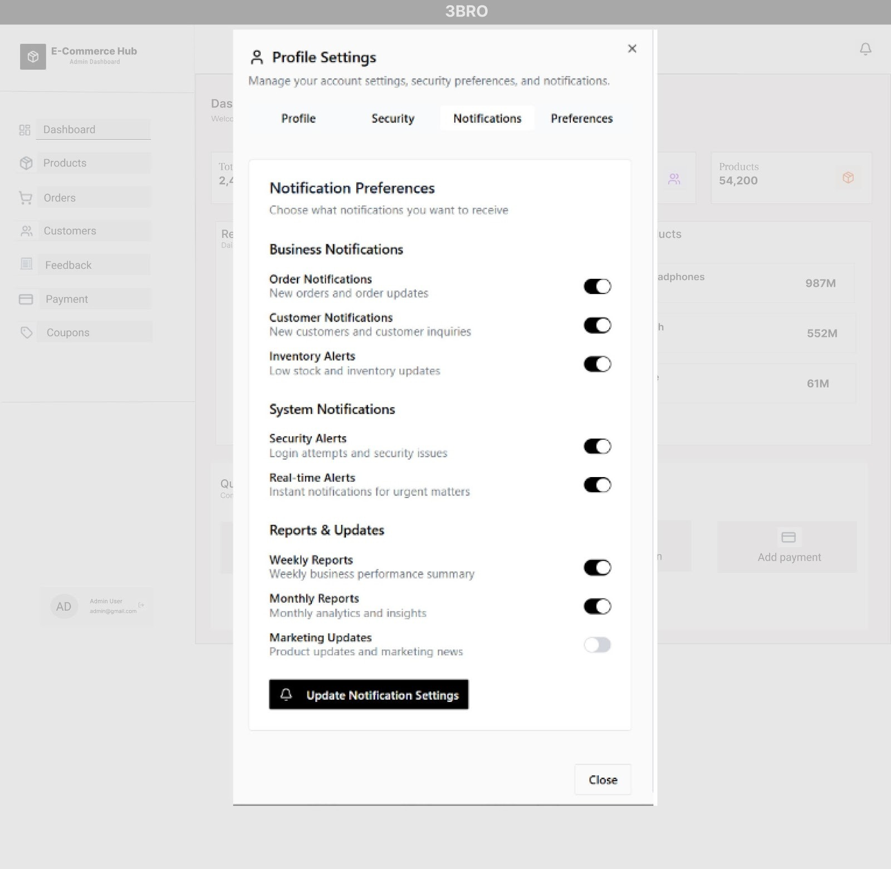

Chapter 4: Related Work
- Settings
Currently, there are many e-commerce flatforms available on the market; however, most of them do not fully integrate all the features that our system aims to provide. Existing flatforms often focus mainly on product listings and purchasing function, while lacking tools that support small business in managing inventory, handling orders efficiently, or personalizing the shopping experience for customers and listing recommendation products.
Notable examples include:
- Shopee – offers a large marketplace but is often overwhelming for small sellers and lacks simple, built-in tools for personalized product management.
- Lazada – strong in promotions and logistics partnerships but limited in providing customization options for small online shops.
- Tiki – known for fast delivery and product authenticity but not optimized for flexible store management or tailored customer interactions.
- Feature Comparison
Our e-commerce website integrates product browsing, seller management tools, and order tracking in a single platform, unlike other existing systems that typically focus on only one or two of these features. Shopee offers a wide marketplace but provides limited control for small sellers. Lazada excels in promotions and logistics but lacks flexible product management tools. Tiki is strong in fast delivery and product authenticity but does not fully support customizable store features for independent sellers.
- 3BRO’s Competitive Advantages
- All-In-One Solution: Combines products bookings, review management, product suggestions, and admin settings in single flatform.
- User-Friendly Design: Offers a modern, easy user interface for customers.
- Scalable & Flexible: Can adapt to sessional trends, customer demands, and customer incentive system.

Chapter 5: Conclusion & Future Works
- Conclusion
The E-Commerce platform has successfully integrated a wide range of essential features, including product browsing, secure purchasing, customer review management, and comprehensive administrative tools. This all-in-one solution enables users to explore products, place orders, share feedback, and receive personalized recommendations, while administrators can efficiently manage inventory, users, and business policies.
Throughout its development, the platform was built with a modern, intuitive interface and cutting-edge technologies to ensure security, performance, and scalability. Early evaluations highlight the system’s practicality, with positive feedback emphasizing its ability to enhance both customer shopping experiences and overall management efficiency.
In conclusion, this eCommerce platform is more than just an online shopping system; it is a complete digital commerce and management solution with strong potential for future expansion and real-world deployment.
- Future Works
To further enhance 3BRO website and expand its capabilities, several improvements can be implemented in future versions:
- Mobile App: Provide application for customers.
- AI-Power Product Suggestions: Provide personalized recommendations based on user history.
- Cloud Synchronization: Enable real-time data synchronization across multiple devices for a seamless user experience.
- Expanded Payment Options: Support multiple payment gateways and international currencies
- Customer Loyalty Program: Implement reward points, membership levels, and discount vouchers to increase customer retention.
- Advanced Order Tracking: Provide live shipping updates, estimated delivery time, and notifications at each delivery stage.
By continuously expanding and refining these features, the 3BRO e-commerce platform aims to become a leading solution for both customers and sellers, offering a seamless, efficient, and intelligent online shopping experience for all users.

References
[1] Vercel, “Next.js docs,” Next.js. https://nextjs.org/docs
[2] “Installing with Vite - Installation,” Tailwind CSS. https://tailwindcss.com/docs/installation/using-vite
[3] “ASP.NET Core, an open-source web development framework | .NET,” Microsoft. https://dotnet.microsoft.com/en-us/apps/aspnet
[4] “Introduction - Ant Design.” https://ant.design/docs/spec/introduce
[5] “Introduction Figma” https://help.figma.com/hc/en-us/categories/360002051613-Get-started

