MINISTRY OF EDUCATION AND TRAINING

FPT UNIVERSITY
Capstone Project Document
Child Vaccine Schedule Tracking System

<Group Name>
Group Members | Lê Đặng Minh Trí - SE183122  Phạm Việt Hoàng - SE183123  Hồ Ngọc Sang - SE183247  Nguyễn Tăng Tài Phát - SE184119  Nguyễn Hoàng Điền - SE183112
Supervisor | Nguyễn Ngọc Lâm
Capstone Project code | SWD392
-Ho Chi Minh, February 2025-
Table of Contents

Definition and Acronyms 4
I. Project Introduction 5
1. Overview 5
1.1 Project Information 5
1.2 Project Team 5
2. Product Background 5
3. Existing Systems 5
4. Business Opportunity 6
5. Project Scope & Limitations 6
II. Software Requirement Specification 7
1. Product Overview 7
1.1 High-level Overview 7
1.2 Environment & Usage 7
1.3 Anticipated Users 7
2. Screen Flows 7
3. Functional Requirements 9
4. Non-Functional Requirements 21
4.1 External Interfaces 21
4.2 Quality Attributes 21
5. Requirement Appendix 22
5.1 Business Rules 22
III. Software Design Description 23
1.System Design 23
1.1 System Architecture 23
1.2 Use Case 24
1.2.1 Use Case Diagram 24
1.2.2 Description 25
1.2.3 Use Case Specification 28
1.3 Activity Diagram 44
1.4 State Machine Diagrams 49
2. Database Design 50
3. Detailed Design 50
3.1 Class Diagram 50
3.2 Package Diagram 51
3.3 Sequence Diagram 51
Acknowledgement
Firstly, we would like to express our deepest gratitude to Nguyễn Ngọc Lâm, our tireless mentor and guide throughout this project. Their keen eye for detail, insightful suggestions, and unwavering support were instrumental in shaping the final outcome. Their presence was a constant source of inspiration and confidence, pushing us to reach our full potential.
As we bid farewell to this academic journey, our hearts overflow with appreciation for the dedicated FPT University lecturers who shared their invaluable knowledge and wisdom. With each lesson, they equipped us with the tools and expertise needed to navigate this ambitious endeavour. We are eternally grateful for their guidance and commitment to our success.
Beyond academia, we are deeply indebted to our families and friends for their unwavering support. Their cheering voices resonated through every hurdle, reminding us of our capabilities and fueling our determination. Thank you for being the wind beneath our wings, propelling us forward even when the path seemed daunting.
Finally, a heartfelt acknowledgement to Nguyễn Ngọc Lâm for becoming a lifeline throughout the project. From navigating technological complexities to crafting compelling documentation, you were always there to lend a hand. Your dedication and collaboration are etched in the very fabric of this project.
We acknowledge that our inexperience and unfamiliarity with certain technologies inevitably led to lapses and imperfections. We humbly ask for your understanding and forgiveness for any shortcomings. It is with immense gratitude for your unwavering support and guidance that we present this finished project on online child vacc. Thank you.
Regards,

Definition and Acronyms
Acronym | Definition
PWM | Psychology website
AWS | Amazon Web Services
BA | Business Analysis
BR | Business Rule
ERD | Entity Relationship Diagram
GUI | Graphical User Interface
PM | Project Manager
SDD | Software Design Description
SPMP | Software Project Management Plan
SRS | Software Requirement Specification
UAT | User Acceptance Test
UC | Use Case
API | Application Program Interface

I. Project Introduction

1. Overview

1.1 Project Information

Project Name: Children Vaccination System

Project Code: CVS-001

Group Name:

Project Type: Web-based system

Target Users: Vaccination Center

1.2 Project Team

Project Manager: None

Backend developers: Lê Đặng Minh Trí, Nguyễn Tăng Tài Phát

Frontend developers: Hồ Ngọc Sang, Phạm Việt Hoàng, Nguyễn Hoàng Điền

Stakeholders:

Healthcare providers

Vaccine suppliers

Parents/guardians

Government health departments

2. Product Background

The increasing demand for child vaccinations and the need for a more convenient and efficient way to purchase and schedule vaccinations have led to the development of this online vaccination system. Traditionally, parents have had to visit vaccination centers in person, leading to long wait times and limited access to vaccine availability information. This system aims to solve these issues by providing an online platform for customers to purchase vaccines and schedule appointments.

Additionally, we will collaborate with trusted vaccine suppliers to ensure a variety of vaccine categories are available, offering parents reliable and safe options for their children.

3. Existing Systems
Some existing systems provide online medical bookings or pharmacy sales, but they do not focus specifically on child vaccination purchases and scheduling. Potential references for system design include:
- VNVC
- CDC.GOV
Our system will integrate key features from these while providing a dedicated vaccination service with direct vaccine import management from certified providers.

4. Business Opportunity
The market demand for child vaccination services is growing due to increasing awareness of preventable diseases. Many parents struggle with scheduling vaccinations due to their busy lifestyles, and some rural areas have limited access to vaccine availability.

5. Project Scope & Limitations
Scope
- Vaccine Purchasing: Online vaccine selection and payment.
- Appointment Scheduling: Parents can book vaccination appointments at partner clinics.
- Inventory Management: Admins can track vaccine stocks and update availability.
- User Management: Profiles for parents, healthcare providers, and system admins.
- Payment Integration: Secure online payment via credit card, online banking, or cash on-site.
Limitations
- No Direct Vaccine Delivery: The system will not support home vaccine delivery due to safety regulations.
- Limited Partner Clinics: Initially, only selected healthcare facilities will be part of the network.
- Regulatory Compliance: The system will follow government health regulations, which may impose restrictions on certain features.
- One Child Per Transaction: The system does not allow purchasing vaccines for multiple children in a single transaction. Parents must complete a separate purchase for each child.

II. Software Requirement Specification

1. Product Overview

1.1 High-Level Overview

The Children Vaccination System is an online platform that allows parents or guardians to purchase vaccines and schedule vaccination appointments at authorized healthcare facilities. The system ensures safe and efficient vaccination services by collaborating with certified vaccine providers.

The platform eliminates long waiting times by enabling online purchases, while also supporting on-site vaccine purchases at clinics. Each purchase is limited to one child per transaction, ensuring accurate medical record-keeping.

1.2 Environment & Usage

Web-Based System: Accessible via browsers on desktops, tablets, and mobile devices.

Users: Parents, healthcare staff, system administrators.

Online & On-Site Usage: Parents can either book and pay online or visit a facility to purchase.

Secure Transactions: Integrated with online payment gateways for digital payments, with an option for cash payments at clinics.

1.3 Anticipated Users

Parents/Guardians:

Register and manage their child's vaccination records.

Purchase vaccines and schedule appointments.

Healthcare Providers (Clinics/Doctors/Nurses):

Manage vaccine inventory.

Verify appointments and administer vaccinations.

System Administrators:

Manage user accounts, clinics, and vaccine providers.

Oversee system operations and ensure compliance with health regulations.

2. Screen Flows
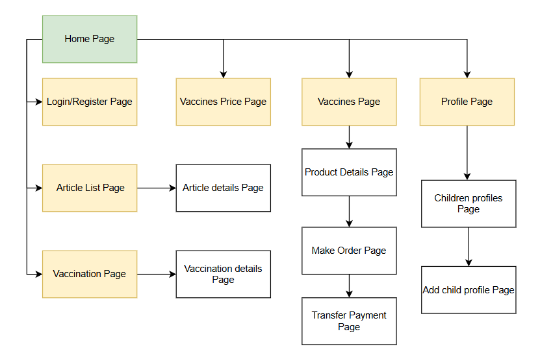
2.1. Customer Screen Flow

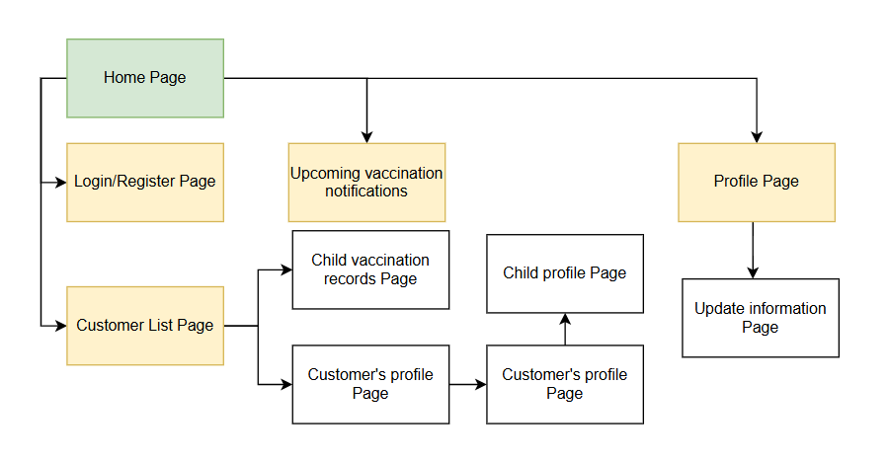
2.2. Staff Screen Flow

3. Functional Requirements

3.1 Login

3.1.1 Enter login credentials
- Description: The user enters their email/phone number and password to log in.
- Actor: All authenticated users.
- Input: Email/phone number, password.
- Process:
- User enters login details in the form.
- System validates input format (e.g., email structure).
- If invalid, the system displays an error message.
- Output: System proceeds to authentication or displays an error message.

3.1.1 Role-Based Access Control
- Description: The system redirects users to different sections based on their roles.
- Actor: System.
- Input: Authenticated user’s role.
- Process:
- After login, the system checks the user's role.
- Users are redirected to their role's perspective screen.
- Output: User is directed to the appropriate screen.

3.2 Create Staff Account

3.2.1 Enter Staff Account Details
- Description: The admin user enters staff details to create a new account.
- Actor: Admin.
- Input: Staff email/phone number, name, role, password.
- Process:
  - Admin fills in the required staff details in the form.
  - The system validates input format (e.g., email structure, password strength).
  - If invalid, the system displays an error message.
- Output: The system proceeds to account creation or displays an error message.

3.2.2 Role-Based Access Control
- Description: The system assigns the created account a role and restricts access accordingly.
- Actor: System.
- Input: Staff role.
- Process:
  - After account creation, the system verifies the assigned role.
  - Users logging in with the new account are redirected to their role's designated screen.
- Output: The new staff user gains access to their appropriate dashboard.

3.3 Update Staff Account - Role: Admin

3.3.1 Enter Updated Staff Account Details
- Description: The admin user updates the details of an existing staff account.
- Actor: Admin.
- Input: Staff email/phone number, name, role, password (if changed).
- Process:
  - Admin selects a staff account to update.
  - Admin modifies the necessary details in the form.
  - The system validates input format (e.g., email structure, password strength if changed).
  - If invalid, the system displays an error message.
- Output: The system proceeds to update the account or displays an error message.

3.3.2 Role-Based Access Control
- Description: The system ensures that the updated account retains the correct role-based access.
- Actor: System.
- Input: Updated staff role.
- Process:
  - After updating the account, the system verifies the assigned role.
  - Users logging in with the updated account are redirected to their role's designated screen.
- Output: The updated staff user gains access to their appropriate dashboard.

3.4 Update Vaccine Information - Role: Admin

3.4.1 Enter Updated Vaccine Information
- Description: The admin user updates the details of an existing vaccine record.
- Actor: Admin.
- Input: Vaccine name, manufacturer, batch number, expiration date, dosage, availability status.
- Process:
  - Admin selects a vaccine record to update.
  - Admin modifies the necessary details in the form.
  - The system validates input format (e.g., correct date format, batch number structure).
  - If invalid, the system displays an error message.
- Output: The system proceeds to update the vaccine record or displays an error message.

3.4.2 Role-Based Access Control
- Description: The system ensures that only authorized users (admins) can update vaccine information.
- Actor: System.
- Input: Admin role verification.
- Process:
  - The system verifies that the user has admin privileges.
  - If the role is valid, the update is applied. Otherwise, access is denied.
- Output: The vaccine information is updated, or the admin receives an access restriction message.

3.5 Update Vaccine’s Stock Detail - Role: Admin

3.5.1 Enter Updated Vaccine Stock Details
- Description: The admin user updates stock details of a vaccine, including quantity and storage conditions.
- Actor: Admin.
- Input: Vaccine name, batch number, quantity, storage location, storage temperature, expiration date, availability status.
- Process:
  - Admin selects a vaccine stock record to update.
  - Admin modifies the necessary details in the form.
  - The system validates input format (e.g., numeric values for quantity, correct date format).
  - If invalid, the system displays an error message.
- Output: The system proceeds to update the stock details or displays an error message.

3.5.2 Role-Based Access Control
- Description: The system ensures that only authorized users (admins) can update vaccine stock details.
- Actor: System.
- Input: Admin role verification.
- Process:
  - The system verifies that the user has admin privileges.
  - If the role is valid, the update is applied. Otherwise, access is denied.
- Output: The vaccine stock details are updated, or the admin receives an access restriction message.

3.6 Register a Vaccination - Role: Customer

3.6.1 Enter Vaccination Registration Details
- Description: The customer registers for a vaccination appointment by providing necessary details.
- Actor: Customer.
- Input: Full name, date of birth, contact information, preferred vaccine, preferred date & time, vaccination center.
- Process:
  - Customer fills in the required vaccination registration details in the form.
  - The system validates input format (e.g., correct date format, valid contact information).
  - If invalid, the system displays an error message.
- Output: The system proceeds to confirm the vaccination appointment or displays an error message.

3.6.2 Role-Based Access Control
- Description: The system ensures that only authenticated customers can register for vaccination.
- Actor: System.
- Input: Customer authentication status.
- Process:
  - The system verifies that the user is logged in as a customer.
  - If authentication is valid, the registration is processed. Otherwise, access is denied.
- Output: The customer successfully registers for vaccination, or the system denies access if authentication fails.

3.7 Make Payment
3.7.1 Select Payment Method
Description: The customer selects a preferred payment method to complete the vaccination registration.
Actor: Customer
Input: Selected payment method (e.g., Credit Card, Bank Transfer, E-wallet).
Process:
- Customer navigates to the payment section after registration confirmation.
- Customer selects a preferred payment method from the available options.
- System displays payment details and instructions based on the selected method.
Output: Payment method is selected, and relevant details are displayed.

3.7.2 Enter Payment Information
Description: The customer enters the necessary information for the selected payment method.
Actor: Customer
Input: Payment details (e.g., card number, expiration date, CVV, or bank account information).
Process:
- Customer fills in the payment information according to the selected method.
- System validates the payment details for accuracy and completeness.
- If invalid, the system displays an error message.
Output: Payment information is validated or an error message is displayed.

3.7.3 Confirm Payment
Description: The customer confirms and submits the payment.
Actor: Customer
Input: Valid payment details.
Process:
- Customer reviews the payment details.
- Customer clicks the "Confirm Payment" button.
- System processes the payment through the integrated payment gateway.
- System verifies payment success or failure.
Output: Payment is processed, and a success or failure message is displayed.
3.8 Report Injection Reaction Information
3.8.1 Access Reaction Reporting Form
Description: The customer accesses the form to report any reaction after vaccination.
Actor: Customer
Input: None (user navigates to the reporting section).
Process:
- Customer navigates to the "Report Injection Reaction" section in the system.
- System displays a form for submitting reaction information.
Output: Reaction reporting form is displayed.

3.8.2 Enter Reaction Details
Description: The customer inputs the details of the injection reaction.
Actor: Customer
Input: Reaction description, date and time of symptoms, severity level, any actions taken.
Process:
- Customer fills in the reaction description and other required fields.
- System validates the input (e.g., required fields are completed).
- If input is invalid, the system displays an error message.
Output: Reaction information is validated or an error message is displayed.

3.9 Edit Profile Information
Description: The customer updates their profile details such as name, contact, address, etc.
Actor: Customer
Input: Updated name, contact information, address, date of birth, or other profile fields.
Process:
- Customer modifies the desired fields.
- System validates input (e.g., valid phone number, date format).
- If invalid, the system displays an error message.
Output: Updated information is validated, or an error message is displayed.

3.10 Update Vaccine Information
Description:The customer updates their vaccine information, such as vaccination status, date of vaccination, vaccine type, and other relevant details.
Actor:Customer
Input:Updated vaccine-related fields, including, vaccination status (e.g., fully vaccinated, partially vaccinated), date of vaccination (e.g., first dose, second dose), vaccine type (e.g., Pfizer, Moderna, etc.), additional vaccine details (e.g., booster shot status, location of vaccination)
Process:
- The customer logs into their account.
- The customer navigates to the vaccine information section in their profile.
- The customer modifies or enters new vaccine-related fields (e.g., update the date of vaccination, add a booster shot).
- The system validates the inputs:
  - Ensure the date format is correct (e.g., MM/DD/YYYY).
  - Verify that the vaccine type matches a predefined list of valid vaccine types.
  - Ensure the vaccination status is consistent with the selected vaccine type and dates (e.g., no second dose before the first dose).
  - Check if the booster shot status is applicable based on the customer’s vaccination history.
- If any input is invalid, the system displays an error message specific to the invalid field (e.g., “Please select a valid vaccine type,” “Invalid date format”).
- If all inputs are valid, the system updates the vaccine information in the database.
Output:
- Updated vaccine information is saved and reflected in the customer’s profile.
- If validation fails, an error message is displayed indicating which field has the issue (e.g., “Invalid date,” “Please select a valid vaccine type”).

3.11 Add New Profile
Description:The customer creates a new profile by entering their personal and contact information.
Actor:
Customer
Input:
Full name, email address, phone number, date of birth, address (street, city, state, zip code), password (for account creation), additional profile details (e.g., preferred language, profile picture)
Process:
- The customer navigates to the registration or sign-up page.
- The customer enters the required fields to create a new profile:
  - Full name, email address, phone number, date of birth, and address.
  - The customer also creates a password (if required for the system).
- The system validates the entered information:
  - Ensure the email is in the correct format (e.g., name@domain.com).
  - Verify that the phone number is valid (e.g., correct number of digits, country code).
  - Check that the date of birth reflects a valid age (e.g., customer should be of minimum age).
  - Ensure the password meets security standards (e.g., minimum length, includes special characters).
- If any information is invalid, the system displays an error message with specific details (e.g., “Invalid email address,” “Password too short”).
- If all inputs are valid, the system creates the new customer profile in the database and sends a confirmation email or SMS to verify the registration.
- The customer can then log in to their newly created profile.
Output:
- A new customer profile is created and saved in the system.
- If validation fails, the system displays error messages for the fields that need correction.

3.12 Cancel Vaccine Schedule
3.12.1 View Scheduled Appointments
Description: The customer can view their scheduled vaccination appointments.
Actor: Customer
Input: User account (authenticated)
Process:
- Customer navigates to the appointment section.
- System displays a list of upcoming vaccination schedules.
- Customer selects a specific appointment for cancellation.
Output: Appointment details are shown for the customer.

3.12.2 Request Appointment Cancellation
Description: The customer submits a cancellation request for a selected vaccine schedule.
Actor: Customer
Input: Appointment selection, cancellation confirmation.
Process:
- Customer selects the appointment to cancel.
- Customer confirms the cancellation.
- System processes the cancellation request.
- System updates the appointment status to "Cancelled."
Output: Appointment status is updated, and a confirmation message is displayed.

3.13 Pending Vaccination Cancellation
Description: The customer or staff submits a cancellation request for a pending vaccination.
Actor: Customer, Staff
Input: Pending vaccination selection, cancellation confirmation.
Process:
- Customer or staff selects the pending vaccination request to cancel.
- User confirms the cancellation.
- System processes the cancellation request.
- System updates the status of the pending vaccination to "Cancelled."
Output: Pending vaccination status is updated, and a cancellation confirmation message is displayed.

3.14 Confirm Precondition for Vaccinating
Description: The doctor reviews the patient’s medical history and evaluates whether they are fit to receive the vaccine.
Actor: Doctor
Input: Patient’s medical records, vaccination schedule.
Process:
- Doctor accesses the patient’s profile from the system.
- System retrieves the patient’s medical history and displays it.
- Doctor reviews medical records (e.g., allergies, underlying conditions).
Output: Doctor gains information necessary to assess the patient’s eligibility for vaccination.

3.15 Register
3.15.1 Fill in Registration Form
Description: The guest enters personal details to create an account.
Actor: Guest
Input: Full name, date of birth, email/phone number, password, address.
Process:
- Guest opens the registration form.
- Guests enter personal information into the form fields.
- System validates input format (e.g., valid email, password requirements).
- If invalid, the system displays an error message.
Output: System proceeds to the next step or displays an error message.

3.15.2 Submit Registration Form
Description: The guest submits the registration form to create an account.
Actor: Guest
Input: Completed registration form.
Process:
- Guest clicks the submit button.
- System verifies the uniqueness of email/phone number.
- If the email/phone number is already registered, the system displays an error message.
- If unique, the system stores the user’s information in the database.
- System sends a confirmation email or SMS (optional).
Output: System confirms successful registration or displays an error message.

3.16 Confirm Vaccination Registration
3.16.1 Review Vaccination Registration Request
Description: Staff reviews pending vaccination registration requests.
Actor: Staff
Input: Pending vaccination registration requests.
Process:
- Staff navigates to the vaccination registration management section.
- Staff views a list of pending vaccination registration requests.
- Staff selects a specific registration request for review.
Output: Staff is presented with registration details.

3.16.2 Confirm Registration
Description: Staff confirms the vaccination registration request.
Actor: Staff
Input: Registration request details.
Process:
- Staff verifies the registration details (e.g., vaccine type, patient information).
- Staff clicks the "Confirm" button.
- System updates the status of the vaccination registration to "Confirmed."
- System notifies the customer about the confirmation via email/SMS.
Output: Registration status is updated to "Confirmed," and the customer is notified.

3.17 Register Vaccination for Customer

3.17.1 Enter Customer Vaccination Details
Description: The staff member registers a customer's vaccination details in the system.
Actor: Staff.
Input: Customer information (name, date of birth, contact details), vaccine type, vaccination date.
Process:
- Staff enters the customer's vaccination details into the system.
- System validates input fields (e.g., required fields, valid date format).
- If invalid, the system displays an error message.
Output: System proceeds to save vaccination details or displays an error message.

3.17.2 Role-Based Access Control
Description: Only staff members with the appropriate role can register vaccinations.
Actor: System.
Input: Authenticated staff role.
Process:
- After login, the system verifies if the user has staff privileges.
- If authorized, the staff can proceed with the vaccination registration.
- If unauthorized, the system restricts access and displays an error message.
Output: Authorized staff can register vaccinations, or access is denied for unauthorized users.

3.18 Update Customers’ Profile

3.18.1 Enter Updated Customer Information
Description: The staff member updates a customer's profile details in the system.
Actor: Staff.
Input: Customer information (name, date of birth, contact details, address, etc.).
Process:
- Staff searches for the customer's profile in the system.
- Staff updates the necessary fields with new information.
- System validates input fields (e.g., required fields, valid formats).
- If invalid, the system displays an error message.
Output: System saves the updated profile or displays an error message.

3.18.2 Role-Based Access Control
Description: Only staff members with the appropriate role can update customer profiles.
Actor: System.
Input: Authenticated staff role.
Process:
- After login, the system verifies if the user has staff privileges.
- If authorized, the staff can access and update customer profiles.
- If unauthorized, the system restricts access and displays an error message.
Output: Authorized staff can update customer profiles, or access is denied for unauthorized users.

3.19 Add New Customer’s Child Profile

3.19.1 Enter Child Profile Information
Description: The staff member adds a new child profile under a customer's account.
Actor: Staff.
Input:Child information (name, date of birth, gender, medical histo, height, weight).
Process:
- Staff searches for the parent's profile in the system.
- Staff enters the child's profile details.
- System validates input fields (e.g., required fields, valid formats).
- If invalid, the system displays an error message.
Output: System saves the child’s profile under the parent’s account or displays an error message.

3.19.2 Role-Based Access Control
Description: Only staff members with the appropriate role can add a new child profile.
Actor: System.
Input: Authenticated staff role.
Process:
- After login, the system verifies if the user has staff privileges.
- If authorized, the staff can access the customer’s profile and add a child profile.
- If unauthorized, the system restricts access and displays an error message.
Output: Authorized staff can add a child profile, or access is denied for unauthorized users.

3.20 Add New Customer’s Child Profile

3.20.1 Enter Child Profile Information
Description: The staff member adds a new child profile under a customer's account.
Actor: Staff.
Input: Child’s information (name, date of birth, gender, medical history, weight, height).
Process:
- Staff searches for the customer's profile in the system.
- Staff selects the option to add a child profile.
- Staff enters the child's profile details.
- System validates input fields (e.g., required fields, valid formats).
- If invalid, the system displays an error message.
Output: System saves the child’s profile under the customer’s account or displays an error message.

3.20.2 Role-Based Access Control
Description: Only staff members with the appropriate role can add a new child profile.
Actor: System.
Input: Authenticated staff role.
Process:
- After login, the system verifies if the user has staff privileges.
- If authorized, the staff can access the customer’s profile and add a child profile.
- If unauthorized, the system restricts access and displays an error message.
Output: Authorized staff can add a child profile, or access is denied for unauthorized users.

3.21 Confirm Vaccinated Child Profile

3.21.1 Verify and Confirm Child’s Vaccination Status
Description: The vaccinator confirms that a child has received a vaccination and updates their profile accordingly.
Actor: Vaccinator.
Input: Child’s profile, vaccine details (type, batch number, date of administration), confirmation status.
Process:
- Vaccinator searches for the child’s profile in the system.
- Vaccinator verifies vaccination details (e.g., vaccine type, batch number, date).
- Vaccinator confirms the vaccination status and updates the record.
Output: System updates the child’s vaccination record.

3.21.2 Role-Based Access Control
Description: Only vaccinators with the appropriate role can confirm a child’s vaccination.
Actor: System.
Input: Authenticated vaccinator role.
Process:
- After login, the system verifies if the user has vaccinator privileges.
- If authorized, the vaccinator can access and update the child’s vaccination status.
- If unauthorized, the system restricts access and displays an error message.
Output: Authorized vaccinators can confirm the vaccination, or access is denied for unauthorized users.

3.2.1 <Function Name 2.1>

3.3 Update staff account

3.3 Update staff account

4. Non-Functional Requirements

4.1 External Interfaces
- User Interfaces
Web-based Interface: The system will be accessible via web browsers on desktops and mobile devices.
Basic Mobile Compatibility: The system will have a responsive design but not a dedicated mobile app.
Single Language Support: Initially, the system will support only one language (e.g., English).
- Hardware Interfaces
The system will run on a basic web server with limited computing resources.
Healthcare providers can access the system using standard computers or tablets with internet access.
- Software Interfaces
Simple Payment Integration: The system will use a basic online banking API (or manual payment confirmation for cash).
Basic Email Notifications: Parents will receive confirmation emails for successful bookings and payments.
No External Health Database Integration: The system will not connect to national health records.

4.2 Quality Attributes
- Performance
The system should handle up to 10 concurrent transactions without noticeable lag.
Vaccine inventory updates should reflect within 10-15 seconds after a transaction.
- Scalability
The system is designed for small-scale use (up to a few hundred users).
Expansion to multiple vaccination centers will require manual adjustments to the system.
- Security
Basic user authentication (email and password-based login).
SSL encryption for secure data transmission.
No advanced security features like multi-factor authentication (MFA) at this stage.

5. Requirement Appendix

5.1 Business Rules

ID | Rule Definition | Use case
BR-01 | The person who register must not have an account yet, register by their email address and phone number | UC-01
BR-02 | Only users with a customer role can access and select an available schedule. If the user is not logged in or does not have the customer role, the system will restrict access and prompt a login request. | UC-04
BR-03 | Only users with a staff role can access and confirm the customer's vaccination schedule. If the user is not logged in or does not have the staff role, the system will restrict access and prompt a login request. | UC-05
BR-04 | Only staff can create a vaccination for customers. If customer doesn't have account yet, staff must create for the customer | UC-08
BR-05 | The system must check vaccine stock before confirming the purchase. | UC-08
BR-06 | Only approved payment methods (e.g., cash, credit card, insurance) are allowed. | UC-08
BR-07 | Once a payment is confirmed, it cannot be canceled unless processed through an official refund request. | UC-09
BR-08 | Support requests must include a valid description. The description must be clear, no empty or vague requests | UC-16
BR-09 | Each staff account must have a unique email. | UC-17
BR-10 | Updated information must be valid and complete. | UC-18
BR-11 | Deactivated accounts cannot be used to log in. | UC-19
BR-12 | All customers must stay at the clinic for 30 minutes after vaccination. | UC-10
BR-13 | The staff must provide standardized advice based on predefined medical guidelines. | UC-10
BR-14 | Users cannot change system-assigned details (e.g., employee ID, role permissions) | UC-11
BR-15 | All changes must follow system validation rules (e.g., valid email format). | UC-11
BR-16 | There is no option to restore the account once it has been permanently deleted. | UC-19
BR-17 | The staff can only cancel the schedule when and only when the schedule is full or the vaccine is out of stock | UC-05

III. Software Design Description

1. System Design

1.1 System Architecture

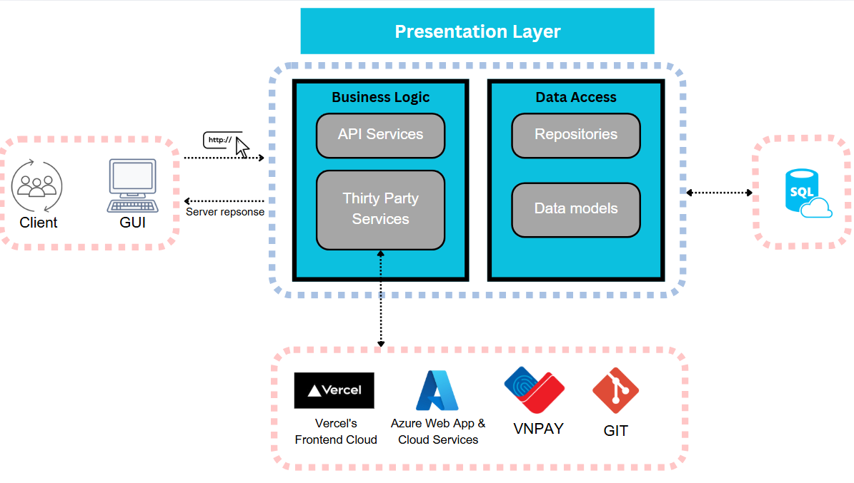1.2. UseCase

1.2.1 Use Case Diagram
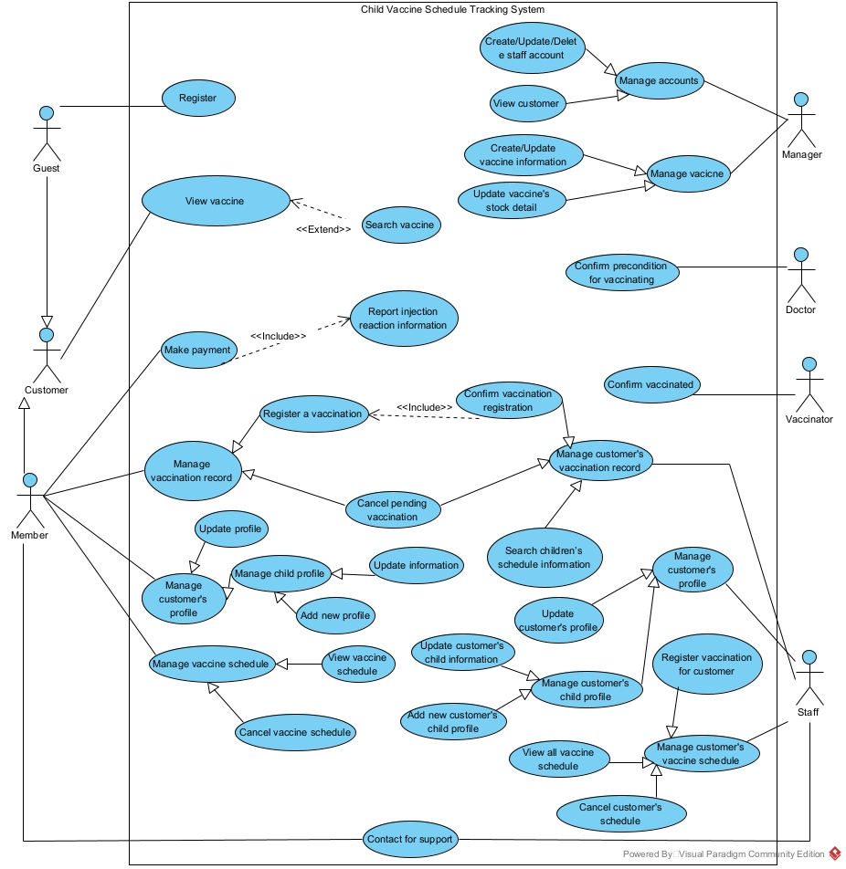

1.2.2 Description

ID | Use Case | Actors | Description
UC-01 | Register | Guest | This feature allows guests to register in the system.
UC-02 | View vaccine | Guest, Customer, Staff | This feature allows users to view vaccine information in the system.
UC-03 | Search vaccine | Guest, Customer, Staff | This feature allows users to look up for vaccine information within the system.
UC-04 | Register a vaccination | Customer | This feature allows users to book a new vaccination schedule in the system.
UC-05 | Confirm vaccination registration | Staff | This feature allows staff to confirm a registered vaccination in the system.
UC-06 | Cancel pending vaccination | Customer, Staff | This feature allows users to cancel a pending vaccination in the system.
UC-07 | Search children’s schedule information | Staff | This feature allows staff to look up for children’s vaccination schedules in the system.
UC-08 | Register vaccination for customer | Staff | This feature allows staff to register a new vaccination for the customer in the system.
UC-09 | Make payment | Customer | This feature allows users to make online payment after registering a vaccination.
UC-10 | Report injection reaction information | Customer | This feature allows customers to report reaction information after injection.
UC-11 | Update profile | Customer | This feature allows users to update profile information in the system.
UC-12 | Update information | Customer | This feature allows users to update children’s profiles in the system.
UC-13 | Add new profile | Customer | This feature allows users to create new children’s profiles in the system.
UC-14 | View vaccine schedule | Customer | This feature allows users to view their vaccination schedule in the system.
UC-15 | Cancel vaccine schedule | Customer | This feature allows users to cancel vaccination schedules in the system.
UC-16 | Contact for support | Customer, Staff | This feature allows users to contact support within the system.
UC-17 | Create staff account | Manager | This feature allows admin to create a new staff account within the system.
UC-18 | Update staff account | Manager | This feature allows admin to update staff accounts within the system.
UC-19 | Delete staff account | Manager | This feature allows admin to deactivate existing staff accounts within the system.
UC-20 | View customer | Manager | This feature allows the admin to view all customers within the system.
UC-21 | Create vaccine information | Manager | This feature allows admin to create a new vaccine within the system.
UC-22 | Update vaccine information | Manager | This feature allows admin to update an existing vaccine information in the system.
UC-23 | Update vaccine’s stock detail | Manager | This feature allows admin to update vaccines' stock in the system.
UC-24 | Confirm precondition for vaccinating | Doctor | This feature allows doctors to confirm children’s preconditions before injection.
UC-25 | Confirm vaccinated | Vaccinator | This feature allows vaccinators to confirm children’s being vaccinated.
UC-26 | Update customers’ profile | Staff | This feature allows staff to update customers' profiles in the system.
UC-27 | Update customers’ child information | Staff | This feature allows staff to update children’s profiles for customers in the system.
UC-28 | Add new customers’ child profile | Staff | This feature allows staff to addchildren’s profiles for customers in the system.
UC-29 | View all vaccine schedule | Staff | This feature allows staff to view all vaccination schedules of all customers in the system.
UC-30 | Search children’s schedule information | Staff | This feature allows staff to search vaccination schedules of all customers in the system.

1.2.3 Use Case Specification

ID and Name: | UC-01 Register
Created By: | Hồ Ngọc Sang | Date Created: | 12/02/2025
Primary Actor: | Guest | Secondary Actor: | System
Trigger: | The guest proceeds to create a new account in the system.
Description: | This use case allows a guest to create a new account in the system.
Pre-conditions: | The guest must not have an existing account in the system.
Post-conditions: | A new account is created in the system.
Normal Flow: | - Guests open the application or website and navigate to the register interface.  - Guests input their phone number, email, name, password and confirm password into the respective fields.  - Guests click the "Register" button to submit their credentials.  - The system checks if the phone number exists in the system, validates the input and adds a new account in the database.  - The system displays a confirmation message that a new account was created successfully.
Alternative Flows: | 3a. Guests click the “Cancel” button  If the actor decides not to create a new account, they click "Cancel", and nothing changes in the database.
Exception Flows: | 5a. Invalid Input  If the actor enters invalid data (e.g., invalid email format), the system displays an error message and prompts them to correct it.  6a. System Failure  If the system fails to create a new account, it notifies the actor and logs the error.
Priority: | High
Business Rule: | BR - 15, BR - 01

ID and Name: | UC-04 Booking a vaccination schedule
Created By: | Phạm Việt Hoàng | Date Created: | 15/02/2025
Primary Actor: | Customer | Secondary Actor:
Trigger: | The actor clicks the “Booking“ button.
Description: | This feature allows customers to book a vaccination schedule.
Pre-conditions: | The user must have an account as a customer.  The user must log in.  The customer must have their child’s profile.
Post-conditions: | A new vaccination schedule will be sent to the system and wait for the staff to confirm.
Normal Flow: | - Customer opens the application or website and navigates to the booking vaccination page.  - Customer selects their child they want for the injection.  - Customer fills the form, input date, time, select type of vaccine, select place for vaccination.  - Customer hits the confirm button and the system will navigate to the payment page.  - When finish payment, the customer will wait for staff to confirm
Alternative Flows: | 1a: If the user doesn’t log in yet, the system will navigate to the login page.  2a: If customer doesn’t have their child in their profile yet, the system will navigate to add child profile page  5a: If payment fail, the system will require to pay again
Priority: | High
Business Rule: | BR-02

ID and Name: | UC-05 Confirm customer’s vaccination registration
Created By: | Phạm Việt Hoàng | Date Created: | 15/02/2025
Primary Actor: | Staff | Secondary Actor: | Customer
Trigger: | The actor with the role Staff clicks the “Confirm“ button.
Description: | This feature allows staff to confirm a registered vaccination in the system.
Pre-conditions: | The user must have an account as a staff member.  The user must log in as staff.  The customer must have a registered vaccination before.
Post-conditions: | A notification will be sent to customer “Your vaccination schedule has been confirmed”
Normal Flow: | - Staff opens the application or website and navigates to the confirm vaccine page.  - Staff check the schedule and quantity of the vaccine.  - Staff hit the “Confirm” button.
Alternative Flows: | 1a: If the user doesn’t log in yet, the system will navigate to the login page.  2a: If the schedule is full, staff hit the “Cancel” button, choose the reason “SCHEDULE IS FULL” and the system will send a notification for that customer, then the system will ask for re-booking vaccination.  2b: If the vaccine is out of stock, staff hit the “Cancel” button, choose the reason “OUT OF STOCK” and the system will send a notification for that customer, then the system will ask for re-booking vaccination.
Priority: | High
Business Rule: | BR-03, BR-17

ID and Name: | UC-07 Search children’s schedule information
Created By: | Phạm Việt Hoàng | Date Created: | 15/02/2025
Primary Actor: | Staff | Secondary Actor:
Trigger: | Staff inputs child’s information (parent’s phone number, child’s name) and hit “Search” button
Description: | This feature allows staff to look up for children’s vaccination schedules in the system.
Pre-conditions: | The user must have an account as a staff member.  The user must log in as staff.  The customer must have their child’s profile.  The customer must book a vaccination schedule for their child before.
Post-conditions:
Normal Flow: | - Staff opens the application or website and navigates to the confirm vaccine page.  - Staff inputs the parent's phone number and child’s name.  - Staff hits the “Search” button.
Alternative Flows: | 1a: If the user doesn’t log in yet, the system will navigate to the login page.  3a: If the parent doesn’t have an account, the staff will register an account for the parent.  3b: if the parent doesn’t create their child profile yet, the staff will create their child profile for the parent.
Priority: | Medium
Business Rule:

ID and Name: | UC-08 Register vaccination for customer
Created By: | Lê Đặng Minh Trí | Date Created: | 15/02/2025
Primary Actor: | Staff | Secondary Actor: | System
Trigger: | The user chooses “Register vaccination” in the Main Page.
Description: | This feature allows staff to register a new vaccination for the customer in the system.
Pre-conditions: | 1. The user logs in to the system as “Staff”.  2. The customer’s details exist in the system.
Post-conditions: | 1. The vaccination purchase is recorded successfully.  2. The vaccine stock is updated.  3. The customer receives a purchase receipt.
Normal Flow: | 1. The staff select “Register new vaccination”.  2. The staff searches and selects the customer.  3. The system displays available vaccines along with prices.  4. The staff selects the vaccine type and enters the quantity.  5. The system calculates the total cost.  6. The staff enters payment details and confirms the purchase.  7. The system processes the transaction and updates the vaccine stock.  8. The system generates a purchase receipt for the customer.  9. The system records the vaccination purchase in the customer’s history.
Alternative Flows: | 2a. If the customer’s record does not exist, the system prompts the staff to register a new customer before proceeding.  3a. If the selected vaccine is out of stock, the system notifies the staff to reselect another.  7a. If the payment fails, the system displays an error message and allows the staff to retry or choose another payment method.
Priority: | High
Business Rule: | BR-04, BR-05, BR-06

ID and Name: | UC-09 Make payment
Created By: | Lê Đặng Minh Trí | Date Created: | 15/02/2025
Primary Actor: | Customer | Secondary Actor: | Payment Gateway System
Trigger: | The customer proceeds to make payment after receiving confirmation staff.
Description: | The system facilitates the payment transaction via a secure payment gateway and updates the order/payment status accordingly.
Pre-conditions: | The user receives confirmation notification by staff.
Post-conditions: | 1. The vaccination purchase is recorded successfully.  2. The vaccine stock is updated.  3. The customer receives a purchase receipt.
Normal Flow: | 1. The customer selects the "Make Payment" option.  2. The system displays order details and the total amount due.  3. The customer selects a payment method (Credit Card, Debit Card, E-Wallet, etc.).  4. The system redirects the customer to the payment gateway.  5. The customer enters payment details and submits the payment.  6. The payment gateway processes the transaction.  7. If the payment is successful, the system:  - Updates the order status to "Paid".  - Send a payment confirmation to the customer.  - Generates a receipt and updates payment records.  8. The system redirects the customer to a payment success page.
Alternative Flows: | 6a. Customer Cancels Payment  If the customer decides to cancel the payment before confirming, the system returns them to the order summary page without changing the payment status.  6b. Payment Gateway Timeout  If the payment gateway does not respond within a specified time, the system notifies the customer to try again.  6c. Insufficient Funds  If the payment fails due to insufficient funds, the system notifies the customer and allows them to select another payment method.  6d. Expired Payment Session  If the customer does not complete the payment within a certain time limit, the system expires the session and requires the customer to restart the payment process.
Exception Flows: | 7a. Payment Gateway Failure  If the payment gateway is down, the system displays an error message and advises the customer to try again later.  7b. Invalid Payment Details  If the customer enters incorrect card details or invalid credentials, the payment is declined, and the system prompts them to enter valid information.  7c. Duplicate Payment Attempt  If a duplicate payment request is detected, the system prevents it and notifies the customer that the order is already paid.
Priority: | High
Business Rule: | BR-07

ID and Name: | UC-10 Report injection reaction information
Created By: | Lê Đặng Minh Trí | Date Created: | 15/02/2025
Primary Actor: | Staff | Secondary Actor: | Customer
Trigger: | This feature allows staff to report reaction information after injection.
Description: | This use case describes how a staff member records an injection reaction report after the mandatory 30-minute post-vaccination observation period. The customer remains at the clinic, reports their reaction, and receives standard advice before being allowed to leave.
Pre-conditions: | 1. The customer has received vaccine injections from injectors.  2. The customer has been waiting for at least 30 minutes before getting called by the reporting staff.
Post-conditions: | 1. The reaction report is logged in the system.  2. The customer receives appropriate advice based on their symptoms.  3. The customer is cleared to leave after completing the reporting procedure.
Normal Flow: | 1. After receiving the vaccination, the customer is directed to a waiting area for a mandatory 30-minute observation.  2. A system reminder or staff announcement notifies the customer when the time is up.  3. The staff calls the customer for the reaction report and opens the "Injection Reaction Reports" module in the system.  4. The staff asks the customer if they have experienced any reactions and records.  5. The staff reviews the reported symptoms and provides guidance.  6. The staff saves the report, and the system logs it under the customer’s medical record.  7. The system confirms that the reaction report is completed.  8. The customer is allowed to leave the clinic.
Alternative Flows: | 6a. Customer Has a Severe Reaction During the 30-Minute Observation  If the customer shows visible signs of distress (e.g., fainting, difficulty breathing), staff immediately provides emergency assistance instead of following the standard reporting flow.
Exception Flows: | 1a. Customer Leaves Without Reporting  If the customer leaves before completing the report, the system flags an incomplete reaction report, and the staff must follow up.
Priority: | High
Business Rule: | BR-12, BR-13

ID and Name: | UC-11 Update profile
Created By: | Lê Đặng Minh Trí | Date Created: | 15/02/2025
Primary Actor: | Staff, Customer | Secondary Actor: | System
Trigger: | This feature allows staff to report reaction information after injection.
Description: | This use case describes how a customer or staff member updates their personal information in the system, such as name, contact details, and address
Pre-conditions: | The actor (customer or staff) is logged into the system.
Post-conditions: | The actor's profile is updated with the new information.
Normal Flow: | 1. The actor logs into their account and navigates to the "Profile Settings" page.  2. The system displays the current profile information.  3. The actor selects "Edit Profile" and updates allowed fields:  4. The actor clicks "Save Changes".  5. The system validates the input and updates the profile in the database.  The system displays a confirmation message that the update was successful.
Alternative Flows: | 5a. Actor Cancels Update  If the actor decides not to update their profile, they click "Cancel", and no changes are saved.
Exception Flows: | 6a. Invalid Input  If the actor enters invalid data (e.g., incorrect email format), the system displays an error message and prompts them to correct it.  6b. System Failure  If the system fails to save changes, it notifies the actor and logs the error.
Priority: | Medium
Business Rule: | BR-14, BR-15

ID and Name: | UC-12 Update information
Created By: | Hồ Ngọc Sang | Date Created: | 18/02/2025
Primary Actor: | Customer | Secondary Actor: | System
Trigger: | This feature allows customers to update children’s profiles in the system.
Description: | This use case describes how a customer updates their children’s information in the system, such as name, date of birth, pre-existing condition, gender, height and weight.
Pre-conditions: | 1. The actor (customer) is logged into the system.  2. The child’s profile existed in the system.
Post-conditions: | The children’s profile is updated with the new information.
Normal Flow: | 1. The actor logs into their account and navigates to the "Profile Settings" page.  2. The system displays the current child’s profile information.  3. The actor selects "Edit Profile" and updates allowed fields.  4. The actor clicks "Save Changes".  5. The system validates the input and updates the profile in the database.  6. The system displays a confirmation message that the update was successful.
Alternative Flows: | 4a. Actor Cancels Update  If the actor decides not to update their profile, they click "Cancel", and nothing changes in the database.
Exception Flows: | 5a. Invalid Input  If the actor enters invalid data (e.g., invalid date of birth), the system displays an error message and prompts them to correct it.  6a. System Failure  If the system fails to save changes, it notifies the actor and logs the error.
Priority: | Medium
Business Rule: | BR-14, BR-15

ID and Name: | UC-13 Add new profile
Created By: | Hồ Ngọc Sang | Date Created: | 18/02/2025
Primary Actor: | Customer | Secondary Actor: | System
Trigger: | This feature allows customers to add new children’s profiles in the system.
Description: | This use case describes how a customer adds their children’s profiles in the system.
Pre-conditions: | 1. The actor (customer) is logged into the system.  2. The child’s profile doesn't exist in the system.
Post-conditions: | A new child’s profile is created in the system.
Normal Flow: | 1. The actor logs into their account and navigates to the "Profile Settings" page.  2. The actor clicks on the “Add new profile” button.  3. The actor fills in the “Name”,”Day of birth”, “Height”, “Weight”, “Pre-existing condition” input fields and selects gender.  4. The actor clicks "Add Profile".  5. The system validates the input and adds a new child’s profile in the database.  6. The system displays a confirmation message that a new child’s profile is created successfully.
Alternative Flows: | 4a. Actor Cancels Add Profile  If the actor decides not to add a new child’s profile, they click "Cancel", and nothing changes in the database.
Exception Flows: | 5a. Invalid Input  If the actor enters invalid data (e.g., invalid date of birth), the system displays an error message and prompts them to correct it.  6a. System Failure  If the system fails to save changes, it notifies the actor and logs the error.
Priority: | High
Business Rule: | BR-15

ID and Name: | UC-14 View vaccine schedule
Created By: | Hồ Ngọc Sang | Date Created: | 18/02/2025
Primary Actor: | Customer | Secondary Actor: | System
Trigger: | This feature allows customers to view their children’s vaccination schedules in the system.
Description: | This use case describes how a customer views their up-coming children’s vaccination schedule in the system.
Pre-conditions: | 1. The actor (customer) is logged into the system.
Post-conditions: | The customer proceeds to view their children’s vaccination schedule in the system.
Normal Flow: | 1. The actor logs into their account and navigates to the "View Schedule" page.  2. The system shows a list of their children’s upcoming vaccination schedules with date, time, place for the injection.
Exception Flows: | 2a. No schedule  If the actor hasn’t registered any injection or there isn’t any up-coming vaccination in the schedule, the system will display a message to let the actor know there is no up-coming vaccination for them in the schedule.
Priority: | High
Business Rule: | BR-18

ID and Name: | UC-15 Cancel vaccine schedule
Created By: | Hồ Ngọc Sang | Date Created: | 18/02/2025
Primary Actor: | Customer | Secondary Actor: | System
Trigger: | This feature allows customers to cancel their children’s vaccination schedules in the system.
Description: | This use case describes how a customer cancels an up-coming vaccination schedule in the system.
Pre-conditions: | 1. The actor (customer) is logged into the system.  2. The vaccination schedule that the actor wants to cancel has already existed in the system.  3. The vaccination schedule has not been fully confirmed by the staff.
Post-conditions: | The customer proceeds to cancel their children’s up-coming vaccination schedule in the system.
Normal Flow: | 1. The actor logs into their account and navigates to the "View Schedule" page.  2. The actor clicks on the vaccination appointment that they want to cancel.  3. The actor clicks on the “Cancel Schedule” button.  4. The system shows a confirmation pop-up to make sure that the actor wants to cancel the vaccination schedule.  5. The actor clicks on the “Confirm” button in the pop-up.  6. The selected vaccination schedule is successfully cancelled.
Alternative Flows: | 5a. Actor Doesn’t Confirm  If the actor decides not to cancel the selected vaccination schedule, they click "Cancel", and nothing changes in the database.
Exception Flows: | 6a. System Failure  If the system fails to save changes, it notifies the actor and logs the error.
Priority: | Medium
Business Rule: | BR-19

ID and Name: | UC-16 Contact for support
Created By: | Nguyễn Hoàng Điền | Date Created: | 15/02/2025
Primary Actor: | Customer, Staff | Secondary Actor:
Trigger: | The actor clicks the “Contact Support” button.
Description: | This feature allows users to contact support within the system.
Pre-conditions: | The user must be logged into the system.
Post-conditions: | A support request is submitted to the system and can be processed by staff.
Normal Flow: | 1. User navigates to the “Contact Support” section.  2. User fills in the form with issue details.  3. User submits the support request.  4. The system stores the request and notifies staff.  5. Staff reviews and processes the request.
Alternative Flows: | 3a. The user can check the status of their previous support requests.  3b. The user can update their submitted support request if needed.
Priority: | Medium
Business Rule: | BR-08

ID and Name: | UC-17 Create staff account
Created By: | Nguyễn Hoàng Điền | Date Created: | 15/02/2025
Primary Actor: | Admin | Secondary Actor:
Trigger: | The actor clicks the “Create Staff Account” button.
Description: | This feature allows admin to create a new staff account within the system.
Pre-conditions: | Admin must be logged into the system.
Post-conditions: | A new staff account is created in the system.
Normal Flow: | 1. Admin navigates to the staff management section.  2. Admin clicks the “Create Staff Account” button.  3. Admin enters the required information (e.g., name, email, role).  4. Admin submits the form.  5. The system creates a new staff account.
Alternative Flows: | Admin can assign roles and permissions to the newly created staff account.
Priority: | High
Business Rule: | BR-09

ID and Name: | UC-18 Update staff account
Created By: | Nguyễn Hoàng Điền | Date Created: | 15/02/2025
Primary Actor: | Admin | Secondary Actor:
Trigger: | The actor clicks the “Update Staff Account” button.
Description: | This feature allows admin to update staff accounts within the system.
Pre-conditions: | Admin must be logged into the system.
Post-conditions: | Staff account information is updated in the system.
Normal Flow: | 1. Admin navigates to the staff management section.  2. Admin selects a staff account to update.  3. Admin modifies the necessary information.  4. Admin submits the changes.  5. The system updates the staff account information.
Alternative Flows: | Admin can reset the staff account password if necessary.
Priority: | Medium
Business Rule: | BR-10

ID and Name: | UC-19 Delete staff account
Created By: | Nguyễn Hoàng Điền | Date Created: | 15/02/2025
Primary Actor: | Admin | Secondary Actor:
Trigger: | The actor clicks the “Delete Staff Account” button.
Description: | This feature allows admin to deactivate existing staff accounts within the system.
Pre-conditions: | Admin must be logged into the system.
Post-conditions: | The selected staff account is deactivated.
Normal Flow: | 1. Admin navigates to the staff management section.  2. Admin selects the staff account to deactivate.  3. Admin clicks the “Delete” button.  4. The system permanently deletes the staff account from the system.
Alternative Flows: | There is no option to restore the account once it has been permanently deleted.  If the admin deletes the account by mistake, they will need to create a new staff account from
Priority: | Medium
Business Rule: | BR-11, BR-16

ID and Name: | UC-20 View customers
Created By: | Nguyễn Tăng Tài Phát | Date Created: | 15/02/2025
Primary Actor: | Admin | Secondary Actor:
Trigger: | The administrator chooses “View customers” in the Dashboard Page.
Description: | This feature allows the administrator to inspect the customers in the system.
Pre-conditions: | The user logs in to the system as “Admin”, the system is online and accessible.
Post-conditions: | Authorized access, retrieves and displays customer data correctly, maintains logs (if enabled), enforces security, and does not modify any records.
Normal Flow: | The admin enters valid credentials and accesses the system.  The admin selects the "View Customers" option from the dashboard or menu.  The system fetches the list of customers from the database.  The retrieved customer data is shown in a structured format (e.g., table or list).  (Optional): The admin can filter, sort, or search customers based on criteria like name, email, or status.  (Optional): Clicking on a customer opens a detailed profile with more information.  The admin successfully views the customer data without modifying any records.
Alternative Flows: | Session timeout requiring re-login, database failure showing an error, and unauthorized access being denied.
Priority: | High
Business Rule:

ID and Name: | UC-21 Create vaccine information
Created By: | Nguyễn Tăng Tài Phát | Date Created: | 15/02/2025
Primary Actor: | Admin | Secondary Actor:
Trigger: | The administrator chooses “Create” in the Dashboard/Vaccine Page.
Description: | This feature allows the administrator to add new vaccines in the system.
Pre-conditions: | The user logs in to the system as “Admin”, the system is online and accessible.
Post-conditions: | The vaccine record is successfully stored in the database
Normal Flow: | The admin accesses the system with valid credentials.  The admin selects the "Create" option in the Vaccine Dashboard page.  The admin fills in required fields like name, manufacturer, dosage, expiry date, and storage conditions.  The admin clicks the “Create" button.  The system checks for missing or incorrect information.  The system stores the new vaccine details in the database.  The system confirms successful creation and may provide an option to view or edit the record.
Alternative Flows: | Session timeout requiring re-login, no customers found, invalid filters returning no results, database failure showing an error, and unauthorized access being denied.
Priority: | High
Business Rule:

ID and Name: | UC-22 Update vaccine information
Created By: | Nguyễn Tăng Tài Phát | Date Created: | 15/02/2025
Primary Actor: | Admin | Secondary Actor:
Trigger: | The administrator chooses “Update” in the Dashboard/Vaccine Page.
Description: | This feature allows the administrator to add new vaccines in the system.
Pre-conditions: | The user logs in to the system as “Admin”, the system is online and accessible.
Post-conditions: | The vaccine record is successfully stored in the database
Normal Flow: | The admin accesses the system with valid credentials.  The admin selects the "Update" option in the Vaccine Dashboard page.  The admin rewrites the information like name, manufacturer, dosage, expiry date, and storage conditions.  The admin clicks the “Update" button.  The system checks for missing or incorrect information.  The system stores the vaccine details in the database.  The system confirms successful updates and may provide an option to view or edit the record.
Alternative Flows: | Session timeout requiring re-login, no customers found, invalid filters returning no results, database failure showing an error, and unauthorized access being denied.
Priority: | High
Business Rule:

ID and Name: | UC-23 Update Vaccine’s stock detail
Created By: | Nguyễn Tăng Tài Phát | Date Created: | 15/02/2025
Primary Actor: | Admin | Secondary Actor:
Trigger: | The Admin initiates the update process for vaccine stock details.
Description: | The Admin updates the stock details of vaccines, including quantity, batch number, and expiry date, ensuring the database reflects accurate inventory information.
Pre-conditions: | The user logs in to the system as “Admin”, the system is online and accessible.
Post-conditions: | The updated vaccine stock details are successfully stored in the database.  The updated information is available for further transactions and reporting.
Normal Flow: | The Admin logs into the system.  The Admin navigates to the vaccine stock management section.  The Admin selects the vaccine that needs an update.  The system retrieves and displays the current stock details.  The Admin modifies the stock information (e.g., quantity, batch number, expiry date).  The Admin submits the changes.  The system validates the inputs.  If validation is successful, the system updates the stock details in the database.  A confirmation message is displayed to the Admin.
Alternative Flows: | Session timeout requiring re-login, no customers found, invalid filters returning no results, database failure showing an error, and unauthorized access being denied.
Priority: | High
Business Rule:

1.3. Activity diagram
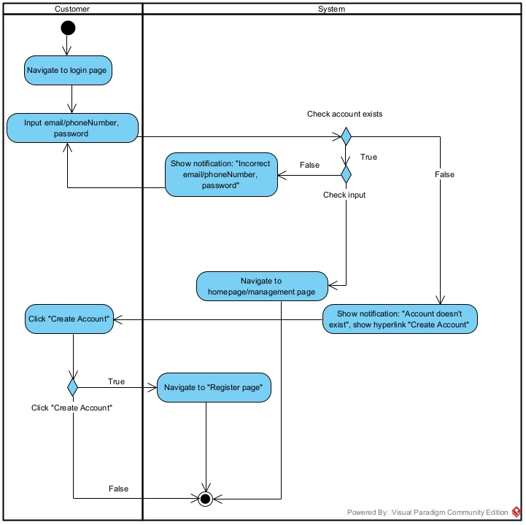
Login activity diagram
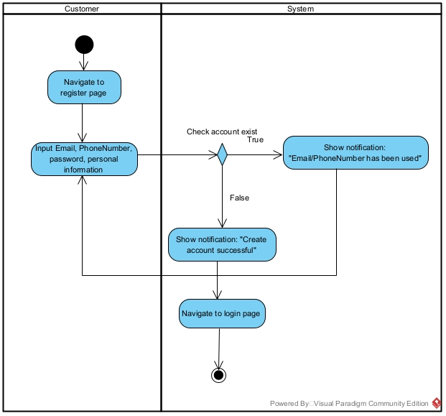
Register activity diagram
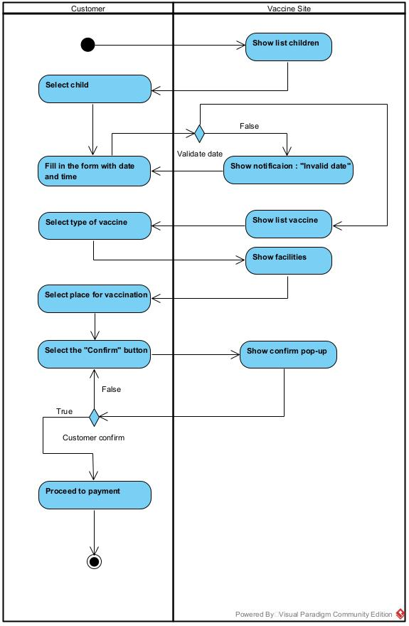
Register a vaccination activity diagram
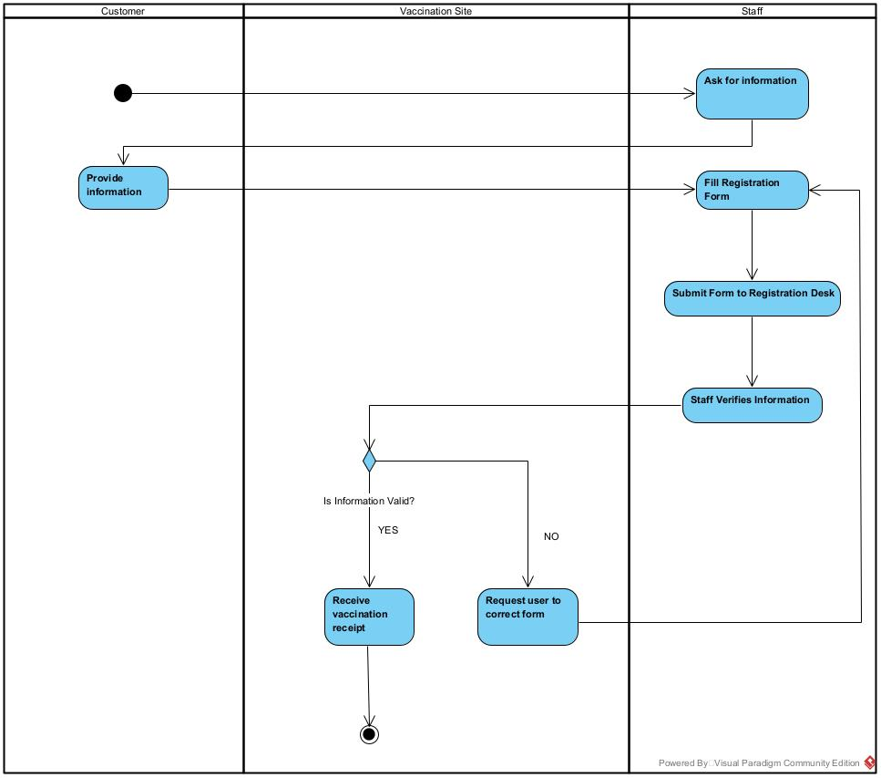
Register on site vaccination activity diagram
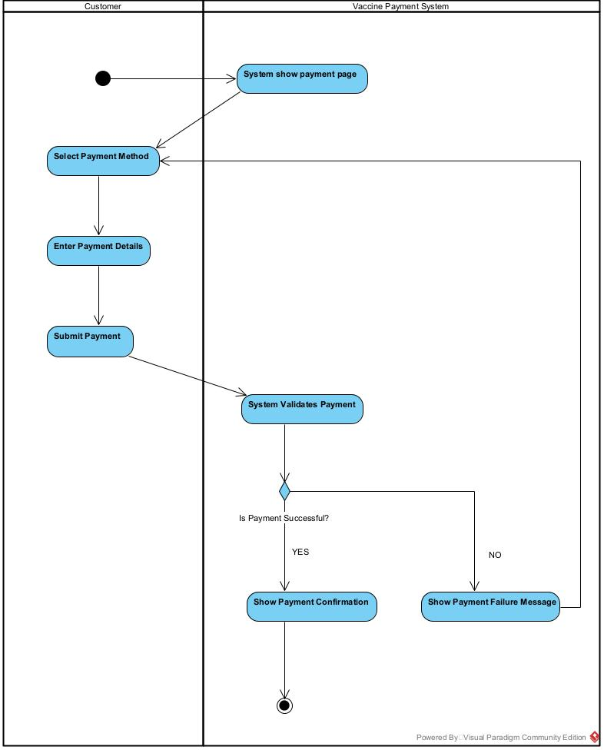
Online payment activity diagram
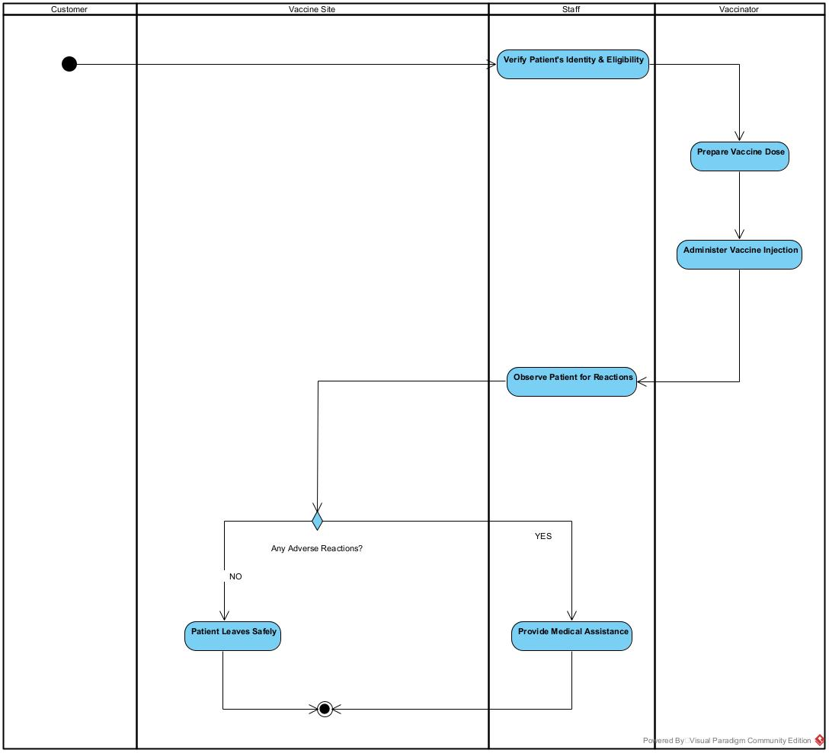
Injecting vaccine activity diagram

1.4. State Machine Diagrams
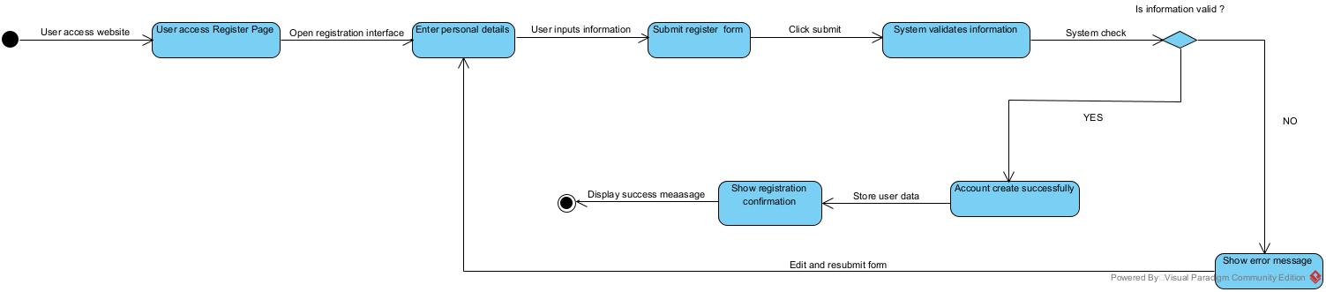
Register account for vaccination state machine diagram
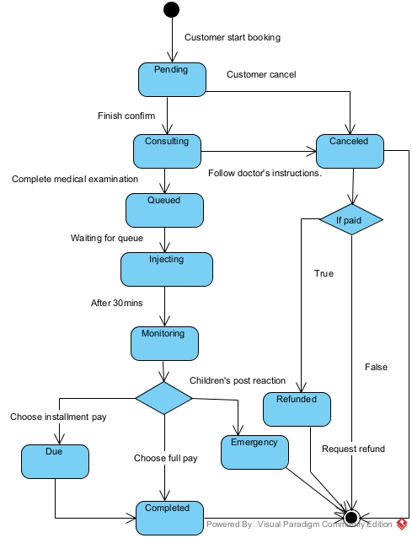

2. Database Design
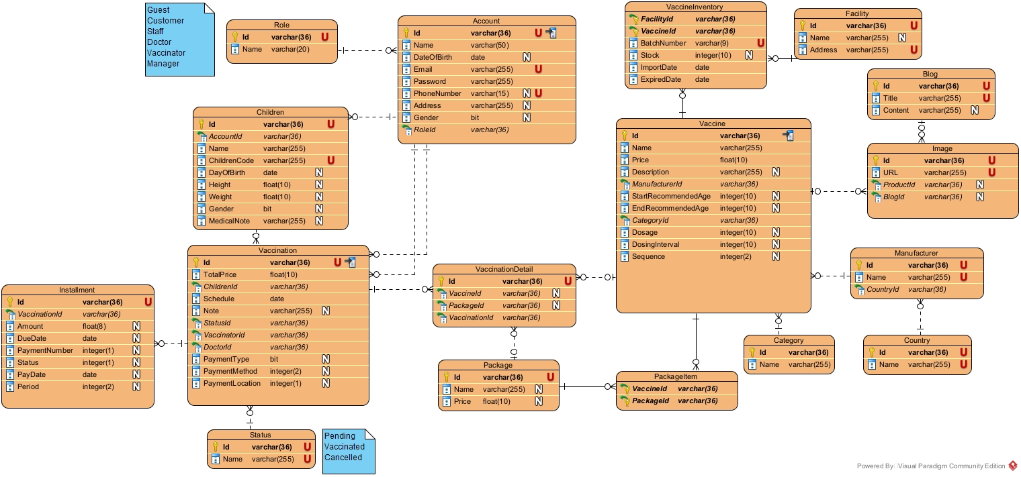

3. Detailed Design

3.1 Class Diagram
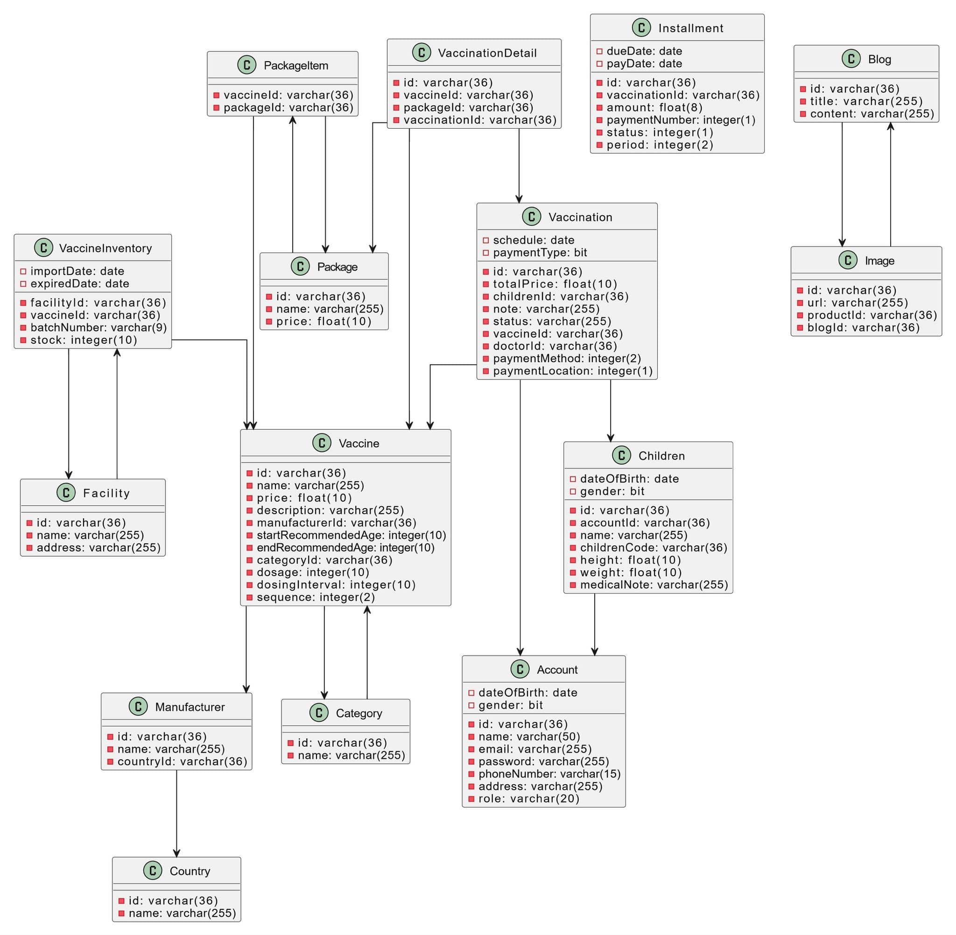
Core system class diagram

3.2 Package Diagrams

1. Front-end

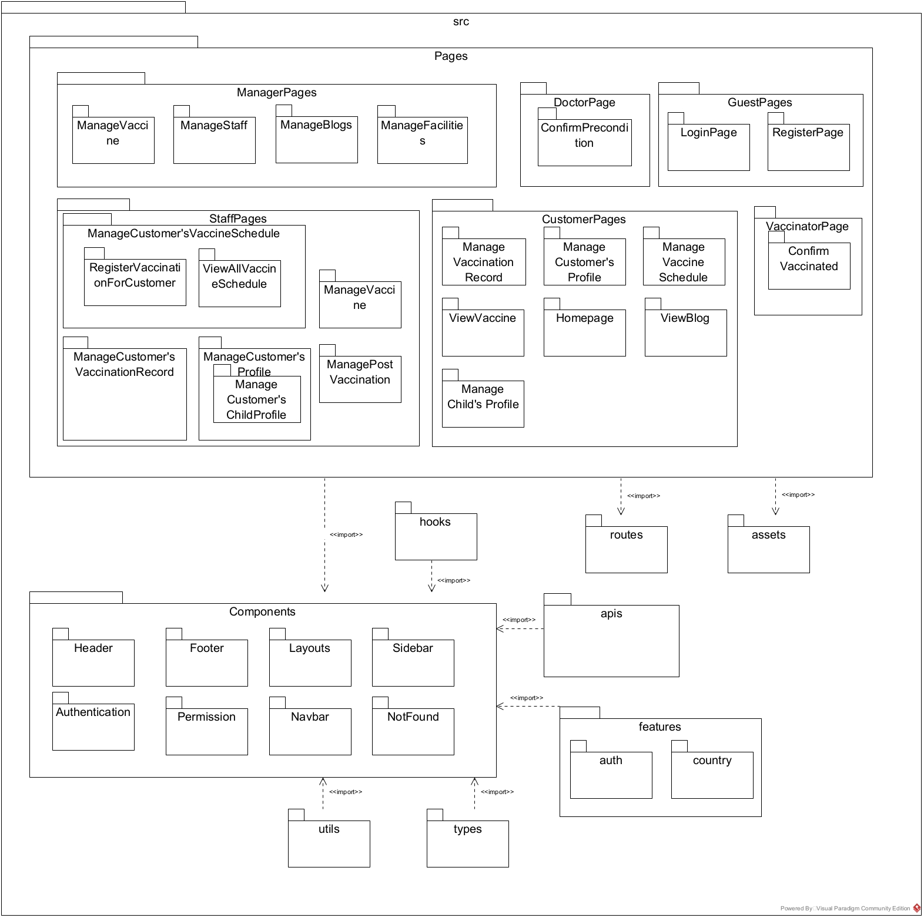

2. Back-end

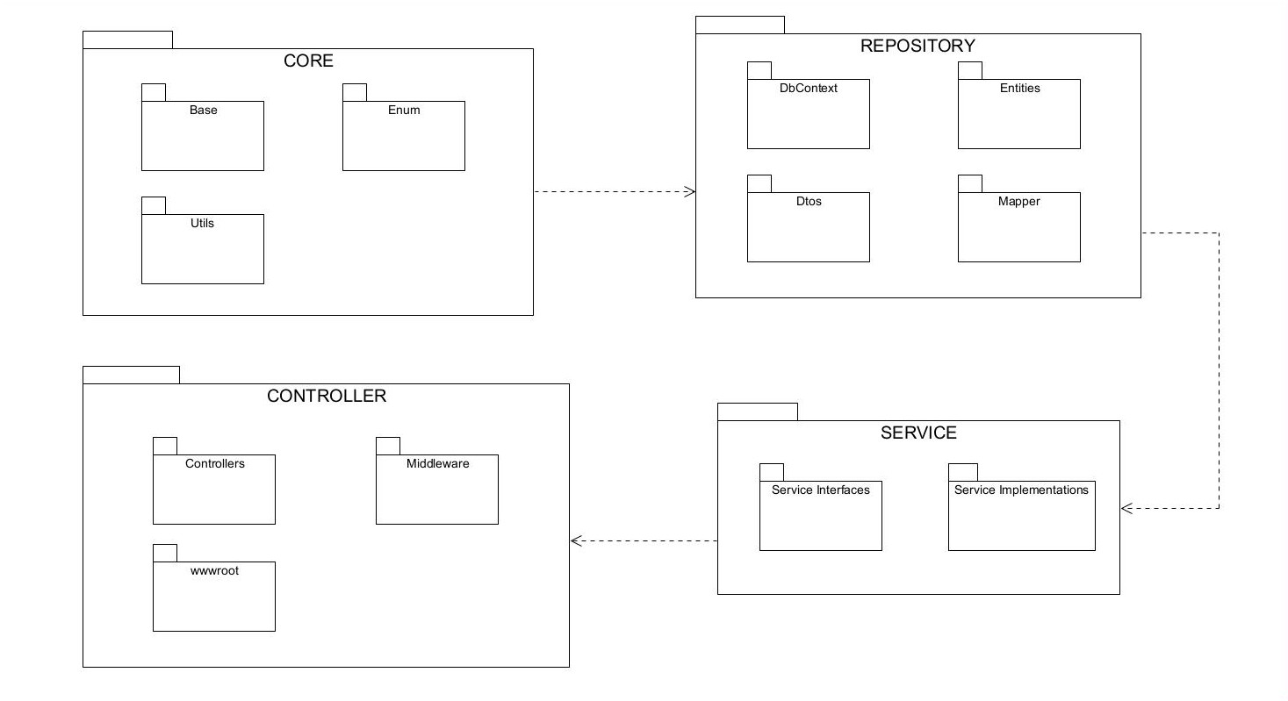

3.3 Sequence Diagrams
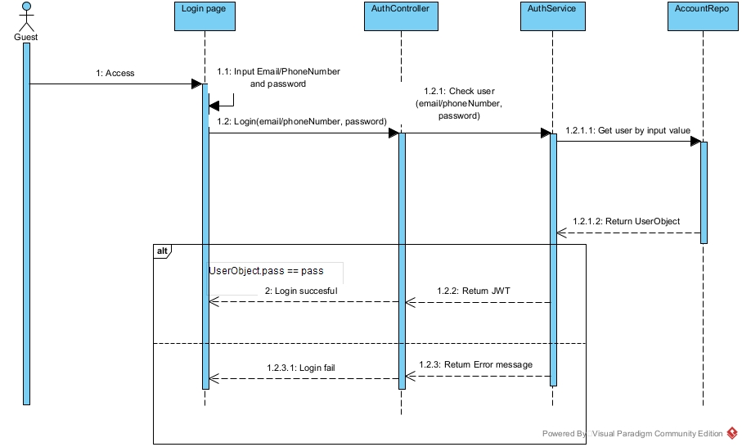
Login sequence diagram
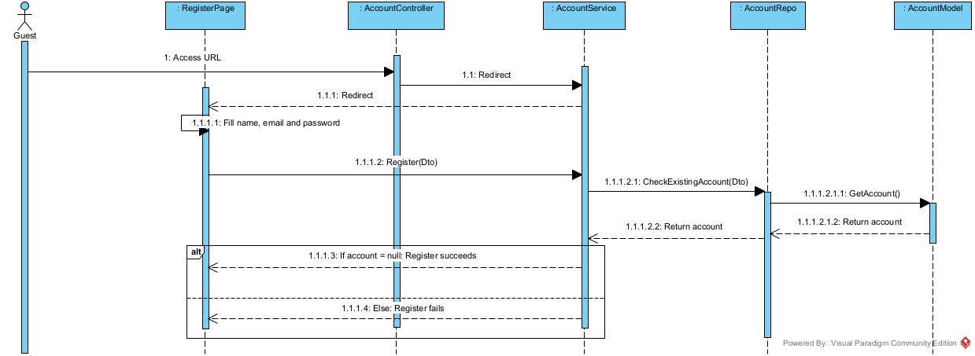
Register account sequence diagram

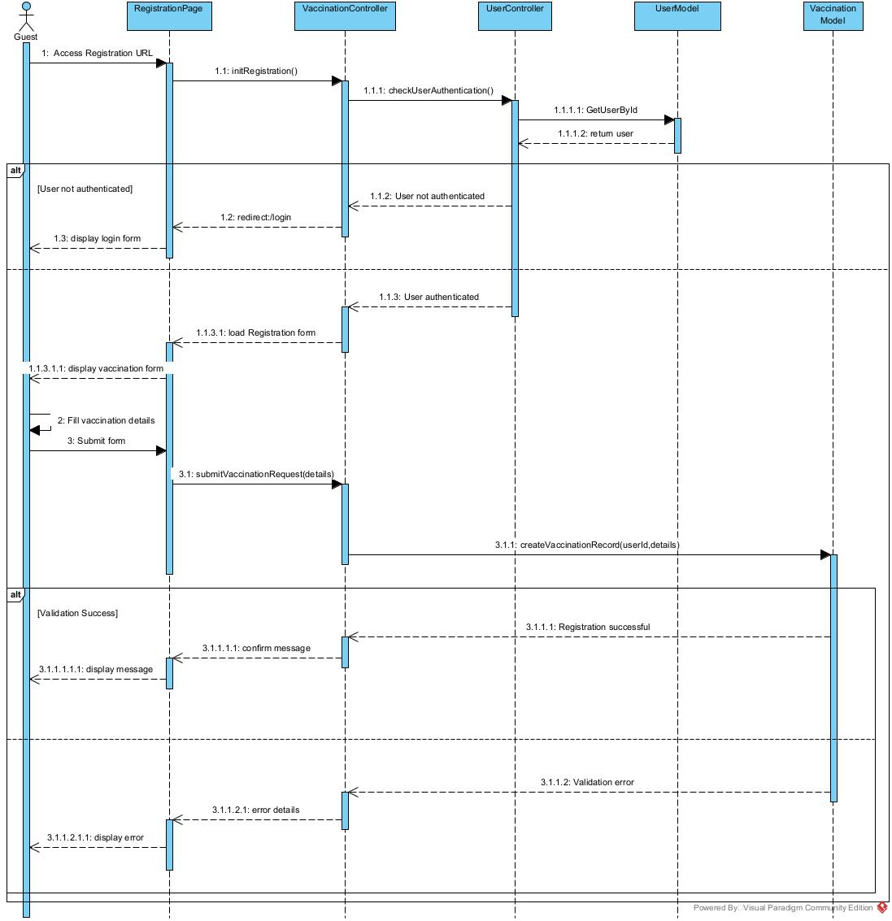
Registration Vaccination sequence diagram

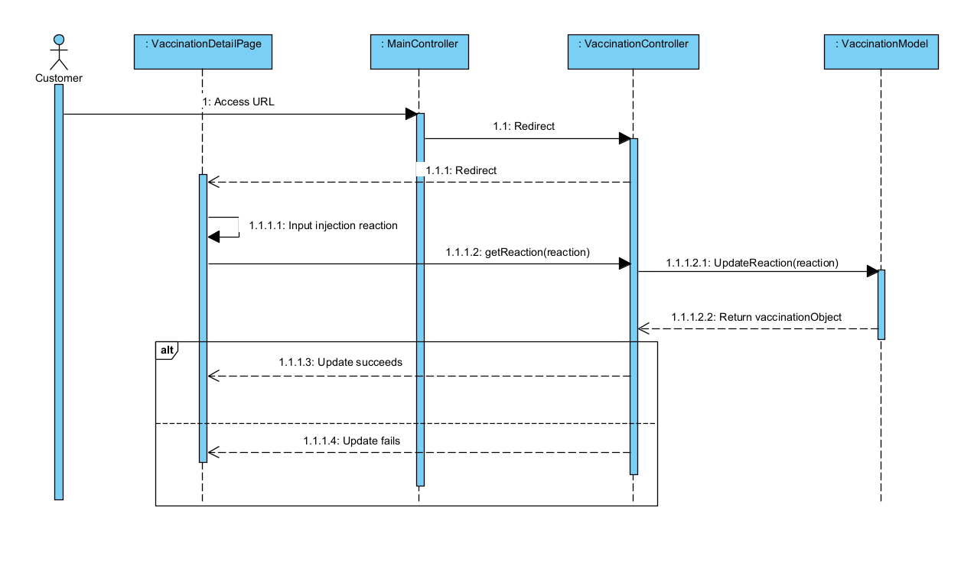
Report Injection Reaction

