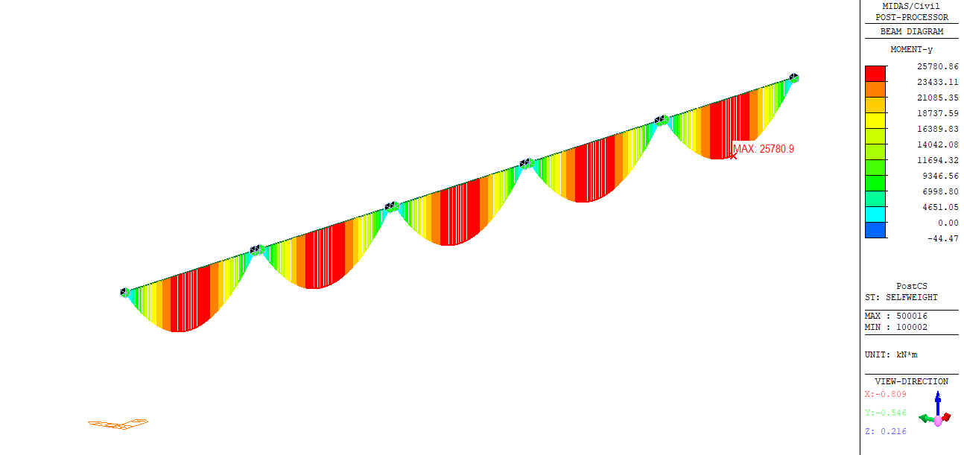
Figure 1 momen My G1

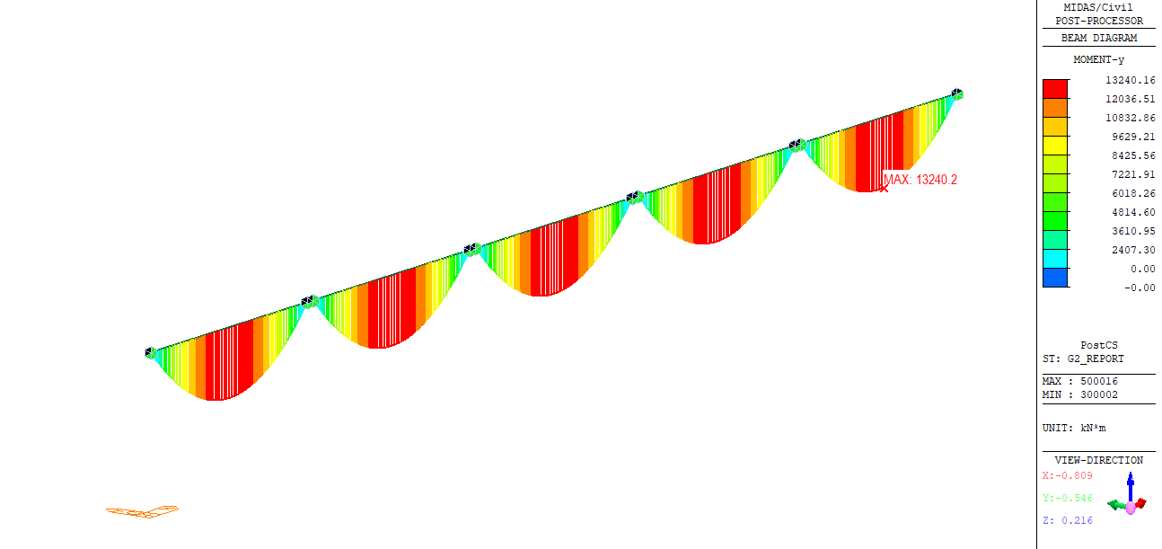
Figure 2 momen My G2

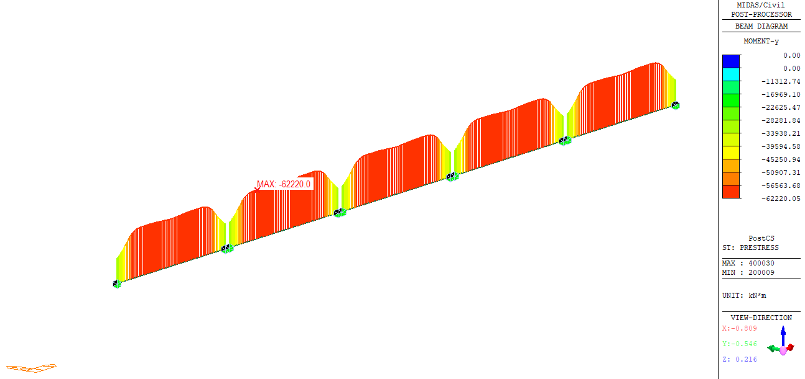
Figure 3 momen My PT

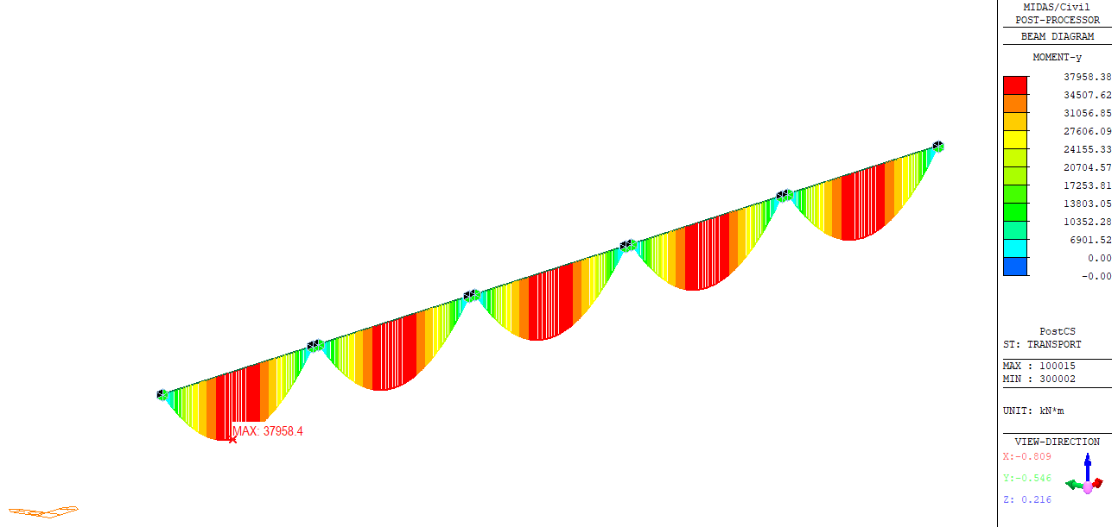
Figure 4 momen My xe van chuyen dam

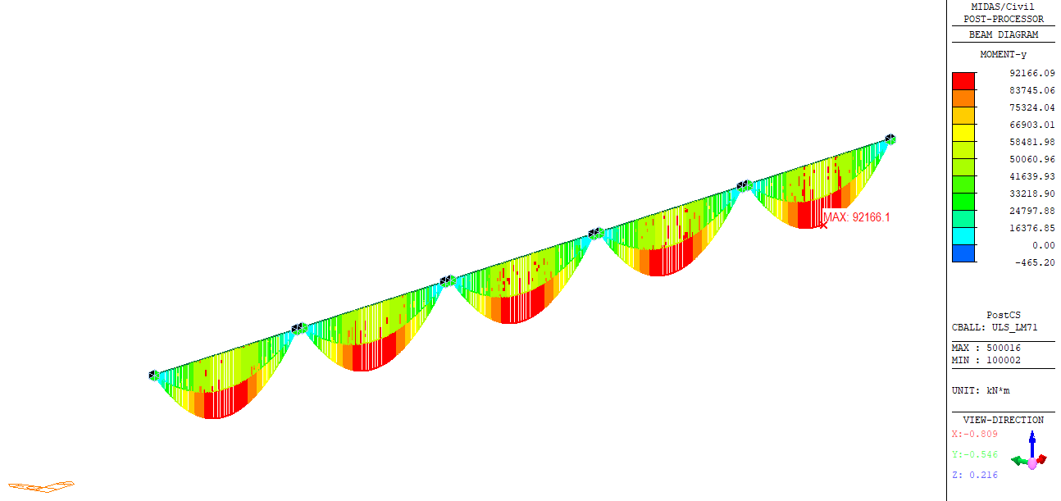
Figure 5 momen My ULS LM71

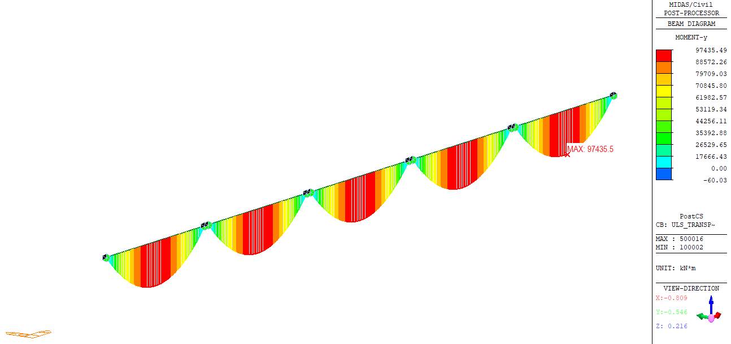
Figure 6 momen My ULS van chuyen

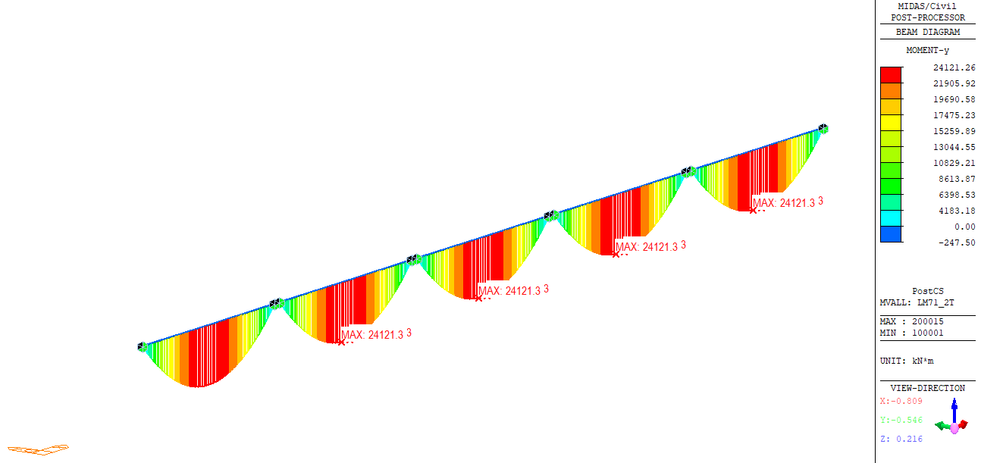
Figure 7 momen My LM71 2 lan

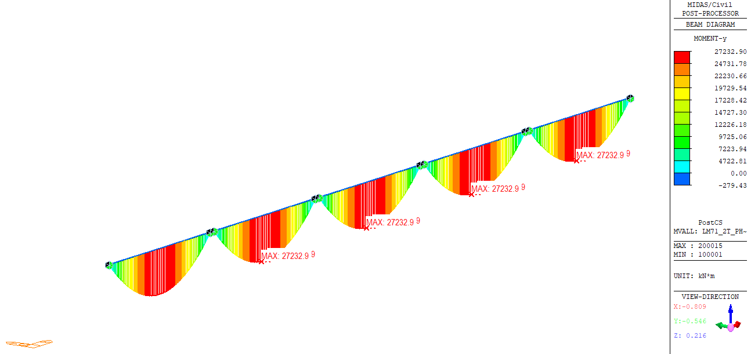
Figure 8 momen My LM71 2 lan phi

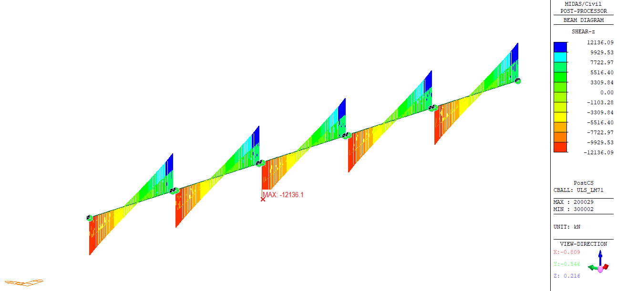
Figure 9 Luc cat ULS

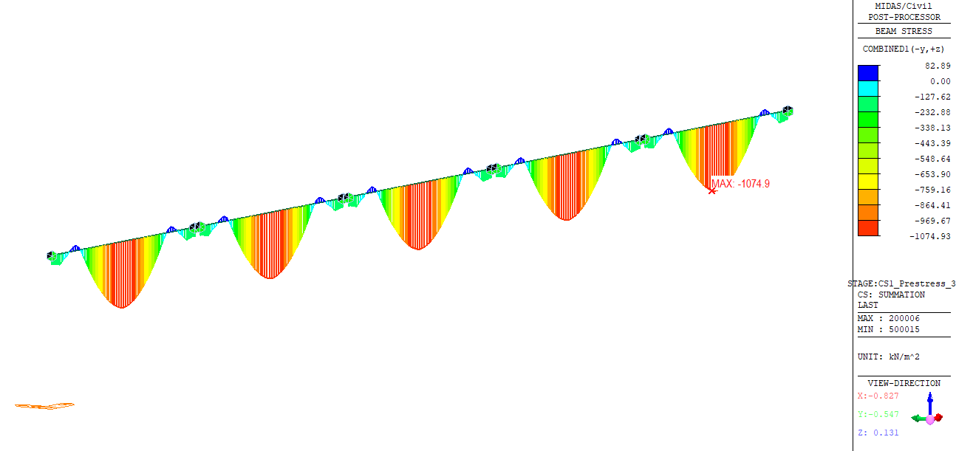
Figure 10 BeamStrsDgrm 3 ngay

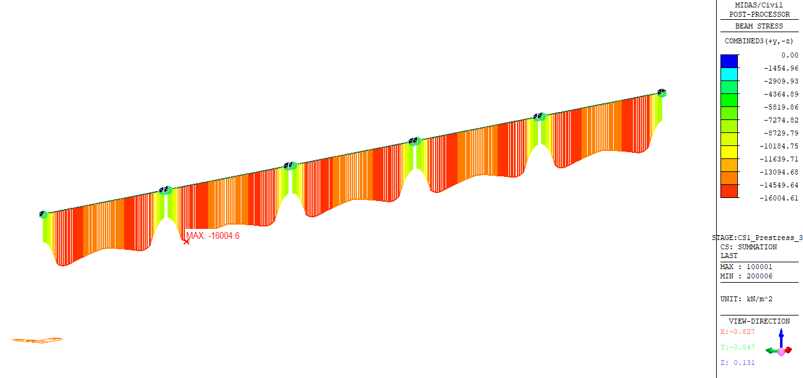
Figure 11 BeamStrsDgrm 3 ngay bot

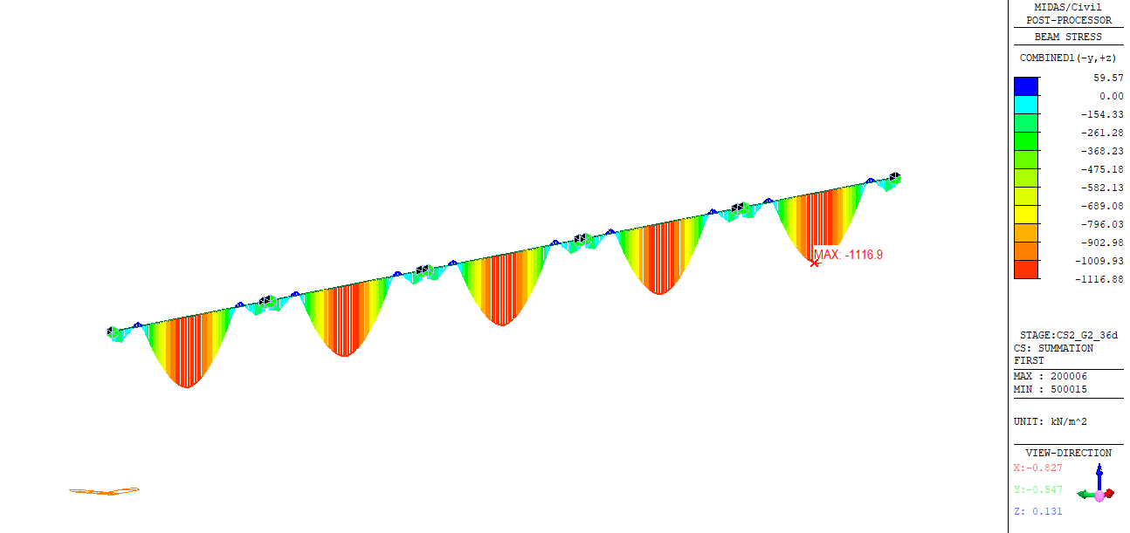
Figure 12 BeamStrsDgrm 36 day top

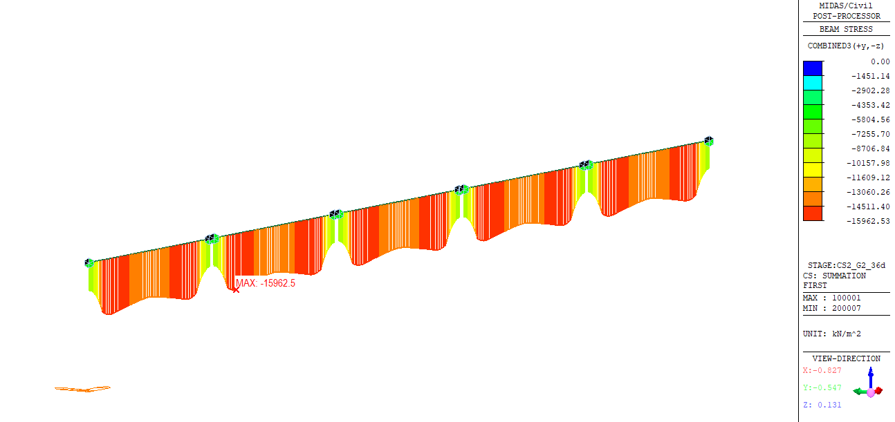
Figure 13 BeamStrsDgrm 36 day bot

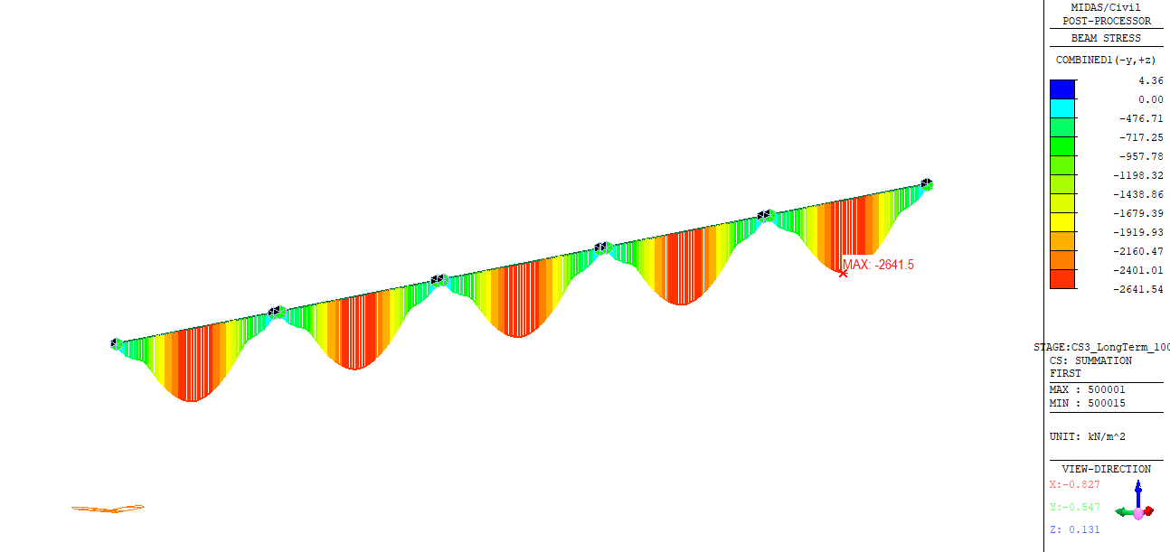
Figure 14 BeamStrsDgrm 100y top

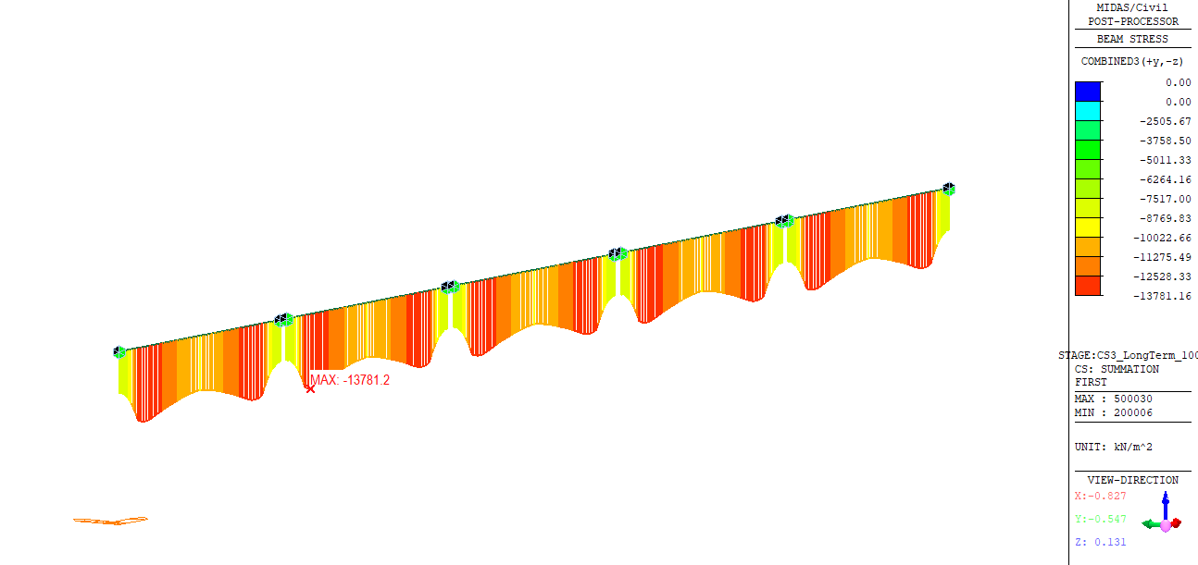
Figure 15 BeamStrsDgrm 100y bot

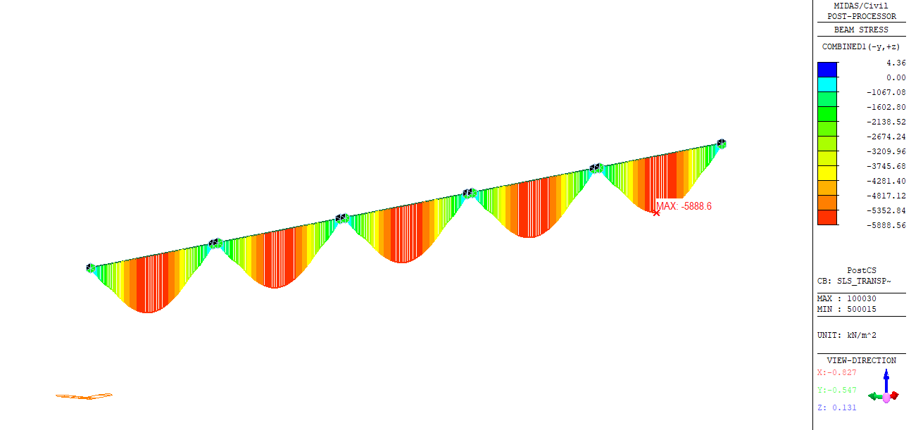
Figure 16 BeamStrsDgrm SLS Trans

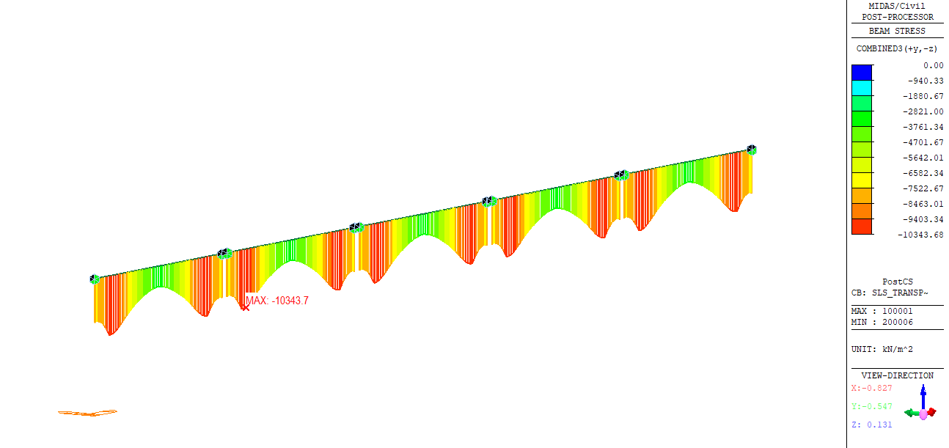
Figure 17 BeamStrsDgrm SLS Trans bot

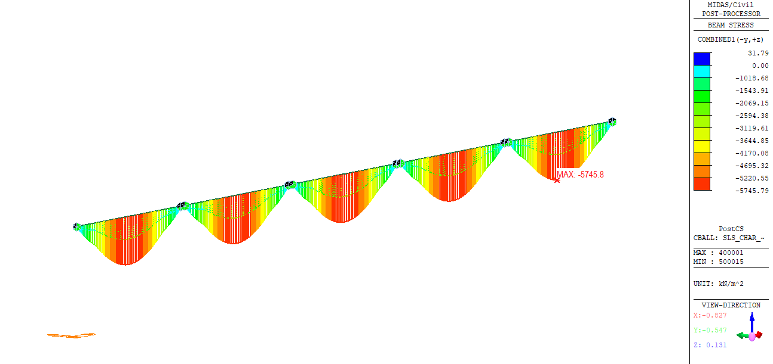
Figure 18 BeamStrsDgrm SLS top

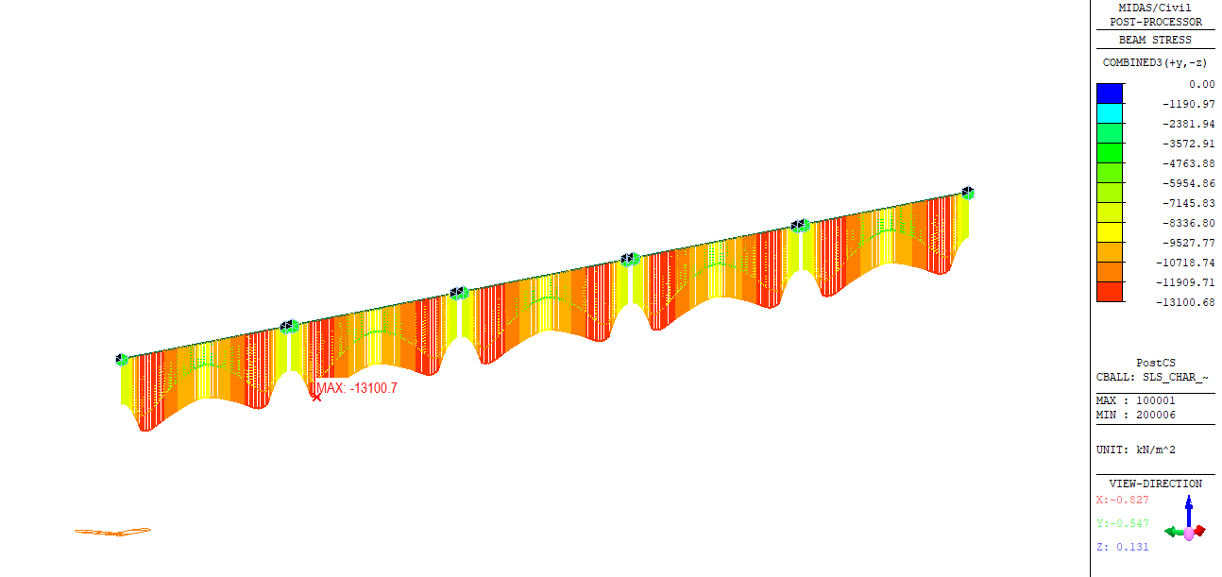
Figure 19 BeamStrsDgrm SLS bot

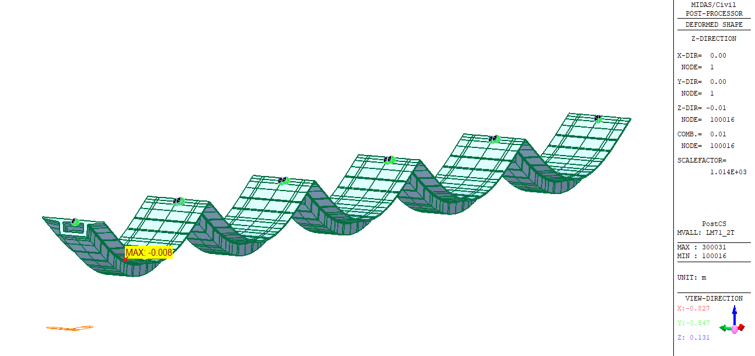
Figure 20 do vong do LM71

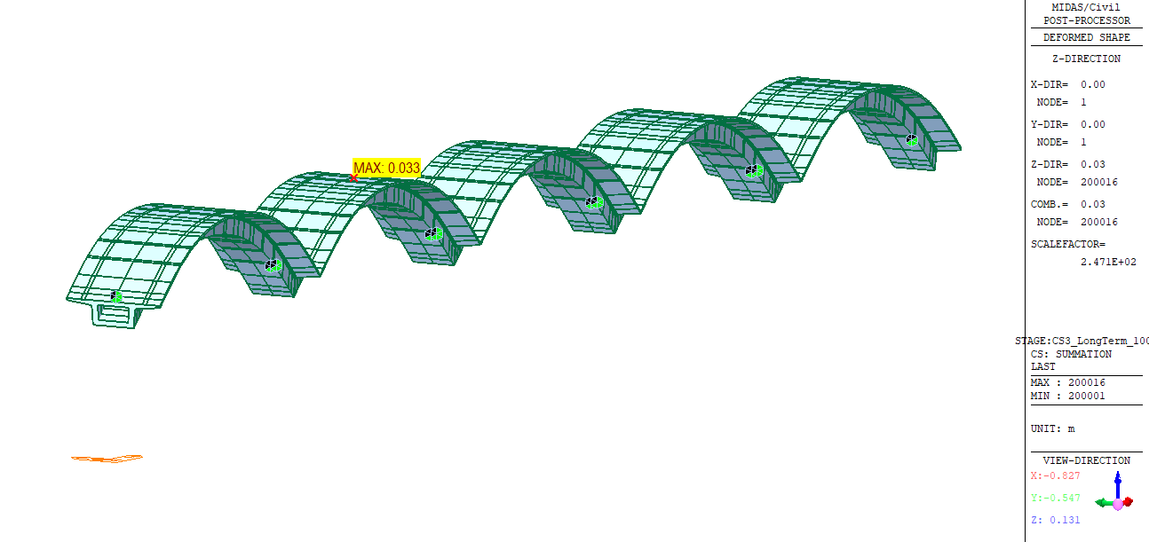
Figure 21 do vong sau 100y

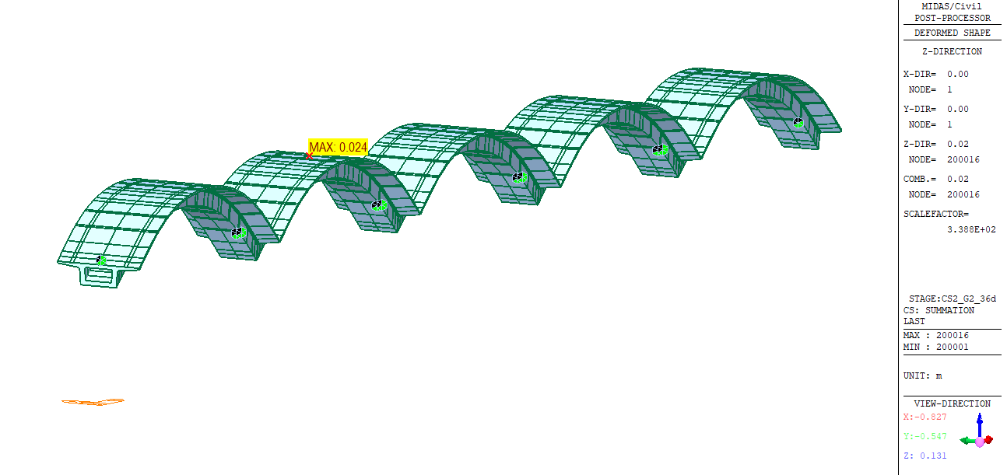
Figure 22 do vong sau GD2

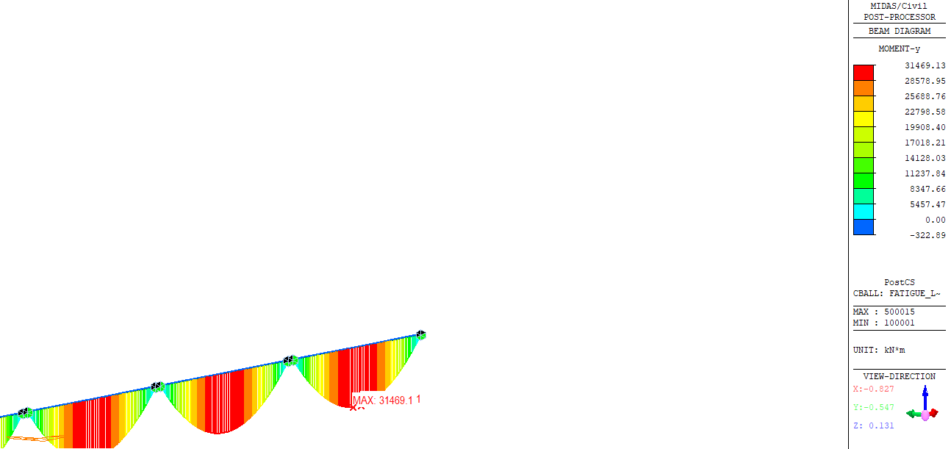
Figure 23 momen Fatigue

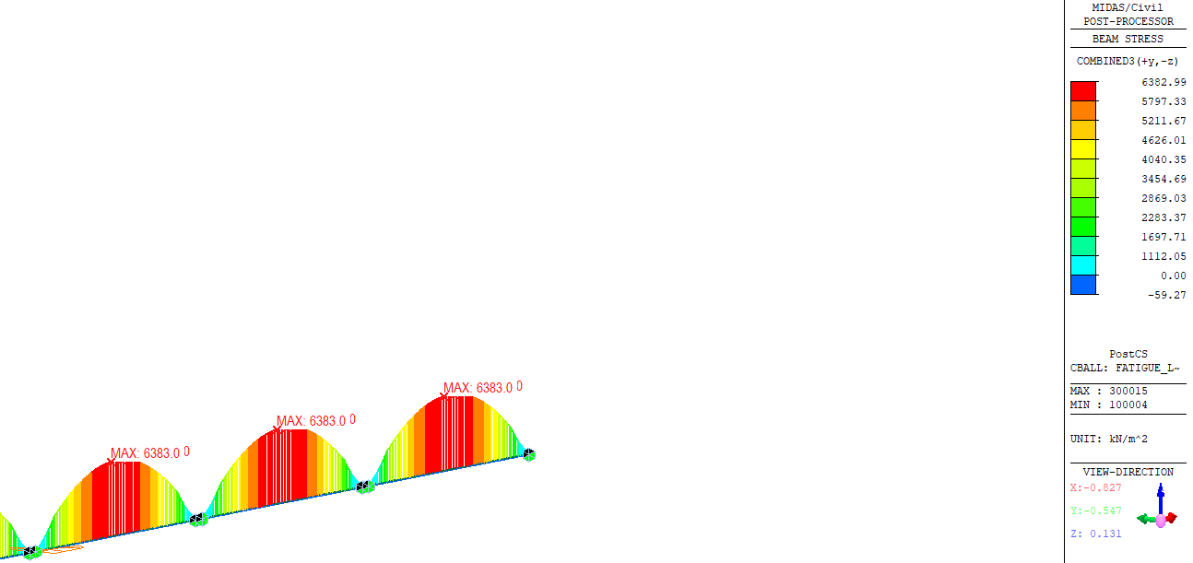
Figure 24 ung suat fatigue

