EVM – Volunteer Event Management System
(Consolidated Documentation)
This document consolidates the mandatory scope delivered for the EVM (Volunteer Event Management System) built on OutSystems. It outlines completed features, the layered architecture, key entities, the reminder timer design, a test checklist, and a backlog of enhancements.

1. Features Completed (Mandatory)
Volunteer Web App:
- Browse Upcoming Events (Title, Date/Time, Location).
- Event Details with live weather (OpenWeather) for the event’s coordinates.
- Sign up for events with capacity enforcement (MaxVolunteers) and duplicate prevention.
- My Events: Upcoming & Past.
- Submit Feedback after the event (rating + comments; visible only when eligible).

Admin Web App:
- CRUD Events (Title, Description, Location, Lat/Lng, Start/End, MaxVolunteers, Status).
- Location search via OpenWeather Geocoding to auto-fill Location + Lat/Lng.
- CRUD Email Templates with tokenized Subject/Body (Key = "ReminderBeforeStart").
- Reminder Timer to notify volunteers X days before start; NotificationLog for idempotency.

Weather Integration:
- OpenWeather Current Weather by lat/long; Direct Geocoding (search by text).

Email & SMTP:
- Gmail SMTP (Service Center) using App Password; plain‑text or templated reminders sent from Admin Timer.

2. Architecture (Layers & Modules)
The implementation follows the OutSystems Architecture Canvas: End‑User Apps → Core → Foundation. UI modules never call external providers directly; Core encapsulates business logic and integrations.

2.1 Modules
Foundation
- EVM_Foundation_WeatherProvider – REST to OpenWeather (Direct Geocoding, Current Weather).

Core
- EVM_Core_Events – Event & EventStatus; weather accessors; helpers for event operations.
- EVM_Core_Participations – Participant & ParticipationStatus; IsUserRegistered, GetCapacityRemaining, SignUpForEvent.
- EVM_Core_Feedback – Feedback; CanSubmitFeedback (ended or Completed + registered + not yet given), SubmitFeedback.
- EVM_Core_Notifications – EmailTemplate, NotificationLog; GetEmailTemplateByKey, ApplyTokens, BuildTokensForEventUser.

End‑User Apps
- EVM_Admin_Web – Event & Email Template admin, and EventReminder_Run Timer.
- EVM_Web_App – Upcoming Events list, Event Details (with weather), My Events (Upcoming/Past), Feedback popup.

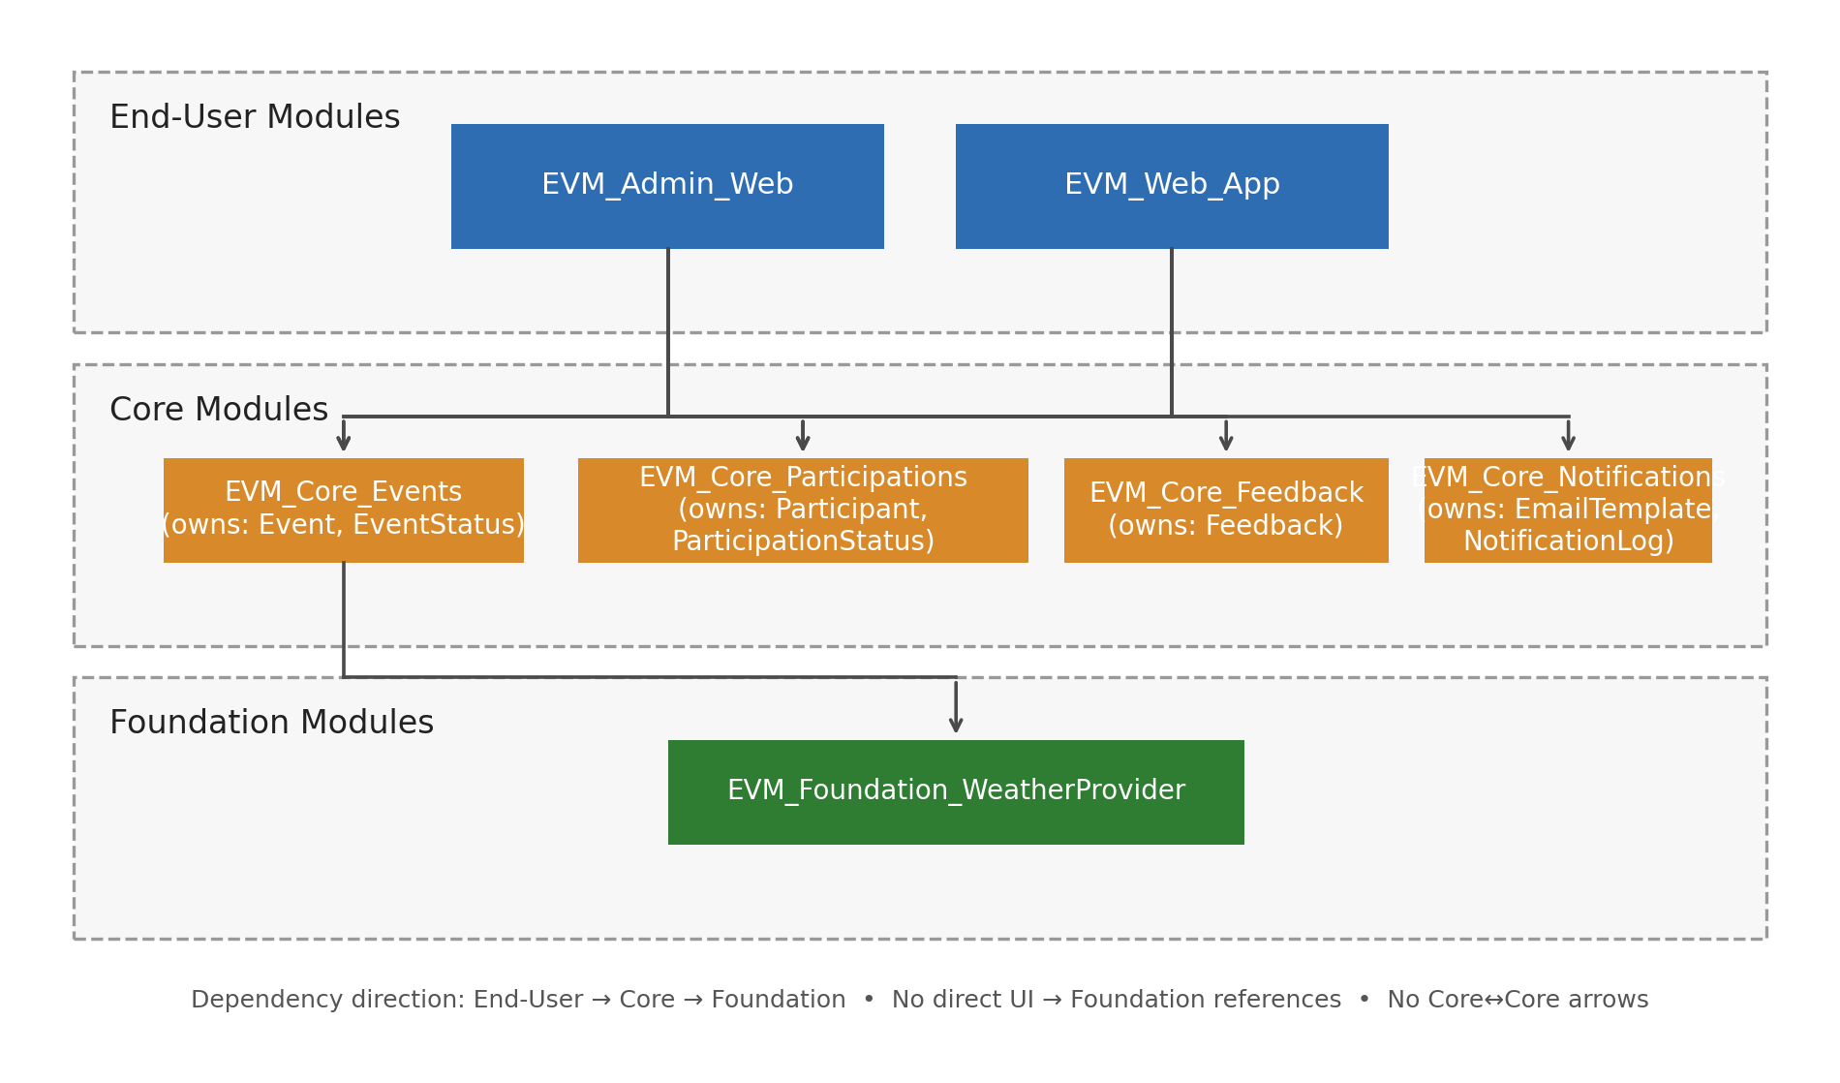
Figure 1. Architecture Canvas (End‑User → Core → Foundation, orthogonal connectors).

3. Data Model (Entities)
Entity | Key Attributes | Notes
Event | Title, Description, Location, Latitude, Longitude, Start, End, MaxVolunteers, StatusId | Status: Draft/Published/Completed.
EventStatus (SE) | Draft, Published, Completed | Static entity.
Participant | EventId, UserId, StatusId, RegisteredAt, CancelledAt | Unique (EventId, UserId).
ParticipationStatus (SE) | Registered, Cancelled | Static entity.
Feedback | EventId, UserId, Rating, Comments, CreatedAt | Unique (EventId, UserId).
EmailTemplate | Key, Name, SubjectTemplate, BodyTemplate, IsActive, UpdatedAt, UpdatedBy | Tokenized templates; Key unique.
NotificationLog | Type, SendAt, StatusId, ErrorMsg, EmailTemplateId, RegistrationId | Idempotent reminder tracking.
(Optional) WeatherCache | Lat, Lng, ProviderHash, Json, CachedAt | If caching is enabled in Core.

4. Reminder Timer (EventReminder_Run)
Runs every 15–30 minutes. For events whose Start falls within a configurable window at Now + N days, the timer sends a reminder email to each registered volunteer who hasn’t already been sent one, and writes a NotificationLog row (Sent/Failed).
Key configuration (Site Properties in Admin Web):
- ReminderDaysBefore
- ReminderWindowMinutes
- MaxEmailsPerRun
- Template Key: "ReminderBeforeStart"; tokens supplied by BuildTokensForEventUser.

5. Test Checklist
- Create a Published event with Start = Now + N days + a few minutes; set Lat/Lng.
- Register a volunteer; verify capacity decrements (unless unlimited).
- Manually run EventReminder_Run in Service Center; confirm email received; check NotificationLog.
- After event end, submit feedback; verify one feedback per user/event.

6. Enhancements (If Time Permits)
Optional tasks:
- Mobile app (check‑in, Camera upload).
- BPT post‑event process: follow‑ups, feedback collection, participation report.
- Offline check‑in/notes with Local Storage & sync.
- Custom Extension: distance between coordinates; participation code; sanitizers.

Operational & UX:
- LogMessage helper (centralized structured logs, level toggle).
- Google Maps: map + autocomplete; compute distances; sort events near volunteer.
- Event images: attach & include in emails. If S3 disallowed, expose an API that streams image bytes with MIME type for safe linking in emails.
- Invite volunteers by entering emails and sending invitations with a deep link.
- Anonymous participation mode (no Users dependency), with optional email confirmation/OTP.
- Statistics dashboard: events vs attendance, feedback averages, registrations over time, revenue.

Appendix A — Architecture Canvas (OutSystems)
This section documents the solution using the OutSystems Architecture Canvas. It clarifies module boundaries, data ownership, dependencies, and the allowed direction of references.
- A.1 Layers & Allowed Dependencies
- End‑User Apps → Core → Foundation → External Services
- Rules: End‑User Apps depend only on Core; Core depends on Foundation; Foundation talks to external services. No UI→Foundation or Foundation→Core references. Entities are owned by Core modules.
- A.2 End‑User Apps
- EVM_Web_App — Volunteer UI for browsing/upcoming, details+weather, sign‑up, My Events, feedback.
- EVM_Admin_Web — Admin UI for events & email templates; hosts EventReminder_Run timer.
- A.3 Core
- EVM_Core_Events — Event, EventStatus; weather facades.
- EVM_Core_Participations — Participant, ParticipationStatus; capacity & registration logic.
- EVM_Core_Feedback — Feedback; rules & submission.
- EVM_Core_Notifications — EmailTemplate, NotificationLog; tokenization & idempotency.
- A.4 Foundation
- EVM_Foundation_WeatherProvider — REST to OpenWeather; provider is stateless; any caching in Core.
- A.5 External Services
- OpenWeatherMap (Geocoding + Current Weather); Gmail SMTP for outbound email.
- A.6 Data Ownership & Delete Rules
- EventStatus → Protect; ParticipationStatus → Protect; EmailTemplate → Protect (if referenced); NotificationLog → Ignore.
- A.7 Cross‑Cutting Concerns
- Site Properties: ReminderDaysBefore, ReminderWindowMinutes, MaxEmailsPerRun, OpenWeatherApiKey, VolunteerPortalBaseUrl.
- Security: Registered Volunteers; Admin role.
- Timer: EventReminder_Run (Admin Web).
- Caching: optional WeatherCache entity in Core.
- A.8 UI Composition & Reuse
- WB_WeatherBannerByCoords (reusable weather banner).
- WB_FeedbackDialog (reusable popup for feedback).

