# ERD overview

See the data model/ ERD in the file Use_Case_Diagram.mdj or the file html_docs/index.html

The USER table contain information of the user for example user name, password, first name, last name, public key to verify the digital signature of the user,…

User can have one or more role: admin, staff and client (We can consider additional roles as the system evolves). These roles is stored in the ROLE table.

Each role has specified permissions, which are stored in the PERMISSION table.

The user with role admin can create a form structure with a graphical user interface. The form structure will be stored in the FORM STRUCTURE table. The most important column in this table is the “structure” column, which has data type “JSON”. The example of a form in real world and it’s structure, that is stored in table FORM STRUCTURE, is shown below.

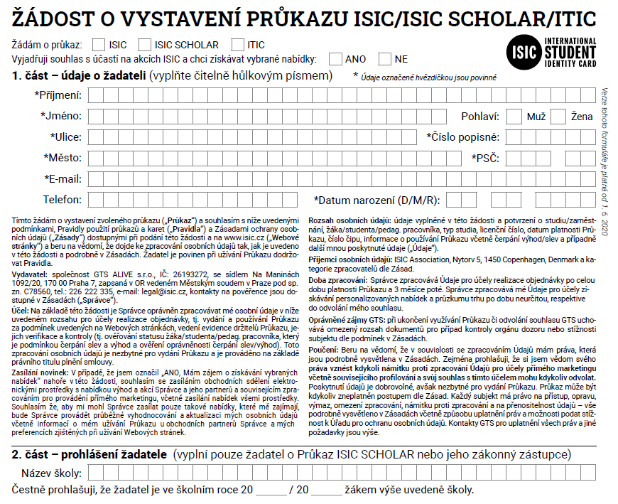The form APPLICATION FOR ISSUE OF AN ISIC / ISIC SCHOLAR / ITIC LICENSE in real word.

[  
 "APPLICATION FOR ISSUE OF AN ISIC / ISIC SCHOLAR / ITIC LICENSE",  
 {  
 "section_name": "data on the applicant",  
 "permission": ['client', 'staff'],  
 "fields": {  
 "First name": "text",  
 "Last name": "text",  
 "Sex": "boolean",  
 "Address": "text",  
 "Email": "text",  
 "Telephone": "integer",  
 "Date of Birth": "date",  
 },  
 "description": ". . .",  
 "digital_signature": ["signature of client", "signature of staff"]  
  
 },  
 {  
 "section_name": "declaration of the applicant",  
 "permission": ['client'],  
 "fields": {  
 "Name of the school": "text"  
 },  
 "description": ". . .",  
 "digital_signature": ["signature of client"],  
 }  
]

The simplified form structure in data type JSON, that stored in column “structure” of the table FORM STRUCTURE.

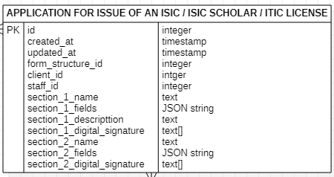After the admin creates the form structure and stores in database, a new table will be create. The name of this table will be the name of the form structure, the columns will be as follow.

The final table is the BLOCKCHAIN table, which contains a timestamp, a transaction in JSON, a current hash of the block, and the previous hash of the previous block. The transaction will contain the information about editor (client or staff) id, form structure id, form instance id, the change that was made (example: Si Anh changed section 1), encrypted data and the editor digital signature.

transaction = [  
 {  
 "editor_id": 1,  
 "form_structure_id": 1,  
 "form_instance_id": 1,  
 "change": "Si Anh changed section 1",  
 "encrypted_data": "some encrypted data",  
 "editor_digital_signature": "digital signature of Si Anh"  
 },  
  
 {  
 "editor_id": 2,  
 "form_structure_id": 1,  
 "form_instance_id": 1,  
 "change": "Bob changed section 2",  
 "encrypted_data": "another encrypted data",  
 "editor_digital_signature": "digital signature of Bob"  
 },  
  
 ...  
]

An example of a transaction

To create database, execute the SQL command in file createDatabase.sql