# State chart diagram of a form instance

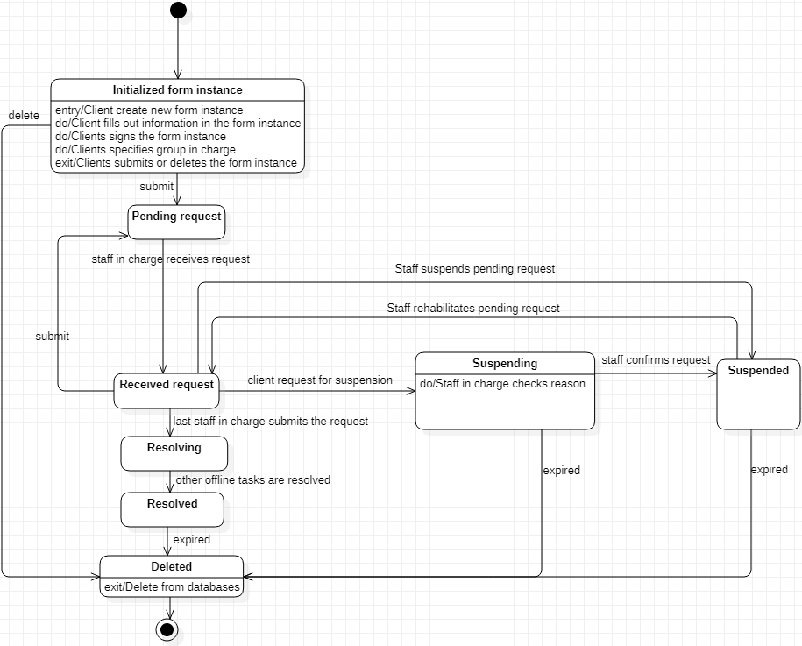

## Initialized form instance.

Client creates a form instance, fills out information, specifies group(s) in charge of resolving the form, signs and submits its.

Form instance now becomes a “pending request”.

## Pending request

All specified groups will see the pending request.

Staff of the group will decide to receive the pending request or not. Then the request will have state “received”.

## Received request

In the received state, all staffs that received