Cluster 4 Network Validation
Evidence Report
Cybersecurity Portfolio Project
Prepared for: Paul Pham
Project folder: cybersecurity-projects/cluster4-network-validation
Generated: 24 June 2026
──────────────────────────────────────────────────────────────────────────────────────────
Purpose
This report documents the completion evidence for a safe Python-based network validation project. The project validates approved TCP services in an isolated lab, exports sample JSON/CSV evidence, includes unit testing, and protects private lab files from public GitHub tracking.

1. Project Overview
Area | Summary
Project name | Cluster 4 Network Validation
Repository path | cybersecurity-projects/cluster4-network-validation
Main script | network_check.py
Configuration files | services.json for public sample testing; services.private.json kept local and ignored by Git
Evidence outputs | Sample JSON and CSV files stored in the evidence folder
Testing | Python unit tests passed successfully
Safety control | Network allowlist and documentation-only sample IP addresses

2. Completion Summary
Checkpoint | Status
Correct project directory confirmed | Completed
Safe sample validation run completed | Completed
Unit tests passed | Completed
Documentation folder created | Completed
Evidence folder created | Completed
Screenshots folder created | Completed
Test plan created | Completed
Methodology created | Completed
Sample JSON evidence created | Completed
Sample CSV evidence created | Completed
Private configuration excluded from Git tracking | Completed
Conclusion: The project is GitHub-ready as a safe portfolio project. The evidence shows the validator runs, tests pass, documentation exists, sample evidence has been created, and sensitive private files are not tracked by Git.

3. Evidence Index
Figure | Screenshot | What it proves
1 | 01-project-folder-terminal.png | Local editor command issue documented
2 | 01-project-folder.png | Base project files confirmed
3 | 02-safe-sample-run.png | Safe sample validation run
4 | 03-unit-tests-passed.png | Unit tests passed
5 | 04-project-folders-created.png | Project folders created
6 | 05-test-plan-created.png | Test plan created
7 | 06-methodology-created.png | Methodology created
8 | 07-gitignore-confirmed.png | .gitignore confirmed
9 | 08-sample-json-evidence.png | Sample JSON evidence created
10 | 09-sample-csv-evidence.png | Sample CSV evidence created
11 | 10-evidence-folder-complete.png | Evidence folder complete
12 | 11-final-folder-structure.png | Final folder structure confirmed
13 | 12-git-status-before-commit.png | Git status check
14 | 13-git-push-success.png | Git push confirmation
15 | 14-tracked-files-safe.png | Tracked files safety check
16 | screenshot dir.png | Screenshot directory evidence
Note: The local VS Code command issue is included as troubleshooting evidence only. It does not affect the project result because the required folders, documents, evidence files, tests, and Git tracking checks were completed successfully.

Figure 1: Local editor command issue documented
Shows the VS Code command was not recognised in PowerShell. This was a local editor setup issue and was resolved by opening the folder manually and using Notepad to create project files.
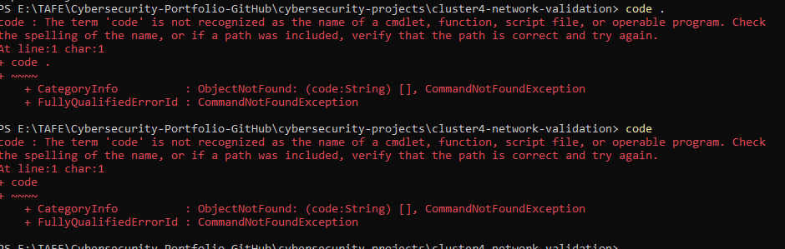
Figure 1. 01-project-folder-terminal.png

Figure 2: Base project files confirmed
Shows the original project files: README, Python script, service configuration, and unit test file.
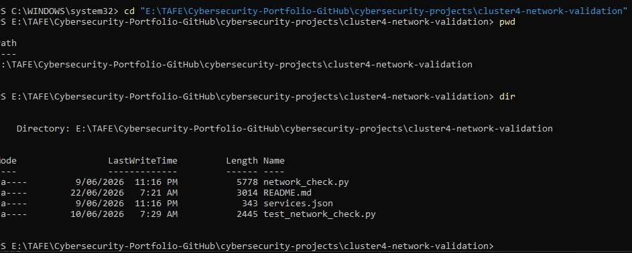
Figure 2. 01-project-folder.png

Figure 3: Safe sample validation run
Shows the Python validator running against documentation-only IP addresses. Results are skipped safely, with no real network scanning.
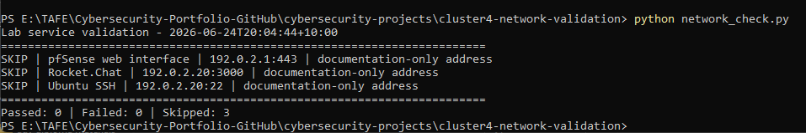
Figure 3. 02-safe-sample-run.png

Figure 4: Unit tests passed
Shows four unit tests passed, confirming scope validation, documentation-address skipping, target rejection, and structured output generation.
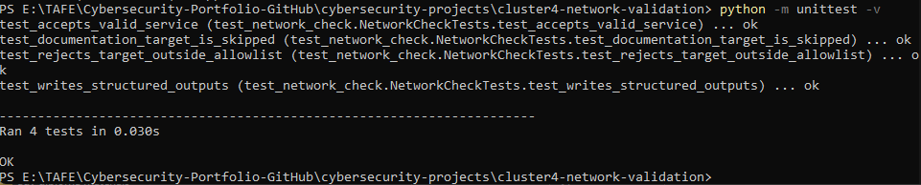
Figure 4. 03-unit-tests-passed.png

Figure 5: Project folders created
Shows the documentation, evidence, and screenshots folders added to improve the portfolio structure.
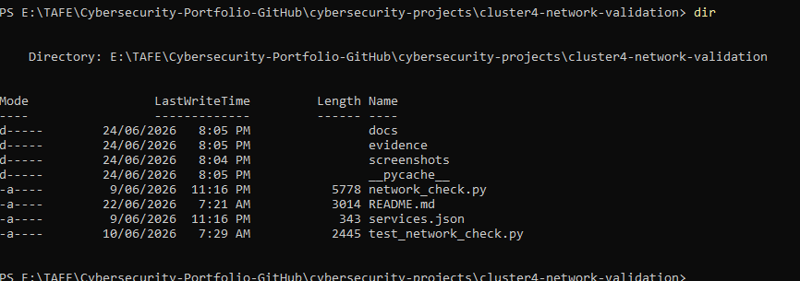
Figure 5. 04-project-folders-created.png

Figure 6: Test plan created
Shows the test plan document outlining purpose, scope, environment, test method, expected results, and evidence to collect.
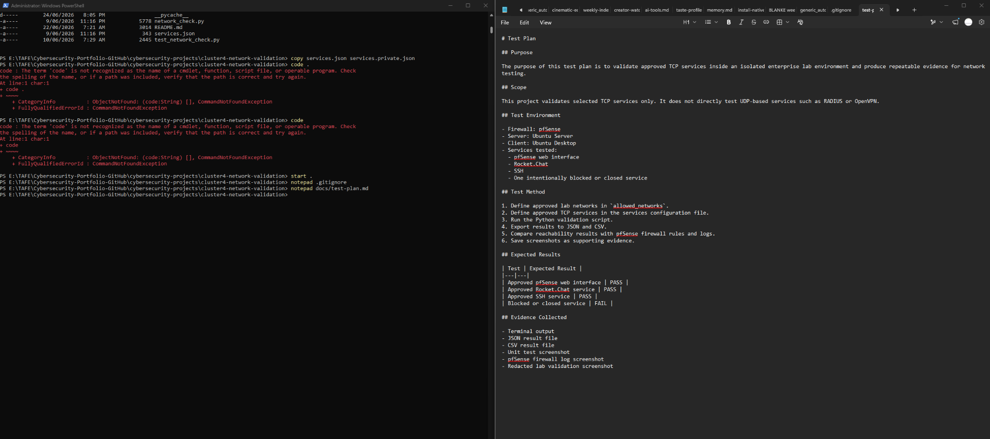
Figure 6. 05-test-plan-created.png

Figure 7: Methodology created
Shows the methodology document explaining safety controls, testing approach, limitations, and portfolio value.
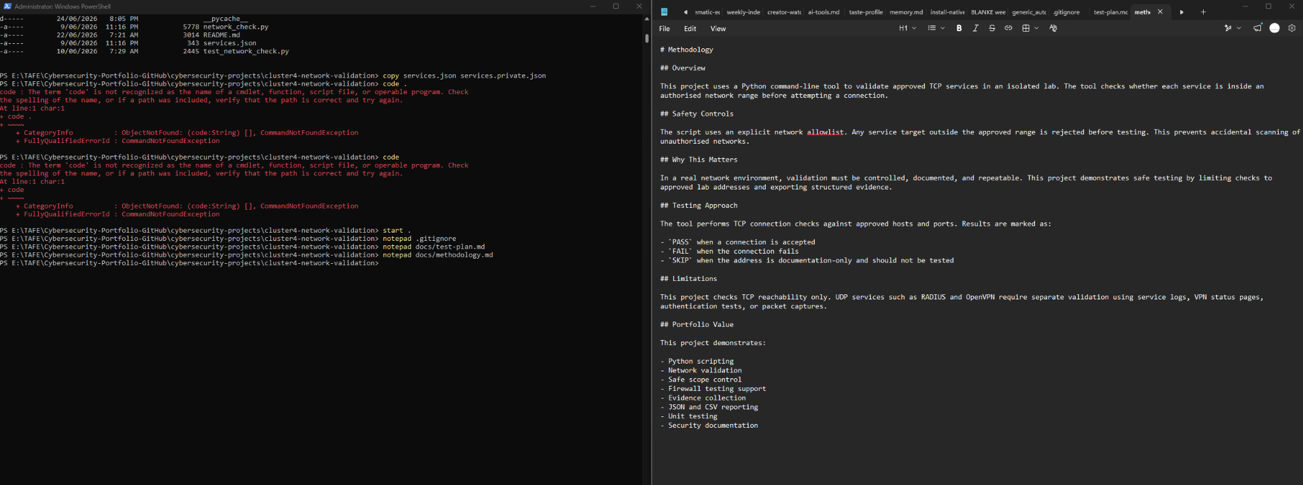
Figure 7. 06-methodology-created.png

Figure 8: .gitignore confirmed
Shows .gitignore exists and confirms the private service configuration is local only. The later Git tracked-file check confirms it is not tracked.
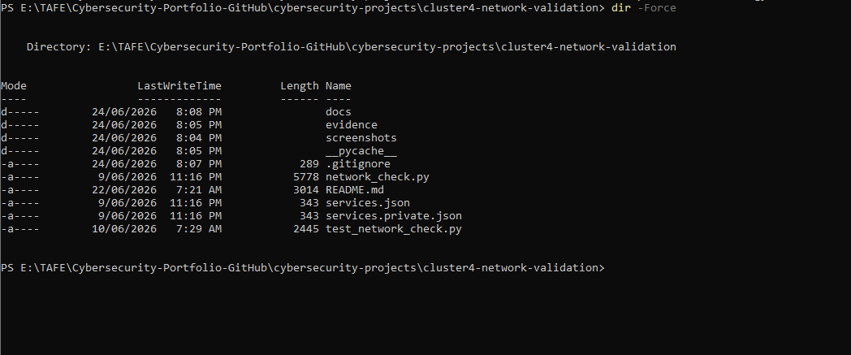
Figure 8. 07-gitignore-confirmed.png

Figure 9: Sample JSON evidence created
Shows safe sample JSON evidence using documentation-only IP addresses.
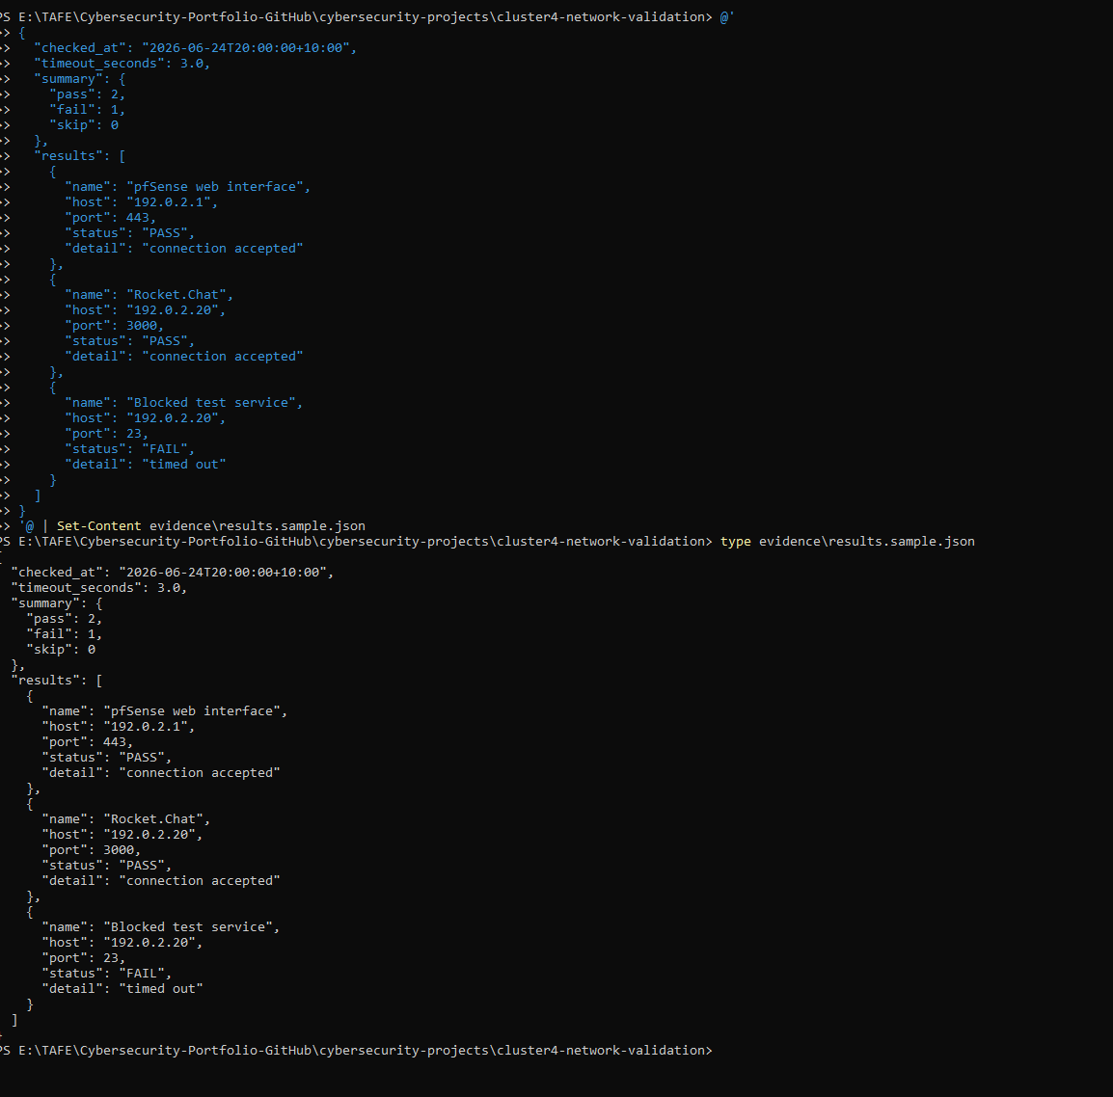
Figure 9. 08-sample-json-evidence.png

Figure 10: Sample CSV evidence created
Shows safe sample CSV evidence for portfolio/public GitHub use.
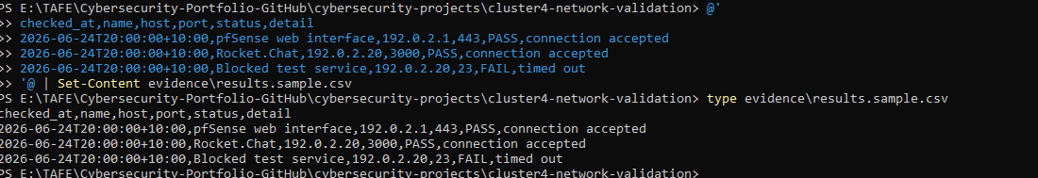
Figure 10. 09-sample-csv-evidence.png

Figure 11: Evidence folder complete
Shows both sample evidence files present in the evidence folder.
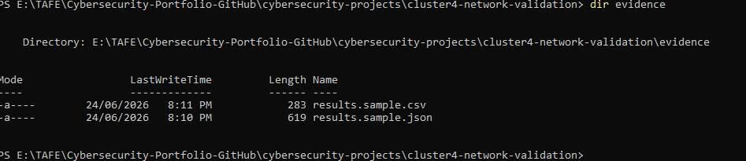
Figure 11. 10-evidence-folder-complete.png

Figure 12: Final folder structure confirmed
Shows the final project layout, including docs, evidence, screenshots, source files, and local private configuration.
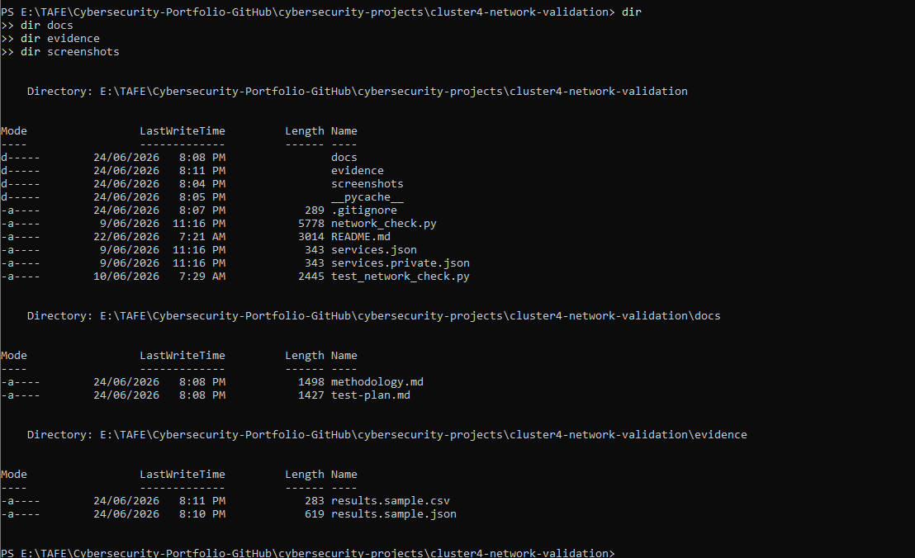
Figure 12. 11-final-folder-structure.png

Figure 13: Git status check
Shows the working tree clean, indicating current changes have been handled locally.
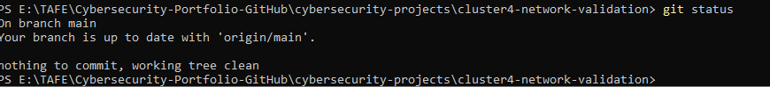
Figure 13. 12-git-status-before-commit.png

Figure 14: Git push confirmation
Shows git push completed and the local branch is up to date with origin/main.
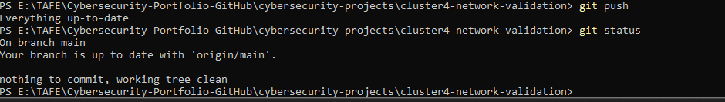
Figure 14. 13-git-push-success.png

Figure 15: Tracked files safety check
Shows files tracked by Git. Private configuration and Python cache are not tracked, which protects sensitive lab details.
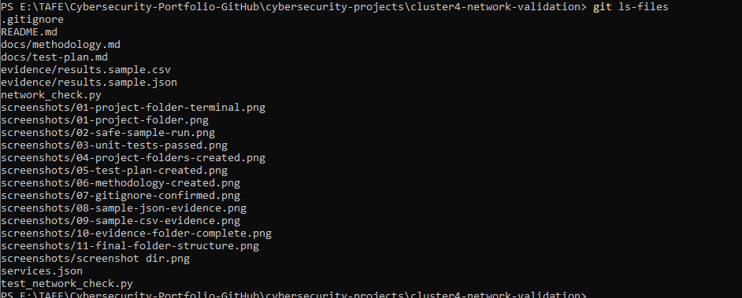
Figure 15. 14-tracked-files-safe.png

Figure 16: Screenshot directory evidence
Shows the screenshots folder creation and early folder listing evidence.
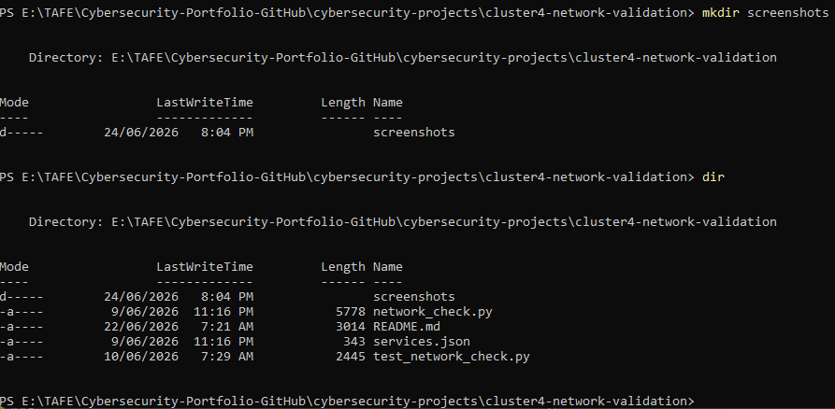
Figure 16. screenshot dir.png

Appendix A - Key Commands Used
cd "E:\TAFE\Cybersecurity-Portfolio-GitHub\cybersecurity-projects\cluster4-network-validation"
dir
mkdir screenshots
mkdir evidence
mkdir docs
python network_check.py
python -m unittest -v
notepad .gitignore
notepad docs/test-plan.md
notepad docs/methodology.md
type evidence\results.sample.json
type evidence\results.sample.csv
dir evidence
dir -Force
git status
git push
git ls-files

Appendix B - Recommended GitHub README Add-on
## Evidence Summary
This project includes safe portfolio evidence only. The public sample configuration uses documentation-only IP addresses and avoids exposing private lab details.
Evidence included:
- Safe sample validation run
- Unit test results
- Test plan
- Methodology notes
- Sample JSON output
- Sample CSV output
- Git tracking safety check
Private lab files such as `services.private.json` are excluded using `.gitignore` and should not be uploaded publicly.

