Lab06

Name Phan Trung Thuan Students ID B2111957 Class M03 Date 11/09

**System environment setting for pen-test**

|  |  |  |  |
| --- | --- | --- | --- |
| Resources | Sender(attacker) | Receiver(victim) | Homepage |
| OS |  |  | Windows |
| IP address |  |  | 172.30.119.11 |
| URL |  |  | http://localhost:80 |
| Web browser |  |  | Chrome |
| CSS language |  |  | Boostrap |
| Web server |  |  | Apache |
| Web application |  |  | PHP |
| DB server script |  |  | PHPMyAdmin |
| Others |  |  |  |

Select one model from A,B,C and exercise following steps, You can other different your model

1. Install web server (if necessary) => screen shot and explain in detail

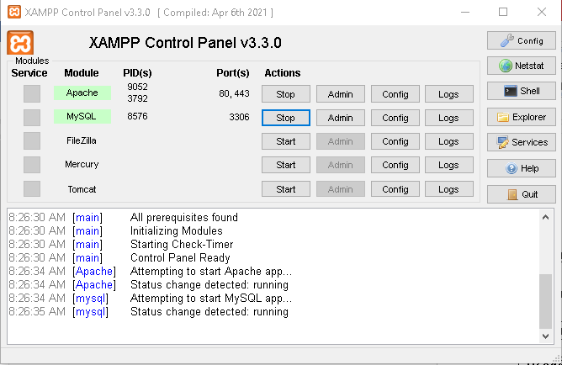

I already install XAMPP

1. Install web application => screen shot and explain in detail

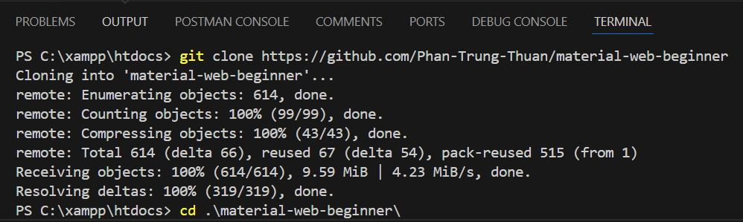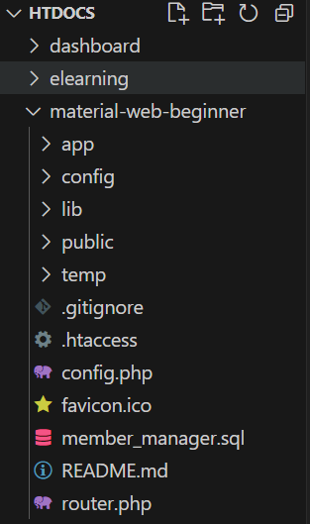

I use a small project from github so I just clone it into my repository and my local computer (in xampp/htdocs)

1. Install SQL DB server =>  screen shot and explain in detail

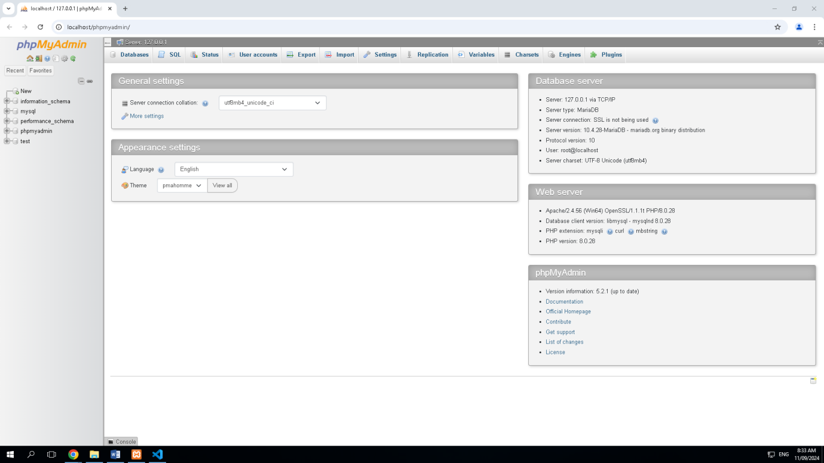

XAMPP already included PHPMyAdmin

1. Develop client log in screen (if necessary) => screen shot and explain in detail

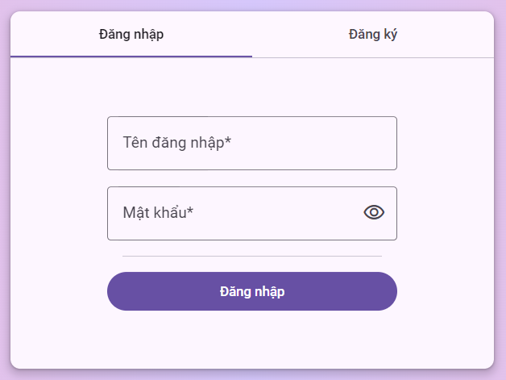

1. Creat SQL DB table(sharing with group table or not?) => screen shot and explain in detail

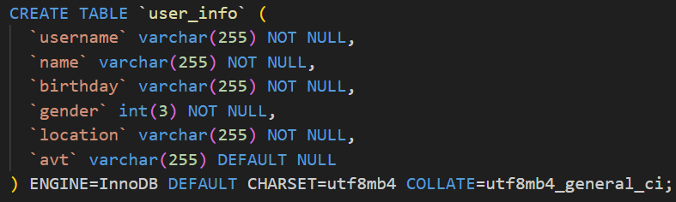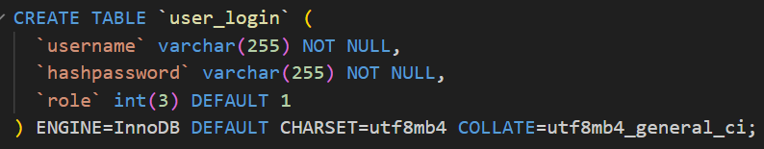

Create user_infor and user_login table for save user personal informations and account information respectively

1. Creat test data(ID,PW data,sharing with group table or not?) => screen shot and explain in detail

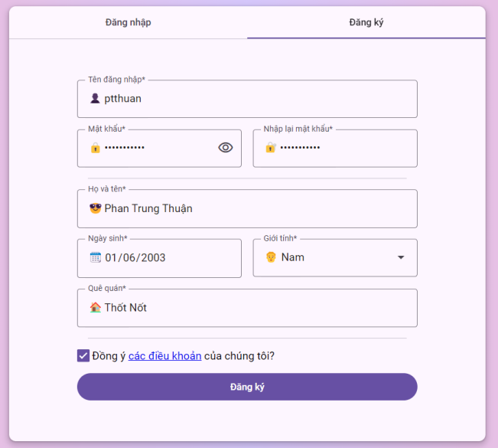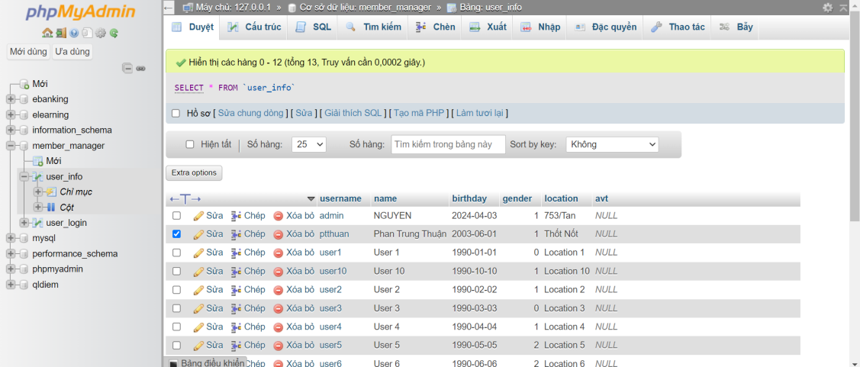

Create test account using Sign up form

1. **Connection test from client to** web application

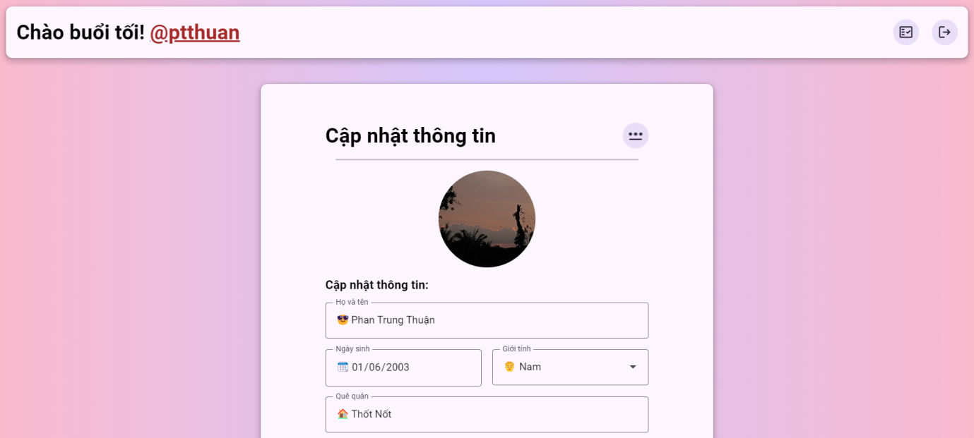

Login using my own account