

Capstone Project Report
Report 4 – Software Design Document

– Ho Chi Minh City, November 2026 –

Table of Contents
I. Record of Changes 0
II. Software Design Document 0
1. System Design 0
1.1 System Architecture 0
1.2 Package Diagram 0
1.3 Technology Declaration 0
2. Database Design 0
3. Detailed Design 0
3.1 Overall System Workflow 0
3.2 Transaction Data Processing 0
3.3 Mining Execution & Configuration 0
3.4 Algorithm Benchmarking 0
3.5 Product Recommendation & Approval 0
3.6 Layout & Campaign Management 0
3.7 A/B Testing & Performance Evaluation 0
3.8 Customer Shopping & Bundle 0

I. Record of Changes
Date | A*  M, D | In charge | Change Description
03 Nov 2026 | A | Nguyễn Minh Khôi | Created the SDD from the official template: system architecture, package diagram, database design (Flyway V1–V19) and detailed design (class and sequence diagrams) of the eight main workflows.
04 Nov 2026 | M | Nguyễn Minh Khôi | Updated the database design to the final schema (31 tables, 59 foreign keys): complete logical diagram, six area diagrams, the two storage tables created by migration V11 and separate descriptions for every table; later figures renumbered.
04 Nov 2026 | A | Nguyễn Minh Khôi | Added for Review 2: technology declaration (Section 1.3), conceptual ERD and state machine diagrams of the main entities (Section 2) and an activity diagram for each workflow (Sections 3.1.4–3.8.4); figures renumbered.
*A - Added M - Modified D - Deleted

II. Software Design Document

1. System Design

1.1 System Architecture
PASPM is a single web application with a React client and a Spring Boot backend. The backend is organised by business domain and stores all data in one MySQL database; mining is delegated to the SPMF library, which runs in a separate Java 25 process because the backend runs on Java 17. The diagram shows the components and their connections; the table explains each component.
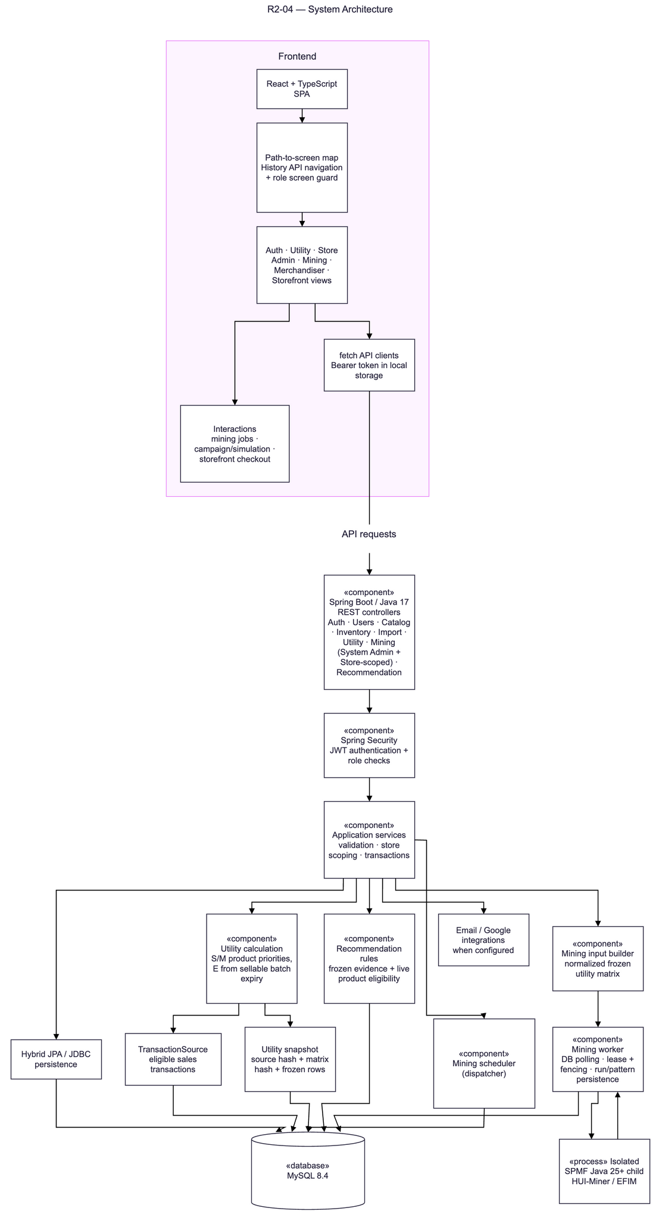
Figure 1: System architecture
No | Component | Description
1 | React + TypeScript SPA | Web client. A path-to-screen map with a role screen guard routes each user to the screens of their role; API clients send the bearer token with every request.
2 | REST controllers (Spring Boot, Java 17) | HTTP endpoints for authentication, users, catalogue, inventory, import, utility, mining (System Administrator and store-scoped) and recommendation.
3 | Spring Security | JWT authentication and role checks on every endpoint; store scope is taken from the authenticated account.
4 | Application services | Validation, store scoping and transaction boundaries of each use case.
5 | Utility calculation | Computes base and weighted utility from stock and seasonal product priorities and the expiry score derived from sellable batches.
6 | TransactionSource | Reads the eligible sales transactions of a store for a date range.
7 | Utility snapshot | Stores the frozen matrix rows with source and matrix hashes.
8 | Mining input builder | Converts a frozen snapshot into the normalised SPMF input (six decimals, GCD scaling, 32-bit integer check).
9 | Mining worker | Polls the database for queued requests, holds a lease with a fencing token and persists runs and itemsets.
10 | Mining scheduler (dispatcher) | Turns due schedule occurrences into utility snapshots and mining requests.
11 | Isolated SPMF child process | Runs HUI-Miner or EFIM from SPMF 2.67a in a separate Java 25 process with heap, time and output limits.
12 | Recommendation rules | Builds BUNDLE, CROSS_SELL, FBT and BANNER candidates from frozen evidence and checks live product eligibility.
13 | Hybrid JPA / JDBC persistence | JPA for products and categories, JDBC (JdbcTemplate) for all other data.
14 | MySQL 8.4 | Relational database; schema managed by Flyway migrations V1–V19.
15 | Email / Google integrations | SMTP delivery of OTP emails and Google identity verification, used when configured.

1.2 Package Diagram
The package diagram has three layers. The Application layer contains one package per business domain; each domain is divided into api (controllers), application (services), domain (models) and persistence sub-packages, which are logical groups of the Java classes. All dependencies are «use» dependencies. In the code, two pairs of packages depend on each other: Identity & Access with Shared Kernel, and Catalog & Inventory with Mining.
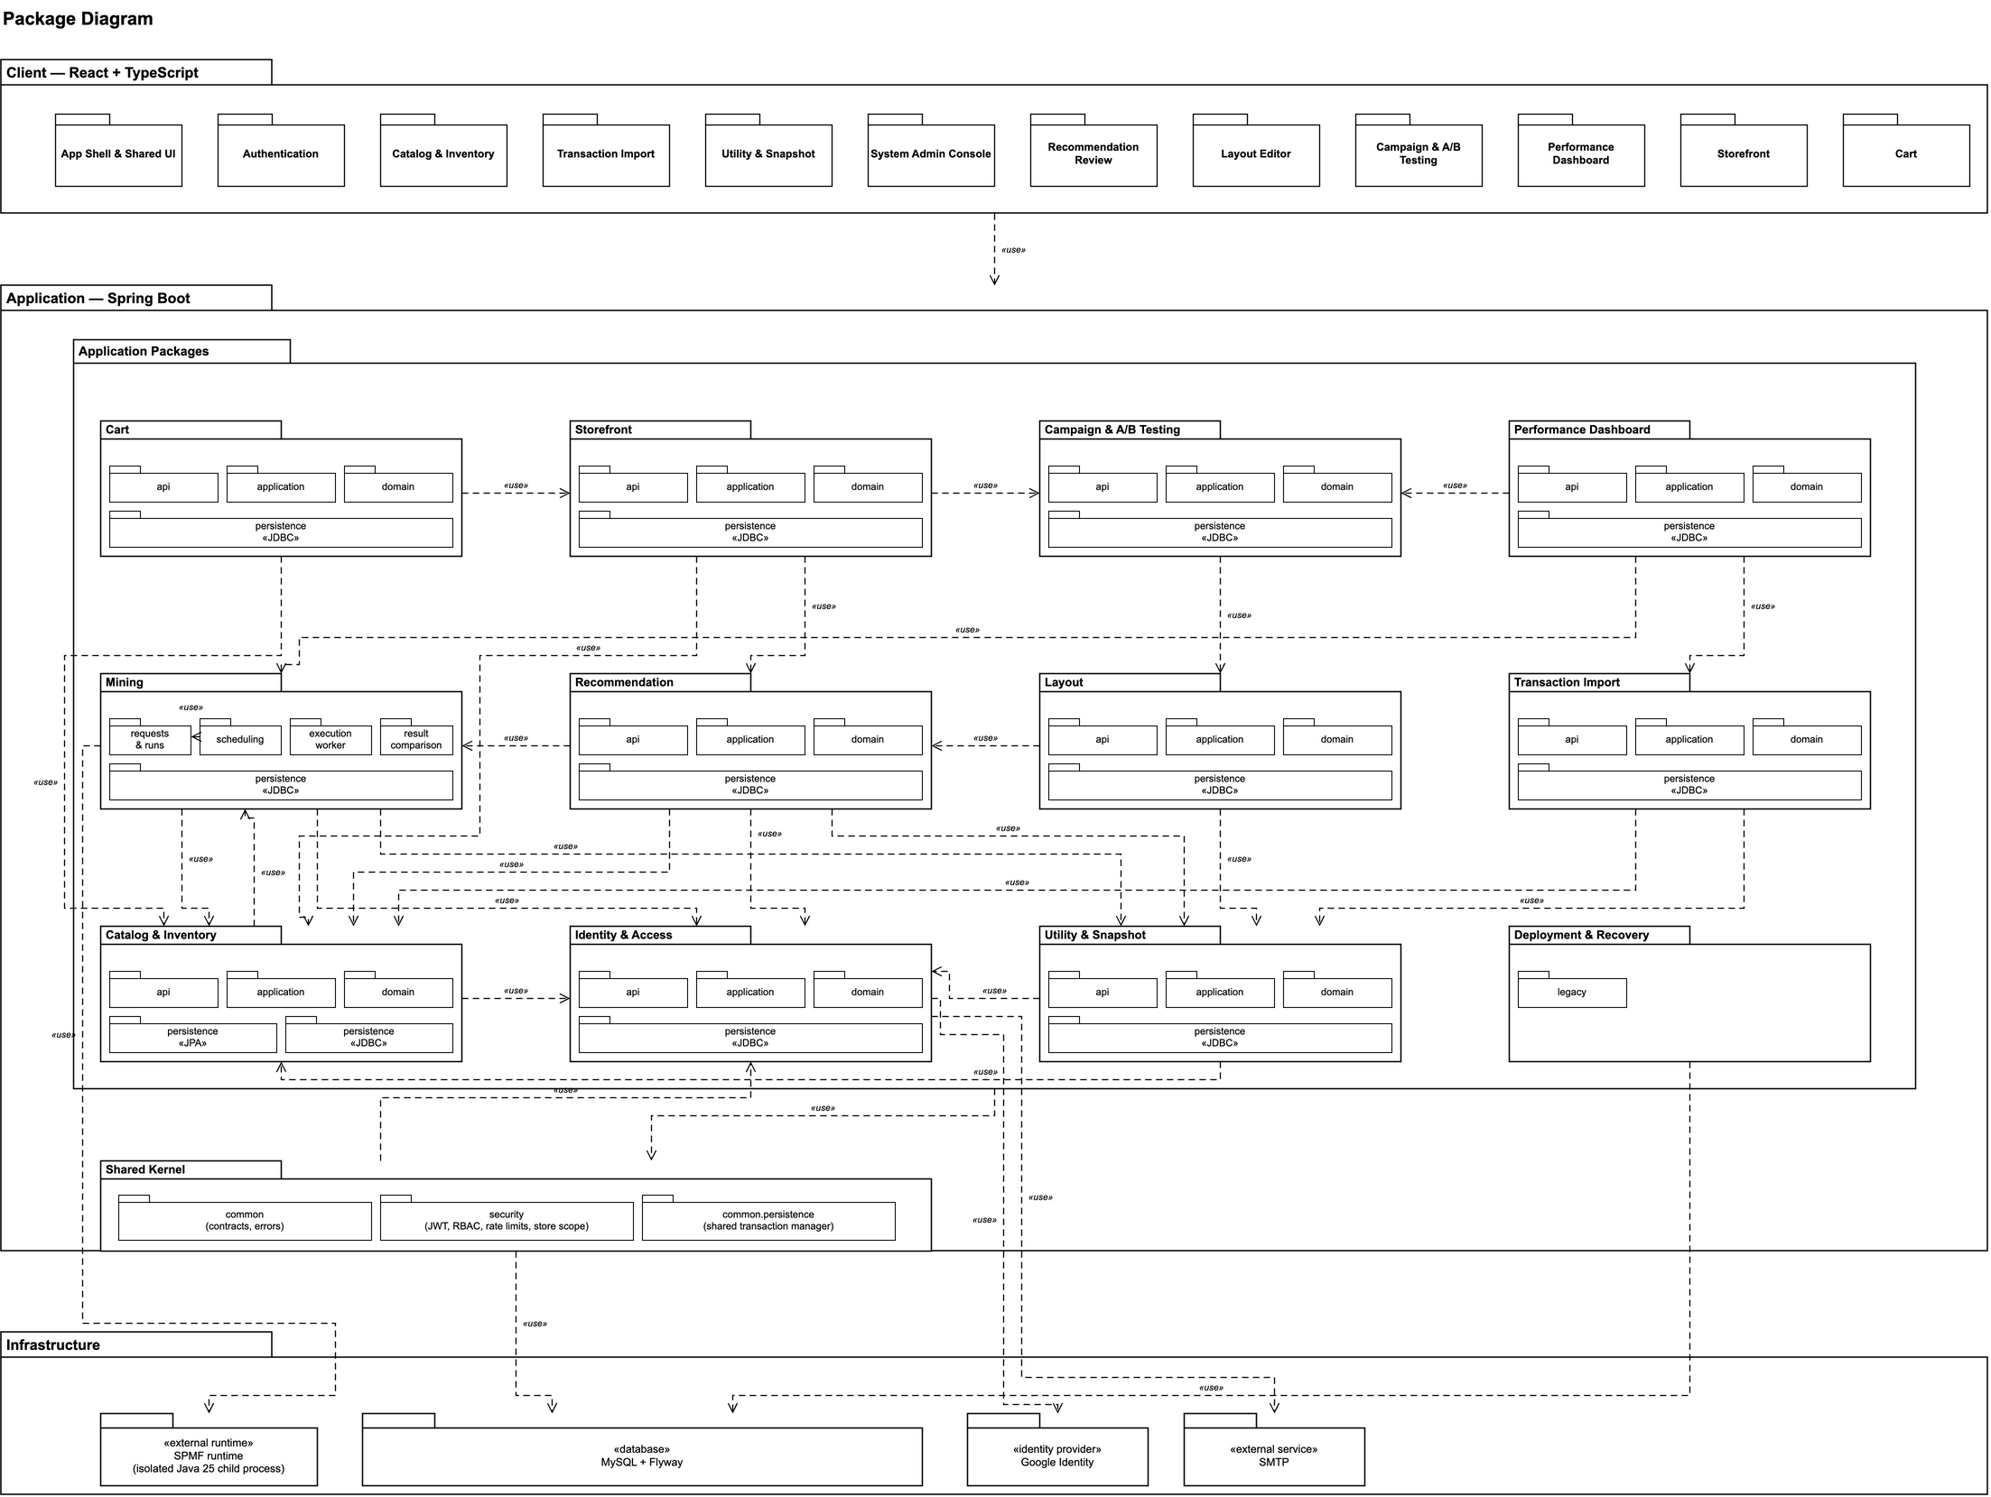
Figure 2: Package diagram
Package Descriptions
No | Package | Description
01 | Client packages | App Shell & Shared UI, Authentication, Catalog & Inventory, Transaction Import, Utility & Snapshot, System Admin Console, Recommendation Review, Layout Editor, Campaign & A/B Testing, Performance Dashboard, Storefront and Cart: the screens of each domain in the React client. They call the Application layer through the REST API.
02 | Identity & Access | Java packages auth and user: login, registration, OTP, Google sign-in, accounts, roles, store assignment and avatars.
03 | Catalog & Inventory | Java package catalog (category, product, inventory): categories, products and inventory batches; JPA persistence for products and categories, JDBC for inventory.
04 | Transaction Import | Java package transaction (importing, query): CSV parsing, per-order validation, import batches and transaction queries; provides the eligible transaction source.
05 | Utility & Snapshot | Java package utility: utility configuration, product scores, expiry score, weighted utility matrix and immutable snapshots.
06 | Mining | Java package mining: mining configuration, requests and runs, scheduling, execution worker with SPMF runtime, and HUI-Miner/EFIM result comparison.
07 | Recommendation | Java package recommendation: candidate rules, frozen evidence reader, live eligibility, review and recommendation policy.
08 | Layout | Layouts built from approved groups with placement utility (designed, not yet in the code).
09 | Campaign & A/B Testing | Campaign drafts, publication, activation and A/B simulation reports (designed, not yet in the code).
10 | Storefront | Active homepage layout, product details and offered bundles for the End Customer (designed, not yet in the code).
11 | Cart | Basket and whole-bundle add-to-cart with stock recheck (designed, not yet in the code).
12 | Performance Dashboard | Simulated utility and revenue reports, A/B reports and benchmark charts (designed, not yet in the code).
13 | Shared Kernel | Java packages common and security: shared contracts and error handling, JWT, RBAC, rate limits, store scope and the shared transaction manager.
14 | Deployment & Recovery | Java package deployment.legacy: Flyway callback and recovery of legacy utility matrix data.
15 | Infrastructure | MySQL + Flyway (database), SPMF runtime (isolated Java 25 process), Google Identity and SMTP.

1.3 Technology Declaration
The table declares the third-party services, development technologies, source code management, deployment environments and AI tools of the project.
Group | Item | Declaration
Third-party service | Google Identity (Google Sign-In) | Purpose: optional sign-in and registration. The user signs in at Google in the browser; the backend verifies the ID token with Google's public keys (googleapis.com/oauth2/v3/certs) and reads the subject, email and email-verified flag.
Third-party service | SMTP email service | Purpose: one-time passwords for registration, invitation and password reset. Data sent: recipient email address and the OTP message. The server is configured by SMTP_HOST; Mailpit is used in development.
Development technology | Back-end | Java 17 (Eclipse Temurin 17.0.21); Spring Boot 3.5.7 (Web, Security, OAuth2 Resource Server, JDBC, Data JPA, Mail, Validation); Flyway; springdoc-openapi 2.8.14; Apache Commons CSV 1.14.1.
Development technology | Mining library | SPMF 2.67a (archive pinned by SHA-256), run in a separate Java 25 process.
Development technology | Front-end | React 19, React Router 7, TypeScript 6, Vite 8, Tailwind CSS 4; tests with Vitest, Testing Library and Playwright 1.64.
Development technology | Database | MySQL 8.4 (H2 for automated tests).
Development technology | Mobile | None; the client is a responsive web application.
Source code and DevOps | Platform | GitHub: backend repository PhanHoangDuy61/CP_FA26_PASPM_BE and frontend repository ThaiTuKien1012/FE-FA26 (branch dev).
Source code and DevOps | CI/CD | GitHub Actions workflow "Backend verification" on pull requests into dev and on manual dispatch: SPMF downloader security tests, the Java 17 test suite and the MySQL 8.4 test group. No automatic deployment.
Source code and DevOps | Branch rules | Work branches are named <member>/<type>/<topic> and are merged into dev through pull requests that run the CI workflow; main is the default branch.
Deployment environment | Development | Each developer machine (Windows or macOS): MySQL 8.4 and Mailpit in Docker Compose (compose.yml); backend run with Maven.
Deployment environment | Staging (planned) | Linux server with Docker Compose: compose.yml and compose.backend.yml, backend image built from the Dockerfile. Deployment: build the JAR and the image, then start the services. Rollback: start the previous image again and, if a migration ran, restore the database backup taken before the deployment (Flyway has no down migrations).
Deployment environment | Production | Not part of the capstone scope.
AI tool | Claude Code (Anthropic Claude models) | Design, code, tests, code review and diagrams.
AI tool | OpenAI Codex | Code and tests.
AI tool | Claude (chat) | Drafting and reviewing the specification, design and report documents.

2. Database Design
The database is MySQL 8.4 and its schema is created by the Flyway migrations V1–V19 (V11 is a Java migration that creates the archive and storage registry for utility matrix data). It has 31 tables and 59 foreign keys. Store-scoped tables carry store_id and use composite foreign keys (store_id, id), so a record can only reference records of the same store. Figure 3 shows the conceptual model with the main entities and their relationships, and Figure 4 the complete logical model. Figures 5–10 show the same tables grouped by area, with the related tables of other areas; the two storage tables created by V11 are shown in Figure 4.
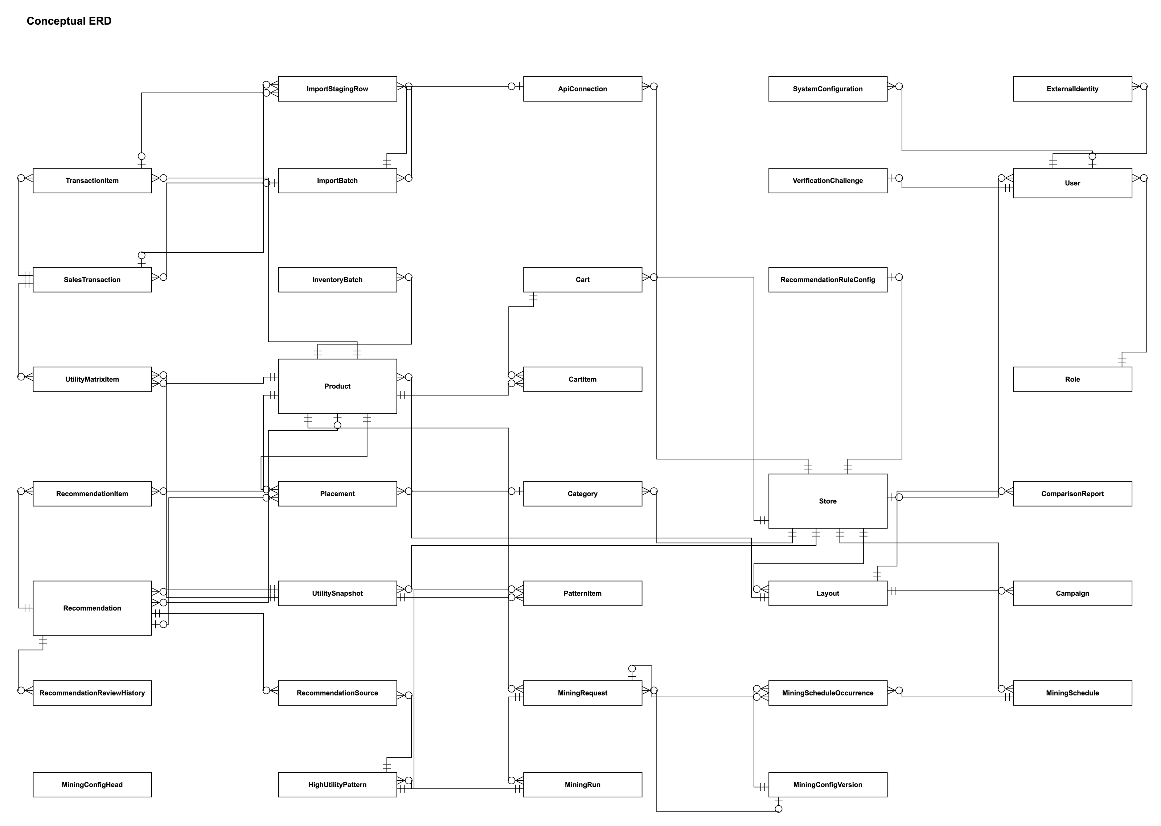
Figure 3: Conceptual entity relationship diagram
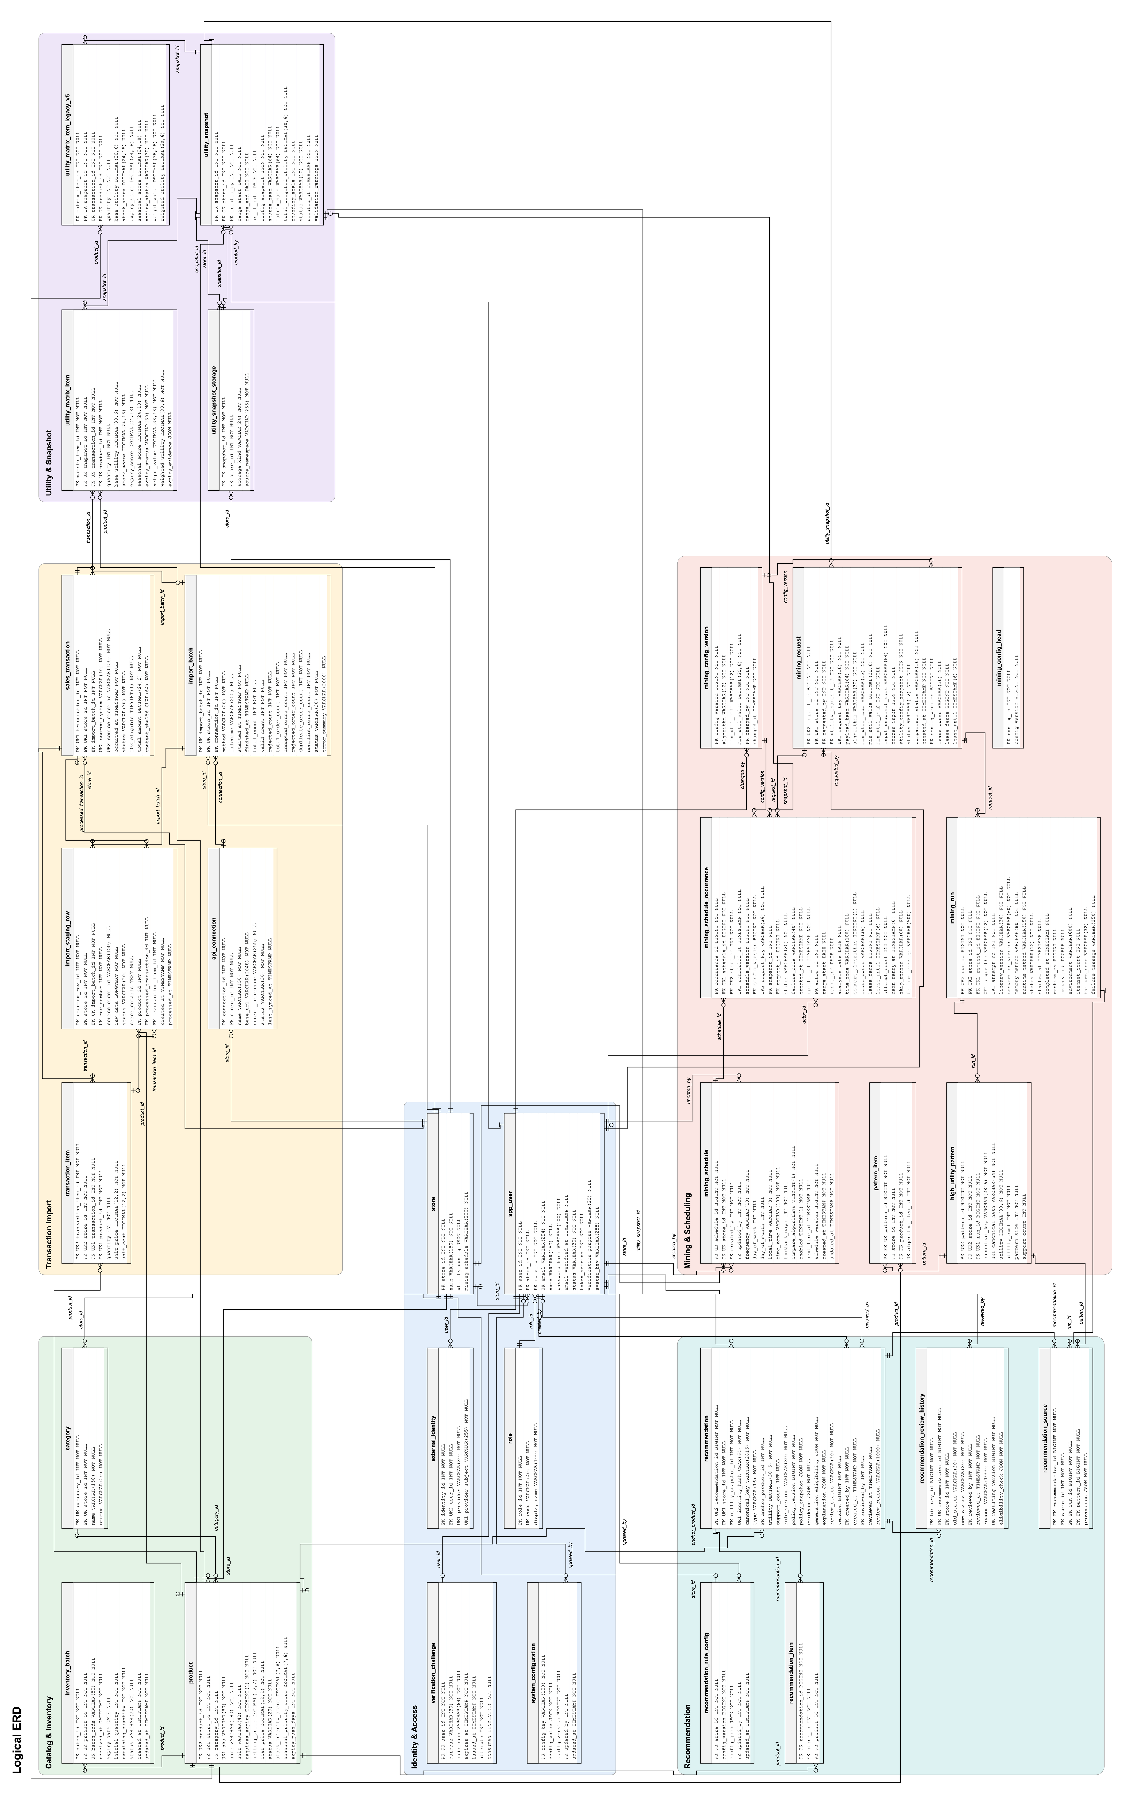
Figure 4: Logical database diagram (31 tables)
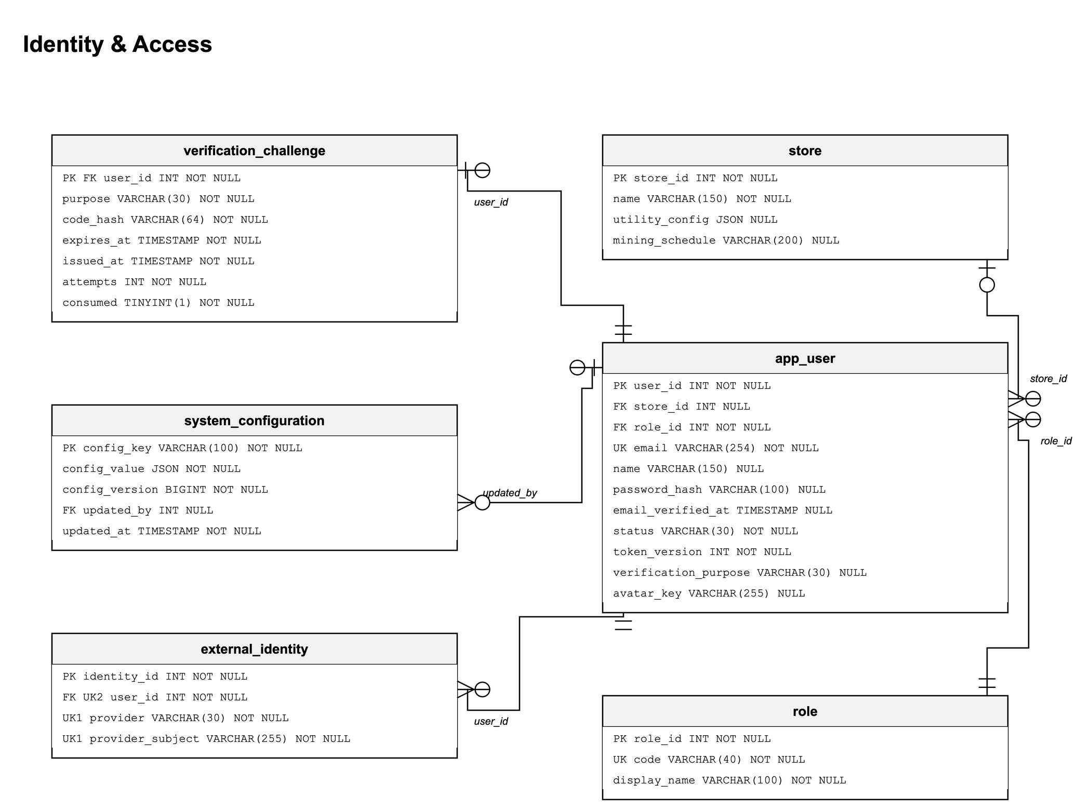
Figure 5: Database diagram – Identity & Access
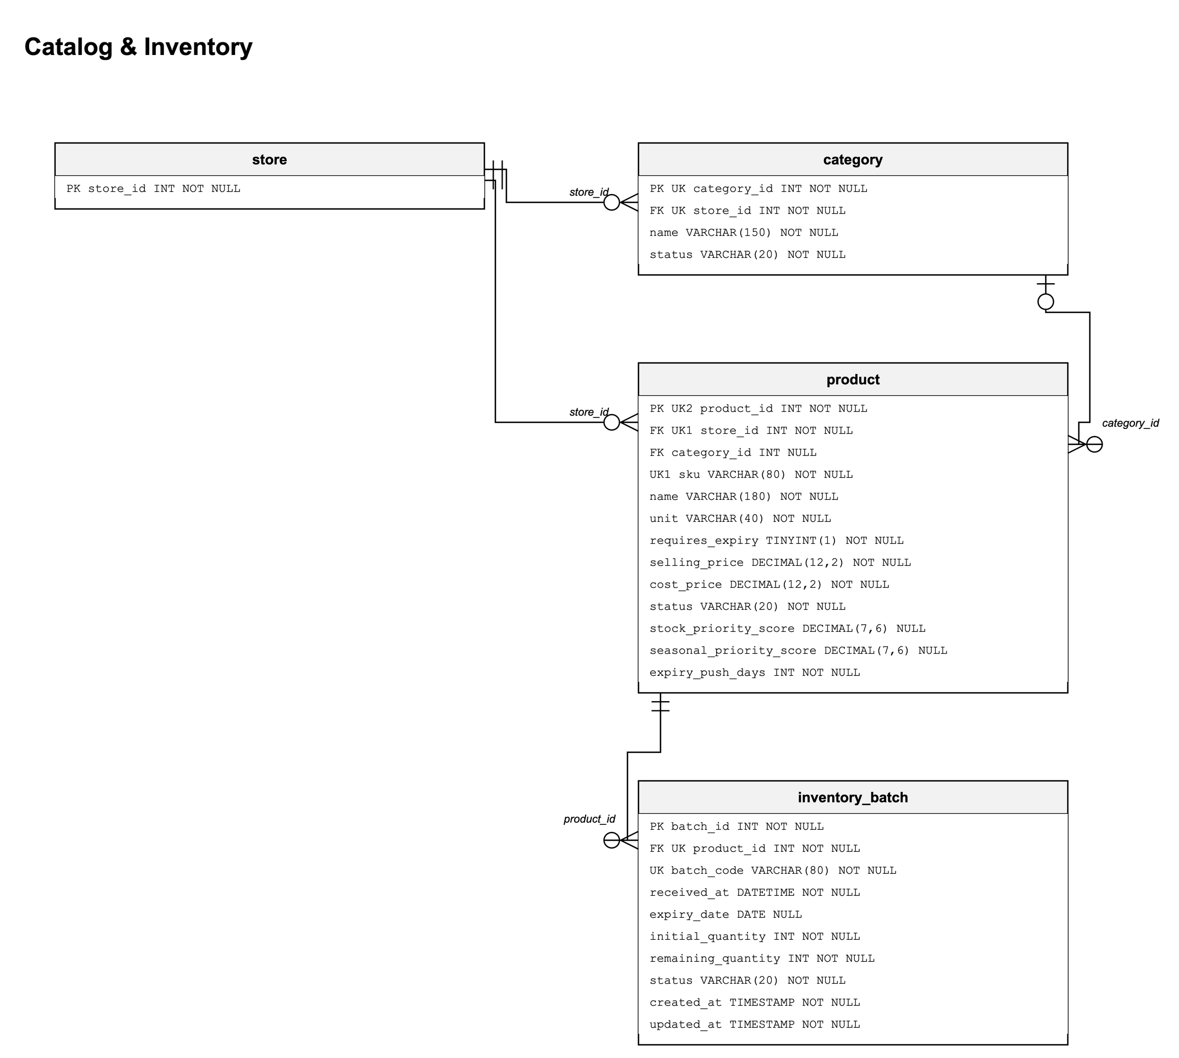
Figure 6: Database diagram – Catalog & Inventory
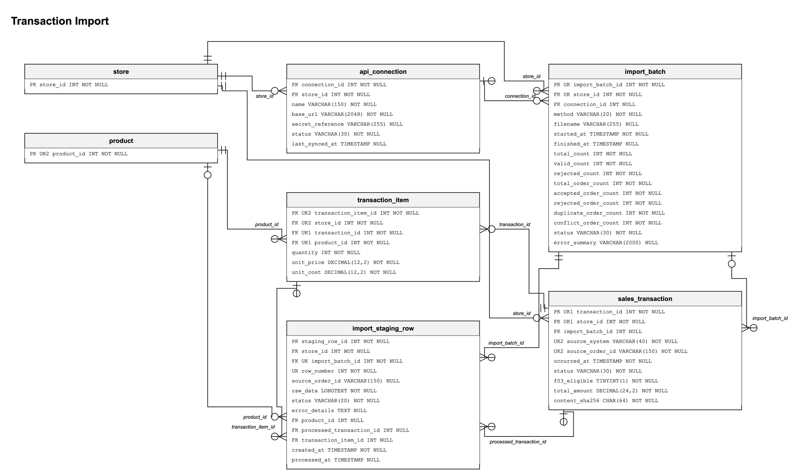
Figure 7: Database diagram – Transaction Import
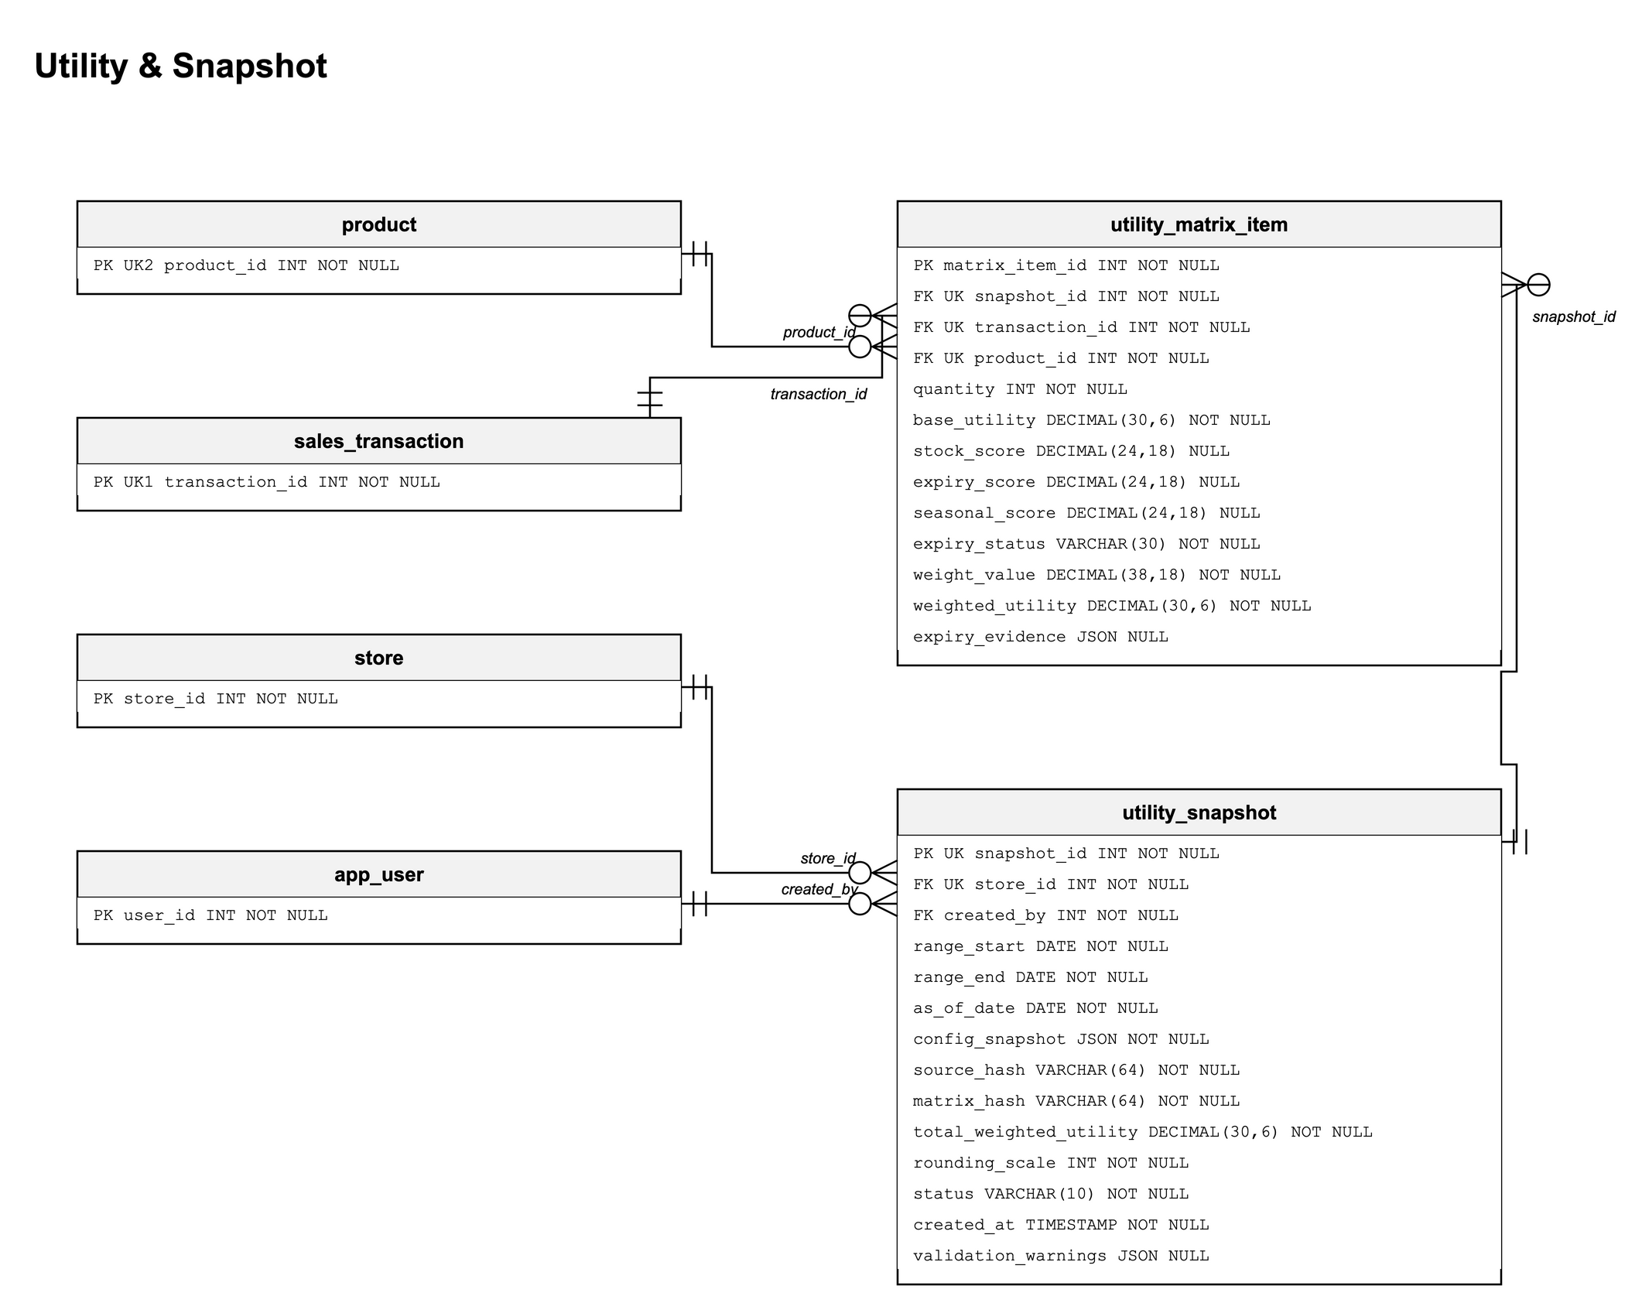
Figure 8: Database diagram – Utility & Snapshot
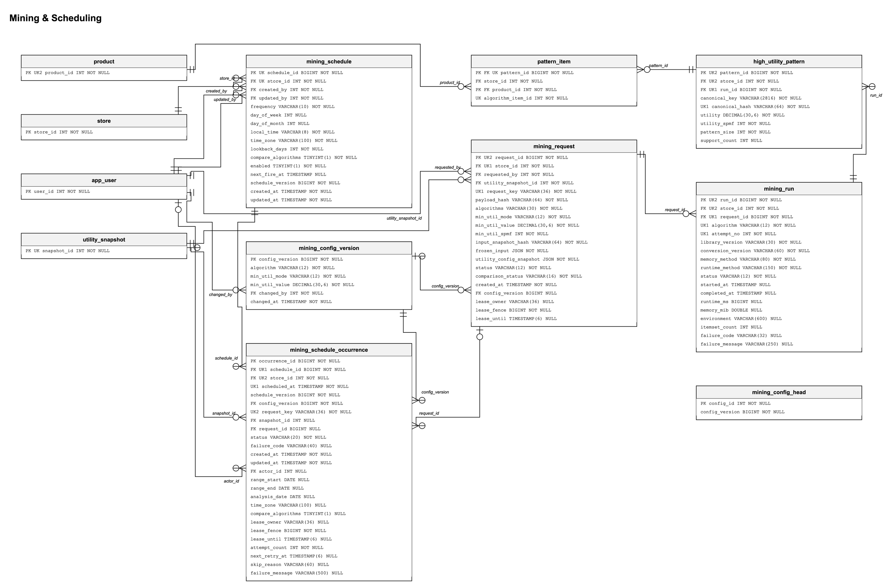
Figure 9: Database diagram – Mining & Scheduling
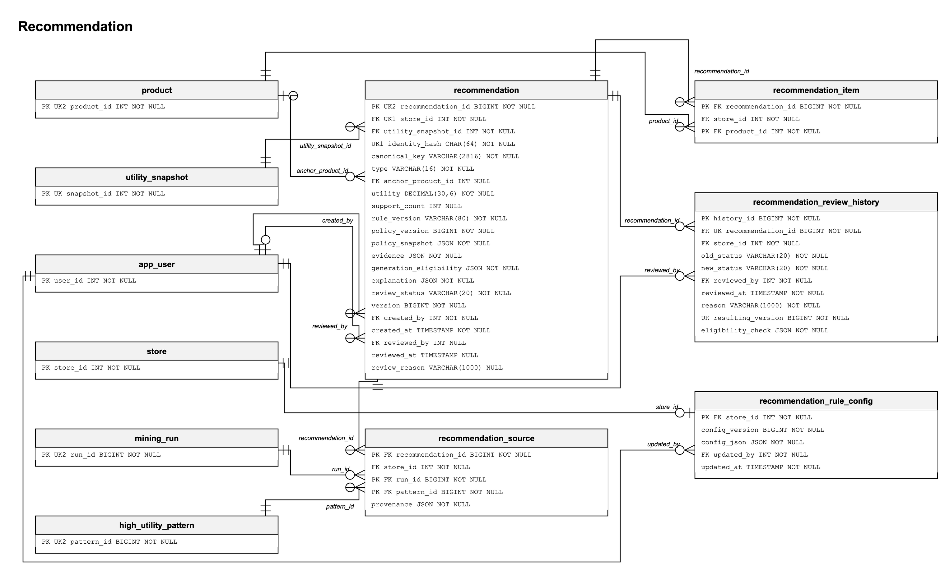
Figure 10: Database diagram – Recommendation
Table Descriptions
No | Table | Description
01 | store | A retail store; the unit of data isolation.  - Primary key: store_id
02 | role | Role codes: SYSTEM_ADMIN, STORE_ADMIN, MERCHANDISER, END_CUSTOMER and the internal SYSTEM_SCHEDULER.  - Primary key: role_id  - Unique: (code)
03 | app_user | Account with email, password hash, role, optional store, status (PENDING_VERIFICATION, ACTIVE, INACTIVE) and token version.  - Primary key: user_id  - Foreign keys: store_id → store; role_id → role  - Unique: (email)
04 | verification_challenge | Current OTP challenge of an account: purpose, code hash, expiry and attempt count.  - Primary key: user_id  - Foreign keys: user_id → app_user
05 | external_identity | Google identity linked to an account.  - Primary key: identity_id  - Foreign keys: user_id → app_user  - Unique: (provider, provider_subject); (user_id, provider)
06 | category | Product category of a store (ACTIVE or INACTIVE).  - Primary key: category_id  - Foreign keys: store_id → store  - Unique: (store_id, category_id)
07 | product | Product of a store: SKU, name, unit, prices, expiry requirement, stock and seasonal priority scores and expiry-push days.  - Primary key: product_id  - Foreign keys: store_id → store; category_id → category  - Unique: (store_id, sku); (store_id, product_id)
08 | inventory_batch | Received batch of a product with quantities, expiry date and status (ACTIVE or BLOCKED).  - Primary key: batch_id  - Foreign keys: product_id → product  - Unique: (product_id, batch_code)
09 | system_configuration | Versioned global settings, e.g. the utility λ policy.  - Primary key: config_key  - Foreign keys: updated_by → app_user
10 | utility_snapshot | Immutable snapshot of the weighted utility for a date range with its configuration, hashes and status (READY or FAILED).  - Primary key: snapshot_id  - Foreign keys: store_id → store; created_by → app_user  - Unique: (store_id, snapshot_id)
11 | utility_matrix_item | One product of one transaction in a snapshot: base utility, scores, weight and weighted utility.  - Primary key: matrix_item_id  - Foreign keys: snapshot_id → utility_snapshot; product_id → product; transaction_id → sales_transaction  - Unique: (snapshot_id, transaction_id, product_id)
12 | utility_matrix_item_legacy_v5 | Read-only archive of the utility matrix rows of snapshots created in the earlier v5 matrix format; created by migration V11 and protected against changes.  - Primary key: matrix_item_id  - Foreign keys: snapshot_id → utility_snapshot; product_id → product  - Unique: (snapshot_id, transaction_id, product_id)
13 | utility_snapshot_storage | Storage registry of each utility snapshot: where its matrix is kept (LEGACY_V5_ARCHIVE or F04_LIVE) and its source namespace; created by migration V11.  - Primary key: snapshot_id  - Foreign keys: snapshot_id → utility_snapshot; store_id → store; (store_id, snapshot_id) → utility_snapshot
14 | api_connection | Store API connection record; not used by any function.  - Primary key: connection_id  - Foreign keys: store_id → store
15 | import_batch | One file import with its counts and status (PROCESSING, COMPLETED, COMPLETED_WITH_ERRORS, FAILED).  - Primary key: import_batch_id  - Foreign keys: store_id → store; connection_id → api_connection  - Unique: (store_id, import_batch_id)
16 | sales_transaction | Imported order: source order id, time, status, eligibility for utility profiling and content hash.  - Primary key: transaction_id  - Foreign keys: store_id → store; import_batch_id → import_batch  - Unique: (store_id, transaction_id); (store_id, source_system, source_order_id)
17 | transaction_item | Order line: product, quantity, unit price and unit cost.  - Primary key: transaction_item_id  - Foreign keys: transaction_id → sales_transaction; product_id → product  - Unique: (transaction_id, product_id); (store_id, transaction_item_id)
18 | import_staging_row | Raw row of an import with its validation status and errors.  - Primary key: staging_row_id  - Foreign keys: import_batch_id → import_batch; product_id → product; processed_transaction_id → sales_transaction; transaction_item_id → transaction_item  - Unique: (import_batch_id, row_number)
19 | mining_request | Mining request for a store snapshot: algorithms, minUtil, frozen input, status, comparison status and lease fields.  - Primary key: request_id  - Foreign keys: utility_snapshot_id → utility_snapshot; requested_by → app_user; config_version → mining_config_version  - Unique: (store_id, request_key); (store_id, request_id)
20 | mining_run | Execution of one algorithm for a request: status, runtime, memory, itemset count and failure details.  - Primary key: run_id  - Foreign keys: request_id → mining_request  - Unique: (request_id, algorithm, attempt_no); (store_id, run_id)
21 | high_utility_pattern | Discovered itemset of a run with its utility and the products it contains.  - Primary key: pattern_id  - Foreign keys: run_id → mining_run  - Unique: (run_id, canonical_hash); (store_id, pattern_id)
22 | pattern_item | One product of a discovered itemset.  - Primary key: pattern_id, product_id  - Foreign keys: pattern_id → high_utility_pattern; product_id → product  - Unique: (pattern_id, algorithm_item_id)
23 | recommendation_rule_config | Versioned recommendation policy of a store.  - Primary key: store_id  - Foreign keys: store_id → store; updated_by → app_user
24 | recommendation | Candidate of type BUNDLE, CROSS_SELL, FBT or BANNER with utility, evidence, explanation and review status.  - Primary key: recommendation_id  - Foreign keys: utility_snapshot_id → utility_snapshot; anchor_product_id → product; created_by → app_user; reviewed_by → app_user  - Unique: (store_id, identity_hash); (store_id, recommendation_id)
25 | recommendation_item | One product of a recommendation candidate.  - Primary key: recommendation_id, product_id  - Foreign keys: recommendation_id → recommendation; product_id → product
26 | recommendation_source | Mining run and itemset from which a recommendation candidate was derived.  - Primary key: recommendation_id, run_id, pattern_id  - Foreign keys: recommendation_id → recommendation; run_id → mining_run; pattern_id → high_utility_pattern
27 | recommendation_review_history | Audit record of each approval or rejection.  - Primary key: history_id  - Foreign keys: recommendation_id → recommendation; reviewed_by → app_user  - Unique: (recommendation_id, resulting_version)
28 | mining_config_head | Single-row pointer to the current version of the global mining configuration.  - Primary key: config_id
29 | mining_config_version | Version history of the global mining configuration: algorithm, minUtil mode and value, author and time.  - Primary key: config_version  - Foreign keys: changed_by → app_user
30 | mining_schedule | Weekly or monthly schedule of a store: day, local time, time zone, lookback days and enabled flag.  - Primary key: schedule_id  - Foreign keys: store_id → store; created_by → app_user; updated_by → app_user  - Unique: (store_id, schedule_id)
31 | mining_schedule_occurrence | One due time of a schedule with its frozen context, request, status (including SKIPPED) and retry fields.  - Primary key: occurrence_id  - Foreign keys: schedule_id → mining_schedule; config_version → mining_config_version; snapshot_id → utility_snapshot; request_id → mining_request; actor_id → app_user  - Unique: (schedule_id, scheduled_at); (store_id, request_key)

State Machine Diagrams
The state machine diagrams show the life cycle of the main entities that have a status column.
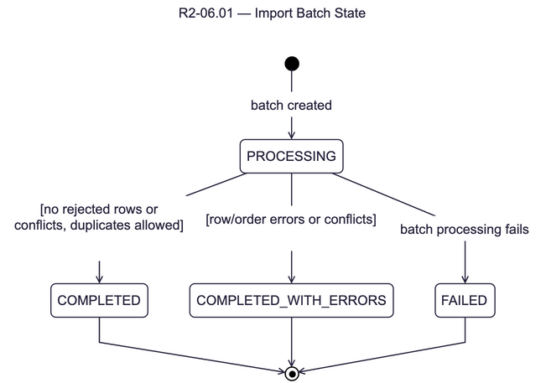
Figure 11: State machine – Import batch
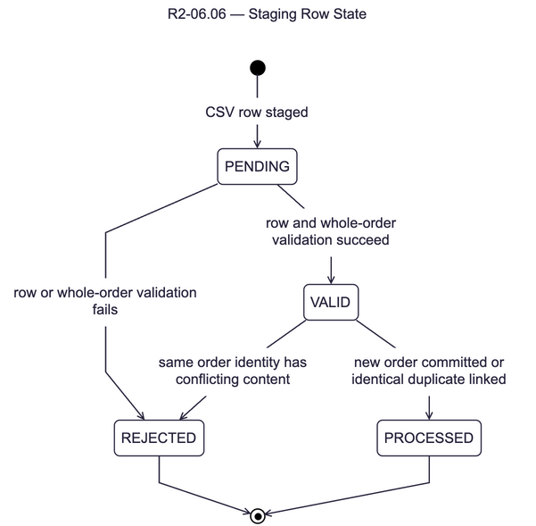
Figure 12: State machine – Import staging row
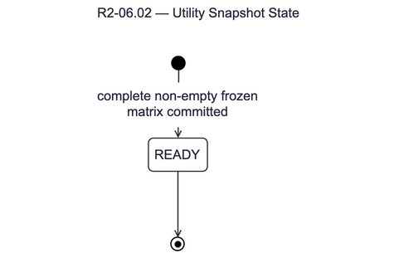
Figure 13: State machine – Utility snapshot
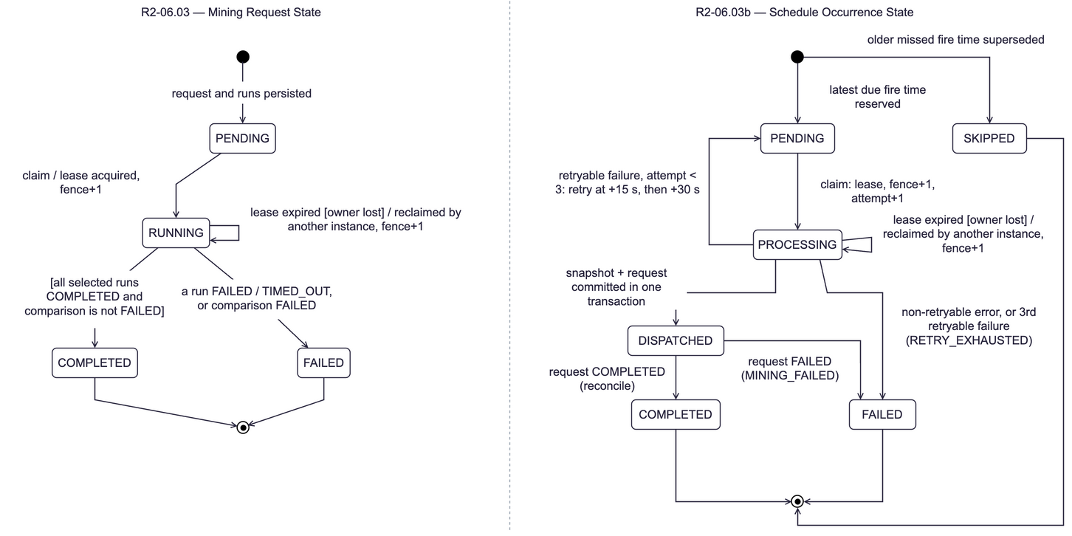
Figure 14: State machine – Mining request and schedule occurrence
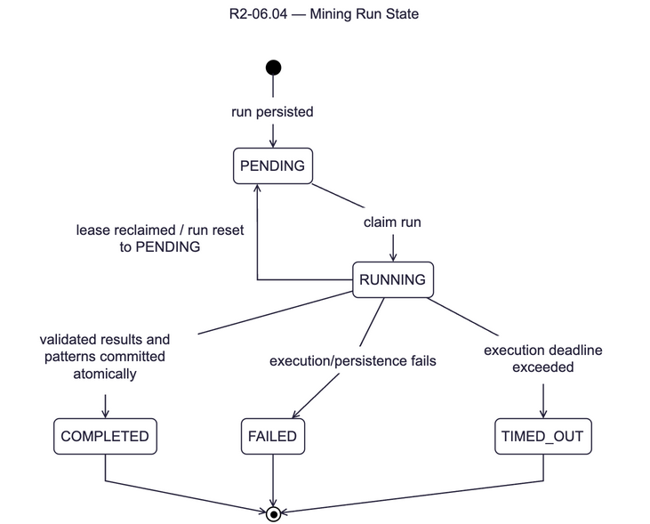
Figure 15: State machine – Mining run
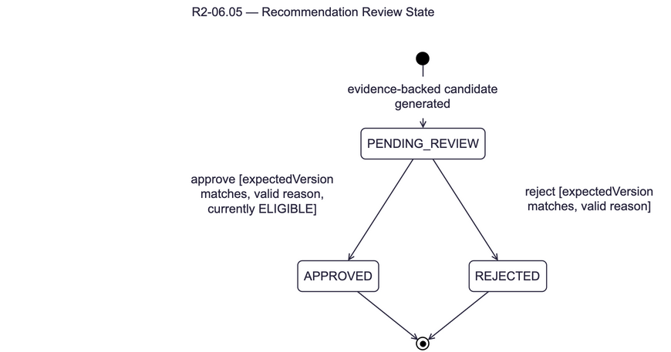
Figure 16: State machine – Recommendation review

3. Detailed Design

3.1 Overall System Workflow
End-to-end flow from transaction import to the storefront. The class diagram shows the main services and views of every domain.

3.1.1 Class Diagram
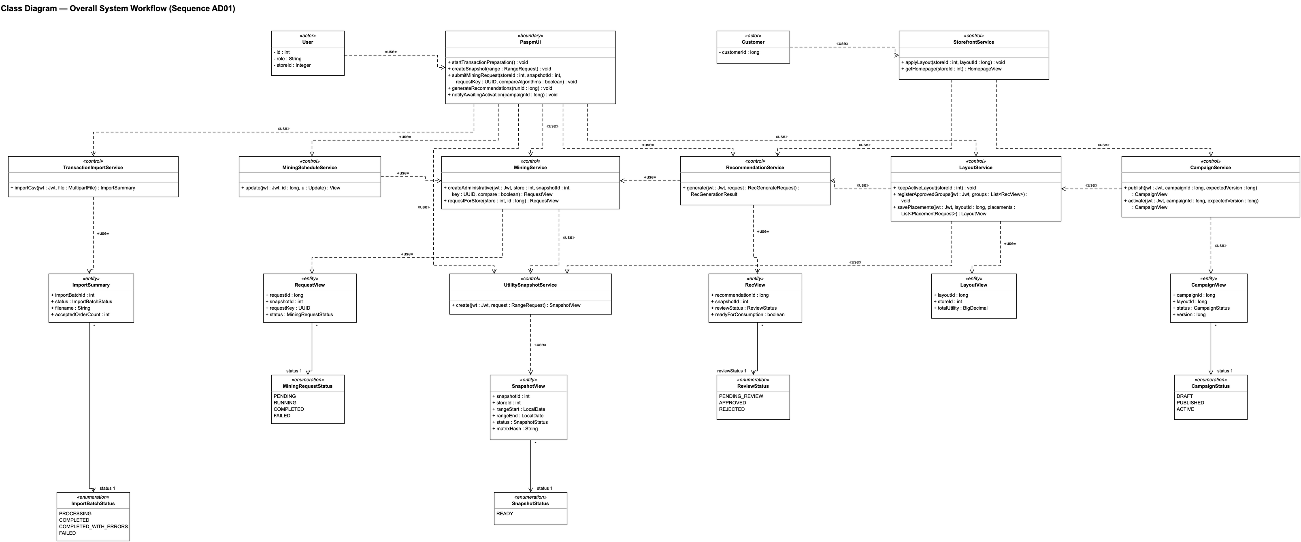
Figure 17: Class diagram – Overall System Workflow

3.1.2 Class Specifications
No | Class | Description
1 | User | Actor; attributes: id, role, storeId.
2 | Customer | Actor; attributes: customerId.
3 | PaspmUi | Boundary; operations: startTransactionPreparation, createSnapshot, submitMiningRequest, generateRecommendations, notifyAwaitingActivation.
4 | TransactionImportService | Control; operations: importCsv.
5 | UtilitySnapshotService | Control; operations: create.
6 | MiningService | Control; operations: createAdministrative, requestForStore.
7 | MiningScheduleService | Control; operations: update.
8 | RecommendationService | Control; operations: generate.
9 | LayoutService | Control; operations: keepActiveLayout, registerApprovedGroups, savePlacements.
10 | CampaignService | Control; operations: publish, activate.
11 | StorefrontService | Control; operations: applyLayout, getHomepage.
12 | ImportSummary | Entity; attributes: importBatchId, status, filename, acceptedOrderCount.
13 | SnapshotView | Entity; attributes: snapshotId, storeId, rangeStart, rangeEnd, status, matrixHash.
14 | RequestView | Entity; attributes: requestId, snapshotId, requestKey, status.
15 | RecView | Entity; attributes: recommendationId, snapshotId, reviewStatus, readyForConsumption.
16 | LayoutView | Entity; attributes: layoutId, storeId, totalUtility.
17 | CampaignView | Entity; attributes: campaignId, layoutId, status, version.
18 | ImportBatchStatus | Enumeration: PROCESSING, COMPLETED, COMPLETED_WITH_ERRORS, FAILED
19 | SnapshotStatus | Enumeration: READY
20 | MiningRequestStatus | Enumeration: PENDING, RUNNING, COMPLETED, FAILED
21 | ReviewStatus | Enumeration: PENDING_REVIEW, APPROVED, REJECTED
22 | CampaignStatus | Enumeration: DRAFT, PUBLISHED, ACTIVE

3.1.3 Sequence Diagram
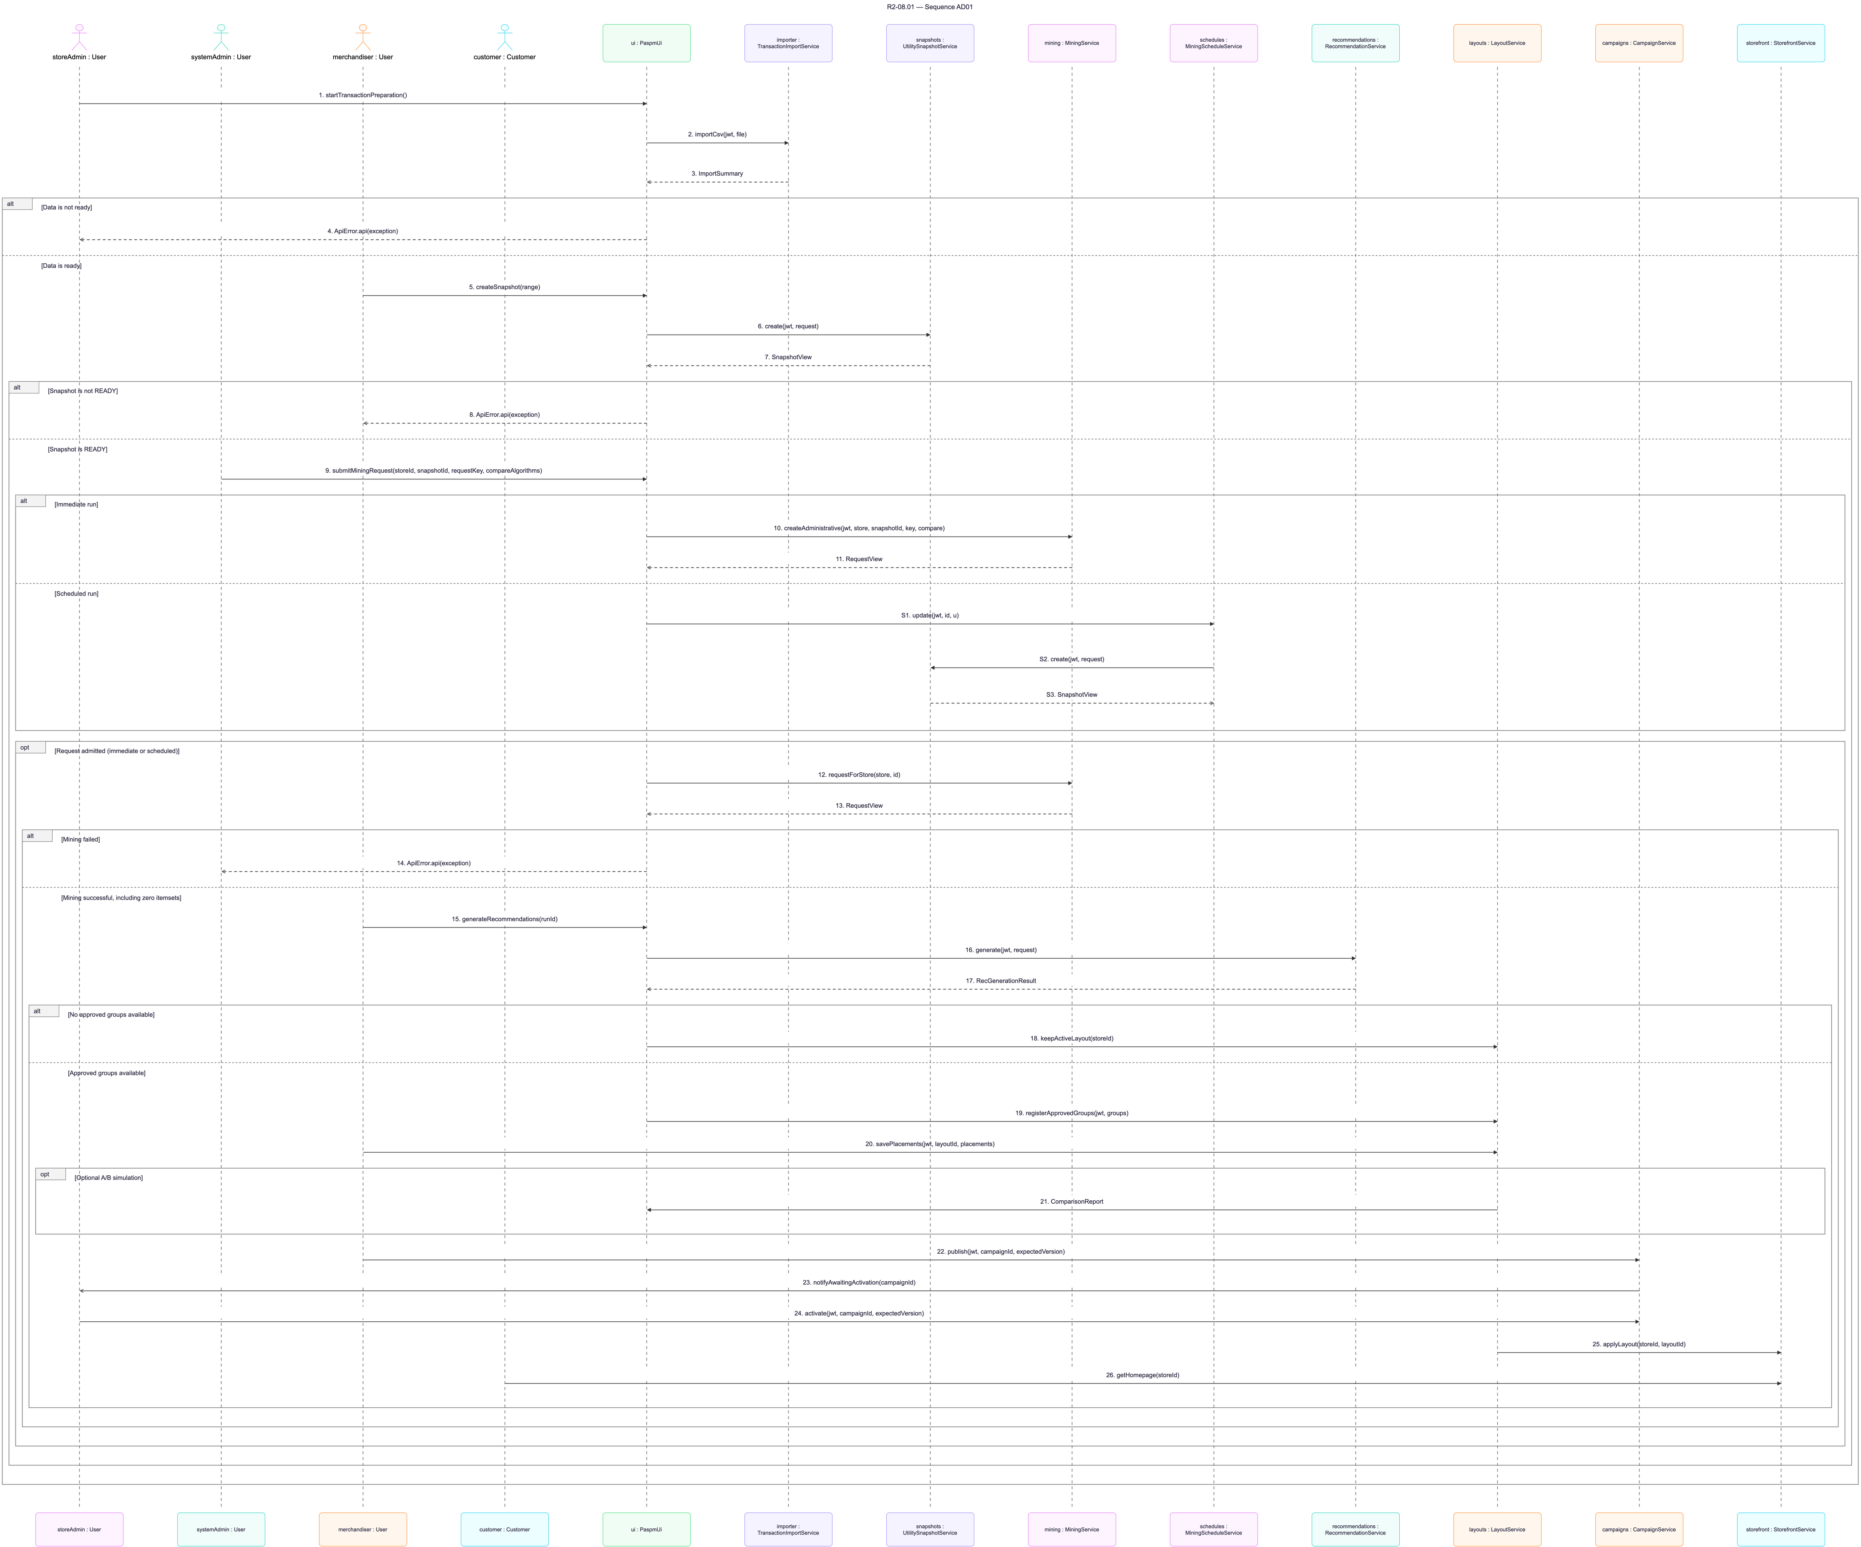
Figure 18: Sequence diagram – Overall System Workflow

3.1.4 Activity Diagram
The activity diagram shows the actors and the business steps of the workflow.
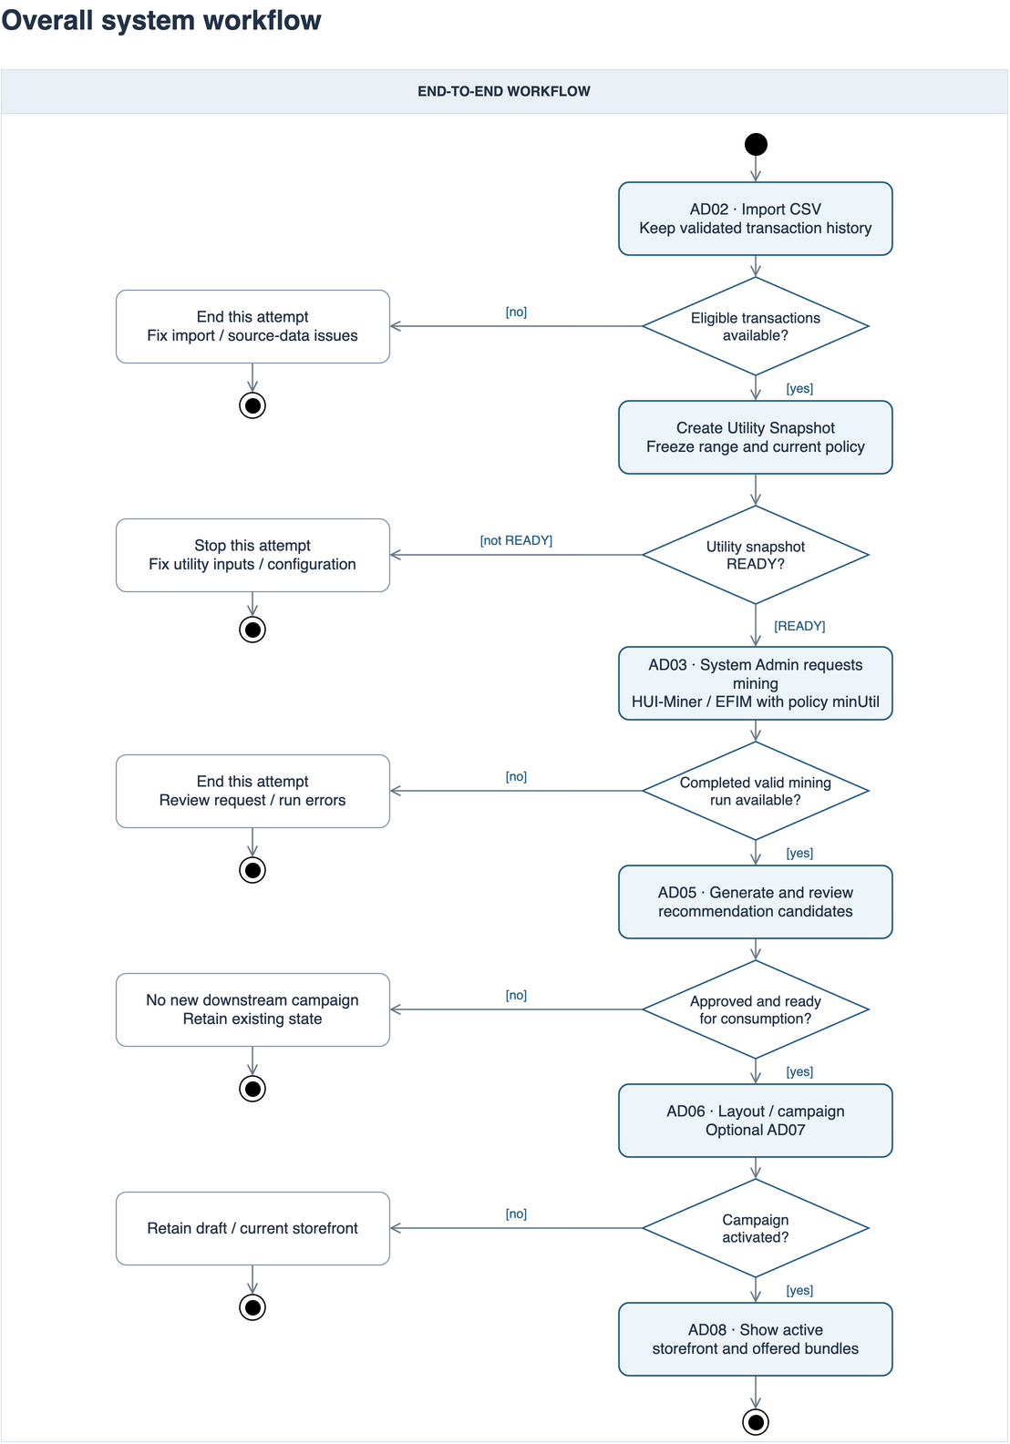
Figure 19: Activity diagram – Overall System Workflow

3.2 Transaction Data Processing
CSV import with staging, per-order validation, duplicate and conflict handling and the import summary.

3.2.1 Class Diagram
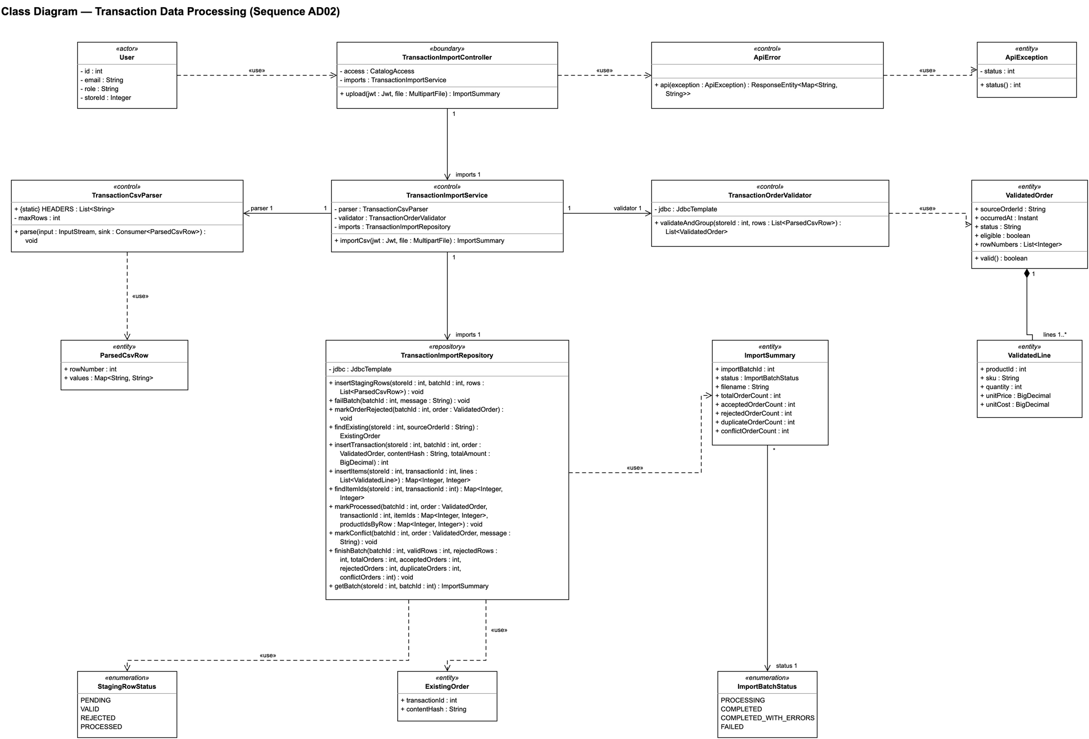
Figure 20: Class diagram – Transaction Data Processing

3.2.2 Class Specifications
No | Class | Description
1 | User | Actor; attributes: id, email, role, storeId.
2 | TransactionImportController | Boundary; operations: upload.
3 | ApiError | Control; operations: api.
4 | ApiException | Entity; operations: status.
5 | TransactionImportService | Control; operations: importCsv.
6 | TransactionCsvParser | Control; operations: parse.
7 | TransactionOrderValidator | Control; operations: validateAndGroup.
8 | TransactionImportRepository | Repository; operations: insertStagingRows, failBatch, markOrderRejected, findExisting, insertTransaction, insertItems, findItemIds, markProcessed, markConflict, finishBatch, getBatch.
9 | ParsedCsvRow | Entity; attributes: rowNumber, values.
10 | ValidatedOrder | Entity; operations: valid.
11 | ValidatedLine | Entity; attributes: productId, sku, quantity, unitPrice, unitCost.
12 | ExistingOrder | Entity; attributes: transactionId, contentHash.
13 | ImportSummary | Entity; attributes: importBatchId, status, filename, totalOrderCount, acceptedOrderCount, rejectedOrderCount, duplicateOrderCount, conflictOrderCount.
14 | ImportBatchStatus | Enumeration: PROCESSING, COMPLETED, COMPLETED_WITH_ERRORS, FAILED
15 | StagingRowStatus | Enumeration: PENDING, VALID, REJECTED, PROCESSED

3.2.3 Sequence Diagram
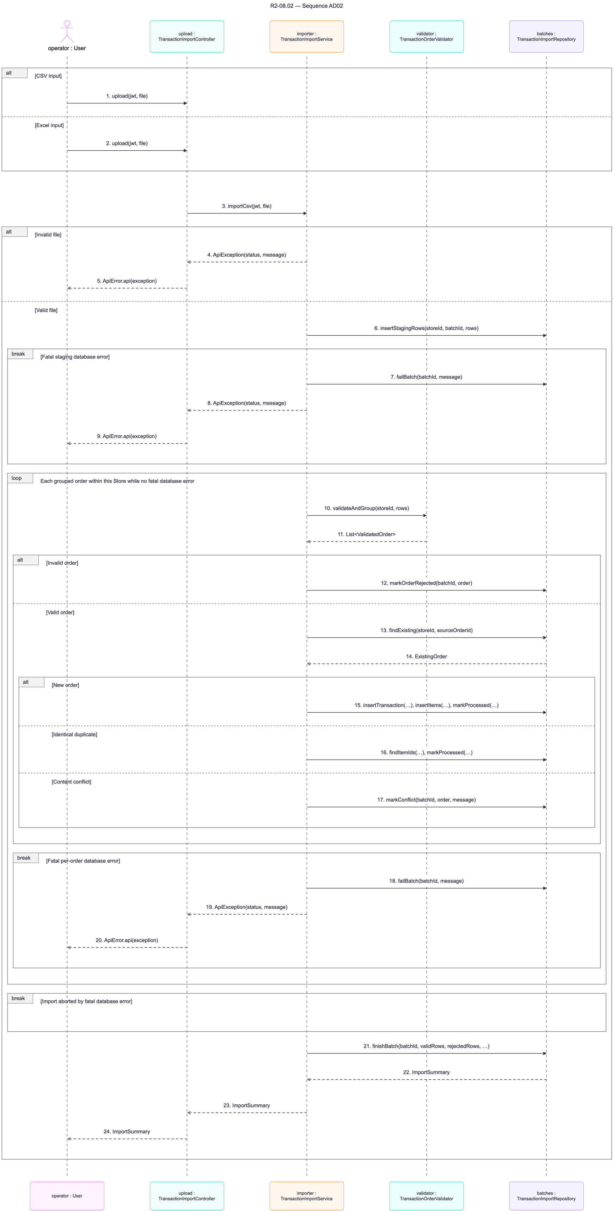
Figure 21: Sequence diagram – Transaction Data Processing

3.2.4 Activity Diagram
The activity diagram shows the actors and the business steps of the workflow.
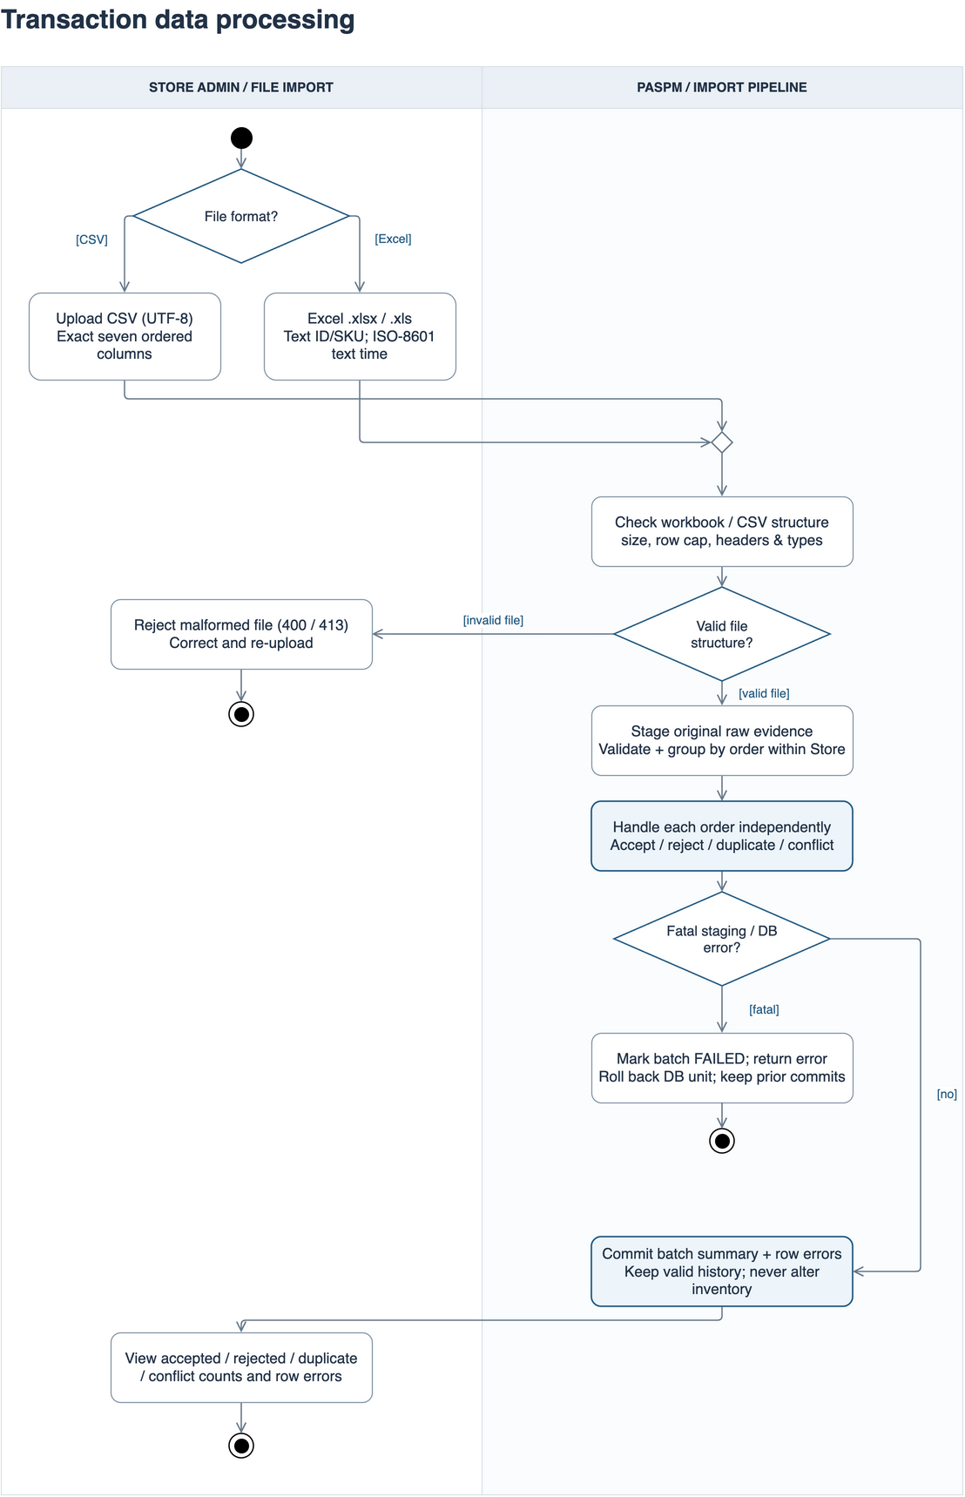
Figure 22: Activity diagram – Transaction Data Processing

3.3 Mining Execution & Configuration
Manual and scheduled mining: request creation, durable dispatch with leases, SPMF execution and run persistence.

3.3.1 Class Diagram
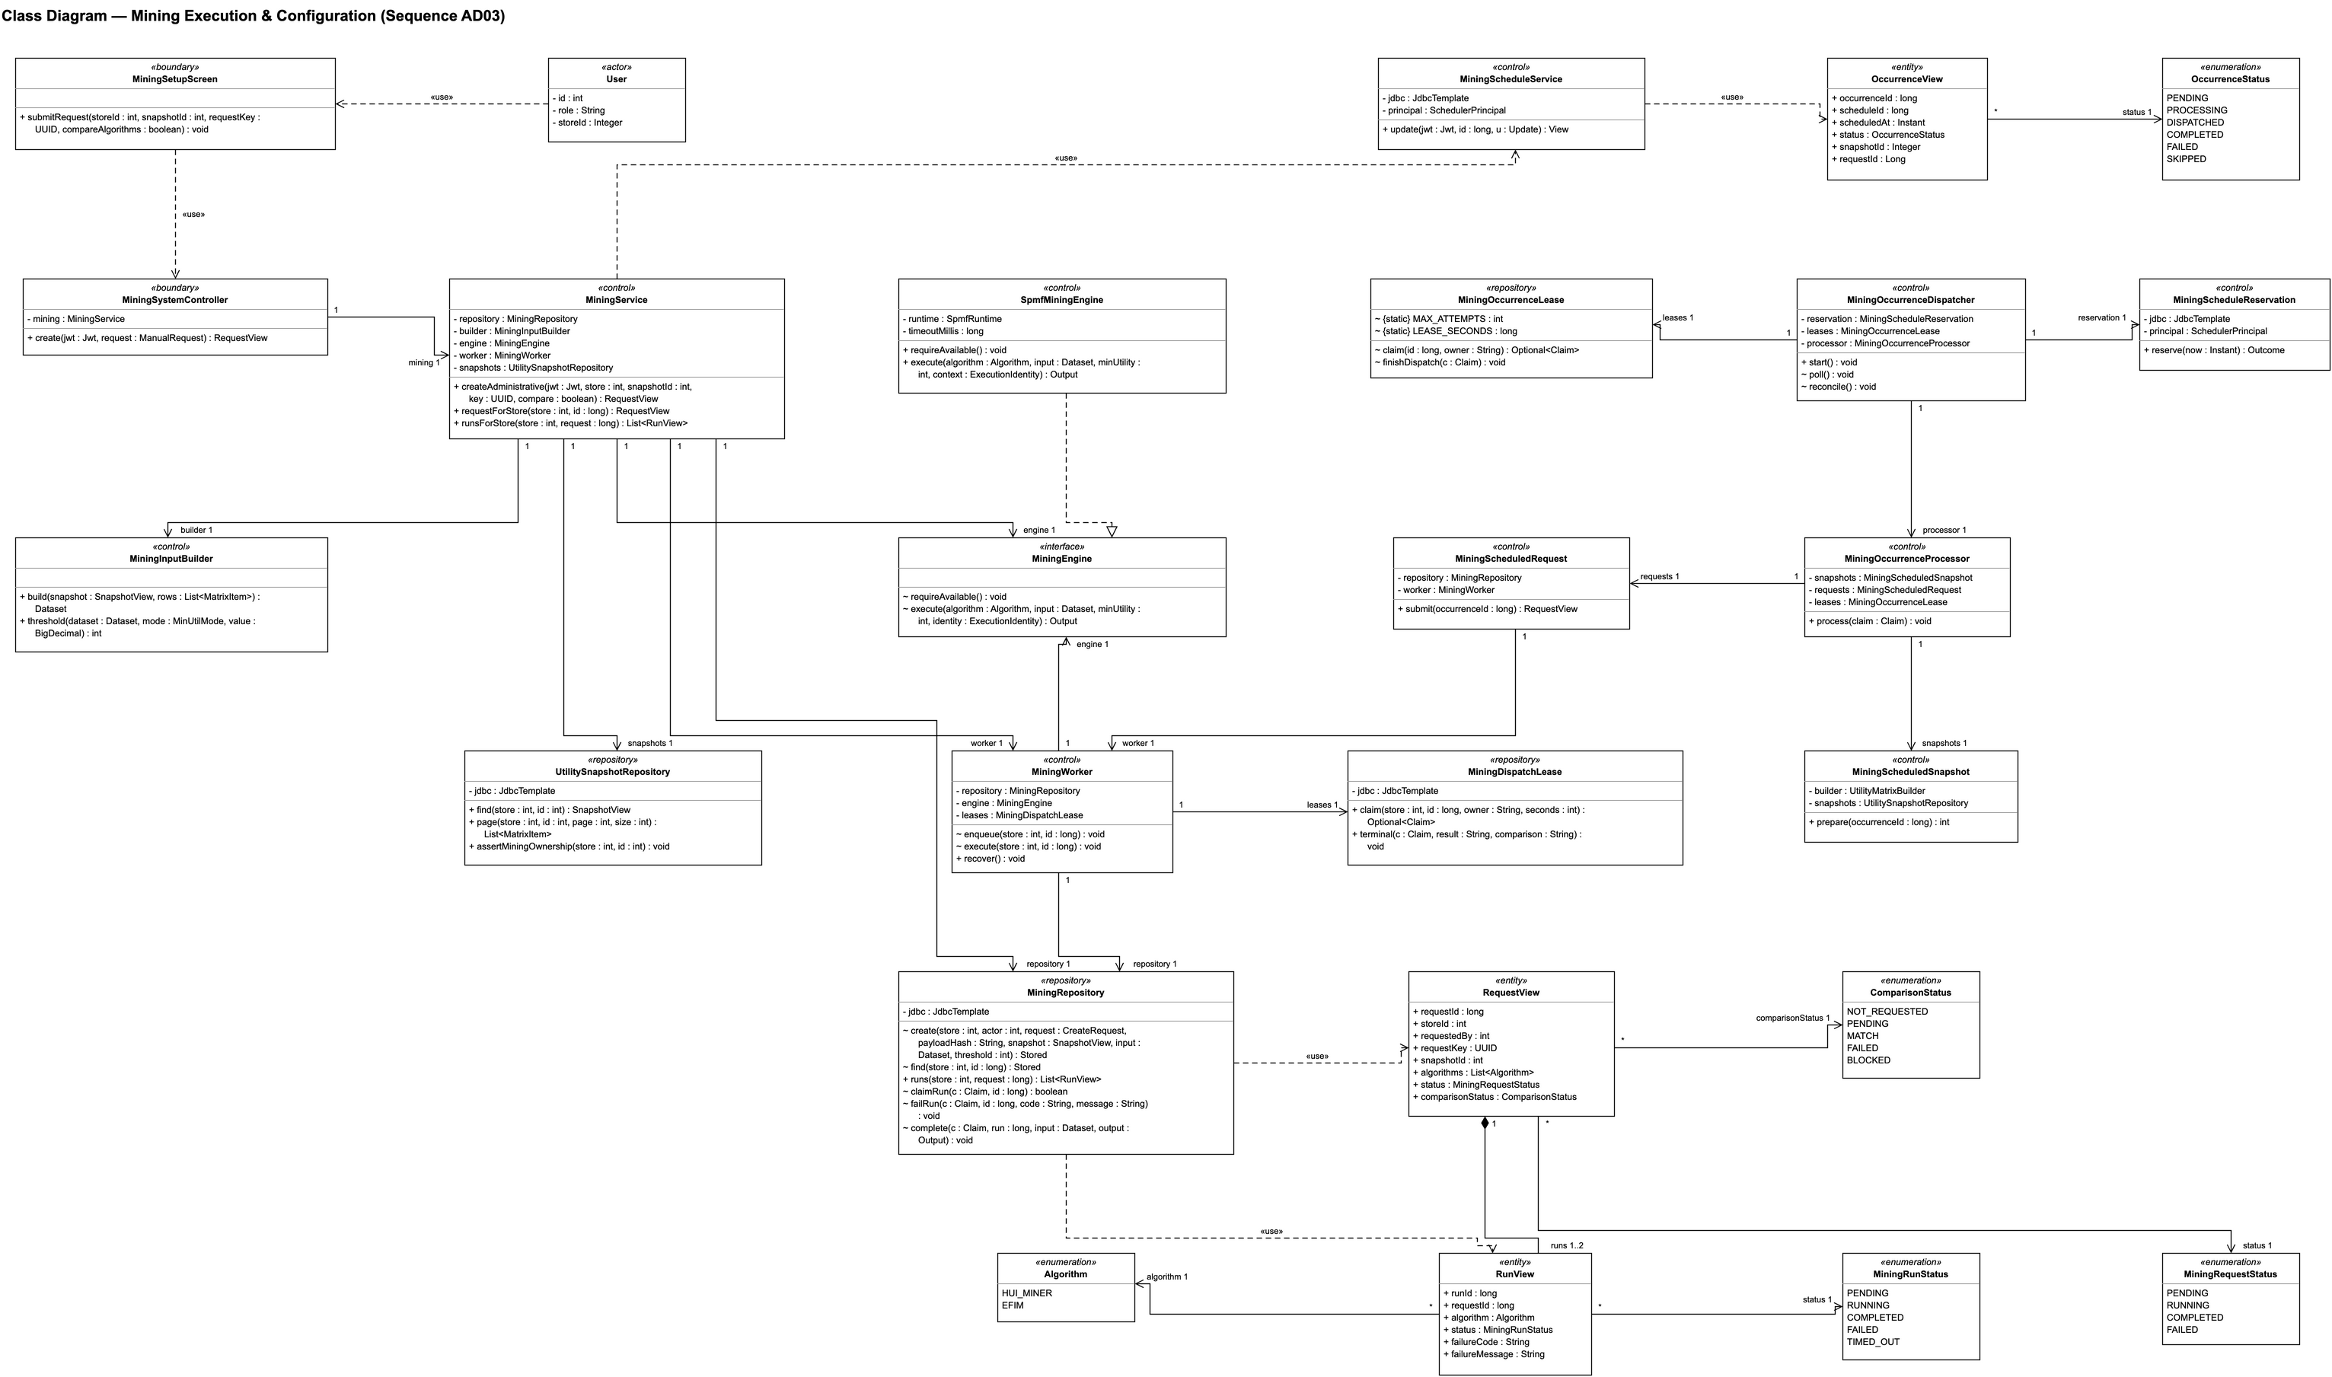
Figure 23: Class diagram – Mining Execution & Configuration

3.3.2 Class Specifications
No | Class | Description
1 | User | Actor; attributes: id, role, storeId.
2 | MiningSetupScreen | Boundary; operations: submitRequest.
3 | MiningSystemController | Boundary; operations: create.
4 | MiningScheduleService | Control; operations: update.
5 | MiningService | Control; operations: createAdministrative, requestForStore, runsForStore.
6 | MiningOccurrenceDispatcher | Control; operations: start, poll, reconcile.
7 | MiningWorker | Control; operations: enqueue, execute, recover.
8 | MiningInputBuilder | Control; operations: build, threshold.
9 | MiningEngine | Interface; operations: requireAvailable, execute.
10 | SpmfMiningEngine | Control; operations: requireAvailable, execute.
11 | MiningScheduleReservation | Control; operations: reserve.
12 | MiningOccurrenceProcessor | Control; operations: process.
13 | MiningScheduledSnapshot | Control; operations: prepare.
14 | MiningScheduledRequest | Control; operations: submit.
15 | MiningOccurrenceLease | Repository; operations: claim, finishDispatch.
16 | MiningRepository | Repository; operations: create, find, runs, claimRun, failRun, complete.
17 | MiningDispatchLease | Repository; operations: claim, terminal.
18 | UtilitySnapshotRepository | Repository; operations: find, page, assertMiningOwnership.
19 | RequestView | Entity; attributes: requestId, storeId, requestedBy, requestKey, snapshotId, algorithms, status, comparisonStatus.
20 | RunView | Entity; attributes: runId, requestId, algorithm, status, failureCode, failureMessage.
21 | OccurrenceView | Entity; attributes: occurrenceId, scheduleId, scheduledAt, status, snapshotId, requestId.
22 | MiningRequestStatus | Enumeration: PENDING, RUNNING, COMPLETED, FAILED
23 | MiningRunStatus | Enumeration: PENDING, RUNNING, COMPLETED, FAILED, TIMED_OUT
24 | OccurrenceStatus | Enumeration: PENDING, PROCESSING, DISPATCHED, COMPLETED, FAILED, SKIPPED
25 | ComparisonStatus | Enumeration: NOT_REQUESTED, PENDING, MATCH, FAILED, BLOCKED
26 | Algorithm | Enumeration: HUI_MINER, EFIM

3.3.3 Sequence Diagram
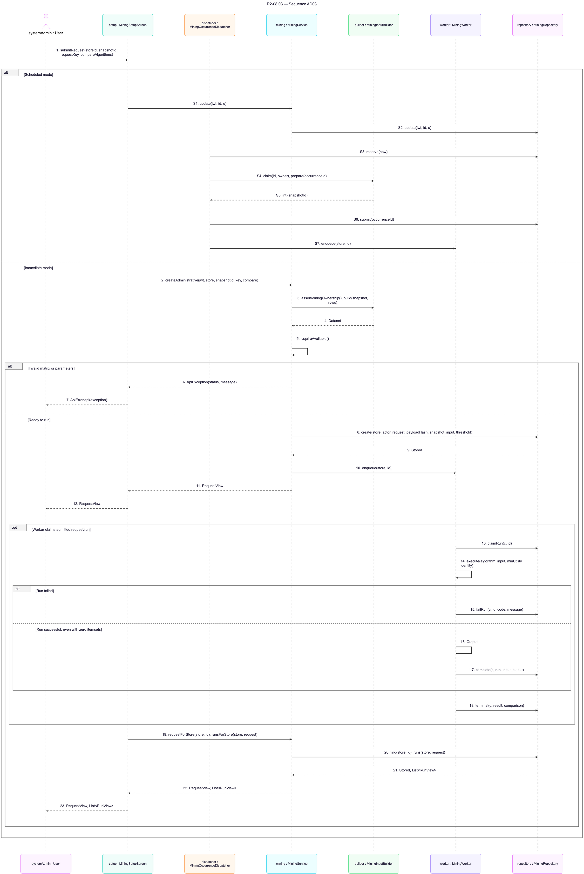
Figure 24: Sequence diagram – Mining Execution & Configuration

3.3.4 Activity Diagram
The activity diagram shows the actors and the business steps of the workflow.
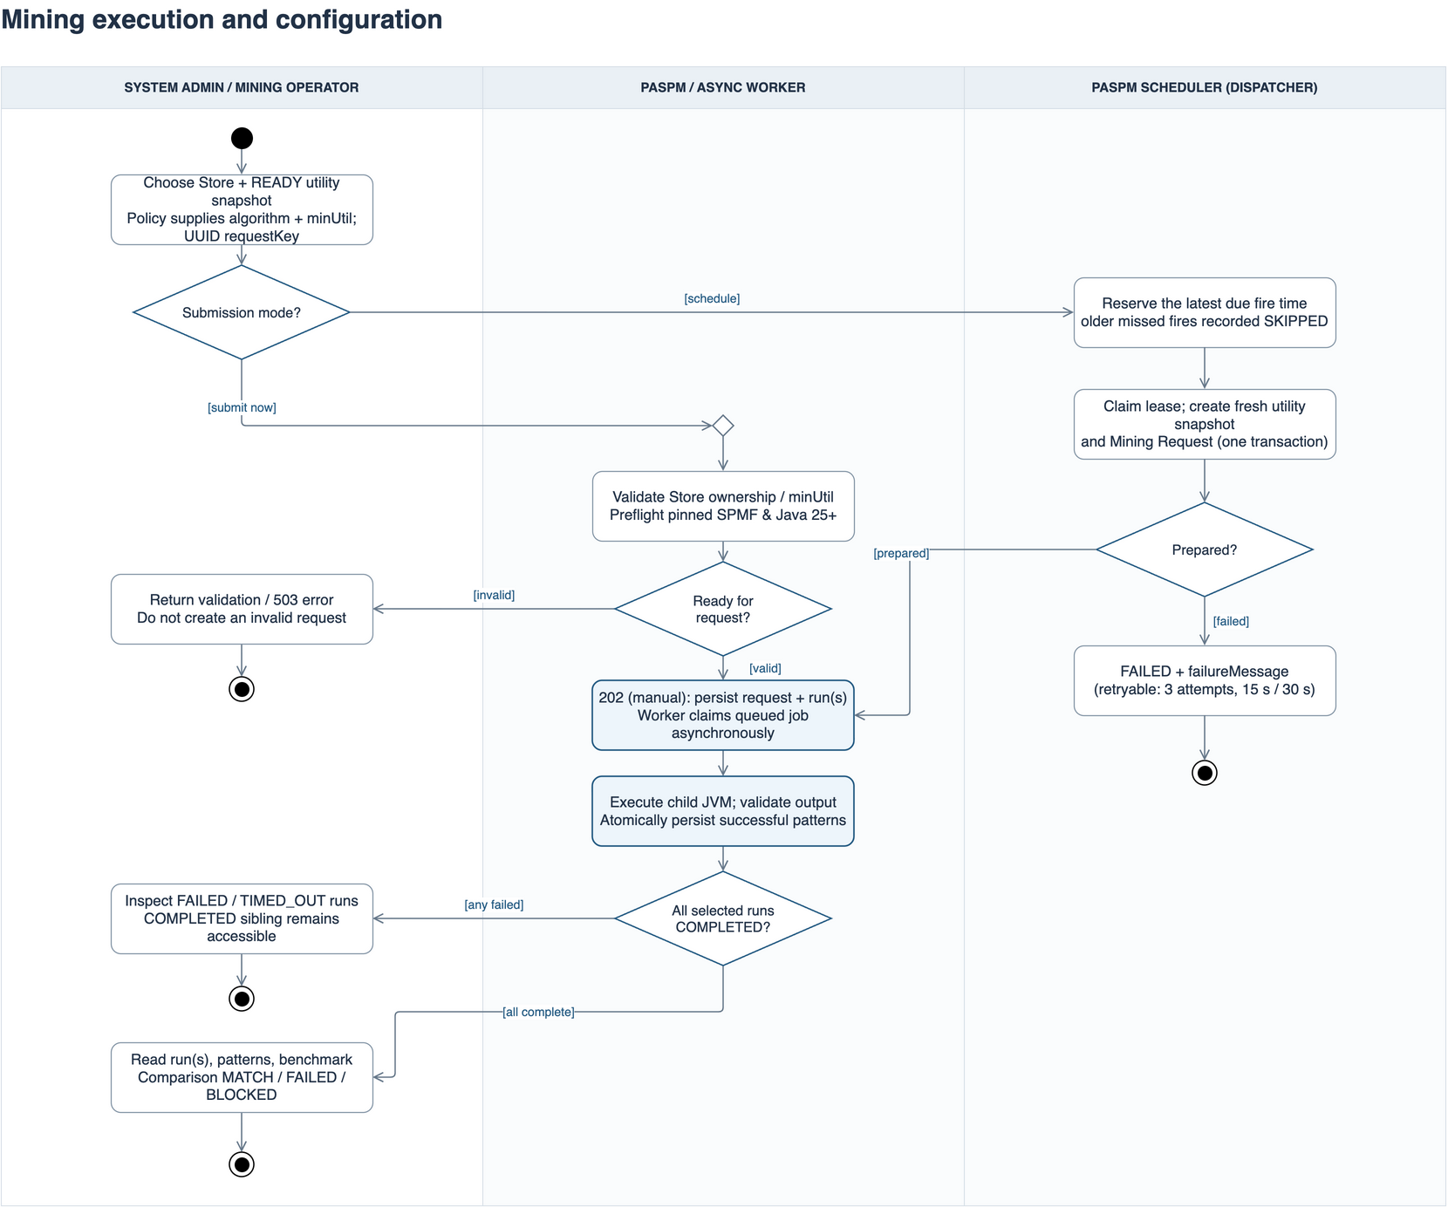
Figure 25: Activity diagram – Mining Execution & Configuration

3.4 Algorithm Benchmarking
Paired HUI-Miner and EFIM runs on the same input and the benchmark view with the comparison status.

3.4.1 Class Diagram
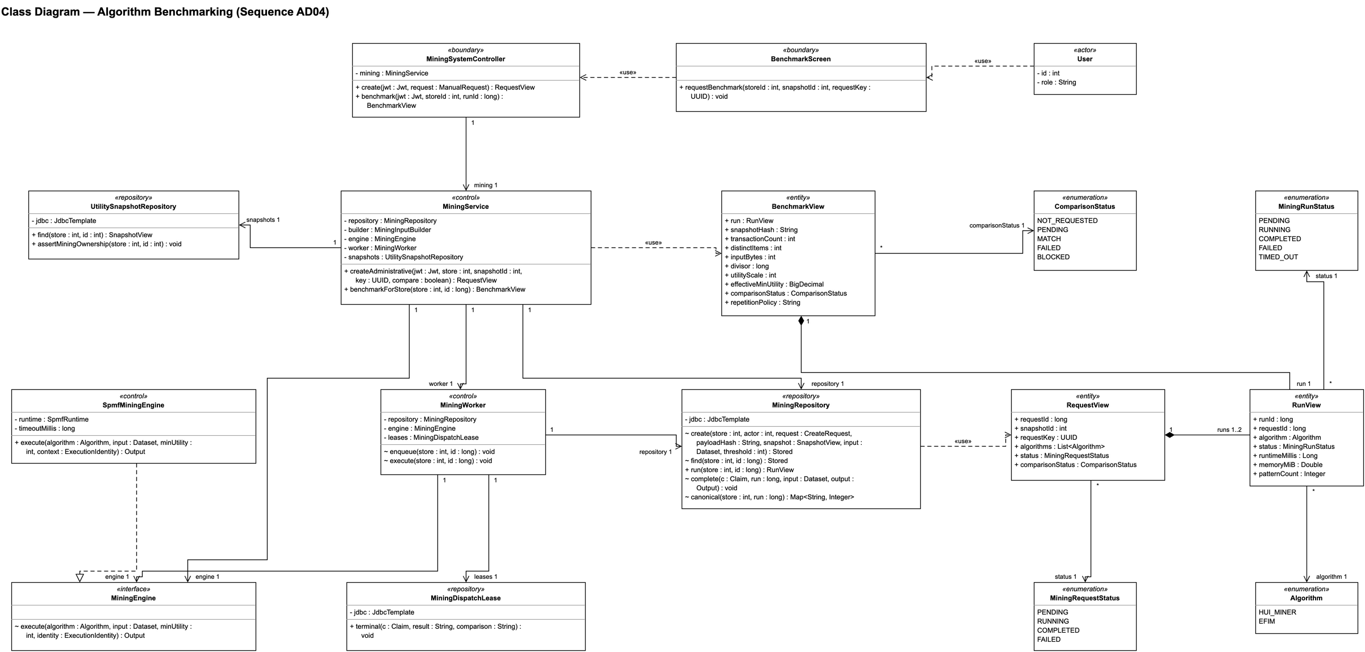
Figure 26: Class diagram – Algorithm Benchmarking

3.4.2 Class Specifications
No | Class | Description
1 | User | Actor; attributes: id, role.
2 | BenchmarkScreen | Boundary; operations: requestBenchmark.
3 | MiningSystemController | Boundary; operations: create, benchmark.
4 | MiningService | Control; operations: createAdministrative, benchmarkForStore.
5 | MiningWorker | Control; operations: enqueue, execute.
6 | UtilitySnapshotRepository | Repository; operations: find, assertMiningOwnership.
7 | MiningEngine | Interface; operations: execute.
8 | SpmfMiningEngine | Control; operations: execute.
9 | MiningRepository | Repository; operations: create, find, run, complete, canonical.
10 | MiningDispatchLease | Repository; operations: terminal.
11 | BenchmarkView | Entity; attributes: run, snapshotHash, transactionCount, distinctItems, inputBytes, divisor, utilityScale, effectiveMinUtility, comparisonStatus, repetitionPolicy.
12 | RunView | Entity; attributes: runId, requestId, algorithm, status, runtimeMillis, memoryMiB, patternCount.
13 | RequestView | Entity; attributes: requestId, snapshotId, requestKey, algorithms, status, comparisonStatus.
14 | MiningRunStatus | Enumeration: PENDING, RUNNING, COMPLETED, FAILED, TIMED_OUT
15 | MiningRequestStatus | Enumeration: PENDING, RUNNING, COMPLETED, FAILED
16 | ComparisonStatus | Enumeration: NOT_REQUESTED, PENDING, MATCH, FAILED, BLOCKED
17 | Algorithm | Enumeration: HUI_MINER, EFIM

3.4.3 Sequence Diagram
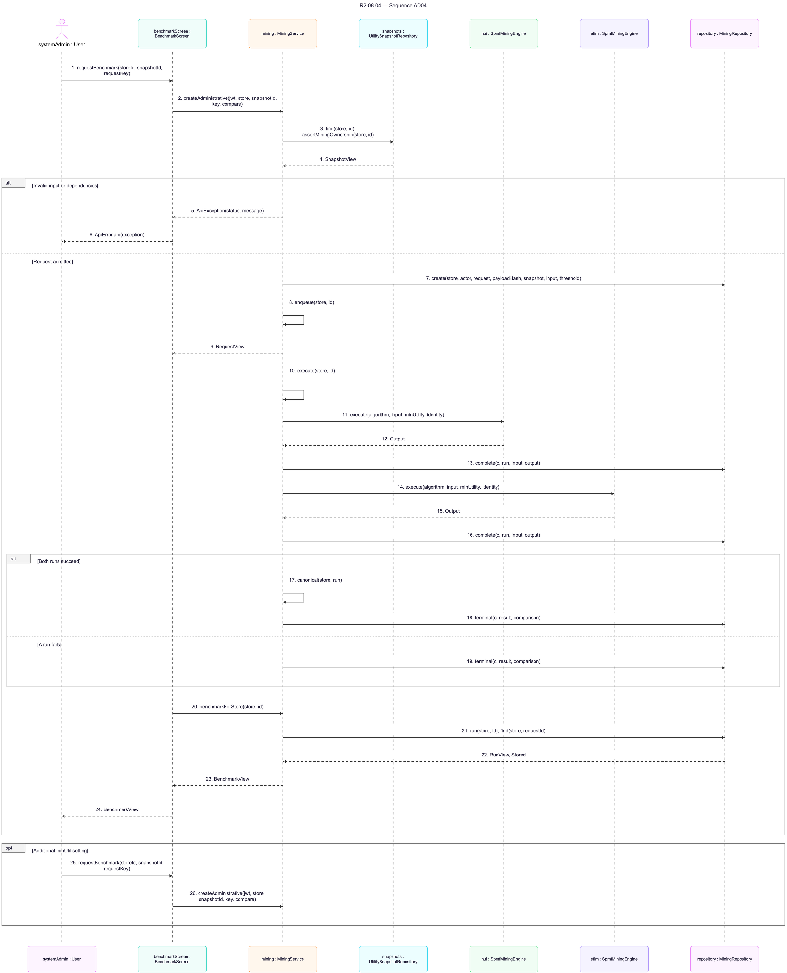
Figure 27: Sequence diagram – Algorithm Benchmarking

3.4.4 Activity Diagram
The activity diagram shows the actors and the business steps of the workflow.
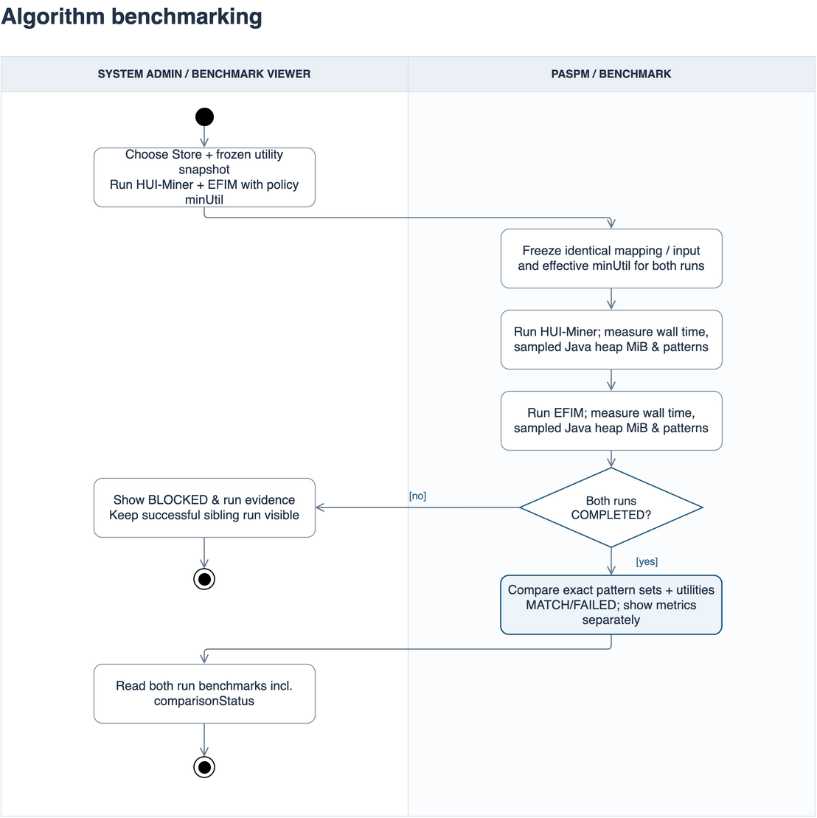
Figure 28: Activity diagram – Algorithm Benchmarking

3.5 Product Recommendation & Approval
Candidate generation from a completed run, live eligibility and the approve/reject review.

3.5.1 Class Diagram
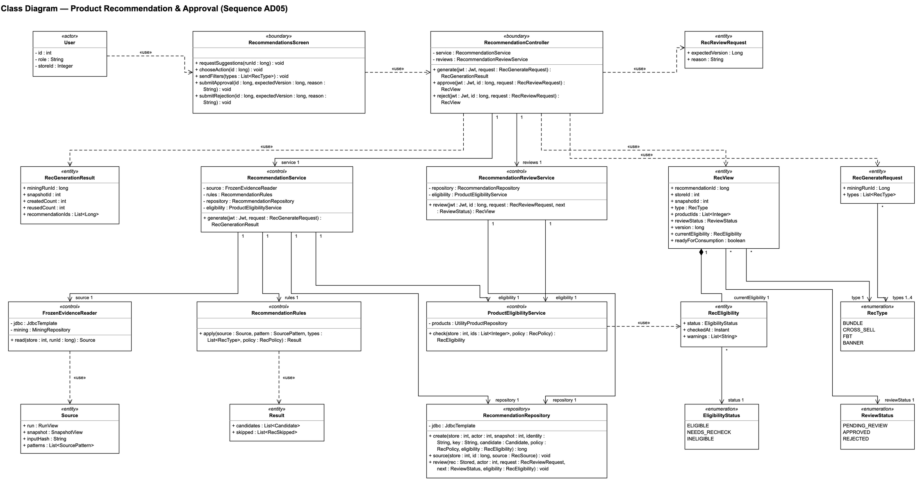
Figure 29: Class diagram – Product Recommendation & Approval

3.5.2 Class Specifications
No | Class | Description
1 | User | Actor; attributes: id, role, storeId.
2 | RecommendationsScreen | Boundary; operations: requestSuggestions, chooseAction, sendFilters, submitApproval, submitRejection.
3 | RecommendationController | Boundary; operations: generate, approve, reject.
4 | RecommendationService | Control; operations: generate.
5 | RecommendationReviewService | Control; operations: review.
6 | FrozenEvidenceReader | Control; operations: read.
7 | RecommendationRules | Control; operations: apply.
8 | ProductEligibilityService | Control; operations: check.
9 | RecommendationRepository | Repository; operations: create, source, review.
10 | Source | Entity; attributes: run, snapshot, inputHash, patterns.
11 | Result | Entity; attributes: candidates, skipped.
12 | RecView | Entity; attributes: recommendationId, storeId, snapshotId, type, productIds, reviewStatus, version, currentEligibility, readyForConsumption.
13 | RecEligibility | Entity; attributes: status, checkedAt, warnings.
14 | RecGenerationResult | Entity; attributes: miningRunId, snapshotId, createdCount, reusedCount, recommendationIds.
15 | RecGenerateRequest | Entity; attributes: miningRunId, types.
16 | RecReviewRequest | Entity; attributes: expectedVersion, reason.
17 | ReviewStatus | Enumeration: PENDING_REVIEW, APPROVED, REJECTED
18 | RecType | Enumeration: BUNDLE, CROSS_SELL, FBT, BANNER
19 | EligibilityStatus | Enumeration: ELIGIBLE, NEEDS_RECHECK, INELIGIBLE

3.5.3 Sequence Diagram
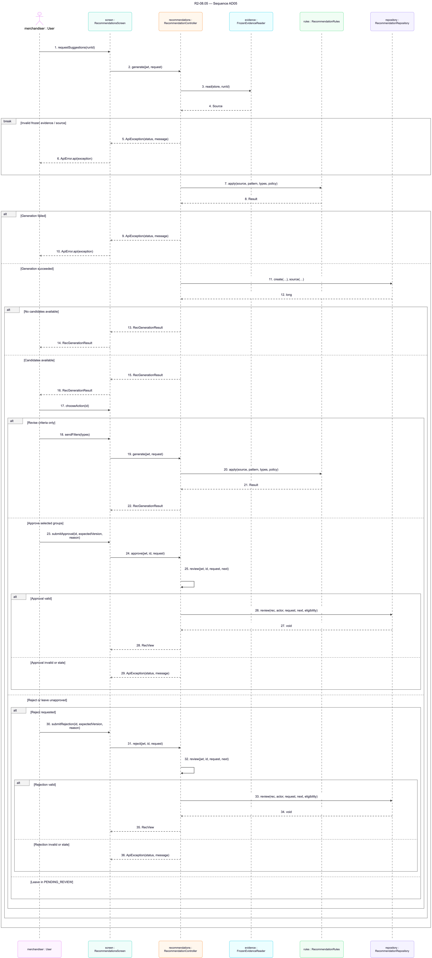
Figure 30: Sequence diagram – Product Recommendation & Approval

3.5.4 Activity Diagram
The activity diagram shows the actors and the business steps of the workflow.
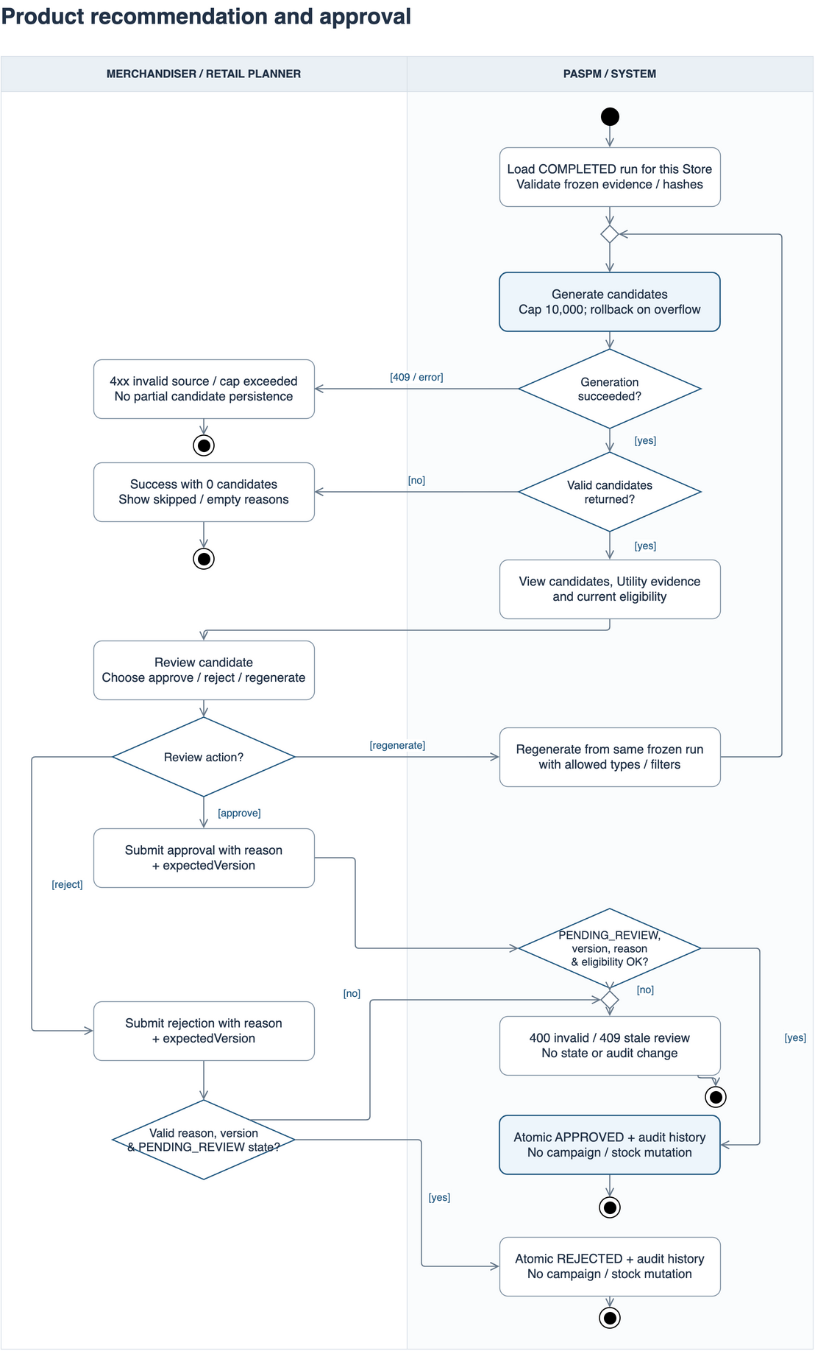
Figure 31: Activity diagram – Product Recommendation & Approval

3.6 Layout & Campaign Management
Layout B from approved groups against baseline A, campaign draft, publication and activation. These classes are designed and not yet implemented.

3.6.1 Class Diagram
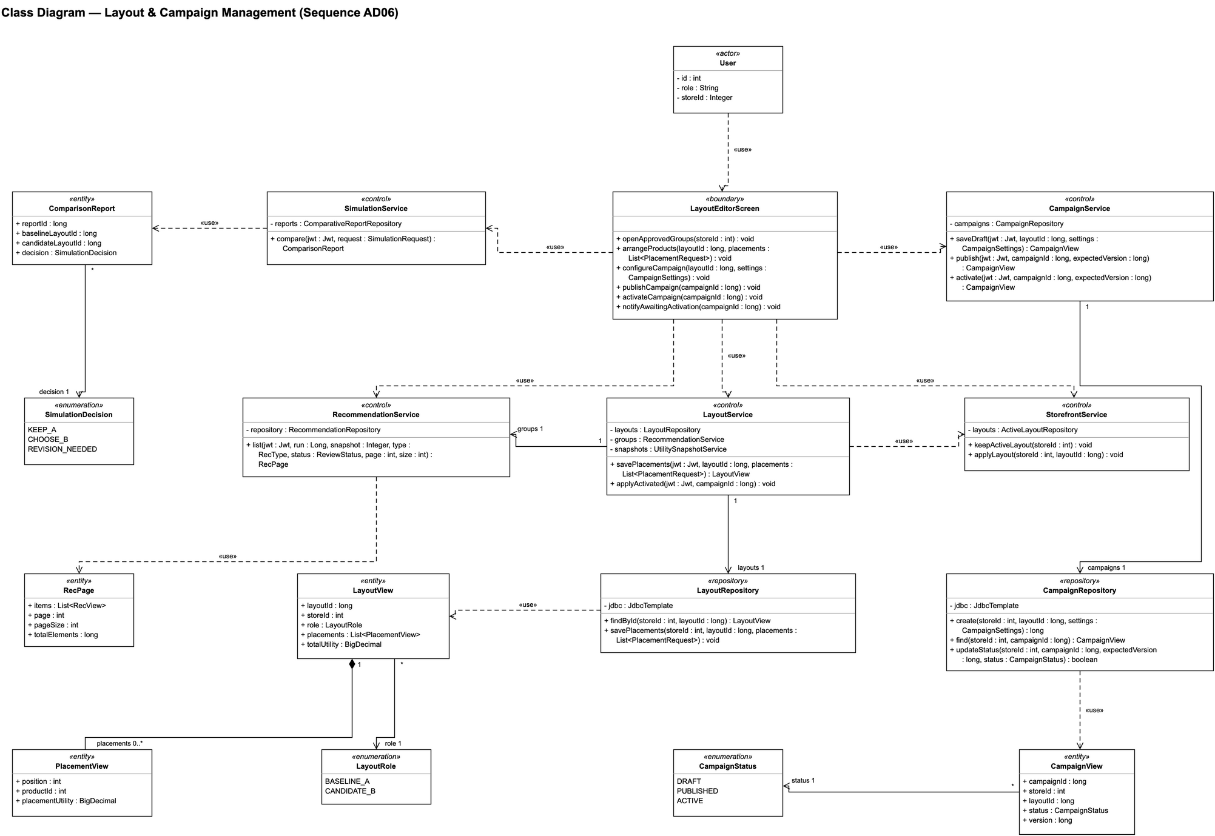
Figure 32: Class diagram – Layout & Campaign Management

3.6.2 Class Specifications
No | Class | Description
1 | User | Actor; attributes: id, role, storeId.
2 | LayoutEditorScreen | Boundary; operations: openApprovedGroups, arrangeProducts, configureCampaign, publishCampaign, activateCampaign, notifyAwaitingActivation.
3 | RecommendationService | Control; operations: list.
4 | LayoutService | Control; operations: savePlacements, applyActivated.
5 | CampaignService | Control; operations: saveDraft, publish, activate.
6 | SimulationService | Control; operations: compare.
7 | StorefrontService | Control; operations: keepActiveLayout, applyLayout.
8 | LayoutRepository | Repository; operations: findById, savePlacements.
9 | CampaignRepository | Repository; operations: create, find, updateStatus.
10 | LayoutView | Entity; attributes: layoutId, storeId, role, placements, totalUtility.
11 | PlacementView | Entity; attributes: position, productId, placementUtility.
12 | CampaignView | Entity; attributes: campaignId, storeId, layoutId, status, version.
13 | ComparisonReport | Entity; attributes: reportId, baselineLayoutId, candidateLayoutId, decision.
14 | RecPage | Entity; attributes: items, page, pageSize, totalElements.
15 | LayoutRole | Enumeration: BASELINE_A, CANDIDATE_B
16 | CampaignStatus | Enumeration: DRAFT, PUBLISHED, ACTIVE
17 | SimulationDecision | Enumeration: KEEP_A, CHOOSE_B, REVISION_NEEDED

3.6.3 Sequence Diagram
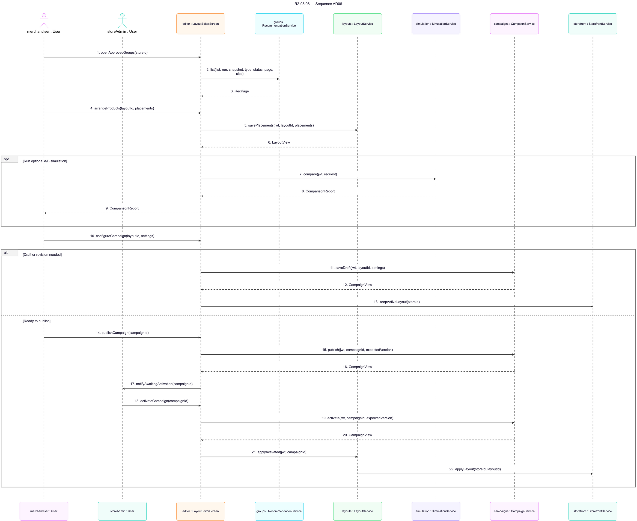
Figure 33: Sequence diagram – Layout & Campaign Management

3.6.4 Activity Diagram
The activity diagram shows the actors and the business steps of the workflow.
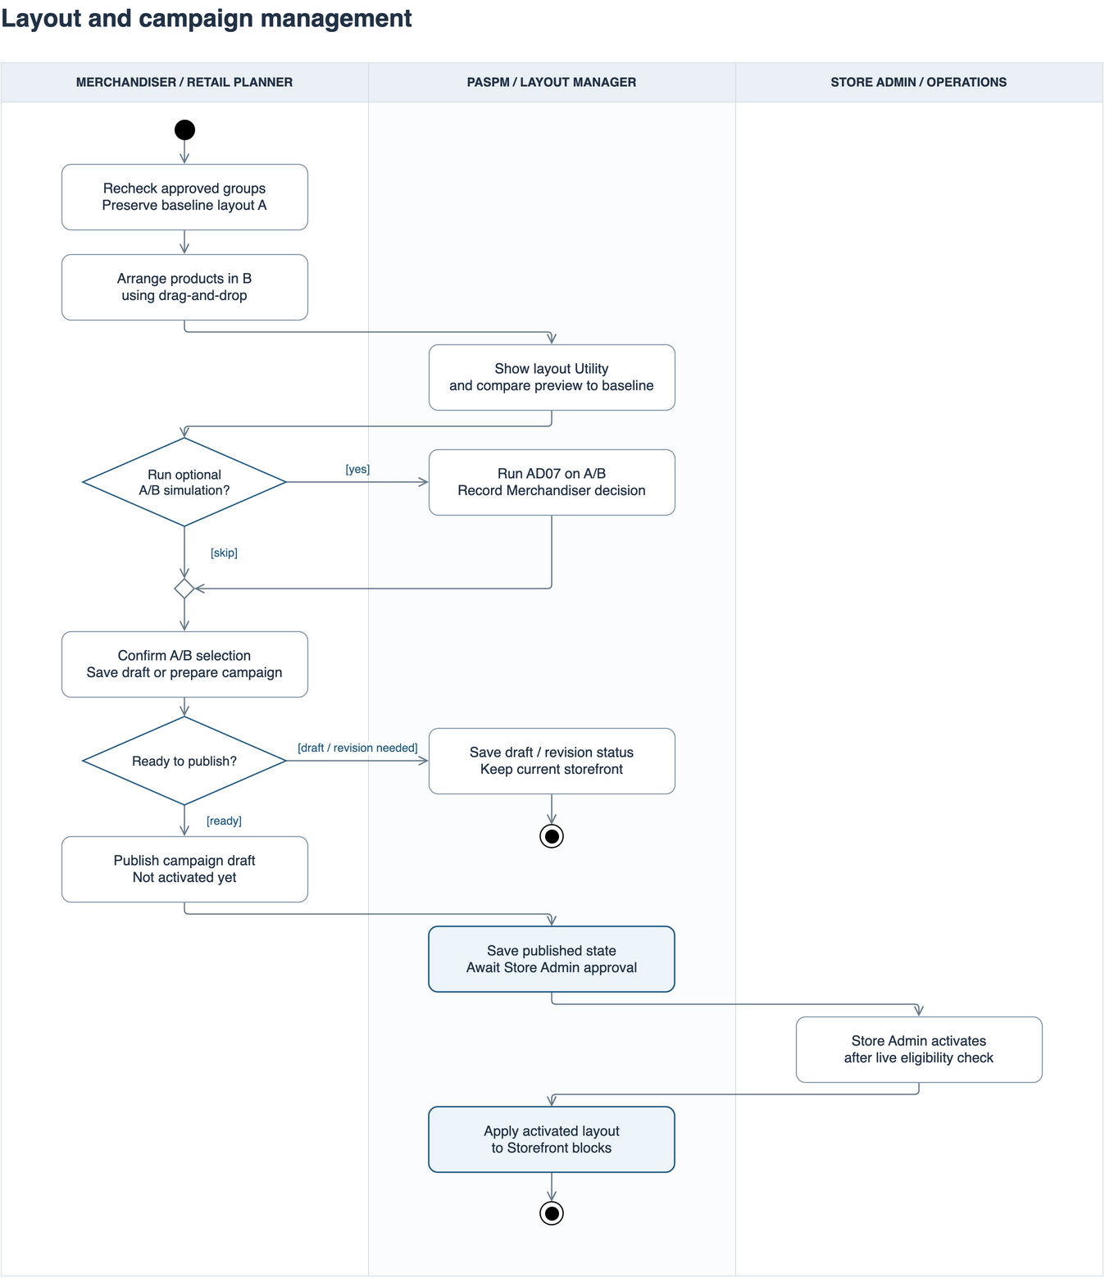
Figure 34: Activity diagram – Layout & Campaign Management

3.7 A/B Testing & Performance Evaluation
Simulation of layouts A and B and the comparison report. These classes are designed and not yet implemented.

3.7.1 Class Diagram
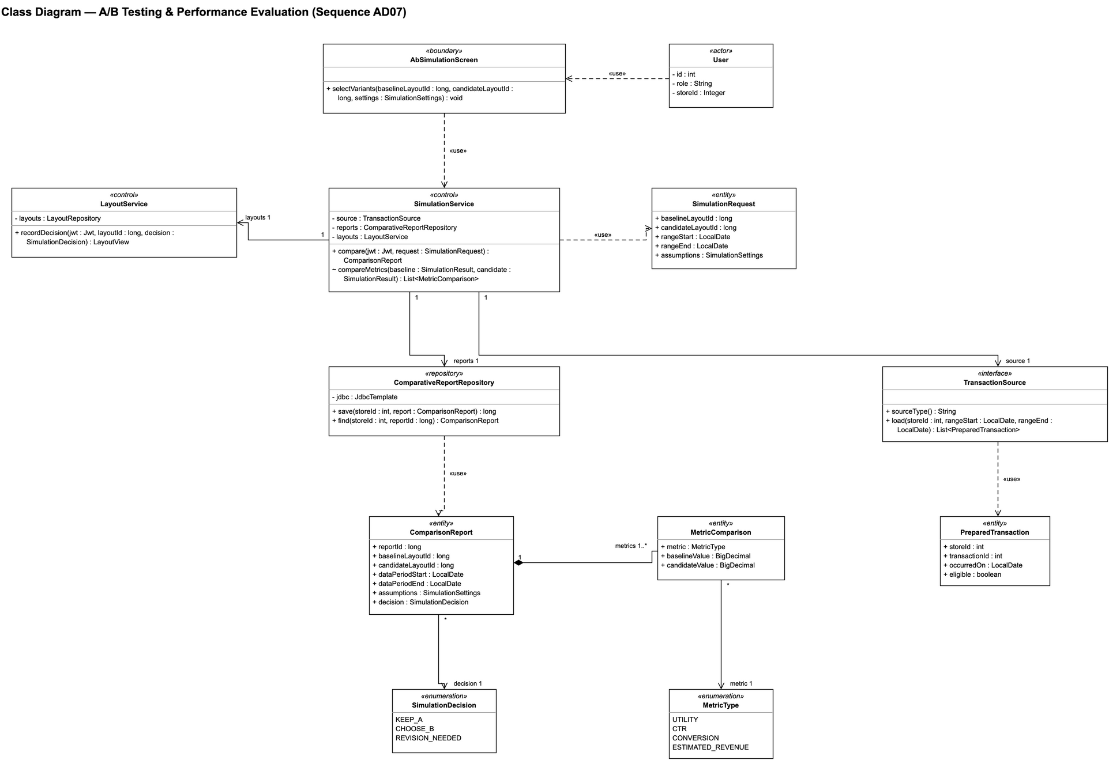
Figure 35: Class diagram – A/B Testing & Performance Evaluation

3.7.2 Class Specifications
No | Class | Description
1 | User | Actor; attributes: id, role, storeId.
2 | AbSimulationScreen | Boundary; operations: selectVariants.
3 | SimulationService | Control; operations: compare, compareMetrics.
4 | TransactionSource | Interface; operations: sourceType, load.
5 | ComparativeReportRepository | Repository; operations: save, find.
6 | LayoutService | Control; operations: recordDecision.
7 | SimulationRequest | Entity; attributes: baselineLayoutId, candidateLayoutId, rangeStart, rangeEnd, assumptions.
8 | ComparisonReport | Entity; attributes: reportId, baselineLayoutId, candidateLayoutId, dataPeriodStart, dataPeriodEnd, assumptions, decision.
9 | MetricComparison | Entity; attributes: metric, baselineValue, candidateValue.
10 | PreparedTransaction | Entity; attributes: storeId, transactionId, occurredOn, eligible.
11 | MetricType | Enumeration: UTILITY, CTR, CONVERSION, ESTIMATED_REVENUE
12 | SimulationDecision | Enumeration: KEEP_A, CHOOSE_B, REVISION_NEEDED

3.7.3 Sequence Diagram
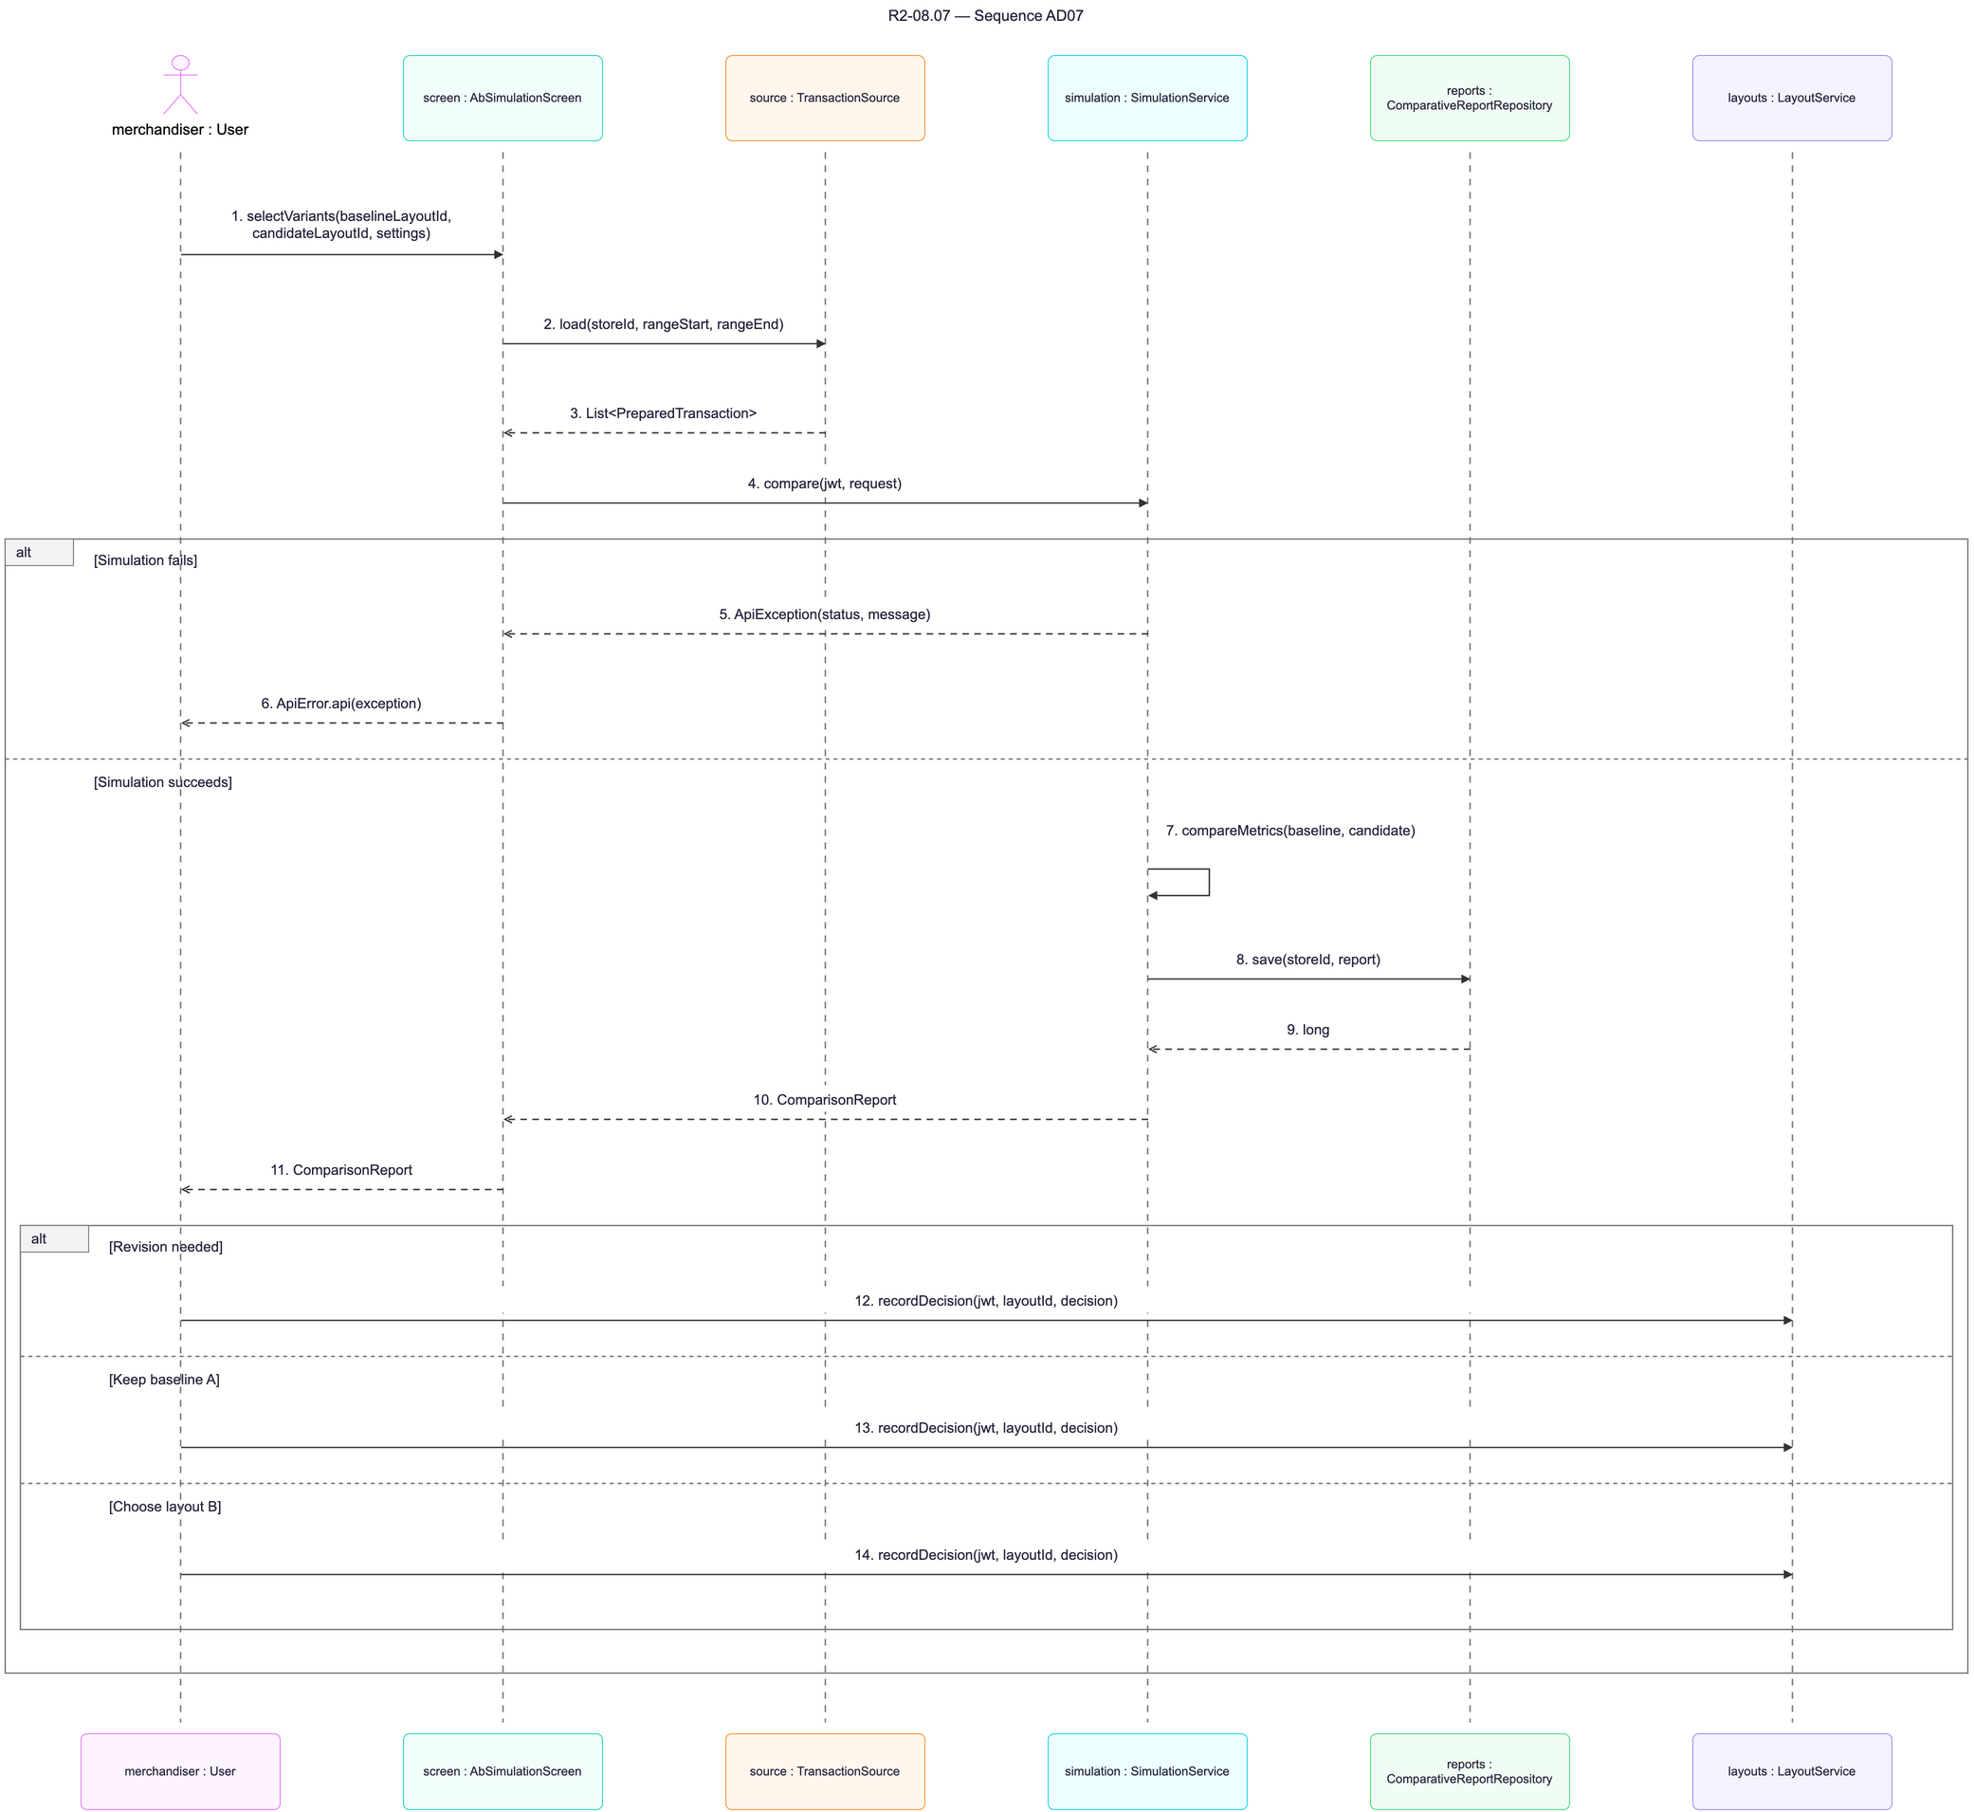
Figure 36: Sequence diagram – A/B Testing & Performance Evaluation

3.7.4 Activity Diagram
The activity diagram shows the actors and the business steps of the workflow.
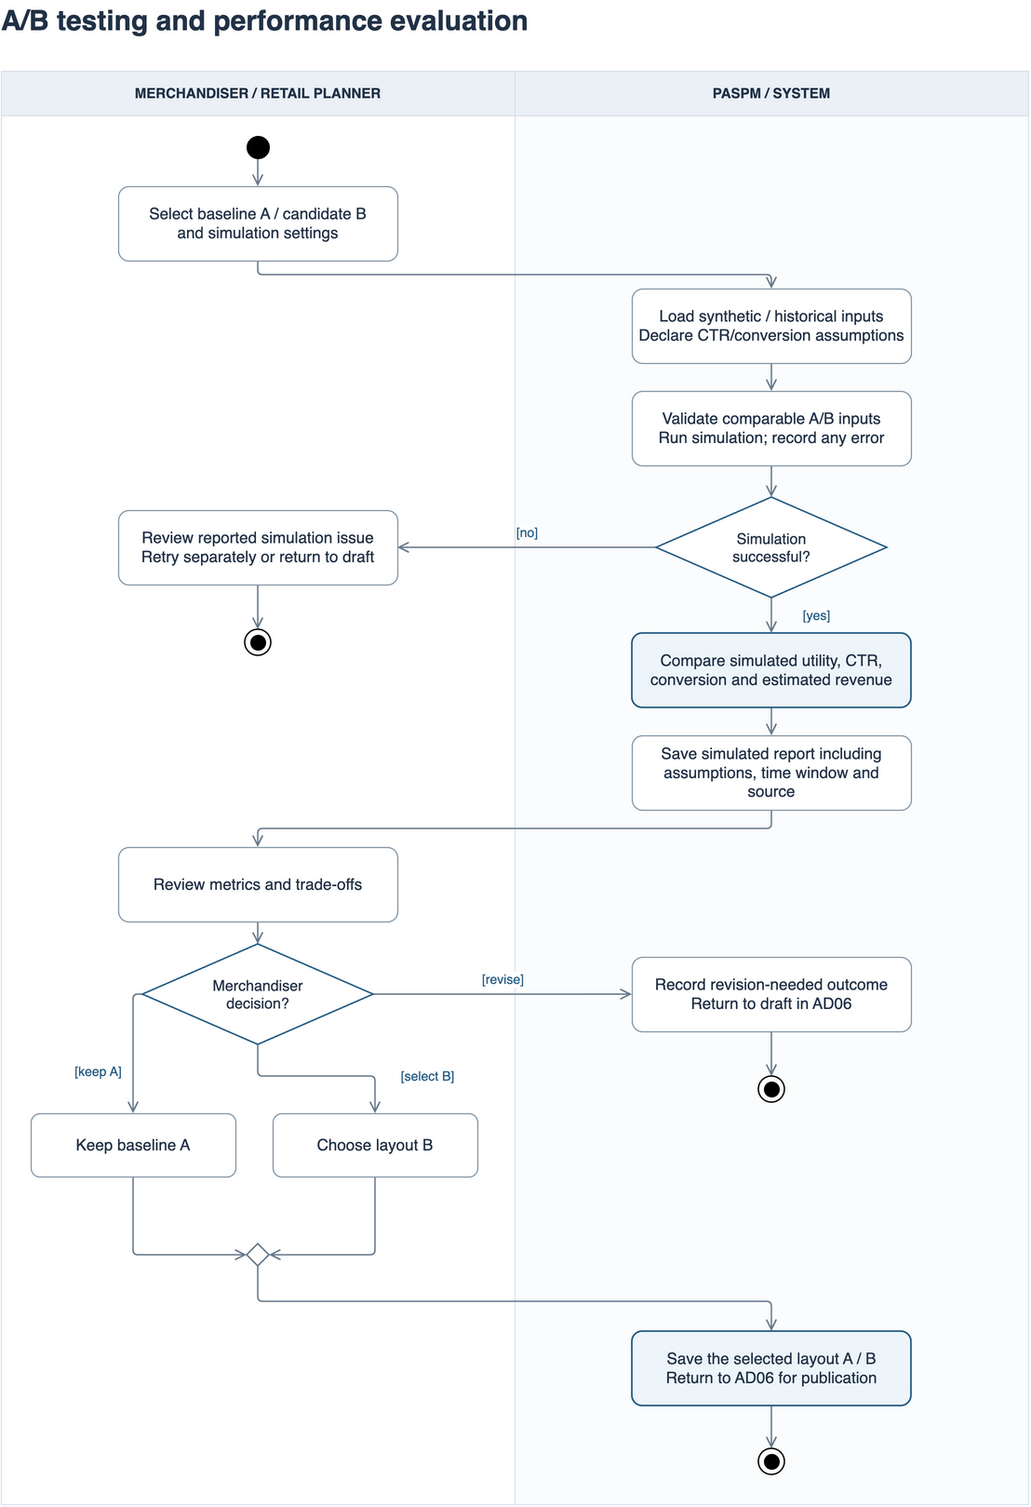
Figure 37: Activity diagram – A/B Testing & Performance Evaluation

3.8 Customer Shopping & Bundle
Storefront homepage, product details, offered bundles and whole-bundle add-to-cart. These classes are designed and not yet implemented.

3.8.1 Class Diagram
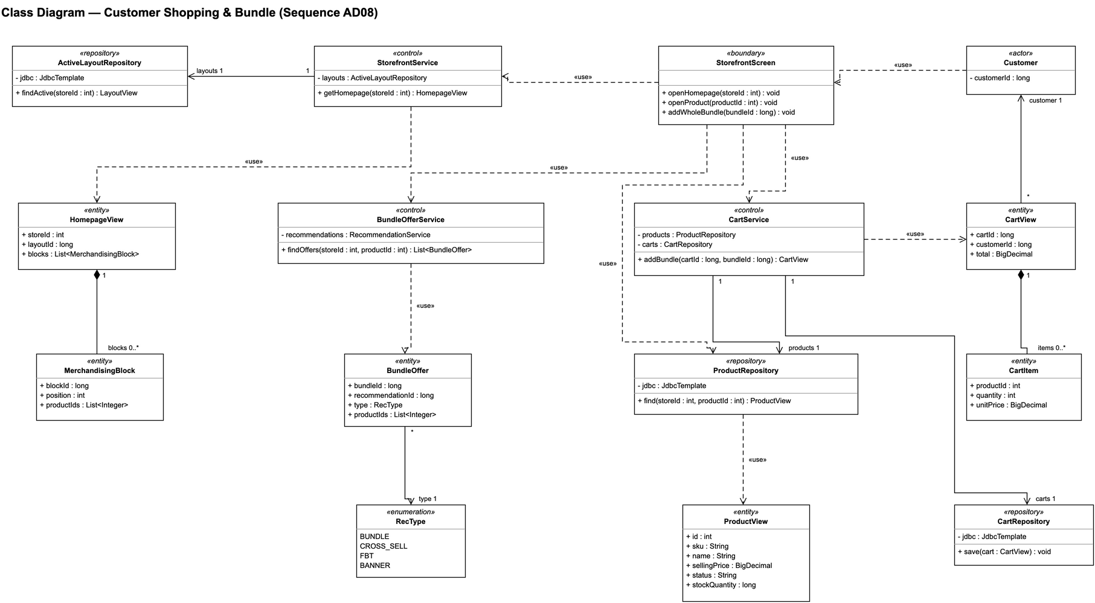
Figure 38: Class diagram – Customer Shopping & Bundle

3.8.2 Class Specifications
No | Class | Description
1 | Customer | Actor; attributes: customerId.
2 | StorefrontScreen | Boundary; operations: openHomepage, openProduct, addWholeBundle.
3 | StorefrontService | Control; operations: getHomepage.
4 | BundleOfferService | Control; operations: findOffers.
5 | CartService | Control; operations: addBundle.
6 | ActiveLayoutRepository | Repository; operations: findActive.
7 | ProductRepository | Repository; operations: find.
8 | CartRepository | Repository; operations: save.
9 | HomepageView | Entity; attributes: storeId, layoutId, blocks.
10 | MerchandisingBlock | Entity; attributes: blockId, position, productIds.
11 | ProductView | Entity; attributes: id, sku, name, sellingPrice, status, stockQuantity.
12 | BundleOffer | Entity; attributes: bundleId, recommendationId, type, productIds.
13 | CartView | Entity; attributes: cartId, customerId, total.
14 | CartItem | Entity; attributes: productId, quantity, unitPrice.
15 | RecType | Enumeration: BUNDLE, CROSS_SELL, FBT, BANNER

3.8.3 Sequence Diagram
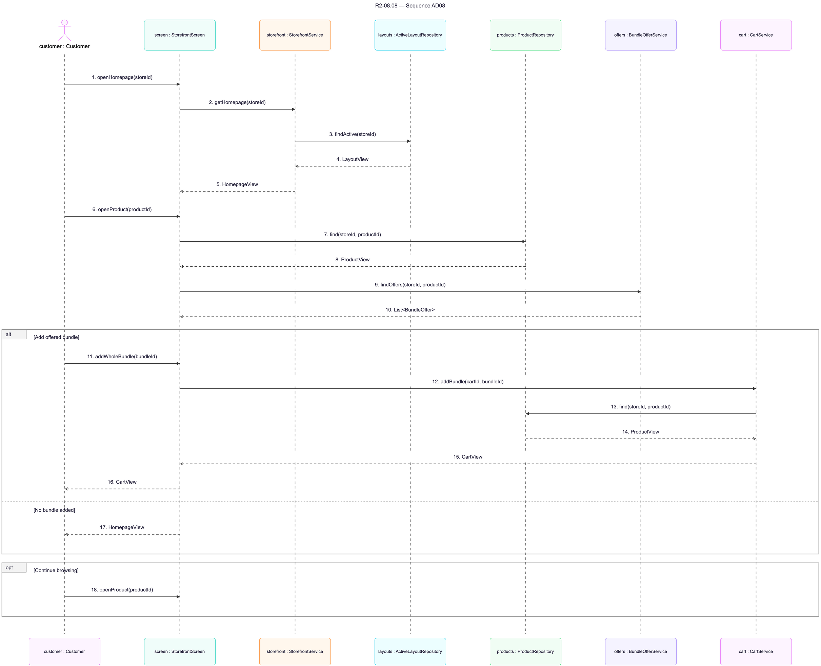
Figure 39: Sequence diagram – Customer Shopping & Bundle

3.8.4 Activity Diagram
The activity diagram shows the actors and the business steps of the workflow.
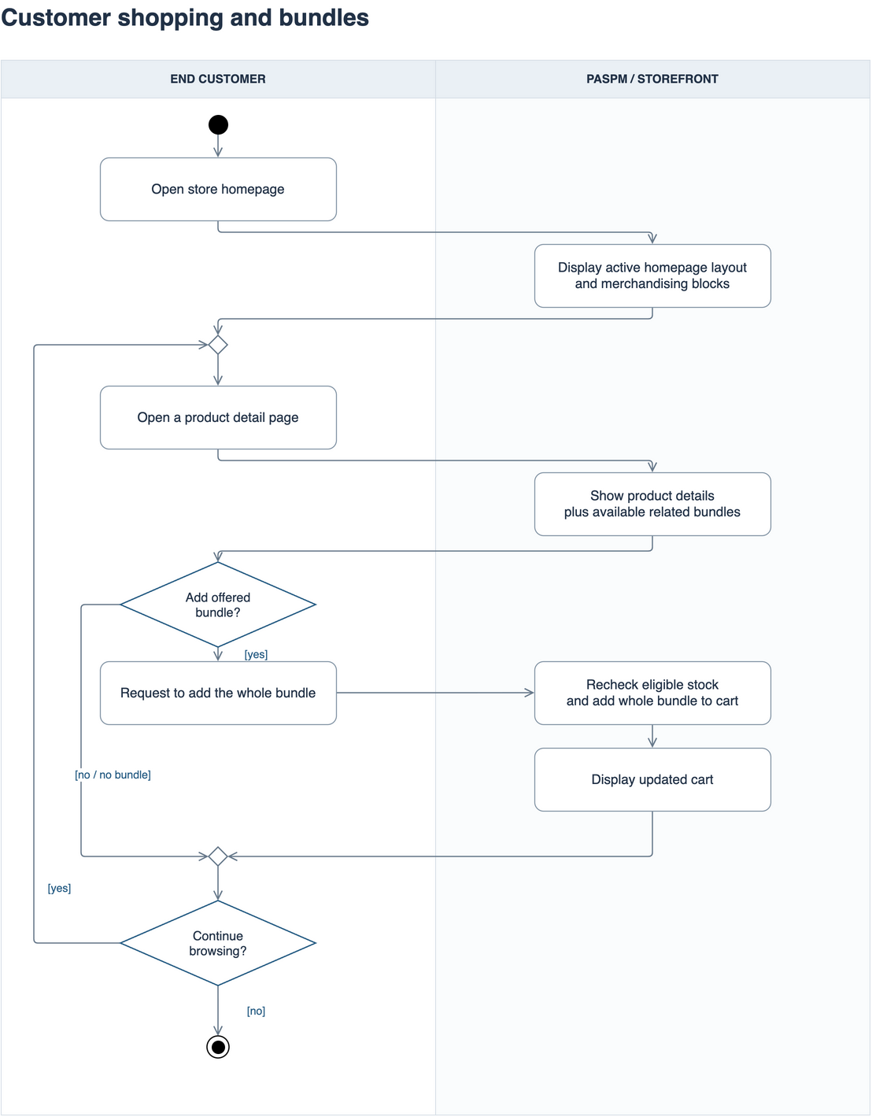
Figure 40: Activity diagram – Customer Shopping & Bundle

