

Capstone Project Report
Report 3 – Software Requirement Specification

– Ho Chi Minh City, November 2026 –
Table of Contents
I. Record of Changes 3
II. Software Requirement Specification 4
1. Product Overview 4
2. User Requirements 5
2.1 Actors 5
2.2 Use Cases 5
3. Functional Requirements 8
3.1 System Functional Overview 8
3.2 User and Authorization Management 13
3.3 Product and Inventory Margin Management 15
3.4 Dynamic Utility Profiling 16
3.5 Transaction File Import and Data Pipeline 17
3.6 Mining Configuration and Benchmark Hub 18
3.7 Recommendation Engine and Bundle Suggestions 20
3.8 Visual Layout Drag-and-Drop Simulator 22
3.9 A/B Testing Layout and Campaign Manager 23
3.10 Merchandising Storefront 23
3.11 Dynamic Bundle Add-to-Cart 24
3.12 Retail Performance Dashboard 24
4. Non-Functional Requirements 25
4.1 External Interfaces 25
4.2 Quality Attributes 25
5. Requirement Appendix 26
5.1 Business Rules 26
5.2 Common Requirements 26
5.3 Application Messages List 26
5.4 Other Requirements 27

I. Record of Changes
Date | A*  M, D | In charge | Change Description
03 Nov 2026 | A | Nguyễn Minh Khôi | Created the SRS from the official template: product overview, actors, use cases, screen flow, screen authorization, non-screen functions, ERD, functional requirements of the 11 features, non-functional requirements, business rules and messages.
04 Nov 2026 | M | Nguyễn Minh Khôi | Updated the ERD to the final schema (31 tables, 59 foreign keys) with the conceptual and logical diagrams, and added the two utility storage tables created by migration V11 to the entity descriptions.
*A - Added M - Modified D - Deleted

II. Software Requirement Specification

1. Product Overview
PASPM (Product Arrangement Support Platform) is a web application that helps a retail store decide which products to group, promote and place together. It imports the store's historical sales transactions, computes a weighted utility for every sold item from profit and the store's stock, expiry and seasonal priorities, mines high-utility itemsets with the HUI-Miner and EFIM algorithms, and turns the discovered itemsets into recommendation candidates (bundles, cross-sell pairs, frequently-bought-together groups and banner groups) that a merchandiser reviews. Approved groups are then used to build layouts and A/B campaigns, which a store administrator activates for the customer storefront.
The system serves four business roles: System Administrator, Store Administrator, Merchandiser and End Customer. Store data is isolated: every store-bound function works only on the store of the signed-in account. The context diagram below shows the external actors and the data they exchange with PASPM. The external systems used by PASPM are the Google identity service for Google sign-in, an SMTP email service for one-time passwords, a MySQL database and the SPMF data mining library, which runs in a separate Java 25 process.
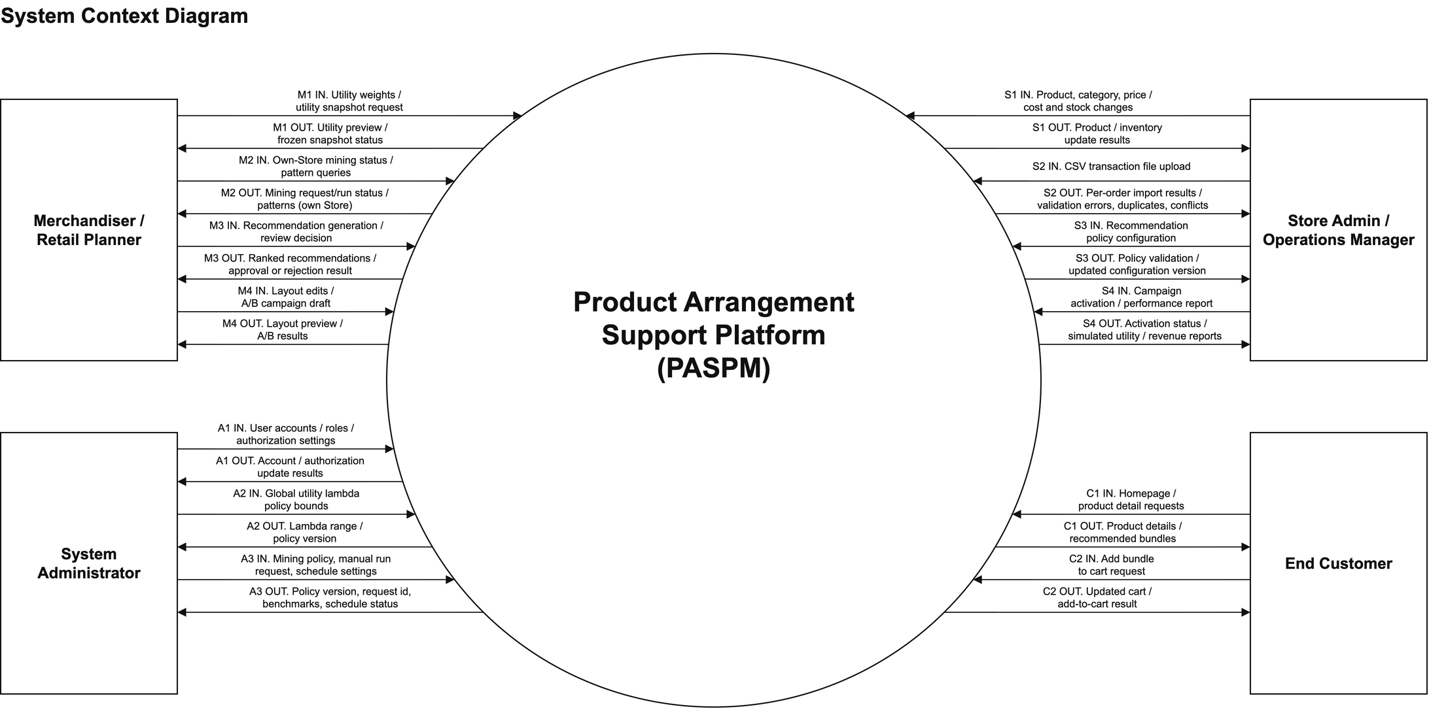
Figure 1: System context diagram

2. User Requirements

2.1 Actors
# | Actor | Description
1 | System Administrator | Manages user accounts, roles and store assignment; sets the global λ policy for utility weighting; owns the mining configuration (algorithm and minUtil), runs manual mining for a selected store, manages weekly or monthly mining schedules and views the HUI-Miner/EFIM benchmark. Reads store snapshots, mining requests and runs, but not raw mining patterns.
2 | Store Administrator | Operates one store: manages categories, products, prices, costs and inventory batches, imports transaction files, reads mining results and recommendations, sets the store recommendation policy, activates approved campaigns and views performance and A/B reports.
3 | Merchandiser | Plans merchandising for one store: configures utility weights and product priority scores, creates utility snapshots, reads mining results, generates and reviews recommendation candidates, arranges layouts and prepares A/B campaigns and simulations.
4 | End Customer | Registers an account, browses the storefront and product details, views offered bundles and adds a whole bundle to the cart.
5 | System Scheduler | Internal machine principal (not a person) under which scheduled mining runs are executed; it cannot sign in.

2.2 Use Cases

2.2.1 Diagram(s)
The use case diagram groups the use cases into four areas: system administration and mining configuration, merchandising and A/B campaigns, retail data and performance, and the customer storefront. UC21 includes UC30, and UC29 extends UC28 when the customer chooses to add an offered bundle. Use case IDs keep their original numbering.
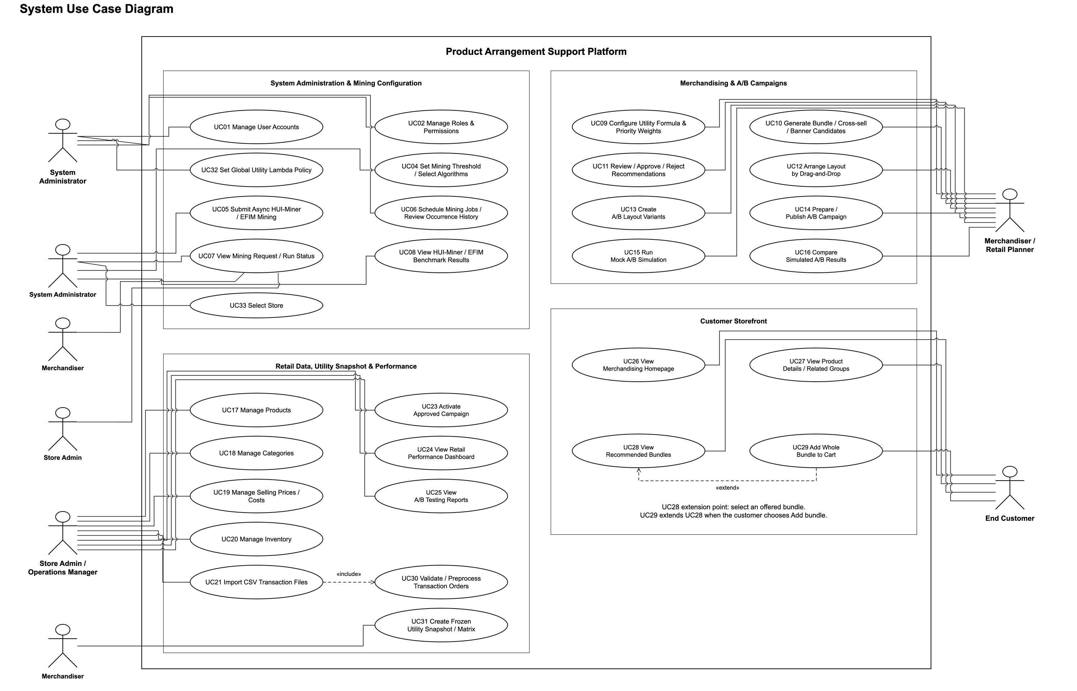
Figure 2: Use case diagram

2.2.2 Descriptions
ID | Use Case | Actors | Use Case Description
01 | Manage User Accounts | System Administrator | List, view, invite and rename accounts and activate or deactivate them; an invited account becomes active only after OTP verification.
02 | Manage Roles & Permissions | System Administrator | Assign one role to an account and, for Store Administrator and Merchandiser, the store it belongs to.
04 | Set Mining Threshold / Select Algorithms | System Administrator | Save a new version of the mining configuration: active algorithm (HUI-Miner or EFIM) and minUtil as a percentage or an absolute value.
05 | Submit Async HUI-Miner / EFIM Mining | System Administrator | Submit a mining request for a selected store and READY utility snapshot; the request is queued and executed asynchronously.
06 | Schedule Mining Jobs / Review Occurrence History | System Administrator | Create and edit a weekly or monthly schedule per store, enable it and review the history of scheduled occurrences.
07 | View Mining Request / Run Status | System Administrator, Merchandiser, Store Administrator | Follow the status of mining requests and runs; Store users also read the discovered itemsets of their store.
08 | View HUI-Miner / EFIM Benchmark Results | System Administrator | Compare runtime, sampled memory, itemset count and output equality of the two algorithms on the same input.
09 | Configure Utility Formula & Priority Weights | Merchandiser | Set the enabled criteria, their weights α, β, γ and λ for the store, and the stock and seasonal priority score of each product.
10 | Generate Bundle / Cross-sell / Banner Candidates | Merchandiser | Generate recommendation candidates of the selected types from a completed mining run of the store.
11 | Review / Approve / Reject Recommendations | Merchandiser | Approve or reject a pending candidate with a reason after the system rechecks current product eligibility.
12 | Arrange Layout by Drag-and-Drop | Merchandiser | Place approved product groups into a layout by drag-and-drop and see the utility score of each placement.
13 | Create A/B Layout Variants | Merchandiser | Keep the current layout as baseline A and build a candidate layout B from approved groups.
14 | Prepare / Publish A/B Campaign | Merchandiser | Save a campaign draft and publish it for activation by the Store Administrator.
15 | Run Mock A/B Simulation | Merchandiser | Simulate layouts A and B on historical or synthetic data with declared assumptions.
16 | Compare Simulated A/B Results | Merchandiser | Compare simulated utility, click-through rate, conversion and estimated revenue, then keep A, choose B or revise.
17 | Manage Products | Store Administrator | Create, update, activate and deactivate products of the store.
18 | Manage Categories | Store Administrator | Create, update, activate and deactivate product categories.
19 | Manage Selling Prices / Costs | Store Administrator | Maintain the selling price and cost price of each product.
20 | Manage Inventory | Store Administrator | Receive inventory batches with quantity and expiry date, adjust remaining quantity or block a batch, and read the inventory summary.
21 | Import CSV Transaction Files | Store Administrator | Upload a CSV file of historical sales; valid orders are stored, invalid orders are reported. Includes UC30.
23 | Activate Approved Campaign | Store Administrator | Activate a published campaign after a live eligibility check, so that its layout is applied to the storefront.
24 | View Retail Performance Dashboard | Store Administrator | View simulated utility impact of layouts, simulated bundle revenue and algorithm benchmark charts.
25 | View A/B Testing Reports | Store Administrator | Read saved A/B simulation reports with their assumptions and time window.
26 | View Merchandising Homepage | End Customer | Open the storefront homepage that shows the active layout and merchandising blocks.
27 | View Product Details / Related Groups | End Customer | Open a product page with its details and the related product groups.
28 | View Recommended Bundles | End Customer | View the bundles offered by the active campaign.
29 | Add Whole Bundle to Cart | End Customer | Add all products of an offered bundle to the cart in one action after a stock recheck; extends UC28.
30 | Validate / Preprocess Transaction Orders | Store Administrator (through UC21) | Validate rows, group them by order and accept, reject or mark each order as duplicate or conflict.
31 | Create Frozen Utility Snapshot / Matrix | Merchandiser | Freeze the weighted utility matrix of a date range, with its configuration and evidence, for mining.
32 | Set Global Utility Lambda Policy | System Administrator | Set the allowed range [λmin, λmax] for the store λ value; the policy is versioned.
33 | Select Store | System Administrator | Choose the store whose snapshot is mined or whose schedule is managed.

3. Functional Requirements

3.1 System Functional Overview
This section gives an overview of the system functions: the screen flow, the screen descriptions, the authorization of each screen, the functions that run without a screen and the data entities.

3.1.1 Screens Flow
After login, each user is taken to the landing screens of their role. The screen flow below shows the screens and the navigation between them.
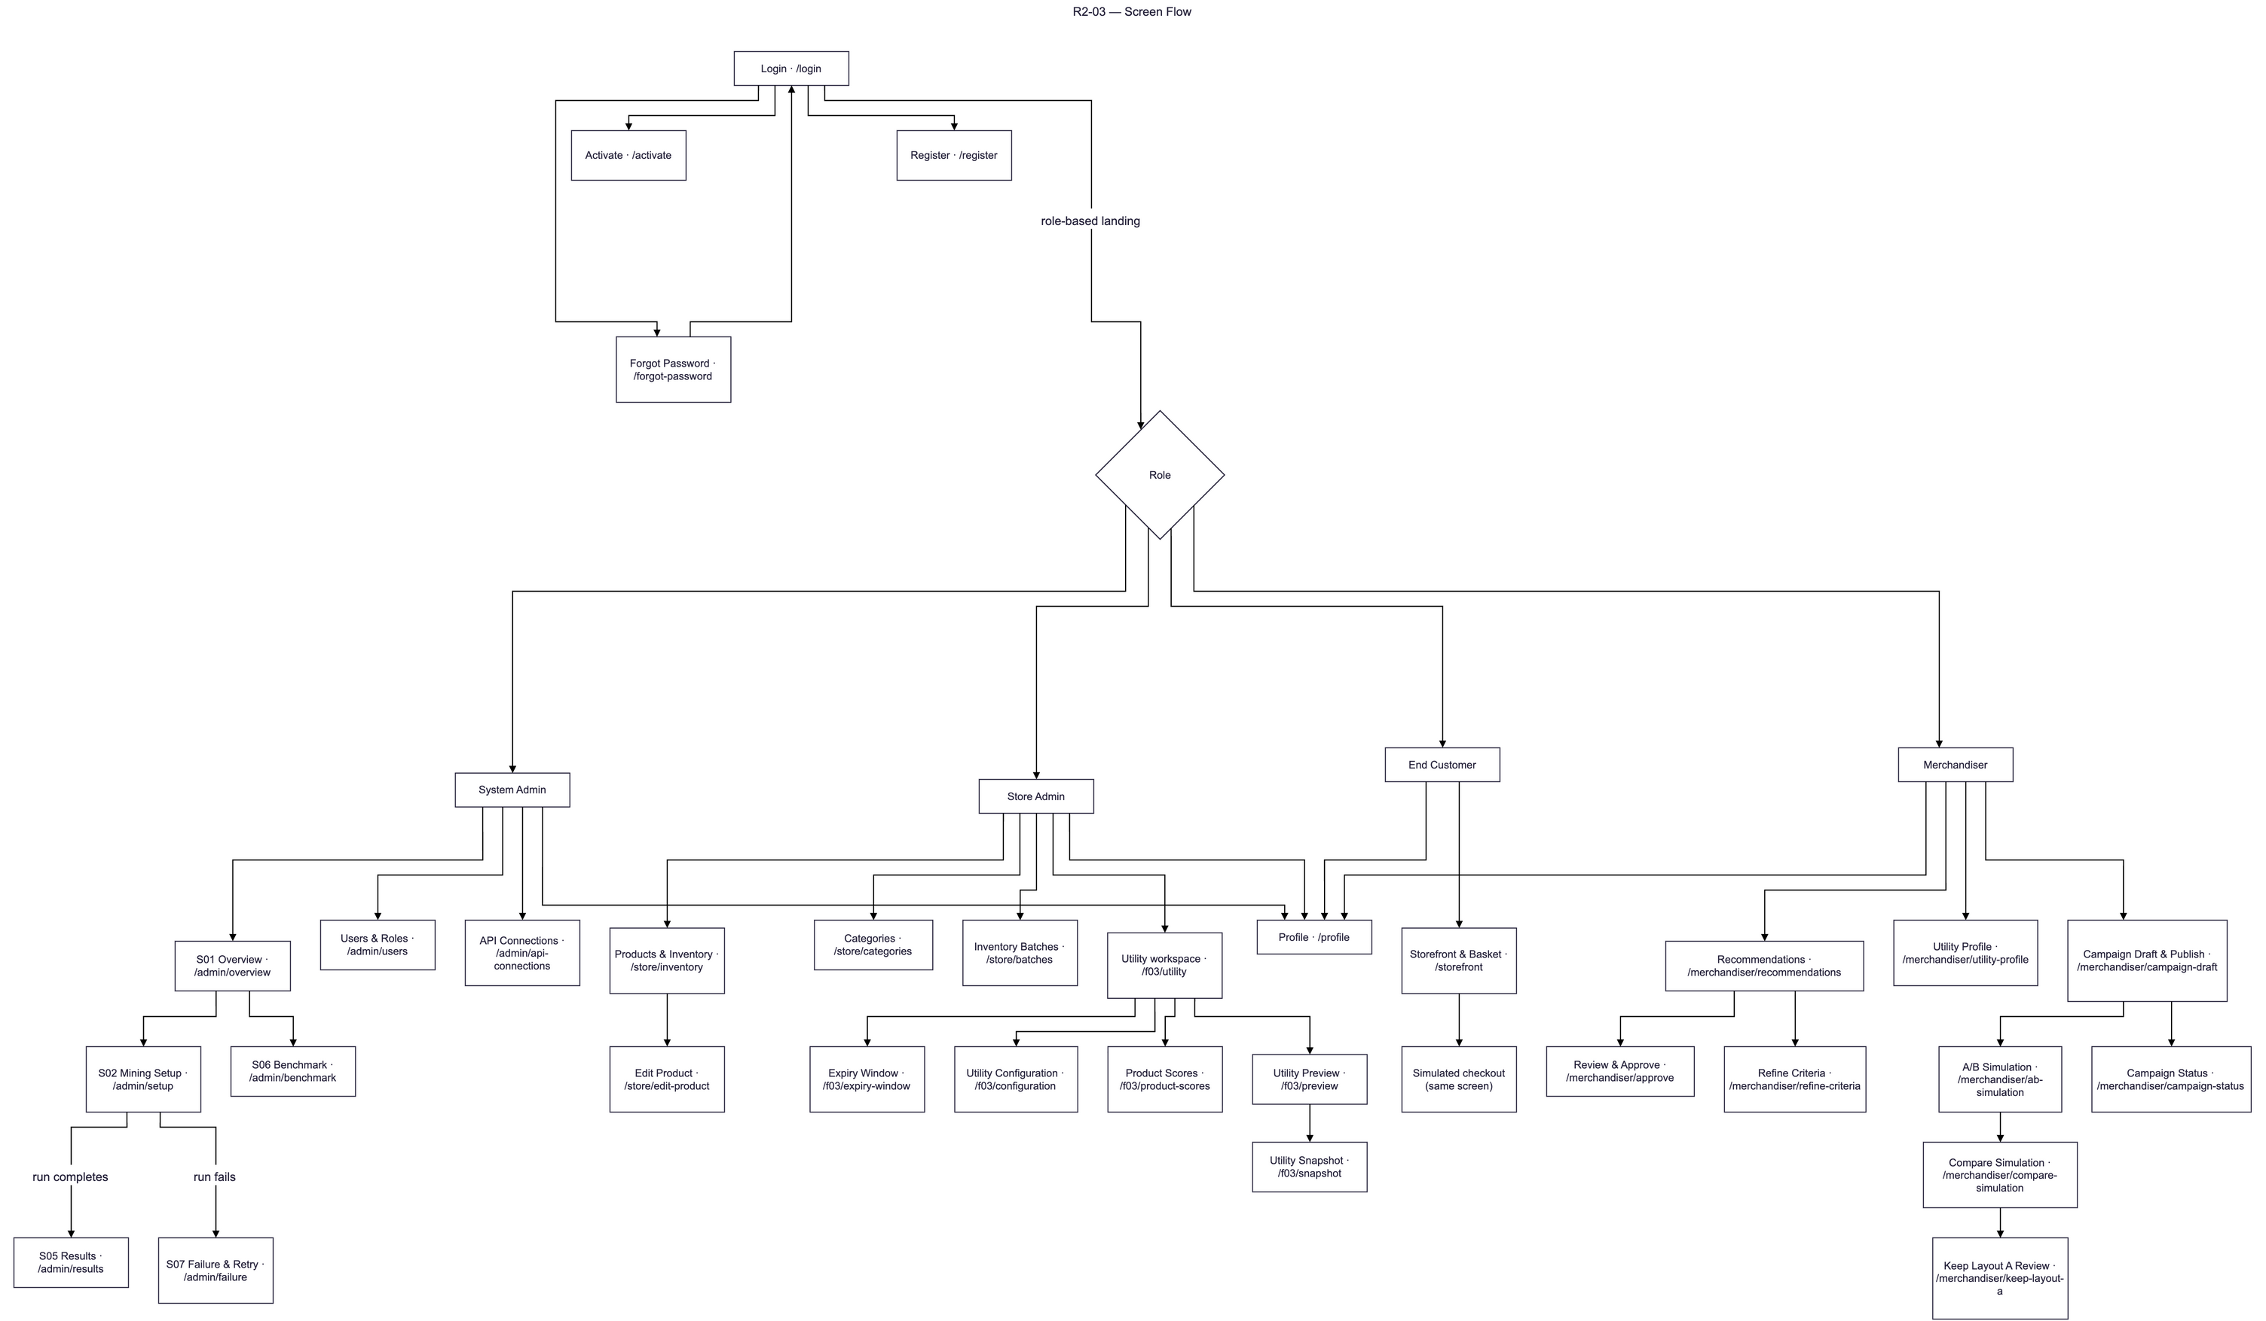
Figure 3: Screen flow

3.1.2 Screen Descriptions
# | Feature | Screen | Description
1 | Authentication | Login | Sign in with email and password or with Google; routes the user to the landing screen of their role.
2 | Authentication | Register | Self-registration of an End Customer account with OTP verification sent by email.
3 | Authentication | Activate | Activate an invited account by entering the OTP received by email.
4 | Authentication | Forgot Password | Request a password reset code and set a new password.
5 | Authentication | Profile | View own account, change password, link a Google identity and manage the profile avatar.
6 | Mining | S01 Overview | Landing screen of the System Administrator, leading to Mining Setup and Benchmark.
7 | Mining | S02 Mining Setup | Mining configuration (algorithm, minUtil) and submission of a request for a selected store and snapshot.
8 | Mining | S05 Results | Status of the request and its runs, itemset counts and comparison status.
9 | Mining | S07 Failure & Retry | Failed or timed-out runs with their failure code and message.
10 | Mining | S06 Benchmark | Runtime, sampled memory and itemset count of HUI-Miner and EFIM with the comparison result.
11 | User Management | Users & Roles | Account list and detail, invitation, role and store assignment, activation status.
12 | Data Import | API Connections | List of the store API connection records kept in the database; external API ingestion is outside the project scope.
13 | Catalog | Products & Inventory | Searchable, paged product list of the store with category, prices, status and sellable stock.
14 | Catalog | Edit Product | Create or update a product: SKU, name, unit, category, selling and cost price, expiry requirement and expiry-push days.
15 | Catalog | Categories | Create, rename, activate and deactivate categories.
16 | Catalog | Inventory Batches | Receive batches and adjust remaining quantity or status of a batch.
17 | Utility Profiling | Utility workspace | Entry screen of utility profiling with links to configuration, scores, preview and snapshot.
18 | Utility Profiling | Expiry Window | Store expiry window kept for compatibility; scoring uses the product expiry-push days instead.
19 | Utility Profiling | Utility Configuration | Enabled criteria, weights α, β, γ and λ of the store.
20 | Utility Profiling | Product Scores | Stock and seasonal priority scores of each product.
21 | Utility Profiling | Utility Preview | Weighted utility computed for a date range before it is frozen.
22 | Utility Profiling | Utility Snapshot | Create and read an immutable utility snapshot and its matrix.
23 | Recommendation | Recommendations | Ranked candidate list with filters by run, snapshot, type and review status.
24 | Recommendation | Review & Approve | Candidate detail with utility evidence and current eligibility; approve or reject with a reason.
25 | Recommendation | Refine Criteria | Regenerate candidates from the same completed run with selected types.
26 | Recommendation | Utility Profile | Utility profile of the store for the Merchandiser.
27 | Layout & Campaign | Campaign Draft & Publish | Arrange approved groups in layout B against baseline A, save a draft and publish the campaign.
28 | Layout & Campaign | A/B Simulation | Select layouts A and B, simulation settings and data source, and run the simulation.
29 | Layout & Campaign | Compare Simulation | Compare the simulated metrics of A and B.
30 | Layout & Campaign | Keep Layout A Review | Record the decision to keep the baseline layout.
31 | Layout & Campaign | Campaign Status | Status of published and activated campaigns.
32 | Storefront | Storefront & Basket | Homepage blocks, product details, offered bundles and the basket with a simulated checkout.

3.1.3 Screen Authorization
Screen | System Admin | Store Admin | Merchandiser | End Customer
Login / Register / Activate / Forgot Password | X | X | X | X
Profile | X | X | X | X
S01 Overview, S02 Mining Setup, S06 Benchmark | X
S05 Results, S07 Failure & Retry (requests and runs) | X | X | X
Read discovered itemsets |  | X | X
Users & Roles, API Connections | X
Products & Inventory, Categories (read) |  | X | X
Create / update / change status |  | X
Edit Product, Inventory Batches |  | X
Utility Configuration, Product Scores (edit), Utility Preview, Utility Snapshot |  |  | X
Utility workspace, Product Scores (read) |  | X | X
Expiry Window |  | X
Recommendations, Review & Approve (read) |  | X | X
Generate, approve, reject; Refine Criteria |  |  | X
Recommendation policy update |  | X
Utility Profile, Campaign Draft & Publish, A/B Simulation, Compare Simulation, Keep Layout A Review |  |  | X
Campaign Status |  | X | X
Activate campaign |  | X
Storefront & Basket |  |  |  | X

3.1.4 Non-Screen Functions
# | Feature | System Function | Description
1 | Mining | Mining worker | Polls the database for queued mining requests, claims one with a lease and fencing token, runs SPMF in an isolated Java 25 child process, validates the output and stores runs and itemsets; an expired lease lets another instance take over.
2 | Mining | Scheduled mining dispatcher | At each due time of an enabled schedule, reserves the latest due occurrence (older missed ones are recorded as SKIPPED), creates a fresh utility snapshot and a mining request under the System Scheduler principal, and retries a failed preparation up to 3 attempts (15 s, 30 s). It runs only on an instance where dispatch is enabled.
3 | Mining | SPMF runtime check | Verifies the pinned SPMF archive (checksum and version) and the Java 25 runtime before a request is admitted.
4 | Authentication | OTP email | Sends one-time passwords for registration, invitation and password reset through the configured SMTP service.
5 | Platform | Database migration | Applies the Flyway schema migrations V1–V19 at start-up and validates the schema.

3.1.5 Entity Relationship Diagram
The database has 31 tables and 59 foreign keys, created by the Flyway migrations V1–V19. Figure 4 shows the conceptual model with the main entities and their relationships. Figure 5 shows the complete logical model, in which each table lists its columns with the primary key (PK) and foreign keys (FK). Planned layout, campaign and cart data are not yet part of the schema.
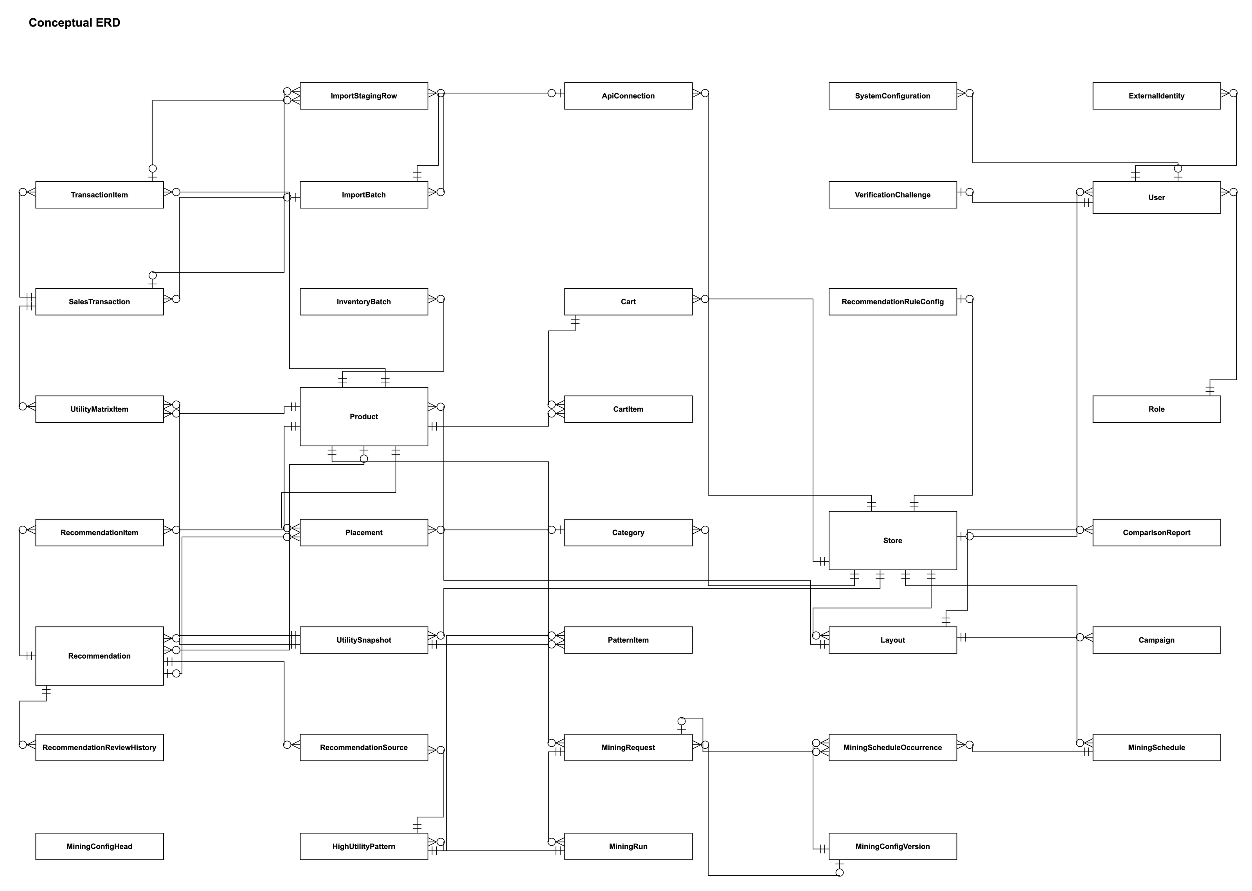
Figure 4: Conceptual entity relationship diagram
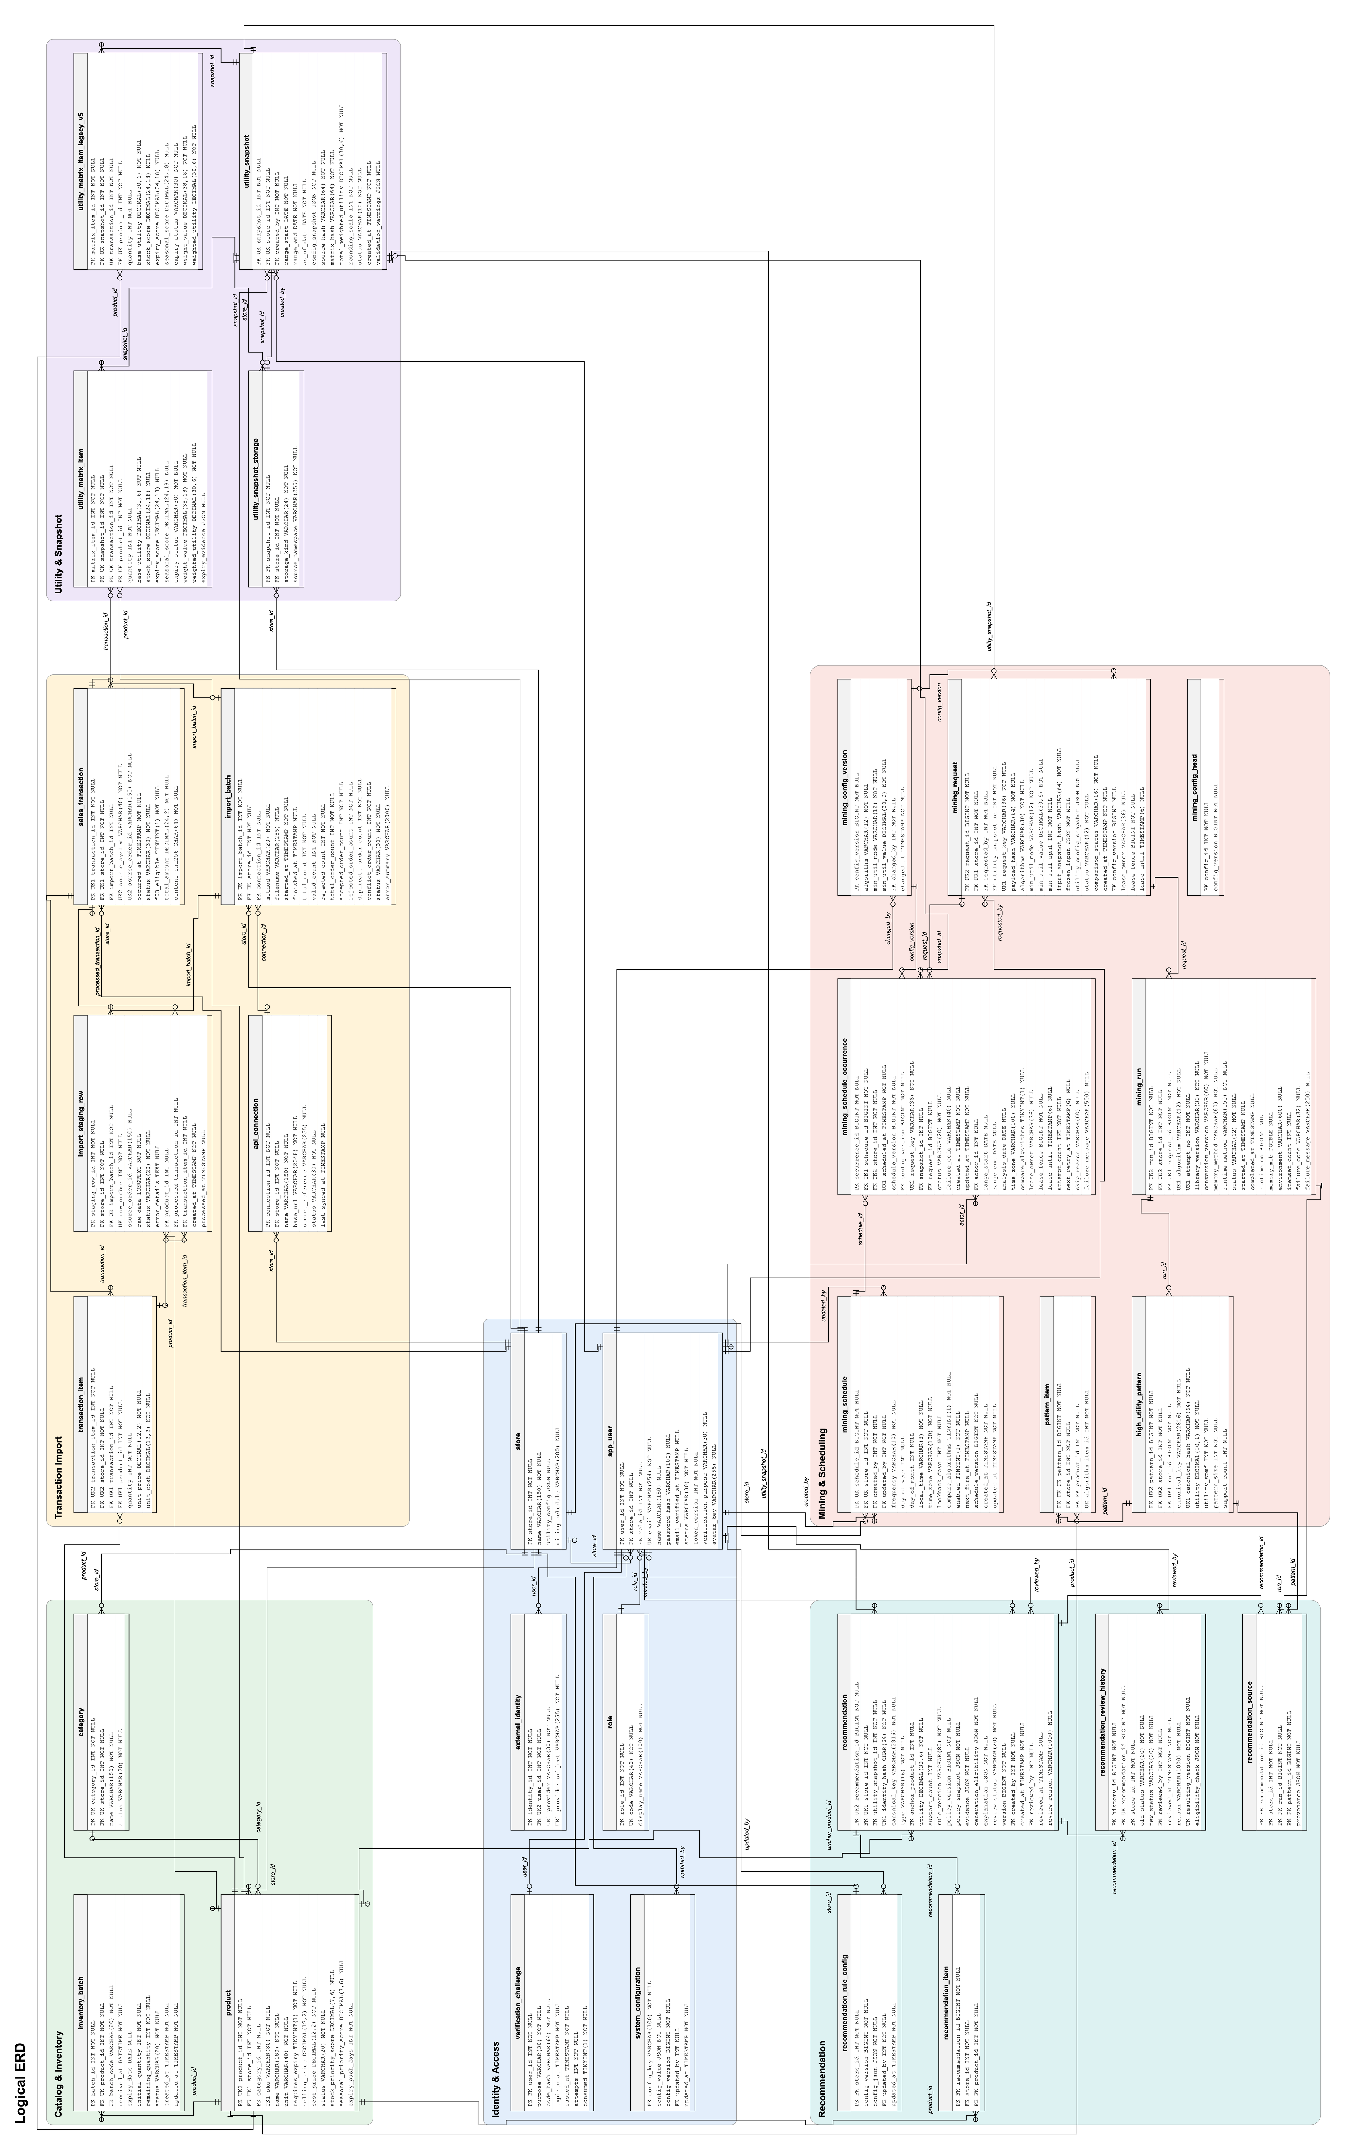
Figure 5: Logical entity relationship diagram (31 tables)
Entities Description
# | Entity | Description
1 | store | A retail store; the unit of data isolation.
2 | role | Role codes: SYSTEM_ADMIN, STORE_ADMIN, MERCHANDISER, END_CUSTOMER and the internal SYSTEM_SCHEDULER.
3 | app_user | Account with email, password hash, role, optional store, status (PENDING_VERIFICATION, ACTIVE, INACTIVE) and token version.
4 | verification_challenge | Current OTP challenge of an account: purpose, code hash, expiry and attempt count.
5 | external_identity | Google identity linked to an account.
6 | system_configuration | Versioned global settings, e.g. the utility λ policy.
7 | category | Product category of a store (ACTIVE or INACTIVE).
8 | product | Product of a store: SKU, name, unit, prices, expiry requirement, stock and seasonal priority scores and expiry-push days.
9 | inventory_batch | Received batch of a product with quantities, expiry date and status (ACTIVE or BLOCKED).
10 | api_connection | Store API connection record; not used by any function.
11 | import_batch | One file import with its counts and status (PROCESSING, COMPLETED, COMPLETED_WITH_ERRORS, FAILED).
12 | import_staging_row | Raw row of an import with its validation status and errors.
13 | sales_transaction | Imported order: source order id, time, status, eligibility for utility profiling and content hash.
14 | transaction_item | Order line: product, quantity, unit price and unit cost.
15 | utility_snapshot | Immutable snapshot of the weighted utility for a date range with its configuration, hashes and status (READY or FAILED).
16 | utility_matrix_item | One product of one transaction in a snapshot: base utility, scores, weight and weighted utility.
17 | utility_matrix_item_legacy_v5 | Read-only archive of the utility matrix rows of snapshots created in the earlier v5 matrix format; created by migration V11 and protected against changes.
18 | utility_snapshot_storage | Storage registry of each utility snapshot: where its matrix is kept (LEGACY_V5_ARCHIVE or F04_LIVE) and its source namespace; created by migration V11.
19 | mining_config_head / mining_config_version | Current version and history of the mining configuration (algorithm, minUtil mode and value).
20 | mining_request | Mining request for a store snapshot: algorithms, minUtil, frozen input, status, comparison status and lease fields.
21 | mining_run | Execution of one algorithm for a request: status, runtime, memory, itemset count and failure details.
22 | high_utility_pattern / pattern_item | Discovered itemset of a run with its utility and the products it contains.
23 | mining_schedule | Weekly or monthly schedule of a store: day, local time, time zone, lookback days and enabled flag.
24 | mining_schedule_occurrence | One due time of a schedule with its frozen context, request, status (including SKIPPED) and retry fields.
25 | recommendation_rule_config | Versioned recommendation policy of a store.
26 | recommendation | Candidate of type BUNDLE, CROSS_SELL, FBT or BANNER with utility, evidence, explanation and review status.
27 | recommendation_item / recommendation_source | Products of a candidate and the runs and itemsets it was derived from.
28 | recommendation_review_history | Audit record of each approval or rejection.

3.2 User and Authorization Management

3.2.1 Login and Registration
Function trigger: Opening the application or choosing Register, Activate or Forgot Password on the Login screen.
Function description: Anonymous users sign in, register as End Customer, activate an invited account or reset a password. After login the system issues a JSON Web Token and routes the user to the landing screen of the role.
Screen layout: prototype screen below (interface demonstration; data rules are those in the function details).
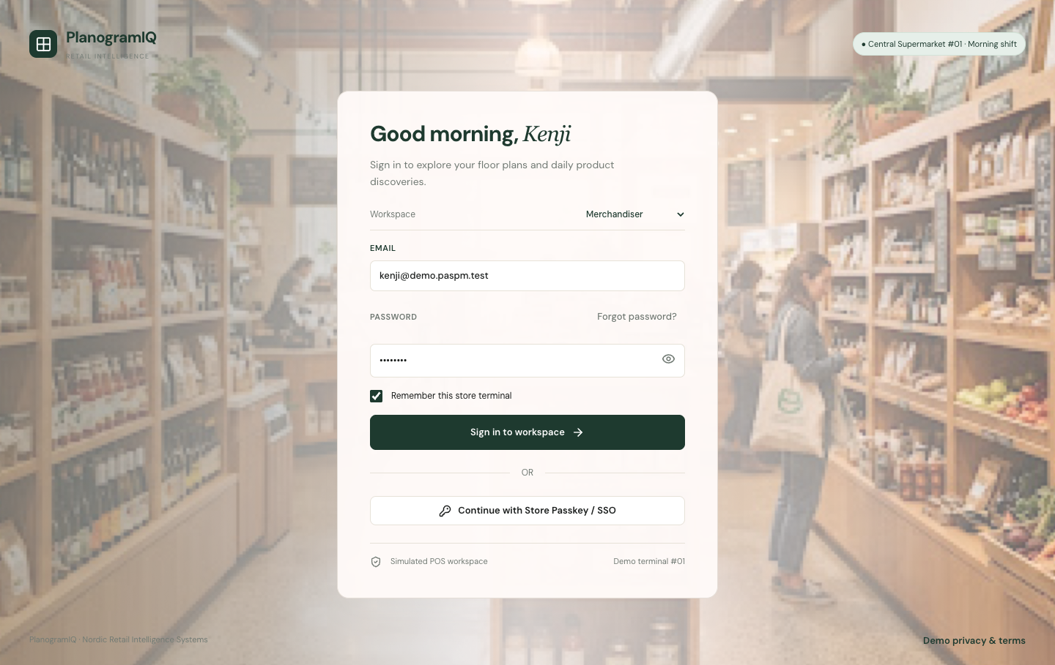
Figure 6: Login screen
Function details:
- Passwords have 12–72 characters with at least one lower-case letter, one upper-case letter and one digit.
- Wrong credentials always return the same message; login attempts are limited to 30 per IP address and 10 per email in 15 minutes.
- An OTP is valid for 10 minutes, can be resent after 60 seconds and is invalidated after five wrong attempts.
- Registration with an email that already exists is refused with "Email already exists".
- Google sign-in requires a verified Google email; Google registration creates a pending End Customer account that still needs OTP verification.
- The token is valid for 900 seconds by default; there is no refresh token. Changing a password, the role or the status invalidates older tokens.

3.2.2 Users & Roles
Function trigger: System Administrator opens Users & Roles.
Function description: The System Administrator lists, views, invites and renames accounts, assigns a role and a store, and activates or deactivates accounts.
Function details:
- System Administrator and End Customer accounts have no store; Store Administrator and Merchandiser accounts must belong to an existing store.
- An invited account becomes active only after the invitee verifies the OTP; setting the status to ACTIVE cannot bypass it.
- The System Scheduler account is hidden from user and role lists and cannot be modified.

3.2.3 Profile
Function trigger: Any signed-in user opens Profile.
Function description: Users read their account, change their own password (current password required), link a Google identity and upload a JPEG or PNG avatar.
Function details:
- Only the owner can read or change the avatar.

3.3 Product and Inventory Margin Management

3.3.1 Products & Inventory and Edit Product
Function trigger: Store Administrator opens Products & Inventory; Merchandiser has read-only access.
Function description: The product list supports search, filter, sort and paging. The Store Administrator creates and updates products, including selling price, cost price and expiry-push days, and activates or deactivates them.
Screen layout: prototype screen below (interface demonstration; data rules are those in the function details).
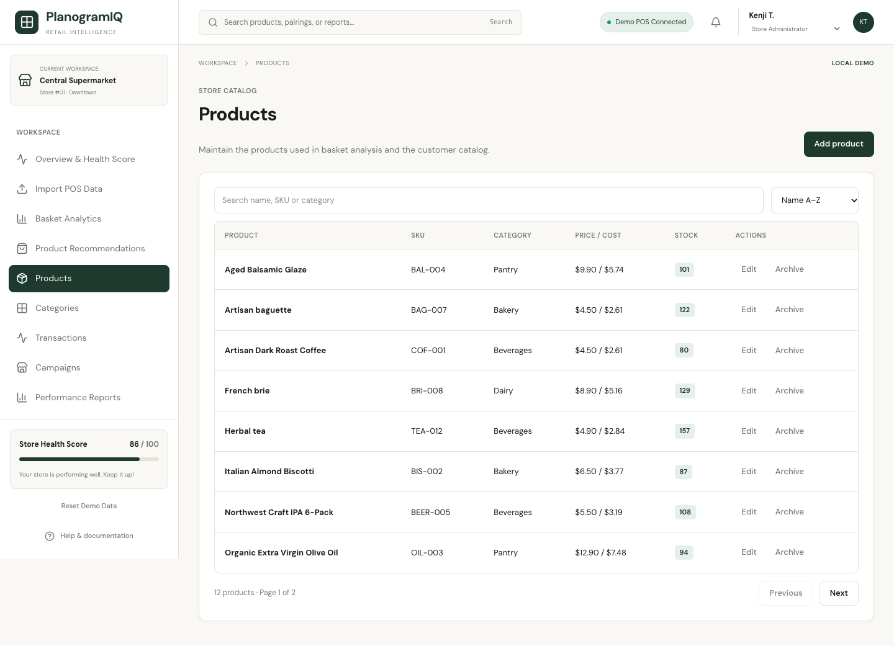
Figure 7: Products & Inventory screen
Function details:
- The SKU is unique within the store; a duplicate SKU is refused.
- Prices are non-negative amounts with two decimals.
- Expiry-push days is an integer ≥ 0; an omitted value is stored as 0.
- Products and categories are deactivated, never deleted.

3.3.2 Categories
Function trigger: Store Administrator opens Categories.
Function description: Create, rename, activate and deactivate the categories of the store.
Function details:
- A product can reference only an active or inactive category of the same store.

3.3.3 Inventory Batches
Function trigger: Store Administrator opens Inventory Batches from a product.
Function description: Receive a batch with batch code, received time, expiry date and quantity; adjust the remaining quantity or block the batch; read the inventory summary.
Function details:
- The batch code is unique per product.
- A product that requires expiry needs an expiry date on every batch.
- Remaining quantity is between 0 and the initial quantity.
- Sellable stock counts ACTIVE batches with remaining quantity > 0 whose expiry date is after today in the store time zone.

3.4 Dynamic Utility Profiling

3.4.1 Utility Configuration and Product Scores
Function trigger: Merchandiser opens Utility Configuration or Product Scores from the Utility workspace.
Function description: The Merchandiser enables the criteria and sets α (stock), β (expiry), γ (seasonal) and λ, and enters the stock and seasonal priority score of each product.
Function details:
- W(i) = 1 + λ × [α × S(i) + β × E(i) + γ × M(i)].
- Enabled weights are in [0, 1] and sum to exactly 1; with all criteria disabled W(i) = 1.
- λ must lie inside the global policy set by the System Administrator (0 to 0.5 by default).
- S(i) and M(i) are scores in [0, 1] with at most six decimals.
- E(i) = 1 when the earliest sellable batch expires within the product expiry-push days, otherwise 0; non-expiring products have E(i) = 0.

3.4.2 Utility Preview and Utility Snapshot
Function trigger: Merchandiser opens Utility Preview, then creates a snapshot.
Function description: The system computes base and weighted utility for the eligible transactions of the selected date range. Creating a snapshot freezes the matrix, the configuration, the scores and the expiry evidence.
Function details:
- Base utility = quantity × (unit price − unit cost) at the time of sale.
- Only COMPLETED transactions whose prices are not below cost are eligible.
- Utilities use six decimals (half-up rounding).
- A snapshot is immutable; a change of configuration or range requires a new snapshot.
- A range with no eligible items is refused with "No eligible transaction items in the selected range".

3.4.3 Global λ Policy
Function trigger: System Administrator updates the utility λ policy (no dedicated screen in the screen flow).
Function description: The System Administrator sets the allowed range [λmin, λmax].
Function details:
- The policy is versioned; a change never rewrites store values or existing snapshots.

3.5 Transaction File Import and Data Pipeline

3.5.1 Import CSV Transaction File
Function trigger: Store Administrator uploads a CSV file (no dedicated screen in the screen flow).
Function description: The system stages the raw rows, validates them, groups them by order and stores every valid order; the import summary lists accepted, rejected, duplicate and conflicting orders with row errors.
Screen layout: prototype screen below (interface demonstration; data rules are those in the function details).
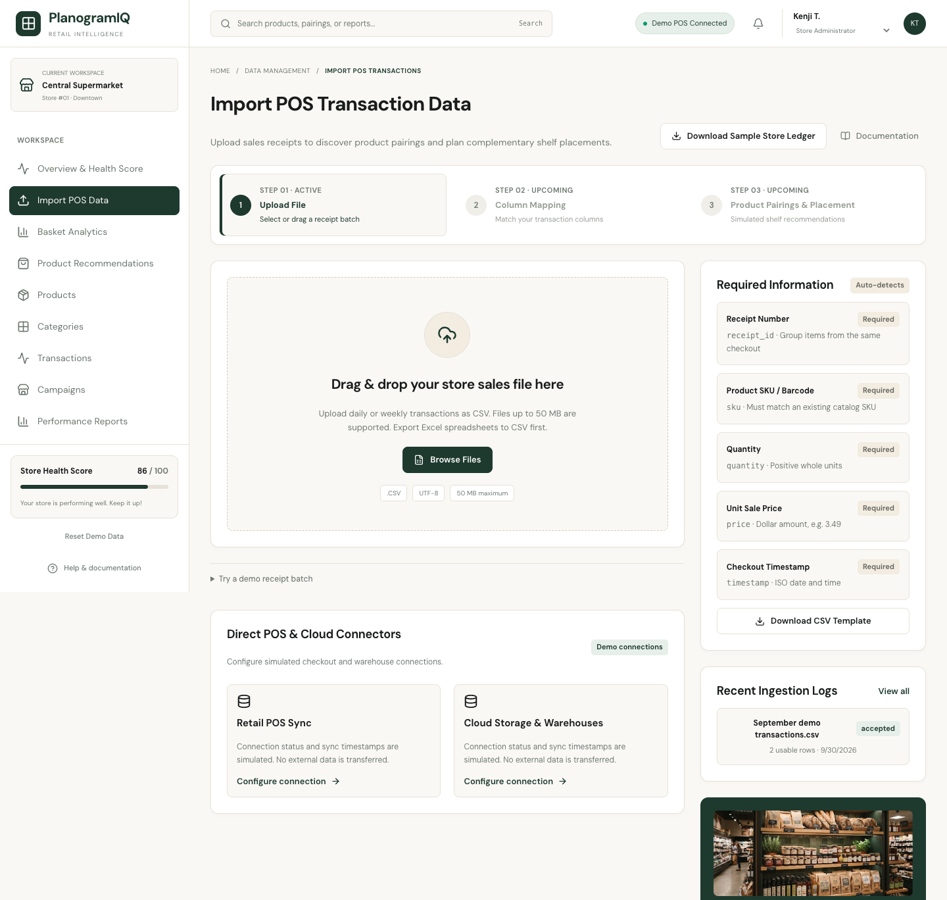
Figure 8: Import (prototype) screen
Function details:
- Header: source_order_id, occurred_at, sku, quantity, unit_price, unit_cost, status; UTF-8; occurred_at in ISO-8601 with a UTC offset.
- Order status is COMPLETED, CANCELLED, REFUNDED or PARTIAL_REFUND, and all lines of an order must agree.
- At most 5 MiB and 10,000 data rows per file.
- Each valid order is saved atomically; invalid orders do not remove valid ones (COMPLETED_WITH_ERRORS).
- The same order with the same content is a duplicate; with different content it is a conflict. History is kept.
- SKUs must exist in the importing store. Imports never change inventory batches.
- Cancelled and refunded orders are kept as history but are not used for utility profiling.

3.6 Mining Configuration and Benchmark Hub

3.6.1 S02 Mining Setup
Function trigger: System Administrator opens S01 Overview, then S02 Mining Setup.
Function description: The System Administrator saves the mining configuration and submits a request for a selected store and READY snapshot; the request is accepted (HTTP 202) and executed asynchronously.
Screen layout: prototype screen below (interface demonstration; data rules are those in the function details).
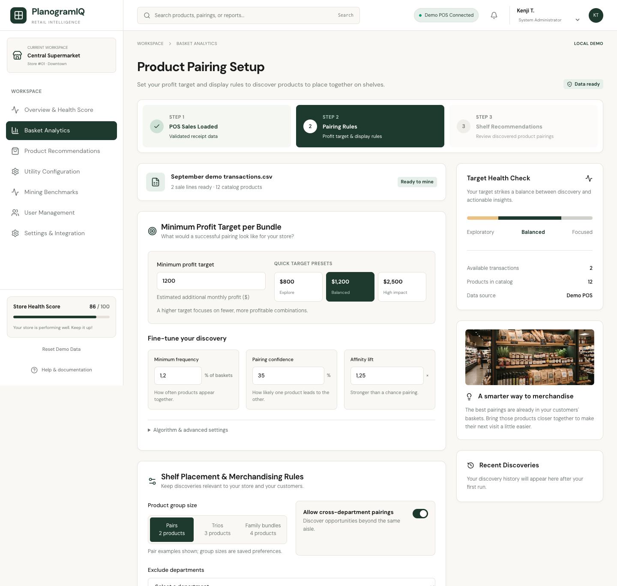
Figure 9: Mining Setup (prototype) screen
Function details:
- The algorithm and minUtil (PERCENTAGE ≤ 100 or ABSOLUTE) come from the active configuration version and are pinned into the request.
- A percentage threshold is converted to minUtil = δ/100 × total weighted utility and rounded up on the SPMF integer scale.
- The request key makes submission idempotent; reusing a key for a different request is refused.
- One request accepts at most 256 products and 20,000 matrix rows.
- Each run has a 256 MiB heap, a 60-second time limit and a cap of 2,000 stored patterns by default.

3.6.2 S05 Results and S07 Failure & Retry
Function trigger: Opened from S02 when a run completes or fails.
Function description: Shows the request and run status, itemset counts and the comparison status; Store users of the store also read the itemsets.
Screen layout: prototype screen below (interface demonstration; data rules are those in the function details).
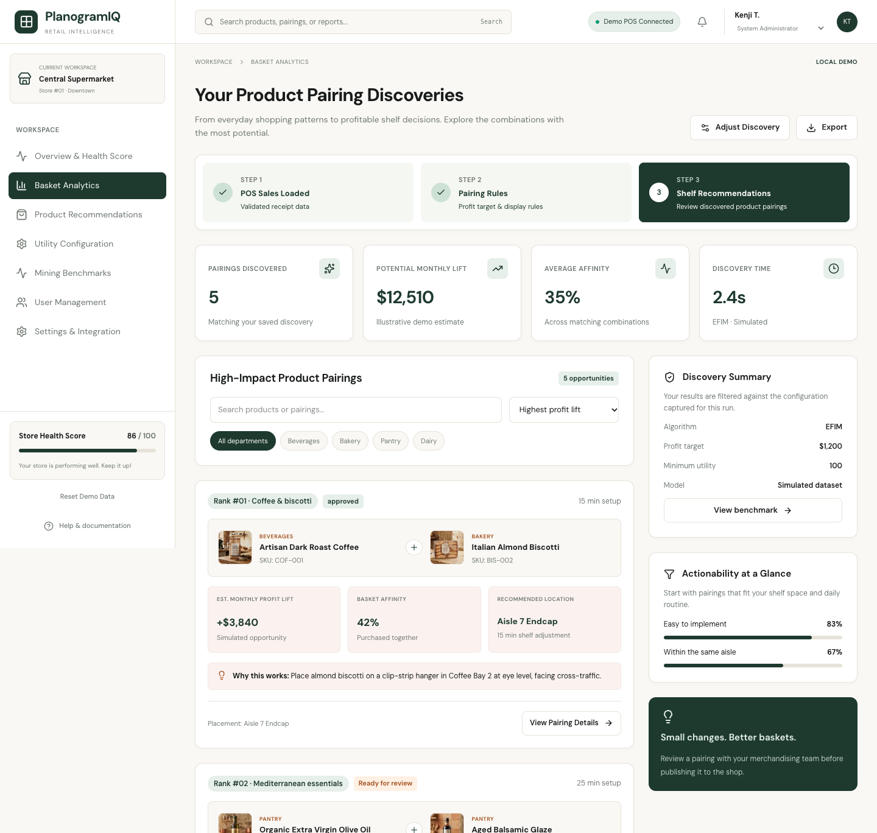
Figure 10: Results (prototype) screen
Function details:
- Request states: PENDING, RUNNING, COMPLETED, FAILED; run states add TIMED_OUT.
- When both algorithms run, the comparison is MATCH only if their itemsets and utilities are identical.
- The System Administrator cannot read raw itemsets.

3.6.3 S06 Benchmark
Function trigger: System Administrator opens S06 Benchmark from S01 Overview.
Function description: Compares runtime, sampled Java heap and itemset count of HUI-Miner and EFIM on the same request.
Function details:
- Metrics of the two runs are shown separately with the comparison status.

3.6.4 Mining Schedules
Function trigger: System Administrator manages schedules for a selected store (no dedicated screen in the screen flow).
Function description: Create a weekly or monthly schedule, enable it and review the occurrence history.
Function details:
- Lookback is 7–365 days; times use the store calendar zone Asia/Ho_Chi_Minh; a monthly day beyond the month end runs on the last day.
- After downtime only the latest missed occurrence runs; older ones are recorded as SKIPPED.
- A failed preparation is retried up to three attempts and the final error is stored.
- Enabling is accepted only where scheduled dispatch is enabled; otherwise the system answers 503.

3.7 Recommendation Engine and Bundle Suggestions

3.7.1 Recommendations and Refine Criteria
Function trigger: Merchandiser opens Recommendations.
Function description: The Merchandiser generates candidates from a completed run of the store and filters the ranked list by run, snapshot, type and review status.
Screen layout: prototype screen below (interface demonstration; data rules are those in the function details).
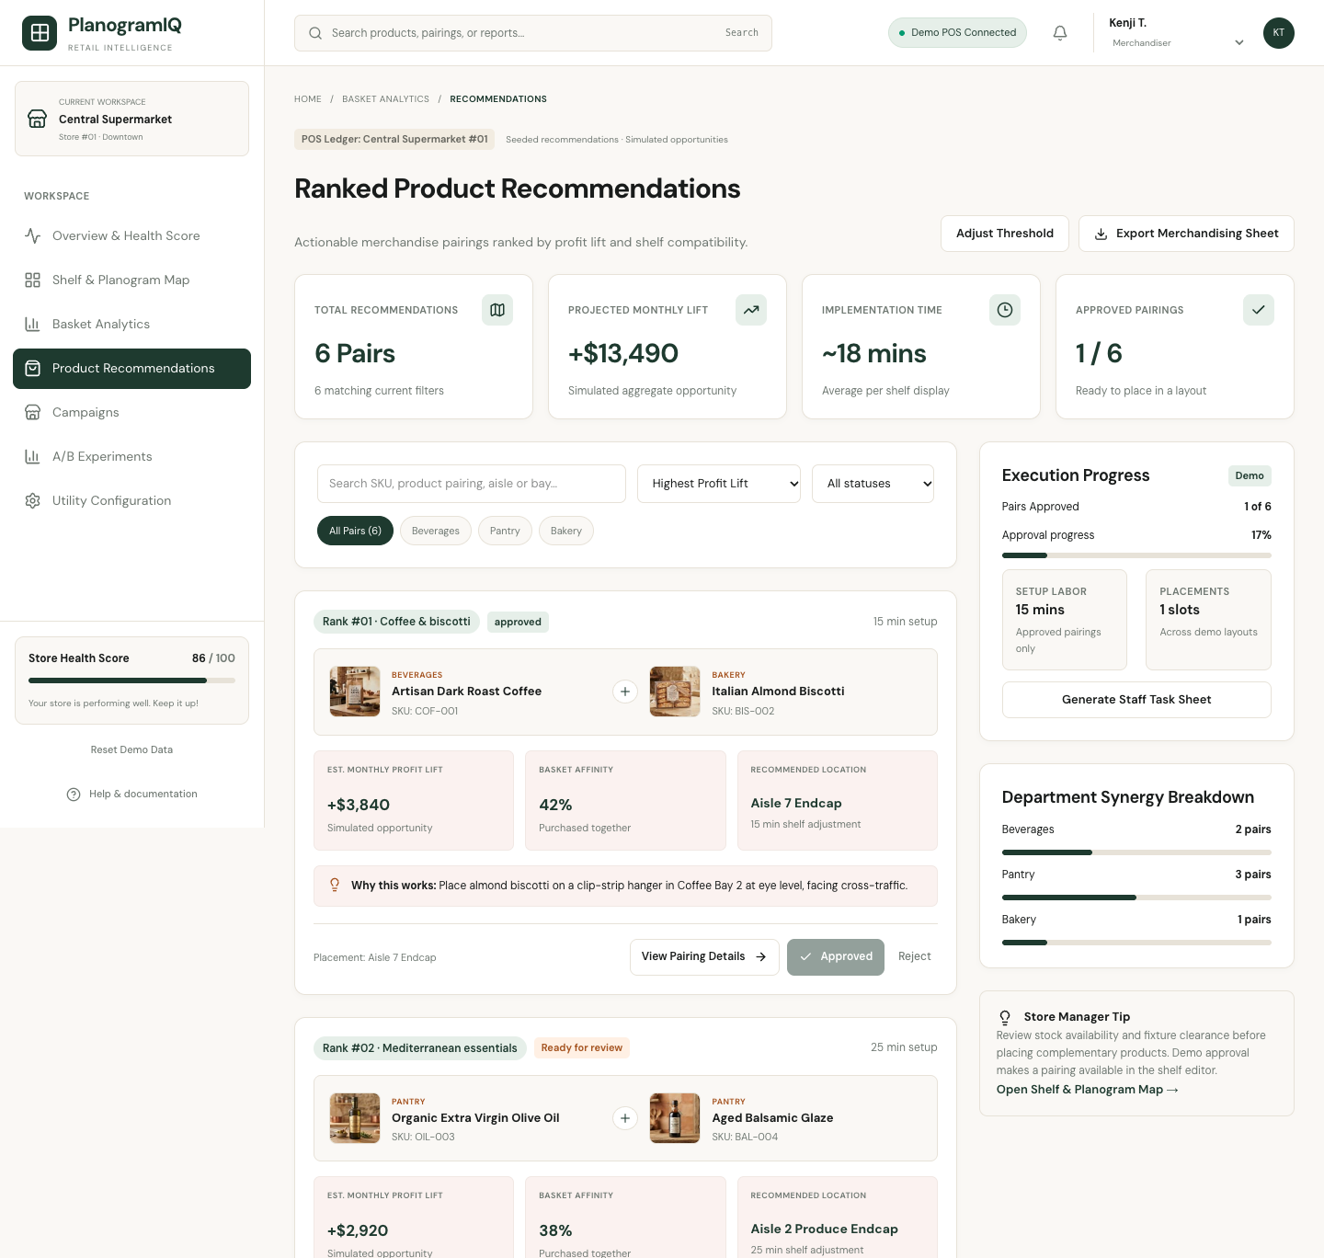
Figure 11: Recommendations (prototype) screen
Function details:
- Types: BUNDLE (whole itemset, 2–4 products by default), CROSS_SELL (anchor and targets, confidence ≥ 0.50), FBT (support count ≥ 2 and support ratio ≥ 0.05) and BANNER.
- Generation is deterministic and idempotent; invalid evidence or more than 10,000 candidates is refused without partial results.
- Page size is 1–100.

3.7.2 Review & Approve
Function trigger: Merchandiser opens a candidate from Recommendations.
Function description: Shows utility evidence and current eligibility; the Merchandiser approves or rejects the candidate with a reason.
Screen layout: prototype screen below (interface demonstration; data rules are those in the function details).
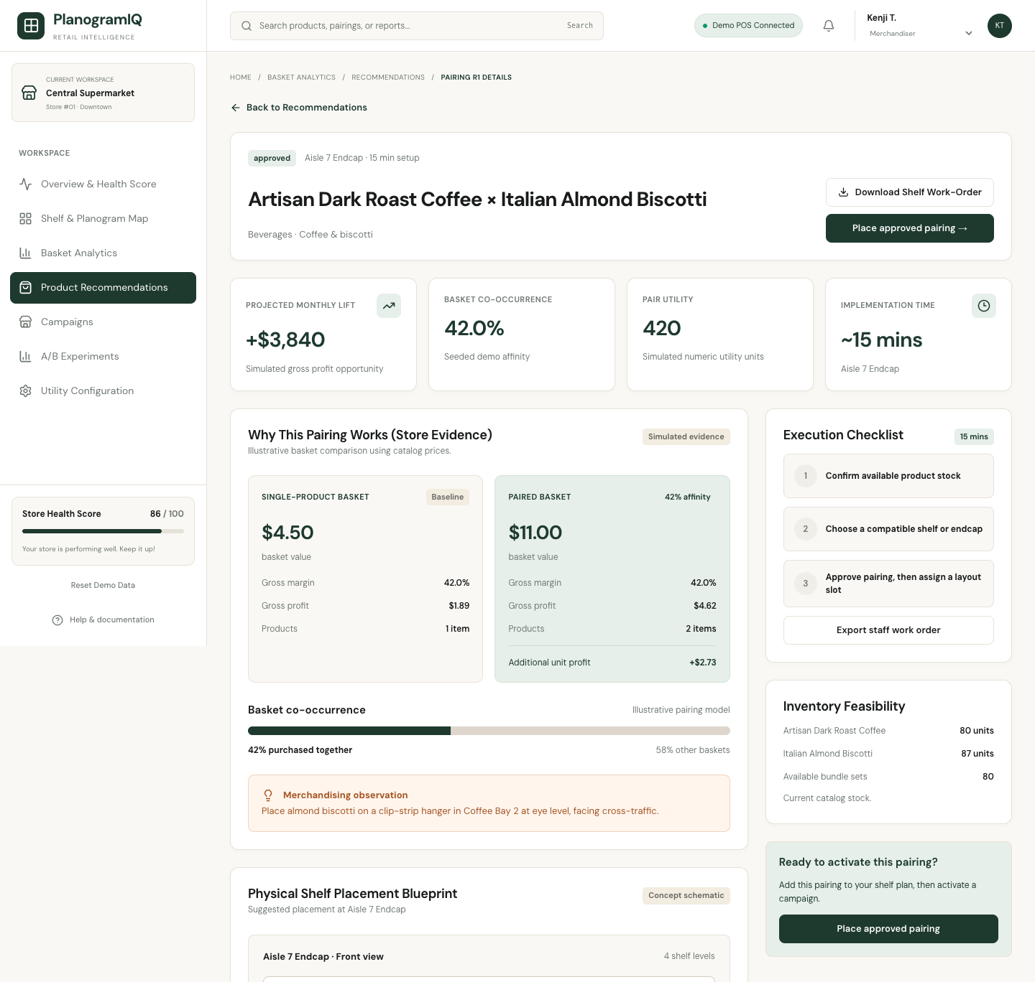
Figure 12: Review & Approve (prototype) screen
Function details:
- Only PENDING_REVIEW → APPROVED or REJECTED is allowed; a reason of at most 1,000 characters is required.
- The expected version is checked; a stale review is refused.
- Approval rechecks live eligibility (active product, enough sellable stock, valid expiry); rejection is allowed even when ineligible.
- Approval does not publish a layout, activate a campaign or reserve stock.

3.7.3 Recommendation Policy
Function trigger: Store Administrator updates the store recommendation policy (no dedicated screen in the screen flow).
Function description: Sets the rule thresholds of the store.
Function details:
- The policy is versioned; existing candidates keep the policy captured at generation.

3.8 Visual Layout Drag-and-Drop Simulator

3.8.1 Arrange Layout
Function trigger: Merchandiser opens Campaign Draft & Publish.
Function description: The Merchandiser places approved groups into layout B by drag-and-drop, keeps the current layout as baseline A and sees the utility score of each placement compared with the baseline.
Function details:
- Approved groups are rechecked for eligibility before they are used.

3.9 A/B Testing Layout and Campaign Manager

3.9.1 Campaign Draft & Publish
Function trigger: Merchandiser saves or publishes the layout from Campaign Draft & Publish.
Function description: A campaign is saved as draft or published; a published campaign waits for activation by the Store Administrator.
Function details:
- Publishing does not change the storefront until the campaign is activated.

3.9.2 A/B Simulation and Compare Simulation
Function trigger: Merchandiser opens A/B Simulation from Campaign Draft & Publish.
Function description: Simulates layouts A and B on historical or synthetic data with declared click-through and conversion assumptions, then compares simulated utility, click-through rate, conversion and estimated revenue.
Function details:
- A/B results are simulated and labelled as such; they do not show real customer behaviour.
- The Merchandiser keeps A, chooses B or returns the layout to draft; the report keeps its assumptions, time window and data source.

3.9.3 Activate Campaign and Campaign Status
Function trigger: Store Administrator activates a published campaign from Campaign Status.
Function description: After a live eligibility check, the activated layout is applied to the storefront blocks.

3.10 Merchandising Storefront

3.10.1 Storefront & Basket
Function trigger: End Customer opens the storefront.
Function description: Shows the homepage blocks of the active layout, product details with related groups and the bundles offered by the active campaign.
Screen layout: prototype screen below (interface demonstration; data rules are those in the function details).

Figure 13: Storefront (prototype) screen

3.11 Dynamic Bundle Add-to-Cart

3.11.1 Add Whole Bundle to Cart
Function trigger: End Customer chooses to add an offered bundle.
Function description: The system rechecks sellable stock and adds all products of the bundle to the basket in one action; checkout is simulated.

3.12 Retail Performance Dashboard

3.12.1 Performance Dashboard and A/B Reports
Function trigger: Store Administrator opens the performance reports (no dedicated screen in the screen flow).
Function description: Shows the simulated utility impact of layouts, simulated bundle revenue, saved A/B reports and the algorithm benchmark charts.
Function details:
- Simulated values are labelled as simulated.

4. Non-Functional Requirements

4.1 External Interfaces
- User interface: a web single-page application built with React and TypeScript; screens and navigation follow the screen flow in Section 3.1.1.
- Backend interface: REST API over HTTPS with JSON bodies and bearer JWT authentication (89 operations in the OpenAPI description); errors are returned as {"error": "<message>"} with the HTTP status.
- Google Identity: optional Google sign-in and registration; the email must be verified by Google.
- SMTP email service: delivery of one-time passwords for registration, invitation and password reset.
- SPMF 2.67a: HUI-Miner and EFIM run in a separate Java 25 process with the SPMF input format; the archive is pinned by SHA-256.
- MySQL 8.4: persistent storage, schema managed by Flyway migrations V1–V19.

4.2 Quality Attributes

4.2.1 Usability
- Each role sees only the screens of its own workspace and lands on its main screen after login.
- Validation errors are shown per field or per row, e.g. the import summary lists every rejected row with its reason.
- Empty results are shown as an explicit state (for example no itemset at a high threshold) instead of an error.
- The prototype screens are designed for desktop and mobile widths from 320 px to 1440 px.

4.2.2 Reliability
- A mining request is stored before it is executed; a worker holds it with a lease and fencing token, so an interrupted run is taken over by another instance without duplicate results.
- Each valid import order and each review decision is committed atomically; a failure does not leave partial data.
- Utility snapshots are immutable and keep source and matrix hashes, so mining and recommendations can be traced to their input.
- Scheduled preparation is retried up to three times and the final error is recorded.
- No availability, MTBF or MTTR target has been defined for the project.

4.2.3 Performance
- Capacity limits: CSV import 5 MiB and 10,000 rows per file; one mining request 256 products and 20,000 matrix rows; mining run 256 MiB heap and 60 seconds; recommendation generation 10,000 candidates.
- Measured locally (26 October 2026, not a service-level target): the import service processed 10,000 rows in about 6.6 seconds (about 1,500 rows per second); listing 100 recommendations took a median of 10.5 ms on MySQL 8.4.
- Measured mining times on FoodMart are reported in Report 5; every run took less than 0.5 seconds.
- No response-time or throughput target has been defined for the project.

4.2.4 Security
- Role-based access control on every API operation; a wrong role receives 403 and an unauthenticated call 401.
- Store isolation: records of another store are answered as not found (404).
- Passwords are stored as BCrypt hashes; OTP codes are stored as hashes.
- Login and OTP requests are rate-limited.

5. Requirement Appendix

5.1 Business Rules
ID | Rule Definition
BR-01 | Every store-bound record belongs to exactly one store; users of a store see only that store's data.
BR-02 | An account has exactly one role; Store Administrator and Merchandiser accounts belong to one store, System Administrator and End Customer accounts to none.
BR-03 | Stock is not stored on the product; it is derived from active, non-expired inventory batches.
BR-04 | Only COMPLETED transactions whose unit prices are not below unit cost are used for utility profiling.
BR-05 | Weighted utility W(i) = 1 + λ[αS + βE + γM]; enabled weights sum to 1 and λ lies within the global policy.
BR-06 | A utility snapshot is immutable once created.
BR-07 | Only a READY snapshot of the selected store can be mined; both algorithms receive identical input.
BR-08 | The mining configuration is versioned; a request keeps the version it was created with.
BR-09 | Recommendation candidates come only from COMPLETED mining runs of the same store.
BR-10 | A candidate can be approved or rejected only once, by a Merchandiser, with a reason.
BR-11 | Approval of a candidate does not publish a layout, activate a campaign or reserve stock.
BR-12 | A campaign changes the storefront only after the Store Administrator activates it.
BR-13 | A/B testing results are simulated and must be labelled as simulated.

5.2 Common Requirements
- All dates and times are stored with an offset; store-local dates use the time zone Asia/Ho_Chi_Minh.
- Lists are paged: page index ≥ 0 and page size 1–100.
- Money values use two decimals; utility values use six decimals with half-up rounding.
- Updates of versioned objects (configurations, schedules, reviews) send the expected version; a changed version is refused with 409.
- Records are deactivated rather than deleted; history (imports, reviews, occurrences) is kept.

5.3 Application Messages List
# | Message code | Message Type | Context | Content
1 | MSG01 | Error 401 | Login fails | Invalid credentials or account unavailable
2 | MSG02 | Error 401 | Token missing, expired or revoked | Invalid or expired token
3 | MSG03 | Error 403 | Role is not allowed to use the function | Forbidden
4 | MSG04 | Error 409 | Registration with an existing email | Email already exists
5 | MSG05 | Error 400 | OTP is wrong or expired | Invalid or expired verification
6 | MSG06 | Error 429 | OTP requested again too soon | Wait before requesting another OTP
7 | MSG07 | Error 400 | Request body fails validation | Invalid request fields
8 | MSG08 | Error 404 | Product of another store or unknown id | Product not found
9 | MSG09 | Error 400 | Batch without expiry date for an expiry-required product | Expiry date is required for this product
10 | MSG10 | Error 413 | Import file larger than the limit | Uploaded file exceeds the 5 MiB limit
11 | MSG11 | Error 400 | Snapshot range without eligible transactions | No eligible transaction items in the selected range
12 | MSG12 | Error 400 | Snapshot too large for one mining request | Snapshot matrix exceeds mining row limit
13 | MSG13 | Error 409 | Mining requested before a configuration exists | Configure mining policy before execution
14 | MSG14 | Error 409 | Configuration saved with an outdated version | Mining configuration version conflict
15 | MSG15 | Error 503 | Schedule enabled where dispatch is disabled | Scheduled mining dispatch is not available
16 | MSG16 | Error 409 | Generation from a run that is not completed | Mining run must be completed
17 | MSG17 | Error 409 | Review with an outdated version or state | Recommendation review version or state changed
18 | MSG18 | Error 409 | Approval of an ineligible candidate | Current product inventory is ineligible or requires recheck

5.4 Other Requirements
The approved scope of the transaction pipeline is file import (CSV, with Excel approved). Integration with external POS systems or APIs, polling and webhooks is outside the scope.

