Phần 1: Các lệnh cơ bản thao tác với Docker

1. docker --version

1. docker run hello-world

1. docker pull nginx

4 docker images

5 docker run -d nginx



6 docker ps

7 docker ps -a

8 docker logs <container_id>

9 docker exec -it <container_id> /bin/sh

10 docker stop <container_id>



11 docker restart <container_id>



12 docker rm <container_id>



13 docker container prune

14 docker rmi <image_id>

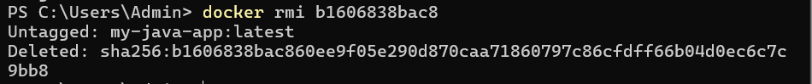

15 docker image prune -a

16 docker run -d -p 8080:80 nginx



17 docker inspect <container_id>

18 docker run -d -v mydata:/data nginx



19 docker volume ls

20 docker volume prune

21 docker run -d --name my_nginx nginx



22 docker stats

23 docker network ls

24 docker network create my_network



25 docker run -d --network my_network --name my_container nginx



26 docker network connect my_network my_nginx



27 docker run -d -e MY_ENV=hello_world nginx



28 docker logs -f my_nginx

29 FROM nginx

COPY index.html /usr/share/nginx/html/index.html

30 docker build -t my_nginx_image .

31 docker run -d -p 8080:80 my_nginx_image



Phần 2 : Build JAR bằng thủ công

